

Module name: Changemakers: Building your Personal Brand for Sustainable Employment

Assessment title: Component 1: Online portfolio

Module code: (BMHP5015_LON)

Lecturer name: Dr. Caroline Salami
Student name: Ekaterina Kist

Student ID: 2336279

Word count: 2129

Task 1 – Unit 1: Brand You
Unit 1 focused on developing self-awareness and understanding how personal values shape professional identity. At the beginning of the module, I associated personal branding mainly with how others perceive me. However, my understanding has developed, and I now recognise that personal branding is a continuous and reflective process that involves aligning my values, behaviours, and long-term goals in a consistent way.
A key concept explored in this unit was autonomy, which refers to taking responsibility for one’s own learning and development. Within Health and Social Care (H&SC), this is particularly important due to the constantly evolving nature of practice, policies, and patient expectations. According to CIPD (2023), professionals are increasingly expected to engage in continuous learning to remain effective in their roles. Reflecting on this, I realised that I have sometimes relied too heavily on structured teaching rather than actively seeking opportunities to develop independently. This has encouraged me to take a more proactive approach to my learning going forward.
Another important concept was the changing nature of careers. Traditional linear career paths are becoming less common, and individuals are now expected to adapt to changing roles and environments. The World Economic Forum (2023) highlights that adaptability and lifelong learning are essential for employability. This has influenced my perspective on my future career as a researcher, as I now understand that this goal may involve a variety of roles and experiences rather than a single fixed pathway. At the same time, this realisation has made me aware that such flexibility requires confidence and decision-making skills, which I am still developing.
The concept of emotional intelligence (EI) was also particularly significant. I learned that EI involves recognising and managing emotions in both oneself and others, which is essential for effective communication and teamwork in healthcare settings. Research suggests that emotional intelligence contributes to improved collaboration and patient care (West et al., 2020). Reflecting on my own abilities, I believe that I demonstrate empathy; however, I need to improve my confidence in expressing my views, particularly in group discussions.
In addition, this unit encouraged me to reflect on the consistency between my personal values and professional behaviour. I realised that having clear values is not sufficient unless they are demonstrated through actions. This is particularly important in H&SC, where trust and professionalism are essential. For example, qualities such as respect, empathy, and integrity must be consistently applied in practice. This reflection highlighted a gap between my intentions and my confidence in certain situations, particularly when communicating my ideas. Therefore, developing greater self-confidence and assertiveness will be an important focus for my future development.
Overall, Unit 1 helped me to develop a deeper understanding of myself and highlighted the importance of continuous reflection in shaping a professional identity.
Screenshots of Unit 1 forum activities:
- Figure 1: Reflection on personal branding discussion
- Figure 2: Emotional intelligence activity response
- Figure 3: Boundaryless career forum contribution
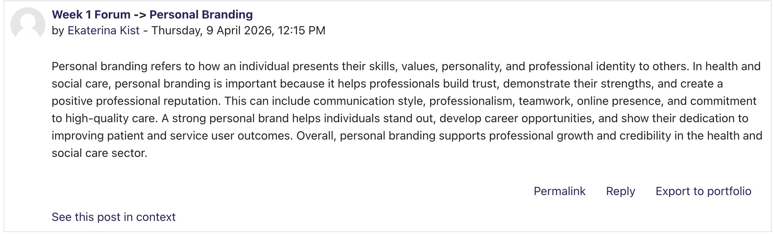
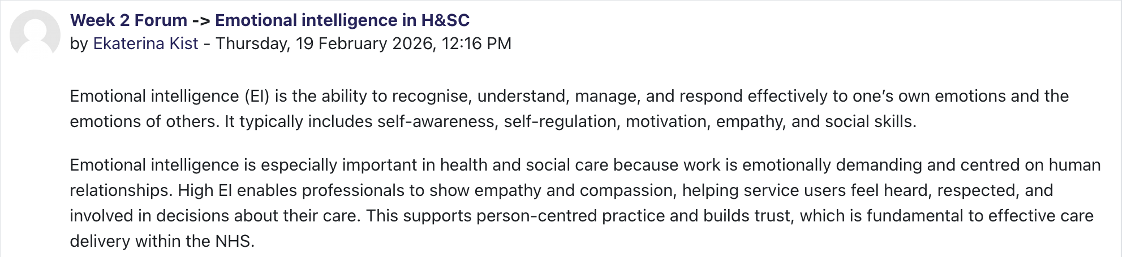

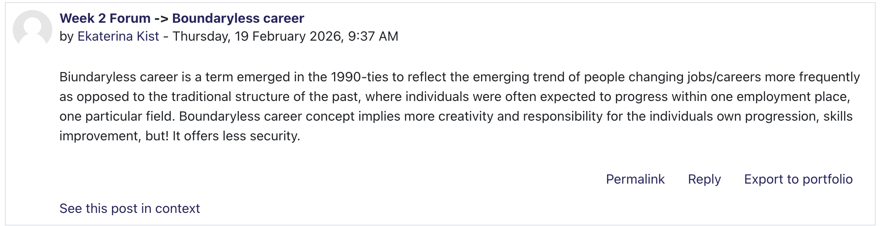

Task 2 – Unit 2: It’s a Small World
Unit 2 expanded my understanding of Health and Social Care by focusing on global connections, diversity, and professional relationships. It emphasised that healthcare systems are influenced by wider social, cultural, and economic factors, and that professionals must be able to work effectively within this complexity.
One of the main areas of learning was networking, which I initially viewed as simply making professional contacts. However, I came to understand that networking involves building meaningful relationships that support collaboration and knowledge sharing. In healthcare, effective communication and teamwork are essential for delivering coordinated and high-quality care (NHS England, 2023). Reflecting on this, I realised that I need to become more confident in engaging with others and actively participating in professional interactions.
The concept of social prescribing also broadened my perspective on healthcare. It highlighted the importance of addressing non-medical factors that affect health and wellbeing, such as social isolation and financial difficulties. This aligns with the concept of social determinants of health, which recognises that health outcomes are shaped by social and environmental conditions (World Health Organization, 2022; UK Health Security Agency, 2025). This has encouraged me to think more holistically about healthcare and the role of professionals in supporting individuals beyond clinical treatment.
Another key area explored in this unit was cultural competence. In a diverse society, healthcare professionals must be able to provide care that is respectful and responsive to different cultural backgrounds. NHS policies emphasise the importance of equality, diversity, and inclusion in improving patient experiences (NHS England, 2023). Reflecting on this, I recognise that cultural competence is not only about knowledge but also about attitudes, including openness and willingness to learn from others.
I also considered the role of bureaucratic structures within healthcare organisations. While these structures provide clear systems and accountability, they can sometimes reduce flexibility and slow decision-making. This highlighted the need to balance organisational efficiency with responsiveness to individual patient needs.
Furthermore, this unit made me reflect on the importance of stepping outside my comfort zone when building professional relationships. I realised that I often hesitate to initiate conversations in unfamiliar environments, which may limit my ability to form valuable connections. However, effective networking requires active participation and openness to new experiences. This suggests that developing confidence in communication is not only beneficial but necessary within H&SC, where collaboration across disciplines is common. Moving forward, I aim to engage more actively in discussions and professional interactions.
Overall, Unit 2 helped me to understand the complexity of healthcare systems and reinforced the importance of communication, cultural awareness, and collaborative working.
Screenshots of Unit 2 forum activities:
- Figure 1: Reflection on Networking Discussion
- Figure 2: Reflection on Bureaucratic Hierarchy in H&SC Discussion
- Figure 3: Social Prescribing Study Forum contribution
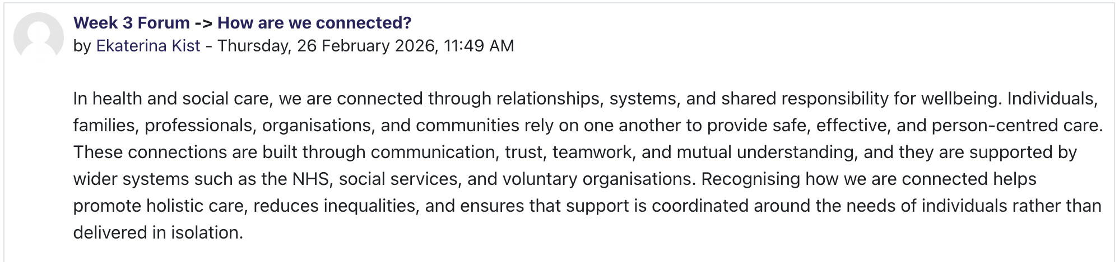

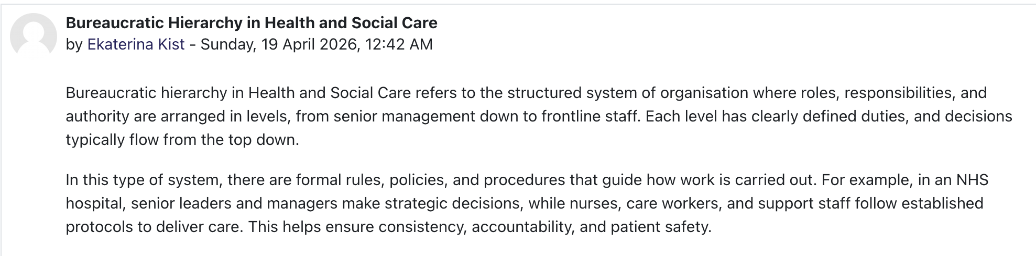

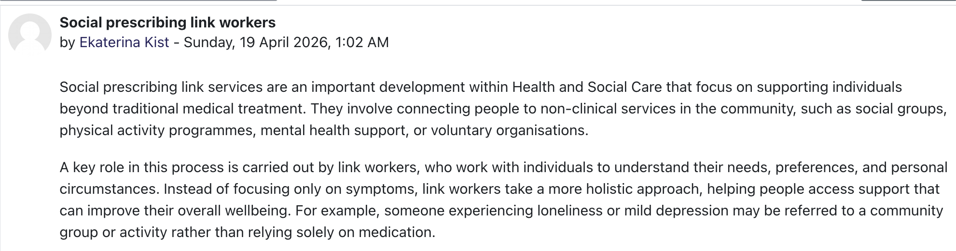

Task 3 – Unit 3: Opportunity Knocks
Unit 3 focused on recognising and creating opportunities for personal and professional development. It encouraged a more proactive and strategic approach to career planning.
One of the most useful concepts introduced was SMART goal setting, which helped me to structure my ambition of becoming a researcher into clear and achievable steps. Breaking down this long-term goal into smaller, manageable objectives made it feel more realistic and increased my motivation. It also provided a clear direction and allowed me to monitor my progress over time.
The concept of a serendipity mindset was particularly interesting, as it emphasised the importance of being open to unexpected opportunities. Rather than focusing only on planned outcomes, this approach encourages flexibility and curiosity. This aligns with current labour market trends, where adaptability is highly valued (World Economic Forum, 2023). However, I recognise that adopting this mindset requires stepping outside of my comfort zone, which I sometimes find challenging.
The idea of stretch goals also encouraged me to challenge myself beyond my perceived limits. Although initially intimidating, I now understand that growth often occurs when individuals take on tasks that feel difficult or unfamiliar. This has motivated me to participate more actively in my learning and seek opportunities to develop new skills.
Another important aspect of this unit was the development of a professional online presence. I learned that platforms such as LinkedIn are valuable tools for networking and career development. Engaging with professional communities online can help individuals access opportunities and stay informed about developments in their field (CIPD, 2023). Reflecting on this, I recognise that I need to improve my online presence to better represent my skills and career goals.
This unit also made me reflect on my attitude towards risk and failure. I realised that fear of making mistakes can sometimes prevent me from pursuing opportunities. However, I am beginning to view failure as part of the learning process rather than something negative.
This unit also highlighted the importance of self-reflection in recognising opportunities. I realised that opportunities are not always immediately visible and often require initiative and awareness to identify. In the past, I may have overlooked opportunities due to uncertainty or lack of confidence. However, I now understand that developing a proactive mindset is essential for career progression. This includes actively seeking experiences, asking questions, and being willing to take calculated risks. As a result, I feel more prepared to approach my career with a greater sense of responsibility and openness to new possibilities.
Overall, Unit 3 has helped me to develop a more confident and proactive approach to my career development.
Screenshots of Unit 3 forum activities:
- Figure 1: Reflection on the Serendipity Mindset Discussion
- Figure 2: Importance of Online Presence Activity Response
- Figure 3: Opening Doors to Jobs in H&SC Forum Contribution
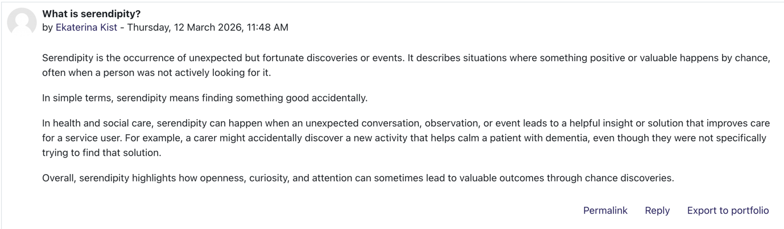
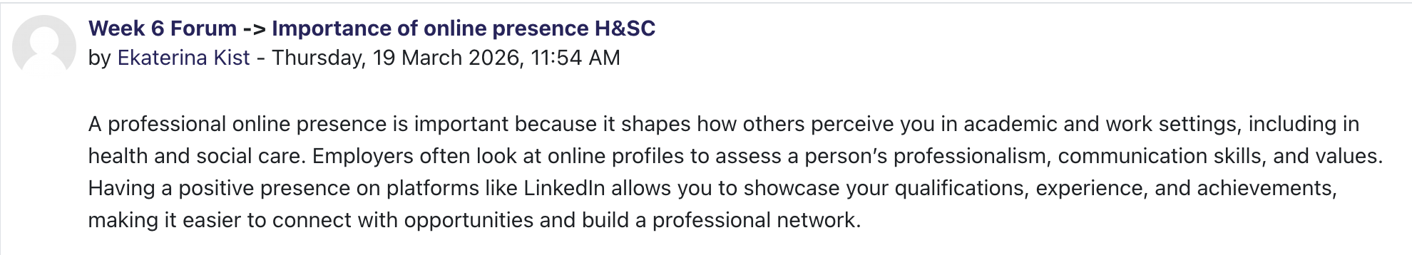

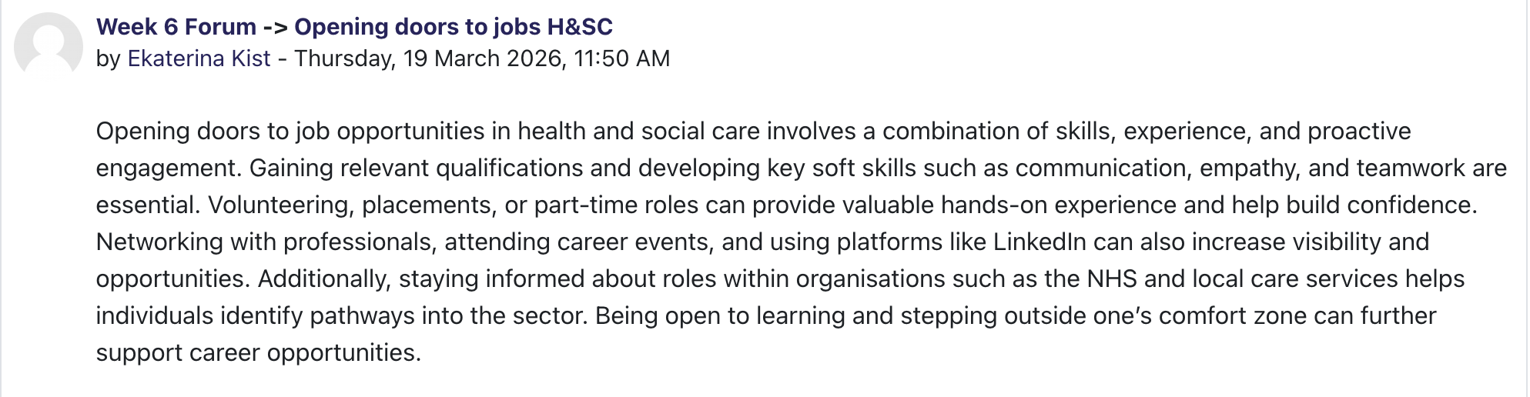

Task 4 – Unit 4: The Pursuit of Happiness
Unit 4 focused on wellbeing, resilience, and sustaining long-term career satisfaction. These concepts are particularly important in Health and Social Care, where professionals often experience high levels of stress and emotional demands.
One of the key insights from this unit was the importance of wellbeing in maintaining professional effectiveness. Research suggests that supporting staff wellbeing improves job satisfaction, reduces burnout, and enhances patient care (NHS England, 2023; West et al., 2020). Reflecting on this, I recognise that prioritising my own wellbeing is essential for sustaining a long-term career in H&SC.
The concept of resilience was also significant. I learned that resilience involves the ability to adapt to challenges and recover from setbacks. This is particularly relevant in healthcare, where professionals frequently encounter emotionally demanding situations. Developing resilience requires both personal coping strategies and support from others.
The idea of grit further emphasised the importance of persistence in achieving long-term goals. Becoming a researcher will require sustained effort and determination, and this unit helped me to understand the importance of maintaining focus despite challenges.
Mentoring was another key topic explored. Mentors can provide guidance, encouragement, and support, helping individuals to develop both personally and professionally. Evidence suggests that mentoring contributes to increased confidence and career progression (West et al., 2020). Reflecting on this, I recognise the value of seeking mentorship as part of my development.
Finally, I explored the impact of technology on healthcare. While technological advancements offer many benefits, they also require professionals to continuously update their skills. Reports highlight the growing importance of digital literacy and adaptability in maintaining employability (OECD, 2021; World Economic Forum, 2023).
An additional important concept explored in this unit was the idea of recognising and challenging limiting beliefs. I learned that negative self-perceptions can restrict personal and professional development by creating unnecessary barriers. Reflecting on this, I realised that I sometimes doubt my abilities, particularly when facing new or unfamiliar challenges. This suggests that developing a more positive and realistic self-view is essential for building confidence and resilience.
The unit also emphasised the importance of maintaining a healthy work–life balance. In H&SC, professionals often prioritise the needs of others, which can lead to neglecting their own wellbeing. However, this approach is not sustainable in the long term. Research indicates that poor work–life balance contributes to stress and burnout, ultimately affecting both staff wellbeing and quality of care (NHS England, 2023). This highlights the importance of setting boundaries and recognising personal limits.
In addition, I developed an understanding of the concept of continuous adaptation in response to technological and organisational change. Healthcare systems are evolving rapidly, and professionals must remain flexible and open to learning new skills. This reinforces the idea that professional development is an ongoing process rather than a fixed achievement.
Overall, Unit 4 reinforced the importance of maintaining wellbeing, developing resilience, and adapting to change in order to sustain a successful career.
Screenshots of Unit 4 forum activities:
- Figure 1: Challenging Limiting Q&A Forum Contribution
- Figure 2: Goals Not Achieved and Antifragile Concept Reflection
- Figure 3: Importance of Mentoring Forum Activity

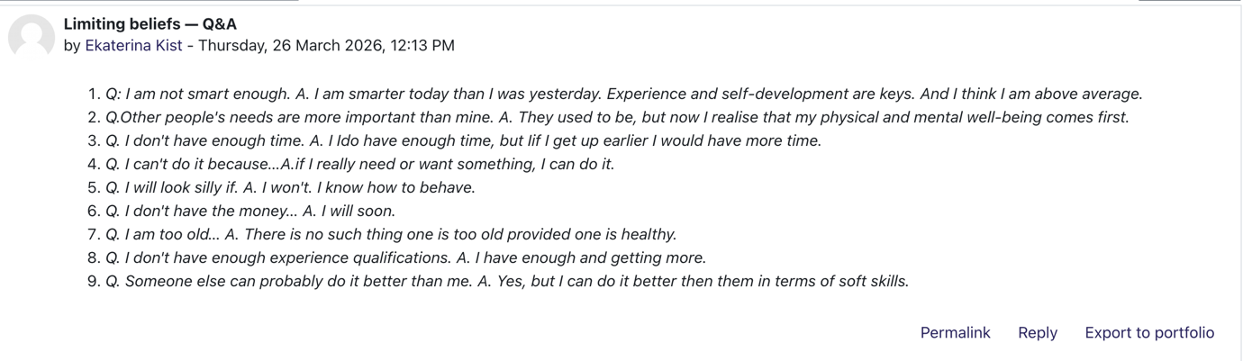
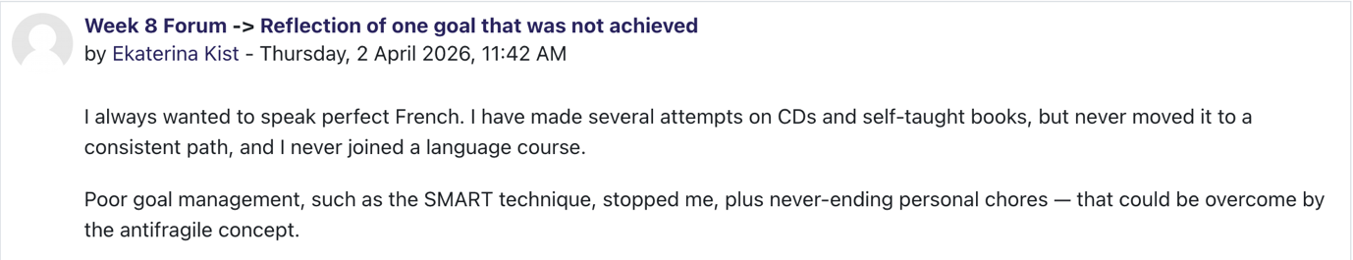
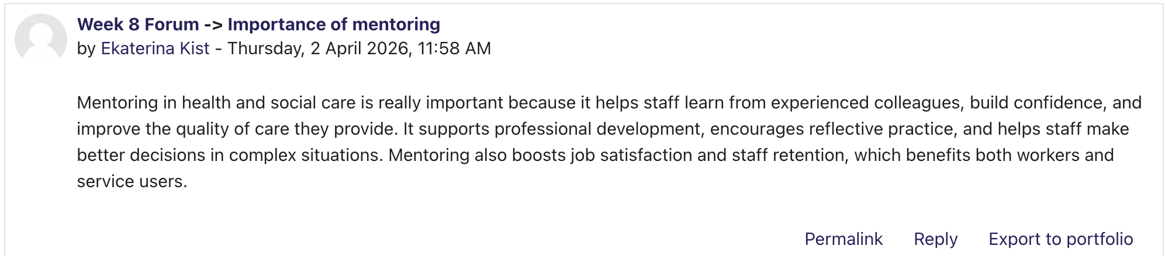

Conclusion
In conclusion, this module has significantly improved my understanding of employability within Health and Social Care. It has helped me move beyond a narrow focus on academic achievement to a broader understanding of the skills and qualities needed for long-term success.
Each unit contributed to my development by focusing on different aspects of professional growth, including self-awareness, networking, opportunity recognition, and wellbeing. The combination of theory and reflection allowed me to apply these ideas to my own experiences.
This module has strengthened my confidence in pursuing a career in research within H&SC. I now understand that achieving this goal requires not only academic knowledge but also resilience, adaptability, and continuous self-improvement.
Overall, the knowledge and skills I have developed will support me in navigating future challenges and contributing positively to the field of Health and Social Care. This module has also encouraged me to adopt a more reflective approach, which will be essential in continuously improving my practice. Moving forward, I intend to apply these insights in both my academic and professional journey, ensuring that I continue to develop the skills and qualities required for a sustainable and meaningful career in Health and Social Care.

References
CIPD (2023) Learning and skills at work survey report 2023. London: CIPD. Available at: https://www.cipd.org/uk/knowledge/reports/learning-skills-work/ (Accessed: 16 April 2026).
NHS England (2023) We are the NHS: People Plan 2023/24. London: NHS England. Available at: https://www.england.nhs.uk/publication/we-are-the-nhs-people-plan-for-2020-21-action-for-us-all/ (Accessed: 16 April 2026).
NHS England (2023) NHS equality, diversity and inclusion improvement plan. Available at: https://www.england.nhs.uk/long-read/nhs-equality-diversity-and-inclusion-improvement-plan/ (Accessed: 16 April 2026).
UK Health Security Agency (2025) Health inequalities in health protection report 2025. Available at: https://www.gov.uk/government/publications/health-inequalities-in-health-protection-report/health-inequalities-in-health-protection-report-2025 (Accessed: 16 April 2026).
West, M. et al. (2020) Caring for doctors, caring for patients. Available at: https://www.gmc-uk.org/cdn/documents/caring-for-doctors-caring-for-patients_pdf-80706341.pdf (Accessed: 16 April 2026).
World Health Organization (2022) Social determinants of health. Available at: https://www.who.int/health-topics/social-determinants-of-health (Accessed: 16 April 2026).
World Economic Forum (2023) The future of jobs report 2023. Available at: https://www.weforum.org/reports/the-future-of-jobs-report-2023/ (Accessed: 16 April 2026).
OECD (2021) Health at a glance 2021. Available at: https://www.oecd.org/en/topics/digital-health.html (Accessed: 16 April 2026).

