Finance Management - SBMA7100D

Assignment 1 (parts 1 & 2)

Student Number 1707375

Word count – Part 1: 2589. Part 2: 2494.

Total: 5083

Table of Contents
1 Part 1 – FTSE 100 listed company report 4
2 Introduction 4
2.1 FTSE 100 companies 4
2.1.1 Hargreaves Lansdown 4
2.1.2 Rationale for selection 4
3 Financials 5
3.1 HL financials v Sector performance 5
3.1.1 Profitability 5
3.1.2 Liquidity 6
3.1.3 Gearing 6
3.1.4 Efficiency Ratios 7
3.1.5 Investor Ratios 8
4 Conclusions and Recommendations 8
4.1.1 Limitations 9
4.1.2 Opportunities 9
5 Part 2 – James Plc 10
5.1 Introduction 10
5.1.1 James Plc 10
5.2 Options Appraisal 10
5.2.1 Investment? 10
5.2.2 Assumptions 10
5.2.3 Non-discounting methods of Investment Appraisal 11
5.3 Net Present Value (NPV) 11
5.3.1 Option (a) 11
5.3.2 Option (b) 11
5.3.3 Option (c) 12
5.4 Internal Rate of Return (IRR) 12
5.5 Fundamentals 13
5.5.1 Profitability 13
5.6 Investment considerations 14
5.7 Investment Recommendation to the Board 15
5.7.1 Preferred Option: 16
6 References 17
7 Appendices 20
7.1 Hargreaves Lansdown Financial Statements 20
7.1.1 Income Statement 20
7.1.2 Balance Sheet 21
7.1.3 Cashflow Statement 23

Table 1 - Profitability: HL v Sector TTM 5
Table 2 - Profitability: HL v Sector 5ya 6
Table 3 - HL Profitability Margin & ROCE 6
Table 4 - ROCE comparison HL v SLA 6
Table 5 - Liquidity Ratios HL 6
Table 6 - Gearing Ratios HL 7
Table 7 - Efficiency: HL v Sector ave TTM 8
Table 8 - Efficiency Ratios HL 8
Table 9 - HL Investor Ratios 8
Table 10 - Option (a) NPV 11
Table 11 - Option (b) NPV 12
Table 12 - Option (c) NPV 12
Table 13 - Investment options summary 13
Table 14 - Option (a) IRR calculations 13
Table 15 - Option (b) IRR calculations 13
Table 16 - Option (c) IRR calculations 13
Table 17 - Profit appraisal 14
Table 18 - Investment options summary 17

Part 1 – FTSE 100 listed company report

Introduction

FTSE 100 companies
Launched in 1984 as a partnership between the Financial Times and London Stock Exchange with a base listing of 1000; the FTSE 100 lists the stocks of the 100 largest eligible companies by market capital to trade on the London Stock Exchange (LSEG, 2018). Market Capitalisation (total value of shares in the listing) of the FTSE 100 as of February 2018 was just over £2trillion, with Financials, Oil and Gas, and Consumer Goods companies representing around half of Market Capital as of February 2018 (LSE, 2018).

Hargreaves Lansdown
Founded in 1981 by Peter Hargreaves, and Steve Lansdown, Hargreaves Lansdown (HL) is a publicly traded Financial Services company listed in the FTSE 100 (LSE, 2019). HL have close to 1.1million active clients and manage approximately £85 billion of investments; making it the UKs largest direct investment service (Hargreaves Lansdown, 2019).
HL has strong performance in direct investment markets, considered by the company to be due to its industry leading IT platform, customer interface, and commitment to simplicity (Hargreaves Lansdown, 2018). This dominant market position is potentially also aided by the failure of competitors to attract a significant portion of the c£200billion invested by DIY investors. In recent times this is in part driven by issues with some of HL competitors IT systems and investor platforms (Financial Times, 2018).
The strong position in DIY investment and HL’s boards’ belief in their internal systems and investor platform has given confidence to the organisation to expand. The UK cash savings market is competitive, but potentially lucrative with estimated worth of around £700billion in the UK (FCA, 2015), although HL analysis considers a further £1.1trillion as “addressable” (Hargreaves Lansdown, 2018, p. 10). The opportunity for growth in the UK market is therefore significant.
Whilst the position appears to be relatively positive, this report will analyse and critique company performance in respect of its financial fundamentals reviewing data including at least the last 2 years of financial reports. Ratio analysis for profitability, liquidity, gearing, and efficiency will be conducted, with the report concluding with a set of recommendations to the board for how any opportunities to optimise the company’s financial performance can be realised.

Rationale for selection
Criteria for this report required selection of a FTSE 100 listed company and subsequent analysis of their financial statements. Statements of several FTSE 100 companies were reviewed, with HL being selected for further analysis in this report. Financials are the largest sector listed on the index (by Market Capitalisation) and the UK market is currently the second largest financial centre in the world (FT, 2018). This high-profile sector therefore represents a key component of the UK economy and makes an interesting area of study for further review.
HL was founded in Bristol and represents a business of keen local interest, being recognised in the top 50 companies in the South West by a regional enterprise network (South West Business, 2018). As a significant player in the UK’s leading economic sector and with relative uncertainty across the economy driven primarily due to Brexit, it is felt that an appraisal of this important local company is both timely and apt.

Financials
The ability to raise finance is a key component of successful enterprise, and it is commonly accepted that there are 2 broad streams for companies in terms of raising finance: Investment, and debt. Although there are recent developments in the avenues open to organisations, such as crowdfunding etc, capital raised is broadly be classified into investments, or debt (Rossi, 2014).
Either avenue requires the assessment in terms of whether finance invested, or loaned, represents value, or a likely safe return. Therefore, analysis of financial ratios is helpful to investors and potential creditors in understanding the financial health of a business in relatively simple terms (Atrill, 2009). Although financial ratio analysis can provide useful data and be done relatively quickly, by itself this would represent only a shallow critique of a business strengths and weaknesses.
Deeper analysis is required to understand why performance is weak or strong, and what factors may have influenced change. Atrill describes the usefulness of ratios as best – “enabling us to know which questions to ask, rather than providing the answers.” (2009, p. 68). Therefore this report will describe some of the key ratios for HL, then attempt to explain contributing factors influencing performance, concluding with some recommendations for optimising performance.

HL financials v Sector performance
In the section below we review some key financial data in comparison to the sector performance for 2 periods: a 5 year average (5ya), and trailing twelve months (TTM), using data available from a global finance portal (Investing.com, 2019), as well as financial statements from the year end annual report (Hargreaves Lansdown, 2018).

Profitability
HL is outperforming the sector average in 3 measures of profitability in both TTM and 5ya. All measures performance in TTM broadly in favour by factor of 2 times across all 3 margins (195%-211% range). This is mirrored in 5ya (215%-310% range), all be it with slightly increased operating margin performance against sector average for 5ya (factor of 3 times)
Table 1 - Profitability: HL v Sector TTM
TTM | HL | Sector
Operating margin | 65.04% | 31.91%
Pre-tax margin | 65.33% | 31.03%
Net Profit margin | 52.88% | 27.15%

Table 2 - Profitability: HL v Sector 5ya
5ya | HL | Sector
Operating margin | 59.61% | 19.21%
Pre-tax margin | 60.04% | 27.18%
Net Profit margin | 47.89% | 22.26%

Profitability – Trend Analysis
Analysing HL performance between 2014 and 2018 we can see steady growth in Operating Margin of around 12%, with significant uplift in margin between 2015 and 2017 of around 35%. This tells us that HL are achieving better value for their sales since 2017 despite significant investment in their infrastructure. HL attributes this to the scalability of their operating model delivering efficiencies and driving margins up to an “industry leading” 65.04% (Hargreaves Lansdown, 2018, p. 15).
HL are effective at profit generation and perform at over 80% ROCE in each of the last 5 years. (ROCE (Return on Capital Employed) describes how effectively HL is generating profits from its Capital). The average ROCE for UK based companies in 2018 is around 12.7%, with Servicing and Manufacturing companies being slightly higher at around 17% & 15% respectively (ONS, 2018). Identifying ROCE data for financial institutions is slightly more challenging as this ratio is not widely reported, however comparison with a leading FTSE 100 listed competitor – Standard Life Aberdeen (SLA) demonstrates HL significantly stronger performance in ROCE analysis for each year between 2014 & 2017. HL are therefore able to generate significant revenues with relatively little capital required.
Table 3 - HL Profitability Margin & ROCE
 | 2014 | 2015 | 2016 | 2017 | 2018
Operating Margin | 58.04% | 50.12% | 56.20% | 67.70% | 65.04%
ROCE | 98.04% | 85.31% | 88.79% | 93.15% | 81.90%

Table 4 - ROCE comparison HL v SLA
 | 2014 | 2015 | 2016 | 2017
SLA | 16.50% | 13.58% | 19.30% | 15.55%
HL | 98.04% | 85.31% | 88.79% | 93.15%

Liquidity
HL report a current ratio climbing close to 2:1. Stable growth from 2016 onwards and improvement from the 2015 position demonstrates HL is in a stable position and able to meet its liabilities with relative comfort. A current ratio of around 2 is seen to demonstrate a decent balance between a company effectively managing its assets in a productive manner, and one who can meet its liabilities with relative comfort (Atrill, 2009), (Saleem & Rehman, 2011).
Table 5 - Liquidity Ratios HL
 | 2014 | 2015 | 2016 | 2017 | 2018
Current ratio | 1.68 | 1.51 | 1.39 | 1.65 | 1.96
Acid test ratio | 1.68 | 1.51 | 1.39 | 1.65 | 1.96

Gearing
Described as “The existence of fixed-payment-bearing securities (i.e. loans) in the capital structure of a business” (Atrill, 2009, p. 577), gearing occurs when a business is financed by borrowing rather than owner finance, or put another way “the extent to which a company’s operations are funded by lenders versus shareholders.” (Investopedia, 2018). The extent to which a company is ‘geared’ is an important factor in assessing risk. Also of note, companies financed in this way are exposed to associated costs of finance, such as interest payments, therefore will have to find ways to offset these costs compared to competitors with lower reliance on gearing. Gearing is therefore a measure of risk, and companies potentially exposed to increased market risks should be consciously looking to have a low Gearing ratio.
Gearing ratios can be thought of in terms of 2 distinct parts, the Gearing Ratio, and the Interest Cover Ratio. Atrill, (2009) describes each ratio thusly: What is the contribution of long-term lenders to the capital structure of the business? What available operating profit is there to cover any interest payable? (p. 89).
Table 6 - Gearing Ratios HL
 | 2014 | 2015 | 2016 | 2017 | 2018
Gearing Ratio | 0.4% | 0.3% | 0.4% | 0.5% | 0.5%
Interest Cover Ratio | 8255 | 8921 | 7658 | 6217 | 5107

HL does not report significant non-current liabilities; therefore, it is reasonable to describe the company as primarily financed via its Equities and Revenue. Gearing of less than 1% is reported for each of the last 5 financial years, with only notional changes year on year, which are relatively insignificant with a company of this size (in terms of financial operations). HL would cover its Interest with comfort as the operating profit is well above 5000 times any interest payable.

Efficiency Ratios
Efficiency Ratios help us to understand the management of resources within a company, for example how well-used assets may be, and the effective management of a company’s liabilities. Relationships positively correlating Efficiency with higher Profitability in Financial sector organisations are relatively widely reported (Oral & Yolalan, 1990), (Halkos & Salamouris, 2004), (Hays, et al., 2009), and so therefore Efficiency Ratios represent an area of interest for a broad range of spectators including Investors and managers.
Reviewing revenue per employee, and net income per employee for the previous TTM and comparing to industry average, we can see that HL performance in under that reported for industry average in previous TTM. Whilst HL ratios for efficiency are below that of industry average, they should not be considered in isolation.
HL has invested significantly in staffing and technology development, with a 34% uplift in people from 2017 to 2018. HL recognise this investment and consider this a positive response to growing client numbers and associated levels of activity. By reinvesting in the servicing functions HL believe they reinforce their scalability and project future productivity gains and associated growth:
“We consciously and significantly increased our investment in people, digital marketing and technology during the 2017 financial year. We believe the Group’s focus on client service is core to our success and necessary to capture the structural growth opportunity in the UK savings and investments market” (Hargreaves Lansdown, 2018, p. 36).

Table 7 - Efficiency: HL v Sector ave TTM
TTM | HL | Sector
Revenue/Employee | £320,170 | £1.05m
Net Income/Employee | £169,310 | £406,060

Table 8 - Efficiency Ratios HL
 | 2014 | 2015 | 2016 | 2017 | 2018
Revenue (£m) | 358.39 | 395.14 | 388.33 | 385.70 | 447.60
Employees | 844 | 970 | 1043 | 1185 | 1398
Revenue/Employee (£m) | 0.425 | 0.407 | 0.372 | 0.325 | 0.320

Investor Ratios
For some investors, dividends can represent somewhat of a double-edged sword; on the one hand there is the return of a small payout as a result of investments, however this is financed from the profits of a company and is therefore not available for reinvestment which could potentially add value to the business and increase the return price on shares (Atrill, 2009), (Investopedia, 2018).

Earnings per Share (EPS)
EPS is considered as a key measure of a share’s performance. It describes the investment potential of a business when viewed over time (Atrill, 2009). Year on year performance shows 19.5% growth between ‘16/17, and 11.19% ‘17/18, with overall growth of 44.06% since 2014. Growth at this level is considered strong performance and will give investors confidence in the future earning power of HL.

Price/Earnings Ratio
Analysis of the continued strength of HL P/E ratio seems to indicate that investors share the board’s confidence in the future prospects of HL. Comparing HL performance with FTSE 100 listed companies, HL ranks in at number 7 for companies listing P/E ratios, and is broadly in line with competitors in the financial sector (LSE, 2019).
Table 9 - HL Investor Ratios
 | 2014 | 2015 | 2016 | 2017 | 2018
EPS | 34.5p | 33.2p | 37.4p | 44.7p | 49.7p
EPS - %Growth | 8.83% | -3.77% | 12.34% | 19.85% | 11.19%
P/E Ratio | 35.88 | 34.73 | 33.24 | 29.13 | 39.67
Dividend Yield Ratio | 2.58% | 2.86% | 2.74% | 2.01% | 2.03%
DPS - %Growth | 8.14% | 3.12% | 2.75% | -22.73% | 52.67%

Conclusions and Recommendations
Individual ownership of shares has declined steadily from a peak of 54% of UK population in 1963 to around 12% in 2006, dropping to around 10% during the global financial crisis in 2008 and subsequently rebounding to around 12% since 2014 (ONS, 2017). Given the low rates of interest offered to savers in cash accounts it is relatively surprising to see stagnation in the levels of share ownership in the UK.
Both HL and the London Stock Exchange Group articulate that public awareness of stocks and the opportunities these afford for wealth creation is “at an all-time high”, and therefore markets and individual investment represents “a key component of financial market infrastructure” (LSEG, 2018, p. 1). HL argue that DIY financiers are an increasingly important and highly influential group, with huge future market potentials (Hargreaves Lansdown, 2018). It therefore seems vital to future growth that key that data is accessible and comparable in a meaningful way, and financial literacy is supported which in turn can drive investment.
Financial Ratios have a key role in helping us to understand organisations and their financial performance, as well as inform decisions around investment and management of companies (Atrill, 2009). Whilst acknowledging the value of financial ratios, it is important to understand they also have limitations both in terms of structure and understanding, but also in application for analysis (Faello, 2015).

Limitations
Ratios can help us to understand a company’s performance, i.e. company A may report a ROCE of 5%, however what does a ROCE of 5% mean in relation to what should be reasonably expected of a company of similar size, sector, and state? Ratio analysis has value in helping investors compare performance against either benchmarked levels, or an identified competitor for example. The ability to compare helps us to understand what is good, why is it good, and also to put these questions into context. Using ROCE comparison (section 2.1.1.1) we can benchmark performance of HL vs a competitor (SLA) which shows significant advantage to HL over SLA in this measure sustained over 5 year period. This would give investors confidence in HL profitability in comparison to its peers.
A challenge in this report has been to identify sector data for some of the key metrics as not all measures are routinely reported, and there is diffusion in some of the accounting and reporting methods used for preparation of financial statements, in spite of significant regulation of listed companies (Atrill, 2009). Whilst some data has been available, it has allowed the viewing of a partial picture, but it is still difficult to fully appraise HL against the market and its sector competitors.

Opportunities
HL is a highly performing financial firm, demonstrating low debt, high profitability, reasonable liquidity and efficiencies, and supported confidently in the markets with strongly performing investor ratios. Detailed in the annual report are the strategic growth & investment plans with significant attention to technology & infrastructure, and investment in people resource. HL plans to grow the client base further is planned to attract increasing revenues in line with recent growth (16% for 2017/18).
Efficiency ratios are slightly lower than competitors and therefore HL have opportunities to further expand the efficiencies seen in isolated areas of the business which have reported 15% (helpdesk) & 25% (operations) uplifts in productivity (Hargreaves Lansdown, 2018). HL have increased retained earnings year-on-year with growth of 31% between 2017 & 2018. Retained earnings stand at c£399mill in 2018, compared with £228mill in 2014, an uplift of c75%. HL have the opportunity to employ capital from retained earnings to generate further revenues and business value.
HL report profitability favourably against its competitors and focus should be clarified on what allows HL to generate returns of c93% compared with c15% reported by SLA for example. HL are in a position to be relatively ambitious with its financial plans, focussing on growing revenues, increasing capital employed (and deriving returns), and driving efficiencies in line with reported initiatives from its operations.

Part 2 – James Plc

Introduction
The idea of investment in business centres around creation of value (Atrill, 2009). There is much discussion about the focus of organisational objectives, with interesting and somewhat opposing positions offered by (Drucker, 1954), (Friedman, 1970), and (Denning, 2014) amongst others as to whether enterprise is about creating customers, maximising profits, or serving customers.
Value can of course be defined in monetary or other terms, such as social good (Emerson, 2003), and therefore organisational goals and outcomes will vary from company to company, although commonly linked by the aim to create value for their stakeholders (Hillman & Keim, 2001). Monetary value can be explored from a couple of different positions, for example wealth maximisation, or return on investment (Atrill, 2009). Each organisation will have their own perspectives on whether making the largest possible amount of money, or seeing the highest rate of return against money invested is the most important.

James Plc
James Plc are producers of garden ware with a shortlist of 4 investing options for consideration in this report:
- Invest or Not
- Investment options:
  - Expand retail operations – cost £750k
  - Web-based operations (internet sales) – cost £1.2million
  - Diversify product lines (conservatory/greenhouse manufacture) – cost £2million

This report will evaluate investment options using Net Present Value (NPV) with assumed Cost of Capital at 8%, and propose a recommendation for the consideration of the Board of Directors which states Internal Rate of Return (IRR) on the preferred option.

Options Appraisal

Investment?
Approaching this task as a binary choice the options boil down to a) not making an investment and recommending status quo, or b) identifying an investment opportunity. All businesses require some investment at some point, and therefore decisions on the potential returns or value for that investment are important (Atrill, 2009). Data for current cashflows and operating margin are not presently available, and therefore it is challenging to recommend not investing as the preferred option of this report. It is assumed that revenue growth is a primary aim of the business and therefore options will be appraised on this basis.

Assumptions

Operating Profit Margin
Using ONS data an assumed OPM of 15.6% is adopted for financial modelling. This figure is based on the average OPM for UK manufacturing corporations Q2 2018 (ONS, 2018).

Capital Employed
Capital Employed as investment cost/project term.

Non-discounting methods of Investment Appraisal
4 main methods of capital budget appraisal are commonly used, Accounting Rate of Return (ARR), Payback Period (PP), Net Present Value (NPV), and Internal Rate of Return (IRR). Non-discounting methods (as well as non-systematic, ‘intuition-based’ methods) of financial appraisal are relatively popular, although limited systems of analysis (Atrill, 2009).
Relatively quick and easy to calculate, ARR and PP ratios are expressed as percentages and are subsequently popular with managers for their familiar look and feel. Discounted Cash-Flow techniques are richer in their projections, but also fuller in their complexities. Managers and decision makers may have limited skills and literacy in the techniques, and therefore rely on more straight forwards and familiar methods in their capital budgeting, thus allowing non-discounting methods to dominate capital budgeting decision making practices (Pike, 1996), (Ryan & Ryan, 2002), (Rossi, 2014).

Net Present Value (NPV)
NPV is viewed as a leading method for appraisal of investment decisions and a stronger option with fewer limitations than either ARR (Accounting Rate of Return), PP (Payback Period), or IRR (Internal Rate of Return) (Dudley Jr, 1972), (Atrill, 2009). A strength of NPV is the consideration of the role time in realising both costs and benefits of an investment (Sunde & Lichtenberg, 1995). More simply described, receipt of £1000 with immediate effect is felt to be more valuable that £1000 deferred for several months, due in part to missed opportunities for the £1000 to work for the owner, i.e. missed interest, investment, inflation, and risk. Compensation for the increased risk and opportunity loss may be sought in any investment decision, and the NPV method is strongest at sighting decision makers with this information (Atrill, 2009).

Option (a)
Investment in option (a) has an initial investment price of £750,000. The yield of projected cashflow returns at the end of the accounting period is c£1.9million. NPV of the investment is £813,000. This means the total future projected cashflows is worth £813,000 immediately, or £1.9million at the end of the accounting period. The NPV value is positive and therefore option (a) should be considered for investment.
Table 10 - Option (a) NPV

Option (b)
Investment in option (b) has an initial investment price of £1.2million. The yield of projected cashflow returns at the end of the accounting period is c£2.9million. NPV of the investment is c£1.15million. This means the total future projected cashflows is worth £1.15million immediately, or £2.9million at the end of the accounting period. The NPV value is not positive and therefore option (b) should not be considered for investment.
Table 11 - Option (b) NPV

Option (c)
Investment in option (c) has an initial investment price of £2million. The yield of projected cashflow returns at the end of the accounting period is c£4.5million. NPV of the investment is c£1.64million. This means the total future projected cashflows is worth £1.64million immediately, or £4.5million at the end of the accounting period. The NPV value is not positive and therefore option (c) should not be considered for investment.
Table 12 - Option (c) NPV

Internal Rate of Return (IRR)
Described as “somewhat laborious” to calculate by hand (Atrill, 2009, p. 142), IRR is a method of investment appraisal that involves discounting future cashflows that when applied, will show an NPV of 0. Harvard Business Review have described IRR as “the rate at which a project breaks even”, and also, “more conceptual than NPV” (Harvard Business Review, 2016). The process is somewhat iterative and many financial websites and texts recommend using a financial calculator or a software package for this calculation which increases its accessibility, however does not address how users will develop understanding of its underlying mechanics.
For calculation of the IRR, a discounting table (Atrill, 2009, p. 527) was used and results summarised below for the NPV and IRR values of the proposed investment options. Hurdle rates are used to assess the value of an investment opportunity, sometimes described as the Minimum Acceptable Rate of Return (MARR) it benchmarks the point at which investors should expect their returns to exceed (CFI, 2015).
Businesses will set their own benchmarks for Hurdle rates and this may be given some steer from shareholders etc, however a common benchmark of 12% is frequently used due to comparisons with stockmarket returns, although this may be set higher for companies in more volatile markets (Wikipedia, n.d.). For purposes of this analysis a Hurdle rate of 20% was set taking into account 8% Cost of Capital plus allowances for other costs.
Each of the 3 options demonstrated IRR greater than the proposed Hurdle rate of 20% with higher IRR shown against option a and option c showing the smallest IRR. To calculate IRR an excel sheet was created with formulas to extrapolate discount rates beyond 20% as early iterations of option (a) showed that discounting rates of 20% and below would not yield an NPV of 0. Projected cash flows were multiplied by discounting rates to show present value and the total for the project.
Table 13 - Investment options summary
Detailed in the tables below are the workings for IRR for options (a) – (c).
Table 14 - Option (a) IRR calculations
Table 15 - Option (b) IRR calculations
Table 16 - Option (c) IRR calculations

Fundamentals

Profitability
Assuming an Operating Margin of 15% a forecast ROCE was created to assess potential profitability of the investments. Assumptions on Capital Employed was crudely stated to be the Initial Investment costs over the project term i.e. Option (a) for example £750k / 4 years = £187.5k/pa. This is flawed methodology; however, it is consistent. And so whilst comparisons in regards to external investments would not draw valid conclusions, there is some validity in internal comparison as all methodology was equally flawed across each model.
Option (a) achieves the highest average profitability over the project with 38% mean ROCE. Peak ROCE is achieved in Year 4 by option (b), however mean is slightly lower at 36% and the ROCE for option (b) does not catch up with either competitor before Year 3. Option (c) has the lowest mean ROCE of 34%, but has the best growth between Years 1 & 3.
Figure 1 - Projected ROCE years 1-4
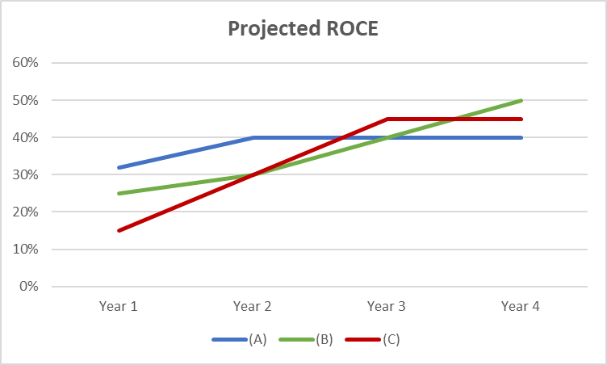
In terms of profit maximisation, option (c) demonstrates the largest amount of money made for the company over the project period. Mean yearly profits are around £170k which is over double the profits seen in option (a). If the goal of the organisation is profit maximisation, option (c) would offer the best choice, however the ROCE analysis above favours option (a).
Table 17 - Profit appraisal
Option | Year 1 (£’000) | Year 2 (£’000) | Year 3 (£’000) | Year 4 (£’000) | Total (£’000)
(a) | 60 | 75 | 75 | 75 | 285
(b) | 75 | 90 | 120 | 150 | 435
(c) | 75 | 150 | 225 | 225 | 675

Investment considerations
In this financial report we have reviewed the investment potential of 3 differing options: Expanding retail operations, Increasing Web-based operations, and Diversifying manufacturing product lines to conservatories/greenhouses. Analysis of the data favours investment in either option (a) or option (c), dependant on whether the organisational goal is wealth maximisation (c), or best value return on investment (a). Both options require physical infrastructure development and reliance on traditional models of customer behaviour.
The chart below from ONS (2018) shows steadily climbing retail spending in the UK market, however in-store performance is relatively static. Projections & future cash flow analysis in this report supports option (a) as a relatively strong proposition, however taking into account market climate and continued growth in online sales there are decisions to be made in regards to future investment. Online trade has increased every year since 2008. Whilst James Plc modelling suggest option (b) slightly weaker in this analysis it is worth considering the behaviour of the market, but also our competitors.
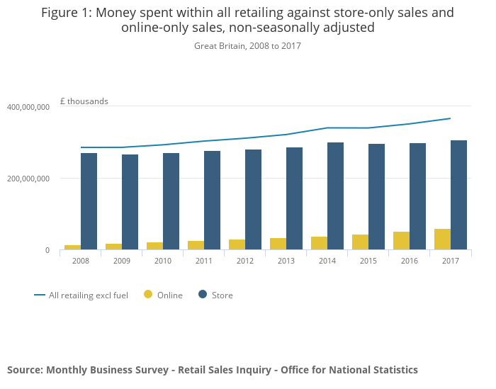
Strategic direction from other similar companies may drive industry sales online and James Plc may not have the agility to respond having committed the capital resource to either retail stores or manufacturing. A secondary aspect of option (b) is potential for future development opportunities to utilise the technological infrastructure in different ways. Many organisations have realised market growth and efficiencies from enhanced technology investment as in the Part 1 case study – Hargreaves Lansdown (Hargreaves Lansdown, 2018).
Consideration should be given to how the proposed investment projects are financed and how this may impact the returns on investment, and also the potential impacts on daily operations. Leveraging debt to fund investment would come with additional costs and financial implications, therefore a blended approach utilising a portion of retained earnings and some finance would be preferable. If larger capital projects are selected then it may be necessary to increase borrowings in order to cover necessary finance, however this will extend the repayment period and associated costs, therefore financial returns from the project will be required to proportionally return higher levels to offset these costs.
Financing may not be restricted to just borrowing and internal reserves. Alternative sources of funding may exist for certain workstreams that may have benefits for other agencies. For example, local authorities can apply for ringfenced funding from the IEG grant to develop ICT-based technologies and electronic service access (Gov.uk, 2015). Government portal from the Department for Business, Energy & Industrial Strategy lists access to potential finance streams with filters to help identify most suitable schemes. A brief search of the domain highlighted 93 schemes that may fit criteria for some of the investment options proposed (Gov.uk, 2019).
Identifying grants, loans, or government finance etc will mean that equity in James Plc is preserved, and this may be a preferential source of capital than raising through a shares issue for example. The most preferable finance sourcing may be a portfolio approach, with moneys identified from revenues, reserves, potential grants, a small share issue, and some capital borrowing. Some research has indicated this approach as beneficial as the risks and benefits to investment are shared, therefore not exposing any one part to too great a degree (Francois & Hubner, 2010).

Investment Recommendation to the Board
This report has appraised 4 investment proposals detailed above. Investment consideration 1, do not make an investment. In the appraisal of options, the option of maintaining status quo is useful to consider. Risk aversion may lead decision makers to lean towards status quo, however opportunities for benefits, growth, and improvement may be missed. It is recommended during appraisal that alternatives are considered as a test of the preferred option (Gov.scot, 2018). The recommendation of this report is that James Plc should make an investment. Therefore the status quo option should be rejected.
Detailed options appraisal is described in the sections above and recommendations take into account return on investment (using discounted future cashflow methodology), financing, as well as company objectives.
On the basis of return on investment, option (a) represents the best value investment with the highest IRR and NPV returns. Infrastructure and investment wise there are concerns that this investment may have a shorter half-life than the other options based on market analysis of customer behaviours as detailed by ONS, with more sales moving away from physical retail bases to online sales (ONS, 2018). Gross total cashflows for the investment are also the smallest absolute returns. In spite of the supportive NPV & IRR data, this report recommends this option is not considered for investment at this time.
Option (c) has the weakest NPV and IRR returns of the 3 available investment proposals and also the highest initial investment costs. Financing the initial costs may be problematic and impactful to James Plc in a slightly restrictive way. Manufacturing allows risk to be shared with other stakeholders, however retail slowdown and changing consumer habits expose this option to downstream risks which mean the risk/return appetite from the board will need to be high. Option (c) has the highest gross cashflow return for the project, however reports a negative NPV. It is recommended by this report that there are more suitable options for investment and therefore this option should not be considered at this time.

Preferred Option:
This report recommends option (b) as the preferred option for investment. Moderate initial investment costs mean financing should be achievable and not negatively impactful for James Plc. Return on Investment measured through IRR breaches the 20% hurdle rate, although NPV is a slightly negative value. Considering the options as risk based decisions, option (b) is felt to have the most long term potential for wealth maximisation (Coleman, 2007) Internet sales is a strong growth market for the UK (ONS, 2018) and therefore it is felt the capital investment into technology infrastructure would have a life beyond the initial project scope. This potential is felt to be worth the trade-off of slightly reduced NPV against option (a). Strong ROCE trajectory (5.2.1) is demonstrated with option (b) achieving the highest ROCE of all investment options in year 4.
Table 18 - Investment options summary

References
Atrill, P., 2009. Financial Management for Decision Makers. 5th ed. Harlow: Prentice Hall.
CFI, 2015. Resources. [Online]
Available at: https://corporatefinanceinstitute.com/resources/knowledge/finance/hurdle-rate-definition/
[Accessed 17th January 2019].
Coleman, L., 2007. Risk and Decision Making by Finance Executives: A Survey Study. International Journal of Managerial Finance, 3(1), pp. 108-124.
Denning, S., 2014. Forbes.com. [Online]
Available at: https://www.forbes.com/sites/stevedenning/2014/06/17/why-the-worlds-dumbest-idea-is-finally-dying/#4aba1798104e
[Accessed 17th January 2019].
Drucker, P. F., 1954. The Practice of Management. 1st ed. New York: Harper & Brothers.
Dudley Jr, C. L., 1972. A Note on Reinvestment Assumptions in Choosing Between Net Present Value and Internal Rate of Return. The Journal of Finance, 27(4), pp. 907-915.
Emerson, J., 2003. The Blended Value Proposition: Integrating Social and Financial Returns. California Management Review, 45(4), pp. 35-51.
Faello, J., 2015. Understanding the Limitations of Financial Ratios. Academy of Accounting and Financial Studies Journal, 19(3), p. 75.
FCA, 2015. Cash Savings Market Study Report: part 1, London: FCA.
Financial Times, 2018. fastFT. [Online]
Available at: https://www.ft.com/content/e4d4f070-5802-11e8-b8b2-d6ceb45fa9d0
[Accessed 8th January 2019].
Francois, P. & Hubner, G., 2010. A Portfolio Approach to Venture Capital Financing, Montreal: EDHEC.
Friedman, F., 1970. A Friednzan doctrine. The New York Times Magazine, 13th September, p. 17.
FT, 2018. Brexit. [Online]
Available at: https://www.ft.com/content/88cdec40-b03c-11e8-8d14-6f049d06439c
[Accessed 9th January 2019].
Gov.scot, 2018. Investment Appraisal. [Online]
Available at: https://www.mygov.scot/investment-appraisal/
[Accessed 17th January 2019].
Gov.uk, 2015. Modern Gov. [Online]
Available at: https://moderngov.dover.gov.uk/Data/Cabinet/20040927/Agenda/$Agenda05_AppendixC.doc.pdf
[Accessed 17th January 2019].
Gov.uk, 2019. Department for Business, Energy & Industrial Strategy. [Online]
Available at: https://www.gov.uk/business-finance-support?keywords=&types_of_support%5B%5D=finance&types_of_support%5B%5D=equity&types_of_support%5B%5D=grant&types_of_support%5B%5D=loan&business_stages%5B%5D=established&industries%5B%5D=manufacturing&business_sizes%5B%
[Accessed 17th January 2019].
Halkos, G. E. & Salamouris, D. S., 2004. Efficiency Measurement of the Greek Commercial Banks with use of Financial Ratios. Management Accounting Research, 15(2), pp. 201-224.
Hargreaves Lansdown, 2018. Annual Report 2018, Bristol: Hargreaves Lansdown.
Hargreaves Lansdown, 2018. Key Financial Data. [Online]
Available at: https://www.hl.co.uk/investor-relations/key-financial-data
[Accessed 10th January 2019].
Hargreaves Lansdown, 2019. The HL Business. [Online]
Available at: https://www.hl.co.uk/investor-relations/the-hl-business
[Accessed 7th January 2019].
Harvard Business Review, 2016. Financial Analysis. [Online]
Available at: https://hbr.org/2016/03/a-refresher-on-internal-rate-of-return
[Accessed 17th January 2019].
Hays, F., De Lurgio, S. A. & Gilbert Jr, A. H., 2009. Efficiency Ratios and Community Bank Performance. Journal of Finance and Accountancy, 1(1), pp. 1-15.
Hillman, A. J. & Keim, G. D., 2001. Shareholder Value, Stakeholder Management, and Social Issues: What's the Bottom Line?. Strategic Management Journal, 22(2), pp. 125-139.
Investing.com, 2019. Markets & Shares. [Online]
Available at: https://uk.investing.com/equities/hargreaves-ratios
[Accessed 10th January 2019].
Investopedia, 2018. Gearing. [Online]
Available at: https://www.investopedia.com/terms/g/gearing.asp
[Accessed 4th January 2019].
Investopedia, 2018. Investing Strategy. [Online]
Available at: https://www.investopedia.com/articles/investing/082015/3-biggest-misconceptions-dividend-stocks.asp
[Accessed 11th January 2019].
Lammie, H. R., 1958. Return on Capital Employed. Journal of Accountancy, 106(2), p. 35.
LSE, 2018. At A Glance. [Online]
Available at: https://www.lseg.com/markets-products-and-services/our-markets/london-stock-exchange/ftse-100-stocks-listed-london/glance
[Accessed 9th January 2019].
LSE, 2019. Stocks. [Online]
Available at: https://www.londonstockexchange.com/exchange/prices-and-markets/stocks/summary/company-summary/GB00B1VZ0M25GBGBXSET1.html
[Accessed 5th January 2019].
LSEG, 2018. FTSE 100: LONDON'S GLOBAL BENCHMARK. [Online]
Available at: https://www.lseg.com/markets-products-and-services/our-markets/london-stock-exchange/ftse-100-stocks-listed-london/ftse-100-londons-global-benchmark
[Accessed 9th January 2019].
ONS, 2017. Ownership of UK quoted shares: 2016, Newport: Office for National Statistics.
ONS, 2018. Profitability of UK companies: April to June 2018, Newport: Office for National Statistics.
ONS, 2018. Retail Industry. [Online]
Available at: https://www.ons.gov.uk/businessindustryandtrade/retailindustry/articles/comparingbricksandmortarstoresalestoonlineretailsales/august2018
[Accessed 17th January 2019].
Oral, M. & Yolalan, R., 1990. An empirical study on measuring operating efficiency and profitability of bank branches. European Journal of Operational Research, 46(3), pp. 282-294.
Pike, R., 1996. A Longitudinal Survey on Capital Budgeting Practices. Journal of Business Finance & Accounting, 23(1), pp. 79-92.
Rossi, M., 2014. Capital Budgeting in Europe: Confronting Theory with Practice. International Journal of Managerial and Financial Accounting, 6(4), pp. 341-356.
Rossi, M., 2014. The New Ways to Raise Capital: An Exploratory Study of Crowdfunding. International Journal of Financial Research, 5(2), pp. 8-18.
Ryan, P. A. & Ryan, G. P., 2002. Capital Budgeting Practices of the Fortune 1000: How Things Have Changed. Journal of Business and Management, 8(4), pp. 355-364.
Saleem, Q. & Rehman, R. U., 2011. Impacts of Liquidity Ratios on Profitability. Interdisciplinary Journal of Research in Business, 1(7), pp. 95-98.
South West Business, 2018. Manufacturing News. [Online]
Available at: http://www.southwestbusiness.co.uk/sectors/manufacturing/the-top-150-companies-in-the-west-2018-25012018075815/
[Accessed 7th January 2019].
Sunde, L. & Lichtenberg, S., 1995. Net-Present-Value Cost/Time Tradeoff. Internation Journal of Project Management, 13(1), pp. 45-49.
Wikipedia, n.d. MARR. [Online]
Available at: https://en.wikipedia.org/wiki/Minimum_acceptable_rate_of_return
[Accessed 17th January 2019].

Appendices

Hargreaves Lansdown Financial Statements
Obtained online from Hargreaves Lansdown Financial Data (Hargreaves Lansdown, 2018)

Income Statement

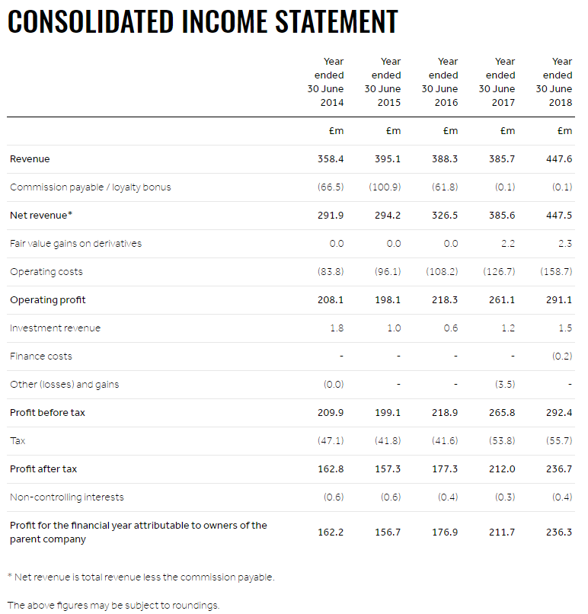

Balance Sheet
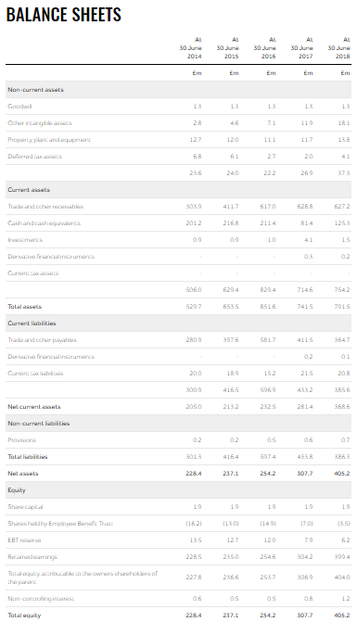

Cashflow Statement
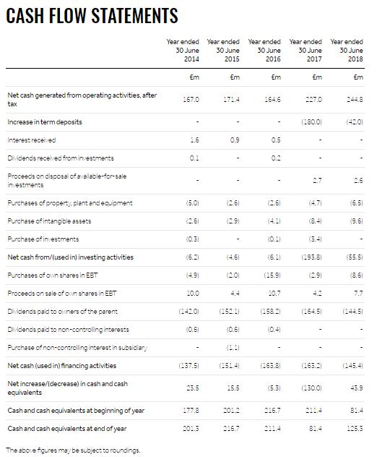

Market value of greater the £4billion required to list on FTSE index
Abbreviated to “HL.” In the FTSE 100 share listings
HL do not report the Interest payable, therefore assumed borrowing rate of 3% to calculate Interest Cover

