

Dissertation – Proposal
LCBB6000
Topic: “Supply Chain Management in the UK - challenges and opportunities”

Student name: Florin Alin Cretulescu
Student ID: 1911820

September 2022

Abstract
Chapter 1 is the introduction chapter which would delineate a succinct background followed by a rationale where the issue has been stated. This chapter also involves the proposed aim, objectives, and research question.
Chapter 2 is the literature review where secondary sources have been used to accumulate information on the research topic. It has helped in exploring the challenges and opportunities involved within the supply chain management system of UK firms.
Chapter 3 signifies the research methodology where proposed techniques have been mentioned that can meet the demand of the research. The data collection method has been mentioned along with ethical considerations and a timeline.

Table of Contents

Chapter 1: Introduction 3
1.1 Background of the topic 3
1.2 Research Rationale 3
1.3 Significance of the topic 5
1.4 Purpose of the research 5
1.5 Proposed aim 5
1.6 Objectives 5
1.7 Research questions 6
Chapter 2: Literature Review 7
2.1 Introduction 7
2.1 Significance of supply chain management (SCM) in the business 7
2.2 Opportunities associated with supply chain management 7
2.3 Challenges related to supply chain management 8
2.4 Strategies to overcome the identified challenges faced in supply chain management 8
2.5 Theoretical Framework 9
2.6 Conceptual Framework 10
2.7 Literature Gap 10
Chapter 3: Research Methods and Methodology 12
3.1 Introduction 12
3.2 What research philosophy and why? 12
3.3 What research paradigm and why? 12
3.4 What research approach and why? 12
3.5 What research methodology and why? 13
3.6 What research strategy and why? 13
3.7 Sampling methods and why 13
3.8 Data collection methods/tools 13
3.10 Time prospects of the research (Gantt chart) 14
3.11 Ethical consideration of the research 14
3.12 Summary 14
Chapter 4: Conclusion 15
Chapter 5: References and Bibliography 16

Chapter 1: Introduction

1.1 Background of the topic
Supply chain management refers to the flow of goods and services which includes procedures of transforming raw materials into the final product. Supply, production, inventory, capacity and distribution planning are a few activities that should be present in a compact supply chain. In the UK, supply chain management is quite diversified because marketers can whenever require can change logistics and supply chain operations to cope with market change. According to Craighead et al. (2020), the COVID-19 pandemic has brought to the forefront more than certain events in the last few decades, the significance of SCM (supply chain management). During the pandemic, UK's SMEs and MNCs have faced supply chain disruption issues while operating regional and global supply chain operations which is stated below in this section.

1.2 Research Rationale
COVID 19 has brought an immensely negative business experience and supply chain disruptions which pose a multi-trillion economic threat which is a major issue in the UK. Starting from the Food sector, fashion sector and technology sector, every business entity in the UK is suffering because of supply chain issues; these issues are highly impacting the lives of UK consumers. The (NFU) National Farmers' Union of the UK has requested for the government to give a commitment to keeping the nation's self-sufficiency in their food production at 60%. The UK's food industry representatives have spread awareness that the country is facing a worsening and ineffective food supply chain crisis without enough help from their government (BBC, 2021). The UK government has assisted different firms to improve their supply chain activities during this year by reducing supply chain expenses. Looming trade wars especially between the United States and China, arrangements for the post-Brexit economy in the Euro zone and an enhancing focus on - sustainability and also environmental consciousness are all pushed global supply chains. New car sales in the UK fell by 9% in July 2022 as supply chain issues are appearing and also Large corporate car fleets registered an - 18.2% decline (Guardian, 2022).

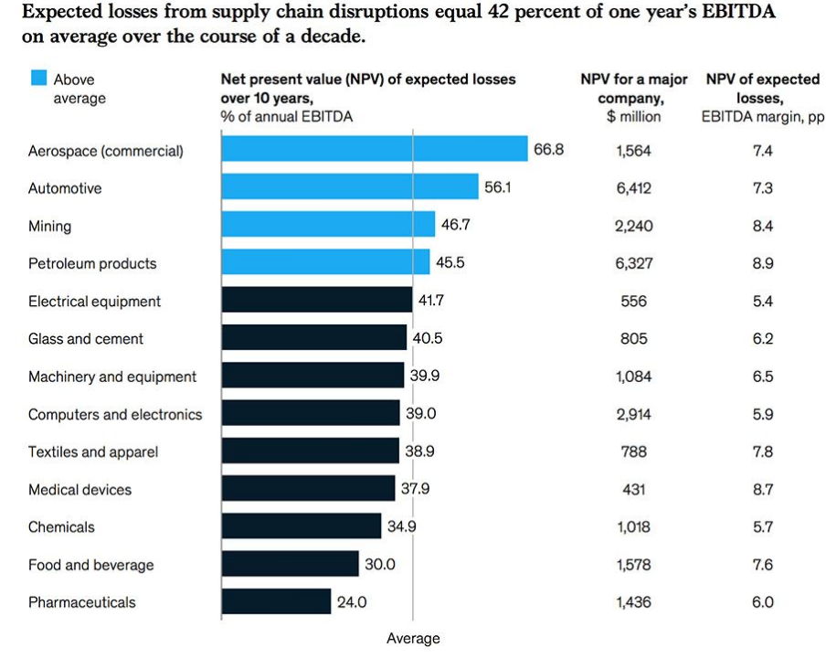
Figure 1.1.1: EBITDA’s Supply chain disruption issues
(Source: Consultancy, 2020)
Currently, these are major issues now because it has affected the UK economy in a wider way. Isolating the UK's economic impacts of Brexit is quite difficult because this has overlapped with the pandemic, global supply chain disruption and also energy and food expenses shocks. The research will shed light by identifying several opportunities in order to recover from this serious situation and avoid complicated supply chain activities.

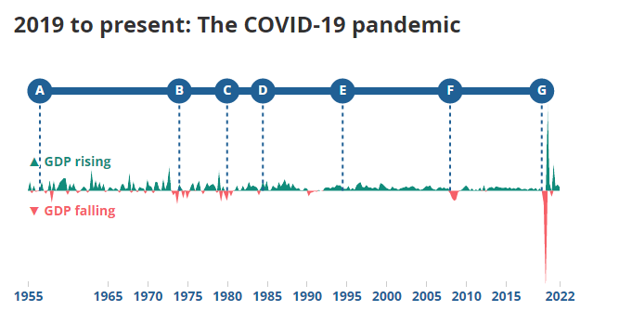
Figure 1.1.2: GDP fluctuations of UK in COVID 19 pandemic
(Source: Ons, 2022)

1.3 Significance of the topic
This research will be quite significant for its high business value which will be delivered through relevant findings. The research will be on the UK’s supply chain management’s opportunities and threats in the current year after the pandemic which will assist future research by providing meaningful insights.

1.4 Purpose of the research
The main purpose of the research is to critically evaluate relevant challenges and opportunities in the UK's supply chain. In this literature, several articles and journals will be critically evaluated to analyze their opinions on UK's supply chain management in COVID 19 pandemic and how deeply it has affected the country's economy.

1.5 Proposed aim
The research aims to identify challenges and opportunities of supply chain management which are associated with the UK organizations.

1.6 Objectives
- To analyze the significance of the supply chain management process in UK businesses
- To determine challenges related to supply chain management
- To evaluate opportunities associated with supply chain management in the U.K
- To formulate recommended strategies to overcome major challenges which are associated with the supply chain process in the companies in the UK

1.7 Research questions
- What is the significance of the supply chain management process in UK businesses?
- What are the opportunities associated with supply chain management in the U.K?
- What are the challenges related to supply chain management?
- What strategies can be recommended to overcome the challenges associated with supply chain management?

Chapter 2: Literature Review

2.1 Introduction
The literature review chapter would be evaluating the theories and devised literature that have been formulated in correspondence with the subject of supply chain management. In that consideration, the context will be presenting a critical evaluation of the theories and models of supply chain management while understanding its conceptual standpoint and thereupon illustrating its significance as well as the opportunities associated with it. The chapter will also provide a comprehensive discussion on the challenges related to supply chain management as well as the strategies that can be undertaken to mitigate the inconsistencies identified in the context of supply chain management.

2.1 Significance of supply chain management (SCM) in the business
A supply chain management entails an entire flow of production for a service or good that initiates from raw components while leading towards delivering the final goods to the consumer. In that regard, Mukhamedjanova (2020) opines that it is a framework comprising three or more entities such as individuals or organizations that are involved directly in the upstream or downstream flow of products, finances, services, and information from a manufacturer to a customer. Continuing on the same line, Saeed and Kersten (2019) consider supply chain management to be essential for a business as it can help in driving higher profits by improving the satisfaction level of customers with the delivery of efficient services and products. On the other hand, Biswas and Sarker (2020) stated that an effective SCM can help a business operate at a lower cost while it requires a coordinated plan as one of its features that can match supply with the demands of production and customers being met in time. Aside from that, Min et al. (2019) stated that an SCM framework does entail characteristics such as integration of technology, and an effective network design for distribution and procurement of raw material. It helps a business to remain competitive while letting it grow which further contributes to its competitive ability.

2.2 Opportunities associated with supply chain management
One of the considerable opportunities provided by supply chain management to a business is the attainment of cost efficiency within a firm. As per Saeed and Kersten (2019), incurring cost efficiency tends to optimize all business processes while minimizing the cost of packaging, production and transportation thus minimizing overall expense and helping drive a sustainable business. However, Tien et al. (2019) indicated operating a supply chain management effectively requires trained and qualified human resources wherein an organization is incurred with heavy expense to acquire a skilled taskforce. To that extent, organizations might find it unfavorable when seeking to implement an effective supply chain framework.

2.3 Challenges related to supply chain management
Businesses aim to implement an effective SCM framework, there are considerable challenges encountered in the process. According to Invernizzi et al. (2018), the foremost challenge is the inefficiency incurred in the flow of production resulting in delay of delivery that further leads to customer dissatisfaction and leading to operational inefficiency. The operational inefficiency incurred in the supply chain process does reflect on the inventory management wherein an organization fails to comply with the customer demand for being unable to control the timing of new stock deliveries. The issue has seen to be relevant in the UK as 66% of businesses have experienced delays in production of goods and delivery of services during the pandemic (SAP, 2022). Along with this, lack of coordination is another challenge among departments while it leads to inefficient communication between the buyer and the supplier thus resulting in supply chain disruptions.

2.4 Strategies to overcome the identified challenges faced in supply chain management
According to McMaster et al. (2020), for improvement in the risk of global business management, the supply chain management of fashion MNCs needs to be modified. The author has found that lean supply chain management can be used for the advantages in the waste reduction and cost reduction of the MNCs. An agile supply chain was also proposed in that article to combat the market risks by enhancing the relationship between buyer-supplier and communication. Improvement in the effective inventory cost is also beneficial to mitigate such challenges. Belhadi et al. (2021), has conducted an empirical survey among 145 firms for evaluating short-term SCR strategies. From those findings, the author has entailed that technologies of advanced industry 4.0 and local sources of supply could be implemented in the workplace to mitigate the risks of SCM. Inferred to the above claim, it can be stated that the right software platform for SCM, optimization of inventory and the demands, and driving down and the management of supply chain costs are the ways to solve the barriers of SCM.

2.5 Theoretical Framework
2.5.1 The Agile model of Supply Chain
“Agile Supply Chain” is the system referring to the distribution of the production to the end-users concerning the factors like cost savings, flexibility maintenance, high productivity, responsive demand marketing and quick decision-making. According to Alzoubi and Yanamandra (2020), information sharing in ASC is helpful in achieving superiority in the performance of the supply chain. According to Centobelli et al. (2020), ASC is the strategic move to compete with the competitive pressures and market instability. It is a good example of digitalization as the management of the demand chain was more technology-centric and information-centric. ASC is useful in the chosen research to find the great opportunities of the supply chain management of the UK. Lot of UK companies are investing in digital technology to compete with the issues after the outbreak of pandemics. The theory will help the UK companies in increasing the growth in the supply chains.
2.5.2. Institutional Theory
Institutional Theory offers significant insights into the adaptation of relevant practices and the tools within the SCM and OM. According to Saeed et al. (2018), institutional theory can be used to identify several types of pressure like regulatory pressure, competitive pressure and market pressure during SCM practices. The theory will be used in the chosen research to identify the challenges of the SCM practices by UK companies like customer dissatisfaction and operational inefficiency, increasing inventory cost, and communication issue between supplier and buyer and unparallel demand and inventory. Reputed companies like Morrison, Tesco, ASDA and Aldi after the pandemic are facing a lot of challenges in SCM.

2.6 Conceptual Framework
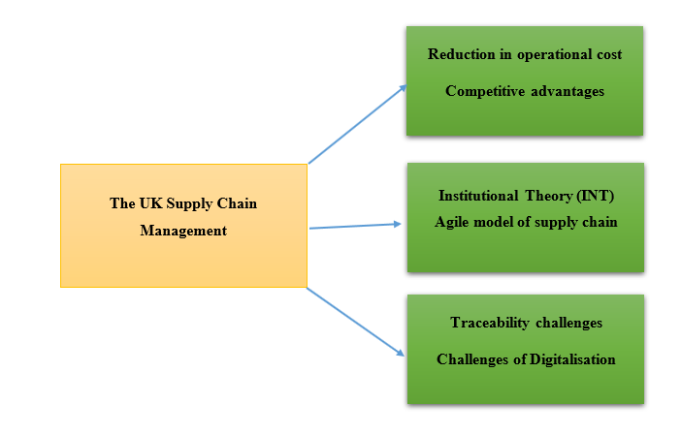
Figure 2.2: Conceptual framework
(Source: Self-developed)

2.7 Literature Gap
There are some gaps in the alignment with the related topic with the pandemic scenario. The existing literature has only covered supply chain management in the UK but the role of the involved person in the management has not been covered in the existing LR. There is an absence of the case study in the existing LR. Additionally, less detailed elaboration about the opportunities, challenges and significance of the SCM will be situated in the existing literature due to the pandemic. The empirical studies proposed by the authors in the journals hamper the existing literature due to a lack of valid relevance. Only some parts of the research are accessible in most of the journals or articles available in various platforms like Google Scholar, and ProQuest.
2.8 Summary
The literature review has proposed that there are many opportunities and challenges regarding supply chain management in the UK. The research objectives have been elaborately discussed with the help of the information of the different journals and articles available in ProQuest and Google Scholar. A literature gap has been added in this chapter to identify the gaps and this will be reduced with the help of findings.

Chapter 3: Research Methods and Methodology

3.1 Introduction
A research methodology will be used as an effective tool to construct the whole research in the systematic way. Several techniques of research methodology will be chosen based on the opportunities and the challenges in the supply chain management of the UK.

3.2 What research philosophy and why?
According to Hürlimann (2019), research philosophy is related to the nature and development of the knowledge for research. The research philosophy is of two types that are epistemology, and ontology. Epistemology methodology will be used as the tool for this research as there is more variability rather than another philosophy. Epistemology philosophy is helpful in framing the research module with the attempt of discovered knowledge.

3.3 What research paradigm and why?
Positivism, interpretivism, realism and pragmatism are the four philosophies and among them, interpretivism will be chosen for the research. The Interpretivism paradigm will be chosen for the research as the qualitative data will be analyzed by the researcher. According to Pham (2018), the interpretive researcher can gain a deeper understanding of the phenomenon and the complexity within it instead of generalizing the base of the understanding. The second critique of interpretivism is that the ontological view will be more subjective than the objective. The limitation of interpretivism is in addressing the impact on social reality and knowledge. The other paradigms will not be chosen for the particular research as they are less effective in the data quality.
Inferring to the above claim that the advantage of interpretivism is that there is a high chance of getting valid and true responses. The disadvantage of this philosophy is its subjective nature, and the researcher will be biased. It will be chosen for the research as it will highlight the current values of the SCM with the perspective of the individuals.

3.4 What research approach and why?
The research approach is the procedure and plan that will enable the steps for making the assumptions of data analysis, collection and interpretation. Deductive, abductive and inductive are the three research approaches and between the three, the deductive approach will be chosen for the research. Machila et al. (2018), the advantage of the deductive approach is that it gets straight to the point and it will save precious time. Inferred from that claim, the deductive approach will be chosen for discussing directly the functionalities of SCM and saving time. Other approaches will not be chosen in the absence of the features of the deductive approach.

3.5 What research methodology and why?
Research methodology is referred to as a tool to explain how a researcher can carry out the whole research. A systematic plan will be involved in the research to resolve the research problem. The primary qualitative research methodology will be used for the research as the data will be gathered from the interview with the managers.

3.6 What research strategy and why?
The research strategy for this research is to gather both primary and secondary data. The primary data will be qualitative and will be gathered from the interviews with the 5 managers from different 5 companies. Thematic analysis will be processed by making themes and here also qualitative data will be considered.

3.7 Sampling methods and why
Random sampling will be used for the research as the managers will be chosen randomly for the interview process. The information will be sampled for primary qualitative and secondary analysis.

3.8 Data collection methods/tools
For the primary analysis, interviews will be processed among the 3 procurement managers and 2 production managers of different companies. For the secondary analysis, the thematic analysis will be processed to gather qualitative data about SCM in the UK.
3.9 Ways of interpreting data/How are you going to interpret data?
The qualitative data will be interpreted from the views of the managers of 5 companies through the interview process. The qualitative data for thematic analysis will be interpreted with the help of the activities of supply chain organizations or the various UK news.

3.10 Time prospects of the research (Gantt chart)
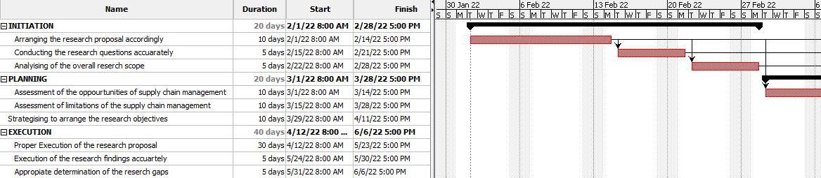
Figure 3.10.1: Gantt Chart
(Source: Self-Developed)

3.11 Ethical consideration of the research
Data Protection Act 2018 will be followed in the research to make the research valid and authentic. According to Bhaimia (2018), it is applicable across the EU and the knowledge managers should applause all the responsibilities of GDPR (General Data Protection Regulation). Inferring to the above claim, the researcher will be obliged to comply with all the norms under the act to protect all the private information of the managers. The researcher will keep in mind that any reflection of the primary data will not be undertaken in a biased way. All personal information about the managers will be confidential by the researcher.

3.12 Summary
The research philosophy, research approach and research strategy will be implemented in the research project. Both primary and secondary analysis would be performed in the research project. Gantt Chart would be attached to present the net time-table taken for the research. Ethical considerations have the major values for the validity of the research.

Chapter 4: Conclusion
The research proposal has depicted the importance of supply chain management in UK business firms while incorporating various activities like supply, distribution management and inventory control throughout the process. The research proposal has incorporated various theoretical frameworks including “the agile model of the supply chain” and “institutional theory” in terms of determining the importance of the particular aims and objectives of this proposal in the case of UK supply chain management. The proposal has also described certain literature reviews and particular methodology in discussing the key findings of research while summarizing the literature gap and significance of the research proposal in conducting further research approaches.

Chapter 5: References and Bibliography
Alzoubi, H.M. and Yanamandra, R., 2020. Investigating the mediating role of information sharing strategy on agile supply chain. Uncertain Supply Chain Management, pp.273-284.
BBC, 2021. Food firms ask government to fix supply chain crisis. [online] Available at: <https://www.bbc.com/news/business-59638988> [Accessed 4 August 2022].
Belhadi, A., Kamble, S., Jabbour, C.J.C., Gunasekaran, A., Ndubisi, N.O. and Venkatesh, M., 2021. Manufacturing and service supply chain resilience to the COVID-19 outbreak: Lessons learned from the automobile and airline industries. Technological Forecasting and Social Change, 163, p.120447.
Bhaimia, S., 2018. The general data protection regulation: the next generation of EU data protection. Legal Information Management, 18(1), pp.21-28.
Biswas, P. and Sarker, B.R., 2020. Operational planning of supply chains in a production and distribution center with just-in-time delivery. Journal of Industrial Engineering and Management (JIEM), 13(2), pp.332-351.
Centobelli, P., Cerchione, R. and Ertz, M., 2020. Agile supply chain management: where did it come from and where will it go in the era of digital transformation?. Industrial Marketing Management, 90, pp.324-345.
Consultancy, 2020. Covid-19 supply chain disruptions pose multi-trillion economic threat. [online] Available at: <https://www.consultancy.uk/news/25320/covid-19-supply-chain-disruptions-pose-multi-trillion-economic-threat> [Accessed 4 August 2022].
Craighead, C.W., Ketchen Jr, D.J. and Darby, J.L., 2020. Pandemics and supply chain management research: toward a theoretical toolbox. Decision Sciences, 51(4), pp.838-866.
Guardian, 2022. UK new car sales fell 9% in July as supply chain problems continue. [online] Available at: <https://www.theguardian.com/business/2022/aug/04/uk-new-car-sales-fell-9-per-cent-july-supply-chain-problems-chip-shortages> [Accessed 4 August 2022].
Hürlimann, C., 2019. Research Philosophy and Ethics. In Valuation of Renewable Energy Investments (pp. 111-126). Springer Gabler, Wiesbaden.
Invernizzi, D.C., Locatelli, G. and Brookes, N.J., 2018. The need to improve communication about scope changes: frustration as an indicator of operational inefficiencies. Production Planning & Control, 29(9), pp.729-742.
Machila, N., Sompa, M., Muleya, G. and Pitsoe, V., 2018. Teachers understanding and attitudes towards inductive and deductive approaches to teaching social sciences. Multidisciplinary Journal of Language and Social Sciences Education (2664-083X, Online ISSN: Print ISSN: 2616-4736), 1(2), pp.120-137.
McMaster, M., Nettleton, C., Tom, C., Xu, B., Cao, C. and Qiao, P., 2020. Risk management: Rethinking fashion supply chain management for multinational corporations in light of the COVID-19 outbreak. Journal of Risk and Financial Management, 13(8), p.173.
Min, S., Zacharia, Z.G. and Smith, C.D., 2019. Defining supply chain management: in the past, present, and future. Journal of Business Logistics, 40(1), pp.44-55.
Mukhamedjanova, K.A., 2020. Concept of supply chain management. Journal of Critical Reviews, 7(2), pp.759-766.
Ons, 2022. GDP and events in history: how the COVID-19 pandemic shocked the UK economy - Office for National Statistics. [online] Available at: <https://www.ons.gov.uk/economy/grossdomesticproductgdp/articles/gdpandeventsinhistoryhowthecovid19pandemicshockedtheukeconomy/2022-05-24> [Accessed 4 August 2022].
Pham, L.T.M., 2018. Qualitative approach to research a review of advantages and disadvantages of three paradigms: Positivism, interpretivism and critical inquiry. University of Adelaide, pp.3.
Saeed, A., Jun, Y., Nubuor, S.A., Priyankara, H.P.R. and Jayasuriya, M.P.F., 2018. Institutional pressures, green supply chain management practices on environmental and economic performance: A two theory view. Sustainability, 10(5), p.1517.
Saeed, M.A. and Kersten, W., 2019. Drivers of sustainable supply chain management: identification and classification. Sustainability, 11(4), p.1137.
Saeed, M.A. and Kersten, W., 2019. Drivers of sustainable supply chain management: identification and classification. Sustainability, 11(4), p.1137.
SAP, 2022. Supply Chain Crisis: Over 85% of UK businesses plan to move from 'just in time' to 'just in case' model and prioritise UK-based solutions to overcome challenges. SAP UK News Center. Available at: https://news.sap.com/uk/2022/06/supply-chain-crisis-over-85-of-uk-businesses-plan-to-move-from-just-in-time-to-just-in-case-model-and-prioritise-uk-based-solutions-to-overcome-challenges/ [Accessed August 23, 2022].
Tien, N.H., Anh, D.B.H. and Thuc, T.D., 2019. Global supply chain and logistics management. Dehli: Academic Publications.

