Military Hand Grenade Report
Chemistry: ACDA4011
Jordan Hayston
OME (Ordnance, Munitions and Explosives)
Faculty of Architecture, Computing and Engineering (FACE)
Submission Deadline: 11th December 2020

Contents
Introduction 1
Method 2
Discussion 3
The Ignition Train 3
The Nature of an Explosion 3
Past / Current Designs 4
No. 36 / No. 36M (The Mills Bomb) 4
L2A1 / L2A2 (M26) 4
L109A1 / HG 85 4
Considered Materials and Their Properties 5
Primer 5
Time Delay / Safety Fuse 7
Detonator 8
Main Charge 9
Conclusions 11
The Future of Grenades 11
Overview 11
References 12

Introduction
This report details the chemistry of commonly used materials used in high explosive military hand grenades. The report covers each stage of the ignition train including the initiation of a priming composition, the burning of a safety fuse and the detonation of a main charge. The chemistry of the explosive materials used for each of these stages is briefly detailed, including the balanced equations and calculation of heat release. It also explores the physical and chemical properties of said materials, and also how they are manufactured safely. Furthermore, the report summarises research into past and current HE grenade designs used in warfare by the British military. This provides a vague understanding of how the United Kingdom’s explosive arsenal has developed over the past 100 years. Following this, the future of grenades is explored in the conclusion.

Method
In this report, I first outlined the process of an ignition train and discussed its relevance to military hand grenades. I then continued to explain the nature of a chemical explosion, describing how energy is released from unstable materials. Once I had given a basic understanding of the chemistry of explosives, I carried out internet and literature research into some of the past and current designs of military hand grenades used by the United Kingdom to show how they have progressed in the last 100 years. With this understanding, I was then able to carry out further research into the specific grenade components and the kinds of materials that can be used in each stage of the ignition train. This information allowed me to explain each material’s physical and chemical properties, as well as their relevance to military hand grenades.

Discussion

The Ignition Train
The ignition train is the sequence of events which results in the detonation of explosives. High Explosives (HE) ignition trains can consist of two or three steps. A two-step ignition train would simply be a detonator and a HE charge. A three-step ignition train would consist of a detonator, a Primary Explosive (booster) and then the main HE charge (Secondary Explosive).
High Explosives are manufactured to be insensitive for safety purposes, which is why an ignition train is required to detonate them.
In the context of a hand grenade, the ignition train is as follows:
Primer Time Delay Fuse Detonator Main Charge
There are different applications of this grenade design, for example it is used in fragmentation grenades where the main charge sends fragments travelling outwards at high velocities towards enemies. Another application would be for a defensive flash grenade, designed to disorient enemies instead of harming them.

The Nature of an Explosion
A chemical explosion occurs when a substance decomposes, generally by combustion (an exothermic oxidation reaction). When this happens, heat and gas products are released at high velocities and this is what is seen as the explosion. Explosives are synthesised specifically to be unstable materials that can release large amounts of energy upon detonation. This energy is released as the unstable bonds are broken and more stable products are formed as a result. [1]

Past / Current Designs

No. 36 / No. 36M (The Mills Bomb)
The Mills Bomb was originally manufactured as the No. 5 grenade and it was later modified to be fired from a rifle, which was then named the No. 23. It was further modified into the No. 36 and then the No. 36M. The No. 36M Mk. 1 had an oval cast iron shell, corrugated on the exterior both for grip and to allow even fragment formation. [2]

L2A1 / L2A2 (M26)
The L2 grenade series was the British military’s version of the American M26 grenade, which replaced the No. 36M. They were first introduced in the early 1950s and remained in use until 2001 when they were replaces by the L109 grenade series. [3]
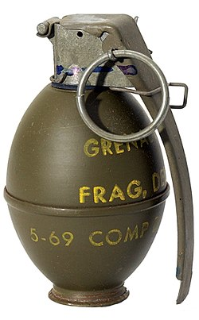

L109A1 / HG 85
The L109A1 is manufactured by Switzerland under the name HG 85 and is the standard issue anti-personnel hand grenade used by the British, Dutch and Swiss military. It is RDX/TNT filled at around a 55:45 mix with a 3-4 second fuse delay and steel casing. The inner of the steel casing is dimpled allowing for even fragmentation on detonation, producing approximately 1800 fragments weighing at 0.01g each. The L109A1 has a lethal radius of around 10 metres, and a safety radius of around 20 metres. It is slightly heavier than most grenades, allowing the user to throw it an average of 30 metres. The one difference in design between the L109A1 and the HG 85 is that the L109A1 has an extra safety clip. [4] [5] [6]
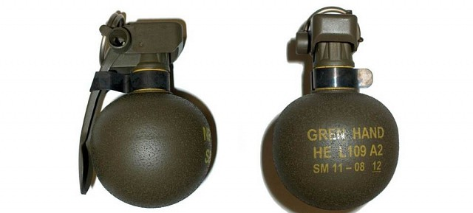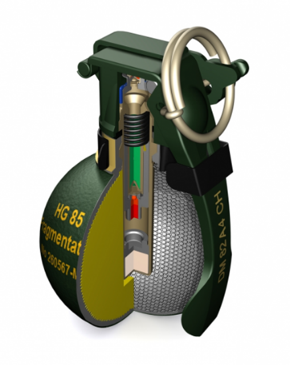

Considered Materials and Their Properties

Primer
An explosive primer is used as an initiator for detonators; it is a highly sensitive material that is easily ignited by a form of shock stimuli. With regards to grenades, a primer is often used in a percussion cap, which is detonated when the arming hammer is released from its spring tension after the handle has been let go.

Lead Styphnate
Lead Styphnate is a primary explosive often used in primer and detonator mixtures. It is an orange-brown crystalline solid manufactured by the reaction between lead ethanoate and magnesium styphnate in an aqueous solution. [1]
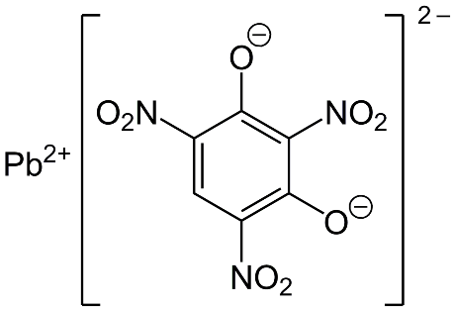
Several formulations based on lead styphnate were developed by the US Army for use in percussion primers. [7] Composition VH4 was also developed for use in percussion caps by the UK’s Ministry of Defence with lead styphnate (composition 1303) as the main constituent. [1] [8]
Pictured below is a table of common primer compositions based on lead styphnate.
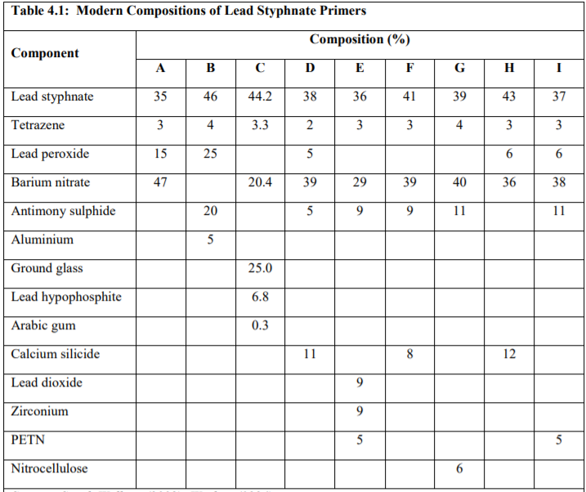 [9]
$$4PbC_{6}H_{3}N_{3}O_{9}→4Pb+24CO+{6N}_{2}+12H_{2}O$$
The balanced reaction for lead styphnate produces lead, carbon monoxide, nitrogen gas, and water (steam).

Heats of Formation:
$$4PbC_{6}H_{3}N_{3}O_{9}=-3215.06KJ/mol$$
$$4Pb=0KJ/mol$$
$$24CO=-2652.72KJ/mol$$
$${6N}_{2}=0KJ/mol$$
$$12H_{2}O=-3429.84KJ/mol$$

Heat of Detonation:
$$∆H=\left(0-2652.72+0-3429.84\right)-\left(-3215.06\right)KJ/mol$$
$$∆H=-2867.5KJ/mol$$

Time Delay / Safety Fuse
A time delay fuse is a tube of fabric/metal containing a form of gunpowder or other type of pyrotechnic material. It burns at a set rate allowing for a time delay before detonation. This means that a varying length of fuse can provide different delays, for example a longer fuse will provide a longer delay and vice versa. [10]

Gunpowder
Gunpowder dates back to the eighth century, where it was discovered by Chinese alchemists. It has been widely used for centuries in a variety of applications such as in firearms propellant, mining, and pyrotechnics. Gunpowder is not actually a material itself, rather a mixture of sulphur, charcoal, and potassium nitrate; The sulphur and charcoal act as the fuel, and the potassium nitrate acts as an oxidiser.
$$2KNO_{3}+S +3C → K_{2}S+{3CO}_{2}+N_{2}$$
The products of the gunpowder detonation are potassium sulphide, carbon dioxide and nitrogen gas.
With regards to a hand grenade, gunpowder can be used in a safety fuse as a slow-burning pyrotechnic. Safety fuse is typically a form of gunpowder encased in a textile material, such as cotton, and sometimes with a wax coating. This allows for a delay period between the ignition of the priming material and the detonation of the main charge. The length of the time delay can be altered by changing the length of the fuse, which will have a predetermined burn rate.

Heats of Formation:
$2KNO_{3}= -989KJ/mol$ [11]
$K_{2}S= -428.1KJ/mol$ [12]
${3CO}_{2}= -1180.5KJ/mol$ [13]

Heat of Detonation
$$∆H=\left(-428.1-1180.5\right)-\left(-989\right)KJ/mol$$
$∆H=-619.6KJ/mol$

Detonator
The detonating charge is a primary explosive responsible for detonating the main charge in a munition. It is required to be sensitive to the shock produced either by a primer or in the grenade’s case, the time delay safety fuse.

Lead Azide
Lead azide is a white crystalline solid that is manufactured by mixing dilute solutions of lead ethanoate and sodium azide. In this process, large crystals may form and detonate so as a safety precaution the solutions need to be stirred vigorously. It is often used in composite fuze detonators and also mixed with tetrazene in percussion fuze detonators. [1] [14]
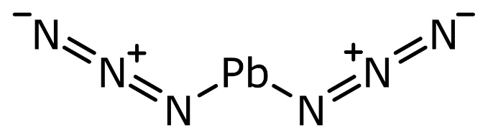
$PbN_{6} →$ $Pb+{3N}_{2}$
The products of a lead azide decomposition are lead and nitrogen gas.

Heats of Formation:
$PbN_{6}= 462.332KJ/mol$ [15]
${3N}_{2}=0KJ/mol$ (using bond energies) [16]

Heat of Detonation:
$$∆H=(0)-\left(426.3\right)KJ/mol$$
$∆H=-426.3KJ/mol$

Tetrazene
Tetrazene can be produced as either fluffy pale-yellow crystals, or in microgranular form by reacting sodium nitrate and aminoguanidine carbonate in diluted ethanoic acid. It is often mixed with lead azide or lead styphnate to increase their sensitivity.
$C_{2}H_{8}N_{10}O$
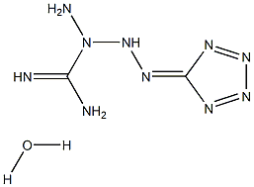

Heat of Formation:

$$C_{2}H_{8}N_{10}O=189.00±3 kJ/mol$$

Main Charge
The main charge in an explosive device is responsible for the core effect; it is required to be the least sensitive to avoid accidental detonation, which is why a more sensitive explosive material is required to initiate it. In a grenade design, it is the final stage of the ignition train and it will detonate 3-4 seconds after it is armed, allowing the user enough time to throw it.

RDX
RDX (Research Development eXplosive) is a secondary explosive often mixed with wax or TNT to reduce its sensitivity. It is a white crystalline solid synthesized by treating hexamine with nitric acid. RDX crystals range in size from 10-1000 microns and its detonation velocity is 8700m/s. [17]
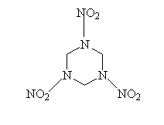
RDX is commonly used in military applications; it is used as a HE munition filling, as an energising ingredient in propellants, in plastic explosives and also in special applications like linear cutting charges. [1]
$$C_{3}H_{6}N_{6}O_{6(s)}→ {3CO}_{\left(g\right)}+{3N}_{2\left(g\right)}+{3H}_{2}O_{(g)}$$
The products of an RDX decomposition are carbon monoxide, nitrogen gas and water (steam).

Heats of Formation:
$C_{3}H_{6}N_{6}O_{6}=79.10±5 KJ/mol$ [18]
$3CO= -331.59KJ/mol$
${3N}_{2\left(g\right)}=0KJ/mol$
$${3H}_{2}O_{(g)}= -857.46KJ/mol$$

Heat of Detonation:
$$∆H=\left(-331.59+0-857.46\right)-\left(79.1\right)KJ/mol$$
$∆H=-1268KJ/mol$

TNT
TNT (trinitrotoluene) is a pale yellow-brown crystalline solid manufactured by mixing nitric acid and sulphuric acid on toluene. It is often mixed with RDX, HMX and ammonium nitrate in HE munition fillings and is also used commercially as a blasting explosive.
$2C_{7}H_{5}N_{3}O_{6(s)}→ {3N}_{2\left(g\right)}+{7CO}_{(g)}+{5H}_{2}O_{(g)}+{7C}_{(s)}$ [19]
The products of a TNT detonation are nitrogen gas, carbon monoxide, water (steam) and carbon in the form of soot.
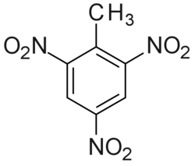

Heats of Formation:
$2C_{7}H_{5}N_{3}O_{6}=63.20 ±5 KJ/mol$ [20]
${3N}_{2\left(g\right)}=0KJ/mol$
$$3CO= -773.71KJ/mol$$
$${5H}_{2}O_{(g)}= -1429.1KJ/mol$$
$${7C}_{\left(s\right)}=0KJ/mol$$

Heat of Detonation:
$$∆H=\left(-773.71-1429.1-0-0\right)-\left(63.20\right)KJ/mol$$
$$∆H=-2266.01KJ/mol$$

Conclusions

The Future of Grenades
Although the grenades currently used by the United Kingdom’s military are sufficient, there is always room for improvement; new designs and ideas could potentially put our army at an advantage.
In 2016, the American government announced that their military were developing their first new grenade since 1968. This decision was based on the fact that their M67 grenade, which they had been using for this period of time, had limitations with respect to terrain and safety. The new grenade designs that they have been developing show promise to be less sensitive to other explosions and to have a larger fragmentation radius, specifically in highly vegetated areas.
Furthermore, they are working to bring back a blast only grenade which can take out targets without the use of fragments. This design was planned to be put into service in 2020. In addition to this, there are also plans to eventually develop a multipurpose grenade which will have the ability to switch between blast and fragmentation at the operator’s will. [21]
There are also talks about a potential stackable grenade, capable of producing a bigger explosion. This grenade will be able to stack up to 3 at once and provide users with more flexibility when it comes to the complex warfare they partake in. It relies not on fragmentation, but over-pressurisation to produce casualties. [22]

Overview
This report has briefly followed the history of high explosive hand grenades used by the British military, and the chemistry of the materials used in each stage of the ignition train. For each explosive material, I provided a balanced equation stating the products below each and calculated the heats of formation along with the heats of detonation. Although I produced a lot of sources for this report, I found the research part quite difficult as the nature of this task is not something easily found on the internet.

References

[1] | K. Walter, Introduction To Explosives, The Royal Military College Of Science (Shrivenham), 1984.
[2] | Textbook of Ammunition, His Majesty's Stationary Office, 1936.
[3] | M. Factory, “L2 (grenade),” [Online]. Available: https://www.militaryfactory.com/smallarms/detail.asp?smallarms_id=555#:~:text=The%20L2A2%20was%20the%20British%20military%20designation%20of%20the%20American%20M26%20series.&text=36M%20grenades%20in%20British%20military,and%20out%20shell%20casing%20layers.
[4] | “Elite UK Forces,” [Online]. Available: https://www.eliteukforces.info/weapons/grenades/.
[5] | “Weapon Systems,” [Online]. Available: https://development.weaponsystems.net/system/697-BB01%20-%20HG%2085.
[6] | D. W. Lynn, The Grenade Recognition Manual, 2001.
[7] | M. D. Corporation, “Percussion Primers Design Requirement,” 1982.
[8] | M. o. Defence, “Defence Standard 13-179 Initiatory Composition VH4/1,” 1995.
[9] | E. C. Agency, “Identification of Lead Styphnate as SVHC,” 2011.
[10] | U. AMC, “Engineering Design Handbook - Ammunition Series Fuzes,” 1969.
[11] | Chemister, “Potassium Nitrate Data Sheet,” [Online]. Available: http://chemister.ru/Database/properties-en.php?dbid=1&id=513.
[12] | Chemister, “Potassium Sulphide Data Sheet,” [Online]. Available: http://chemister.ru/Database/properties-en.php?dbid=1&id=522.
[13] | N. C. WebBook, “Carbon Dioxide Data Sheet,” [Online]. Available: https://webbook.nist.gov/cgi/cbook.cgi?ID=C124389&Mask=1.
[14] | “Chemical Book - Lead Azide,” [Online]. Available: https://www.chemicalbook.com/ChemicalProductProperty_EN_CB0851554.htm.
[15] | PubChem, “Lead Azide Data sheet,” [Online]. Available: https://pubchem.ncbi.nlm.nih.gov/compound/Lead-azide#section=Decomposition.
[16] | W. Chemist, “Common Bond Energies,” [Online]. Available: http://www.wiredchemist.com/chemistry/data/bond_energies_lengths.html.
[17] | Chemring, “Explosive Materials,” [Online]. Available: https://www.chemring.co.uk/what-we-do/countermeasures-and-energetics/explosive-material.
[18] | Chemeo, “RDX Data Sheet,” [Online]. Available: https://www.chemeo.com/cid/60-441-5/1%2C3%2C5-Triazine%2C%20hexahydro-1%2C3%2C5-trinitro-.
[19] | C. Wiki, “Trinitrotoluene - TNT,” [Online]. Available: https://www.ch.ic.ac.uk/vchemlib/mim/bristol/tnt/tnt_text.htm.
[20] | Chemeo, “TNT Data Sheet,” [Online]. Available: https://www.chemeo.com/cid/12-617-3/Trinitrotoluene#ref-nist-webbook.
[21] | M. Myers, “Army Times,” 26 August 2017. [Online]. Available: https://www.armytimes.com/news/your-army/2017/08/26/the-army-is-working-on-a-safer-but-more-lethal-hand-grenade/.
[22] | S. Snow, “Marine Corps Times,” 23 September 2019. [Online]. Available: https://www.marinecorpstimes.com/news/your-marine-corps/2019/09/23/this-could-be-the-corps-next-grenade/.

