Security Analysis Report
Vigilant Trust & Asset Management (VTAM)



Prepared by:
Student Name – CHRIS ANTWI BOASIAKO
Student ID - 2432249

Word limit = 2000 words (Report + Presentation)

Abstract

This coursework focuses on developing and implementing a comprehensive data security and governance framework that protects sensitive patient information for hospitals and clinics. It is designed to strengthens regulatory compliance, safeguard data privacy, and maintain the highest standards of confidentiality, integrity, and availability. The framework aligns with healthcare regulations and industry best practices, establishing clear data ownership, classification, access controls, encryption standards, and lifecycle management processes. It integrates risk management, continuous monitoring, third party oversight, and incident response to proactively address emerging threats in an evolving cyber landscape. It fosters a culture of security awareness across all levels of the organisation through target training, accountability structures, executive leadership engagement and ensuring that every employee understand their role in protecting patient data. This technology processes will not only strengthen compliance but also build trust with our healthcare partners and the patients they serve.

Table of Contents

- Introduction ---------------------------------------------------------------------- Page No.

- Task -----------------------------------------------------------------------------------

2.1 Identification of Modern Threats ---------------------------------------------

2.2 Modern Security Policies ------------------------------------------------------

2.3 Technical Mitigation Measures ------------------------------------------------

2.4 Proactive Monitoring and Incident Response -------------------------------

2.5 Continuous Training and Awareness ------------------------------------------

- Conclusion ---------------------------------------------------------------------------

References ------------------------------------------------------------------------------------

Appendix (Presentation Slides) ------------- --------------------------------------------

- Introduction

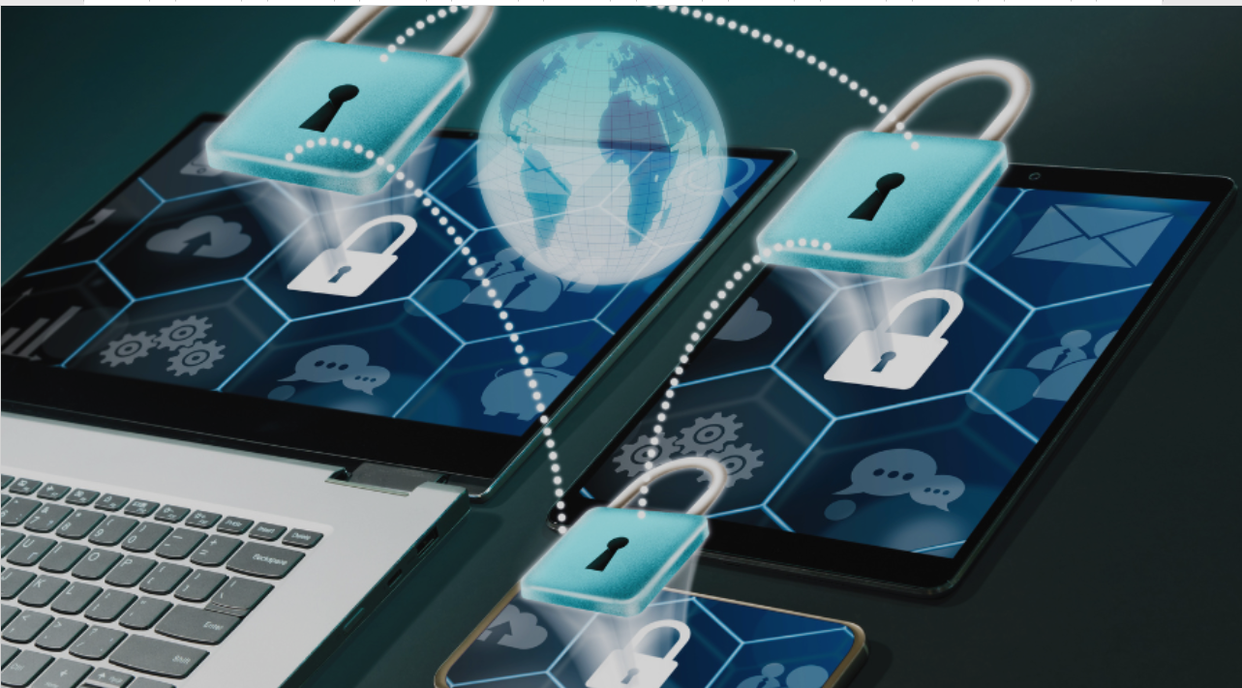

Figure 1. Security Challenges in Computers [1]

Computer security, or cybersecurity, protects computers, networks, and data from unauthorized access, attacks, and damage. It faces challenges from evolving malware, ransomware, phishing, insider threats, and vulnerabilities in legacy systems, compounded by human error and the rapid growth of interconnected devices. Globally, cybersecurity has had a major impact—enabling safe digital commerce, healthcare, and communications, while breaches and cyberattacks have caused financial losses, disrupted critical services, and compromised personal and corporate data, demonstrating that cybersecurity is both a technological and societal imperative.

- Task

2.1 Identification of Modern Threats
Companies of today face a wide range of threats that can impact operations, regulations, compliance and financial stability. Hackers or intruders gaining access to the network will result in threats such as information theft, identity theft, data loss manipulation and disruption of service. It occurs when someone has authorised access to the network through a user account or has physical access to the network equipment. These threats can be internal or external. Understanding the risks associated with these threats helps in building effective controls.

INTERNAL THREATS
Internal threats come from within the organisation i.e. employees, contractors or trusted partners. Human error remains one of the leading cause of data breaches. The common methods hackers use to obtain information directly from internal or authorised users are Pretexting, Phishing, and Vishing. Some common security threats include data theft for financial gain, sabotage of systems or data, privilege abuse, and sending sensitive data to the wrong recipient. Risks are often increased by excessive access rights, inadequate access reviews, shared accounts, weak passwords or credential reuse, and employees using unauthorised software or cloud services. Additional vulnerabilities include weak change management, falling victim to phishing attacks, inadequate incident response planning, and outdated policies, all of which can significantly compromise organisational security and data protection.

EXTERNAL THREATS
External threats come from outside the organisation and are more sophisticated and targeted. Most of these attacks come from Cybercriminals, Nation-State Actors, Advanced Persistent Threats, Third- Party & Supply Chain Risks, Hacktivists, and Physical Threats among others. These threats matter in the healthcare sector because they handle sensitive data and the impact of these threats can lead to regulatory fines, lawsuits, loss of customer trust, operational disruption and a long-term brand damage.

  - Modern Security Policies

A security policy is a set of security objectives for a company that includes rules of behaviour for users, administrators and specific systems. These objectives, rules and requirements collectively ensure the security of network, data and the computer systems within the organisation. This focus on the problems of protecting the states of data (data at rest/in storage, data in transit, data in process) in the cyber world using CIA TRIAD and the concept of Authentication, Authorisation and Accounting (AAA). The following structured set of security policies aligned with Zero Trust principles and framework (NIST, CSF and ISO 27001) tailored for a healthcare environment handling sensitive information can be adopted for the purpose of establishing leadership, accountability and oversight for information security. The goal is to protect the cyber world through the functional principles of Confidentiality, Integrity and Availability.
These include:
1.Conducting risk assessment at least annually and after major changes. Regular review of security policies that is align with regulatory requirement (HITECH)
2.Ensure only authorised individuals access systems and data by implementing Role-Based Access Control (RBAC), applying the principle of least privilege, conducting quarterly access reviews, and requiring Multi-Factor Authentication (MFA) for remote access. Access should be immediately revoked when an employee leaves the organisation or changes roles, and shared user accounts must be strictly prohibited to maintain accountability and strengthen security.
3. Protect sensitive information according to its classification level—such as public, internal, confidential, or restricted—by ensuring all data is properly classified at the time of creation and handled according to its sensitivity. Appropriate secure disposal methods, including data wiping for digital media and shredding for physical documents, must be used to prevent unauthorised access or recovery of sensitive information.
4. Protect the organisation’s network infrastructure from unauthorised access and cyber threats by deploying firewalls at network perimeters, disabling unused ports and services to reduce potential attack surfaces, and conducting regular vulnerability scans and penetration tests to identify and address security weaknesses.
5. Secure workstations, servers, and mobile devices by prohibiting the installation of unauthorised software, ensuring all company-issued laptops and mobile devices are encrypted, and enabling remote wipe capabilities to protect organisational data if devices are lost or stolen.
6. Manage risks associated with cloud services and vendors by conducting thorough vendor risk assessments before onboarding, ensuring secure cloud configuration standards are implemented and maintained, and continuously monitoring third-party access to detect and prevent unauthorised or risky activities.
7. Incident Response Policy to ensure rapid detection, containment and recovery from security incidents. These can be done by maintaining a documented Incident Response Plan and establishing a 24/7 report mechanism.
8. Implement a Risk Management Policy to identify, assess, and mitigate security risks by maintaining a comprehensive risk register and prioritising risks based on impact and likelihood analysis to ensure that the most critical threats are addressed promptly and effectively.
9. Implement a Logging, Monitoring, and Audit Policy to ensure continuous monitoring and forensic readiness by retaining logs in accordance with regulatory requirements, regularly reviewing security logs to detect suspicious activity, and conducting periodic internal audits to evaluate the effectiveness of security controls and compliance.
10. The Business Continuity and Disaster Recovery Policy ensures operational resilience and patient safety by conducting regular backup restoration testing to verify data integrity and system recoverability, as well as performing annual disaster recovery exercises to validate response procedures and maintain organizational readiness in the event of disruptions.
11. The Acceptable Use Policy defines the proper use of company systems and data by prohibiting unauthorised access or data sharing, restricting the use of personal devices unless formally approved, and forbidding any attempts to bypass or circumvent established security controls.
12. Implementation best practices ensure effectiveness by assigning clear policy ownership, integrating policies into employee onboarding processes, reviewing them annually or after major incidents, aligning them with recognised frameworks such as NIST CSF, ISO 27001, and CIS Controls, tracking policy compliance metrics, and automating enforcement wherever possible.

  - Technical Mitigation Measures

Below are some of the targeted mitigation plans for a healthcare processing sensitive patient information showing what it mitigates and how it will be operationally implemented.

MITIGATING RANSOMWARE ATTACKS
1.THREATS: Ransomware. Lateral movement within the network.
MEASURES:
A. Immutable and segmented backups should be implemented by deploying encrypted backups stored in immutable storage, such as WORM-enabled storage, to prevent unauthorised modification or deletion. Organisations should conduct quarterly restoration tests to verify backup integrity and recovery capability, while also restricting backup administrator accounts through Multi-Factor Authentication (MFA) and privileged access controls to minimise the risk of unauthorised access or misuse.
B. Network segmentation should be implemented by separating clinical systems, production environments, and corporate networks using VLANs and firewalls to reduce the risk of lateral movement during a cyber incident. Micro-segmentation should also be applied to high-risk assets, such as Electronic Health Record (EHR) databases, to provide an additional layer of protection and tighter access control.
C. Endpoint Detection and Response (EDR) should be implemented by deploying EDR agents across all endpoints and servers to provide continuous monitoring and threat detection. Behavioural-based detection should be enabled to identify suspicious activity, with automatic isolation of compromised devices to quickly contain potential security incidents.
2.MITIGATING INSIDER THREATS AND PRIVILEGE MISUSE THREATS:
Mitigating insider threats and privilege misuse involves implementing controls to prevent unauthorised access to Protected Health Information (PHI), detecting and preventing data exfiltration, and limiting opportunities for privilege abuse through strict access management, monitoring, and enforcement of least-privilege principles.
MEASURES:
Implement Role-Based Access Control (RBAC) by mapping job roles to ensure users receive only the minimum access required for their responsibilities and conduct quarterly access recertification to review and validate permissions. Strengthen Privileged Access Management (PAM) by automatically rotating administrator passwords and securely vaulting privileged credentials. Enhance User Activity Monitoring by logging all access to Protected Health Information (PHI) and triggering alerts for suspicious behaviour such as bulk data downloads or after-hours access. These measures also support mitigating phishing and social engineering threats by reducing excessive privileges, closely monitoring user behaviour, and protecting sensitive credentials from misuse.
3.Key threats include credential theft, business email compromise (BEC), and malware delivery, all of which can lead to unauthorised access, financial loss, and disruption of operations if not properly detected and mitigated.
MEASURES:
A. Multi-Factor Authentication (MFA) should be enforced for email, VPN, cloud systems, and administrative accounts, using phishing-resistant methods such as FIDO2 keys or app-based push notifications to enhance security and prevent unauthorised access.
B. Email security should be strengthened by deploying an Email Security Gateway with advanced threat protection (ATP), enabling URL rewriting, and using attachment sandboxing to detect and block malicious content before it reaches users.
C. The security awareness program should include mandatory annual training for all employees and monthly phishing simulations to reinforce safe practices and improve the organisation’s overall security posture.

4.Mitigating medical device and legacy system risks involves addressing threats such as unpatched vulnerabilities, lateral movement through IoT devices, and potential device compromise by implementing regular updates, network segmentation, and strict access controls.
MEASURES:
A. Medical device inventory and risk management should include maintaining an up-to-date asset inventory and identifying devices running unsupported operating systems to assess and prioritise risks effectively.
B. Network isolation for medical devices should be implemented by placing them on dedicated VLANs and restricting outbound internet access to reduce exposure to external threats and limit potential lateral movement.
C. Compensating controls for legacy systems should include applying virtual patching through intrusion prevention systems and enforcing strict firewall rules around unsupported systems to reduce vulnerabilities and limit potential attack paths.
5. Mitigating third-party and supply chain risks involves addressing threats such as vendor breaches, cloud misconfigurations, and compromised software updates by implementing strong vendor security requirements, monitoring third-party access, and validating the integrity of updates before deployment.
MEASURES:
A. Vendor Risk Management Program should be implemented by conducting pre-contract security assessments and scoring vendors based on their risk tier to ensure appropriate security controls are in place before granting access to organisational systems or data.
B. Continuous monitoring should be implemented by using third-party risk monitoring platforms to track vendor security posture and by reassessing high-risk vendors annually to ensure they continue to meet required security standards.
6.Mitigating cloud misconfigurations involves addressing threats such as exposed databases, publicly accessible storage buckets, and identity mismanagement by implementing proper access controls, regular configuration reviews, and continuous monitoring to ensure cloud resources are securely configured.
MEASURES:
A. Cloud Security Posture Management (CSPM) should be implemented to enforce encryption by default and ensure that public access to storage is disabled unless it is explicitly approved, helping to reduce the risk of data exposure and misconfiguration in cloud environments.
B. Zero Trust Architecture should be implemented by enforcing identity verification for every access request and applying conditional access policies that consider factors such as device health and user location to ensure secure and controlled access to systems and data.
7.Mitigating data leakage and compliance failures involves addressing threats such as exposure of Protected Health Information (PHI), regulatory penalties, and accidental data sharing by implementing strong data protection controls, monitoring data access, and enforcing compliance with relevant regulations.
MEASURES:
A. Data Loss Prevention (DLP) should be deployed across email, endpoints, and cloud environments to help prevent sensitive information from being improperly shared, while continuously monitoring for Protected Health Information (PHI) identifiers to detect and stop potential data leaks.
B. Encryption standards should require AES-256 encryption for data at rest and ensure that all company laptops and portable devices are fully encrypted to protect sensitive information from unauthorised access in case of loss or theft.
C.A formal data classification policy should be implemented to ensure sensitive information is properly identified and protected. Staff should be trained on correct data handling procedures, and Protected Health Information (PHI) should be clearly labelled as “Restricted” to ensure appropriate access and security controls are applied.
8.Strengthening incident detection and response involves addressing threats such as delayed breach detection, failures in regulatory reporting, and escalating attack impacts by implementing robust monitoring, rapid response procedures, and clear escalation protocols to minimise damage and ensure compliance.
MEASURES:
A.A centralized SIEM should aggregate logs from EHR systems, firewalls, cloud platforms, and endpoints, define alert thresholds for suspicious activity, and maintain 24/7 monitoring to detect and respond to security incidents promptly.
B. An incident response plan should define roles, responsibilities, and escalation paths, while establishing a clear breach notification workflow. Regular tabletop exercises should be conducted to test readiness and ensure effective response during actual security incidents.
9.Strengthening organizational security culture involves addressing threats such as human error, policy non-compliance, and resistance to security practices by promoting awareness, reinforcing adherence to policies, and fostering a culture that values security at all levels of the organization.
MEASURES:
Security measures should include executive-led messaging to emphasize the importance of security, a reward program for reporting suspicious activity, embedding security training in the onboarding process, and establishing departmental security champions to promote best practices across the organization.

  - Proactive Monitoring and Incident Response
Yes, a robust plan for ongoing monitoring and incident response can be structured around continuous monitoring, threat detection, alert triage, incident response, notification, and post-incident review.
Continuous 24/7 monitoring involves collecting logs and telemetry from firewalls, EHR systems, cloud platforms, endpoints, IoT devices, and VPNs, aggregating and correlating them in real time using a centralized SIEM to detect patterns and anomalies, and using dashboards and alerts to visualize system health and flag suspicious activity. Here is how it works:

1.Continuous monitoring should be implemented by collecting logs and alerts from firewalls, EHR systems, cloud platforms, and endpoints, and using a centralized SIEM to aggregate and correlate this data for comprehensive visibility and threat detection.

2.Threat detection should involve applying automated alert thresholds for suspicious activity, enabling behavioural analytics to identify anomalies, and monitoring for unauthorized access, malware or ransomware, and attempts at data exfiltration.
3.Alert triage should be conducted by the Security Operations Centre (SOC), which reviews incoming alerts, classifies incidents as low, medium, or high severity, and validates whether each alert is a true positive or a false alarm.
4.Incident response should follow a pre-defined Incident Response Plan (IRP), clearly defining roles and responsibilities, isolating affected systems for containment, removing malware or compromised accounts during eradication, and restoring systems from backups to ensure full recovery.
5.Notification and reporting should include informing internal stakeholders and executives of the incident and triggering regulatory breach notifications when Protected Health Information (PHI) or other sensitive data is involved.
6.Post-incident review should involve conducting a root cause analysis, updating policies, controls, and alerts based on findings, and running tabletop exercises to improve readiness and response for future incident.

A flow chart or diagram is essential.

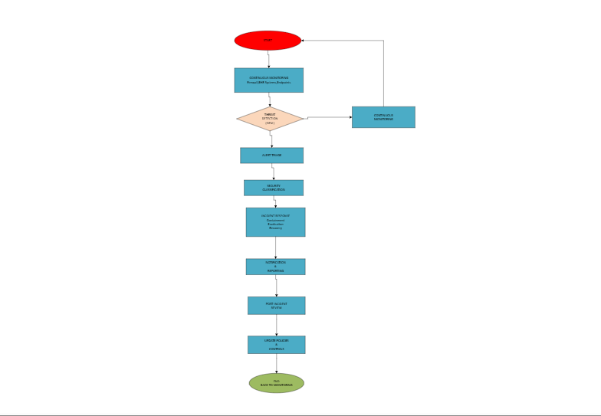

Does the plan incorporate modern concepts like SIEM/SOAR and include specific procedures for current incident types like ransomware? A diagram is expected.

  - Continuous Training and Awareness
An engaging, continuous security training program should combine regular education with realistic attack simulations to strengthen employee awareness and response to modern threats. The program can include mandatory annual security training, supported by ongoing micro-learning sessions and monthly simulated phishing and vishing exercises to test employee readiness. Staff who interact with simulations receive immediate feedback and guidance to improve their response. The program should also promote a positive security culture through clear communication from leadership, easy reporting of suspicious activity, and recognition or rewards for employees who identify potential threats, helping make security awareness a shared responsibility across the organization.

- Conclusion
In conclusion, future improvements should focus on strengthening continuous monitoring, expanding the use of advanced security tools such as SIEM, SOAR, and EDR, and regularly updating security policies to address emerging threats. Organizations should also invest in ongoing staff training and realistic attack simulations to improve human awareness and reduce the risk of social engineering attacks. Additionally, conducting regular security assessments, audits, and incident response exercises will help identify vulnerabilities early and ensure the organization remains resilient against evolving cybersecurity threats.

References
The reference style should be IEEE kindly refer to the library website for details. Add all the references used in this report and make sure they are in-text citied. Word count not included.
Example:

- Stealth Labs, https://www.stealthlabs.com/blog/cyber-security-threats-all-you-need-to-know/ [Accessed on 02/07/2024]

- The Knowledge Academy, https://www.theknowledgeacademy.com/blog/types-of-cyber-security-breaches/ [Accessed on 12/07/2024]

Annexures/ Appendix (If any)
This section includes your PowerPoint/google slides presentation. Word count is included here so please make sure you do not exceed the 2000 words (Report + Presentation) in total. Copy and paste slides. Do not take screenshots.

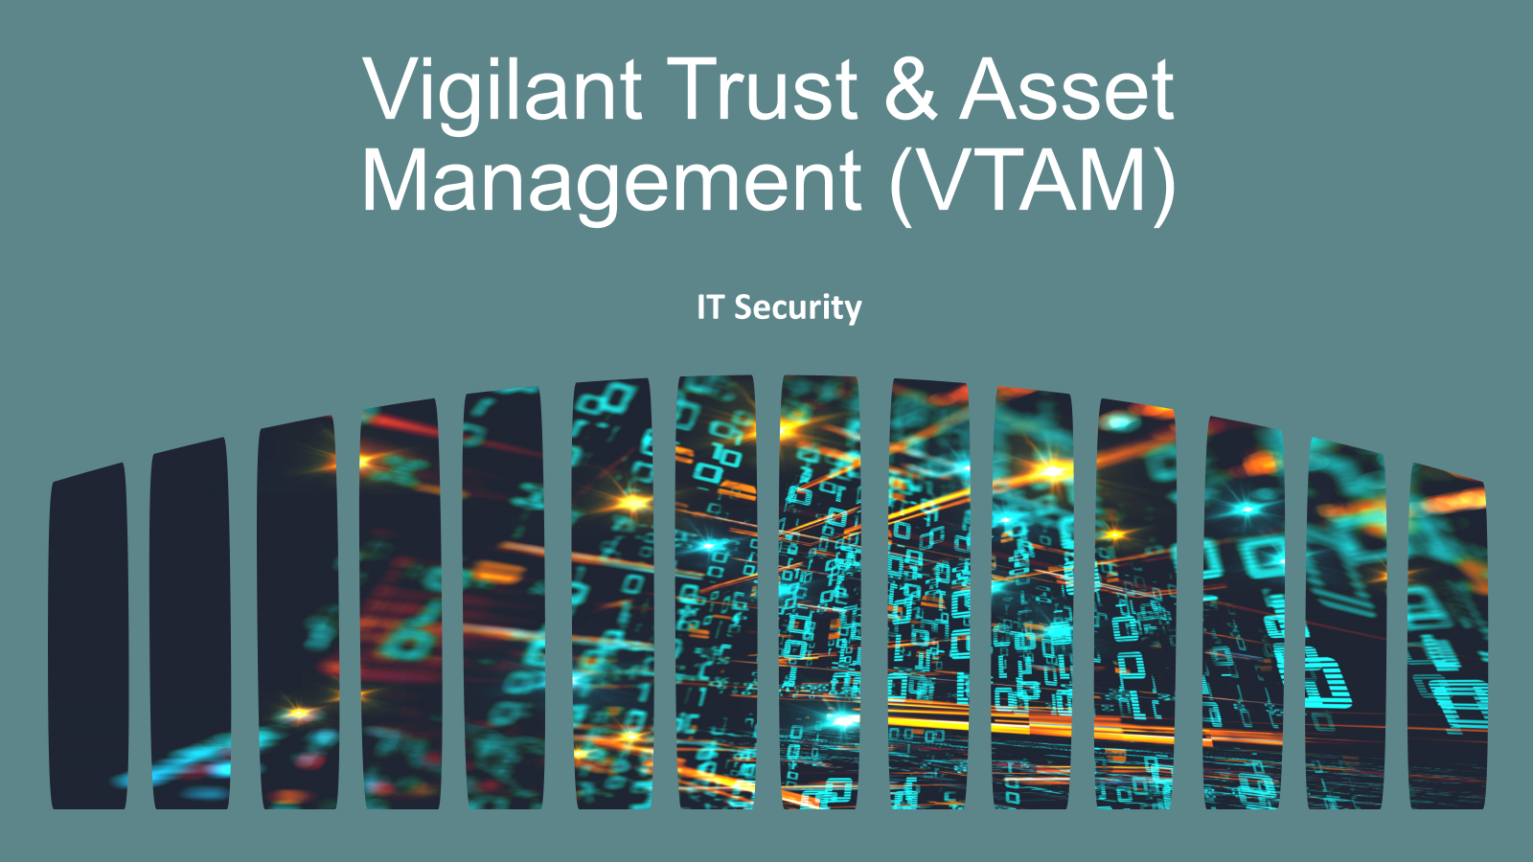

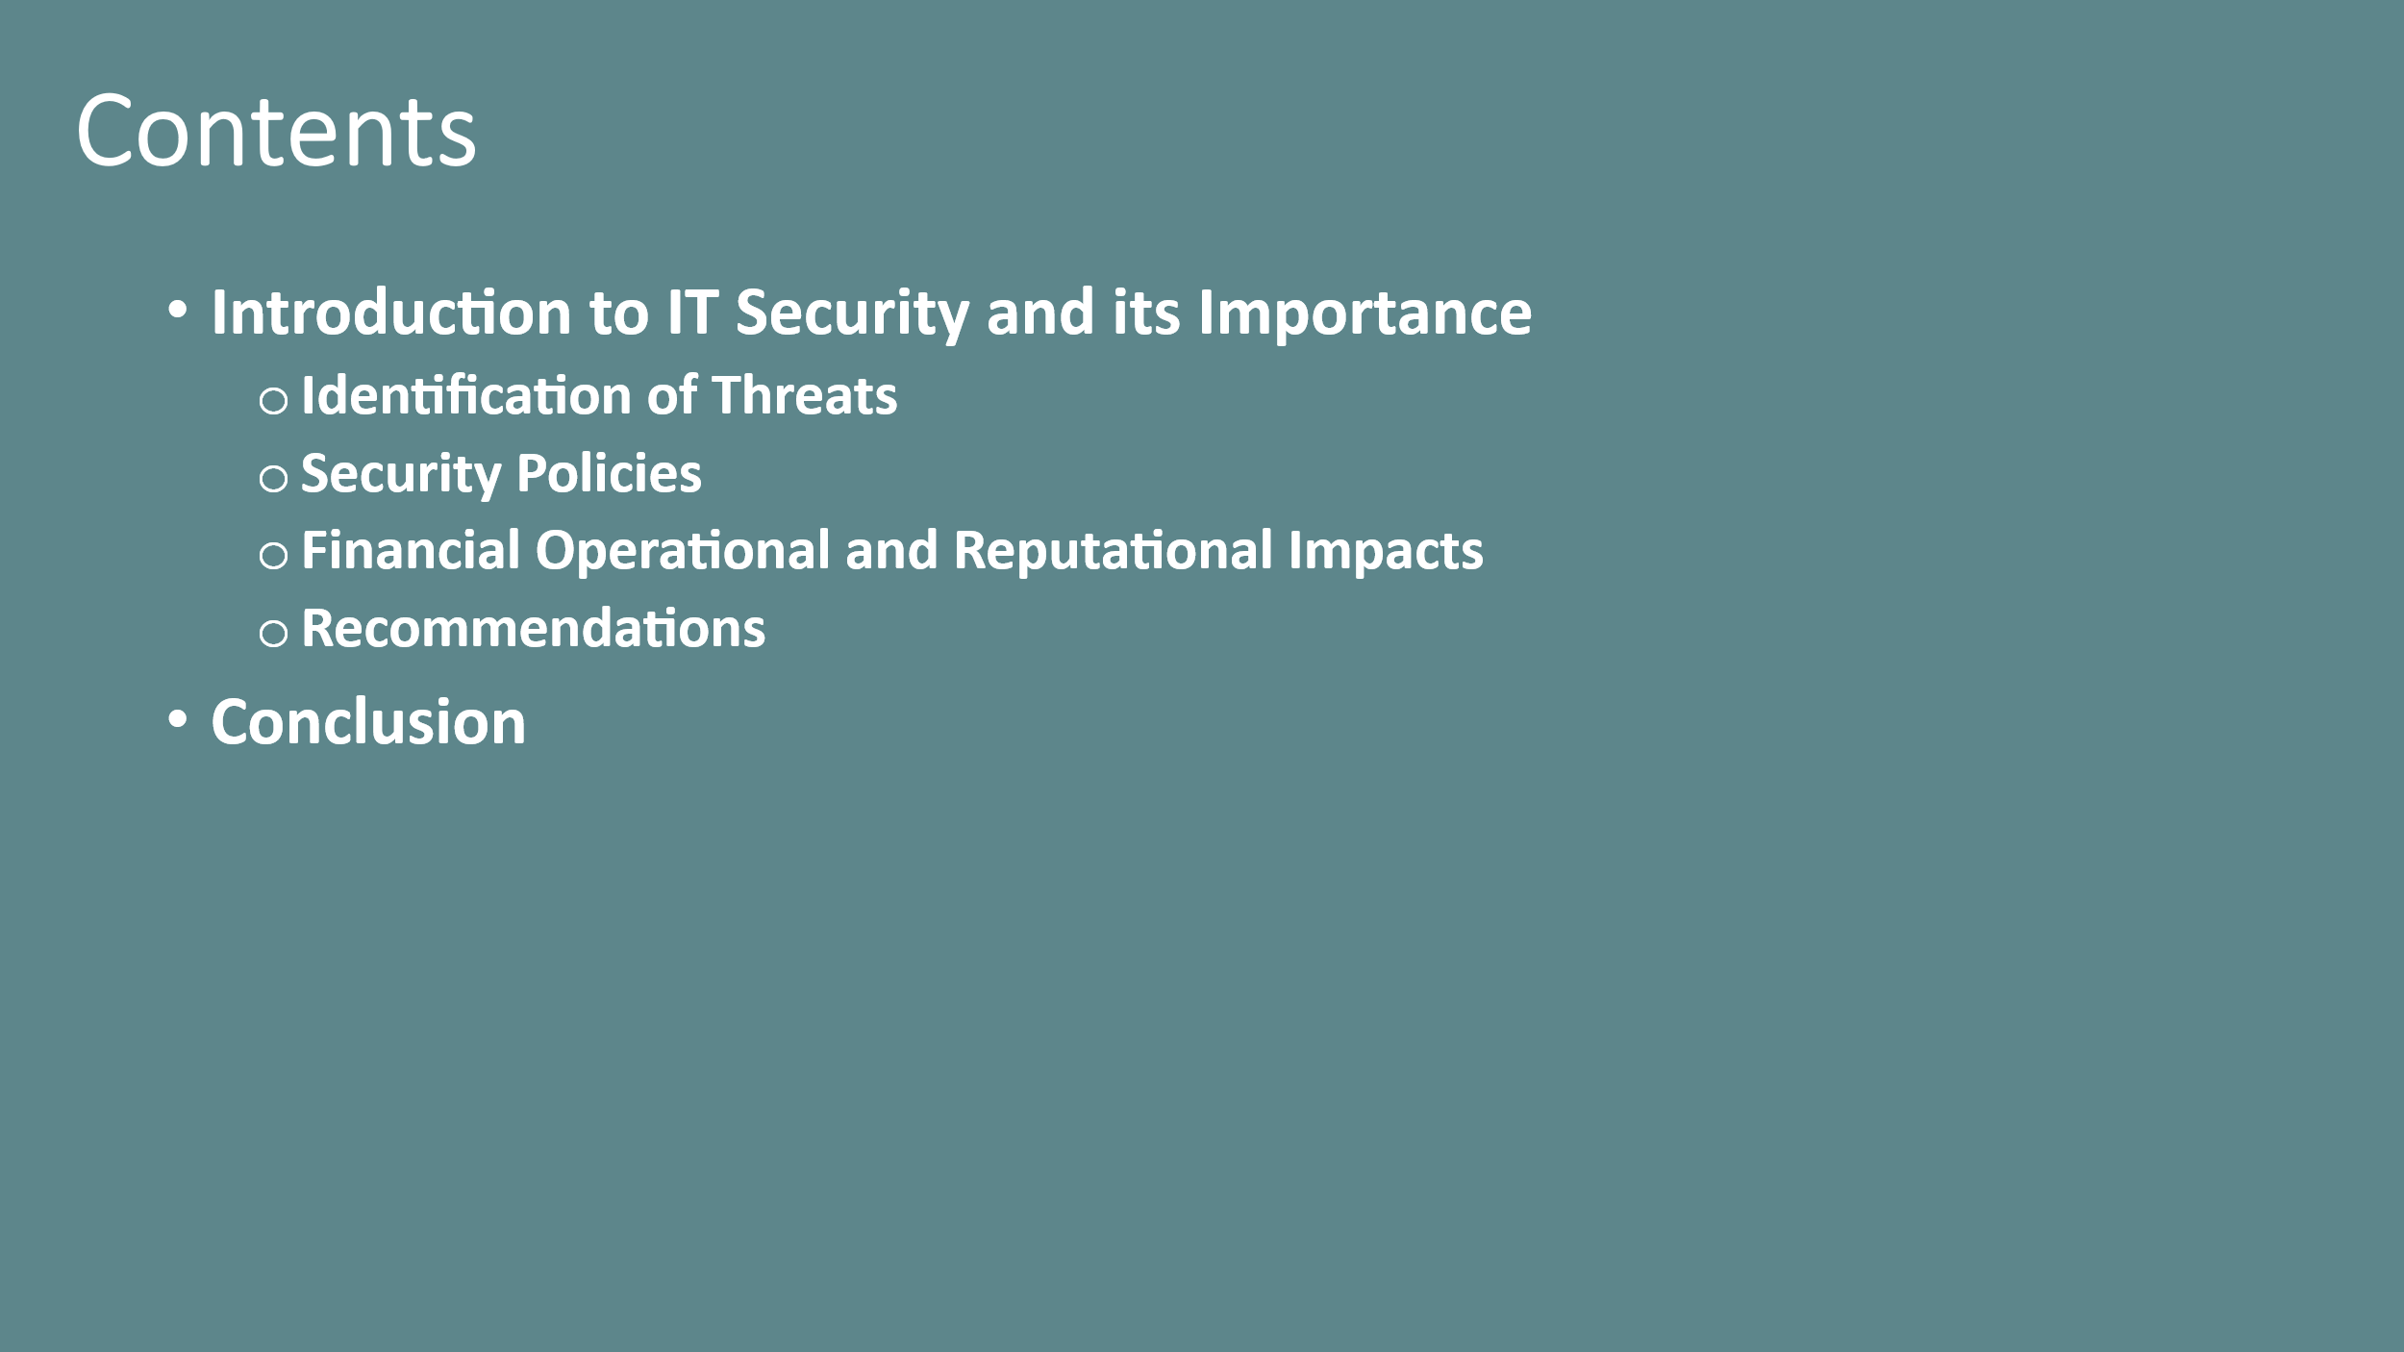

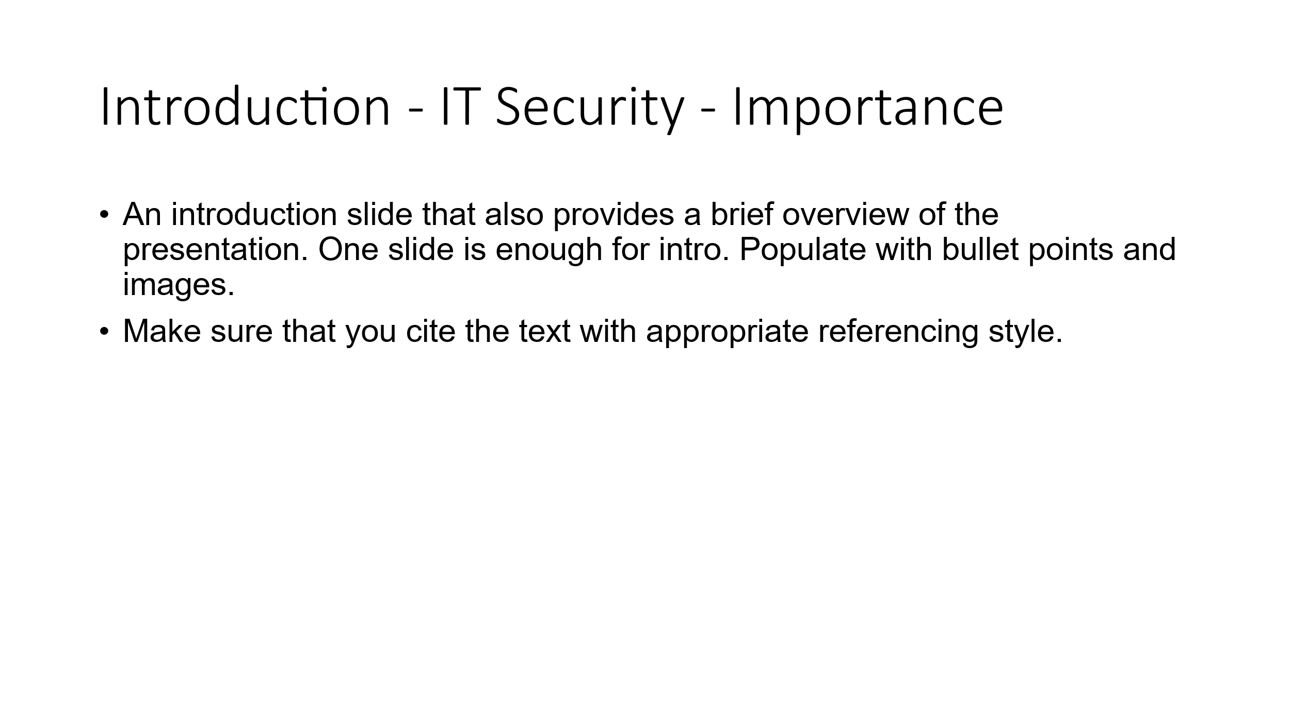

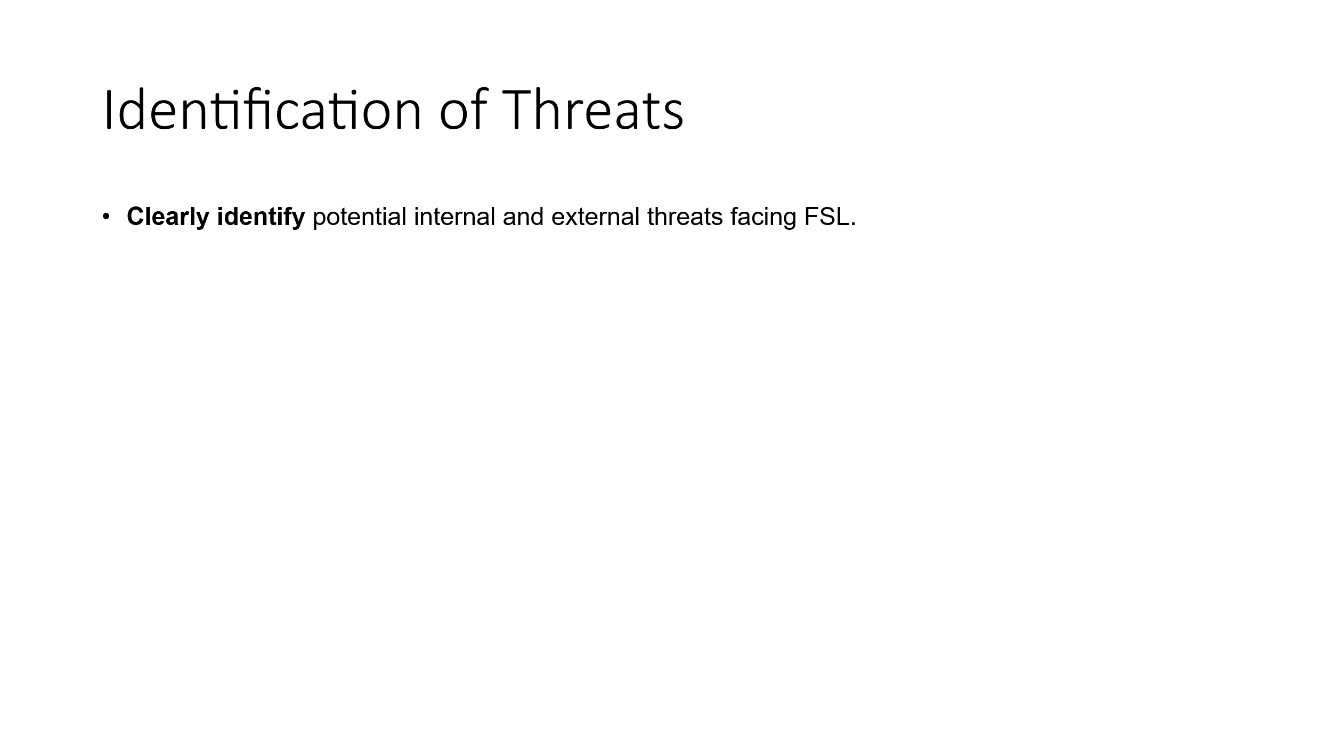

I have not pasted all the slides, but you need to add all the slides.

