BA International Hotel Management

Module name: Contemporary Themes in the Hotel and Hospitality Sector.

Module code: BMIH6001

Assignment Title: Assignment One Conference Research Paper- Sustainability and Net-Zero in the Hotel Industry

Module Lecturer: Dr Ernest Balutie Wavei

Student Name: Anca Roxana Iclanzean

Student ID: 2207144

AI Declaration:
I declare that I have produced this assignment independently, without using computer programs to research or write. I declare that I entirely created all work submitted. I have maintained every draught and reference I used and am ready to send them for review if requested.

Abstract
This research examines what sustainability means in the hotel and hospitality industry. The sector with high carbon emissions and energy use faces much greater scrutiny as world leaders fight climate change. Become more energy efficient to reduce environmental damage, boost work operations, fulfil partners' and regulators' expectations, and respect new regulations.
The first part of the report covers the value of energy efficiency for sustainability and how the hospitality industry differs in its operating needs. It then sees energy efficiency as a key area and explores its practice by examining today's academic and business writings. Data for the study is extracted qualitatively from selected hotels and secondary resources, and the study points out positive practices and areas for improvement.
PEST analysis helps analyse how external factors such as political rules, economics, expected behaviours of society, and technology affect energy efficiency in the sector. The study looks at the energy-saving actions leading hotel groups have taken and steps independent hotels have undertaken and discusses the success of each.
Finally, the report provides helpful recommendations to hotel organisations to overcome today's obstacles. Examples include better rules for all, funding for small businesses, significant investment in technology, and better engagement with those involved. This research clearly shows that energy efficiency should be planned and integrated so that the industry can reach net zero and maintain sustainability.

1. Introduction
Brotherton (2015) stated that hotels and hospitality companies now make sustainability and lowering emissions priorities and energy efficiency central to reaching their targets. Because as much as half of the industry's carbon emissions come from heating, cooling, and lighting energy, prompt action is required (UNWTO, 2022). Cities are adopting energy efficiency because it supports global actions to reduce climate change and the requirements set out by the Paris Agreement and the UN's SDGs, especially goal 13, Climate Action (UNEP, 2023).
Due to its extensive energy use and carbon emissions, the hotel and hospitality industry is now essential in responding to climate change. This report focuses on energy efficiency as a main approach to reaching net-zero targets. Because of increased environmental problems, regulatory changes and what guests expect, hotels must change to keep up and do right by the environment. Based on modern literature, case studies and a PEST analysis, this study cheques the impact of new technologies and policies on the industry's green efforts. Its purpose is to equip the sector with a complete understanding and practical advice to improve its environmental results.
Hotels are always open, and because they serve guests, they need lots of electricity and water to operate efficiently. Because of pressure from travellers, investors, and stakeholders, the industry is expected to put more effort into making its practices sustainable (WTTC, 2023). Becoming energy efficient lets hotels save money, improve their image, and keep profits high for years (IHG, 2021).
Growing energy prices, stricter rules from regulators, and more people looking for green hospitality make energy efficiency even more critical (Zuno Carbon, 2025). That is why energy efficiency is essential for industry survival and competitiveness as sustainability changes rapidly.

2. Literature Review
Cooper and Hall (2019) stated that the hotel sector is becoming increasingly sustainable, influenced by growing environmental issues and the goal of net-zero emissions everywhere. Because hotels always have many electrical uses because of their constant operations, energy efficiency has become an important priority. This research, supported by study results and stories from the industry, looks at how steps toward energy efficiency have affected real hotels.

2.1 Imperative for Energy Efficiency in Hotels
A significant portion of a hotel's energy goes toward heating, cooling, lighting, and electrical appliances. Gitnux (2025) reports that hotels that practise sustainability have seen about a 21% drop in their greenhouse gas emissions. On top of that, hotels that save energy on equipment and utilities can lower running costs by 20%, improving the bottom line and promoting environmental responsibility (Gitnux, 2025).

2.2 Technological Innovations Driving Energy Efficiency

Figure 1: Technological Innovations Driving Energy Efficiency
: (Huijbrechts, 2023)
Integration of Renewable Energy: Renewable energy is a significant part of hotels' efforts to save energy. The Radisson Hotel Group now relies on solar and wind energy at 80 sites, and some of their hotels use only renewable electricity (Huijbrechts, 2023). Like the Galaxy Macau Cotai complex, Universal Beijing Resort in China only uses solar and wind energy to match the nation's target for zero carbon emissions (Reuters, 2025).
Smart Energy Management Systems: Hotels are making significant advances in energy management with technologies such as AI and IoT. These platforms study real-time data to improve energy efficiency, determine when maintenance is needed, and run systems at their most efficient level, according to Huijbrechts (2023). Because of these modern systems, energy use and how things work can see positive changes. Source.
Geothermal and Hydrogen Technology: More hotels worldwide are beginning to use new heating and cooling options, including geothermal systems and hydrogen fuel cells. Radisson Blu Hotel in Frankfurt is connected to a hydrogen fuel cell that supplies heat and proves how different energy sources could be adapted to hotel usage (Batabyal and Das, 2019).

2.3 Case Studies of Energy Efficiency in Practice
Hotel Marcel, New Haven, Connecticut: Hotel Marcel is the U.S.'s first hotel that runs on solar power it produces on-site and cannot be considered an energy user in the eyes of the federal government. Because the hotel has solar panels, triple-glazed windows, and an energy-efficient HVAC system, it now uses less than 20% of the energy that similar properties once required, according to ESG News (2024).
Populus Hotel, Denver, USA: Populus Hotel says it is America's first "carbon positive" hotel, with carbon emissions that are 400%- 500% lower than what is needed to be neutral. Clean energy powers the whole hotel, zero-emission materials are used in construction, and a tree is planted for every guest visit (The Guardian, 2024).
IHCL’s Heritage Hotels, India: IHCL has made its heritage properties more sustainable by going solar and using low-flow water fixtures. The yearly results of these programs show that energy was conserved by 1,550 megawatts, and CO₂ emissions fell by 1,536 metric tons (Condé Nast Traveller, 2023).

2.4 Challenges to Implement Energy Efficiency
It is easy to see why energy-efficient practices are beneficial, but many problems prevent hotels from fully utilising them.

Figure 2: Challenges to Implement Energy Efficiency
Source: (Sharma, Singh, and Tyagi, 2024)
Higher Initial Cost: The high initial cost of installing advanced energy systems often makes some hotel operators hesitant (Singh, Mishra and Yadav, 2024).
Technical Complexities: Blending advanced technologies into present designs may be difficult and require a specialised team (Sharma, Singh, and Tyagi, 2024).
Resistance to Change: Staff and managers might resist new ways of working because they are uncertain about them or lack confidence in them (Singh, Mishra and Yadav, 2024).
Regulatory and Policy Barriers: In many cases, rules are not uniform, or rewards are absent, so energy-efficient methods are rarely adopted (Costa and Costa, 2022).

2.5 Role of Policy and Incentives
Energy efficiency in hotels is supported mainly by government policies and benefits. In addition, the Chinese government helps make tourism greener, aiming towards its net-zero goal by 2060 (Reuters, 2025). Energy-efficient hotels in many countries are recognised through tax reductions, financial grants, and certificates, motivating the whole industry to follow.
Eco-friendly energy practices help hotels reach their sustainability and net-zero goals. By combining renewable energy, clever tech, and new approaches, hotels can reduce environmental damage, improve operations, and make guests happier. However, industry members, decision-makers, and the public must join forces to tackle the industry's financial, technical, and regulatory problems. A sustainable future in hospitality will require ongoing support for green energy and helpful laws.

3. Method
The research used qualitative methods to assess the impact of making hotels more energy efficient as part of environmental goals. Extensive assessments of secondary publications were done using peer-reviewed journal articles, industry reports, and well-known news portals from 2023 to 2025. Journal articles for this study were obtained through ScienceDirect, MDPI, and Google Scholar.
Thematic analysis, a method commonly used for picking out, studying, and reporting on data patterns, was the technique employed here (Braun and Clarke, 2022). Using this approach, the research group grouped their findings into technological innovation, effects on operations, and policy concerns. Results were organised using a framework to analyse environmental, economic, and social issues together, using the Triple Bottom Line (TBL) framework (Elkington, 2017).
All resources in this analysis come from major academic publications and established industry organisations. This research approach allowed us to fully understand energy and the role of efficiency measurement in sustainability.

4. Theme Impact Analysis
The hospitality industry worldwide is making energy efficiency a central part of its sustainability and clean energy decisions. Political rules, financial pressures, community requirements, and the development of technology are driving this change. The PEST framework allows us to observe the many impacts of energy efficiency changes in hotels.

4.1 Political Factors
Everywhere, measures and rules are being implemented that drive or require hospitality companies to become more efficient with energy. For example, Singapore made a big announcement to increase its carbon tax, starting with S$5 per tonne now but increasing to S$25 in 2024 and $45 by 2026—this will affect hotels with high emissions (Hotel News Resource, 2022). Thus, hotels use energy-saving technology to lower their tax responsibilities.
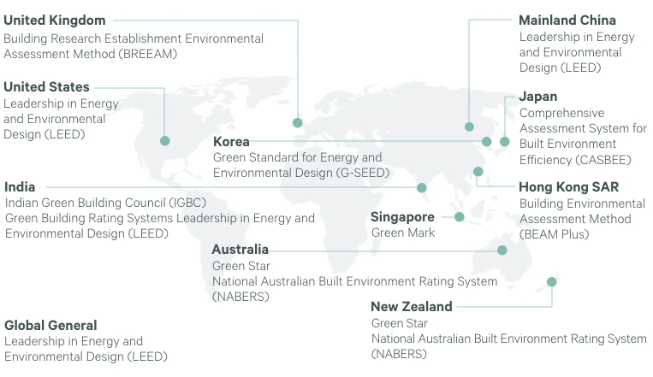
Figure 3: Sustainability Certifications Across the Globe
Source: (Hotel News Resource, 2022)
Because the Chinese government wants carbon neutrality by 2060, significant efforts and money have been made to develop renewable energy options for travellers. It should be noted that the Universal Beijing Resort relies only on clean solar and wind energy for all of its operations (Reuters, 2025).

4.2 Economic Factors
Energy efficiency steps in hotels are essential because they save companies money. Intelligent building systems installed by Hilton Worldwide, including better HVAC and energy technology, have helped the company use 14% less energy (Hotel Insider, 2025). Through an energy-efficient lighting program, Marriott International has lowered energy consumption by 10%, leading to significant cost savings (Hotel Insider, 2025).
Money invested in renewable energy also increases financial security in the long run. A 21.6 kW solar plant was installed at the Mandarin Hotel in Santiago, Chile, which produces enough energy for 19.2 MWh annually and helps save 7.5 tonnes of CO₂ each year (Enel X, 2022). Working on these projects cuts costs and gives the hotel an advantage with people who care about the environment.

4.3 Social Factors
People's interest in sustainability is affecting how hotels work day to day. As more guests care about the environment, hotels mix energy-efficient initiatives into their social responsibility practices. As a case in point, the Populus Hotel in Denver calls itself America's first carbon-positive hotel and helps draw eco-friendly visitors (Condé Nast Traveller, 2024).
People working in the company should engage with sustainability projects. Thanks to a partnership with the MAD Academy, Marriott chefs can now help hotel kitchens reduce their environmental impact by sourcing foods locally and cutting down on waste (Food & Wine, 2025). These programmes allow the environment and encourage all staff to support sustainable practices (Singh, Mishra and Yadav, 2024).

4.4 Technological Factors
Technology greatly improves hotel energy use. Intelligent building technologies, such as IoT and AI, make it possible to check and enhance energy efficiency immediately. Hilton's LightStay program, which records more than 200 environmental measures, has reduced carbon emissions by 30% and saved the company money (Preprints.org, 2024).
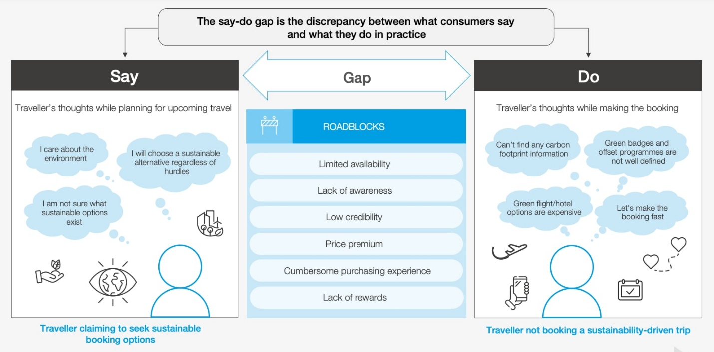
Figure 4: Influence of Technological Factors on Sustainability
Source: (IMES Academy, 2025)
Experts are investigating new ways to reduce the nation's dependence on fossil fuels, such as geothermal and hydrogen fuel cells. At the Radisson Blu Hotel in Frankfurt, hydrogen fuel cells supply clean heat and inspire new ways of thinking about alternative sources in the hotel business (IMES Academy, 2025). Introducing advanced technologies can be both complex and expensive. When considering their systems, hotels should predict how much they can save and how much energy will be used in the building (Singh, Mishra and Yadav, 2024).

4.5 Industry Responses Using Strengths and Weaknesses
The hospitality sector is actively working to improve its energy use. Big hotel chains are developing strong sustainability strategies; Marriott wants to cut carbon emissions by 30 per cent in 2025, and Hilton plans to decrease GHG emissions by 61 per cent in 2030, according to Zuno Carbon (2025). These goals are backed up by choosing renewable power and energy management systems.
Many smaller hotel groups and single hotel businesses are also doing well. Using an energy management system, the Mare Resort in Italy reduced energy usage by modifying equipment and managing consumption in several sectors (Enel X, 2022). The industry, though, deals with constraints such as less money, obstacles with new technology, and constantly needing more standardised sustainability measures. Without regular regulations, hotels have uneven approaches to sustainability, which can prevent them from being compared fairly (Hotel News Resource, 2022).

5. Conclusion
The research points out that energy efficiency is crucial for sustainability and achieving a net-zero goal in hotels. It is clear from the study that new technologies and policy support are pushing the industry forward, but difficulties, including high costs, technical difficulties and inconsistent regulations, remain. Successful case studies prove that emissions and costs can be significantly reduced with renewable energy and intelligent systems. However, to increase the number of users, it is necessary to address financial and structural problems by agreeing on standards, getting more funding and involving all stakeholders. The report recommends that the hotel industry work together to adopt sustainable practices, making hotels leaders in the worldwide low-carbon transition.
In short, energy efficiency is essential for sustainable hotels, and political rules, financial rewards, social values, and new technologies lead to this. Many hotels have moved forward because of new ideas and strategies, but they must still tackle high costs and irregular quality. Organisations must continue collaborating, investing, and getting policy support to fulfil lasting environmental and operational targets.

6. Recommendations
Some suggestions from current literature and relevant practices are presented here to continue improving energy efficiency in the hotel and hospitality industry.

Figure 5: Recommendations for Improving Energy Efficiency in Hospitality Industry
Source: (Author’s Construction)
Strengthen Regulatory Alignment and Certification Standards: Both governments and global organisations are called on to create a universal way of certifying hotels based on energy efficiency. Their adoption could address the problem of greenwashing by supporting transparent reporting of a hotel's energy usage (Hotel News Resource, 2022). Programs like LEED (Leadership in Energy and Environmental Design) and ISO 50001 should receive wide attention, and extra support, and certified properties should benefit from economic incentives (Singh, Mishra and Yadav, 2024).

Providing Financial Support for SMEs: Energy-efficient technologies are expensive for many small and medium hotel businesses. To support investment in green transport, governments, financial institutions, and development banks should suggest Low-interest green loans, grants, and public-private partnerships (Zuno Carbon, 2025). In addition, the hospitality sector could fill its funding gap with specially made green investment funds.

Invest in Smart Tools and Significant Data Analytics: Prioritising intelligent energy systems, including IoT and AI, is essential for hotels of every size. These technologies allow organisations to monitor and improve their energy use in real-time, reducing spending and less environmental damage (Preprints.org, 2024). If staff is trained to use energy data, the efficiency of these systems will improve significantly (IMES Academy, 2025).

Promoting Staff Engagement and Sustainability Training: Energy efficiency policies will only be applicable if employees are knowledgeable and enthusiastic about them. Energy conservation training should be part of onboarding and professional advancement courses and inspire staff to join sustainability initiatives (Food & Wine, 2025). Starting a green committee and acknowledging good work can help increase employees' involvement.

Increase Use of Renewable Energy: They should keep switching to solar, wind, and geothermal energy as sources. Cooperating with renewable energy firms and using on-site technology like solar panels or hydrogen cells can help buildings use much less power from the grid (Enel X, 2022). Renewable technologies should be evaluated during feasibility studies to determine where they will work properly.

Strengthen Customer Engagement and Communication: More and more guests are concerned with sustainable practices. Hotels can explain energy efficiency programs through their marketing and materials provided in guest rooms. Openly discussing progress and asking tourists to help by not changing their linen daily will help a hotel become more environmentally friendly and attractive to loyal guests (Condé Nast Traveller, 2024).

References
Batabyal, D. and Das, D.K. (2019). Global trends, practices, and challenges in contemporary tourism and hospitality management. Hershey, Pennsylvania: Business Science Reference, an imprint of IGI Global.
Braun, V. and Clarke, V. (2022). Using thematic analysis in psychology, Qualitative Research in Psychology, 3(2), pp. 77–101.
Brotherton. B. (2015). Researching Hospitality & Tourism, 2nd Edn. Sage. London
Condé Nast Traveler. (2023). Bright Ideas in Travel 2023. Accessed from https://www.cntraveler.com/story/bright-ideas-in-travel-2023 [Accessed 26 May 2025].
Cooper, C. and Hall, M. (2019). Contemporary Tourism: An International Approach, 4th Edn. Goodfellows, Oxford.
Costa, V. and Costa, C. (2022). Sustainability and competitiveness in the hospitality industry. Hershey, Pennsylvania: Business Science Reference.
Elkington, J. (2017). Cannibals with Forks: The Triple Bottom Line of 21st Century Business. Oxford: Capstone.
Enel X. (2022). Sustainability in the hospitality and hotel industry. Accessed from https://corporate.enelx.com/en/stories/2022/11/energy-efficiency-hotelsEnel X [Accessed 26 May 2025].
ESG News. (2024). Hilton's Hotel Marcel: A Net-Zero Transformation Reshapes Hospitality Industry. Accessed from https://esgnews.com/hilton-hotel-marcel-net-zero-transition-hospitality-industry / [Accessed 26 May 2025].
Food & Wine. (2025). Inside the Sustainability Retreat, That is Reshaping Hotel Kitchens Worldwide. Accessed from https://www.foodandwine.com/marriott-luxury-collection-mad-academy-sustainability-11695866 [Accessed 26 May 2025].
Ford. R.C., Sturman. M.C. (2020). Managing Hospitality Organisations 2nd Edn. Sage, London.
Gitnux. (2025). Sustainability in the Hotel Industry Statistics. Accessed from https://gitnux.org/sustainability-in-the-hotel-industry-statistics/ [Accessed 26 May 2025].
Hotel Insider. (2025). Sustainability initiatives in hotels: How energy-efficient technologies are reducing carbon footprint. Accessed from https://hotelinsider.org/2025/03/06/sustainability-initiatives-in-hotels-how-energy-efficient-technologies-are-reducing-carbon-footprint/ [Accessed 26 May 2025].
Hotel News Resource. (2022). Sustainability and ESG Adoption in the Hotel Industry: A Global Status Update. Accessed from https://www.hotelnewsresource.com/article125774.html [Accessed 26 May 2025].
Huijbrechts, I. (2023). Sustainable Tech Pioneering Green Hotel Buildings and Operations. Accessed from https://www.hotelyearbook.com/article/122000420/sustainable-tech-pioneering-green-hotel-buildings-and-operations.html [Accessed 26 May 2025].
IHG (2021). IHG Green Engage™ system. Available at: https://www.ihgplc.com/en/responsible-business/green-engage [Accessed 26 May 2025].
IMES Academy. (2025). The Rise of Sustainability in Hospitality: The Pivotal Role of Energy Efficiency. Accessed from https://imesacademy.com/the-rise-of-sustainability-in-hospitality-the-pivotal-role-of-energy-efficiency / [Accessed 26 May 2025].
Preprints.org. (2024). Powering Down Hospitality Through a Policy-Driven, Case-Based and Scenario Approach. Accessed from https://www.preprints.org/manuscript/202412.2482 [Accessed 26 May 2025].
Reuters. (2025). How renewable energy is helping China's tourism industry go green. Accessed from https://www.reuters.com/sustainability/climate-energy/how-renewable-energy-is-helping-chinas-tourism-industry-go-green-2025-05-08/ [Accessed 26 May 2025].
Sharma, M., Singh, A.K. and Tyagi, P. (2024). Proceedings of the International Conference on Innovation and Regenerative Trends in Tourism and Hospitality Industry (IRTTHI 2024). 1st ed. Dordrecht: Atlantis Press Zeger Karssen.
Singh, A.B., Mishra, Y. and Yadav, S. (2024). Toward Sustainability: Interventions for Implementing Energy-Efficient Systems into Hotel Buildings. Engineering Proceedings, [online] 67(1), pp.80–80.
The Guardian. (2024). America's first 'carbon positive' hotel comes to Denver - but do its climate claims stack up? Accessed from https://www.theguardian.com/environment/2024/sep/26/first-carbon-positive-hotel-populus-denver-climate-claims [Accessed 26 May 2025].
UNEP (2023) Greening the tourism sector. Available at: https://www.unep.org/resources/report/greening-tourism-sector [Accessed 26 May 2025].
UNWTO (2022) Climate action in tourism. Available at: https://www.unwto.org/climate-action [Accessed 26 May 2025].
WTTC (2023) Hotel sustainability basics. Available at: https://wttc.org/Portals/0/Documents/Reports/2023/Hotel-Sustainability-Basics-Report [Accessed 26 May 2025].
Zuno Carbon. (2025). Hotel Sustainability: challenges & solutions. Accessed from https://www.zunocarbon.com/blog/sustainability-in-the-hotel-industry [Accessed 26 May 2025].

