University of Wales Trinity Saint David
Wales Institute of Science & Art

Motorcycle Geometry Analysis and Dynamic Handling Investigation

Module Code – ACHA4003
Module: Motorcycle Technology

Name: Odysseas Androutsos
Student No: 2005263

December – 2021
Contents
1 Introduction 1
2 Methodology 1
3 Physical Measurements, Motorcycles Characteristics and Calculations 1
3.1 Task 1 - Determine the Centre of Gravity positions for 2 No Motorcycles 1
3.2 Task 2 - Determine the max speed of the motorcycles and the power speed requirements 1
3.3 Task 3 – Evaluation of the results 1
3.4 Task 4 – Geometric data of two modern motorcycles. 1
3.5 Task 5 – Recommendations for alteration to Zero SR/F 2020 1
4 Conclusions 1
5 References 1

List of figures
Figure 1 – Photo of Honda CBR1000F 200 Figure 2 – Photo of Zero SR/F 2020 1
Figure 3 – Schematic diagram for calculating the Centre of gravity 1
Figure 4 – Schematic diagram for showing the CoG of Honda CBR 1000rr 2007 with and without the rider 1
Figure 5 – Schematic diagram showing the CoG of Zero SB/R 2020 with and without the rider 1
Figure 6– Forces acting on the motorcycle Vs speed for Zero SR/R 2020 1
Figure 7 – Forces acting on the motorcycle Vs speed for Zero SR/R 2020 1
Figure 8– Photo of Kawasaki Ninja ZX-10R Figure 9– Photo of BMW S 1000RR 2016 1
Figure 10 – Forces acting on the motorcycle Vs speed for Kawasaki Ninja ZR-10R 2021 1
Figure 11– Forces acting on the motorcycle Vs speed for BMW S 1000rr 2016 1
Figure 12 - Power Curve of Zero SR/F 2020 1

List of Tables
Table 1 - Measurements for Honda CRF1000rr - 2007 1
Table 2 - Measurements for Zero SR/F - 2020 1
Table 3 – Motorcycle characteristics for Honda CBR1000rr 2007 and Zero SB/R 2020 1
Table 4 – Motorcycle characteristics for Kawasaki Ninja ZX-10R 2021 and BMW S1000rr 2016 1

Introduction
It is well known in motorcycling world that the handling characteristics of a motorcycle are importance in order the rider to have a comfortable feeling and feel safe to achieve the maximum power the engine of a motorcycle can offer. This report will investigate the handling characteristics of two motorcycles relatively old motorcycles and two modern types of motorcycle by obtain information about these motorcycles either by actual measurements where this is possible or from the workshop manuals. These information’s will be used to calculate the centre of gravity of the motorcycles and the expected maximum speed under dynamic conditions and the power speed requirements. Final how the geometry of the motorcycles affected the handling characteristics and performance of the motorcycles will be discuss and recommendations about as to how to improve the handling characteristics of one of the motorcycles which are under investigation in this report will be made.

Methodology
To fulfil the requirements of this assessment the characteristics of the following motorcycles will be investigated:
  - HONDA CBR1000rr 2007
  - Zero SR/F – 2020
  - Kawasaki Ninja ZR-10 R 2021 and
  - BMW S 1000RR - 2016
The next step is to measure the physical characteristics of these motorcycles and obtain also other technical information from the workshop manuals.
Using the information which will be obtained the expected maximum speed of the motorcycles under dynamic conditions will be calculated and the handling characteristics of the motorcycles will be discussed.
Finally, recommendations will be made as to what changes can be made to any of the motorcycles which was physical measured in order its characteristics and performance to be improved.

Physical Measurements, Motorcycles Characteristics and Calculations

Task 1 - Determine the Centre of Gravity positions for 2 No Motorcycles
The first task of the report was to determine the centre of gravity of 2 No motorcycles and shown this information of schematic diagram. The two motorcycles which were selected to achieve this task are Honda CBR 1000rr 2007 and Zero SR/F 2020. See photos below:

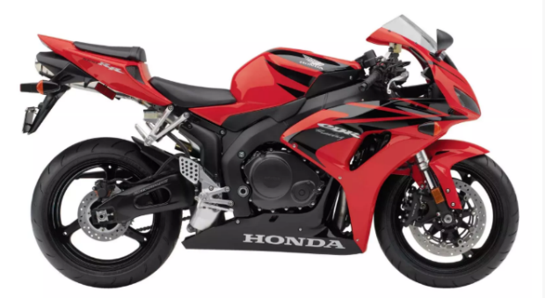
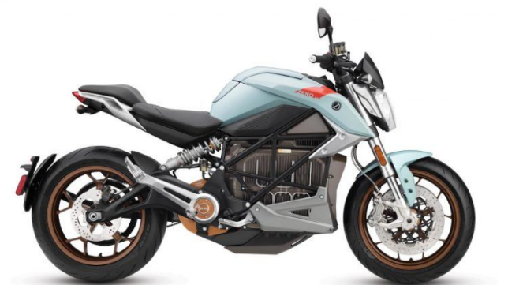

Figure 1 – Photo of Honda CBR1000RR 200 Figure 2 – Photo of Zero SR/F 2020
(2007 Honda CBR1000RR - Gallery | Top Speed, no date) (2020 Electric Motorcycle Spec Shootout, no date)

In order to determine the Centre of gravity of the motorcycles it was necessary to measure force that is exerted on the ground by the front and the rear wheel of the motorcycles in a level and incline positions with and without the rider.
The weight on the front and the rear wheel of the motorcycles under investigation was measured by placing a scale under each wheel of the monocycle as it is shown the figure 3.
The readings of the scales were recorded. Then the readings of the scales were recoded again by placing the rider on the bikes. Then the rear wheel of the bikes was placed on a stool and the reading of the weight scales were recorder with and without the rider.
The weight of the stool, the height of the stool and the wheelbase of each motorcycle were are measure and recorded (see table 1 and 2)

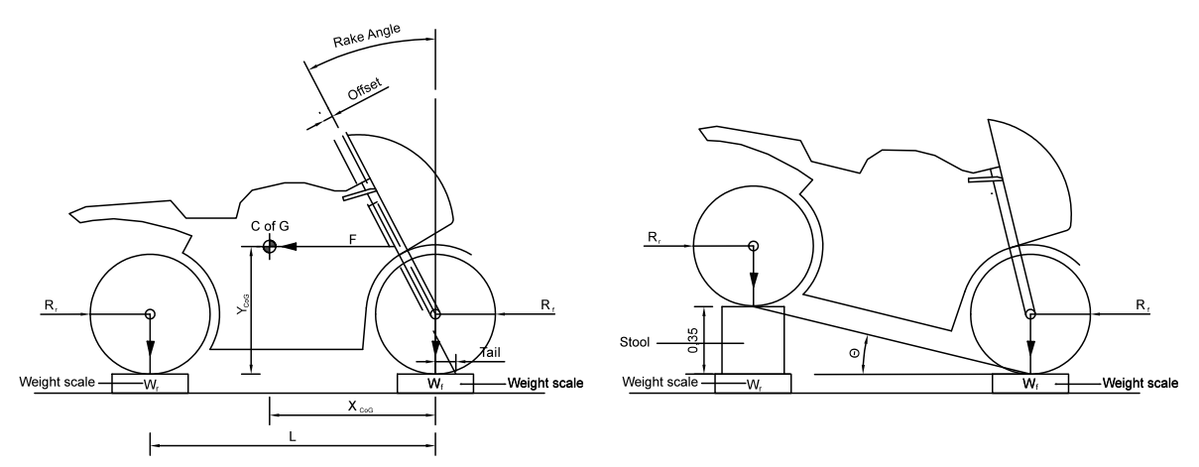
Figure 3 – Schematic diagram for calculating the Centre of gravity

Table 1 - Measurements for Honda CBR1000rr - 2007
Motorcycle Model | CBR 1000rr 2007 - Level |  | CBR 1000rr 2007 - Lifted
Characteristics | No rider | With rider | No rider | With rider
Weight on front wheel (kg) | 104.4 | 134.0 | 112.0 | 147.2
Weight on rear wheel (kg) | 94.65 | 137.2 | 109.2 | 146.0
Rider’s weight (kg) | N/A | 72.15 | N/A | 72.15
Stool Weight (kg) | N/A | N/A | 22.15 | 22.15
Total weight of motorcycle (kg) | 199.05 | 271.2 | 199.05 | 271.05
Wheelbase (m) | 1.39 | - | - | -
Average wheel radius (m) | 0.298 | - | - | -
Stool height (m) | - | - | 0.35 | 0.35
Lifted angle (degrees) | 0 | 0 | 14.58º | 14.58º
Rake angle (degrees) | 23.5º
Tail (m) | 0.1
Curb weight (kg)

Table 2 - Measurements for Zero SR/F - 2020
Motorcycle Model | Zero SR/F 2020 - Level |  | ZERO SR/F 2020 - Lifted
Characteristics | No rider | With rider | No rider | With rider
Weight on front wheel (kg) | 117.7 | 145.3 | 124.7 | 159.2
Weight on rear wheel (kg) | 106.85 | 152.6 | 122.5 | 161.1
Rider’s weight (kg) | N/A | 73.15 | N/A | 73.15
Stool Weight (kg) | N/A | N/A | 22.15 | 22.15
Total weight of motorcycle (kg) | 224.55 | 297.9 | 225.05 | 298.15
Wheelbase (m) | 1.45 | - | - | -
Average wheel radius (m) | 0.305 | - | - | -
Stool height (m) | - | - | 0.35 | 0.35
Lifted angle (degrees) | 0 | 0 | 13.97º | 13.97º
Rake angle (degrees) | 24.5º
Tail (m) | 0.094
Curb weight (kg) | 225.9

Using the information that was obtained for each motorcycle by actual measurements the centre of gravity for each motor cycle was calculated using the equations 1 and 2 with and with and without the rider.
X_{CoG} = $\frac{ (W_{r} x L)}{W_{t}}$ Equation 1

Y_{CoG} = $\frac{ (W_{r}-W_{rlifted} )x L)}{W_{t} x tanΘ}$ + R_{av} Equation 2

Where:
X_{CoG} = The horizontal distance from the centre of gravity to the centre of the front wheel
Y_{CoG} = The vertical distance from the centre of gravity to the ground
W_{t} = The total weight of the motorcycle
W_{r} = The weight on the rear wheel of the motorcycle
W_{rlifted} = The weight on the rear wheel of the motorcycle when lifted on block
Θ = The angle of the lifted motorcycle (=sin⁻¹(height of block/L))
L = Length of the wheelbase
R_{av} = Average radius of the wheels

Centre of Gravity Calculations for Honda CBR 1000rr 2007
Without the rider
X_{CoG} = $\frac{ (94.65 x 1.39)}{199.05}$ = 0.661m
Y_{CoG} = $\frac{ \left(94.65-87.05 \right)x 1.39)}{199.05 x tan{14.58}^{o}}$ + 0.298 = 0.502m
With the rider
X_{CoG} = $\frac{ (137.2 x 1.39)}{271.2}$ = 0.703m
Y_{CoG} = $\frac{ \left(137.2-123.85 \right)x 1.39)}{271.2 x tan{14.58}^{o}}$ + 0.298 = 0.561m
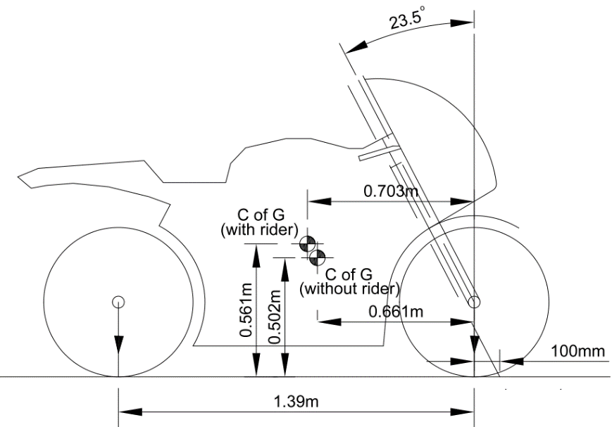
Figure 4 – Schematic diagram for showing the CoG of Honda CBR 1000rr 2007 with and without the rider
Centre of gravity calculations for Zero SR/F 2020
Without the rider
X_{CoG} = $\frac{ (106.85 x 1.45)}{224.55}$ = 0.690m
Y_{CoG} = $\frac{ \left(106.85-100.35 \right)x 1.45)}{224.55 x tan{13.97}^{o}}$ + 0.305 = 0.474m
With the rider
X_{CoG} = $\frac{ (152.6 x 1.45)}{297.7}$ = 0.743m
Y_{CoG} = $\frac{ \left(152.6-138.95\right)x 1.45)}{297.7 x tan{13.97}^{o}}$ + 0.305 = 0.572m
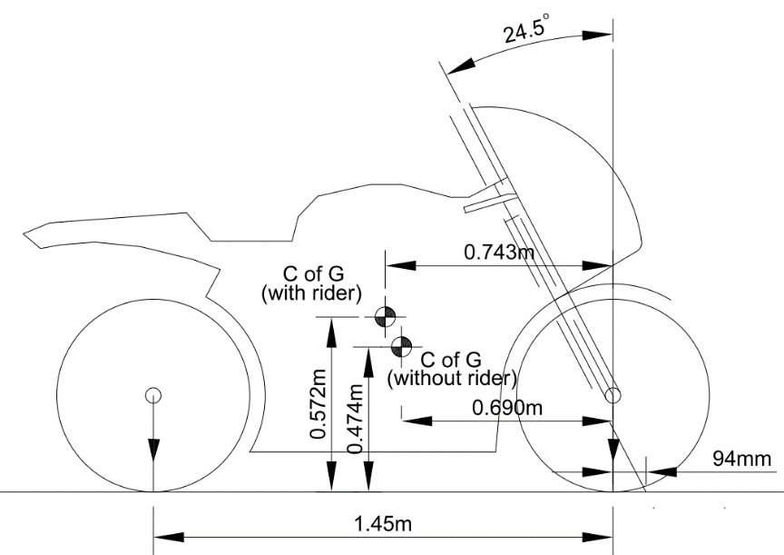
Figure 5 – Schematic diagram showing the CoG of Zero SB/R 2020 with and without the rider

Task 2 - Determine the max speed of the motorcycles and the power speed requirements

From the workshop manual and from other sources in the internet the geometric data and the gear rations and other characteristics of the above-mentioned motorcycles were obtained and are listed in the table 3 below.

Table 3 – Motorcycle characteristics for Honda CBR1000rr 2007 and Zero SB/R 2020
Characteristics | Honda CBR1000rr 2007 * | Zero SB/R 2020 **
Max. Length (m) | 2.03
Max. Width (m) | 0.72
Overall Height (m) | 1.118
Wheel Base (m) | 1.402 | 1.45
Rake angle (degrees) | 23.5º | 24.5º
Trail (m) | 0.100 | 0.094
Primary gear ratio | 1.604
Top Gear ratio | 1.16
Final Reduction | 2.625 | 4.5 (overall ratio)
Dry weight (kg) | 176 | 225.5
Front tyre size | 120/70/ZR17 | 120/70/ZR17
Front tyre (m) | 0.6 | 0.6
Rear tyre size | 190/50ZR17 | 180/55/ZR17
Rear tyre (m) | 0.622 | 0.63
Time from 0-100 km/hr | 3 | 3.7
Top Speed (km/hr) | 295 | 200
Drag Coefficient C_{d} (assumed) | 0.6 | 0.62
Frontal area m² | 0.58 | 0.65
Max Power | 126.4 | 82
RPM at Max Power | 12500 | 5000
Calculated Max Speed (Km/hr) | 300.03 | 131.9
*(2007 Honda CBR1000RR Fireblade (up to 2007) specs review, no date)
*(Full performance review of 2007 Honda CBR1000RR Fireblade (model up to 2007), no date)
*(2007 Honda CBR1000RR Fireblade, no date)
*(Honda CBR1000RR Service manual with hyperlinks, no date)
*(2007 Honda CBR 1000 RR Fireblade specifications and pictures, no date)
*(2007 Honda CBR1000RR - Gallery | Top Speed, no date)
**(2020 Zero Motorcycles SR/F | Cycle World, no date)
**(2020 Zero Motorcycles SR/F Review | Cycle World, no date)
**(2020 Electric Motorcycle Spec Shootout, no date)

Using the information from the above table the maximum speed of each motorcycle was calculated using equation 3.
V_{max} = $\frac{ (RPM x 60 x {π x D}_{r})}{{1000 x R}_{P}{x R }_{T}{ xR}_{F}}$ = $\frac{ (RPM x 60x {π x D}_{r})}{{1000 x R}_{o}}$ Equation 3
Where:
V_{max} = The estimated maximum speed of the motorcycles based on gear ratios and the engine’s RPMs at maximum power.
RPM = The engine revolution per minute at maximum power
R_{P} = Primary ratio
R_{Τ} = Top gear ratio
R_{P} = Final ratio
R_{o} =Overall gear ratio (in case on the electric motorcycles)
Π = 3,14
D_{r} = The diameter of the rear tyre

By applying equation 3 for the for the above-mentioned motorcycle the estimated maximum speed of the motorcycles was calculated as shown below:
Calculations for the estimated speed at maximum power for Honda CBR 1000rr 2007
V_{max} = $\frac{ (RPM x 60 x {π x D}_{r})}{{1000 x R}_{P}{x R }_{T}{ xR}_{F}}$ = $\frac{ (13200 x 60 x 3.14 x 0.622)}{1000 x 1.681 x 1.304 x 2.412 }$ = 300.3 km/hr
Calculations for the estimated speed at maximum power for Zero SR/F 2020
V_{max} = $\frac{ (RPM x 60x {π x D}_{r})}{{1000 x R}_{o}}$ = = $\frac{ (5000 x 60 x 3.14 x 0.63)}{1000 x 4.500 }$ = 131.9 km/hr
It is claimed that the CBR 1000rr 2007 can reach a speed of 295km/hr (estimated) (2007 Honda CBR1000RR Fireblade (up to 2007) specs review, no date) and Zero SR/F 2020 can reach speed of 124mph (200km/hr) (2020 Zero Motorcycles SR/F Review | Cycle World, no date)
In order to be able to determine if these two motorcycles have enough power to rich the above- calculated speeds at the maximum power of their engine/motor it is required to consider the forces that are opposing the motion like the drag force and the rolling resistance and compare the resultant of these forces with the driving force. These forces are given with equations 4, 5 and 6 respectively.
F_{d}$=Cd\frac{1}{2}{pV}^{2}A$ Equation 4
Where:
F_{d} = Drag Force
Cd = Coefficient of drag
P = density of the fluid (in this case is air 1.167kg/m³ at 20ºC and 987mbar)
V = speed of the object
A = Frontal area of the object

F_{w}$=0.02 x m x g$ Equation 5

Where:
F_{w} = Rolling resistance
m = the mass of the motorcycle and the rider
g = acceleration of gravity 9.81 m/s²

F$=\frac{P}{V}$ Equation 6
Where:
F = The driving force
P = The power of the engine or motor
V = the speed of the object (motorcycle)

Considering the above forces, the motorcycles will reach their top speed when the driving force is equal with the opposing forces Fr (Fr = Fd + Fw). In order to find this speed all the data required were entered in a spreadsheet in a excel and the driving force (F_{d}) and the resultant of the opposing forces F_{r} were calculated at 10km/hr intervals up a velocity of 350km/hr. Where the value of the driving forces was close to the value of the opposing forces the value of the speed was adjusted so that to the driving force to be equal with the resultant of the opposing forces. The results are presented on Forces Vs Speed graphs and are shown on the figure 6 and figure 7. It has to be noted here that it was assumed that the motorcycles move on a horizontal plane other wire the opposing or the driving for due to the slope of the ground should have been considered.

Figure 6– Forces acting on the motorcycle Vs speed for Zero SR/R 2020

Figure 7 – Forces acting on the motorcycle Vs speed for Zero SR/R 2020
The frontal area of the bike with the rider was measured after drawing into scale the front view of the bike with the rider in AutoCAD and then using area function in AutoCAD the frontal areas of the bike with the rider was recoded. The coefficient of drag of the motorcycles with the rider couldn’t be obtained from any source these values were assumed based on values C_{d}A values which were presented in last year’s lecture by Tim Tudor.(Tudor, 2020) The rake angle, the trail the wheel base and other characteristics of the bikes were obtain from the workshop manuals and from other sources in the internet and are summarized on table 1. In the calculation the total mass of the motorcycles the it was assumed that the weight of the rider is 65kg and the weight of the fuel, oil and coolant are 10kg.

Task 3 – Evaluation of the results
From the results obtain it can be observed the Honda CBR 1000RR has enough power to reach a speed of 304 Km/hr as it can be seen from the graph 1. This value is 9km/hr more than the estimate reported in “MotorbikeCatalog” (2007 Honda CBR1000RR Fireblade (up to 2007) specs review, no date) This deviation it might be due to the assumptions made in relation to the coefficient of drag and also due to the errors which have been made during he calculation of the frontal area. The rake angle of 23.5º, the tail of 100mm and the wheel base of 1.39m make this motorcycle quick at the bends but it might not he so stable on the straights.
On the other hand, Zero SR/F 2020, which is electric motorcycle has longer Wheel base than CBR 1000rr which makes this motorcycle more stable on the straights. The rake angle of this motorcycle is 24.5º and its tail 94mm. Even though the difference is no much from Honda CBR 1000rr this might make this motorcycle more comfortable to ride due to the increase in the rake angle. Looking on the graph 1 considering the power of this motorcycle it is expected the bike can achieve a speed of 249km/hr. This estimate contradicts the estimated value of 131.9km/h that was calculated based on the gear ratios and the motor RPM of the motor at maximum power and also contradicts the reported value of 124MpH (200km/hr) by “Cycle World” by (2020 Zero Motorcycles SR/F Review | Cycle World, no date) The Graph 2 show that the power of the motorcycle con be used to achieved a speed up to 249km/hr the value of the that was obtained base on the gear ration and the RPM at maximum power tells us that engine revolutions at maximum power are not enough to make the motorcycle go faster given the existing overall gear ratio. To make a more realistic conclusion the power curve of the motor has to be studied in order to assess the performance of the motor after the maximum power is obtained.

Task 4 – Geometric data of two modern motorcycles.

In order to make comparison on how the new motorcycles were modified in order to fulfill the requirements of their use, Kawasaki Ninja ZR-10R and BMW 1000RR 2016 were selected for this investigation. Photos of these motorcycles are shown in Figures 8 and 9 below.

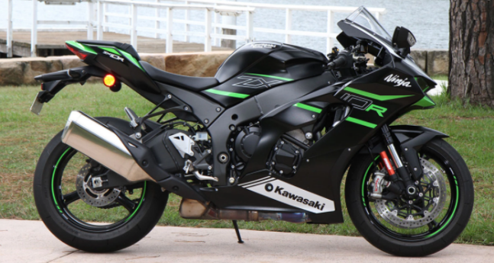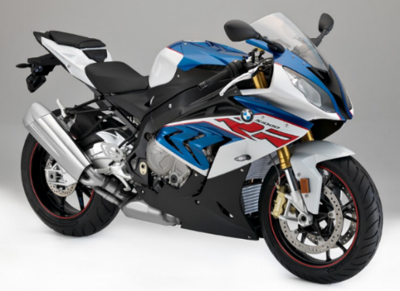
Figure 8– Photo of Kawasaki Ninja ZX-10R Figure 9– Photo of BMW S 1000RR 2016
(KAWASAKI ZX-10R (2021 - on) Review | MCN, no date) (First Ride: 2016 BMW S1000RR, no date)

The geometric characteristics of these motorcycles were obtained from workshop manuals and from other sources in the internet and are listed in Table 4. This table also shows the results of the calculations which were made using a spread sheet in excel related to the expected maximum expected speed base on the gear ration and the engine RPM at maximum power. The same calculations were performed in an excel spreadsheet as it was previously described and the results are graphically presented in figures 10 & 11.

Table 4 – Motorcycle characteristics for Kawasaki Ninja ZX-10R 2021 and BMW S1000rr 2016
Characteristics | Kawasaki Ninja ZX-10R 2021 * | BMW S 1000rr 2016 **
Max. Length (m) | 2.085 | 2.05
Max. Width (m) | 0.75 | 0.826
Overall Height (m) | 1.185 | 1.138
Wheel Base (m) | 1.45 | 1.425
Rake angle (degrees) | 25.0º | 23.5º
Trail (m) | 0.105 | 0.097
Primary gear ratio | 1.681 | 1.652
Top Gear ratio | 1.304 | 1.261
Final Reduction | 2.411 | 2.267
Dry weight (kg) | 207 | 175.5
Front tyre size | 120/70/ZR17M/C | 120/70/ZR17
Front tyre (m) | 0.6 | 0.6
Rear tyre size | 190/55ZR17M/C | 190/55/ZR17
Rear tyre (m) | 0.641 | 0.641
Time from 0-100 km/hr | 2.91 | 3.1
Top Speed (km/hr) | 304 | 201.2
Drag Coefficient C_{d} (assumed) | 0.6 | 0.6
Frontal area m² | 0.642 | 0.642
Max Power | 149.3 | 145.3
RPM at Max Power | 13200 | 13500
Calculated Max Speed (Km/hr) | 301.63 | 295.34
*(Kawasaki, 2021)
*(Kawasaki ZX-10R | Acceleration and Top Speed - MotoStatz, no date)
*(KAWASAKI ZX-10R (2021 - on) Review | MCN, no date)
**(BMW S 1000 RR | 2016 | specs & pictures, no date)
**(2016 BMW S 1000 RR Reviews, Prices, and Specs, no date)

Figure 10 – Forces acting on the motorcycle Vs speed for Kawasaki Ninja ZR-10R 2021

Figure 11– Forces acting on the motorcycle Vs speed for BMW S 1000rr 2016
Looking at these graphs Kawasaki Ninja ZR-10R 2021 can reach a speed of 311km/hr and BMW S1000rr can reach a speed of 308km//hr. Considering the assumptions which were made as far as the coefficient of drag and in the possible errors in calculating the frontal areas, it can be said that the maximum speeds are close the speed which were calculated based on the gear ratios and the RPM of the engines at the maximum of their power.
It seems that a wheel base of 1.4 to 1.45 m a rake angle between 23.5º to 25º and a tail around 100mm contribute to the performance of these motorcycle. Looking at the photos of these motorcycles it is obvious that the aerodynamic design contributes a lot in the performance of these motorcycles. The fact that the rider’s seat is low and engine is low contribute a lot in the stability and the handling characteristics of the motorcycles.

Task 5 – Recommendations for alteration to Zero SR/F 2020
From the motorcycles which were studied under this assignment it seems that Zero SR/F 2020 can be improved. According to Figure 7 this motorcycle can reach a speed of 249km/hr due to the power of its motor. The calculation which was made based on the RPM of the motor at the maximum power and considering the overall gear ratio it was calculated the maximum speed of 131.9 km/hr can be reached. This means the motor of the motorcycle has the power but the setup of the motorcycle does not help to achieve the maximum performance. Also considering the power curve of the motor Figure 12 it shows that the motor can work up to 6500RPM at 90Hp (66.2kw). Considering these factors by reducing the overall gear ratio of the motorcycle to 3.95 a top speed of 195km/hr can be achieved.
Regarding the rake angle, the tail and the wheel base any changes to these parameters have to be tested in the real conditions in order the right combination of these parameters to be established.
Also, it was noticed from the calculations for the centre of gravity with the rider siting on the motorcycle, the centre of gravity is higher. It is recommended to lower the seat of the motorcycle in order to achieve lower centre of gravity.
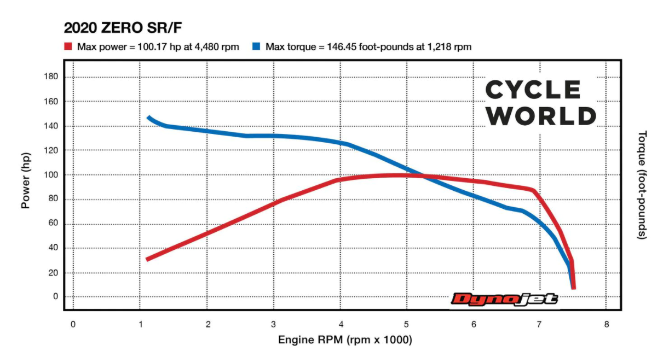
Figure 12 - Power Curve of Zero SR/F 2020
(2020 Zero Motorcycles SR/F Review | Cycle World, no date)

Conclusions
The power of the engine/motor of the motorcycles and the aerodynamic design contribute to the performance of the motorcycle. The geometry of the motorcycle helps the rider to push the motorcycle to its limits. The aim is to produce a motorcycle that will have comfortable riding properties considering the maximum human capabilities. The rake angle the rail the wheel base and the centre of gravity are the contributing factors. Definitely a low centre of gravity helps a lot in the stability of the motorcycle. The other factors like the rake angle, the trail and the wheel base have to be set according to the use of the motorcycles in order achieve comfortable riding characteristics, safe driving and the highest possible performance. The factors can only be assessed by test drives.

References
2007 Honda CBR 1000 RR Fireblade specifications and pictures (no date). Available at: https://bikez.com/motorcycles/honda_cbr_1000_rr_fireblade_2007.php (Accessed: 10 December 2021).
2007 Honda CBR1000RR - Gallery | Top Speed (no date). Available at: https://www.topspeed.com/motorcycles/motorcycle-reviews/honda/2007-honda-cbr1000rr-ar18537/pictures.html (Accessed: 5 December 2021).
2007 Honda CBR1000RR Fireblade (no date). Available at: http://www.motorbike-search-engine.co.uk/2007_bikes/honda_cbr1000rr_fireblade.php (Accessed: 10 December 2021).
2007 Honda CBR1000RR Fireblade (up to 2007) specs review (no date). Available at: https://www.motorbikecatalog.com/moto/2007/62420/honda_cbr1000rr_fireblade.html (Accessed: 12 December 2021).
2016 BMW S 1000 RR Reviews, Prices, and Specs (no date). Available at: https://www.motorcycle.com/specs/bmw/sport/2016/s/1000-rr/detail.html (Accessed: 7 December 2021).
2020 Electric Motorcycle Spec Shootout (no date). Available at: https://www.motorcycle.com/shoot-outs/2020-electric-motorcycle-spec-shootout (Accessed: 11 December 2021).
2020 Zero Motorcycles SR/F | Cycle World (no date). Available at: https://www.cycleworld.com/story/buyers-guide/2020-zero-sr-f/ (Accessed: 12 December 2021).
2020 Zero Motorcycles SR/F Review | Cycle World (no date). Available at: https://www.cycleworld.com/story/motorcycle-reviews/2020-zero-motorcycles-srf-review/ (Accessed: 12 December 2021).
BMW S 1000 RR | 2016 | specs & pictures (no date). Available at: https://bikez.com/motorcycles/bmw_s_1000_rr_2016.php (Accessed: 7 December 2021).
First Ride: 2016 BMW S1000RR (no date). Available at: https://www.motortrend.com/features/2016-bmw-s1000rr-first-ride-review?galleryimageid=5d60a3f3-d1b7-4cb0-9844-bca2c16b217d (Accessed: 12 December 2021).
Full performance review of 2007 Honda CBR1000RR Fireblade (model up to 2007) (no date). Available at: https://www.motorbikecatalog.com/performance/2007/62420/honda_cbr1000rr_fireblade.html (Accessed: 10 December 2021).
Honda CBR1000RR Service manual with hyperlinks (no date). Available at: https://manualmachine.com/honda/cbr1000rr/207444-service-manual-with-hyperlinks/ (Accessed: 10 December 2021).
Kawasaki (2021) ‘Kawasaki Motorcycle service manual 2021.pdf’.
KAWASAKI ZX-10R (2021 - on) Review | MCN (no date). Available at: https://www.motorcyclenews.com/bike-reviews/kawasaki/zx-10r/2021/ (Accessed: 11 December 2021).
Kawasaki ZX-10R | Acceleration and Top Speed - MotoStatz (no date). Available at: https://motostatz.com/kawasaki-zx-10r-acceleration/ (Accessed: 11 December 2021).
Tudor, T. (2020) Motor Cycle Aerodynamics - Power point presentation.

