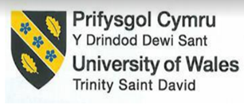

School of Hospitality and Tourism Management
BA International Hotel Management
Module Handbook Autumn Term 2024
BMIH5004
Management and Organisational Behavior
LEVEL 5

Student Name
Ana Maria Stoica
Student ID
2245028

Executive Summary
Marriott International is one of the recognized hotels founded in 1927 by J. Willard and Alice Marriott, it has changed into one of the world's prime hospitality companies, working over 8,700 properties crossways 131 countries and territories. The company's task is to recover the lives of its customers by building and creating unmatched vacation and vacation experiences. This report goals to disparagingly appraise Marriott's organizational structure, culture, new change initiatives, and strategic direction, together at the business and individual hotel levels. Marriott International pays a cross-organizational structure that flawlessly combines functional and divisional basics, hires for effectual decision-making, and operational flexibility across its extensive brand portfolio. This hybrid technique is mainly real agreed the company's diverse diversity of services, which include luxury, premium, and select service hotels transversely many geographical regions. A substantial development in Marriott's organizational structure happened in early 2023 when the company published a complete reorganization plan meant to rationalize operations and reduce costs. This reordering complicated a reduction of over 800 business positions and was projected to produce cost savings of about $80-$90 million. The choice was determined by the need to recuperate operational efficiency amongst developing market dynamics and financial uncertainties Marriott's people-centric culture is reinforced by complete training programs, career development chances, and a comprehensive work environment. The company ranks employee engagement and satisfaction through initiatives as per leadership growth programs, mentorship chances, and modest compensation packages.

Table of Contents
1. Introduction 4
2. Organisational Structure, Culture, and Goals 4
2.1 Organisational Structure 4
2.2 Corporate Culture 6
2.3 Organisational Goals 7
• Strategic Expansion 7
• Innovation in Guest Services 8
• Sustainability and Social Responsibility 9
3. Recent Change Initiatives 10
4. Strategic Direction 11
5. Recommendations 11
6. Conclusion 13
7. References 15

Introduction
Marriott International is one of the recognized hotels founded in 1927 by J. Willard and Alice Marriott, it has changed into one of the world's prime hospitality companies, working over 8,700 properties crossways 131 countries and territories (Marriott.com, 2025). The company's task is to recover the lives of its customers by building and creating unmatched vacation and vacation experiences. This report goals to disparagingly appraise Marriott's organizational structure, culture, new change initiatives, and strategic direction, together at the business and individual hotel levels. The analysis is based on relevant management and organizational behavior theories to clarify the influences that are paying to Marriott's industry management.
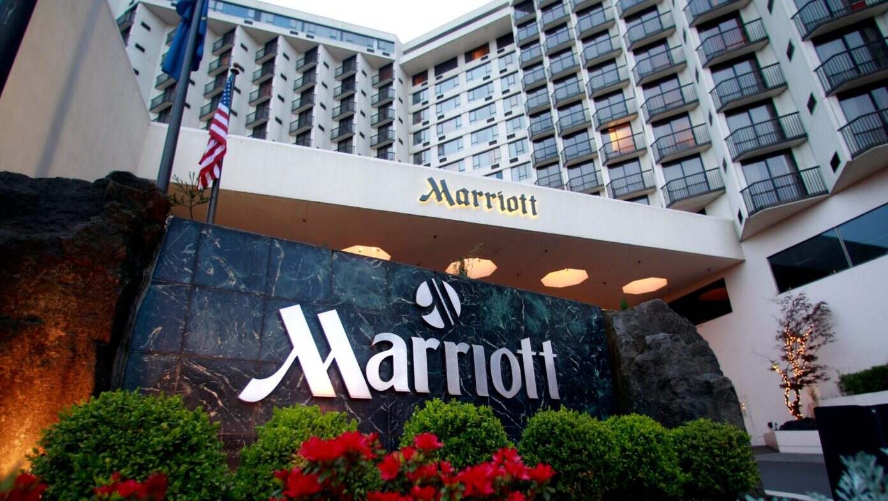
Figure 1: Marriott
(Source: NOHA.GAD, 2023)

2. Organisational Structure, Culture, and Goals

2.1 Organisational Structure
Marriott International pays a cross-organizational structure that flawlessly combines functional and divisional basics, hires for effectual decision-making, and operational flexibility across its extensive brand portfolio (Alshemmari et al., 2024). This hybrid technique is mainly agreed with the company's diverse diversity of services, which include luxury, premium, and select service hotels transversely many geographical regions (Boluwatife Stephen, 2024). The practical feature of the structure allows for specialization and efficiency in important parts for example marketing, finance, human resources, and operations (Sergeevna, 2024).
These functional departments bring central backing to all business units, settling constancy in brand values and operational efficiency (Wesley et al., 2024). On the other hand, the divisional component of Marriott’s structure allows each product or regional division to activate semi-autonomously, providing the single wants of its target market (Kulkov et al., 2024). For example, luxury brands like The Ritz-Carlton and St. Regis have separate operational strategies likened to midscale brands like Courtyard and Fairfield Inn (Neves, 2022). This local suppleness lets Marriott professionally adapt its services and marketing policies to meet the diverse expectations of its worldwide clientele.
A substantial development in Marriott's organizational structure happened in early 2023 when the company publicized a complete reorganization plan meant to rationalize operations and reduce costs (Amanulla and Niyaz, 2024). This reordering complicated a reduction of over 800 business positions and was projected to produce cost savings of about $80-$90 million (Wesley et al., 2024). The choice was determined by the need to recuperate operational efficiency amongst developing market dynamics and financial uncertainties (Neves, 2022). By shortening the layers and combining certain functions, Marriott is destined to hasten decision-making processes, recover communication flow, and improve overall agility.
The restructuring also aligned with Marriott’s strategic objective of leveraging technology and digital transformation (Mullins and Dosser, 2013) Unifying technology functions below a unified leadership structure enabled the company to accelerate digital initiatives, including the implementation of advanced data analytics, AI-driven customer personalization, and improved cybersecurity measures (Mullins, 2019). This rearrangement plan showcases Marriott's proactive method of maintaining a competitive edge in the quickly developing hospitality scenery.

2.2 Corporate Culture
Marriott International's corporate culture is intensely entrenched in its core standards that is by putting people first, following brilliance, and accepting the change (Mullins, 2023). These managerial principles have molded the company's identity since its inception and continue to influence its operations, employee relations, and customer interactions (Boddy, 2017). The cornerstone of Marriott's culture is its "people-first" philosophy, which emphasizes the well-being and development of its employees as a precursor to delivering exceptional customer service (Mullins, 2019). This obligation to employee welfare is summarised in the company's motto, "Take care of associates, and they will take care of the customers."
Marriott's people-centric culture is reinforced by complete training programs, career development chances, and a comprehensive work environment (Mullins and Dosser, 2013) The company ranks employee engagement and satisfaction through initiatives as per leadership growth programs, mentorship chances, and modest compensation packages (Eschenbrenner et al., 2023). Moreover, Marriott's open-door policy inspires see-through communication and empowers staff to put their ideas and apprehensions without the anxiety of revenge (Rastitiati, 2024).
Innovation and flexibility are also essential components of Marriott's corporate culture. Identifying the lively nature of the hospitality industry, the company adopts an environment that inspires creativity, experimentation, and continuous improvement (Alshemmari et al., 2024).
Marriott's leadership actively endorses a culture of change, stirring employees to hold new technologies, business models, and service delivery approaches (Tillery et al., 2023). This cultural outline has been essential in earning Marriott many accolades, counting consistent credit as one of the "World's Best Employers" by Forbes and high employee satisfaction scores.
Furthermore, Marriott's obligation to diversity, equity, and presence (DEI) is a defining feature of its corporate culture (Murni et al., 2023). The company energetically endorses a varied workforce by applying comprehensive hiring practices, secondary employee resource groups, and as long as leadership opportunities for understated groups (Susaeta et al., 2024). Marriott's "Culture of Inclusion" enterprise highlights respect, dignity, and equal chances for all employees, irrespective of their context or identity (Prentice et al., 2024). This comprehensive method not only improves employee morale but also raises an intellect of fit and loyalty, backing Marriott's name as an employer of high quality.

2.3 Organisational Goals
- Strategic Expansion
One of Marriott's essential planned aims is to enlarge its worldwide footmark over strategic attainments, permitting, and partnerships (Altena, 2023). This development policy is placed on growing its attendance in high-demand markets, including Asia-Pacific, the Middle East, and Africa, where the hospitality industry is facing quick growth (Selin, 2022). Through leveraging its vigorous brand portfolio, which comprises luxury brands like The Ritz-Carlton and St. Regis, as well as midscale options like Courtyard and Fairfield Inn, Marriott searches to detention a larger segment of both business and leisure travelers (Rastitiati, 2024).
Marriott's development strategy is determined by a mixture of organic development and deliberate attainments (Chen et al., 2024). The attainment of Starwood Hotels and Resorts in 2016 was a game-changer, meeting Marriott the world's main hotel chain with a joint portfolio of over 7,000 properties across 30 brands (Rastitiati, 2024).
This deliberate move not only protracted Marriott's global reach but also supported its loyalty program by integrating Starwood Preferred Guest (SPG) with Marriott Bonvoy, making it one of the most widespread customer loyalty systems in the industry.
In addition to acquisitions, Marriott is also concentrating on franchising and management contracts as part of its asset-light growth model (Selin, 2022). As a result of partnering with local property owners and developers, Marriott minimizes capital expenditure while maximizing brand presence (Tillery et al., 2023). This approach allows the company to enter developing markets with minimal financial risk. For instance, Marriott's strategic partnership with Chinese hotel giant, Alibaba has improved its digital reach and booking capabilities in China, food preparation to the rising number of Chinese outbound travelers.
- Innovation in Guest Services
Marriott is dedicated to improving guest experiences through technological innovation and modified service offerings (Bharwani and Mathews, 2021). In place of digital transformation continues to redesign the hospitality industry, Marriott is leveraging advanced technologies to deliver unified and convenient experiences for modern travelers (Silvia-Patricia and Elena, 2024). Marriott has presented AI-driven computer-generated concierge systems, for example, ChatBotl which allows visitors to mark requests and investigations via messaging platforms (Shin and Jeong, 2022). This AI-powered service improves guest convenience with instant responses to common questions, room service orders, and local recommendations.
On the other hand, to improve guest convenience and reduce wait times, Marriott's Mobile Check-In feature lets guests check-in and access their rooms by expanding their smartphones (Erdem and Barakazı, 2023). The Mobile main functionality removes the need for physical room keys, allowing a more unified and contactless experience. Marriott leverages data analytics and machine learning to bring modified marketing campaigns and guest experiences (Boukhaoua and Habbache, 2024). Through examining customer preferences, travel history, and payment patterns, Marriott adapts its offers, raises, and recommendations to deliver to individual guest partialities.
Additionally, Marriott's loyalty program, Marriott is unceasingly developing to offer more adapted rewards and select member benefits (Sposato and Kline, 2023). The program includes custom-made involvements in place of VIP access to events, curated travel packages, and adapted room preferences. Over refining customer loyalty and engagement, Marriott donates evocatively to customer holding and repeat bookings.
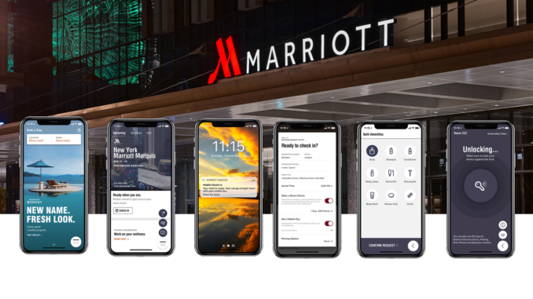
Figure 2: Hotel guest techniques
(Source: HTN Editors, 2019)

- Sustainability and Social Responsibility
In place of its corporate responsibility program, Marriott is absorbed in sustainable business practices and community appointments (Rastitiati, 2024). Knowing the rising rank of environmental sustainability and social impact, Marriott has dedicated itself to dipping its environmental footprint over its "Serve 360: Doing Good in Every Direction" initiative (Pavlova, 2023). This complete sustainability plan plans Marriott's commitment to tolerating the environment and the Marriott is devoted to dipping carbon emissions, conserving water and energy, and minimizing waste (Ruffolo, 2024).
The company has realistic energy-efficient systems, renewable energy sources, and waste reduction programs across its properties (Xie, Y. (2022,). Marriott installed over 7,100 EV chargers crossways in more than 1,800 properties, carrying the rising demand for electric vehicles. Marriott emphasizes making inclusive employment chances and workforce development programs (Lee et al. 2024). The company is devoted to variety and presence, recommending equal chances for women, understated groups, and people with incapacities (Rastitiati, 2024). Over and done with the "Spirit to Serve" program, the company donates to local communities through secondary education, disaster relief, and community growth projects.

Recent Change Initiatives
Marriott International has assumed several planned change initiatives to explain developing market subtleties and improve its competitive position (Neupane and Khanal, 2022). In early 2023, Marriott broadcast a reorganization plan aimed at rationalization operations and plummeting costs. This creativity involved reducing over 800 corporate positions and is projected to achieve $80-$90 million in annual cost savings (Fagyas and Datta, 2023). Through flattening its organizational hierarchy, Marriott improved decision-making efficiency and operational suppleness, allowing a more responsive method to market changes (Eschenbrenner et al., 2023). On the way to diversify its brand portfolio, Marriott introduced its first midscale brand, directing the rising extended-stay segment in the U.S. and Canada.
This planned move objects to the apprehension of a wider customer base, catering to travelers seeking reasonable, longer-term lodging selections (Boukhaoua and Habbache, 2024). On the other hand, Marriott strengthened its emphasis on environmental sustainability by improving its electric vehicle (EV) charging infrastructure (Tillery et al., 2023). As a result of the end of 2023, over 7,100 EV chargers were connected across 1,800+ properties, bringing into line with the increasing demand for eco-friendly travel explanations. The organizational rearrangement better operational efficiency and condensed overhead costs, positioning Marriott to cross economic doubts effectively (Fagyas and Datta, 2023).

The expansion into the midscale market widened Marriott's customer base and improved brand loyalty, although the sustainability efforts wired Marriott's petition to eco-conscious travelers, improving brand reputation (Neupane and Khanal, 2022). The leadership efficiently connected the necessity of these changes, the development of stakeholder engagement, and buy-in. With these creativities with its core standards and strategic goals (Tiller et al., 2023). Marriott established a unified and well-structured change management process, guaranteeing smooth application and negligible disruption.

Strategic Direction
Marriott's strategic direction is placed on maintainable growth, market diversification, and technological invention (Lee et al., 2024). The company intends to enlarge its global footprint through strategic acquisitions and partnerships. For instance, the planned teamwork with MGM Resorts is expected to integrate 17 MGM properties into Marriott's portfolio, improving its presence in the luxury and entertainment segments (Eschenbrenner et al., 2023). To attain its long-term objectives, Marriott is capitalizing on technology to improve guest experiences, counting AI-powered virtual concierge services and predictive analytics for operational optimization.
Moreover, Marriott's emphasis on sustainability, by way of growing renewable energy usage and improving EV infrastructure, brings into line with worldwide environmental tendencies and customer preferences (Torres, 2023).

Recommendations
- Digital Transformation and Personalisation
Marriott should continue to capitalize on progressive data analytics and artificial intelligence to improve guest personalization and operational efficiency (Periasamy and Dinesh, 2024). Applying predictive analytics for demand prediction, personalized marketing campaigns, and lively pricing policies will allow Marriott to get ahead of customer needs and enhance revenue management.

- Sustainability Leadership
Marriott should enlarge its sustainability creativities by capitalizing on renewable energy sources, improving waste management practices, and endorsing eco-friendly guest experiences (Jogarao, 2024). Cooperating with local communities and stakeholders to implement green practices will strengthen Marriott's product name as an environmentally accountable company.

Figure 3: Sustainability Leadership
(Source: Jenns, 2023)
- Workforce Development and Diversity
To uphold its people-first culture, Marriott should rank workforce growth through continuous learning programs, leadership training, and variety and inclusion initiatives (Vinod, 2022). The establishment and mentorship programs and career progression trails will improve employee engagement and maintenance.
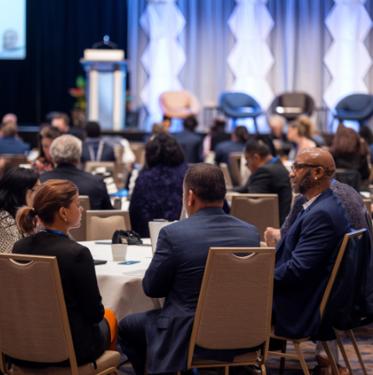
Figure 4: Workforce Development and Diversity
(Source: Author)

- Market Diversification and Strategic Partnerships
Marriott should travel to new market segments, by way of luxury vacation rentals and wellness tourism, to enlarge its revenue streams (Periasamy and Dinesh, 2024). Strategic partnerships with technology earners, local tourism boards, and existing brands will extra improve Marriott's worth proposition and guest experiences.
- Crisis Management and Resilience Planning
Marriott should reinforce its disaster management outline by emerging comprehensive contingency plans for economic slumps, geopolitical risks, and health crises (Jogarao,2024). Structure the organisational resilience done proactive risk management will allow Marriott to cross the doubts and endure growth.

Conclusion
In conclusion, Marriott International's attainment as an international hospitality front-runner is strengthened by its planned organizational structure, lively corporate culture, and clear aims. The company's irritable structure lets operational efficiency while allowing flexibility for localised decision-making, settling consistent quality standards crosswise its varied brand portfolio. Marriott's people-centric culture accepts employee engagement, novelty, and adaptability, pouring exceptional customer service and brand loyalty. The company's planned goals, including global expansion, technological innovation, and sustainability, bring into line with its image of flattering the service offerings, accepting digital transformation, and maintaining its essential standards.

References
Alshemmari, J. M. H. J., and Al Monawer, F. H. (2024). Analyzing the relationship between workplace diversity and innovation and its influence on organizational performance. Journal of System and Management Sciences, 14(1), 471-489.
Altena, G. V. (2023). Marriott Short-Term Rentals For Digital Nomads Campaign Aimed At Advertising Marriott Homes To Nomads And Remote Workers.
Amanulla, A., and Niyaz, S. (2024). Marriot Data Breach: A Case Study Analysis. In Information Technology Security and Risk Management (pp. 241-245). CRC Press.
Bharwani, S., and Mathews, D. (2021). Techno-business strategies for enhancing guest experience in luxury hotels: a managerial perspective. Worldwide Hospitality and Tourism Themes, 13(2), 168-185.
Boddy, D. (2017) Management: An Introduction (7th Ed), Harlow, Pearson
Boluwatife Stephen, A. (2024). Organizational Dynamics: Evaluating the Impact of Understanding Structures, Functions, and Culture. Functions, and Culture (January 25, 2024).
Boukhaoua, A., and Habbache, F. (2024). The importance of communication through social media in building client satisfaction for hotel institutions. Journal of Innovations and Sustainability, 8(1), 02-02.
Chen, Z., Li, Y., and Song, M. (2024). Fundamentals Analysis and Investment Decision-making for Six Companies among Three Industries. Highlights in Business, Economics and Management, 24, 2567-2571.
Erdem, A., and Barakazı, M. (2023). Innovative technology applications in hotel businesses. In Digital Transformation of the Hotel Industry: Theories, Practices, and Global Challenges (pp. 17-36). Cham: Springer International Publishing.
Eschenbrenner, B., Zlatic, A., Bechtel, M., Collins, B., Straley, C., and Gubbels, G. (2023). Marriott International: A Managerial Strategic Audit.
Fagyas, C., and Datta, P. (2023). An investigation of the factors associated with consumer behavior at arrival, check-in and the check-out process: A case study Marriott International Inc. in the UK. Journal of Business and Retail Management Research, 17(2).
HTN Editors (2019). Marriott International Commits to Continued Innovation in Hotel Guest-facing Technologies |. [online] Hoteltechnologynews.com. Available at: https://hoteltechnologynews.com/2019/07/marriott-international-commits-to-continued-innovation-in-hotel-guest-facing-technologies/ [Accessed 15 Feb. 2025].
Jenns, C. (2023). Marriott International publishes a 2023 sustainability report. [online] Hotel Management Network. Available at: https://www.hotelmanagement-network.com/news/marriott-international-2023-sustainability-report/ [Accessed 15 Feb. 2025].
Jogarao, M. (2024). AI in the Hospitality Industry: Revolutionising Guest Experience. In Technology and Luxury Hospitality (pp. 199-210). Routledge.
Kulkov, I., Kulkova, J., Rohrbeck, R., Menvielle, L., Kaartemo, V., and Makkonen, H. (2024). Artificial intelligence‐driven sustainable development: Examining organizational, technical, and processing approaches to achieving global goals. Sustainable Development, 32(3), 2253-2267.
Lee, S., Hwang, D. H. S., Shin, M., and Kang, K. H. (2024). Strategic corporate social responsibility in the tourism and hospitality industry: Conceptual proposal. Tourism Economics, 13548166241299140.
Marriott.com. (2025). About Marriott International | Corporate Information. [online] Available at: https://www.marriott.com/marriott/aboutmarriott.mi [Accessed 15 Feb. 2025].
Miao, J. T. (2024). 6 The infrastructures of innovation districts. Routledge Companion to Creativity and the Built Environment, 73.
Mullins, L. and Dosser, P. (2013) Hospitality Management and Organisational Behaviour (5th Ed) Harlow, Pearson.
Mullins, L. (2019) Organisational Behaviour in the Workplace (12th edition) Harlow: Pearson
Mullins, L. (2023) Management and Organisational Behaviour (13th edition) Harlow: Pearson
Murni, N. G. N. S., Ruki, M., and Antara, D. M. S. (2023). Developing an Implementation Model for Gender Equality and Disability Inclusivity at Marriott Group Hotels in Bali to Foster Sustainable Tourism. International Journal of Social Science Research and Review, 6(10), 169-178.
Neupane, R., and Khanal, T. R. (2022). Evaluation of The Impacts of Training on Employee Performance in The UK Hotel Industry: An Analysis of Employees’ Perspectives at Marriott International. International Journal of Research-GRANTHAALAYAH, 10(3), 57-85.
Neves, D. D. (2022). Marriott International Inc. Equity Research Hotel Giant’s Recovery (Master's thesis, Universidade NOVA de Lisboa (Portugal)).
NOHA.GAD (2023). Marriott to develop two luxury hotels in Neom’s Trojena. [online] Sharikat Mubasher. Available at: https://sharikatmubasher.com/news/article/21375617 [Accessed 15 Feb. 2025].
Pavlova, V. (2023). Encouraging Employee Participation in Environmental Sustainability Practices in Luxury Hotel Company.
Periasamy, P., and Dinesh, N. (2024). Leveraging Digital Transformation Technologies in the Hospitality Industry. In Revolutionising the AI-Digital Landscape (pp. 151-165). Productivity Press.
Prentice, C., Tracogna, A., and Akbar, Y. H. (2024). The Paths to an Enhanced Ecosystem for International Hotel Chains. Journal of the Knowledge Economy, 1-25.
Rastitiati, N. K. J. (2024). A Critical Discourse Analysis (CDA) of Marriott International Core Values. LACULTOUR: Journal of Language and Cultural Tourism, 3(2), 109-114.
Ruffolo, I. (2024). Investigating the Disclosure of Corporate Social Responsibility in International Hotel Chains. INTERNATIONAL JOURNAL OF ENGLISH LINGUISTICS, 14(6), 1-14.
Selin, J. (2022). More than just a workplace: A case study of diversity, equity, and inclusion in Marriott International Inc. hotels.
Sergeevna, T. V. (2024). Examining the Effects of Organisational Culture on Guest Satisfaction in the Hotel Industry, The Ritz-Carlton Hotel Company Case.
Shin, H. H., and Jeong, M. (2022). Redefining luxury service with technology implementation: the impact of technology on guest satisfaction and loyalty in a luxury hotel. International Journal of Contemporary Hospitality Management, 34(4), 1491-1514.
Silvia-Patricia, D., and Elena, C. S. C. (2024). In The Eyes Of Guests. Analyzing Courtyard By Marriott’s Customer Reviews. Romanian Economic and Business Review, 19(1), 18-26.
Sposato, E., and Kline, S. (2023). Hotels vs. Guest Satisfaction. International Journal of Gaming, Hospitality and Tourism, 3(1).
Susaeta, L., Suárez, E., and Babinger, F. (2024). Managing Diversity in the Cruise Industry: Exploring Practices and Metrics. In Diversity, Equity, and Inclusion (DEI) Management (pp. 161-191). Emerald Publishing Limited.
Tillery, H., Sheppard, S., and Ayoun, B. (2023). Marriott’s Strategy to Survive an Economic Crisis: Invest and Reposition the Brand. Journal of Hospitality and Tourism Cases, 11(2), 50-57.
Torres, M. P. R. L. (2023). Empowerment and Sustainability to Promove a Dynamic, Thoughtful, and Inventive Community: The Case of Green Meetings at Casablanca Marriott Hotel (Master's thesis, Universidade NOVA de Lisboa (Portugal)).
Vinod, B. (2022). Personalization in Hospitality. In Revenue Management in the Lodging Industry: Origins to the Last Frontier (pp. 221-244). Cham: Springer International Publishing.
Wesley, S., Jackson, K. N., Martínez Ramos, D., Vanbeber, S., and Mujtaba, B. G. (2024). Marriott Hotel's Practices in Mitigating Discrimination Through Inclusionary Employee Resource Groups. Journal of Business Diversity, 24(1).
Xie, Y. (2022, April). Corporate Social Responsibility: Concept and Cases. In 2022 7th International Conference on Social Sciences and Economic Development (ICSSED 2022) (pp. 1394-1399). Atlantis Press.

