Student name: Nicoleta Aurelia Monafu
Student ID number: 2245344
Program: BA International Hotel Management
Module: Financial Management for the Hotel Industry
Module code: BMIH5007 Contribution to Overall
Module Assessment (%): 50% (2 of 2)
Lecturer: Tristan Hawkins
Internal Verifier: Chris Wilkin
Assignment Title: Report Case Study: The City Hotel

Declaration
“I admit to using Grammarly on 28th October 2024 to fix spelling mistakes in my work. When using Grammarly, there was no need for me to type in any of the prompts but it only offered. A document that has been checked for its spelling and grammar and I decided on what changes I wanted to make”.
“I agree that I have not employed any AI tool in conducting and developing this task. I confirm that I have not offered any of these GAI materials as my writing. I confirm I have copies of my correspondence, originals, and copies of drafts, notes, and documents which I have utilized and which may be requested from me in evidence”

Executive summary
The City Hotel experiencing diminishing revenues, customer satisfaction, and occupancy. The report elevates the hotel’s current business prospects and the past two years’ performance demonstrating declining revenue, high operating expenses, and higher debt levels. The report also discussed the turnaround strategy to improve the financial position of the hotel concerning better cost controls, improved service standards, and re-positioning and marketing strategies. Therefore the hotel found the solution to make a profit again, increase occupancy and guarantee its market share, or offer the best results for the hotel.

Table of Contents
Executive summary 2
1 Introduction 5
2 Scope of the Objectives 5
2.1 Financial performance over the past three years 5
2.1.1 Revenue Analysis 7
2.1.2 External Analysis 8
2.1.3 Profitability Analysis 9
2.1.4 Liquidity Analysis 9
2.1.5 Solvency Analysis 9
2.2 Key reasons behind the decline in profitability 10
2.3 Turnaround strategy 500 Iqra 10
3 Conclusion 13
4 References 15

Introduction

The City Hotel is a full-service hotel in an urban area that offers different facilities to its guests. It offers a wide range of amenities such as event space, restaurants, and bars. Despite its prime location, the City Hotel experienced a decline in occupancy rates, revenue, and customer satisfaction, raising issues about its future growth. Financial challenges are related to low customer satisfaction which has made it critical to analyze the business sustainability. The report analyses the hotel's financial performance, highlights the issues that contribute to the hotel's struggles, and recommends an effective turnaround strategy that aims to restore the financial health and reputation to suggest efficient alternative financial solutions for the hotel.

Scope of the Objectives

Financial performance over the past three years
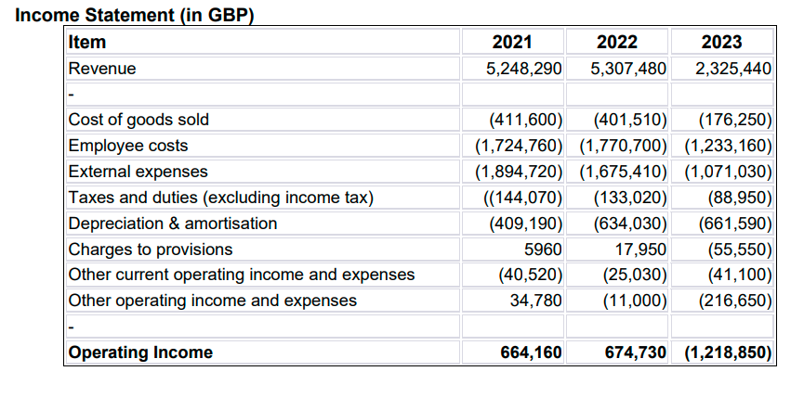
Figure 1: Income statement
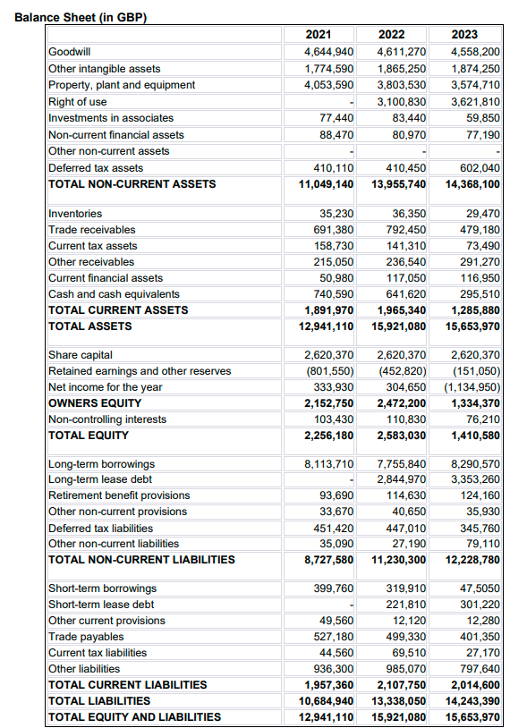
Figure 2: Balance sheet

Revenue Analysis
The revenue of City Hotel has seen a marked decline from 2021 to 2023. The revenue in 2021 was £5,248,290 and in 2023 the revenue was £2,325,440, this is a shocking decline in 3 years which is 56%. The downtrends show that the hotel facing significant challenges in attracting and retaining their customers. A closer examination shows that the various insights like year over year decline. Revenue shows a slight increase from 2021 to 2022 that was from £5,248,290 to £5,307,480, but in 2023 there was a large decline of City Hall revenue. The dramatic decline can be attributed to factors including; reduced accommodation occupancy, lower consumer expenditure on travel and accommodations, and stiff competition from other service providers (Cheng, 2019) like Airbnb. Moreover, the combined revenue reduction rate is patterned with occupancy rates. A decrease in the rate of traveling especially during and after the pandemic has hurt hotel sales (Du et al., 2019). The accommodation subsector has taken a long time to grow and this has affected the income of the City Hotel. In addition, the hotel failed to recognize opportunities to diversify or improve services in response to new customer demand, including a shift from a traditional rigid calendar to self-serve bookings (Spiro and Bhamidi, 2024). The COVID-19 precautions may have denied it the bookings it required (Srivastava et al., 2019).

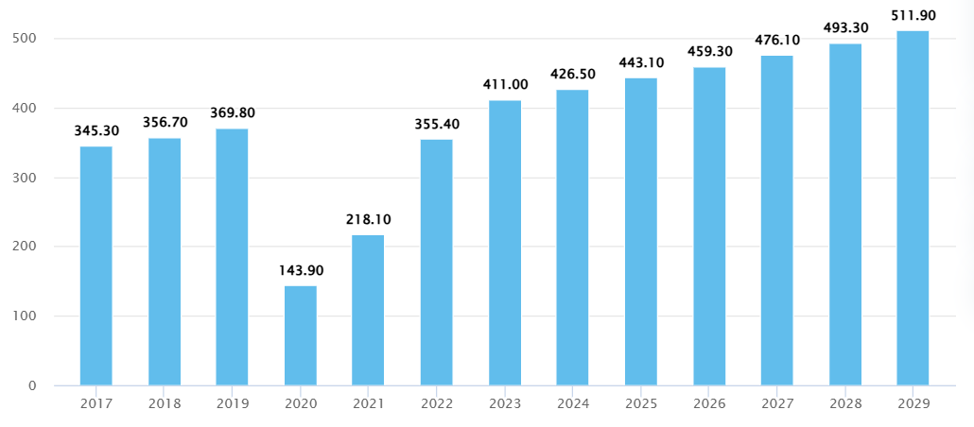
Figure 3: Hotel revenue
Source: (Statista, 2024)

External Analysis

Figure 4: External expenses

The cost has remained relatively constant over the past three years due to the operational nature of the hotel. The total cost of goods sold reduced from £411,600 in the year ended 2021 to £176,250 in the year 2023. This reduction is in concordance with the reduction in sales and implies that the hotel has started to minimize its investment in inventory and other associated expenses to avoid cost accumulations. However, this strategy shows low service quality and can lead to increasing customer frustrations. Another key cost area is employee costs, the area identified that employee cost has increased from £1,724,760 in 2021 to £1,770,700 in 2022 and then reduced to £1,233,160 in 2023. The initial spike may be seen as the recruitment of talented workers before unfavorable conditions while the second is as a result of a company’s downsizing such as firing employees or cutting their working hours. This could have resulted in poor service delivery, especially concerning customers further depressing the service delivery (Furunes and Mkono, 2019). Moreover, there has been a reduction in the operational cost whereby the external expenses have reduced from £1,894,720 in the year 2021 to £1,071,030 in the year 2023. Although this might be efficient financially it might hinder the provision of basic services or incredible marketing demands to get back on its feet (Hossain et al., 2024). Additionally, income increased slightly from the prior fiscal year, £5,248,290 to £5,307,480, but the next year they declined steeply. Additionally, the depreciation and amortization expenses are £661,590 for 2023 while these were £409,190 in 2021 (Gafurov et al., 2019).
This increase points to aging fixed assets which will need some maintenance and could mean capital-intensive upgrades may be required soon, which may be difficult given the current financial position.

Profitability Analysis
The City Hotel's profitability has deteriorated significantly over the past three years, as illustrated by the operating income. The operating income of the hotel last year was £664,160, which slightly improved to £674,730 at the end of the year 2022 and sharply declined to £1,218,850 in 2023. Such a decrease highlights the urgent importance of targeted measures to prevent the deterioration of the situation. Similar to the operating income date, the trend in the net income was £1,134,950 in 2023, but it was £344,562 in 2022 and £41,756 in 2021. The more the losses are revealed as continuous, the more the inference is made that operations are not sustainable and the need for a turnaround makes more sense (Taylor, 2023). Furthermore, Low industry profitability implies enhancing the probability of low-profit margins, mainly caused by escalating operational costs and diminishing revenue (Debella, 2020). In addition, there are no strong measures to control costs, which only contributes to this problem.

Liquidity Analysis
Liquidity is crucial for the City Hotel’s ability to meet short-term obligations. Current assets reduced to £1,285,880, 2023 from £1,891,970, 2021 while current liabilities moderately reduced to £2,014,600 from £1,957,360. This change has led to the decline of the current ratio showing that the company is gradually finding it hard to pay for the short-term debts (Coulon and Coulon, 2020). On the operational cash flow front, there is a significant reduction in the hotel’s cash and cash equivalents of £740,590 in 2021 to £295,510 in 2023. The problem of decreasing cash flows hinders the hotel’s capability to meet daily operating expenses and fund improvements or marketing activities (Turner and Hesford, 2019). Moreover, the negative working capital points to future operating cash shortages, so once again the heavy use of external cash or short-term financing for the hotel.

Solvency Analysis
The solvency of The City Hotel has been adversely affected, raising concerns about its long-term viability. Total liabilities of the hotel also during the period from £10,684,940 in the year ended December 2021 to £14,243,390 in the year ended December 2023. This rising amount of debt next to the decreasing amount of equity proves increasing financial risk. In simple terms, the total equity of the hotel has declined from £2,256,180 in 2021 to £1,410,580 in 2023, part of a significant erosion of the owner’s investment suggesting do not invest or lend in this hotel to all prospective investors and lenders. Even greater reliance on debt financing is illustrated by the increasing debt-to-equity ratio, which suggests that the hotel can be more sensitive to economic cycles, and interest rate changes (Saeidinezhad, 2019). Large multiple could become a problem in the process of recovery and limited future growth.

Key reasons behind the decline in profitability
The City Hotel's profitability is determined due to various reasons, factors are as falling occupancy and revenue which played a central role in reflecting that customers’ demands seem low like the competition hotel (Chikish et al., 2019) Air Bnb, which is a high-budget hotel. Moreover, the other factor is an economic downturn, which greatly affects the traveler’s spending money. In addition, the external conditions of the economy like inflation and the pandemic are a great shock and become one of the significant reasons for to decline e of the hotel's profit (Duan et al., 2022). So for the increased demand, the hotel needs to invest a huge amount in their hotel operations.
The high cost of employee and external expenses have also an effect on hotel profitability. In the hotel, the staff and quality are one of the keys because customers are more likely to receive high-quality services with an affordable range (Al Fahmawee and Jawabreh, 2022) but due to the high quality of services, the cuts in employee costs lead to the low service quality. The employees did not give their efficient services to the guests so the guests feel disappointed and never like to come again. Moreover, the low spending money on marketing, the key essentials, and guest services affects the hotel's reputation and leads to deterring hotel booking (Chauhan and Kularatne, 2021).
It has also seen growing debt levels without a corresponding lift in revenues, aggravating interest expenses, and depleting cash that could be invested in enhancements (Alananga and Sanga et al., 2024).
In this regard, the use of the feasible schemes of the organizational changes to alleviate the pressure on cash flow for The City Hotel enhances the quality of the services provided and adapts to the customers’ expectations to reverse the downward trend of the profitability, numerous challenges arise.

Turnaround Strategy: Enhanced Social Media and Digital Presence
To restore profitability, improve customer satisfaction, and also sustain City Hotel’s competitive advantage, a multi-pronged approach targeting service quality, digital engagement, cost management, and customer satisfaction is essential (Fakir and Baydeniz, 2024). The following strategies address these objectives:
- Enhanced Social Media and Digital Presence
Boost brand awareness, engage customers, and drive occupancy rates through improved digital visibility (Malesev and Cherry, 2021). The initiative is to, launch the targeted campaigns on popular platforms like Instagram, Facebook, and TikTok, which showcase City Hotel’s unique amenities, city attractions, and guest experiences. Include the user-generated content from guests for authentic reviews and interactions. Collaborate with travel influencers and bloggers to expand reach and attract new audiences, which is especially targeting the leisure travel segment. Optimize the City Hotel’s website with SEO-rich content about the local attractions, events, and also travel tips. Incorporate a blog or news section to improve search rankings and engage potential guests searching for city-related travel.
The budget is £10,000 for the content creation, influencer partnerships, and targeted advertising.
- Service Excellence Initiative
Elevate the customer experience by improving service quality, which directly impacts occupancy rates and customer retention (Flores et al., 2020).

The initiative is that conduct regular customer service training for all staff, emphasizing guest interactions, quick problem resolution, and personalized services. Implement digital feedback kiosks or a mobile app to collect real-time guest feedback, which allows immediate action on complaints and service improvements. Introduce small, high-impact amenities to improve guest satisfaction.
Budget: £15,000 for training sessions, feedback kiosks, and amenity upgrades.

- Optimized Operational Efficiency
Reduce the costs without compromising service quality by enhancing operational efficiencies. The initiative is that, adjust the staffing levels based on the seasonal demands, utilizing the part-time or temporary staff to handle peak times and also maintain the service quality without high payroll costs. Negotiate better rates with the suppliers, focusing on long-term partnerships for discounts on bulk purchases. Implement the inventory management systems to reduce waste and control food and beverage costs.
The budget is £5,000 for management systems and consultant fees for the contract renegotiations.
- Local Event Hosting and Facility Utilization
Generate the additional revenue streams by repurposing event spaces and tapping into the local markets. The initiative is to, market event spaces for corporate and social events, co-working spaces, and pop-up events. Partner with local businesses for cross-promotions and joint events, attracting more visitors and also enhancing the hotel’s local reputation.
The budget is £8,000 for minor upgrades to event spaces and the local partnership costs.
- Targeted Marketing Campaigns for New Customer Segments
Capture the new market segments, such as local staycations, leisure travelers, and remote workers. The initiative is to, promote discounted staycation packages for the residents, capitalizing on the trend of local tourism (Wong et al., 2023). The initiative is to, offer attractive long-stay discounts for remote workers, which include the amenities like workspace, Wi-Fi upgrades, and food discounts.
The budget is £10,000 for marketing and promotion of the packages.

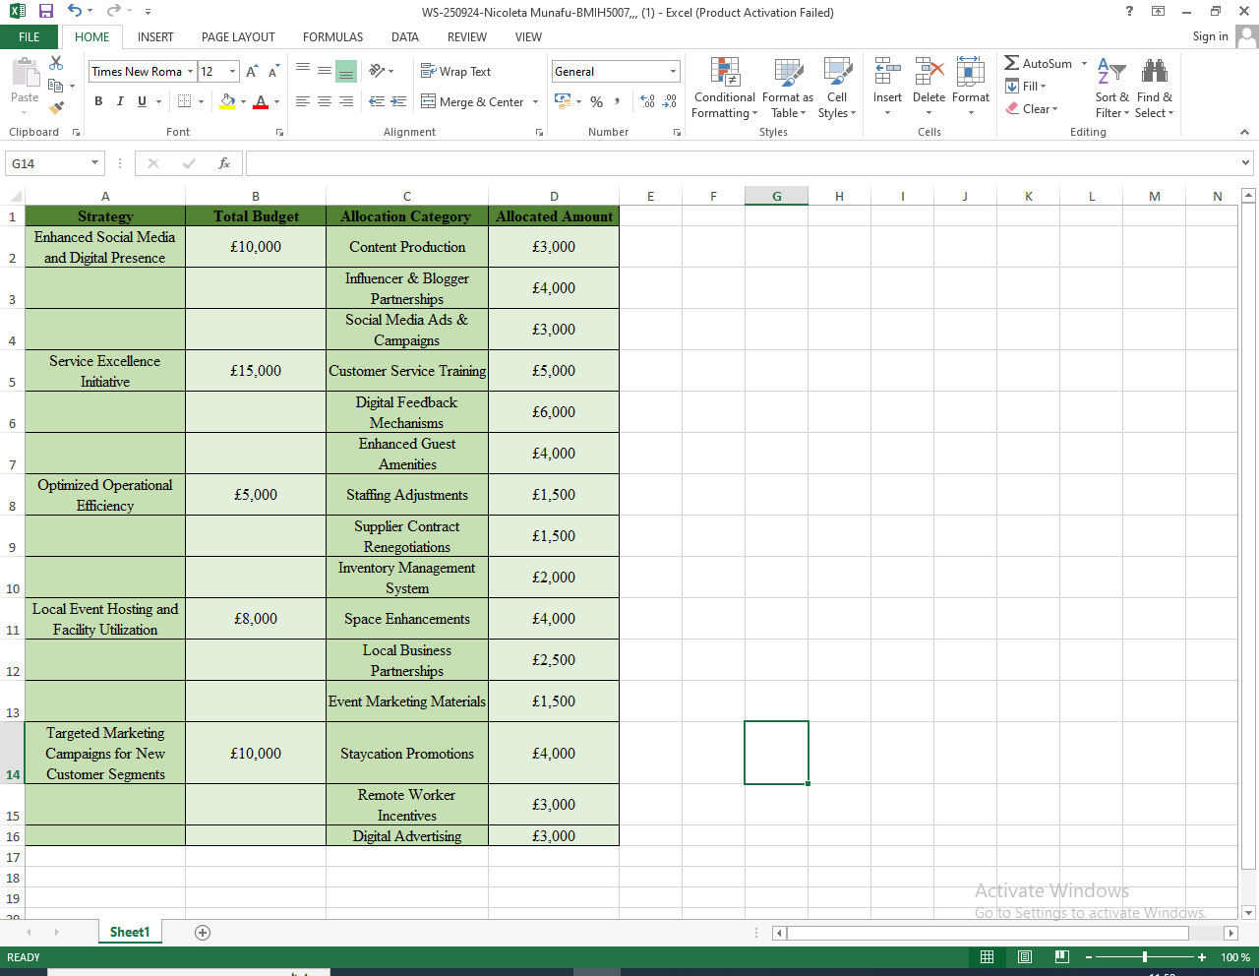

Conclusion
The City Hotel's profitability has declined due to a reduction in revenues, high operating expenses, and increasing debt levels. A change in market conditions, for instance, economic fluctuations, compositions, increased rivalry and internal issues of mismanagement of resources have impacted negatively on solidity and customer satisfaction. However, operational efficiency, the improvement of customer relations, and the marketing campaign specific to the hotel with a focus on the tourist traffic rather than the business should become the main tools of the turnaround strategy. These problems were developed based on the changes in consumers’ needs and better cost control. The City Hotel has the opportunity to become profitable again and strengthen its position in the competitive market.

References
Al Fahmawee, E.A.D. and Jawabreh, O.A., 2022. A study of architectural and intangible environment affecting occupancy rate of five stars business hotel in Amman. Journal of Environmental Management & Tourism, 13(2), pp.530-545.
Alananga, S. and Sanga, S.A., CHAPTER SIX GOVERNMENT DEBT, FOREIGN AID AND ECONOMIC DEVELOPMENT.
Chauhan, A.C. and Kularatne, I., 2021. REGAINING REPUTATION: AUCKLAND LUXURY HOTELS A STAKEHOLDERS’PERSPECTIVES. Rere Āwhio, p.105.
Cheng, J., 2019. Research and Suggestions on Declining Market Shares of Ibis Budget Hotels. Open Journal of Social Sciences, 8(1), pp.253-261.
Chikish, Y., Humphreys, B.R., Liu, C. and Nowak, A., 2019. Sports‐led tourism, spatial displacement, and hotel demand. Economic Inquiry, 57(4), pp.1859-1878.
Coulon, Y. and Coulon, Y., 2020. Debt Ratios. Rational Investing with Ratios: Implementing Ratios with Enterprise Value and Behavioral Finance, pp.63-84.
Debella, F.M., 2020. Profitability Improvement of Construction Firms Through Continuous Improvement Using Rapid Improvement Principles and Best Practices (Doctoral dissertation, Purdue University).
Du, Y., Wang, X., Lei, Z., Li, Y., Hu, B. and Li, G., 2019, December. Analysis and Design of Activity Degree Monitoring Algorithm. In 2019 IEEE International Conference on Cloud Computing Technology and Science (CloudCom) (pp. 362-366). IEEE.
Duan, J., Xie, C. and Morrison, A.M., 2022. Tourism crises and impacts on destinations: A systematic tourism and hospitality literature review. Journal of Hospitality & Tourism Research, 46(4), pp.667-695.
Fakir, F.Z. and Baydeniz, E., 2024. The Future of Blockchain in Tourism and Hospitality: Global Insights. Taylor & Francis.
Flores, A.F., Saldanha, E.S. and Vong, M., 2020. The Mediation Effect of Customer Satisfaction on the Relationship Between Service Quality and Customer Loyalty. Timor Leste Journal of Business and Management, 2, pp.56-65.
Furunes, T. and Mkono, M., 2019. Service-delivery success and failure under the sharing economy. International Journal of Contemporary Hospitality Management, 31(8), pp.3352-3370.
Gafurov, I., Kulikova, L., Sokolov, A., Shaykhutdinova, K. and Negreeva, V., 2019. Depreciation in the aspect of matching revenues and expenses of the company. In E3S Web of Conferences (Vol. 110, p. 02046). EDP Sciences.
Hossain, M.I., Akter, N. and Muzareba, A.M., 2024. Services Marketing. In Marketing in a Transition Economy: New Realities, Challenges, and Prospects (pp. 191-231). Singapore: Springer Nature Singapore.
Malesev, S. and Cherry, M., 2021. Digital and social media marketing market share for construction SMEs. Construction Economics and Building, 21(1), pp.65-82.
Saeidinezhad, E., 2019. Corporate Debt: Where is the Danger?
Spiro, K. and Bhamidi, V., 2024. Employee-Generated Learning: How to develop training that drives performance. Kogan Page Publishers.
Srivastava, P.R., Sengupta, K., Kumar, A., Biswas, B. and Ishizaka, A., 2022. Post-epidemic factors influencing customer's booking intent for a hotel or leisure spot: an empirical study. Journal of Enterprise Information Management, 35(1), pp.78-99.
Taylor, M., 2023. Navigating the Turnaround Process: A longitudinal action research case study examining the phases of the turnaround process of a UK SME and the characteristics of its key stakeholders (Doctoral dissertation, Aston University).
Turner, M.J. and Hesford, J.W., 2019. The impact of renovation capital expenditure on hotel property performance. Cornell Hospitality Quarterly, 60(1), pp.25-39.
Wong, I.A., Lin, Z. and Kou, I.E., 2023. Restoring hope and optimism through staycation programs: An application of psychological capital theory. Journal of Sustainable Tourism, 31(1), pp.91-110.



