Thomas Reynolds (2305662)
Module Code: ACCA5023
Research, build and deploy a virtualised network

Task 1:
Research Hypervisor
A hypervisor is software that allows you to run multiple virtual machines at once. The work you do on one virtual machine won’t influence the other virtual machines. There are two types of hypervisor those being type 1 and type 2. Type 1 has direct access to the hardware's resources. Whereas type 2 is an application that you install on the host operating system. This application can then run multiple virtual machines, a common example of this application is VirtualBox. Using that application you then set how much of the devices resource that virtual machine can use.
Hypervisors allow you to install different operating systems to the host operating system. So if you have a PC that uses Windows but have a project you wish to do on a linux system a type 2 hypervisor would be very useful. You can run multiple different operating systems, and it will not have an impact on the host OS.
As you are running another operating system on top of the hosts operating system, some devices with lower specs will run slowly, impacting productivity. Especially if you intend to run multiple virtual machines for a certain project. As for type 1 there are costs involved which may make it a worse option for certain users. However type 1 is more secure and faster as it runs on the hardware whereas type 2 runs on top of the host operating system.
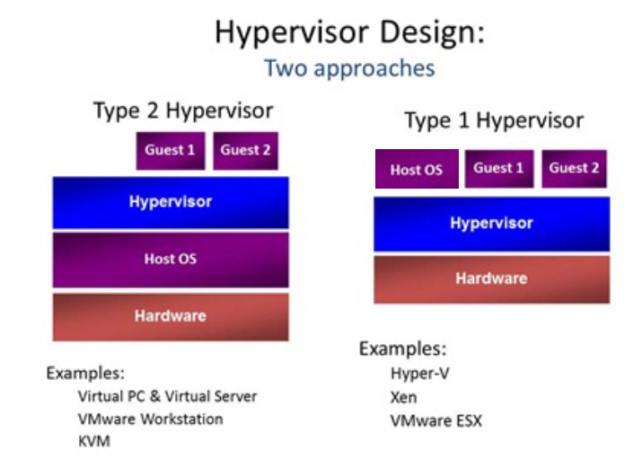
The image above shows the two different hypervisors. With type 2 you can see that you use the host operating system to install the hypervisor. However, the type 1hypervisor is built into the hardware. Then on top of that is where the host operating system and other virtual machines are.

Research IP addressing (400 words)
Data can be sent from one network to another using the internet. The data is split into smaller segments called packets before being sent over the internet. Then when the receiver has been sent all the packets they are joined back to their original form.
The packet knows where to go as the receiver has an IP address. All devices on a network have an IP address. It’s used so the sender's device knows who is supposed to receive the data.
There are different classes when it comes to IPV4 addresses. There are Class A, B, C, D and E. Class D is reserved for multicasting and Class E is experimental. Class A is 1.0.0.0 to 126.255.255.255. Class B is 128.0.0.0 to 191.255.255.255. Class C 192.0.0.0 to 223.255.255.255. Class D is 224.0.0.0 to 239.255.255.255. Class E is for 240.0.0.0 to 254.255.255.255.
IPV4 is a 32 bit address system made up of 4 octets. An example of IPV4 would be, 192.168.43.241
IPV6 is made up of 8 sections of 16 bits which means there are many more possible addresses you can make with IPV6. An example would be, 3FFE:0000:0000:0001:0200:F8FF:FE75:50DF
There are different devices used to transmit this data over networks those being switches and routers. Switches connect devices together to form a network, take a room of an office for example. Those devices in that room are connected to a switch, so those devices can send data to one another. A router is used to send and receive data to other networks. This means devices connected to a router can access the internet. A router is told to send packets to a specific IP address, then those packets reach the network of the receiver and makes its way to that device.
Subnetting is used to help the router know where on the network the receiver is. Otherwise, the packets would have to go to every device on the network to see if it's the intended receiver. This would take too much time, so subnetting is used to break that network into blocks. Then the packet goes to that block and finds the device. Without subnetting internet speeds would be too slow, meaning not a lot would be done.
There are two models which show us how data starts at the host device and ends up at the receiver's device. Those models being the TCP/IP model and the OSI model.
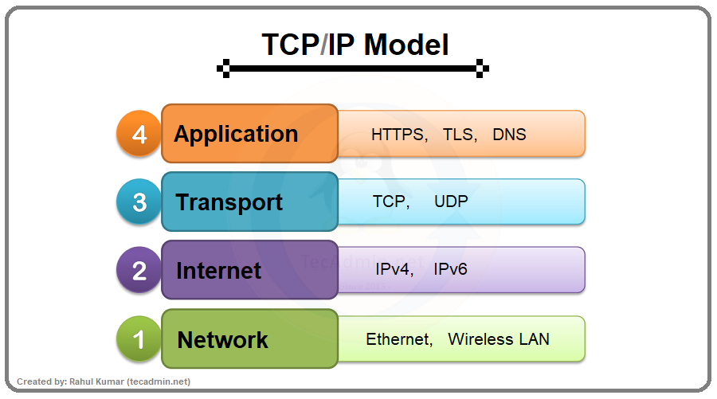

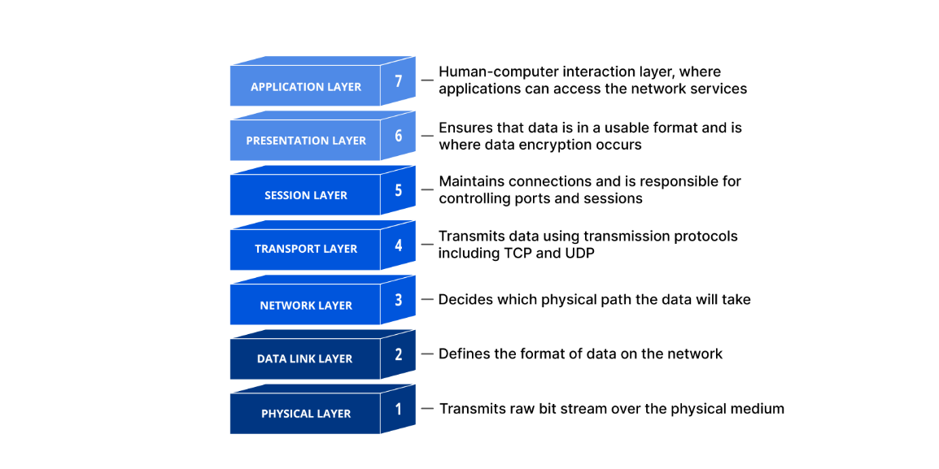
In the OSI layer you can see that the data starts at the hosts device, then that data is converted into frames which can be sent between the switches of a network. Then in the network layer the data is broken into packets, and this is where the path of where data will travel is determined. The transport layer allows for that data to be sent using protocols. The other layers allow for that data to be reconstructed and viewed by the user of the device.

Research Routing (400 words)
Routing is the protocols and rules routers follow to send data through networks. A routing protocol is a set of rules that help a router specify what path the data needs to follow to get to the intended location. As previously stated, IP addresses are used to determine who is supposed to receive certain data and where data is coming from.
Another protocol used is called routing information protocol. This is used to manage router data on a LAN (local area network) or a private WAN (wide area network). It does this by sending routing tables from the gateway host to other routers on the network.
Enhanced interior gateway routing protocol is another protocol used to send out routing information through the network. It does this by sending packets periodically to see who the hosts are on the network. It then uses this information to update the routing table. Open shortest path first (OSPF) is a protocol that uses algorithms to calculate the best and most efficient path traffic should travel.
There are different ways routing can be done. Two of those ways being static and dynamic. Static routing is when manual there are manually entered routes for the router to follow. It only does what it's been told to do. This is secure as static routes are not advertised over the network. Dynamic routing is more complex as it calculates multiple paths traffic could take to reach the same destination. It then works out what is the best path the traffic should take out of all the possibilities it has just come up with. It works this out by routers exchanging information with each other which is done by routing protocols. One advantage of this being that it reacts to the current status of the network. So, if one router malfunctions on the network, if there are still other possible paths the traffic can take the data will still make it to the intended destination. Whereas if the a host on a static route malfunctioned that data would not be able to reach the intended destination. If there was a LAN where all the routers were given static routes and there was a change in the network, then every router would have to be changed manually. This is why for larger networks dynamic routing is better. There may be unexpected errors or changes to a network, dynamic routing allows for people to still use that network as long as there are other viable paths.

Research on Network Services (400 words)
VPN stands for virtual private network. This is used to protect users' data and masks their IP addresses. A VPN protects its users data by creating an encrypted tunnel for your data to travel through. This can be very useful if you are entering personal information on a website or trying to access your financial information. A VPN would make it harder for an attacker to spy on that data. If you are trying to connect to a network in a different location, for example Swansea to Cardiff then a VPN would make that connection much more secure.
DHCP stands for dynamic host configuration protocol. It is used to assign IP addresses to each host on the network it has been deployed on. When a device is added to a network it requests an IP address from the DHCP server. The server acknowledges this and provides an ip address which is then acknowledged. This is very beneficial when it comes to networking as it simplifies configuration, increases scalability and is overall a very useful tool for network management. This can save network administrators a lot of time as they don’t have to manually configure every device when they are moved to a different place on the network.
Active directory allows for a hierarchy and authorization on a network. For example, a user on a network enters the username and password because they want to access something. The network checks with the active directory to see if those credentials were correct, they are granted authorization so they can access network resources. Active directory domain services allow for these different roles within a network as well as authentication and authorization.

Task 2:

C Server - Installation
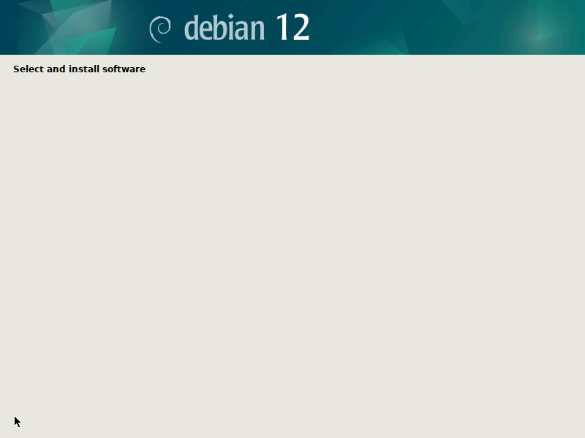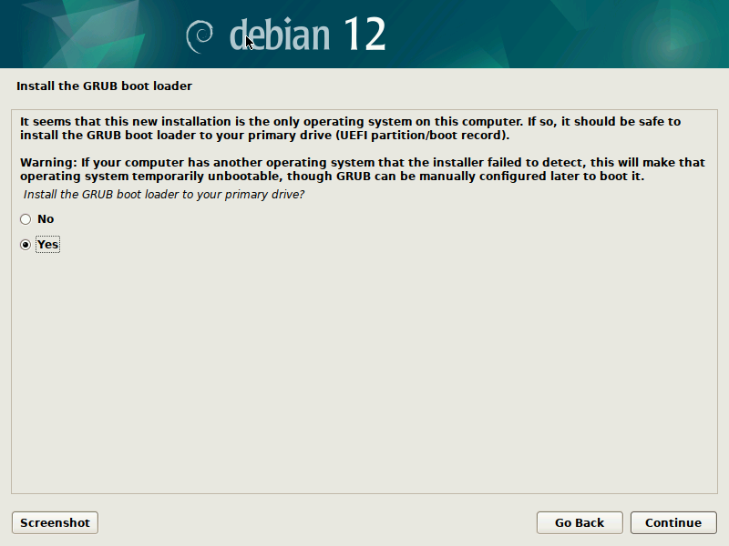

Login for the server
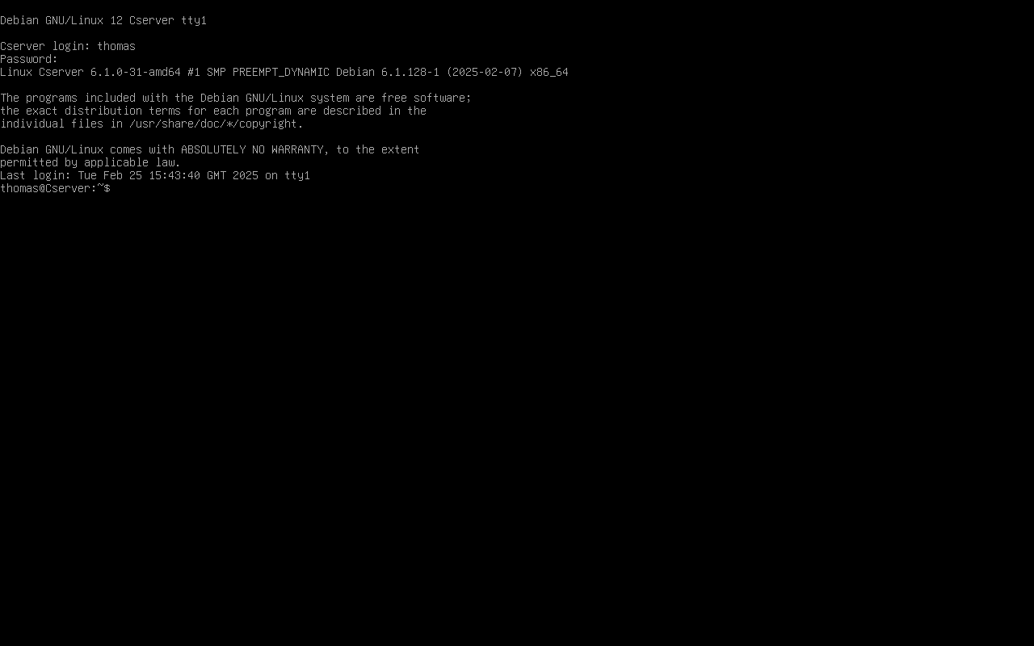
Network interface on Linux server, and successful ping to Windows Server
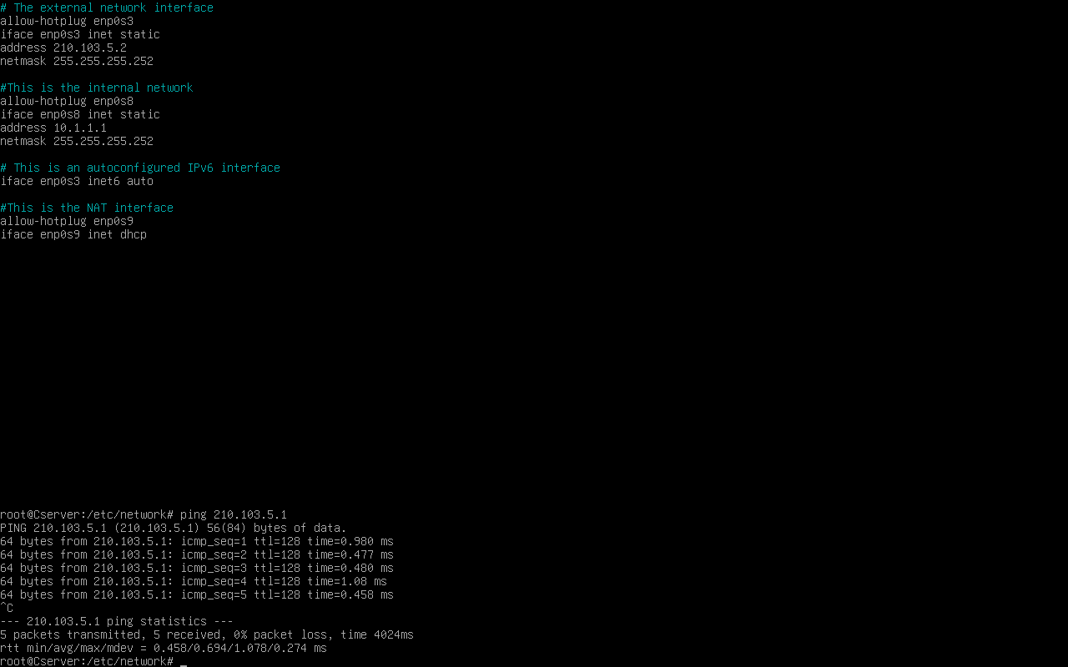

Pinging Linux client
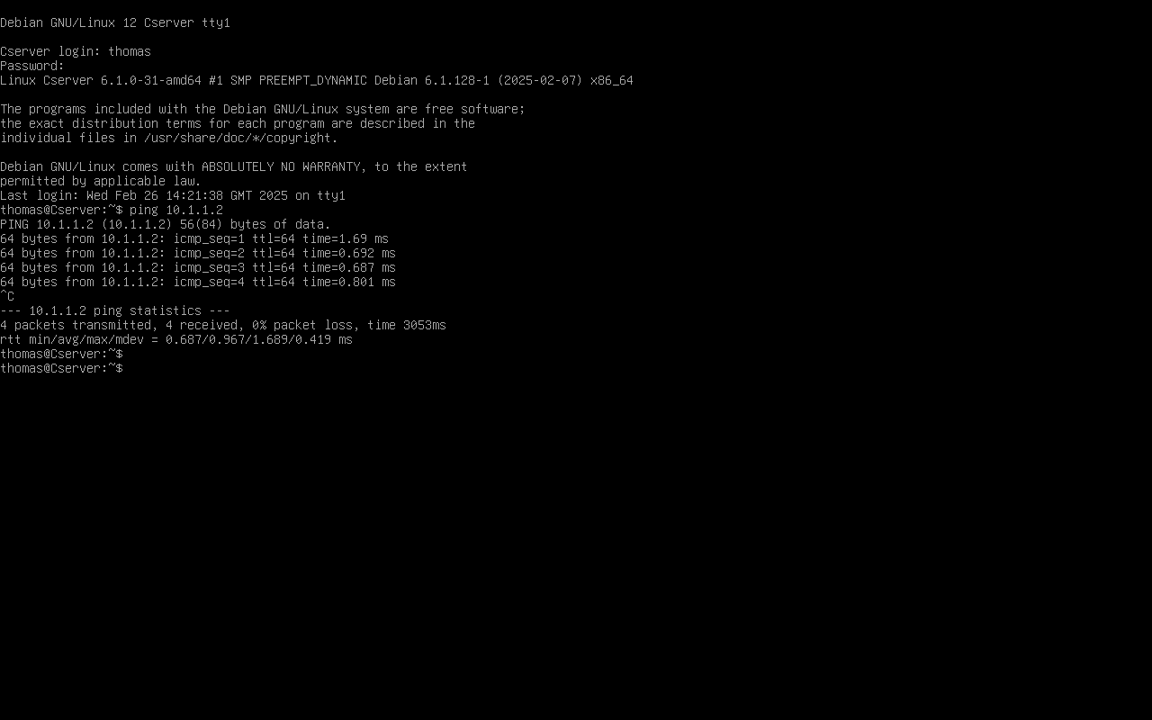
Network interface
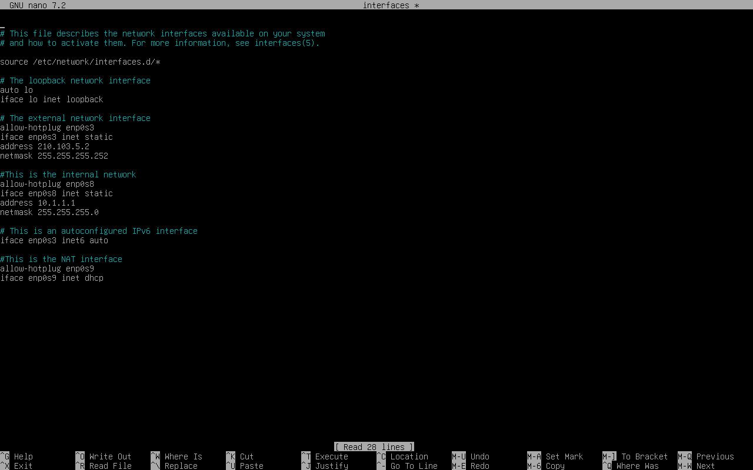

C Client – Pinging the server

Network interface
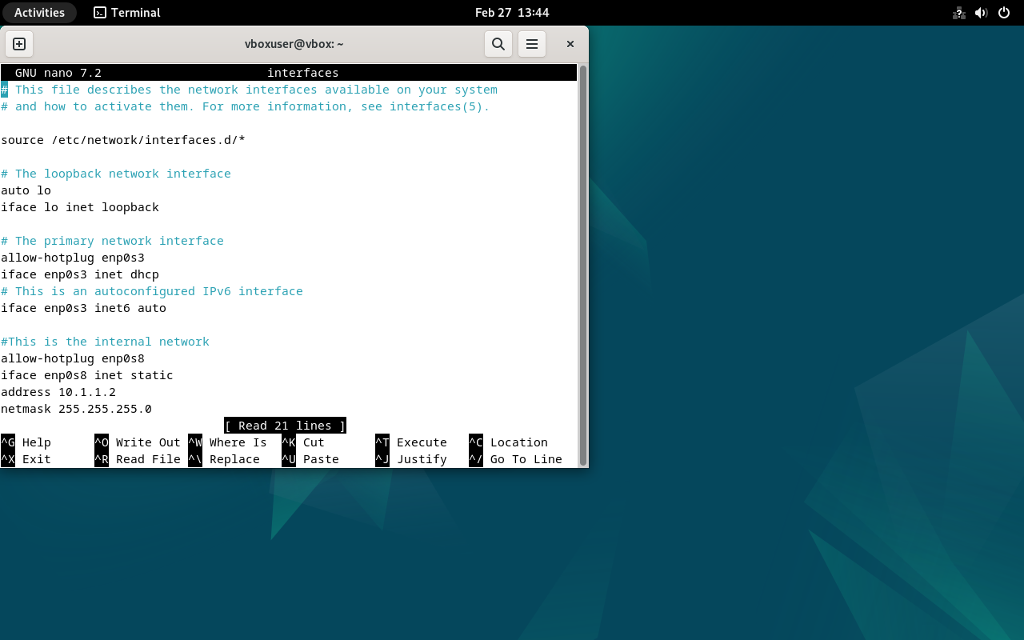
SDC – Pinging client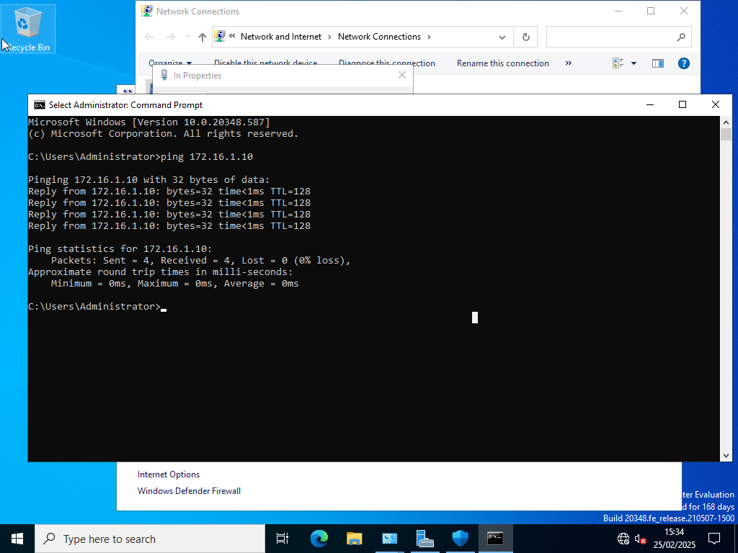

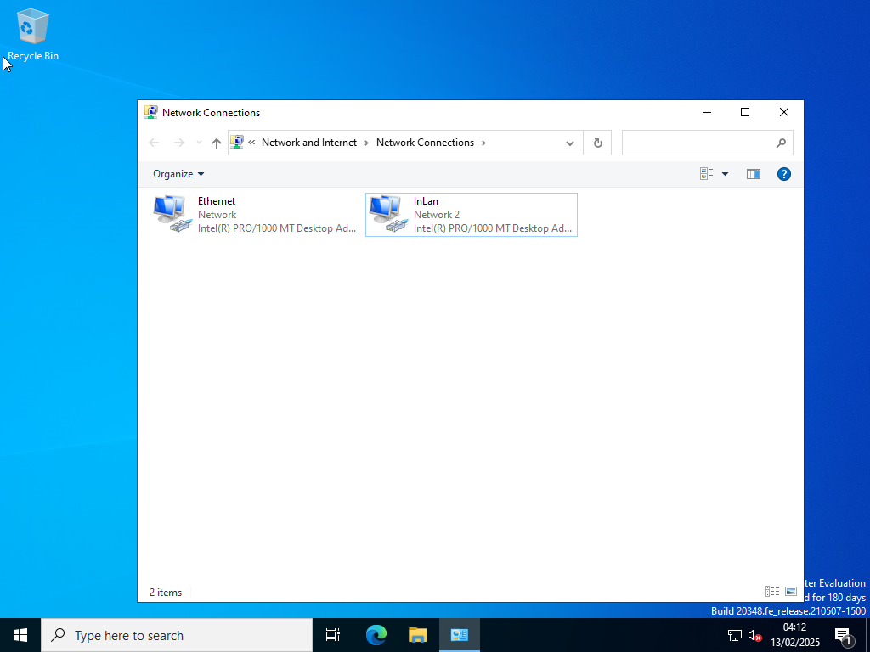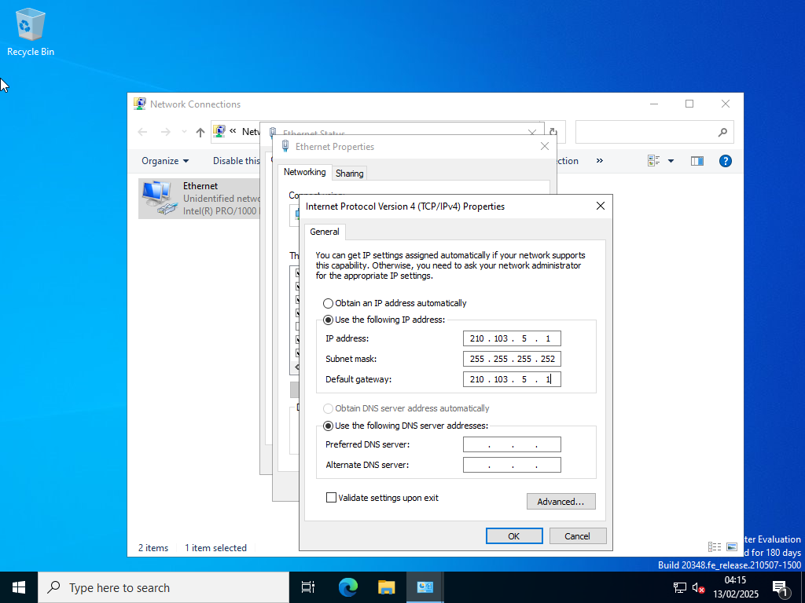
Ethernet set up
Pinging Linux server
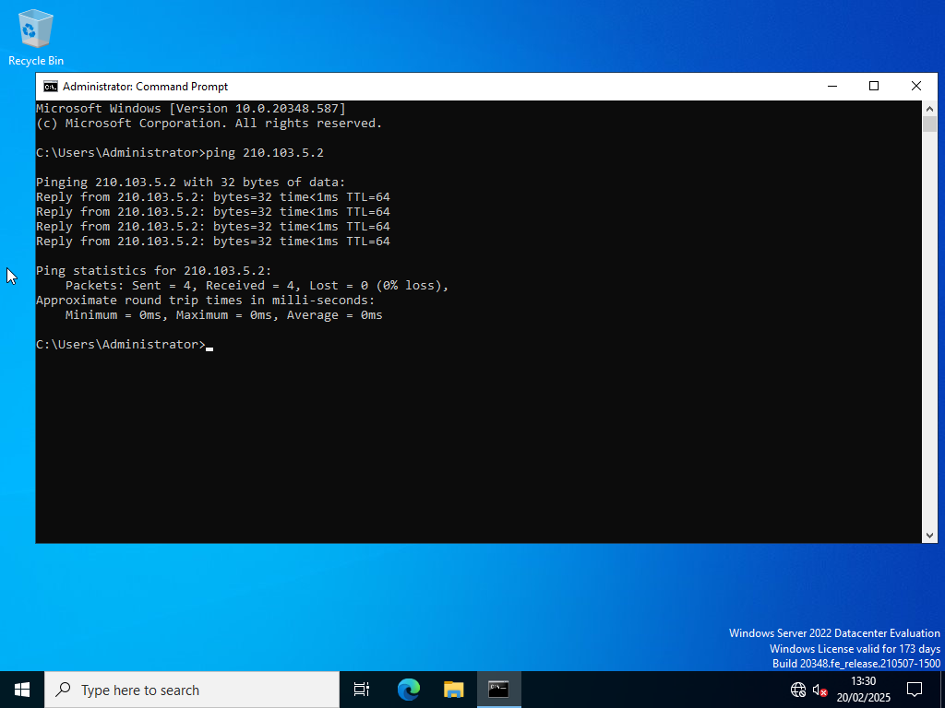

S1- Ethernet set up
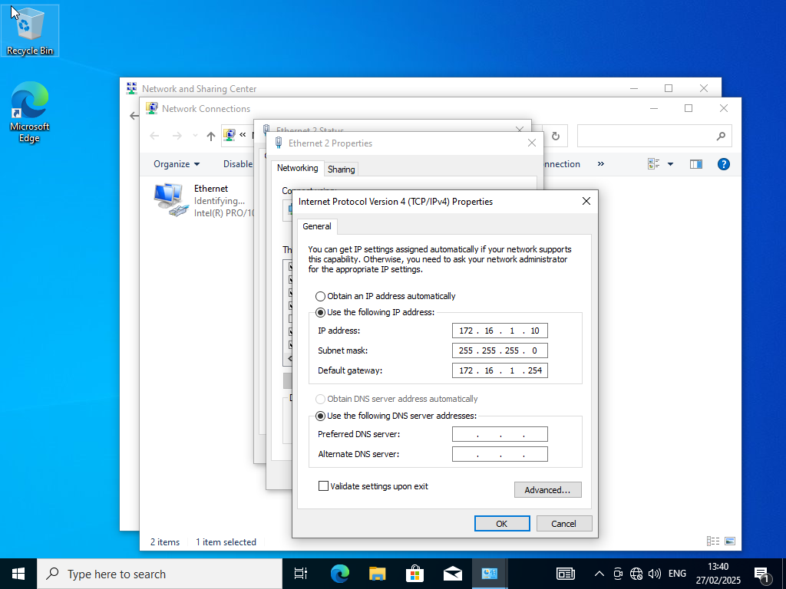
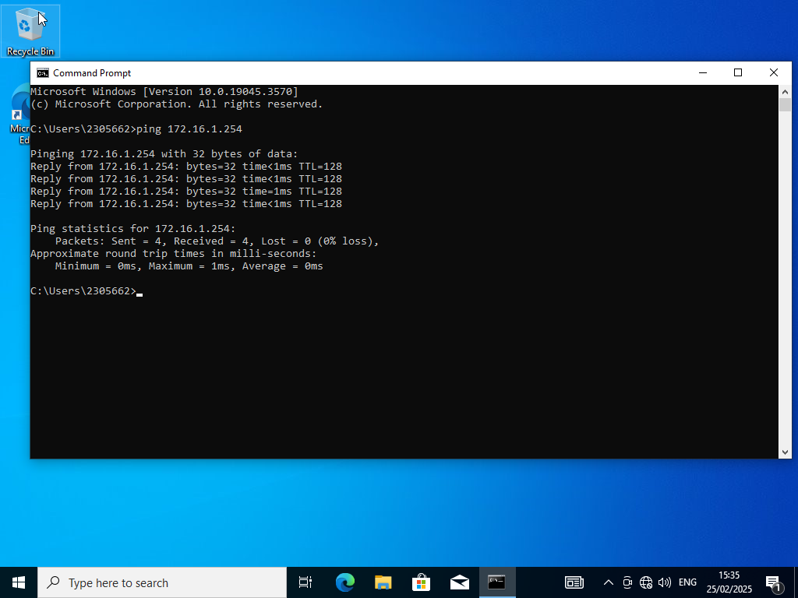
Pinging Windows server

Task 2:
The hypervisor I chose was oracle virtual box which is a type 2 hypervisor. I believe a type 2 hypervisor is a good choice for this project as the PC’s we are using have enough specs to allow us to set up this topology without dramatic lagging or buffering. Also it is a cheaper option than type 1 hypervisors. This software is made for running multiple operating systems at once which is what we need.

The IP addressing scheme is as follows. The servers have a subnet mask of /30 which allows two hosts to be on that network. This makes that network more secure as only those two hosts are on that network. The clients have a subnet mask of /24 which allows other clients to be added in the future, this allows for the network to be expanded on but still follow the same topology.
Linux Server (internal) – 10.1.1.1 /24
Linux Server (external) - 210.103.5.2 /30
Linux Client – 10.1.1.2 /24
Windows Server (Internal) - 172.16.1.254 /24
Windows Server (external)– 210.103.5.1 /30
Windows client – 172.16.1.10 /24

I decided that the servers external connection would be on adapter one. Then adapter two would be used for the inLAN connections from the server to the client. I then noted this down to avoid confusion.
The first connection that was set up was the internal connection between the windows server and client. To start I named the second adapter on the server machine to inLAN so I knew which adapter was which. Then on the two windows machines I entered the IP addresses and subnet masks to adapter 2. However, there was an unsuccessful ping. Some troubleshooting was done and the problem was the connection type that the adapter was connected to. On the virtual box software you can change the network settings of the virtual machine. And on the adapter there were different options for the connection type, it was originally set to NAT then I changed it to internal connection. I did this for the two Windows machines. Then I tried pinging them two ways again and it was successful which you can see in the screenshots. I had also set up the external IP address on adapter one. This image shows the server pinging the client.
And this image below shows the client pinging the server.

Next I set up the Linux server machine. The Linux nano command was used to edit the network interface.
The image above shows the IP addresses I added on the nano network interface. The IP addresses for the external and internal adapter were added. The adapters had different names on the linux machines but that’s why I used comments to help me. Enp0s3 was the external adapter, and enp0s8 was the internal network. A ping test was done to the windows server where there was an unsuccessful ping. Again the problem was due to the connection type on the adapter. After that quick fix the connection was successful. As you can see from the image below.

I then tried pinging from the other way. So, windows server to Linux server and the result was a successful ping.

After this I had to set up the Linux client machine which was the same process as the server.
This is the set up on the nano network interface for the linux machine. As you can see I only had to add the IP address for the one adapter. The connectivity test for the Linux client to server thankfully had no errors. This was the result of the test.
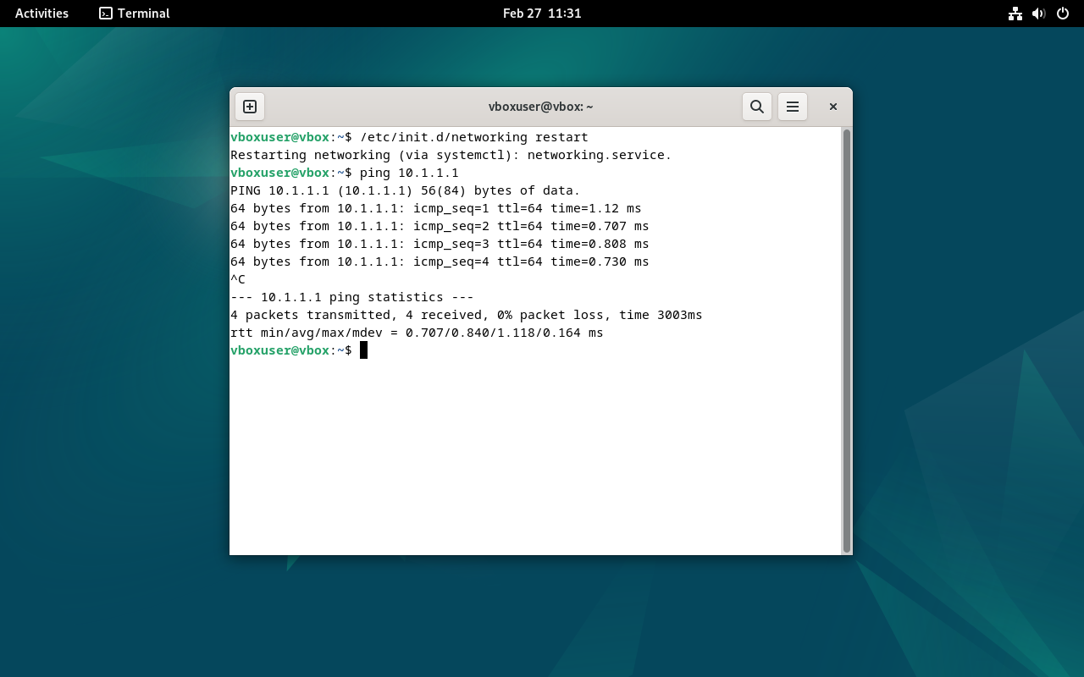

Now that the Linux client machine was set up, I could test the server to client connectivity. Which ended up not working so I went back to troubleshooting. Eventually I found the problem was with the name of the network the internal adapter was on. There were two options those being ‘intret’ and ‘intret2’. The Linux server’s internal adapter was set to ‘intret2’ and the client was set to ‘intret’. I then had them both set to ‘intret’ and tried the test again which led to a successful ping. As you can see from the image below.
After configuring all the IP addresses and getting successful pings the two errors that caused problems were naming conventions and the ethernet adapters. Mainly IP addresses being configured to the wrong ethernet adapter.

Reflection:
During this project the most problems were from adding the network interface to the Linux machines. This was due to lack of experience.
There were other issues, but they were solved after troubleshooting. Those issues were due to the adapters. After troubleshooting successful pings were done from the two servers. And then pings from the server to clients were successful and then clients to server.

References:
1: What is a hypervisor?, VMware,
https://www.vmware.com/topics/hypervisor

2: What is the OSI model?, AWS
https://aws.amazon.com/what-is/osi-model/#:~:text=The%20Open%20Systems%20Interconnection%20(OSI,across%20geographical%20and%20political%20boundaries.

3: What is a VPN, Microsoft Azure,
https://azure.microsoft.com/en-us/resources/cloud-computing-dictionary/what-is-vpn

