POPULATION HEALTH AND DIGITAL HEALTH PROMOTION
(DEMENTIA IN THE UK)

Module Number: LCHS7009
Student Name: Norin MohamadMunafkhan Qureshi
Student ID: 2528087
Lecturer name: Diola Bijlhout`

Table of contents

Blog 1……………………………………………………………3
- Dementia: an increasingly important health problem in the UK
- GPS trackers and wearables: current digital options
- What does the evidence actually indicate?
- Benefits & shortfalls
- Tackling the shortcomings

References

Blog 2…………………………………………………………….7
- Dementia: a healthcare burden set to double
- What’s new in NeuroBand AI
- Applications in health promotion
- Impact analysis
- Trust questions: (for adoption) how can we know?
- Addressing the shortfalls

References

“DIGITAL HEALTH PROMOTION IN DEMENTIA CARE”
Two Blogs: Wearable and AI-Powered Digital Health Technologies

Blog 1- Smart Wearable Technologies for Dementia Care: A Critical Evaluation of Their Role in Digital Health Promotion
Dementia: an increasingly important health problem in the UK
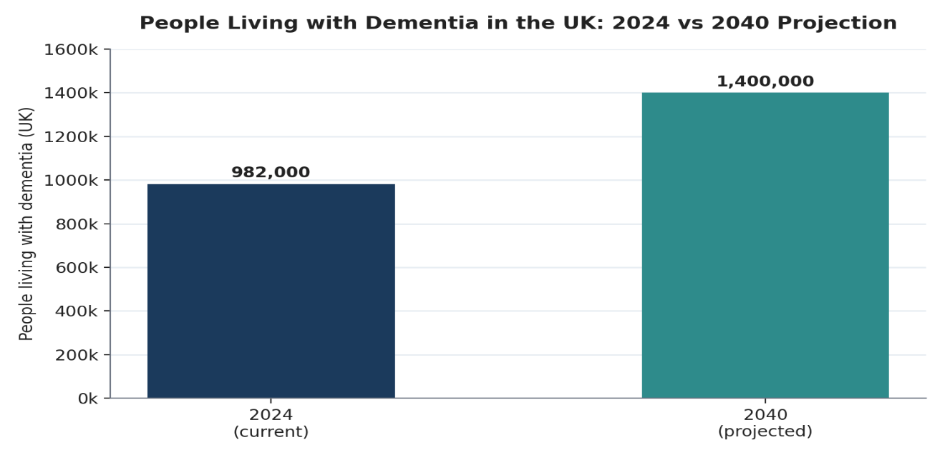
Dementia is now the number one killer in the UK and one of its most challenging digital health issues. Alzheimer’s Society (2024) predicts 982,000 dementia patients across the UK in 2024, increasing to 1.4million in 2040 as the population ages (see figure 1). Supporting this point, data from NHS England (2024) confirms increased demand, with the number of patients on GP dementia registers rising progressively through 2024 to 498,221 (by December) at the same time as diagnosis rate increased to 65.6% of the population over-65 years. The impact of dementia is further underlined by its current annual cost to the UK of >£42billion that Alzheimer’s Society expect to escalate to £90billion by 2040 driven by unpaid and social care. Traditional face-to-face memory services cannot manage this level of demand, creating an urgent need for wearable digital devices enabling independent daily living and increased safety.

Figure 1: People living with dementia in the UK, 2024 vs 2040 projection
(Source: Alzheimer’s Society, 2024)
GPS trackers and wearables: current digital options
Known technologies in UK dementia care include GPS-enabled wearable tracking devices worn as wristbands, shoe insoles, or pendants, which enable family carers and local authorities to track a wandering individual (Building Better Healthcare, 2016). For example, state-funded projects pilots such as the Technology Integrated Health Management (TIHM) test bed - delivered together with the Surrey and Borders Partnership NHS Foundation Trust – responded with wearable sensors and monitors to support independent living for longer (Building Better Healthcare, 2016). The devices foster behaviour change using the COM-B model: they support carer capability with live location data, establish opportunity with constant monitoring, and boost motivation by lowering family worry.

What does the evidence actually indicate?
Doyle et al. (2024) demonstrated that GPS trackers were feasible and acceptable for demander-demanderd learner dyads, though they also noted the increased feeling of security that they provided could delay entry to 24 hours residential care. Similarly, a University of Southampton-led study (University of Southampton, 2018) found GPS trackers enabled rapid location of missing persons and offered families peace of mind. Conversely, following an NICE-cited systematic review, Ehn et al. (2021) identified live evidence of the clinical and economically efficiency of GPSe alarms in the absence of such consensus among users an ongoing deficiency as seen in the figure.2.

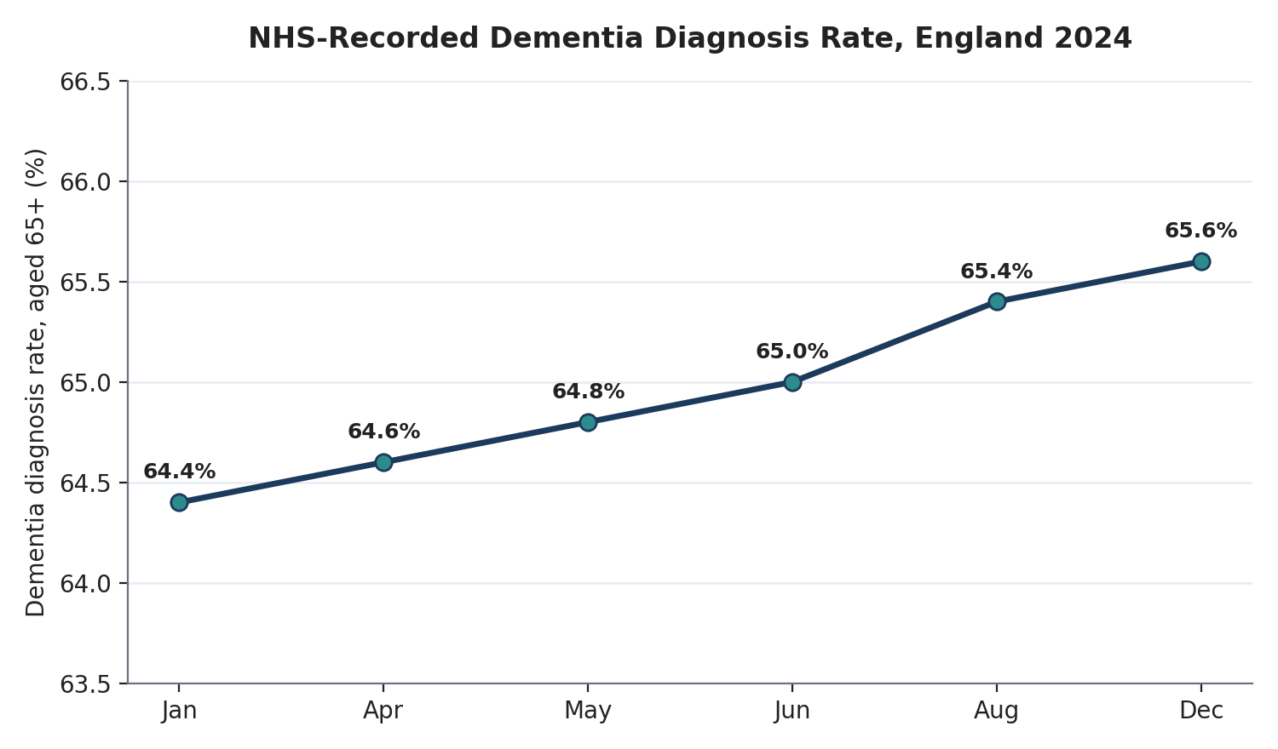
Figure 2: NHS-recorded dementia diagnosis rate, England 2024
(Source: NHS England, 2024)

Benefits & shortfalls
Wearable trackers offer strong potential for scalability, relatively cheaper than residential care, and a way to offer more independence. However, important gaps exist. Most older peoples’ own homes are unlikely to have the connectivity or infrastructure to support these devices, and many older adults and those on low incomes will not have the digital skills or family support to be able to use them reliably, echoing broader digital-inequality issues found across NHS digital health programmes. Ethical issues associated with location-based surveillance could become difficult, especially where individuals cannot safely or meaningfully give consent for monitoring. At present, most evidence is qualitative in nature, with a dearth of larger UK trials to assess cost or long-term health benefits (Ehn et al., 2021).

Tackling the shortcomings
The co-design of devices with people with dementia and their carers, coupled with GDPR-compliant data governance, and access subsidised by the NHS for disadvantaged peoples, could increase uptake and equity. In addition, appropriate structured care-giver training, as Doyle et al. (2024), could ensure trackers are used safely and consistently.

References

- Alzheimer’s Society (2024). The economic impact of dementia. [online] Alzheimer’s Society. Available at: https://www.alzheimers.org.uk/what-we-do/policy-and-influencing/economic-impact-of-dementia [Accessed 20 Jul. 2026].
- Building Better Healthcare (2016). NHS dementia patients to trial wearable technology. [online] Building Better Healthcare. Available at: https://buildingbetterhealthcare.com/nhs-dementia-patients-to-trial-wearable-technology--115778 [Accessed 20 Jul. 2026].
- Doyle, M., Nwofe, E.S., Rooke, C., Seelam, K., Porter, J. and Bishop, D. (2024). Implementing global positioning system trackers for people with dementia who are at risk of wandering. Dementia. https://doi.org/10.1177/14713012241248556.

- Ehn, M., Richardson, M.X., Landerdahl Stridsberg, S., Redekop, K. and Wamala-Andersson, S. (2021).Mobile Safety Alarms Based on GPS Technology in the Care of Older Adults: Systematic Review of Evidence Based on a General Evidence Framework for Digital Health Technologies. Journal of Medical Internet Research, 23(10), p.e27267. https://doi.org/10.2196/27267.

- NHS England (2024). Primary Care Dementia Data, December 2024. [online] NHS Digital. Available at: https://digital.nhs.uk/data-and-information/publications/statistical/primary-care-dementia-data/december-2024 [Accessed 20 Jul. 2026].

- University of Southampton (2018). GPS trackers can save the lives of people with dementia. [online] University of Southampton News. Available at: https://www.southampton.ac.uk/news/2018/04/gps-trackers-dementia.page [Accessed 20 Jul. 2026].

Blog 2 — NeuroBand AI: An Intelligent AI-Powered Wearable Ecosystem for Promoting Health and Independent Living in People with Dementia
Dementia: a healthcare burden set to double
Dementia already costs the UK £42 billion per year. With dementia incidence expected to increase from approximately 982,000 to 1.4 million people by 2040, this costs are predicted to almost double to £90 billion per year. (Alzheimer’s Society, 2024; see Figure 1). GOV.UK dementia profile update December 2024 confirms dementia is still one of the biggest killers with 91,500 deaths involving dementia registered in England in 2023 (GOV.UK, 2024). Although current devices such as GPS trackers are advantageous for safety purposes, they are reactive and provide no indication of risk to the individual or support for cognitive and physical wellbeing in a holistic sense. This is how the NeuroBand AI product would seek to intervene.
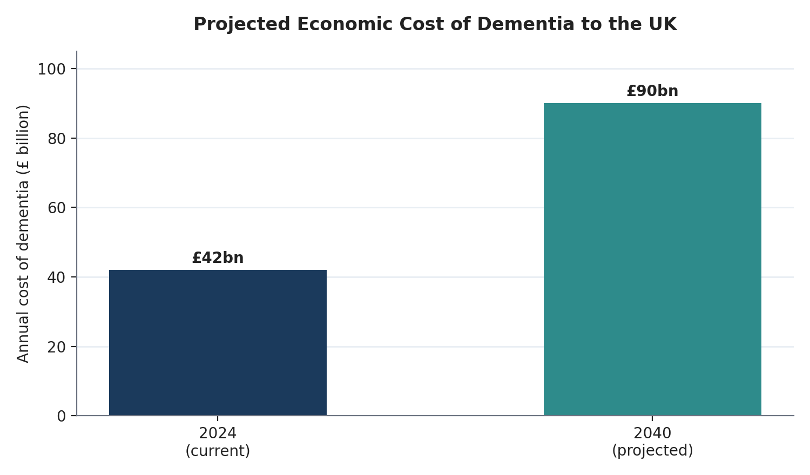
Figure 1: Projected economic cost of dementia to the UK, 2024 vs 2040
(Source: Alzheimer’s Society, 2024)

What’s new in NeuroBand AI
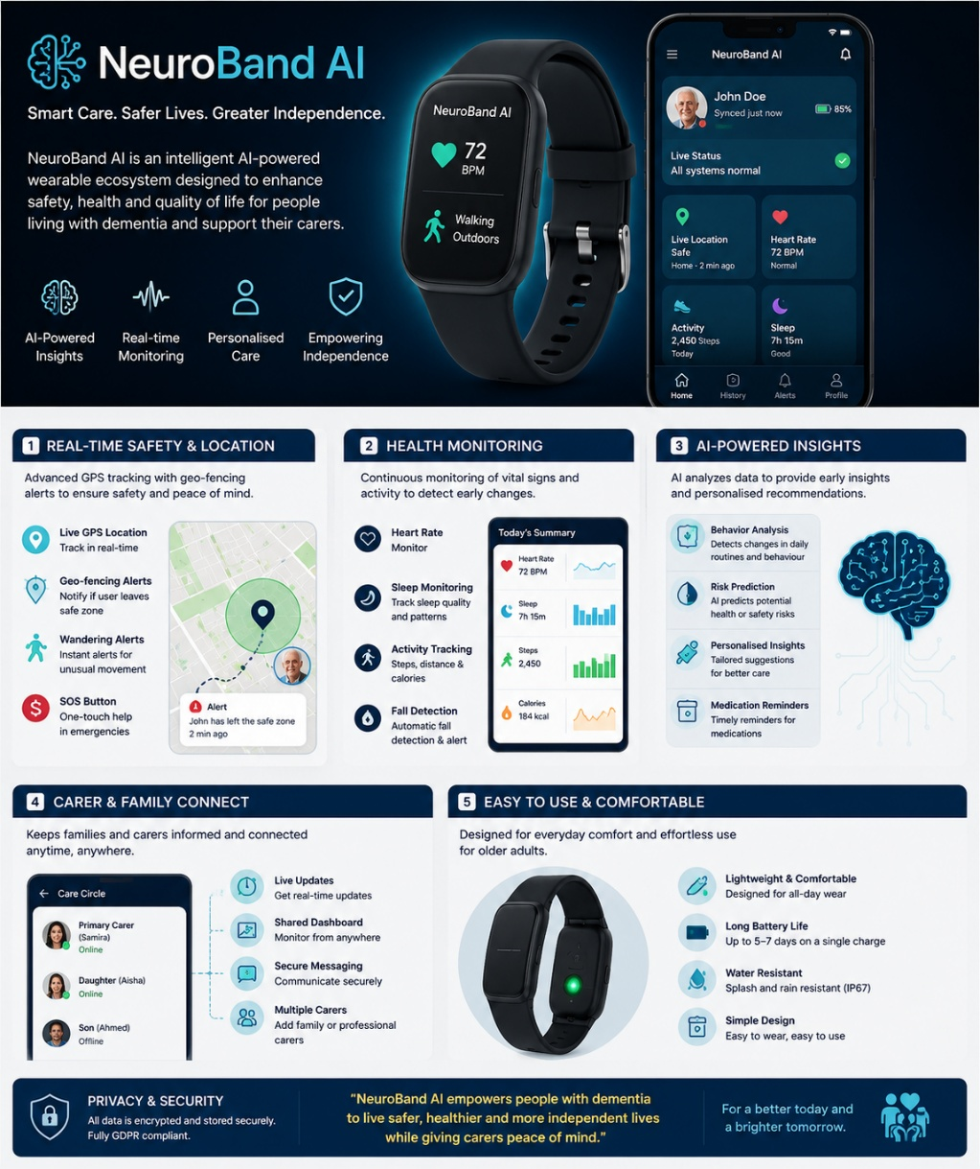
NeuroBand AI; a hypothetical wristband that uses GPS location, fall-detection accelerometry, and heart-rate and sleep sensors to feed an on-device AI model that learns each user’s standard behaviour; so that when there is a change in behaviour, such as irregular wandering, changes in sleep pattern, or an unexpected fall, carers are notified and, with the user’s permission, NHS memory clinics also. NeuroBand AI‘s simulation app converts sensor data into plain-language summaries for carers and healthcare professionals alike, as suggested by the acceptability of use of wearables by elderly people with early cognitive decline, as established in the CODEC II cohort study: acceptability assessment (Wilson, 2025)

Figure 2. NeuroBand AI Mobile Application Interface and Key Functional Features (Author's Concept, 2026).
Applications in health promotion
NeuroBand AI is also based on the Health Belief Model, with reinforced perceived severity (falls, wandering) and benefit (early intervention, independence) according to individualised alerts and educational prompts for carers. And it addresses the COM-B model depicted by the NHS test-bed wearable trials, where capability is increased through constant, objective surveillance; opportunity through the system‘s 24/7 passive data-logging; and motivation through felt sense of achievement, safety, and critical time to intervene (Building Better Healthcare, 2016) - as detailed in Figure 2. It is painted clear here why early, tech-supported intervention becomes paramount as dementia southerns further.

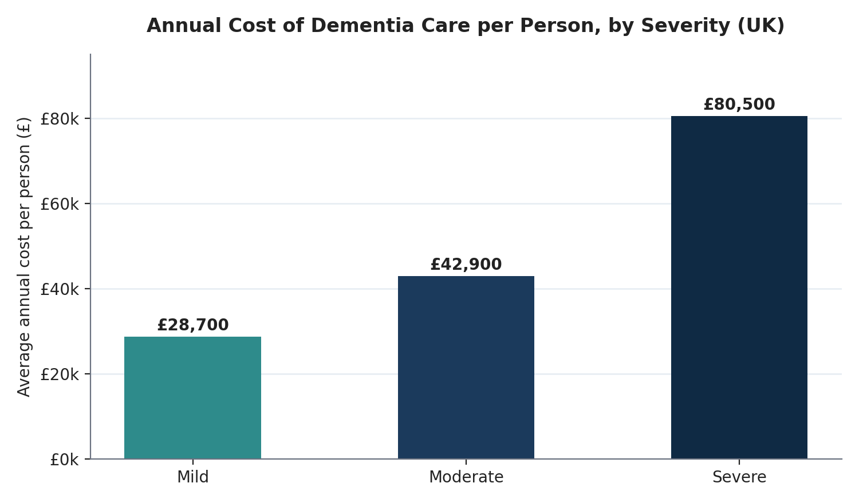
Figure 2: Annual cost of dementia care per person, by severity (UK)
(Source: Alzheimer’s Society, 2024)

Impact analysis
By providing automated monitoring, NeuroBand AI will be able to minimize time-consuming human presence monitoring, and may facilitate identification of decline at an earlier stage, potentially helping prevent the onset of severe dementia where costs per person per year increase from £28,700 to £80,500 (Alzheimer‘s Society, 2024). Linkage to NHS records could facilitate population surveillance and continuity of care. Ethical issues are concerned with over-scrutinising and the guilt-inducing consequences of the constant monitoring.

Trust questions: (for adoption) how can we know?
There are real concerns about accessing health data via a wearable to the NHS systems as security of data, consent and exclusion of digitally excluded groups (e.g., without smart phones or access to internet connection) will prove crucial. If service users (and their families) are not confident that highly sensitive NHS data was secure the uptake of the technology is likely to be poor despite clinical benefits (Wilson et al., 2025).
Addressing the shortfalls

An effective GDPR-compliant data governance system, transparent consent procedures involving both wearer and carer, and heavily subsidised device provision for digitally excluded households would support NeuroBand AI in turning its technical potential into equitable, trusted care.

References

- Alzheimer’s Society (2024). Facts for the media about dementia. [online] Alzheimer’s Society. Available at: https://www.alzheimers.org.uk/what-we-do/news-and-media/facts-media [Accessed 20 Jul. 2026].
- Alzheimer’s Society (2024). The Economic Impact of Dementia — Module 1: Annual Costs of Dementia. [online] Alzheimer’s Society / Carnall Farrar. Available at: https://www.alzheimers.org.uk/sites/default/files/2024-05/the-annual-costs-of-dementia.pdf [Accessed 20 Jul. 2026].
- Building Better Healthcare (2016). NHS dementia patients to trial wearable technology. [online] Building Better Healthcare. Available at: https://buildingbetterhealthcare.com/nhs-dementia-patients-to-trial-wearable-technology--115778 [Accessed 20 Jul. 2026].
- GOV.UK (2024). Statistical commentary: dementia profile, December 2024 update. [online] GOV.UK. Available at: https://www.gov.uk/government/statistics/dementia-profile-updates/statistical-commentary-dementia-profile-december-2024-update [Accessed 20 Jul. 2026].
- Wilson, S., Beswick, E., Morrell, R., Bhogal, S., Tolley, C., Whitfield, T., Wing, K., Mc Ardle, R., Walker, Z. and Slight, S. (2025). Acceptance of wearable technology for the early detection of dementia-causing diseases: perspectives from the CODEC II cohort. Alzheimer’s & Dementia. https://doi.org/10.1002/alz.094258.

