LCBB4004 Marketing Fundamentals
Assessment 1
By Jasmine Kaur

Individual Blog

Submission date: 27-july-2023 12:15PM (UTC+0100)
Submission ID: 210724754
File name: HK1246_Marketing fundamentals 8926.edited(1)
Total Word count: 2238
Total Characters (no spaces): 13821

MODULE NAME: MARKETING FUNDAMENTALS
MODULE CODE: LCBB4004
LECTURERS’S NAME: TUSHARA BALENDRAN
STUDENT NAME: JASMINE KAUR
STUDENT ID: 2222522

ASSESSMENT 1

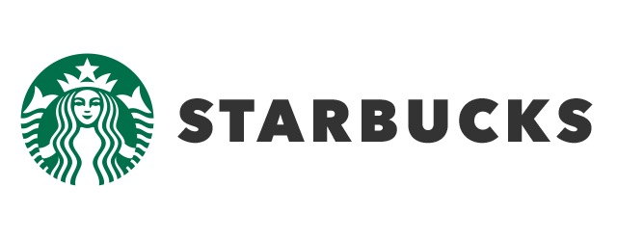
BLOG

History and Heritage of Starbucks

Starbucks began its journey in 1971 in Pike Place Market of Seattle by setting the first store, which offered fresh-roasted coffee beans, tea, and spices.
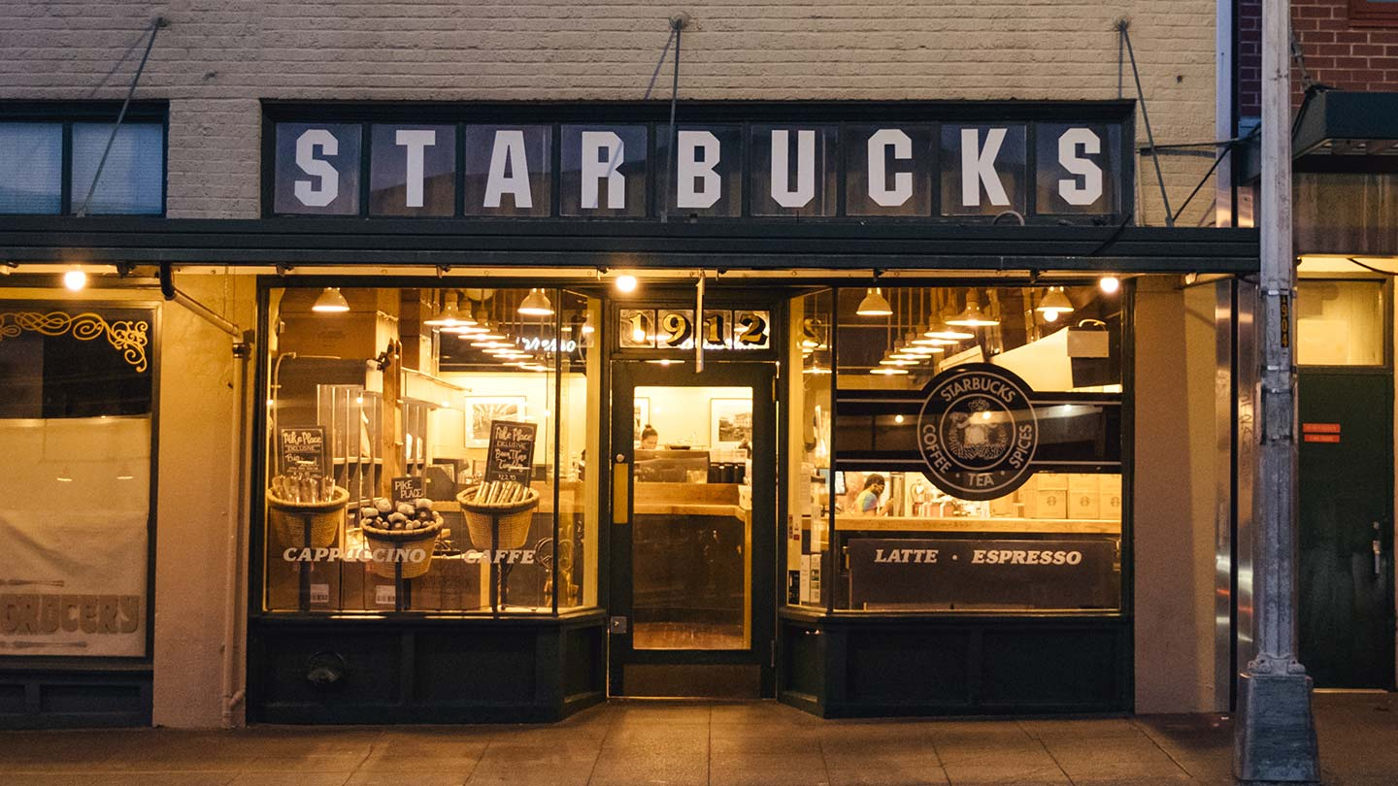
A decade later, Howard Schultz joined the company in 1982 (Starbucks, 2023). He fell in love with Starbucks coffee during a trip to Milan, where he experienced Italian coffee culture. Schultz aimed to bring that artistry and warmth to Starbucks.
By 1987, Starbucks evolved into a coffeehouse by expanding to various cities in the United States.
By 1996-99, it opened stores in Japan, Europe, and China. Over the following decades, Starbucks grew exponentially.

Starbucks logo

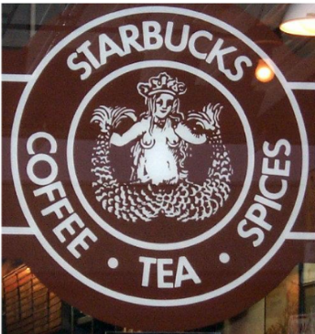 | The original logo appeared in 1971, which had a two-tailed siren or mermaid. It has evolved over the years and is known by everyone (Brassington and Pettitt, 2006). Sansserif typeface was used to mention the words in block letters. The logo was used till 1987.
 | The firm introduced a new logo in 1987. The siren was covered with flowing hair and the badge was green. Dooley (2012) then identifies that in order to make it more attractive, the logo of the company should be unique, simple, and less detailed.

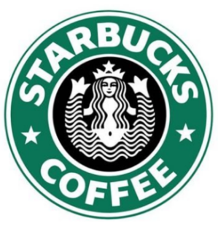  1987-1992 | 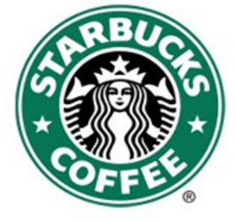  1992-2011 |   Current logo (2011- present)

Mission | 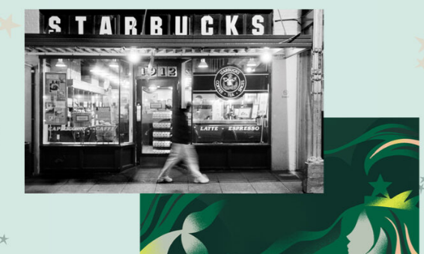
Starbucks fosters boundless opportunities for human connections through each cup served and every conversation with all the communities (Gregory, 2022).

Vision

The company wants to become the finest coffee’s leading purveyor in the world by nurturing and inspiring the human spirit. One cup, one person, and one neighborhood.
Market segmentation of Starbucks

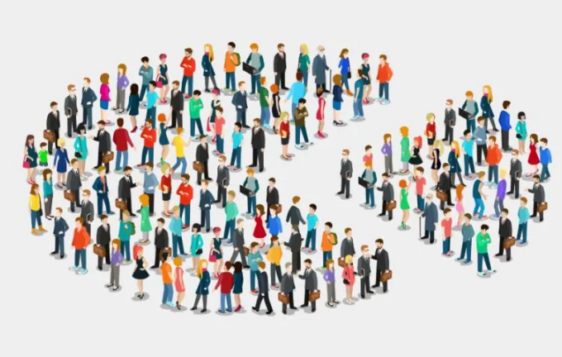
Market segmentation refers to the process of dividing a market into distinct buyer groups based on their specific characteristics, needs, or behaviours (Monil et al. 2020). It helps to apply targeted marketing efforts or provide unique products. Besides, psychographic variables are also used by some firms that offer multiple brands as stated by Kotler et al. (2020, pp. 200-203). Starbucks operates in the global market, which involves diverse and a massive customer base. Thus, it categorises the market into geographic, demographic, psychographic, and behavioural segments to understand the needs of customer groups effectively.
Geographic segmentation
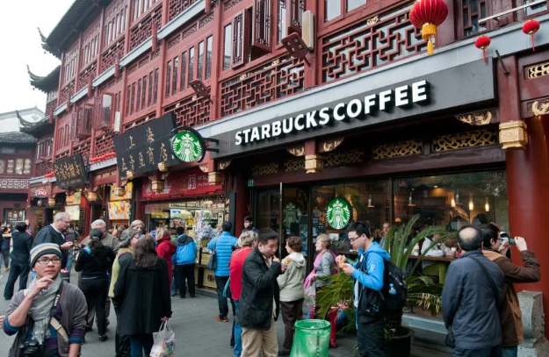
Geographic segmentation plays a crucial role in the targeting strategy of Starbucks, as it operates multiple chains across different nations worldwide. Starbucks primarily divides the geographic market based on regions. For instance, the primary market of the firm is the USA. It also operates in Latin America, Canada, Europe, China, Africa, the Middle East, and the Asia Pacific (Dudovskiy, 2022). Australia has few Starbucks stores. On the other hand, the firm mostly operates in densely populated areas, such as urban and semi-urban areas. Thus, Greater London and other populated areas of the UK have many Starbucks cafes.
Demographic segmentation
Starbucks focuses on both men and women, including graduate or postgraduate students and working professionals, aged between 18 and 60 years. The firm also targets single individuals, married couples with no children as well as older married couples. Typically, most consumers of Starbucks in the UK are highly educated and come from professional backgrounds.
Behavioural segmentation
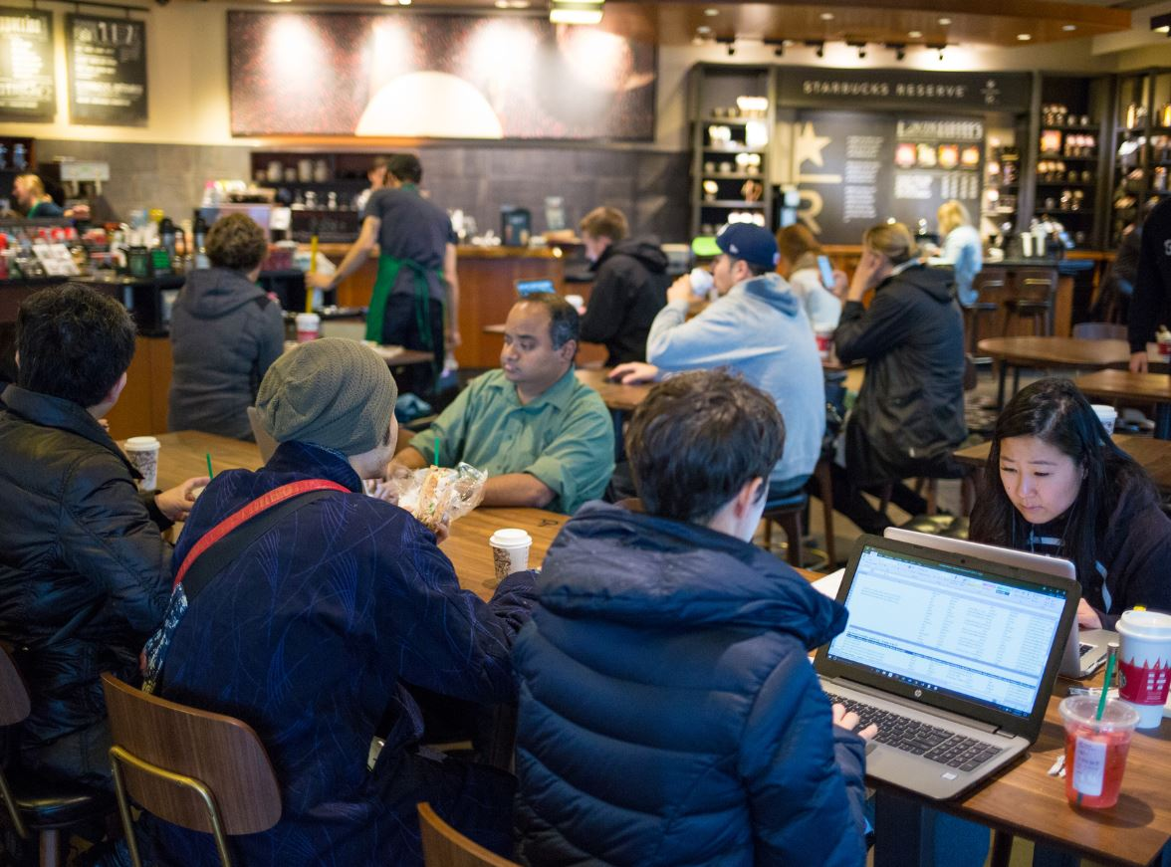
Starbucks employs behavioural segmentation to focus on customers based on their shopping patterns or habits, and convenience. For example, some customers expect a relaxing atmosphere to enjoy their quality coffee, while some people want a place to talk with relatives and friends. In this context, Starbucks encourages such customers to visit their shop and enjoy their leisure time in the relaxing environment of the coffee shop (Aryani et al. 2021). Besides, Starbucks also offers a workspace for customers.
Starbucks categorises regular customers and encourages them to purchase additional food or beverages at different hours of the day. Non-coffee drinkers targeted, who want to enjoy diverse beverages and food offered by Starbucks. Besides, serious coffee lovers or drinkers are targeted, who typically have high incomes and prefer top-quality coffee beans to satisfy their taste.
Psychographic segmentation
Starbucks applies diverse psychographic variables to find potential customers. It categorises the social class of customers to target the upper and middle class of the UK population, as they can afford various products easily. Besides, psychographic segmentation focuses on diverse customers based on their lifestyles. For instance, independent, extroverts, adventurers, learners, extroverts, and aspirers are targeted by Starbucks.

Advantages of segmentation
it helps the company to accelerate its business worldwide by targeting a large group of young people who has high-status desires. The company has a huge group of millennial customers who are loyal to its brand as it is accelerating the business by adapting the modern lifestyle (Fromm, 2014).
Disadvantages of segmentation
the disadvantages of segmentation include the specified group of people. As the company is focusing a specific age group that has the same desires which might hinder the company’s sales growth. Additionally, the company targets the affluent community, which may leave out those who cannot afford to spend money on expensive coffee (Rafii, 2013).

Targeting

Targeting refers to the specific groups or segments to which a company aims to sell its products or services (Lies, 2019). Starbucks has applied diverse targeting strategies to attract local and international customers around the world.
High-income individuals, big spenders: The coffeehouse primarily targets individuals, who have $75,000 or more income (Duncza, 2021). The strategic placement of Starbucks cafes in the UK’s affluent areas helps in this type of targeting. Besides, the firm also attracts middle-income customers surrounding the neighbourhoods of these cafes.
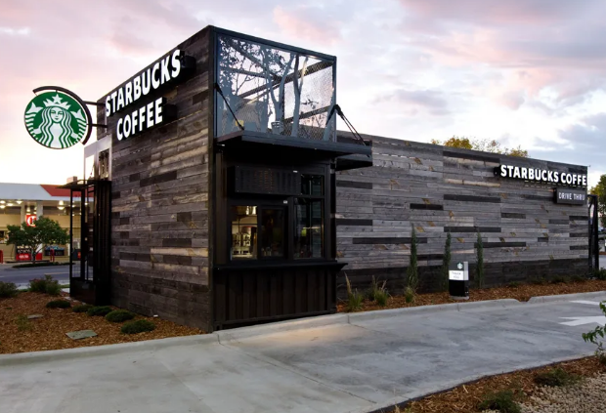
Busy urban areas and suburbs: Starbucks targets the population residing in urban or city areas including the outskirts of cities. This suburban citizen leads a busy lifestyle and often commutes by car or other vehicles to work, stores, gyms, and other places. Thus, they often prefer coffee purchases to refresh their brain and body with strong caffeine (Kusumo et al. 2020). Moreover, they could also purchase various food items and beverages from the cafe. Considering such lifestyles in suburbs and major cities, Starbucks has established numerous cafes in Greater London and other busy areas. Starbucks has partnered with Uber Eats and other platforms to offer swift delivery services.
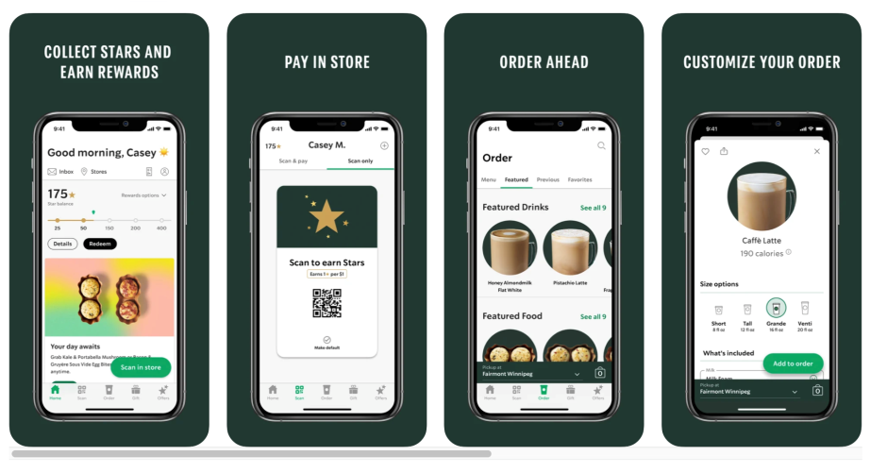
Technology adopters: The firm targets tech-savvy audiences from different age groups, primarily teenagers. These individuals use smartphones and other gadgets, which allow them to use mobile apps and obtain a personalised experience by booking orders and making online payments (Kusumo et al. 2020)). Besides, free Wi-Fi in cafes increased the convenience of customers to set up the office.
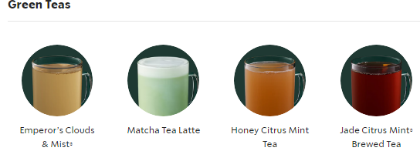
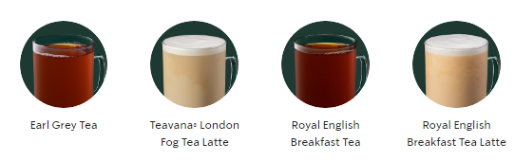
Health-conscious customers: Starbucks promotes healthy food and beverages such as decaf tea, green tea, wellness tea, Royal English Breakfast tea-latte, etc to attract health-conscious individuals (Basak et al. 2020).

Socially-aware people: It promotes diverse eco-friendly practices, which include the use of recycled cups, sustainable coffee production, and minimised carbon footprint. Such programs encourage responsible citizens to purchase products.

Positioning

Starbucks has strategically established its brand identity by promoting it on coffee culture and prioritising customer needs. Diverse values such as quality, reliability, and innovation have been integrated to develop effective marketing strategies, which helped Starbucks to become a global brand. The company used 4 different positioning strategies to strengthen and maintain its brand position around the world including the UK.
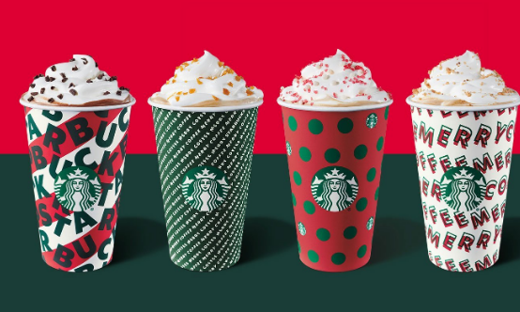
Monopolistic positioning: Starbucks targets premium customers, who are willing to pay a high price for the quality products and services offered (Duncza, 2021). Although this positioning reduces sales in some contexts, the approach helped the firm to establish itself as a premium brand.
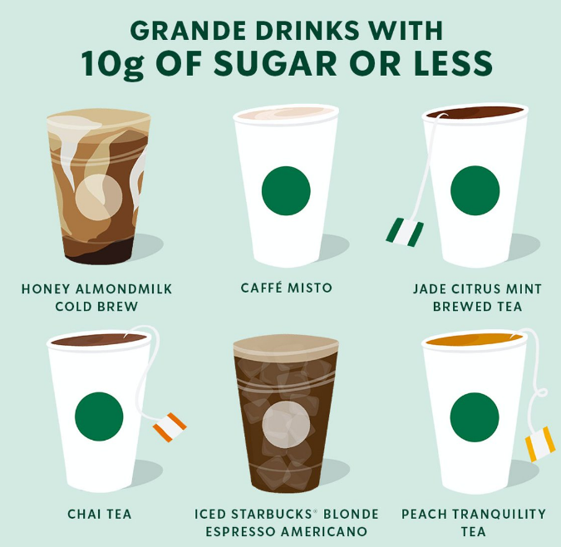
Adaptive positioning: The growing health consciousness of consumers encouraged Starbucks to low-calorie coffee beverages and other products. For instance, Iced Americano contains 11 calories and Caffe Misto contains 63 calories. Such products positioned Starbucks as a health-conscious brand.
Standby positioning: Starbucks has introduced some unique beverages, which are not available in the market. Frappuccino is such a standout innovation, which does not have sufficient market demand. However, it can create a major edge for Starbucks.
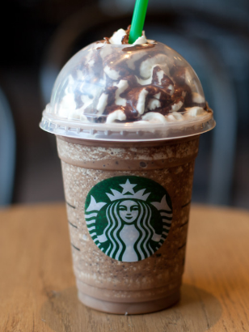
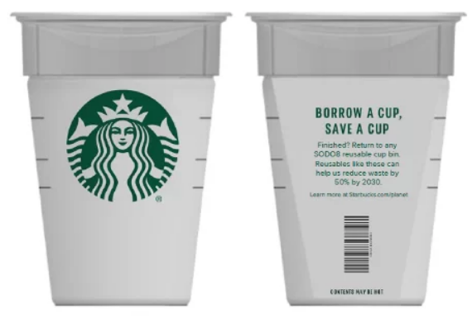
Sustainability positioning: Starbucks is committed to integrate the sustainability principle in all business processes. In this context, Starbucks has launched Greener Stores, which focuses on reduced water consumption, lower emissions, and effective waste management. It also introduced eco-friendly cups and carry bags made of recycled materials (Choudhary and Agarwal, 2021). Thus, Starbucks is promoting its responsible brand image.

Current marketing mix

The marketing mix incorporates diverse marketing tools and strategies, which are used to promote and position products and services through combined marketing efforts. Starbucks has created innovative marketing mix with product, price, place, and promotion to create a strong brand image, which ensures sales and profit.

Starbucks Products
It offers premium quality products based on local taste. It uses premium Arabica beans to offer the best taste to coffee lovers (Kusumo et al. 2020). It produces diverse coffee products such as coffee, latte, and smoothies with distinct flavours.
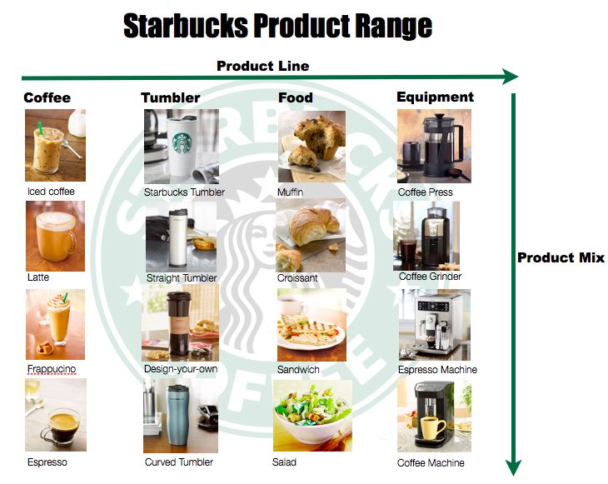
Starbucks also offers tea and other beverages along with snacks, baked goods, and diverse premium food items. All the products have top quality. Besides, Starbucks introduces various seasonal and limited-edition beverages to drive excitement and meet changing customer preferences.

Placement strategy
Starbucks' strategic location choices have been critical to its success.
Direct channels
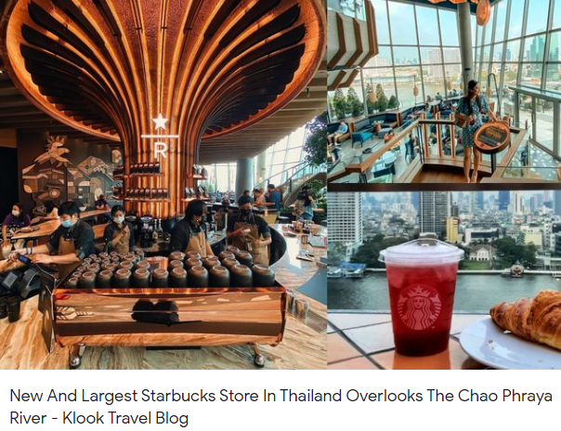
The company strategically places its stores in high-traffic areas like shopping malls, busy streets, airports, train stations, and commercial centres, which draw the attention of customers (Susilo and Mendoza, 2023). Starbucks designs stores uniquely based on the locations and cultures, which attract customers effectively. Thus, they sell products directly. It also sells through mobile apps
Indirect channels
Starbucks' distribute products through franchises and retailers. It has around 19,767 stores over 62 nations across the world (Zhang and Xue, 2022).

Starbucks’ Pricing Strategy
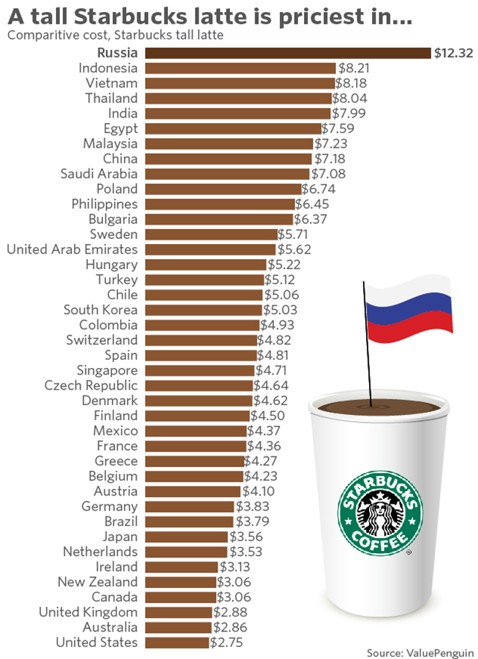
Starbucks uses a value-based pricing strategy worldwide, which is devolved based on the perceived value of customers (Pandey et al. 2021). Typically, Starbucks set prices of products and services based on the quality, customer experience, and atmosphere of its stores. This type of flexible pricing encourages customers to pay higher prices and enjoy the product. The strategy reinforces the premium brand’s image as well as maintains a loyal consumer base.

Promotion Strategies
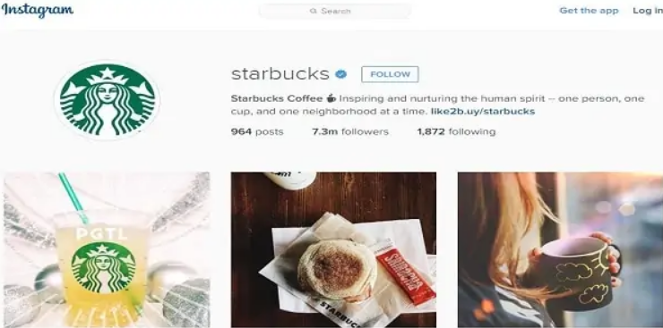
Starbucks effectively uses various promotional tactics to maintain and expand its customer base. The company heavily relies on social media such as YouTube, Twitter, Pinterest, etc., to engage its target audience (Duncza, 2021). Interactive campaigns, and influencer marketing are used in these platforms are used to promote products.
Pi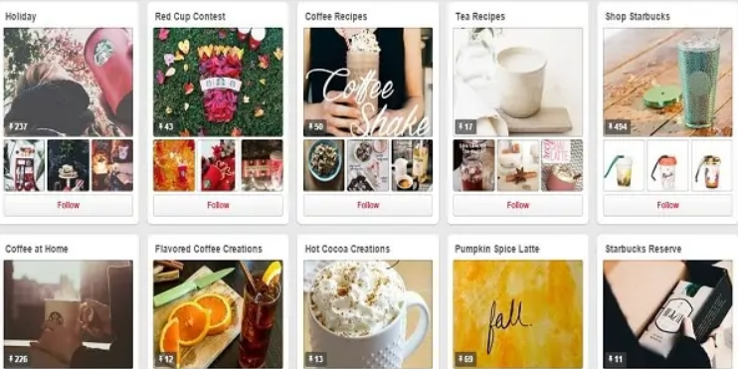
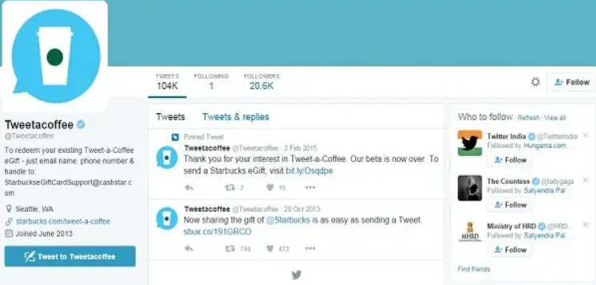
However, Starbucks rarely uses traditional marketing components such as newspapers, magazines, and billboards. Starbucks prefer word-of-mouth to spread brand awareness and attract customer. Moreover, Starbucks' loyalty program and mobile app incentivize customers to make repeat purchases, by offering various discounts and special offers. Thus, it fosters brand loyalty.

Instagram: https://www.instagram.com/starbucks/?hl=en
Twitter: https://twitter.com/Starbucks
Facebook: https://www.facebook.com/Starbucks/
YouTube: https://www.youtube.com/starbucks
LinkedIn: https://www.linkedin.com/company/starbucks

References
Aryani, D.N., Singh, P., Liew, Y.W., Kee, D.M.H., Li, Y., Li, J., Lim, C.Y. and Arif, W., 2021. How brand reputation influences customer satisfaction: A case study of Starbucks, Malaysia. International journal of Tourism and hospitality in Asia Pasific (IJTHAP), 4(3), pp.60-72.
Basak, S., Ranjith, P.V., Prakash, P.A., Albesis, G., Quttainah, M.A., Shukla, S. and Pandey, R., 2020. Business Idea for Starbucks: Organic Yerba Mate Beverages. International Journal of Tourism and Hospitality in Asia Pasific (IJTHAP), 3(2), pp.89-96.
Brassington, F. and Pettitt, S. (2006) Principles of Marketing. 6th end. Essex: Pearson Education.
Choudhary, H. and Agarwal, P. (2021) Green Marketing: Need of the 21st century.
Dooley, R. (2013) 'Starbucks: Loyalty Program Misfire', Forbes, 23 July [Online]. Available at: http://www.forbes.com/ sites/rogerdooley/2013/07/23/starbucks-gold/ (Accessed: 13 May 2014)
Dudovskiy, J., 2022, October 07. Starbucks Segmentation, Targeting and Positioning – Targeting Premium Customers with Quality Products and Service. [online]. Available at https://research-methodology.net/starbucks-segmentation-targeting-and-positioning-targeting-premium-customers-with-quality-products-and-service/
Duncza, L., 2021. ‘Starbucks Social Media Strategy Report’, Kelly Anderson (Accessed: 7 December 2020)
Fromm, J. (2014) Why Starbucks is Still Number One With Millennials. Available at: http://millennialmarketing.com/ 2014/02/why-starbucks-is-still-number-one-with-millennials/ (Accessed: 3 May 2014)
Gregory, L. (2022) Starbucks Mission Statement & Vision Statement (An Analysis). Available at: https://panmore.com/starbucks-coffee-vision-statement-mission-statement (Accessed: 18 June 2022).
Kotler, P. et al. (2020) Principles of marketing. 8th edn. Harlow, England: Pearson.
Kusumo, E., Anita, T.L. and Anggiani, S., 2020. Corporate Language as Corporate Strategy to Sustainable Brand in Indonesia (Case of Starbuck Language). In Culture, People and Technology: The Driving Forces for Tourism Cities Proceedings of 8th ITSA Biennial Conference 2020 (p. 256).
Lies, j. (2019) 'Marketing Intelligence and Big Data: Digital Marketing Techniques on their Way to Becoming Social Engineering Techniques in Marketing’, International Journal of Interactive Multimedia and Artificial Intelligence, Vol. 5, No 5
Monil, P., Darshan, P., Jecky, R., Vimarsh, C. and Bhatt, B.R. (2020) Customer segmentation using machine learning. International Journal for Research in Applied Science and Engineering Technology (IJRASET), 8(6), pp.2104-2108.
Pandey, R., Ganatra, V., Jamnik, S., Goel, P., Goyal, P., Xuan, C.L., Kee, D.M.H., Mein, H.H., En, L.X. and Zen, L.J., (2021) An empirical study on customer satisfaction, perception, and brand image in Starbucks Coffee in India, Asia. International Journal of Tourism and Hospitality in Asia Pasific (IJTHAP), 4(1), pp.53-63.
Rafii, L. (2013) 'The Starbucks or McCafé Crowd: Who Counts More Politically?', Huffington Post, 11 December [Online]. http://www.huffingtonpost.com/ladan-rafii/the-starbucks-or-mccafe-c_b_4262104.html (Accessed: 3 May 2014).
Starbucks., (2023) Our Company. [online]. Available at https://www.starbucks.com/about-us/
Susilo, D. and Mendoza, C.M.T. (2023) MARKETING MODEL OF STARBUCKS: A SUSTAINABILITY MONETIZATION. Jurnal Ekonomi, 12(02), pp.1182-1190.
Zhang, L. and Xue, B. (2022) Strategic Analysis of Starbucks. Financial Engineering and Risk Management, 5(7), pp.106-113.

