Additional boundary maps

We now need to download two additional maps of the Swansea area. LSOA and MSOA.
They work in the same way as the original OA map but allow us to split the data into larger sectors.
Remember to change the format to native MapInfo every time.

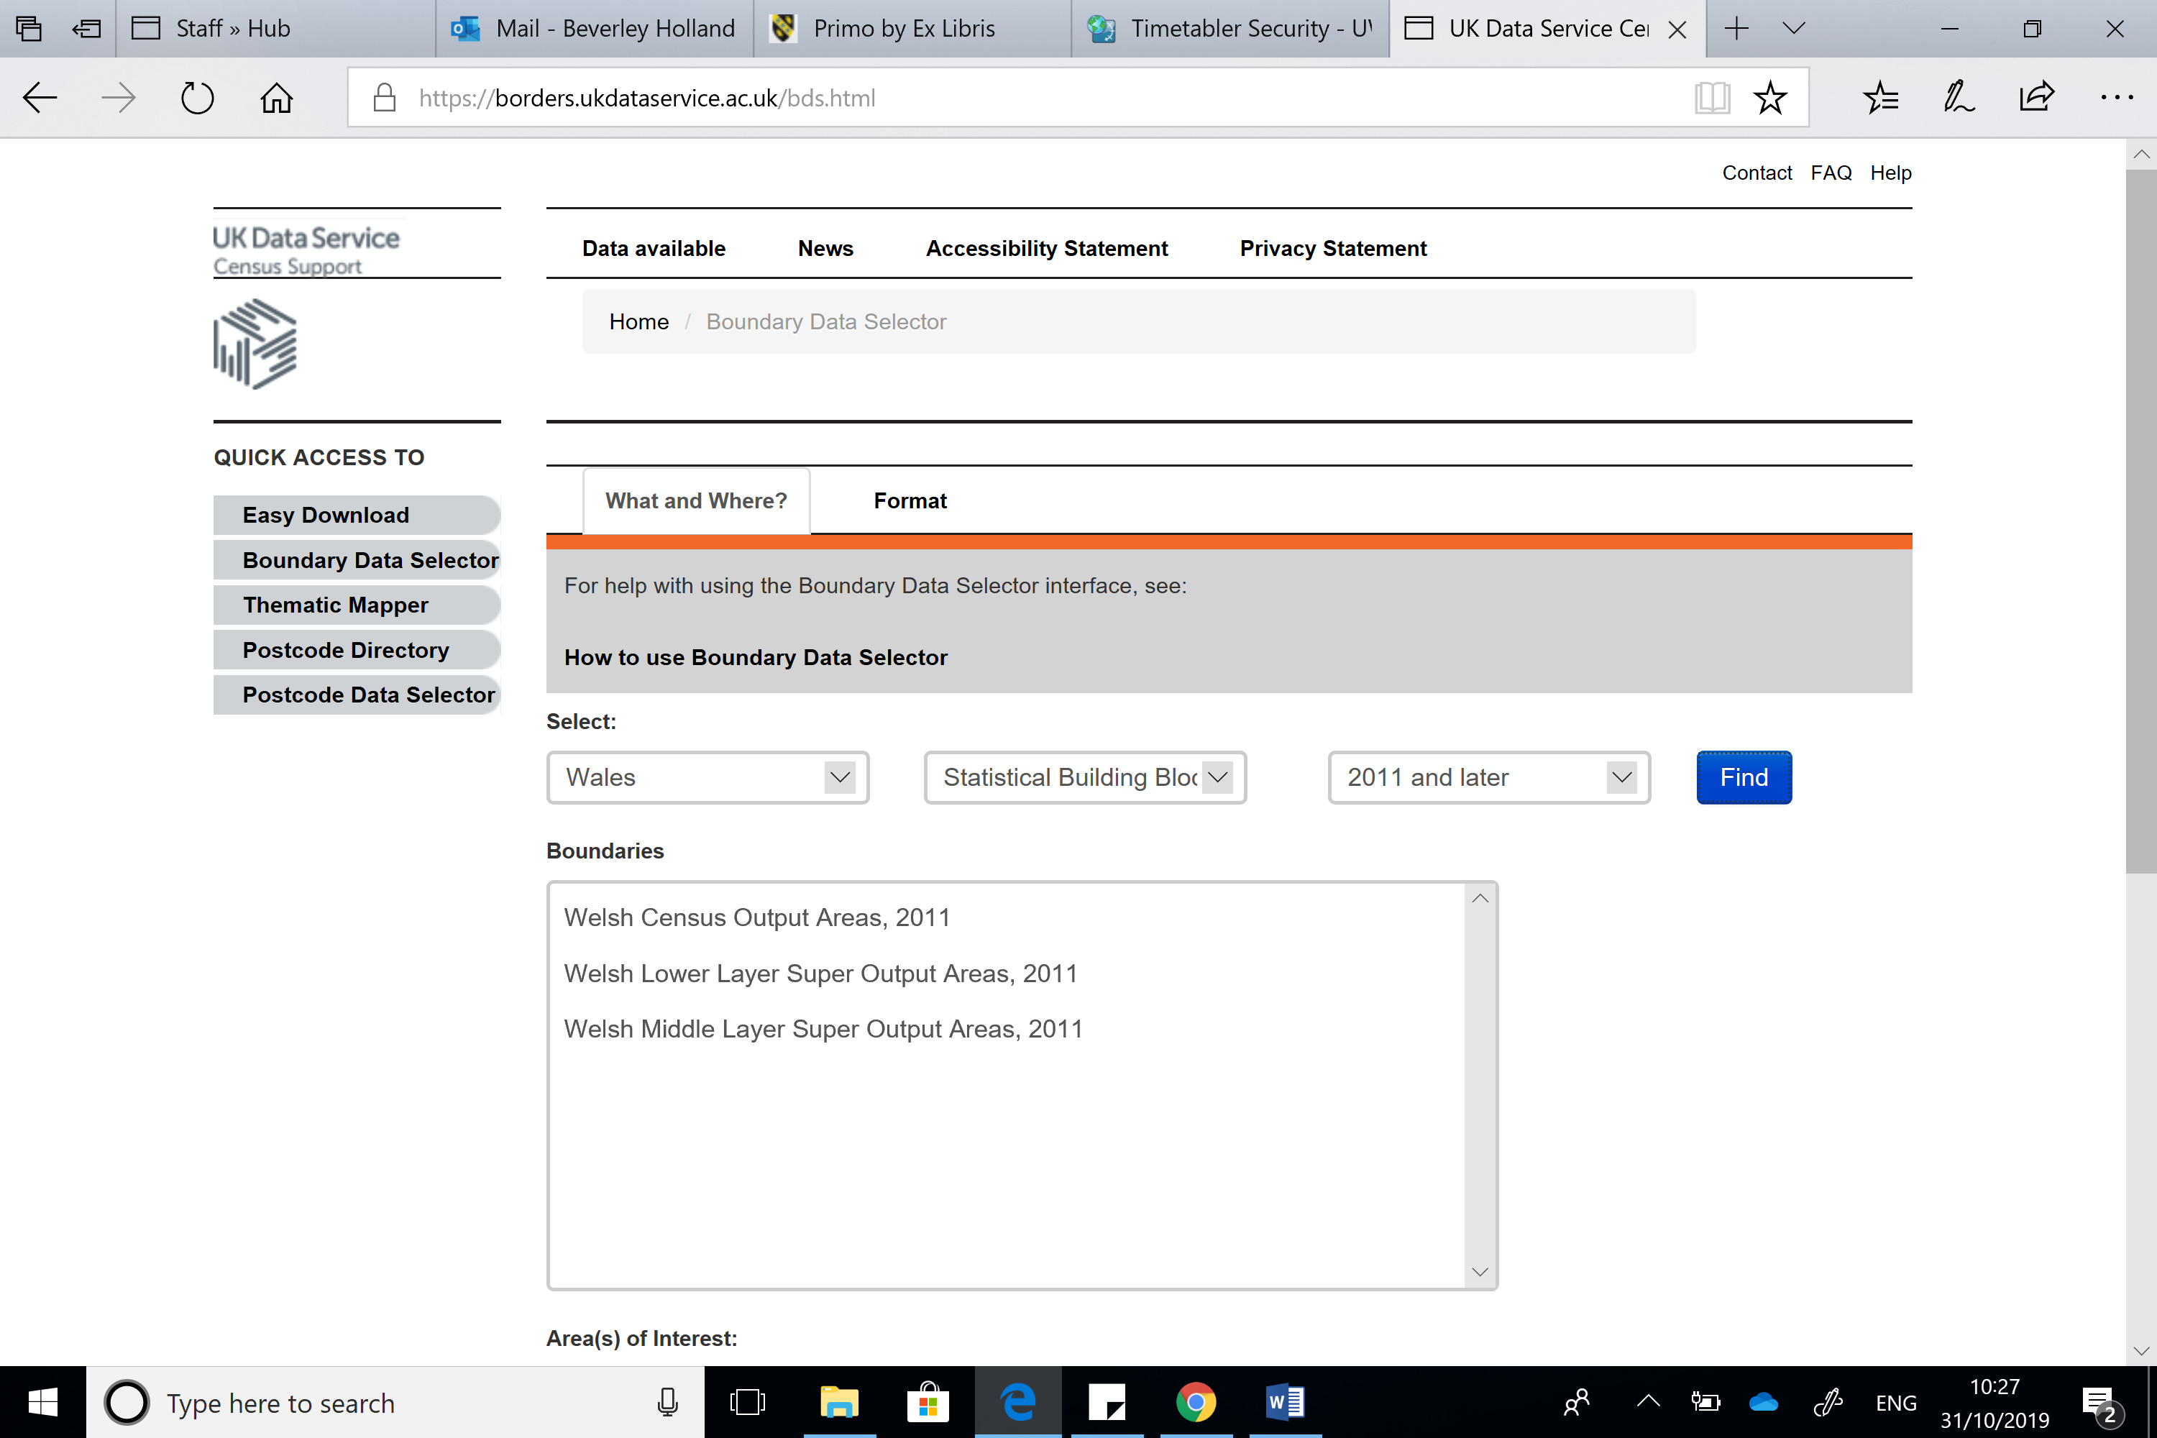

Once again you will note that the maps are prefixed with Wales_lsoa_2011 and Wales_msoa_2011.

The easiest way to save them as a Swansea file is to use the GIS software. Open all the files in MapInfo. Wales_OA, Wales_LSOA and Wales_MSOA.

Using the SAVE COPY AS function select each Map / table and save them back to the same folder but now calling them Swansea_OA etc……

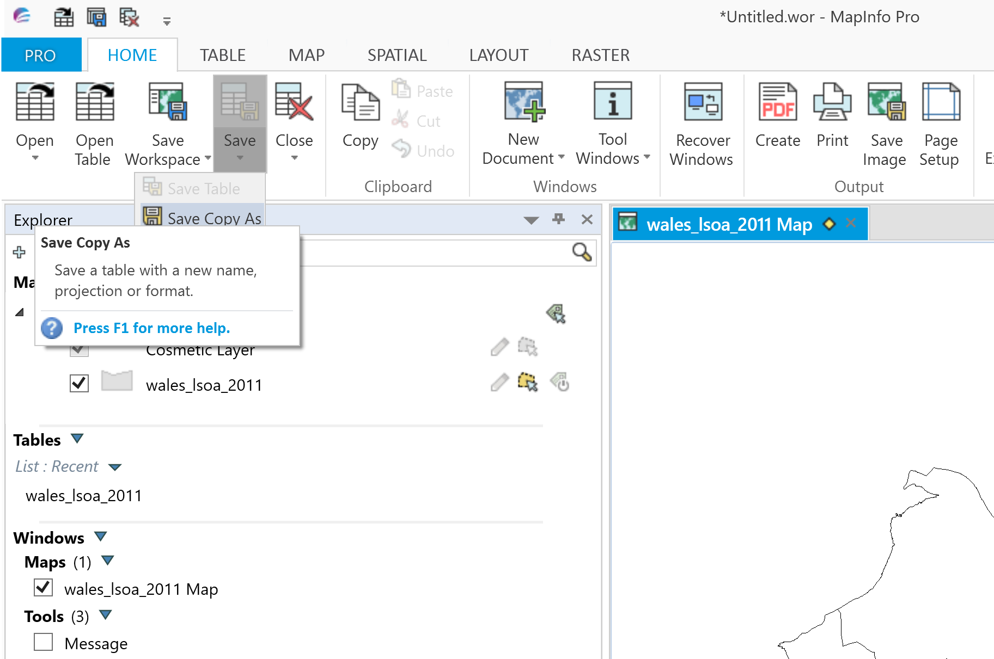

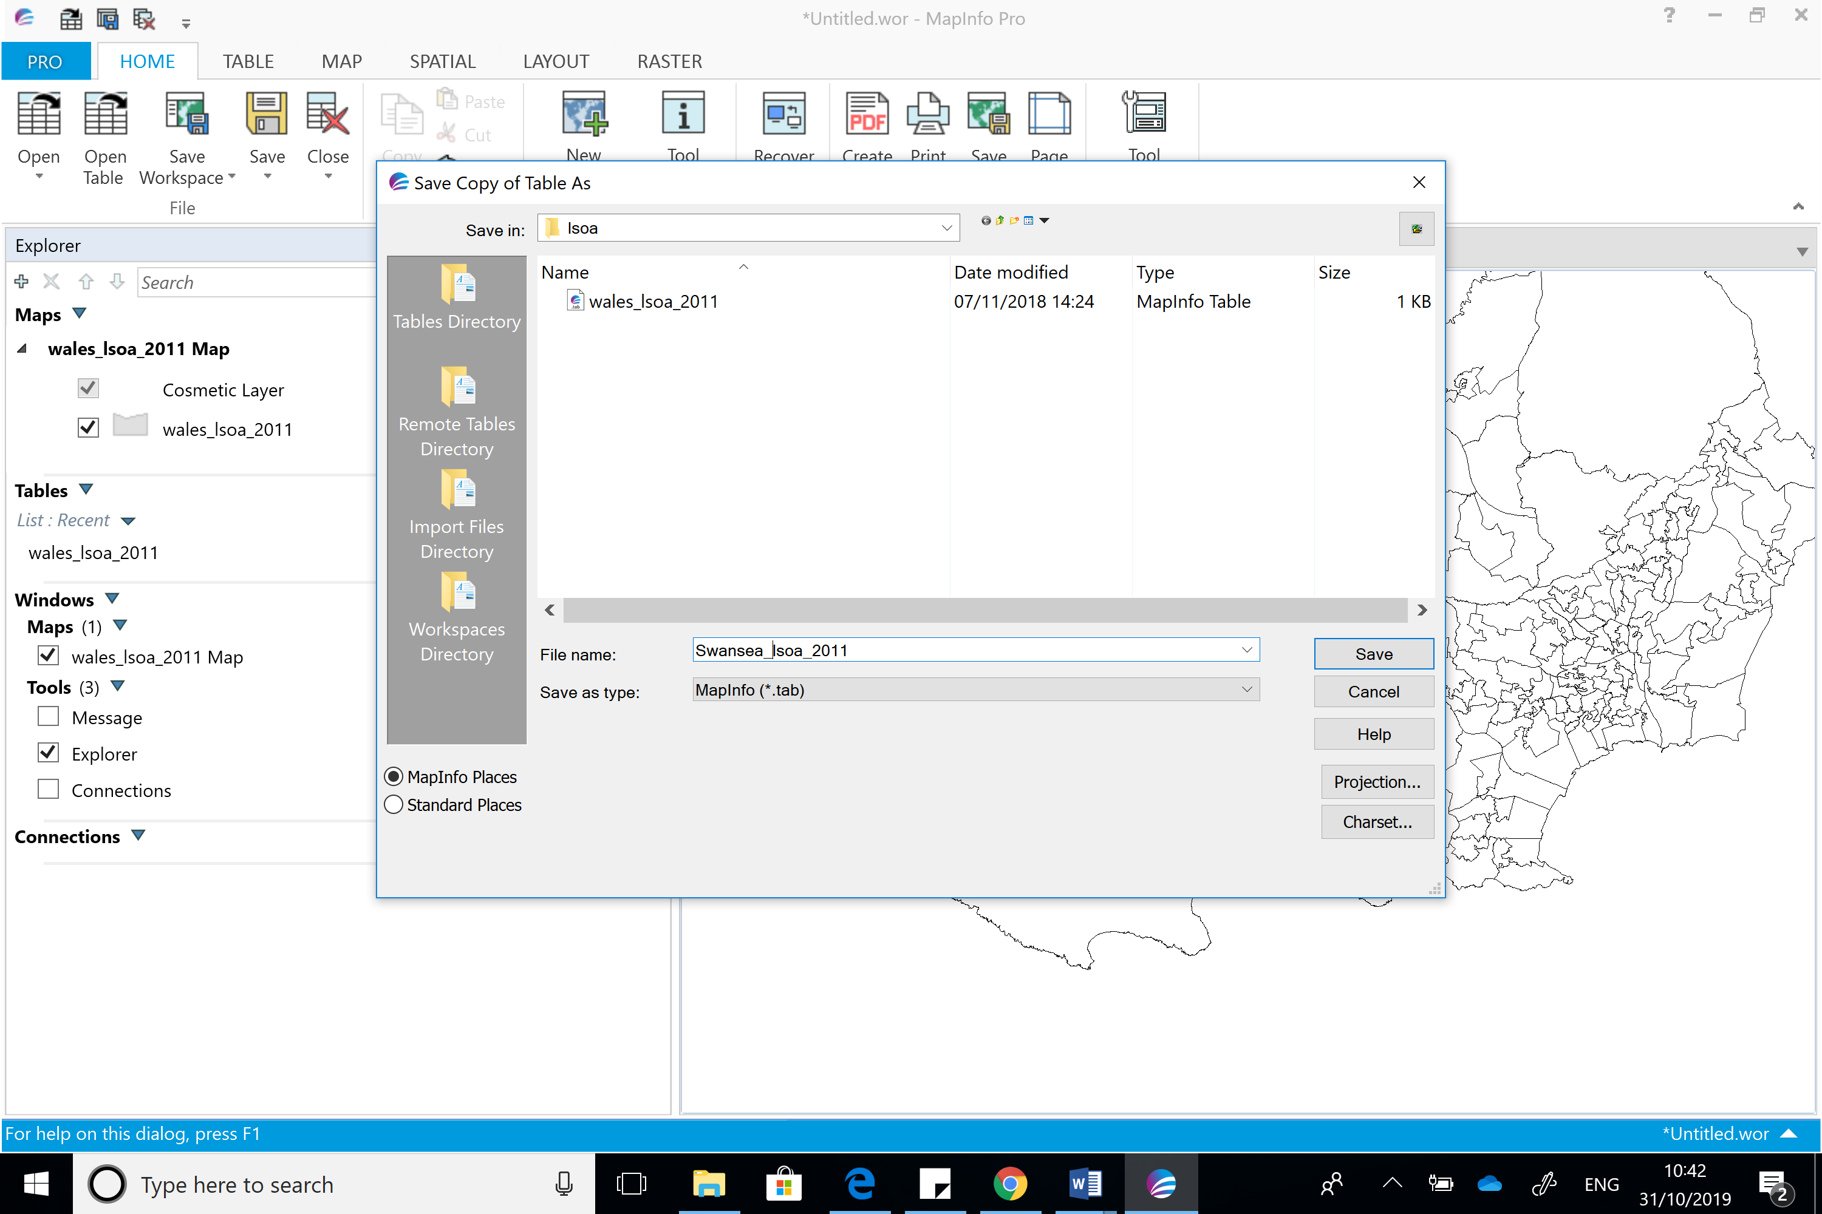

Your file directory should look something like this:-

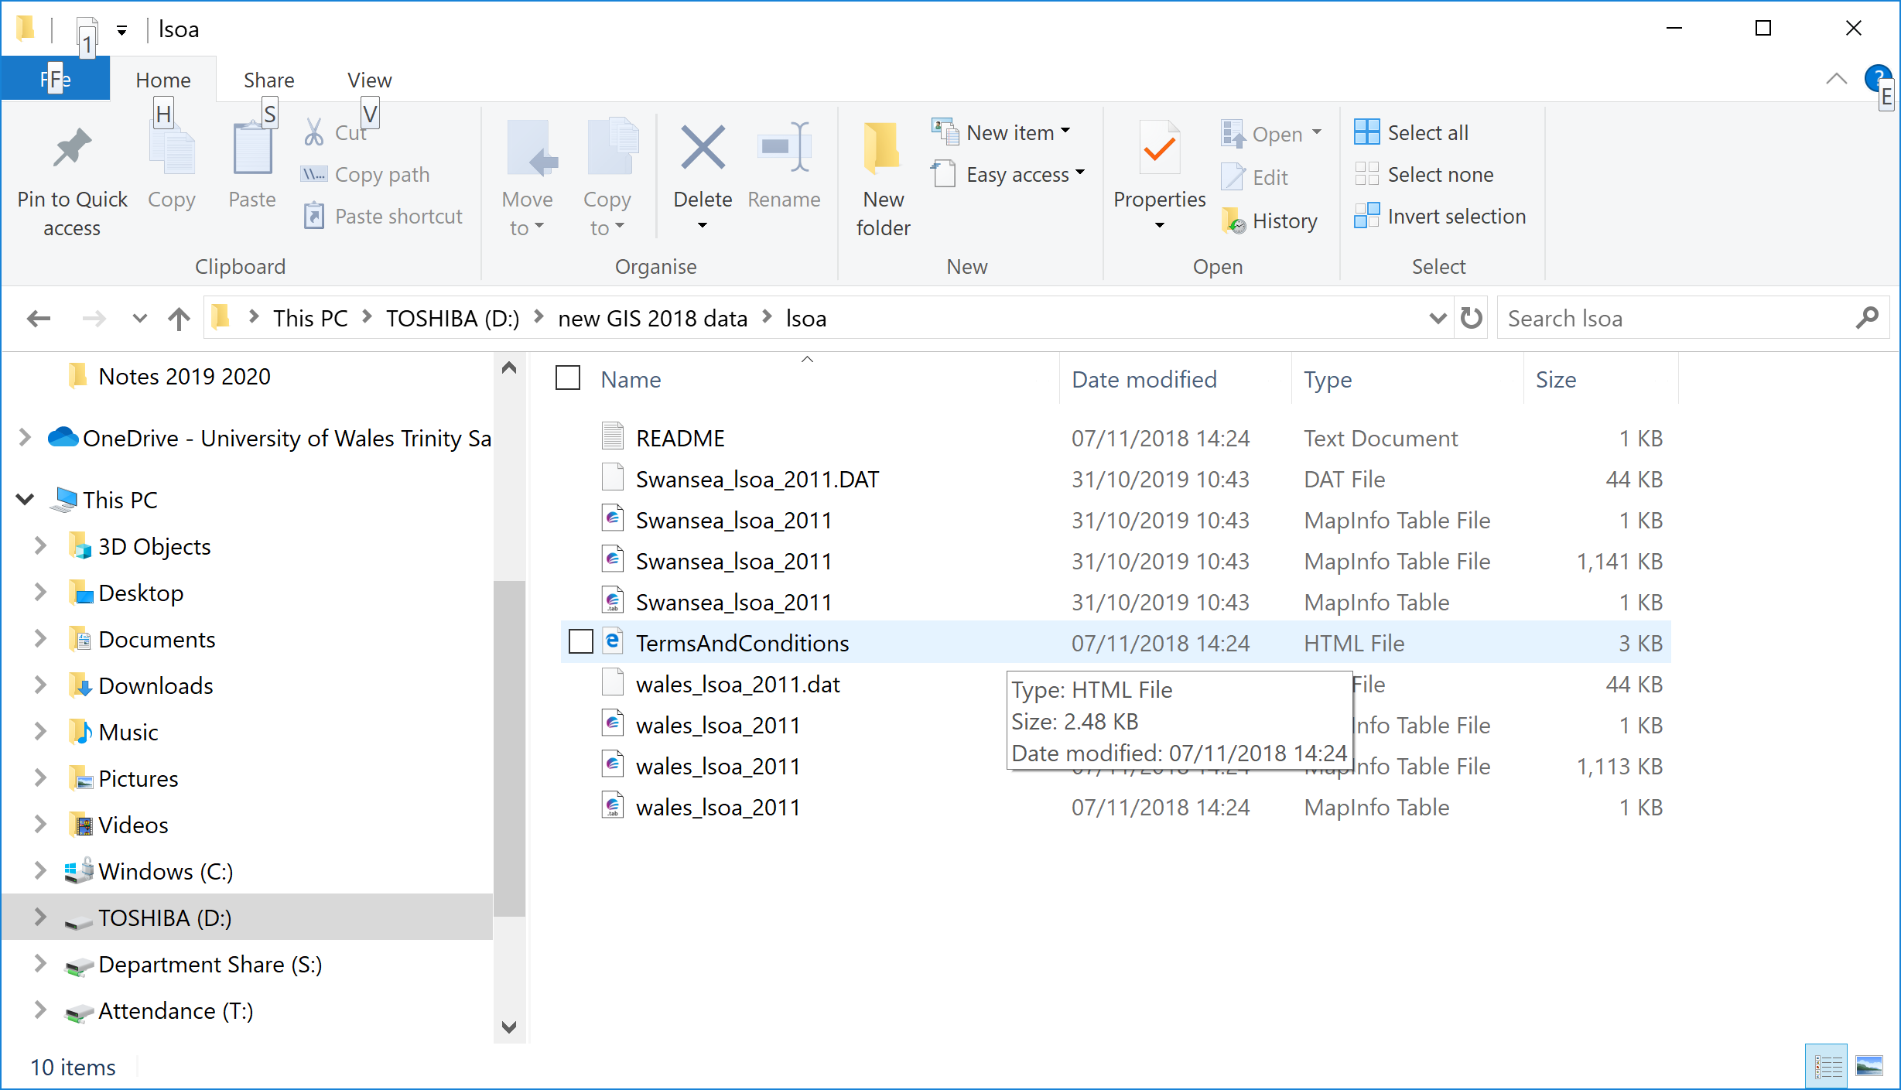
Eventually we can delete the Wales map and just have the Swansea map. Therefor we can download other areas in Wales without overwriting our files.

Once we have renamed all the map files we can restart MapInfo and load up the Swansea Maps.

