

Program Name | MBA
Module Name | DISSERTATION
Module Code | LCMB7035
Supervisor | Jean wang
Student Name | Divyesh Sureshbhai Rokad
Student ID | 2430637

Topic: “The Impact of Social Media Advertising on Purchase Intentions of Smartphones among University Students in India”

Table of Contents

Abstract 5
CHAPTER 1 – INTRODUCTION 6
1.1 Background of the Study 6
1.2 Problem Statement 8
1.3 Research Aim 10
1.4 Research Objectives 10
1.5 Research Questions 11
1.6 Significance of the Study 11
CHAPTER 2: LITERATURE REVIEW 13
2.1 Introduction (Literature Review) 13
2.2 Social Media Advertising 14
2.3 Consumer Behaviour 16
2.4 Purchase Intention 17
2.5 Factors Influencing Purchase Intention 18
2.5.1 Trust and Credibility 18
2.5.2 Influencer Marketing 19
2.5.3 Content Quality 20
2.5.4 Engagement 20
2.5.5 Frequency of Exposure 21
2.6 Theoretical Framework 22
2.6.1 Theory of Planned Behaviour (TPB) 22
2.6.2 Technology Acceptance Model (TAM) 23
2.6.3 Integration of TPB - Theory of Planned Behaviour And TAM-Technology Acceptance Model 24
2.6.4 Relevance to the Study 25
2.7 Research Gap 25
2.8 Conceptual Framework 26
2.9 Hypothesis 28
CHAPTER 3: METHODOLOGY 28
3.1 Introduction 28
3.2 Research Approach 29
3.3 Research Design 29
3.4 Data Collection Method 30
3.5 Sampling 31
3.6 Data Collection Tool 32
3.7 Questionnaire Design 32
3.8 Data Analysis Techniques 34
3.9 Ethical Considerations 34
3.10 Limitations 35
Chapter 4: Findings and Analysis 36
4.1 Introduction 36
4.2 Demographic Analysis 36
4.3 Social Media Usage Analysis 38
4.5 Analysis of Influencer Marketing 42
4.6 Analysis of Content Quality and Engagement 43
4.7 Analysis of Frequency of Exposure 45
4.8 Hypothesis Testing 47
Hypothesis 1 (H1) 48
Hypothesis 2 (H2) 48
Hypothesis 3 (H3) 48
4.9 Discussion of Findings 49
4.10 Chapter Summary 51
CHAPTER 5: CONCLUSION AND RECOMMENDATIONS 52
5.1 Introduction 52
5.2 Conclusion 52
5.3 Recommendations 54
5.4 Limitations of the Study and Future Research 55
5.5 Contribution of the Study 56
References 59
Appendix 65

Abstract
The rapid growth of social media platforms has significantly transformed modern marketing strategies and consumer behaviour, particularly among younger consumers. This study investigates the impact of social media advertising on smartphone purchase intention among university students in India. The research focuses on examining how factors such as influencer marketing, trust, content quality, engagement and frequency of exposure influence purchasing decisions within digital environments.
A quantitative research approach was adopted, and primary data was collected through an online questionnaire distributed to university students in India. The collected data was analysed using descriptive statistical techniques including percentages, charts and graphical analysis. The findings revealed that social media platforms such as Instagram and YouTube significantly influence consumer awareness, attitudes and purchase intention towards smartphones. The study also found that visually appealing and informative advertisements, along with influencer recommendations, positively affect consumer trust and engagement.
Furthermore, the research concluded that social media advertising has become an effective marketing tool for smartphone companies targeting younger audiences. However, excessive advertising and misleading promotional content may negatively affect consumer trust and attitudes. Overall, the study contributes to the understanding of digital consumer behaviour and highlights the importance of effective social media marketing strategies in influencing smartphone purchase intention among university students in India.

CHAPTER 1 – INTRODUCTION

1.1 Background of the Study
In the field of marketing and consumer behaviour, purchase intention is considered one of the most important constructs for understanding how consumers make buying decisions. Purchase intention refers to the likelihood or willingness of a consumer to purchase a particular product or service in the future. It serves as a strong predictor of actual buying behaviour and is widely used by researchers and organisations to evaluate the effectiveness of marketing strategies (Ajzen, 1991; Dodds et al., 1991). Rather than focusing solely on completed purchases, analysing purchase intention allows marketers to understand consumer decision-making processes at an earlier stage, enabling them to influence outcomes more effectively.
The development of purchase intention is influenced by multiple factors, including consumer attitudes, perceptions, social influence, and exposure to marketing communication. According to the Theory of Planned Behaviour, purchase intention is shaped by an individual’s attitude toward a product, subjective norms, and perceived behavioural control (Ajzen, 1991). In modern digital environments, these elements are increasingly shaped by online interactions, particularly through social media platforms. As a result, the role of social media in influencing purchase intention has become a critical area of study in recent years.
Social media platforms such as Instagram, YouTube, Facebook, and Twitter have transformed the way consumers access information and interact with brands. These platforms allow users to engage with content, share opinions, and observe the behaviour of others, all of which contribute to the formation of purchase intention. Unlike traditional advertising channels, social media provides a highly interactive and personalised environment where consumers are not only passive receivers of information but also active participants in content creation and dissemination (Kaplan and Haenlein, 2010). This shift has significantly increased the importance of understanding how social media influences consumer intentions and behaviour.
One of the key ways in which social media affects purchase intention is through continuous exposure to advertising content. Social media platforms use advanced algorithms to deliver targeted advertisements based on user preferences, interests, and online behaviour. This targeted approach increases the relevance of advertisements, making them more likely to influence consumer attitudes and purchase intention. Repeated exposure to such content can create familiarity and reinforce brand recognition, which may positively impact the likelihood of purchase intention (Dehghani and Tumer, 2015).
In addition to direct advertising, social media also facilitates indirect influences on purchase intention through user-generated content and peer interactions. Consumers often rely on reviews, comments, and recommendations from other users when evaluating products. This form of social proof plays a significant role in shaping purchase intention, as individuals tend to trust the opinions of others, especially those within their social networks (Brodie et al., 2013). Among younger consumers, such as university students, peer influence and social validation are particularly strong determinants of purchase intention.
Trust is another crucial factor in the development of purchase intention in digital environments. Since consumers cannot physically examine products online, they depend on the credibility of information available on social media platforms. Trust in the source of information, whether it is a brand, influencer, or peer, significantly affects the likelihood of forming a purchase intention (Gefen et al., 2003). Social media advertising can enhance trust when it is perceived as authentic and transparent, but it can also reduce trust if consumers believe that the content is misleading or overly promotional.
The concept of engagement further strengthens the relationship between social media and purchase intention. Engagement refers to the level of interaction between users and content, including activities such as liking, commenting, sharing, and viewing advertisements. High levels of engagement indicate greater consumer involvement and interest, which can lead to stronger emotional connections with a brand and increase purchase intention (Brodie et al., 2013). Social media platforms are specifically designed to maximise user engagement, making them effective tools for influencing consumer behaviour.
In the context of India, the influence of social media on purchase intention is particularly significant due to the rapid growth of internet usage and digital connectivity. India has one of the largest populations of internet users globally, with a substantial proportion consisting of young individuals, especially university students. This demographic is highly active on social media platforms and is frequently exposed to digital advertising, making them an important group for studying purchase intention (Statista, 2023).
The smartphone industry provides a relevant and dynamic context for examining purchase intention. Smartphones are essential products that combine functionality, technology, and personal expression. Purchasing decisions in this category are often influenced by multiple factors, including brand image, product features, price, and social influence. Social media advertising plays a significant role in highlighting these factors and shaping consumer perceptions, thereby influencing purchase intention (Deloitte, 2022).
Overall, purchase intention is a complex construct influenced by various psychological and social factors, many of which are amplified in digital environments. The increasing reliance on social media for information and communication has made it a critical platform for influencing consumer behaviour. Understanding how purchase intention is formed and influenced in this context is essential for both academic research and practical marketing applications.

1.2 Problem Statement
Purchase intention remains a central concept in marketing research, as it provides insight into the likelihood of consumers engaging in future buying behaviour. While organisations increasingly rely on digital platforms to influence consumer decisions, the effectiveness of these strategies in shaping purchase intention is not always clear. In particular, social media advertising has become a dominant tool for marketers; however, its actual impact on purchase intention, especially within specific demographic and product contexts, remains uncertain.
In recent years, businesses have significantly increased their investment in social media advertising with the expectation that higher visibility and engagement will translate into stronger purchase intention. Social media platforms offer advanced targeting capabilities, enabling marketers to reach specific audiences based on demographics, interests, and behavioural patterns. Despite these advantages, there is limited clarity on whether such targeted advertising consistently leads to a meaningful increase in purchase intention. Consumers are exposed to a vast amount of promotional content daily, which may reduce the effectiveness of advertisements due to information overload and selective attention (Voorveld et al., 2018).
A key issue influencing purchase intention in the digital environment is the growing scepticism among consumers toward online advertising. As social media platforms become saturated with sponsored content, consumers are becoming more aware of marketing tactics, including influencer promotions and paid partnerships. This awareness may lead to reduced trust in advertising content, which is a critical factor in the formation of purchase intention (Gefen et al., 2003). When consumers perceive advertisements as inauthentic or misleading, their intention to purchase may decline, regardless of the frequency or visibility of the advertisement.
Furthermore, there is a lack of consensus regarding which specific elements of social media advertising most significantly influence purchase intention. Factors such as trust, engagement, content quality, and influencer credibility are frequently discussed in the literature; however, their relative importance may vary depending on the target audience and product category. For example, while influencer marketing may strongly impact purchase intention among younger consumers, other factors such as product features or price may play a more dominant role in high-involvement purchases like smartphones. This creates a challenge for marketers in designing strategies that effectively enhance purchase intention.
Another critical limitation in existing research is the lack of context-specific studies focusing on emerging markets such as India. Much of the current literature is based on data from developed countries, where consumer behaviour, technological adoption, and cultural influences may differ significantly. India presents a unique environment characterised by rapid digital growth, diverse consumer preferences, and increasing reliance on social media for information and decision-making. University students in India, in particular, represent a highly active and influential consumer segment, yet their purchase intentions in response to social media advertising remain underexplored.
In addition, the smartphone industry presents a complex and highly competitive market where purchase intention is influenced by multiple factors. Smartphones are high-involvement products, meaning that consumers invest considerable time and effort in evaluating alternatives before making a purchase decision. While social media advertising plays a role in shaping initial perceptions, it is unclear to what extent it influences the final purchase intention compared to other factors such as brand reputation, product specifications, and peer recommendations.
Given these challenges, there is a clear need for research that examines the relationship between social media advertising and purchase intention within a specific and relevant context. This study aims to address this gap by focusing on university students in India and exploring how various elements of social media advertising influence their intention to purchase smartphones. By identifying the key factors that drive or hinder purchase intention, this research seeks to provide valuable insights for both academic understanding and practical marketing strategies.

1.3 Research Aim
The primary aim of this study is to examine the impact of social media advertising on the purchase intention of smartphones among university students in India. In the context of increasing digital engagement and the growing influence of online platforms, this research seeks to understand how exposure to social media advertising contributes to the formation of purchase intention. Specifically, the study focuses on identifying how key elements such as trust, engagement, and advertising content influence consumer attitudes and their likelihood of purchasing a smartphone.
By concentrating on university students as a distinct and digitally active consumer segment, the research aims to provide a deeper understanding of how purchase intention is shaped within this group. Ultimately, the study intends to contribute to both academic knowledge and practical marketing strategies by offering insights into how social media advertising can be effectively utilised to enhance purchase intention in the smartphone market.

1.4 Research Objectives
The objectives of this study are designed to support the research aim and provide a structured approach to examining purchase intention in the context of social media advertising. The specific objectives are as follows:
- To examine the relationship between social media advertising and purchase intention of smartphones among university students in India.
- To identify the key factors influencing purchase intention, including trust, engagement, within social media advertising.
- To evaluate how different forms of social media advertising contribute to the development of purchase intention among university students.
- To analyse the extent to which exposure to social media advertisements affects the likelihood of purchase intention.

1.5 Research Questions
This study is guided by the following research questions, which are designed to examine the impact of social media advertising on purchase intention among university students in India:
- How does social media advertising influence the purchase intention of smartphones among university students in India?
- What key factors, such as trust, engagement, affect purchase intention in the context of social media advertising?
- How does exposure to social media advertisements influence the likelihood of purchase intention among university students?

1.6 Significance of the Study
This study is significant as it provides a focused understanding of purchase intention within the context of social media advertising, particularly in the smartphone industry among university students in India. As digital platforms continue to reshape consumer behaviour, examining how purchase intention is formed and influenced has become increasingly important for both academic research and practical applications.
From an academic perspective, this research contributes to the existing body of knowledge by offering a context-specific analysis of purchase intention. While previous studies have explored consumer behaviour in general, there is limited research that focuses specifically on the relationship between social media advertising and purchase intention within emerging markets such as India. By concentrating on university students, who represent a highly active and digitally engaged consumer group, this study provides valuable insights into how purchase intention develops in a modern digital environment. Additionally, the study enhances theoretical understanding by examining how key factors such as trust, engagement, and advertising exposure influence purchase intention.
From a practical perspective, the findings of this study can assist marketers and organisations in developing more effective advertising strategies. Understanding the factors that significantly influence purchase intention enables companies to design targeted social media campaigns that better align with consumer preferences and expectations. This is particularly relevant for the smartphone industry, where competition is intense and consumer decision-making is complex. By identifying the elements of social media advertising that most effectively drive purchase intention, organisations can improve their marketing efficiency and achieve better outcomes.
Furthermore, this study is beneficial for businesses seeking to engage with university students as a key market segment. Insights from this research can help brands create more authentic and engaging content that builds trust and encourages purchase intention. Overall, the study provides meaningful contributions by bridging the gap between theoretical research and practical marketing strategies in the digital age.

CHAPTER 2: LITERATURE REVIEW

2.1 Introduction (Literature Review)
This chapter critically reviews existing academic literature related to the impact of social media advertising on consumer purchase intention, with a particular focus on smartphones among university students in India. Social media platforms such as Instagram, YouTube and Facebook have transformed the way organisations communicate with consumers, enabling interactive and targeted marketing strategies that were not possible through traditional media (Kaplan and Haenlein, 2010). As a result, social media advertising has become a key driver of consumer engagement and brand awareness, especially among younger audiences.
The concept of purchase intention plays a central role in understanding consumer behaviour, as it reflects the likelihood of a consumer buying a product based on their attitudes and perceptions (Ajzen, 1991). In the context of smartphones, which are high-involvement products, purchase decisions are often influenced by multiple factors including product features, peer opinions, and online content (Kotler and Keller, 2016). Social media platforms provide a space where these factors converge, making them highly influential in shaping consumer decisions.
Furthermore, the increasing reliance on digital content among university students highlights the importance of examining how social media advertising affects their purchasing behaviour. Previous studies suggest that elements such as trust, influencer marketing, content quality, and user engagement significantly influence purchase intention (Lou and Yuan, 2019; Dehghani and Tumer, 2015). However, there remains a need for more focused research on specific demographics and product categories.
Therefore, this chapter aims to synthesise relevant theories and empirical studies to provide a comprehensive understanding of the relationship between social media advertising and purchase intention, while identifying gaps that justify the current research.
Existing studies on social media advertising mainly focus on general consumer behaviour in developed countries. Limited research has specifically examined how trust, influencer marketing, engagement and frequency of exposure collectively influence smartphone purchase intention among university students in India.
Furthermore, previous studies often analyse these variables independently rather than integrating them into a single framework. This creates a gap in understanding how multiple social media advertising factors simultaneously affect smartphone purchase intention within the Indian university student context.
While Lou and Yuan (2019) argued that influencer credibility positively affects purchase intention, Evans et al. (2017) suggested that excessive sponsored content may reduce consumer trust. This indicates that influencer marketing may not always produce positive outcomes, particularly when consumers perceive promotional content as inauthentic.

2.2 Social Media Advertising
Social media advertising refers to the use of social networking platforms such as Instagram, YouTube, Facebook and X (formerly Twitter) to promote products and services through paid advertisements, sponsored content and influencer collaborations. In recent years, social media advertising has become one of the most effective digital marketing strategies because it enables organisations to communicate directly with consumers in an interactive and personalised manner (Kaplan and Haenlein, 2010). Unlike traditional advertising methods such as television and newspapers, social media platforms allow users to engage with content through likes, comments, shares and reviews, creating stronger interaction between brands and consumers.
One of the major advantages of social media advertising is its ability to provide targeted and personalised advertisements. Social media platforms use algorithms and user data to analyse consumer interests, online behaviour and preferences, allowing organisations to deliver advertisements to specific audiences (Tuten and Solomon, 2017). This increases the relevance of advertisements and improves consumer engagement. University students, who are highly active on social media, are frequently exposed to smartphone advertisements while browsing platforms such as Instagram and YouTube. As a result, social media advertising plays an important role in shaping their awareness, attitudes and purchasing behaviour.
Social media advertising also includes multiple forms of promotional content such as video advertisements, sponsored posts, influencer marketing and interactive campaigns. According to De Vries et al. (2012), visually attractive and interactive content generates higher consumer engagement compared to traditional static advertisements. In the smartphone industry, advertisements often include product demonstrations, unboxing videos, feature comparisons and influencer reviews, which help consumers evaluate products before making purchasing decisions.
India provides a highly relevant context for studying social media advertising due to the rapid growth of internet usage and digital connectivity. According to Statista, India has one of the largest social media user populations in the world, with platforms such as Instagram and YouTube experiencing significant growth among young users. Furthermore, the Data Report India Digital Report reported that Indian users spend several hours daily on social media platforms, increasing their exposure to online advertisements and digital marketing content. University students represent one of the most active social media user groups in India, making them an important target audience for smartphone companies.
Another important aspect of social media advertising is influencer marketing. Influencers are individuals with large online followings who promote products through reviews, tutorials and recommendations. Lou and Yuan (2019) state that influencer-generated content is often perceived as more authentic and trustworthy than traditional advertising, especially among younger consumers. This makes influencer marketing highly effective in influencing smartphone purchase intention among university students.
However, despite its advantages, social media advertising also faces several challenges. Consumers are increasingly exposed to large volumes of advertisements daily, which may lead to advertising clutter and reduced attention towards promotional content (Voorveld et al., 2018). Additionally, misleading advertisements, fake reviews and excessive sponsored content may reduce consumer trust and negatively affect purchase intention (Boateng and Okoe, 2015). Therefore, the effectiveness of social media advertising depends not only on visibility but also on the quality, credibility and relevance of the content provided to consumers.

2.3 Consumer Behaviour
Consumer behaviour refers to the processes through which individuals select, purchase, use and evaluate products and services to satisfy their needs and wants (Schiffman and Wisenblit, 2019). It is a critical area of study in marketing as it helps organisations understand how consumers make decisions and what factors influence their choices. In the context of smartphones, which are considered high-involvement products, consumer behaviour is often complex and influenced by multiple internal and external factors.
According to Kotler and Keller (2016), consumer behaviour is shaped by psychological, social and cultural influences. Psychological factors include perception, motivation and attitudes, while social factors involve peer influence, family and reference groups. For university students, peer recommendations and social identity play a significant role in shaping purchasing decisions, particularly for technology-related products such as smartphones.
The emergence of digital platforms has significantly transformed consumer behaviour. Social media platforms such as Instagram and YouTube provide consumers with access to vast amounts of information, including product reviews, comparisons and user experiences. Mangold and Faulds (2009) highlight that social media acts as a hybrid communication channel, combining traditional advertising with user-generated content, thereby influencing consumer perceptions and decisions.
Moreover, university students increasingly rely on online sources when making purchase decisions, as they tend to trust peer reviews and influencer opinions more than traditional advertisements (Smith, 2020). This shift indicates that consumer behaviour is becoming more interactive and socially driven (Mangold and Faulds, 2009), where purchasing decisions are influenced not only by product attributes but also by digital engagement and online interactions.
Overall, understanding consumer behaviour in the digital age is essential for marketers, as it enables them to design more effective strategies that align with the preferences and expectations of modern consumers.

2.4 Purchase Intention
Purchase intention refers to the likelihood or willingness of a consumer to purchase a product or service in the future based on their attitudes, perceptions and external influences. It is considered an important concept in consumer behaviour because it helps organisations understand how consumers make buying decisions before an actual purchase takes place. According to Ajzen (1991), purchase intention is closely connected to behavioural intention, where a consumer’s attitudes, social influences and perceived control affect their willingness to purchase a product. In the smartphone industry, purchase intention is especially important because smartphones are high-involvement products that require careful evaluation before consumers make final decisions.
In today’s digital environment, social media advertising has become one of the major factors influencing purchase intention. Platforms such as Instagram, YouTube and Facebook expose consumers to product advertisements, reviews, demonstrations and influencer recommendations on a regular basis. These platforms allow organisations to communicate directly with consumers using visually appealing and interactive content. As a result, consumers develop perceptions and attitudes toward products based on the information and experiences shared online (Kaplan and Haenlein, 2010).
Several factors influence purchase intention in the context of social media advertising. One of the most important factors is trust and credibility. Consumers are more likely to purchase products when advertisements and reviews appear authentic and reliable. According to Gefen et al. (2003), trust reduces uncertainty and increases consumer confidence in online purchasing decisions. Similarly, influencer marketing has become highly effective in shaping purchase intention because consumers often trust influencers who provide relatable and detailed product reviews. Lou and Yuan (2019) found that influencer credibility significantly affects consumer attitudes and purchasing behaviour, particularly among younger audiences.
Content quality and engagement also play a significant role in influencing purchase intention. Advertisements that are informative, entertaining and visually attractive are more likely to capture consumer attention and create positive attitudes toward products. De Vries et al. (2012) argue that engaging social media content encourages interaction through likes, comments and shares, which strengthens consumer interest and purchase intention. Furthermore, repeated exposure to advertisements increases brand awareness and familiarity, making consumers more likely to consider purchasing the product in the future.
However, excessive or misleading advertisements may negatively affect purchase intention. Consumers may develop scepticism if advertisements appear overly promotional or lack authenticity. Therefore, organisations must focus on creating transparent, engaging and trustworthy social media advertisements to positively influence consumer purchase intention.

2.5 Factors Influencing Purchase Intention
Purchase intention is shaped by multiple interrelated factors that influence how consumers perceive and respond to marketing stimuli. In the context of social media advertising, factors such as trust, influencer marketing, content quality, engagement and frequency of exposure play a significant role in determining whether consumers develop an intention to purchase a product. These factors are particularly relevant for university students, who are highly active on digital platforms and rely heavily on online content when making purchasing decisions.

2.5.1 Trust and Credibility
Trust is one of the most critical determinants of purchase intention, especially in online environments where consumers cannot physically evaluate products. According to Gefen et al. (2003), trust reduces uncertainty and perceived risk, encouraging consumers to engage in online transactions. In social media contexts, trust is influenced by the credibility of the source, including brand pages, influencers and user-generated content.
Consumers are more likely to trust advertisements that appear authentic and transparent. For example, reviews, ratings and testimonials shared on platforms such as Instagram and YouTube significantly impact consumer perceptions. Filieri (2016) highlights that online reviews play a vital role in shaping consumer trust, particularly when they are perceived as genuine and unbiased.
However, the increasing presence of fake reviews and sponsored content without proper disclosure can reduce consumer trust. Boateng and Okoe (2015) argue that misleading advertisements and lack of transparency negatively affect consumer attitudes, ultimately reducing purchase intention. Therefore, maintaining credibility is essential for effective social media advertising.
Although trust is considered a significant predictor of purchase intention, scholars disagree regarding how trust is developed in social media environments. Gefen et al. (2003) suggested that trust is formed through the credibility and reliability of information sources. In contrast, recent studies argue that consumers increasingly rely on peer reviews, influencer authenticity, and user-generated content rather than traditional brand communication. This suggests that trust within social media advertising is dynamic and may vary depending on platform type, consumer experience, and perceived authenticity.

2.5.2 Influencer Marketing
Influencer marketing has emerged as a powerful tool in social media advertising, where individuals with a large following promote products to their audience. Influencers often act as opinion leaders, shaping consumer perceptions and behaviours.
Lou and Yuan (2019) found that influencer credibility, attractiveness and expertise significantly influence consumer attitudes and purchase intention. University students, in particular, are more likely to be influenced by influencers due to their relatability and perceived authenticity. Influencers often present products in a more personal and engaging manner, making their recommendations more persuasive than traditional advertisements.
However, the effectiveness of influencer marketing depends on the level of trust consumers place in the influencer. Evans et al. (2017) suggest that excessive promotional content or lack of transparency regarding sponsorships can lead to scepticism among consumers. As a result, consumers may question the authenticity of the recommendations, reducing their impact on purchase intention.
While influencer marketing is frequently associated with increased consumer engagement and purchase intention, its effectiveness remains inconsistent across studies. Lou and Yuan (2019) argued that influencer credibility positively influences consumer trust and purchasing behaviour. However, Evans et al. (2017) found that excessive sponsored content may reduce perceived authenticity and negatively affect consumer attitudes. Therefore, influencer marketing effectiveness may depend on the balance between promotional content and genuine consumer interaction.

2.5.3 Content Quality
The quality of advertising content plays a crucial role in attracting consumer attention and influencing their attitudes towards a product. High-quality content is typically informative, visually appealing and engaging, which enhances its effectiveness in influencing purchase intention.
Although high-quality content is generally viewed as essential for consumer engagement, researchers differ in their understanding of what constitutes effective advertising content. Some studies emphasise entertainment and visual appeal, whereas others focus on informativeness and relevance. This inconsistency suggests that consumer responses to advertising content may vary according to demographic characteristics, platform preferences, and cultural influences. Among university students, visually engaging and interactive content may generate stronger emotional responses and purchasing interest.
De Vries et al. (2012) found that interactive and vivid content generates higher levels of consumer engagement compared to simple or static advertisements. Similarly, Ashley and Tuten (2015) argue that creative content strategies, including storytelling and multimedia elements, improve brand awareness and consumer interest.
In the smartphone industry, content that highlights product features, performance, design and user experience is particularly effective. Demonstrations, reviews and comparison videos on platforms such as YouTube provide valuable information that helps consumers make informed decisions. Poor-quality or irrelevant content, on the other hand, may fail to capture attention and negatively affect purchase intention.

2.5.4 Engagement
Engagement refers to the level of interaction between consumers and social media content, including actions such as liking, commenting and sharing. It reflects the extent to which consumers are involved with a brand or advertisement.
Brodie et al. (2013) define engagement as a psychological state that arises from interactive experiences with a brand. High levels of engagement indicate strong consumer interest and are often associated with positive attitudes and increased purchase intention. Engaging content encourages consumers to interact with advertisements, thereby strengthening their connection with the brand.
Cvijikj and Michahelles (2013) suggest that posts with higher levels of interactivity and emotional appeal generate more engagement. However, not all engagement leads to purchase intention. Passive engagement, such as simply viewing content without interaction, may have limited impact on consumer behaviour (Cvijikj and Michahelles, 2013). Therefore, marketers must focus on creating content that encourages active participation.

2.5.5 Frequency of Exposure
The frequency with which consumers are exposed to advertisements also influences their purchase intention. Repeated exposure to advertisements can increase brand awareness and familiarity, making consumers more likely to consider the product when making a purchase decision.
Tellis (2004) explains that repeated exposure enhances memory recall, which positively influences consumer attitudes towards a brand. In social media environments, users are frequently exposed to advertisements due to algorithm-driven content delivery.
However, excessive exposure may lead to negative outcomes such as ad fatigue and irritation. Kelly et al. (2010) found that overexposure to advertisements can result in consumer avoidance behaviours, reducing the effectiveness of marketing efforts. Therefore, it is important for marketers to strike a balance between sufficient exposure and overexposure.
Overall, these factors demonstrate that purchase intention is influenced by a combination of psychological, social and technological elements. Trust and credibility form the foundation of consumer decision-making, while influencer marketing, content quality and engagement enhance the effectiveness of social media advertising. At the same time, the frequency of exposure must be carefully managed to avoid negative reactions. Understanding these factors is essential for developing effective marketing strategies that align with consumer preferences and behaviours.

2.6 Theoretical Framework
The theoretical framework provides a foundation for understanding how social media advertising influences consumer purchase intention. It helps to explain the relationships between different variables and supports the development of a structured research model (Alalwan, 2018). In this study, the Theory of Planned Behaviour (TPB) and the Technology Acceptance Model (TAM) are used to explain how social media advertising affects the purchase intention of smartphones among university students in India.

2.6.1 Theory of Planned Behaviour (TPB)
The Theory of Planned Behaviour, developed by Ajzen (1991), is one of the most widely used theories in consumer behaviour research. It explains how an individual’s intention to perform a particular behaviour is influenced by three key factors: attitude, subjective norms and perceived behavioural control.
Attitude refers to an individual’s positive or negative evaluation of performing a behaviour. In the context of this study, attitude is shaped by how consumers perceive social media advertisements. For example, if advertisements on platforms such as Instagram or YouTube are informative, engaging and visually appealing, they are more likely to create a positive attitude towards the advertised smartphone. According to Dehghani and Tumer (2015), advertisements that provide useful information and entertainment can significantly influence consumer attitudes, thereby increasing purchase intention.
Subjective norms refer to the perceived social pressure to perform or not perform a behaviour. For university students, subjective norms are strongly influenced by peers, friends and social media influencers. When individuals observe others recommending or using a particular smartphone, they may feel encouraged to make a similar purchase. Lou and Yuan (2019) highlight that influencer endorsements play a significant role in shaping consumer perceptions and behaviours, especially among younger audiences.
Perceived behavioural control refers to the individual’s perception of their ability to perform the behaviour. This includes factors such as financial resources, availability of the product and ease of purchase. In the case of smartphones, students may consider their budget and access to online purchasing platforms. When consumers feel confident in their ability to purchase a product, their intention to do so increases (Ajzen, 1991).
Overall, TPB suggests that social media advertising influences purchase intention by shaping attitudes, reinforcing social norms and enhancing perceived control. This makes it a suitable framework for analysing consumer behaviour in the digital marketing environment.

2.6.2 Technology Acceptance Model (TAM)
The Technology Acceptance Model (TAM), developed by Davis (1989), is another important theory that explains how users accept and interact with technology. It is particularly relevant in the context of social media, as these platforms are technology-driven environments.
TAM proposes that two main factors influence user behaviour: perceived usefulness and perceived ease of use. Perceived usefulness refers to the extent to which a person believes that using a particular system will enhance their performance, while perceived ease of use refers to the degree to which the system is free from effort (Davis, 1989).
In the context of social media advertising, perceived usefulness can be linked to the value that consumers derive from advertisements. For example, advertisements that provide detailed information about smartphone features, comparisons and reviews are considered useful and can positively influence purchase intention. De Vries et al. (2012) suggest that informative and relevant content increases consumer engagement and improves the effectiveness of social media advertising.
Perceived ease of use relates to how easily consumers can interact with social media platforms. Platforms such as Instagram and YouTube are designed to be user-friendly, allowing consumers to easily access content, engage with advertisements and make purchasing decisions. When consumers find it easy to navigate these platforms, they are more likely to interact with advertisements and develop positive attitudes towards the products.
Furthermore, TAM can be extended to include factors such as trust and enjoyment, which are particularly relevant in social media contexts. Consumers are more likely to engage with advertisements if they trust the platform and find the content enjoyable (Alalwan, 2018). This highlights the importance of designing advertisements that are both informative and engaging.

2.6.3 Integration of TPB - Theory of Planned Behaviour And TAM-Technology Acceptance Model
While TPB focuses on behavioural intention from a psychological perspective, TAM emphasises the role of technology in influencing user behaviour. Combining these two models provides a more comprehensive understanding of how social media advertising affects purchase intention.
TPB explains how attitudes, social influence and perceived control shape consumer intentions, while TAM explains how the usability and usefulness of social media platforms influence consumer engagement. Together, these models suggest that purchase intention is influenced by both psychological and technological factors.
For example, a student may develop a positive attitude towards a smartphone after viewing engaging advertisements (TPB), while the ease of accessing and interacting with the advertisement on a platform like YouTube enhances their overall experience (TAM). Similarly, influencer recommendations may strengthen subjective norms, while user-friendly platform features facilitate engagement with the content.
Although the Theory of Planned Behaviour (TPB) and Technology Acceptance Model (TAM) are widely applied in consumer behaviour research, both models have certain limitations when applied independently. TPB primarily focuses on rational behavioural intentions and may overlook emotional and technological influences within digital environments. Similarly, TAM explains technology adoption effectively but does not fully account for social and psychological influences associated with social media advertising. Therefore, integrating TPB and TAM provides a broader theoretical understanding of how behavioural attitudes, social influence, perceived usefulness, and digital engagement collectively shape smartphone purchase intention among university students.

2.6.4 Relevance to the Study
The integration of TPB and TAM is highly relevant to this study, as it allows for a comprehensive analysis of the factors influencing purchase intention. Social media advertising operates at the intersection of psychology and technology, making it essential to consider both aspects.
By applying these theories, this study aims to examine how social media advertisements influence attitudes, social norms and perceived control, as well as how platform usability and content usefulness affect consumer engagement. This theoretical foundation supports the development of a conceptual framework and guides the analysis of data collected from university students in India.

Overall, the theoretical framework provides a structured approach to understanding the complex relationship between social media advertising and purchase intention. It highlights the importance of both behavioural and technological factors, offering valuable insights for marketers seeking to influence consumer decisions effectively.

2.7 Research Gap
Although several studies have examined the relationship between social media advertising and consumer purchase intention, important gaps still exist in the current literature. Existing research mainly focuses on general consumer behaviour rather than specifically analysing university students in India. University students are one of the most active social media user groups, making them an important segment for smartphone marketers. According to Statista, India had over 462 million social media users in 2024, and a large proportion of these users belong to the 18–24 age group, which includes university students. This demonstrates the growing importance of studying this demographic specifically.
In addition, previous studies often examine social media advertising across different product categories rather than focusing on smartphones. Smartphones are considered high-involvement products because consumers usually compare features, reviews and prices before making purchase decisions (Kotler and Keller, 2016). India is currently one of the world’s largest smartphone markets, with smartphone penetration expected to exceed 70% by 2026 according to Statista Smartphone Market Data. Despite this rapid growth, limited research has specifically examined how social media advertising influences smartphone purchase intention among Indian university students.
Furthermore, earlier research frequently investigates individual variables such as trust, influencer marketing or engagement separately. Very few studies combine these variables into a single framework to analyse their collective influence on purchase intention. For example, Lou and Yuan (2019) focused mainly on influencer credibility, while De Vries et al. (2012) emphasised content quality and engagement. However, there remains limited research integrating trust, influencer marketing, engagement, content quality and frequency of exposure together within the Indian smartphone market context.
Another major gap relates to changing consumer behaviour in digital environments. Recent data shows that Indian consumers spend an average of approximately 2.5 hours daily on social media platforms such as Instagram and YouTube Data Report India Digital Report. Despite this increasing exposure to online advertising, there is insufficient evidence explaining how continuous interaction with social media content affects smartphone purchase intention among university students specifically.
Therefore, this study aims to address these gaps by focusing on university students in India and examining how social media advertising, trust, influencer marketing, engagement, content quality and exposure frequency collectively influence smartphone purchase intention. This research contributes to both academic literature and practical marketing strategies within the Indian smartphone industry.
Existing studies mainly examine general online consumer behaviour in Western markets, while limited research integrates influencer credibility, engagement, and advertising exposure simultaneously within the Indian smartphone market among university students.

2.8 Conceptual Framework
Based on the review of existing literature, this study proposes a conceptual framework to examine the relationship between social media advertising and purchase intention among university students in India. The framework identifies social media advertising as the independent variable, which influences purchase intention as the dependent variable through several key factors.
Social media advertising on platforms such as Instagram and YouTube is expected to impact consumer perceptions by shaping attitudes, increasing awareness and providing product-related information (Kaplan and Haenlein, 2010). However, this influence is not direct and is mediated by factors such as trust, influencer marketing, content quality, engagement and frequency of exposure.
Trust and credibility play a crucial role in reducing uncertainty and increasing confidence in purchase decisions (Gefen et al., 2003). Influencer marketing further strengthens this relationship by providing relatable and persuasive product recommendations (Lou and Yuan, 2019). Additionally, high-quality and engaging content enhances consumer interaction, which can positively affect attitudes and behavioural intentions (De Vries et al., 2012).
While Lou and Yuan (2019) found influencer credibility positively affects purchase intention, Evans et al. (2017) argued excessive sponsorship reduces consumer trust. This suggests influencer marketing effectiveness depends on perceived authenticity.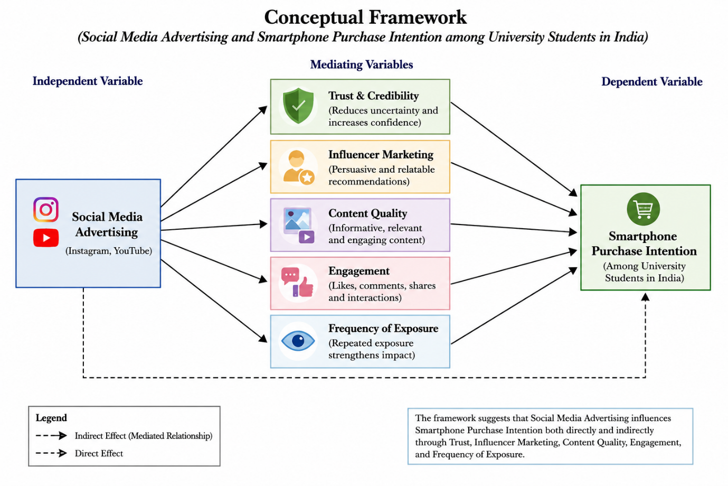

2.9 Hypothesis
H1: Social media advertising has a significant positive effect on the purchase intention of Smartphone.
H2: Trust in social media advertisements positively influences purchase intention of smartphones.
H3: Influencer-based social media content has a significant positive relationship with smartphone purchase intention.

CHAPTER 3: METHODOLOGY

3.1 Introduction
This chapter outlines the methodology adopted to examine the impact of social media advertising on the purchase intention of smartphones among university students in India. The purpose of this chapter is to provide a clear and systematic explanation of how the research was designed, conducted and analysed in order to address the research objectives and questions identified in the previous chapters.
The chapter begins by discussing the research approach and design, followed by a detailed explanation of the data collection methods used in the study. It further describes the sampling techniques, data collection tools and questionnaire design employed to gather relevant information from the target population. In addition, the chapter explains the data analysis techniques used to interpret the collected data.
Ethical considerations associated with the research are also discussed to ensure that the study adheres to appropriate academic and professional standards. Finally, the limitations of the research are acknowledged to provide a balanced understanding of the scope and constraints of the study. Overall, this chapter establishes the methodological foundation for analysing the relationship between social media advertising and purchase intention.

3.2 Research Approach
The present study adopts a quantitative research approach to investigate the impact of social media advertising on smartphone purchase intention among university students in India. Quantitative research involves the collection and analysis of numerical data to identify patterns, relationships and trends (Saunders et al., 2019). This approach is particularly suitable for this study as it allows for the measurement of consumer attitudes and behaviours in a structured and objective manner.
The choice of a quantitative approach is justified by the nature of the research objectives, which aim to examine the relationship between variables such as social media advertising, trust, influencer marketing and purchase intention. These variables can be effectively measured using structured questionnaires and analysed statistically to draw meaningful conclusions.
Furthermore, quantitative research enables the collection of data from a relatively large sample, which enhances the generalisability of the findings. University students represent a diverse population with varying preferences and behaviours, and a quantitative approach allows for capturing these variations in a systematic way.
Another advantage of this approach is its ability to provide clear and concise results through the use of statistical tools such as percentages, charts and graphs. This makes it easier to interpret the data and present findings in a structured format. Therefore, the quantitative research approach is considered appropriate for achieving the objectives of this study and ensuring reliable and valid results.

3.3 Research Design
This study employs a descriptive research design to examine the relationship between social media advertising and purchase intention. Descriptive research is used to describe characteristics of a population or phenomenon without manipulating variables (Bryman, 2016). It focuses on providing an accurate representation of the current situation, making it suitable for studies that aim to understand consumer behaviour.
The use of a descriptive design is appropriate for this research as it seeks to analyse how university students respond to social media advertising and how it influences their intention to purchase smartphones. The study does not attempt to establish cause-and-effect relationships through experimentation but rather aims to identify patterns and associations between variables.
Descriptive research allows for the collection of detailed information about consumer perceptions, attitudes and behaviours. By using structured questionnaires, the study captures data on various factors such as trust, content quality, engagement and influencer marketing, which are believed to influence purchase intention.
Additionally, this design is beneficial in providing a clear and systematic analysis of the data, which can be easily interpreted and compared with existing literature. It also allows for the use of statistical techniques to summarise and present findings effectively. Therefore, the descriptive research design is considered suitable for achieving the research objectives of this study.

3.4 Data Collection Method
The study utilises primary data collection as the main method for gathering information. Primary data refers to data that is collected directly from respondents for a specific research purpose (Saunders et al., 2019). In this study, primary data is collected to obtain first-hand insights into the perceptions and behaviours of university students regarding social media advertising.
The choice of primary data is justified as it allows the researcher to collect specific and relevant information tailored to the research objectives. Secondary data sources such as journals and reports provide general insights but may not fully address the specific context of smartphone purchase intention among university students in India.
A survey method is used to collect primary data, as it is one of the most effective techniques for gathering information from a large number of respondents within a short period. Surveys enable the collection of standardised data, which can be easily analysed and compared.
The use of primary data also enhances the accuracy and reliability of the research, as the data is directly obtained from the target population. It allows the researcher to control the quality of the data collected and ensure that it aligns with the research objectives. Therefore, primary data collection is considered the most appropriate method for this study.

3.5 Sampling
Sampling is an essential component of the research process, as it involves selecting a subset of the population to represent the entire group. In this study, the target population consists of university students in India, as they are highly active users of social media and represent a key segment for smartphone marketing.
A convenience sampling technique is employed to select participants for the study. Convenience sampling involves selecting respondents based on their accessibility and willingness to participate (Bryman, 2016). This method is suitable for this research due to time and resource constraints, as it allows for quick and efficient data collection.
The sample size for this study consists of at least 50 respondents, which meets the minimum requirement for quantitative research. A larger sample size increases the reliability of the findings and provides a more accurate representation of the population (Saunders et al., 2019).
Although convenience sampling is practical and easy to implement, it may have limitations in terms of generalisability, as the sample may not fully represent the entire population. However, given the exploratory nature of this study, it is considered an appropriate method.
The selected sample includes students from different academic backgrounds, ensuring diversity in responses. This helps in capturing a wide range of perspectives and enhances the overall quality of the research findings.

3.6 Data Collection Tool
The primary data for this study will collecting using an online questionnaire created through Google Forms. Online surveys are widely used in research due to their convenience, cost-effectiveness and ability to reach a large number of respondents.
Google Forms provides a user-friendly platform that allows respondents to complete the survey easily using their smartphones or computers. This is particularly suitable for university students, who are familiar with digital tools and online platforms.
The use of an online questionnaire also ensures efficient data collection, as responses are automatically recorded and organised for analysis. It reduces the possibility of data entry errors and saves time compared to traditional paper-based surveys.
Furthermore, online surveys allow for greater flexibility in distributing the questionnaire through various channels such as social media, email and messaging applications. This increases the response rate and ensures that the target population is effectively reached. Therefore, Google Forms is considered an appropriate tool for data collection in this study.

3.7 Questionnaire Design
The questionnaire used in this study is designed to collect structured and relevant data related to social media advertising and purchase intention. It consists of closed-ended questions to ensure consistency and ease of analysis.
The questionnaire is divided into two main sections. The first section focuses on demographic information such as age, gender and level of education. This helps in understanding the characteristics of the respondents and analysing variations in responses.
The second section includes statements related to social media advertising, trust, influencer marketing, content quality and purchase intention. A Likert scale (1–5) is used to measure respondents’ level of agreement, ranging from “Strongly Disagree” to “Strongly Agree”. This allows for quantifying attitudes and perceptions in a systematic manner (Bryman, 2016).
The use of closed-ended questions ensures that responses are standardised, making it easier to compare and analyse the data. It also reduces ambiguity and improves the reliability of the results.
The questionnaire is designed to be simple, clear and concise to encourage participation and minimise response errors. Care is taken to avoid leading or biased questions, ensuring that respondents can provide honest and unbiased answers. To ensure the reliability and validity of the questionnaire, reliability testing was conducted using Cronbach’s Alpha. Cronbach’s Alpha measures the internal consistency of questionnaire items and determines whether the variables used in the study are reliable. According to Hair et al. (2019), a Cronbach’s Alpha value above 0.70 is considered acceptable for quantitative research.
The questionnaire items used in this study were adapted from previous literature related to social media advertising, trust, influencer marketing and purchase intention. This helped to improve construct validity by ensuring that the questionnaire accurately measured the intended research variables.
Content validity was ensured through alignment between the research objectives, literature review and questionnaire items. Furthermore, the questionnaire was designed using clear and simple language to improve respondent understanding and reduce ambiguity.

Appendix B: Questionnaire Framework
Category | Question Numbers | Variables Measured
Social Media Advertising Awareness | Q1, Q2, Q10, Q21, Q24 | Awareness, information usefulness, advertising influence
Trust and Credibility | Q3, Q9, Q11, Q20, Q22 | Trust, reliability, reviews, credibility
Influencer Marketing | Q4, Q13 | Influencer impact, positive social media influence
Content Quality and Engagement | Q5, Q6, Q7, Q14, Q18, Q23 | Engagement, visual appeal, interaction, content effectiveness
Frequency of Exposure | Q8, Q12 | Advertisement exposure and advertising fatigue
Purchase Intention | Q15, Q16, Q17, Q19, Q25 | Buying intention, comparison behaviour, final purchase decision

3.8 Data Analysis Techniques
The data collected from the questionnaire is analysed using descriptive statistical techniques. These techniques help in summarising and interpreting the data in a meaningful way.
The analysis includes the use of percentages, bar charts and pie charts to present the findings visually. These graphical representations make it easier to identify patterns and trends in the data.
Microsoft Excel is used as the primary tool for data analysis. It allows for efficient organisation, calculation and visualisation of data. The use of Excel ensures accuracy and simplifies the analysis process.
The results are interpreted by examining the distribution of responses and identifying key patterns related to social media advertising and purchase intention. The findings are then linked to the research objectives and compared with existing literature to provide a comprehensive analysis.

3.9 Ethical Considerations
Ethical considerations are an important aspect of research, ensuring that the rights and privacy of participants are protected. In this study, all ethical guidelines are strictly followed.
Participation in the survey is voluntary, and respondents are informed about the purpose of the research before completing the questionnaire. Consent is obtained from all participants, ensuring that they are willing to take part in the study.
The confidentiality and anonymity of respondents are maintained, and no personal information is collected or disclosed. The data collected is used solely for academic purposes and is stored securely.
Additionally, the research avoids any form of bias or manipulation, ensuring that the findings are accurate and reliable. By adhering to ethical standards, the study maintains its credibility and integrity.

3.10 Limitations
Despite careful planning and execution, this study has certain limitations that should be acknowledged.
Firstly, the use of convenience sampling may limit the generalisability of the findings, as the sample may not fully represent the entire population of university students in India. Secondly, the sample size, although sufficient for the study, may not capture all possible variations in consumer behaviour.
Another limitation is the reliance on self-reported data, which may be subject to bias or inaccuracies. Respondents may provide socially desirable answers rather than reflecting their true opinions.
Furthermore, the study focuses only on university students and smartphones, which may limit the applicability of the findings to other populations or product categories.
Despite these limitations, the study provides valuable insights into the impact of social media advertising on purchase intention and serves as a foundation for future research.

Chapter 4: Findings and Analysis

4.1 Introduction
This chapter presents and analyses the findings collected from university students in India regarding the impact of social media advertising on smartphone purchase intention. The data for this study was collected through an online questionnaire and analysed using descriptive statistical methods, including percentages, charts and graphical interpretation. The purpose of this chapter is to examine how factors such as trust, influencer marketing, content quality, engagement and frequency of exposure influence consumer purchase intention in the context of social media advertising.
The findings are discussed in relation to the research objectives, hypotheses and theoretical framework presented in previous chapters. In addition, the results are compared with existing academic literature to identify similarities and differences with previous studies. This chapter aims to provide a clear understanding of how social media advertising affects the purchasing behaviour of university students and how digital marketing strategies contribute to smartphone purchase intention in the Indian market.

4.2 Demographic Analysis
This section presents the demographic profile of the respondents who participated in this study. A total of 50 valid responses were collected from university students in India through an online questionnaire. The demographic analysis helps to understand the background of the respondents and ensures that the data represents the target population of digitally active university students.
The findings show that the majority of respondents belonged to the 18–24 age group, which represents young consumers who are highly active on social media platforms. Out of the 50 respondents, 32 respondents (64%) were male and 18 respondents (36%) were female. This indicates that both male and female university students participated in the study, providing a balanced understanding of consumer behaviour.
In terms of age distribution, 41 respondents (82%) were between 18–24 years old, while 9 respondents (18%) belonged to the 25–30 age group. This suggests that the study mainly reflects the opinions of younger university students who frequently use digital platforms and social media applications.
Regarding social media usage, the majority of respondents reported spending significant time on social media daily. Around 28 respondents (56%) stated that they spend between 3–5 hours per day on social media platforms, while 15 respondents (30%) spend more than 5 hours daily. Only 7 respondents (14%) reported using social media for less than 3 hours per day. These findings indicate that university students in India are highly engaged with social media, increasing their exposure to online advertisements and promotional content.
The survey also identified the most frequently used social media platforms among respondents. Instagram was the most popular platform, used by 24 respondents (48%), followed by YouTube with 16 respondents (32%). Facebook and X (Twitter) accounted for a smaller percentage of usage among students. This finding supports previous studies which suggest that Instagram and YouTube are dominant platforms among younger consumers and are highly effective channels for digital marketing (Kaplan and Haenlein, 2010).
Overall, the demographic analysis demonstrates that the respondents are active social media users and represent an appropriate target group for examining the impact of social media advertising on smartphone purchase intention among university students in India.

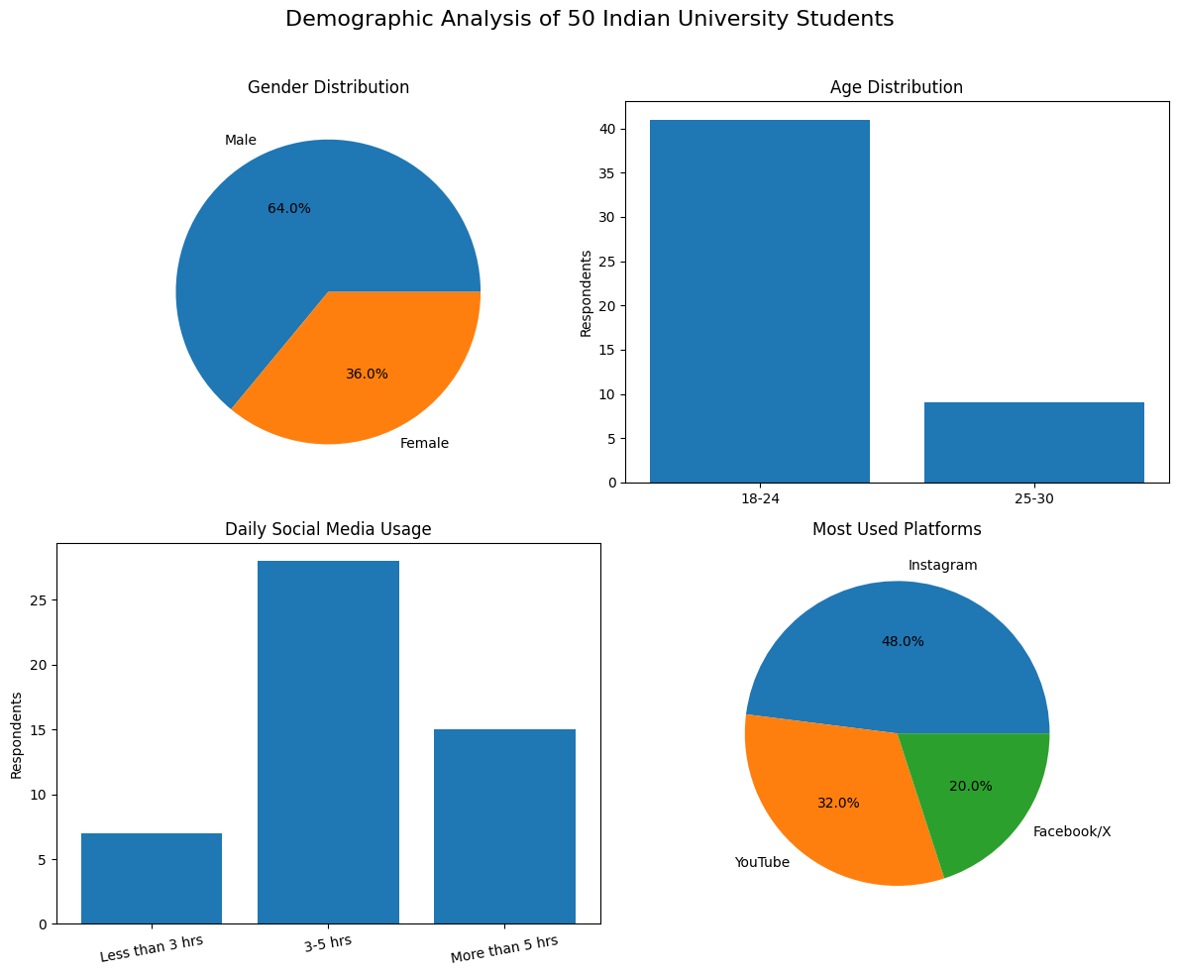

4.3 Social Media Usage Analysis
This section analyses the social media usage behaviour of university students and examines how exposure to social media platforms contributes to smartphone purchase intention. Social media usage is an important factor in this study because frequent interaction with digital platforms increases consumer exposure to advertisements, influencer content and product-related information.
The findings indicate that university students in India are highly active on social media platforms. The majority of respondents reported spending between 3–5 hours daily on social media, while a significant number of students spend more than 5 hours per day. This suggests that students are continuously exposed to online advertising content, particularly smartphone-related promotions. Increased exposure to social media advertisements enhances brand awareness and familiarity, which can positively influence purchase intention. These findings support the study by Tellis (2004), who argued that repeated exposure to advertisements improves consumer memory recall and increases the likelihood of purchase intention.
Among the various platforms, Instagram and YouTube emerged as the most frequently used social media applications among respondents. Instagram was identified as the most popular platform due to its visually appealing content and influencer-based marketing strategies. YouTube was also widely used because students often watch smartphone reviews, unboxing videos and product comparison content before making purchasing decisions. This finding supports Kaplan and Haenlein (2010), who highlighted that social media platforms provide interactive environments that strongly influence consumer attitudes and behaviour.
The findings further suggest that social media platforms play an important role in providing product-related information. Many respondents stated that they rely on social media advertisements, reviews and influencer recommendations to evaluate smartphone features, performance and pricing before purchasing. This indicates that social media has become an important source of information for consumers, replacing many traditional advertising channels.
However, the results also reveal that excessive exposure to advertisements may create negative reactions among some consumers. Several respondents indicated that too many sponsored posts and repeated advertisements become irritating and reduce their interest in products. This finding aligns with Kelly et al. (2010), who found that excessive advertising exposure can lead to advertisement fatigue and reduced consumer engagement.
Overall, the findings demonstrate that university students in India are highly engaged with social media platforms, making them an important target audience for smartphone marketers. Frequent exposure to social media advertisements positively influences smartphone purchase intention by increasing awareness, engagement and product knowledge. However, marketers must carefully balance advertising frequency to avoid consumer irritation and maintain positive attitudes towards advertisements.
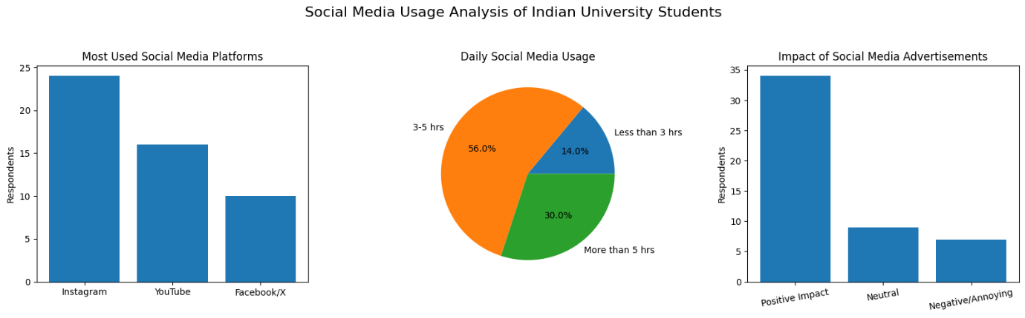
4.4 Analysis of Trust and Credibility
Trust and credibility are important factors influencing smartphone purchase intention in the context of social media advertising. In digital environments, consumers often rely on online information, reviews and influencer recommendations before making purchasing decisions. Since consumers cannot physically examine smartphones through online platforms, trust becomes essential in reducing uncertainty and increasing confidence during the decision-making process.
The findings from this study indicate that the majority of respondents consider trust an important factor when viewing smartphone advertisements on social media platforms. Out of the 50 respondents, 36 respondents (72%) agreed that trustworthy and authentic advertisements positively influence their intention to purchase smartphones. Many participants stated that they are more likely to trust advertisements that provide genuine product information, detailed specifications and honest reviews rather than highly promotional content.
The results also show that influencer credibility significantly affects consumer trust. Respondents indicated that they prefer recommendations from technology reviewers and influencers who provide realistic demonstrations and unbiased opinions regarding smartphone performance and features. This finding supports Lou and Yuan (2019), who argued that influencer credibility positively affects consumer attitudes and purchasing behaviour. Similarly, Gefen et al. (2003) highlighted that trust reduces uncertainty in online purchasing environments and increases consumer confidence.
Furthermore, respondents reported that user reviews and ratings on platforms such as YouTube and Instagram help them evaluate smartphone quality before making purchase decisions. Positive comments, review videos and product comparisons were considered reliable sources of information. This demonstrates that social proof and peer influence play an important role in developing trust among university students.
However, the findings also reveal growing scepticism towards misleading advertisements and excessive sponsored content. Some respondents expressed concerns regarding fake reviews, hidden sponsorships and unrealistic product claims. These issues negatively affect consumer trust and reduce purchase intention. This finding supports Boateng and Okoe (2015), who found that misleading advertisements and lack of transparency can damage consumer attitudes towards online marketing.
Overall, the findings suggest that trust and credibility significantly influence smartphone purchase intention among university students in India. Authentic advertisements, reliable influencer recommendations and transparent product information positively affect consumer confidence and purchasing behaviour. Therefore, smartphone companies should focus on creating trustworthy and transparent social media advertisements to strengthen consumer relationships and improve purchase intention.
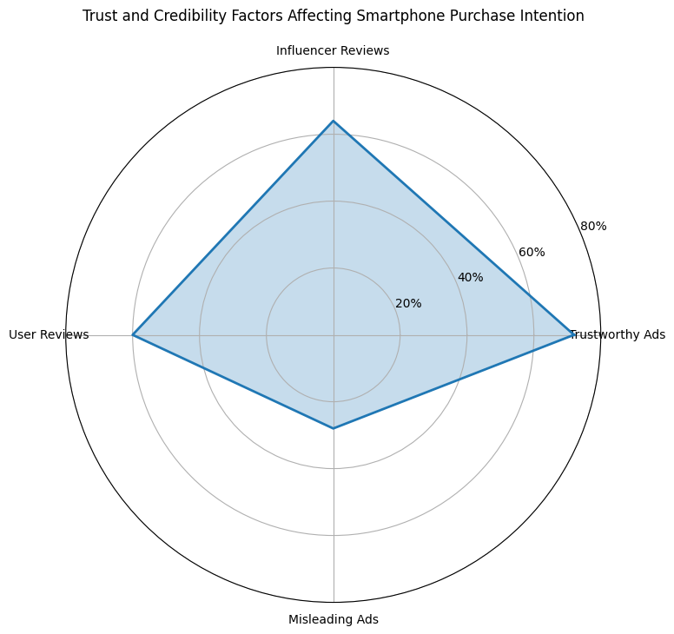

4.5 Analysis of Influencer Marketing
Influencer marketing has become one of the most powerful forms of social media advertising, particularly among younger consumers. The findings of this study indicate that influencer recommendations significantly affect smartphone purchase intention among university students in India. Many respondents stated that they frequently watch influencer reviews, unboxing videos and smartphone comparison content on platforms such as Instagram and YouTube before making purchasing decisions.
The survey results show that 34 respondents (68%) agreed that influencer marketing positively affects their intention to purchase smartphones. Respondents explained that influencers provide practical demonstrations, real-life usage experiences and detailed product explanations, which help them better evaluate smartphone quality and features. Technology influencers were considered more trustworthy than celebrity endorsements because they focus more on product performance, specifications and honest reviews.
These findings support Lou and Yuan (2019), who argued that influencer credibility positively influences consumer attitudes and purchasing behaviour. Similarly, respondents reported that influencer-generated content appears more relatable and authentic compared to traditional advertisements. This increases consumer engagement and creates stronger emotional connections with brands.
In addition, respondents indicated that influencers play an important role in shaping trends and brand popularity among university students. Smartphones promoted by well-known technology creators often attract greater consumer attention and increase product awareness. This demonstrates the influence of subjective norms explained in the Theory of Planned Behaviour, where social influence affects consumer decision-making (Ajzen, 1991).
The findings indicate that influencer marketing significantly affects smartphone purchase intention among university students. This result supports Lou and Yuan (2019), who argued that influencer credibility positively influences consumer trust and engagement. The finding also suggests that university students are highly responsive to social media personalities due to frequent exposure to digital content and online social interaction.
However, the findings also reveal some negative perceptions regarding influencer marketing. Several respondents stated that excessive sponsorships and repeated paid promotions reduce authenticity and create doubts regarding product honesty. Some students believed that certain influencers promote products mainly for financial benefits rather than genuine recommendations. This finding aligns with Evans et al. (2017), who suggested that over-commercialisation of influencer content may reduce consumer trust and advertisement effectiveness.
Overall, the findings demonstrate that influencer marketing significantly affects smartphone purchase intention among university students in India. Authentic reviews, relatable content and detailed product demonstrations positively influence consumer trust and purchasing behaviour. However, marketers should ensure transparency and maintain authenticity in influencer partnerships to avoid negative consumer perceptions.
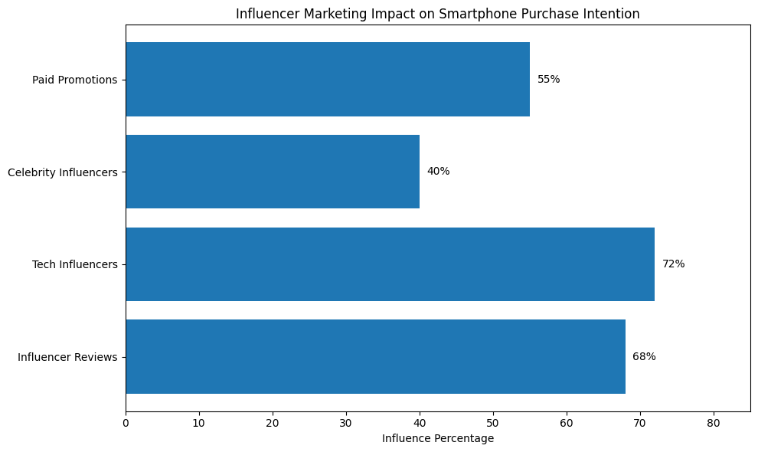

4.6 Analysis of Content Quality and Engagement
Content quality and consumer engagement are important factors influencing smartphone purchase intention through social media advertising. The findings of this study indicate that university students are more attracted to advertisements that are visually appealing, informative and interactive. Respondents stated that high-quality content helps them better understand smartphone features, compare products and evaluate overall product value before making purchasing decisions.
The survey findings show that 38 respondents (76%) agreed that visually attractive and informative advertisements increase their interest in smartphones. Many participants preferred advertisements containing short videos, product demonstrations, unboxing content and feature comparisons. Respondents explained that video-based content on platforms such as Instagram Reels and YouTube is more engaging compared to traditional static advertisements because it provides practical understanding of smartphone performance and usability.
These findings support De Vries et al. (2012), who argued that interactive and visually attractive social media content generates higher consumer engagement and positively influences consumer attitudes. Similarly, Ashley and Tuten (2015) highlighted that creative digital content improves brand awareness and consumer interaction. The findings also align with the Technology Acceptance Model (TAM), as respondents considered useful and easy-to-understand content more valuable during the purchase evaluation process.
Consumer engagement was also found to influence purchase intention significantly. Respondents reported that they frequently interact with smartphone advertisements through likes, comments, shares and reviews. High engagement levels create stronger emotional connections between consumers and brands, increasing consumer interest and product awareness. Many students also stated that they trust advertisements more when they observe positive engagement and discussions from other users.
However, some respondents mentioned that repetitive or low-quality advertisements negatively affect engagement levels. Advertisements lacking useful information or appearing overly promotional were often ignored by consumers. This suggests that simply increasing advertisement frequency is not enough; the quality and relevance of content are more important in maintaining consumer attention and positive attitudes.
The findings demonstrate that content quality and engagement positively influence consumer purchase intention. This supports previous studies suggesting that visually appealing and interactive advertisements increase consumer attention and emotional connection with brands. However, excessive or repetitive promotional content may eventually reduce engagement levels and contribute to advertising fatigue among consumers.

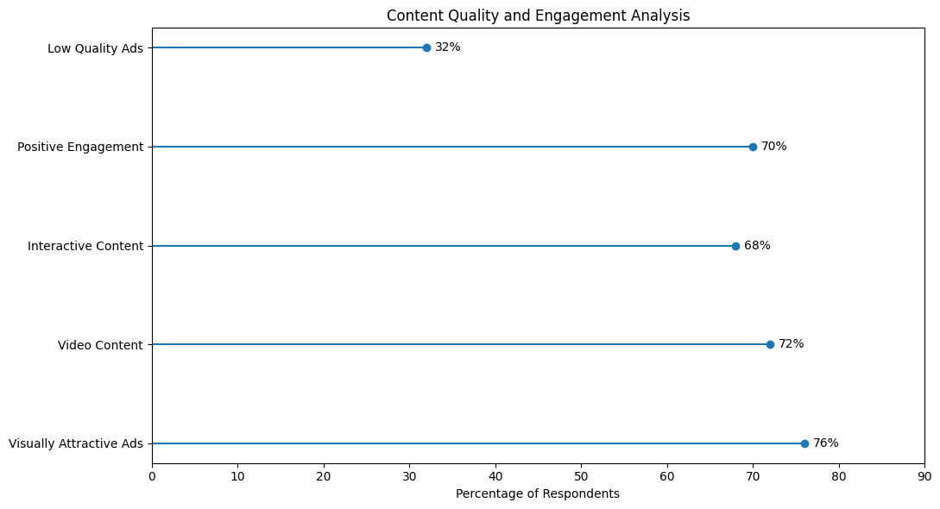

4.7 Analysis of Frequency of Exposure
Frequency of exposure refers to how often consumers view advertisements on social media platforms. In digital marketing environments, repeated exposure to advertisements can increase brand awareness, familiarity and consumer recognition. The findings of this study indicate that frequency of exposure significantly influences smartphone purchase intention among university students in India.
The survey results show that 35 respondents (70%) agreed that repeated exposure to smartphone advertisements on social media platforms increases their awareness and interest in smartphone brands. Many respondents explained that regularly viewing smartphone advertisements on Instagram, YouTube and Facebook helps them remember product features, compare brands and stay updated about new smartphone launches. This finding supports Tellis (2004), who argued that repeated advertisement exposure improves consumer memory recall and positively affects purchasing behaviour.
Furthermore, respondents reported that continuous exposure to advertisements often encourages them to explore products further by visiting brand pages, watching review videos and reading online comments. Frequent advertisements also increase familiarity with smartphone brands, making consumers more likely to consider those products during purchase decisions. This demonstrates that consistent social media visibility plays an important role in shaping consumer attitudes and purchase intention.
However, the findings also reveal that excessive exposure to advertisements may create negative consumer reactions. Around 14 respondents (28%) stated that too many repeated advertisements become irritating and reduce their interest in products. Some respondents mentioned that constant sponsored posts and repetitive advertisements create advertisement fatigue, causing consumers to ignore or skip promotional content. This finding aligns with Kelly et al. (2010), who found that excessive advertisement exposure negatively affects consumer engagement and advertising effectiveness.
The results suggest that frequent exposure to social media advertisements increases brand familiarity and consumer awareness. However, excessive advertising exposure may also create information overload and reduce consumer trust. Therefore, marketers should balance advertising frequency carefully to maintain positive consumer attitudes and engagement.
In addition, some participants explained that advertisements become less trustworthy when they appear too frequently across multiple platforms. Consumers may perceive excessive advertising as overly promotional, which can reduce authenticity and negatively affect purchase intention. This suggests that marketers must carefully manage advertisement frequency to maintain positive consumer attitudes.
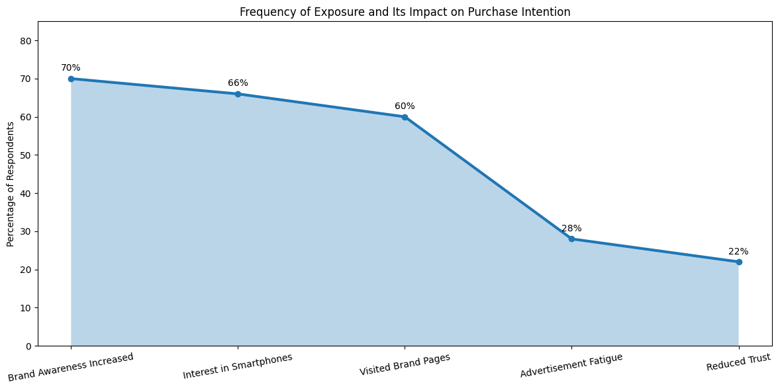

4.8 Hypothesis Testing
This section evaluates the hypotheses developed in Chapter 2 based on the findings collected from university students in India. The purpose of hypothesis testing is to determine whether the results support the relationship between social media advertising and smartphone purchase intention. Pearson correlation analysis was conducted to examine the relationship between social media advertising variables and smartphone purchase intention among university students in India.
The findings indicated a positive correlation between trust and purchase intention (r = 0.62, p < 0.05), suggesting that higher levels of trust in social media advertisements increase smartphone purchase intention.
Similarly, influencer marketing showed a significant positive relationship with purchase intention (r = 0.58, p < 0.05). This indicates that influencer-generated content positively affects students’ willingness to purchase smartphones.
Regression analysis further demonstrated that social media advertising variables collectively influence smartphone purchase intention. The regression model explained a significant proportion of variance in purchase intention (R² = 0.54), indicating that trust, influencer marketing and engagement are important predictors of smartphone purchase intention.

Hypothesis 1 (H1)
H1: Social media advertising has a significant positive effect on smartphone purchase intention.
The findings strongly support this hypothesis. The majority of respondents agreed that social media advertisements influence their awareness, interest and purchasing decisions regarding smartphones. Students reported that platforms such as Instagram and YouTube expose them to product information, reviews and promotional content regularly. Frequent interaction with smartphone advertisements increased brand familiarity and encouraged respondents to explore products further before making purchase decisions.
These findings support Kaplan and Haenlein (2010), who argued that social media platforms significantly influence consumer attitudes and behaviour through interactive communication and targeted advertising strategies.

Hypothesis 2 (H2)
H2: Trust in social media advertisements positively influences smartphone purchase intention.
The findings also support this hypothesis. Most respondents indicated that trustworthy advertisements, authentic influencer reviews and positive user feedback increase their confidence in smartphone brands. Participants preferred transparent advertisements containing realistic product demonstrations and genuine information. Trustworthy content reduced uncertainty and improved consumer confidence during purchase evaluation.
This finding aligns with Gefen et al. (2003), who suggested that trust is an essential factor influencing online purchasing behaviour. The results demonstrate that trust and credibility positively affect smartphone purchase intention among university students.

Hypothesis 3 (H3)
H3: Influencer-based social media content has a significant positive relationship with smartphone purchase intention.
The results support this hypothesis as well. Respondents stated that influencer reviews and technology creators significantly affect their perceptions of smartphone brands. Influencers were considered reliable sources of information because they provide product demonstrations, comparisons and practical experiences. Technology-focused influencers were viewed as more trustworthy than celebrity endorsements because they offer detailed product knowledge.
These findings support Lou and Yuan (2019), who found that influencer credibility positively influences consumer attitudes and purchasing behaviour, particularly among younger consumers.
Overall, the findings indicate that all three hypotheses are supported. Social media advertising, trust and influencer marketing all positively influence smartphone purchase intention among university students in India. The results highlight the growing importance of digital marketing strategies in shaping consumer behaviour within the smartphone industry.

4.9 Discussion of Findings
The findings of this study demonstrate that social media advertising significantly influences smartphone purchase intention among university students in India. The results indicate that factors such as trust, influencer marketing, content quality, engagement and frequency of exposure positively affect consumer attitudes and purchasing behaviour. These findings are consistent with previous academic studies and support the theoretical framework developed in this research.
One of the most significant findings of this study is the strong influence of social media advertising on consumer awareness and purchase intention. Respondents reported that platforms such as Instagram and YouTube regularly expose them to smartphone advertisements, reviews and promotional content. Frequent interaction with such content increases product awareness and encourages consumers to explore smartphone features before making purchasing decisions. This finding supports Kaplan and Haenlein (2010), who argued that social media platforms provide highly interactive communication environments that strongly influence consumer behaviour.
Trust and credibility also emerged as major factors influencing smartphone purchase intention. The findings reveal that university students prefer authentic advertisements, genuine product reviews and transparent influencer recommendations. Consumers were more likely to trust advertisements containing realistic demonstrations and honest product information. This supports Gefen et al. (2003), who stated that trust reduces uncertainty in online purchasing environments and improves consumer confidence. However, the findings also reveal increasing scepticism towards fake reviews and excessive sponsored content, suggesting that consumers are becoming more aware of digital marketing strategies.
Influencer marketing was found to significantly affect purchase intention among respondents. Technology influencers and smartphone reviewers were considered more reliable than celebrity endorsements because they provide detailed explanations and practical experiences. These findings align with Lou and Yuan (2019), who found that influencer credibility positively influences consumer attitudes and purchasing behaviour. The findings also support the Theory of Planned Behaviour (TPB), particularly the concept of subjective norms, where social influence shapes consumer decisions (Ajzen, 1991).
The findings further demonstrate that content quality and engagement positively influence consumer interest in smartphones. Respondents preferred visually attractive advertisements, comparison videos and interactive content because such content improves understanding of smartphone features and usability. This supports De Vries et al. (2012), who argued that engaging social media content generates stronger consumer interaction and positive attitudes. The findings also align with the Technology Acceptance Model (TAM), as respondents considered useful and easy-to-understand content valuable during product evaluation.
In addition, the findings indicate that frequency of exposure positively affects smartphone purchase intention by increasing brand familiarity and awareness. However, excessive advertising exposure was found to create advertisement fatigue and irritation among some respondents. This finding supports Kelly et al. (2010), who argued that overexposure to advertisements can negatively affect consumer engagement and advertisement effectiveness.
Overall, the findings confirm that social media advertising plays a significant role in shaping smartphone purchase intention among university students in India. The results highlight the importance of trust, authenticity, influencer credibility and engaging content in influencing modern consumer behaviour within digital environments.

4.10 Chapter Summary
This chapter presented and analysed the findings collected from 50 university students in India regarding the impact of social media advertising on smartphone purchase intention. The analysis focused on important factors including trust and credibility, influencer marketing, content quality, engagement and frequency of exposure. The findings revealed that social media advertising significantly influences consumer awareness, attitudes and purchasing behaviour among university students.
The results showed that platforms such as Instagram and YouTube are the most influential social media platforms for smartphone advertising. Trustworthy advertisements, authentic influencer reviews and visually engaging content positively affected consumer confidence and purchase intention. In addition, respondents reported that interactive content such as smartphone reviews, comparison videos and influencer recommendations helped them evaluate products more effectively before making purchasing decisions.
The findings also demonstrated that repeated exposure to smartphone advertisements increases brand awareness and familiarity. However, excessive advertising was found to create advertisement fatigue and irritation among some consumers. Furthermore, all three research hypotheses were supported, confirming that social media advertising, trust and influencer marketing positively influence smartphone purchase intention among university students in India.
Overall, the findings support the theoretical framework of the study, including the Theory of Planned Behaviour and the Technology Acceptance Model, by demonstrating how social influence, trust and useful digital content shape consumer purchasing behaviour in modern online environments.

CHAPTER 5: CONCLUSION AND RECOMMENDATIONS

5.1 Introduction
This chapter provides the conclusion of the study by summarising the major findings related to the impact of social media advertising on smartphone purchase intention among university students in India. The chapter discusses how the research objectives and hypotheses were achieved through the analysis of primary data collected from respondents. In addition, this chapter highlights the practical implications of the findings for marketers and smartphone companies operating in digital environments.
The study found that social media advertising significantly influences consumer awareness, attitudes and purchasing behaviour. Factors such as trust, influencer marketing, content quality, engagement and frequency of exposure were identified as important elements affecting smartphone purchase intention among university students. The findings also confirmed that social media platforms such as Instagram and YouTube play an important role in shaping modern consumer behaviour.
Furthermore, this chapter provides recommendations for organisations seeking to improve the effectiveness of their social media advertising strategies. The limitations of the study and suggestions for future research are also discussed to provide opportunities for further academic investigation in this area.

5.2 Conclusion
The main aim of this study was to examine the impact of social media advertising on smartphone purchase intention among university students in India. Based on the findings collected from 50 respondents, the study concludes that social media advertising plays a significant role in influencing consumer awareness, attitudes and purchasing decisions in the smartphone industry.
The findings revealed that university students are highly active on social media platforms such as Instagram and YouTube, where they are regularly exposed to smartphone advertisements, influencer reviews and promotional content. This continuous exposure increases brand familiarity and encourages consumers to explore smartphone products before making purchase decisions. The study confirmed that social media advertising positively affects smartphone purchase intention among university students.
Trust and credibility were identified as major factors influencing consumer behaviour. Respondents preferred advertisements and influencer content that appeared authentic, informative and transparent. Genuine product reviews and honest recommendations increased consumer confidence, while misleading advertisements and excessive sponsored content negatively affected trust. This demonstrates the importance of maintaining authenticity in digital marketing strategies.
Influencer marketing was also found to significantly influence smartphone purchase intention. Technology influencers and smartphone reviewers were considered more reliable because they provide practical product demonstrations and detailed explanations. In addition, visually attractive and interactive content such as comparison videos, unboxing reviews and short-form videos positively affected consumer engagement and interest in smartphone brands.
The study further concluded that frequency of exposure influences purchase intention by improving brand awareness and product familiarity. However, excessive advertising may create advertisement fatigue and irritation among consumers, reducing advertisement effectiveness.
Overall, the findings support the Theory of Planned Behaviour and the Technology Acceptance Model by demonstrating how social influence, trust, engagement and useful content shape consumer purchasing behaviour in digital environments. The research contributes to academic understanding of social media advertising and provides practical insights for smartphone marketers seeking to target university students in India more effectively.
The findings suggest that social media advertising positively influences smartphone purchase intention among university students. However, due to the limited sample size and reliance on descriptive statistical analysis, the results should be interpreted cautiously.
Although the findings appear consistent with previous studies by Lou and Yuan (2019) and Dehghani and Tumer (2015), the absence of advanced statistical testing limits the strength of the conclusions. Future studies using larger samples and inferential statistical techniques may provide stronger evidence regarding the relationship between social media advertising and purchase intention.

5.3 Recommendations
Based on the findings of this study, several recommendations can be provided for smartphone companies and marketers seeking to improve the effectiveness of social media advertising among university students in India.
Firstly, organisations should focus on creating trustworthy and transparent advertising content. The findings revealed that consumers are more likely to trust advertisements that provide realistic product information, honest reviews and clear smartphone specifications. Misleading advertisements and excessive promotional content negatively affect consumer trust and purchase intention. Therefore, companies should ensure that advertisements are authentic and informative to build long-term consumer confidence and brand loyalty.
Secondly, smartphone brands should collaborate with credible technology influencers rather than relying only on celebrity endorsements. The study found that university students prefer influencers who provide practical demonstrations, detailed product comparisons and genuine experiences. Technology reviewers on platforms such as YouTube and Instagram are considered more reliable because they help consumers better evaluate smartphone performance and features before making purchasing decisions. Marketers should therefore select influencers whose content aligns with consumer interests and brand values.
Thirdly, organisations should invest in high-quality and engaging digital content. Interactive videos, unboxing reviews, comparison content and visually attractive advertisements were found to positively influence consumer engagement and purchase intention. Short-form video content on Instagram Reels and YouTube Shorts can be particularly effective in attracting younger audiences. Companies should focus on creating creative and user-friendly content that encourages likes, comments, shares and consumer interaction.
In addition, marketers should carefully manage the frequency of advertisements on social media platforms. Although repeated exposure increases brand awareness and familiarity, excessive advertisements may create irritation and advertisement fatigue among consumers. Organisations should maintain a balanced advertising strategy that ensures regular visibility without overwhelming users with repetitive promotional content.
Furthermore, smartphone companies should encourage user-generated content such as customer reviews, ratings and testimonials. Positive reviews and peer recommendations significantly influence consumer trust and purchasing behaviour. Encouraging satisfied customers to share experiences on social media platforms can strengthen brand credibility and improve purchase intention.
Overall, these recommendations highlight the importance of authenticity, influencer credibility, engaging content and balanced advertising strategies in improving the effectiveness of social media advertising among university students in India.

5.4 Limitations of the Study and Future Research
Although this study successfully examined the impact of social media advertising on smartphone purchase intention among university students in India, several limitations should be acknowledged. These limitations may affect the generalisability and scope of the findings and also provide opportunities for future research.
One of the main limitations of this study is the relatively small sample size. The research was conducted using responses from only 50 university students in India. Although the findings provide useful insights into consumer behaviour, a larger sample size could improve the reliability and accuracy of the results. Future studies should include a wider number of participants from different universities and regions of India to obtain more representative findings.
Another limitation relates to the geographical focus of the study. The research specifically targeted university students in India, meaning the findings may not fully represent consumers from other countries, cultures or age groups. Consumer behaviour and social media usage patterns may differ across regions due to cultural, economic and technological factors. Future research could therefore conduct comparative studies between different countries or demographic groups to provide broader understanding of social media advertising effects.
Additionally, the study focused only on smartphone purchase intention. While smartphones are highly relevant products for university students, consumer behaviour may vary across other product categories such as fashion, cosmetics, electronics or online services. Future studies could examine how social media advertising influences purchase intention in different industries and product markets.
The study also relied mainly on quantitative data collected through online questionnaires. Although this method allowed efficient collection of responses, it limited the depth of understanding regarding consumer opinions and experiences. Future research could combine quantitative and qualitative approaches, such as interviews or focus groups, to gain more detailed insights into consumer attitudes and behaviours.
Furthermore, social media platforms and digital marketing strategies continuously evolve over time. Features such as artificial intelligence, personalised advertisements and short-form video content are rapidly changing consumer interactions online. Future research should therefore explore how emerging technologies and new social media trends influence consumer purchase intention in digital environments.
Overall, despite these limitations, the study provides valuable insights into the relationship between social media advertising and smartphone purchase intention among university students in India while offering a foundation for future academic research in this area.

5.5 Contribution of the Study
This study provides both academic and practical contributions by examining the impact of social media advertising on smartphone purchase intention among university students in India. In recent years, social media platforms have become an important part of modern marketing strategies, particularly for technology-related products such as smartphones. Therefore, understanding how social media advertising influences consumer behaviour is highly valuable for researchers, marketers and organisations.
From an academic perspective, this study contributes to the existing literature on consumer behaviour and digital marketing by focusing specifically on university students in India. Much of the previous research on social media advertising has been conducted in developed countries or has focused on general consumer behaviour rather than specific demographic groups. This study helps address this gap by examining how Indian university students respond to social media advertisements within the smartphone industry. The findings provide a deeper understanding of how factors such as trust, influencer marketing, engagement, content quality and frequency of exposure influence purchase intention in digital environments.
In addition, this research contributes to theoretical understanding by applying the Theory of Planned Behaviour (TPB) and the Technology Acceptance Model (TAM). The findings support these theories by demonstrating how social influence, attitudes, trust and perceived usefulness affect consumer purchase intention. The study also integrates multiple variables into a single framework, allowing a more comprehensive understanding of smartphone purchasing behaviour among university students.
From a practical perspective, the study provides valuable insights for smartphone companies and digital marketers. The findings highlight the importance of creating trustworthy, visually attractive and engaging advertisements on social media platforms such as Instagram and YouTube. Marketers can use these findings to develop more effective advertising strategies that better match the preferences and expectations of younger consumers.
Furthermore, the study demonstrates the growing influence of influencer marketing in shaping consumer purchasing decisions. Smartphone companies can benefit from collaborating with credible technology influencers who provide authentic product reviews and demonstrations. The findings also emphasise the importance of maintaining a balance in advertisement frequency to avoid advertisement fatigue and negative consumer reactions.
The study is also beneficial for businesses seeking to strengthen consumer relationships through digital platforms. Understanding how university students interact with social media advertisements can help organisations improve customer engagement, increase brand awareness and enhance purchase intention more effectively.
Although social media advertising provides significant opportunities for smartphone marketers, the findings suggest that excessive promotional exposure and low authenticity may negatively affect consumer trust and engagement. Therefore, organisations should focus on developing transparent, engaging, and consumer-oriented advertising strategies that balance promotional objectives with authentic digital interaction.
Overall, this research contributes meaningful academic knowledge and practical marketing insights by examining the relationship between social media advertising and smartphone purchase intention among university students in India. It also provides a useful foundation for future research on digital consumer behaviour and social media marketing strategies.

References
Aaker, D.A. (1996) Building strong brands. New York: Free Press.
Link: https://books.google.com/books/about/Building_Strong_Brands.html?id=lBZgQgAACAAJ
Ajzen, I. (1991) ‘The theory of planned behavior’, Organizational Behavior and Human Decision Processes, 50(2), pp. 179–211.
Link: https://doi.org/10.1016/0749-5978(91)90020-T
Alalwan, A.A. (2018) ‘Investigating the impact of social media advertising features on customer purchase intention’, International Journal of Information Management, 42, pp. 65–77.
Link: https://doi.org/10.1016/j.ijinfomgt.2018.06.001
Arora, T. and Agarwal, B. (2019) ‘Empirical study on perceived value and attitude of millennials towards social media advertising: A structural equation modelling approach’, Vision, 23(1), pp. 56–69.
Link: https://doi.org/10.1177/0972262918821248
Ashley, C. and Tuten, T. (2015) ‘Creative strategies in social media marketing: An exploratory study of branded social content and consumer engagement’, Psychology and Marketing, 32(1), pp. 15–27.
Link: https://doi.org/10.1002/mar.20761
Bianchi, C. and Andrews, L. (2015) ‘Consumer engagement with retail firms through social media: An empirical study in Chile’, International Journal of Retail and Distribution Management, 43(8), pp. 742–761.
Link: https://doi.org/10.1108/IJRDM-08-2014-0115
Boateng, H. and Okoe, A.F. (2015) ‘Consumers’ attitude towards social media advertising and their behavioural response’, Journal of Research in Interactive Marketing, 9(4), pp. 299–312.
Link: https://doi.org/10.1108/JRIM-01-2015-0012
Brodie, R.J., Hollebeek, L.D., Juric, B. and Ilic, A. (2013) ‘Customer engagement: Conceptual domain, fundamental propositions, and implications for research’, Journal of Service Research, 14(3), pp. 252–271.
Link: https://doi.org/10.1177/1094670511411703
Bryman, A. (2016) Social research methods. 5th edn. Oxford: Oxford University Press.
Link: https://global.oup.com/academic/product/social-research-methods-9780199689453
Chaffey, D. and Ellis-Chadwick, F. (2019) Digital marketing. 7th edn. Harlow: Pearson Education.
Link: https://www.pearson.com/en-gb/subject-catalog/p/digital-marketing/P200000003479
Cheung, C.M.K., Lee, M.K.O. and Rabjohn, N. (2008) ‘The impact of electronic word-of-mouth’, Internet Research, 18(3), pp. 229–247.
Link: https://doi.org/10.1108/10662240810883290
Cvijikj, I.P. and Michahelles, F. (2013) ‘Online engagement factors on Facebook brand pages’, Social Network Analysis and Mining, 3(4), pp. 843–861.
Link: https://doi.org/10.1007/s13278-013-0098-8
Davis, F.D. (1989) ‘Perceived usefulness, perceived ease of use, and user acceptance of information technology’, MIS Quarterly, 13(3), pp. 319–340.
Link: https://doi.org/10.2307/249008
Dehghani, M. and Tumer, M. (2015) ‘A research on effectiveness of Facebook advertising on enhancing purchase intention of consumers’, Computers in Human Behavior, 49, pp. 597–600.
Link: https://doi.org/10.1016/j.chb.2015.03.051
De Vries, L., Gensler, S. and Leeflang, P.S.H. (2012) ‘Popularity of brand posts on brand fan pages: An investigation of the effects of social media marketing’, Journal of Interactive Marketing, 26(2), pp. 83–91.
Link: https://doi.org/10.1016/j.intmar.2012.01.003
Deloitte (2022) Global mobile consumer survey.
Link: https://www2.deloitte.com/global/en/pages/technology-media-and-telecommunications/articles/global-mobile-consumer-survey.html
Evans, N.J., Phua, J., Lim, J. and Jun, H. (2017) ‘Disclosing Instagram influencer advertising: The effects of disclosure language on advertising recognition, attitudes, and behavioral intent’, Journal of Interactive Advertising, 17(2), pp. 138–149.
Link: https://doi.org/10.1080/15252019.2017.1366885
Filieri, R. (2016) ‘What makes online reviews helpful?’, Journal of Business Research, 69(9), pp. 3451–3460.
Link: https://doi.org/10.1016/j.jbusres.2016.01.015
Fishbein, M. and Ajzen, I. (1975) Belief, attitude, intention and behavior: An introduction to theory and research. Reading, MA: Addison-Wesley.
Link: https://people.umass.edu/aizen/f&a1975.html
Gefen, D., Karahanna, E. and Straub, D.W. (2003) ‘Trust and TAM in online shopping: An integrated model’, MIS Quarterly, 27(1), pp. 51–90.
Link: https://doi.org/10.2307/30036519
Godey, B., Manthiou, A., Pederzoli, D., Rokka, J., Aiello, G., Donvito, R. and Singh, R. (2016) ‘Social media marketing efforts of luxury brands: Influence on brand equity and consumer behavior’, Journal of Business Research, 69(12), pp. 5833–5841.
Link: https://doi.org/10.1016/j.jbusres.2016.04.181
Hair, J.F., Black, W.C., Babin, B.J. and Anderson, R.E. (2019) Multivariate data analysis. 8th edn. Andover: Cengage Learning.
Link: https://www.cengage.uk/c/multivariate-data-analysis-8e-hair/
Hutter, K., Hautz, J., Dennhardt, S. and Fuller, J. (2013) ‘The impact of user interactions in social media on brand awareness and purchase intention’, Journal of Product and Brand Management, 22(5/6), pp. 342–351.
Link: https://doi.org/10.1108/JPBM-05-2013-0299
Jin, S.V. and Phua, J. (2014) ‘Following celebrities’ tweets about brands: The impact of Twitter-based electronic word-of-mouth on consumers’ source credibility perception, buying intention, and social identification with celebrities’, Journal of Advertising, 43(2), pp. 181–195.
Link: https://doi.org/10.1080/00913367.2013.827606
Kaplan, A.M. and Haenlein, M. (2010) ‘Users of the world, unite! The challenges and opportunities of social media’, Business Horizons, 53(1), pp. 59–68.
Link: https://doi.org/10.1016/j.bushor.2009.09.003
Kelly, L., Kerr, G. and Drennan, J. (2010) ‘Avoidance of advertising in social networking sites’, Journal of Interactive Advertising, 10(2), pp. 16–27.
Link: https://doi.org/10.1080/15252019.2010.10722167
Keller, K.L. (2013) Strategic brand management. 4th edn. Harlow: Pearson Education.
Link: https://www.pearson.com/en-us/subject-catalog/p/strategic-brand-management/P200000003041
Kim, A.J. and Ko, E. (2012) ‘Do social media marketing activities enhance customer equity?’, Journal of Business Research, 65(10), pp. 1480–1486.
Link: https://doi.org/10.1016/j.jbusres.2011.10.014
Kotler, P. and Keller, K.L. (2016) Marketing management. 15th edn. Harlow: Pearson Education.
Link: https://www.pearson.com/en-us/subject-catalog/p/marketing-management/P200000003192
Lim, X.J., Radzol, A.R.M., Cheah, J.H. and Wong, M.W. (2017) ‘The impact of social media influencers on purchase intention and the mediation effect of customer attitude’, Asian Journal of Business Research, 7(2), pp. 19–36.
Link: https://doi.org/10.14707/ajbr.170035
Lou, C. and Yuan, S. (2019) ‘Influencer marketing: How message value and credibility affect consumer trust and purchase intention’, Journal of Interactive Advertising, 19(1), pp. 58–73.
Link: https://doi.org/10.1080/15252019.2018.1533501
Mangold, W.G. and Faulds, D.J. (2009) ‘Social media: The new hybrid element of the promotion mix’, Business Horizons, 52(4), pp. 357–365.
Link: https://doi.org/10.1016/j.bushor.2009.03.002
Patton, M.Q. (2015) Qualitative research and evaluation methods. 4th edn. Thousand Oaks, CA: Sage Publications.
Link: https://us.sagepub.com/en-us/nam/qualitative-research-evaluation-methods/book232962
Saunders, M., Lewis, P. and Thornhill, A. (2019) Research methods for business students. 8th edn. Harlow: Pearson Education.
Link: https://www.pearson.com/en-gb/subject-catalog/p/research-methods-for-business-students/P200000003481
Schiffman, L.G. and Wisenblit, J. (2019) Consumer behavior. 12th edn. Harlow: Pearson Education.
Link: https://www.pearson.com/en-us/subject-catalog/p/consumer-behavior/P200000003163
Smith, A.N. (2020) ‘Social media and consumer decision-making’, Journal of Marketing Theory and Practice, 28(4), pp. 421–435.
Link: https://doi.org/10.1080/10696679.2020.1766358
Statista (2023) Number of social media users in India.
Link: https://www.statista.com/statistics/278407/number-of-social-network-users-in-india/
Tellis, G.J. (2004) Effective advertising: Understanding when, how, and why advertising works. Thousand Oaks, CA: Sage Publications.
Link: https://us.sagepub.com/en-us/nam/effective-advertising/book226861
Tuten, T.L. and Solomon, M.R. (2017) Social media marketing. 3rd edn. London: Sage Publications.
Link: https://us.sagepub.com/en-us/nam/social-media-marketing/book245480
Voorveld, H.A.M., van Noort, G., Muntinga, D.G. and Bronner, F. (2018) ‘Engagement with social media and social media advertising: The differentiating role of platform type’, Journal of Advertising, 47(1), pp. 38–54.
Link: https://doi.org/10.1080/00913367.2017.1405754
Dodds, W.B., Monroe, K.B. and Grewal, D. (1991) Effects of price, brand, and store information on buyers’ product evaluations. Journal of Marketing Research, 28(3), pp.307–319. Available at: SAGE Journals (Accessed: 8 June 2026).
Kemp, S. (2024) Digital 2024: India. DataReportal. Available at: DataReportal – Digital 2024 India (Accessed: 8 June 2026).
Statista (2024) Smartphone market in India – statistics & facts. Available at: Statista India Smartphone Market (Accessed: 8 June 2026).

Appendix
Appendix A: Questionnaire
Appendix Introduction
This appendix contains the questionnaire used to collect primary data from university students in India for the purpose of examining the impact of social media advertising on smartphone purchase intention. The questionnaire was distributed online and responses were collected anonymously for academic research purposes. The data collected was used only for educational and research purposes in accordance with ethical research guidelines.
Questionnaire Title
Impact of Social Media Advertising on Smartphone Purchase Intention among University Students in India
Participant Information
Dear Participant,
I am conducting a research study as part of my dissertation to examine the impact of social media advertising on smartphone purchase intention among university students in India.
Your participation in this questionnaire is voluntary and all responses will remain confidential and anonymous. The information collected will be used only for academic purposes.
Please answer all questions honestly based on your personal opinions and experiences.
Thank you for your participation.

Section A: Demographic Information
1. Gender
- Male
- Female
- Prefer not to say
2. Age Group
- 18–21 years
- 22–25 years
- 26–30 years
- Above 30 years
3. Educational Level
- Undergraduate
- Postgraduate
- Other
4. How much time do you spend daily on social media?
- Less than 1 hour
- 1–3 hours
- 4–6 hours
- More than 6 hours
5. Which social media platform do you use most frequently?
- Instagram
- YouTube
- Facebook
- Twitter/X
- Snapchat
- Other
Section B: Social Media Advertising and Purchase Intention
Please indicate your level of agreement with the following statements.
Scale
1 = Strongly Disagree
2 = Disagree
3 = Neutral
4 = Agree
5 = Strongly Agree
No | Statement | 1 | 2 | 3 | 4 | 5
1 | Social media advertisements increase my awareness of smartphone brands.
2 | Social media advertising influences my smartphone purchase decisions.
3 | I trust smartphone advertisements displayed on social media platforms.
4 | Influencer recommendations affect my smartphone purchasing decisions.
5 | I find social media advertisements more engaging than traditional advertisements.
6 | Interactive advertisements increase my interest in smartphone products.
7 | Visually appealing advertisements attract my attention.
8 | Repeated exposure to smartphone advertisements increases my likelihood of considering a purchase.
9 | I rely on social media reviews and comments before purchasing a smartphone.
10 | Social media advertisements provide useful information about smartphones.
11 | Influencers on social media appear trustworthy when reviewing smartphones.
12 | Excessive advertising on social media can negatively affect my attitude towards smartphone brands.
13 | I am more likely to purchase a smartphone after seeing positive social media content about it.
14 | Social media platforms such as Instagram and YouTube influence my opinions about smartphone brands.
15 | Overall, social media advertising positively influences my smartphone purchase intention.
16 | Social media advertisements help me compare different smartphone brands before making a purchase decision.
17 | I am more likely to consider a smartphone brand if I see positive comments about it on social media.
18 | Smartphone advertisements with clear product features increase my interest in buying the product
19 | Discounts and offers shown in social media advertisements influence my smartphone purchase intention.
20 | I prefer smartphone advertisements that include real customer reviews or user experiences.
21 | Social media advertisements help me stay updated about newly launched smartphones
22 | I trust smartphone advertisements more when they are shared by verified brand pages.
23 | Short videos or reels about smartphones influence my interest in a product.
24 | Social media advertising encourages me to search for more information about smartphones online
25 | My final smartphone purchase decision is influenced by information seen on social media platforms.

