
Skills for the Workplace
Module Assignment Submission
Student Name: | OSAWARU WISDOM OSAZUWA OSAZUWA
Student Number: | 1706374
Module No: | (BMSK4003 LON)
Module Title: | DIGITAL SKILLS AND RESEARCH METHODS.

Executive summary
With the advancement in the fields of science and technology, the environment of the workplace has evolved. Modern technology has found its place in the workplace. The most prominent in this regard is the use of social media in the enhancement of the effectiveness and efficiency of the workplace. There are thousands of small businesses that offer their products or services regardless of distance, for example, those who sell their software as a service, create applications or work as a freelancer. Theoretically, one can bring the business to the world level, at a relatively low cost, but there is a plan even more realistic. A person can cover several neighbouring states or get customers from other parts of the world who are willing to pay more. For example, if an individual is an exporter, say, of downy shawls, then the cost of the Internet to promote the brand, can give a good result, because for work, she or he, has a world market. Similarly, social networks can help save money, because often the cost of traditional advertising exceeds the average budget of small businesses. Thirdly, a small business should get the most out of the spent advertising budget. And in conventional forms of advertising, there are very few, cheap ways to attract the attention of customers, compared to social networks. The concept became so acceptable in business that advertising schemes appeared to attract the most relevant audience. To fulfil most of the plan, to promote the brand, you need to have a bright idea of ​​what you want. A strategy without a goal in social networks does not make sense. It means that one must have a way to measure the effectiveness of her or his campaign. Fourth, the social media strategy is based on the management of the brand's reputation, (“The History of Social Media and its Impact on Business - ProQuest,” n.d.).
Furthermore, social media and technology have proved beneficial in workplaces, with more collaboration among team members and colleagues and generating more revenues, (Townsend et al., 1998).
Introduction
Social media or social networking is a collection of online technologies, and it enables the individuals to communicate with one another. This communication is the primary purpose of social media. Communication through the social media may be of various types, such as the sharing of the one's opinions with others, sharing of one's knowledge and experience, and information about a subject. Also, it may involve social interaction, sharing of media like music, videos, photos and educational content and the representation of news, (Fuchs, 2017).
Social media began with the electronic bulletin boards in the era of the 1970s. These served as the first form of online platforms to enable users to log in and communicate with others. Another type of social media at that time was the emerging dating sites. According to a strict interpretation of the term social media, these online dating websites classify as the first ever social networks, (Boyd and Ellison, 2007).
In this regard, LiveJournal, launched in 1999, was the first serious attempt at utilising the internet for communication via written blogs. It served as the primary inspiration for the appearance of later social networks like MySpace, LinkedIn, Facebook and Twitter. The websites like Twitter and Facebook have taken the entire world by storm. Individuals do not only use them for personal communication but also have found extensive applications in business and other workplaces, (Bennett et al., 2010).
Social media can be divided into seven types;
- Blogs
- Social networks
- Joint projects
- Online communities that produce collective content
- Geosocial services
- Online games
- Online communities and groups, (Flew, 2005).
Online Tools
Furthermore, several online tools can be utilised in a workplace and enhance the productivity and efficiency of a workplace. Some of the essential tools in this regard are the Dropbox and Microsoft OneDrive.
Dropbox
Dropbox assists the colleagues in a workplace to collaborate with each other. Valuable data can be put in the Dropbox which can be accessed by other colleagues. Established in 2007 by students of MIT, it serves as a cloud storage. The content dropped in the Dropbox is synchronised with its servers, and hence it updates the data on all the devices in the workplace on which Dropbox is installed, (MICHAEL WALLACE, 1989).
It has increased the productivity of organisations manifolds. The firms that have extended operations on a national or a global scale are the ones that have benefited the most from this service. The teams of employees far away from one another are now interconnected with a continuous and updated sharing of information and corporate data. It has effectively eliminated the boundaries of collaboration in the workplace. Such a phenomenon has resulted in the increase in productivity and hence the financial profits of organisations.
Microsoft OneDrive
OneDrive is another service almost similar, developed by Microsoft. The companies that handle big data on a regular basis have integrated it into their everyday functioning. Collaboration among different corporate offices and management of digital assets have become much more accessible and efficient.
OneDrive creates a cohesive storage for critical data, and since Microsoft develops it, the office applications like Microsoft Word, Excel and other office software readily integrates OneDrive. Less time is spent on searching various workstations, hard disks and network storage spaces for data. The cloud storage provided by Microsoft OneDrive presents a quick solution and a centralised location for information. Furthermore, the content stored on it can be accessed from anywhere at any time, which means that an employee can also work at home in certain circumstances, (Bingham and Conner, 2010).
As it creates a uniform format for all the documents, it increases the productivity of the workplace due to uniformity. On the same note, it also has a co-authoring feature where online data can be edited, and the editing can be viewed in real-time, (Adams et al., 1992).
Practical Use of Technology in Workplace
Although modern technology has been the subject of much criticism due to its ability to decrease the physical interaction among humans, its benefits cannot be discounted. However, technology has benefited businesses and workplaces a great deal. What is required is the efficient use of technology that enhances the functioning of employees in a workplace rather than inhibiting their capabilities. They save time and this saved time, in turn, may be utilised for the much needed physical interactions among colleagues, (Schmidt and Kunzmann, 2006). Some of the useful ways technology can be integrated into a workplace are listed below;
- Use of Technology for Organized Data
Cloud-based data storage and sharing tools like DropBox and OneDrive are very useful in organising data and documents in addition to their sharing. The data is held on these platforms, and hence the employees keep on track. Once the information is safely stored, people can focus on other essential tasks like operations, marketing, and sales, etc. Furthermore, these technologies have provided a safe and secure location for the placement of data, (Angela D. Benson et al., 2002).

- Performance Evaluation
It is imperative for the employer to assess the performance of the employees on a periodical basis. Several tools to manage and evaluate performance such as BambooHR and ClearCompany can be utilised for this purpose. These devices effectively manage these requirements by reviewing the performance of employees and generating a performance review. Furthermore, they have also eliminated the necessity of spreadsheets and human effort in this regard. One just needs to put in the objectives and factors established for the employee and the rest is up to this software, (Black and Lynch, 2001).
- Communication
One of the most crucial roles the modern technology plays in a workplace is the ease of communication. Although email has been in use for discussion for quite a long time, it is not as quick as one wants in some instances. Instant message applications such as HipChat and Flowdock are much faster than the traditional email. One can quickly ping a colleague and also share documents and files. Another option available on these modern technological applications is the creation of customised chat rooms, (Brown et al., 2010). A team working together on a project can highly benefit from this feature. Also, tools like Wrike and Asana assist in the management of projects, and one can keep track of an ongoing project and assign tasks to others holding in regard the deadlines, resources, and constraints, (Bruce, 1999).
- Team Engagement
Technology has provided people with a wide range of ways to engage colleagues and employees and develop their interest in the tasks assigned. TED talk videos can be shown to employees to inspire them and create motivation among them. Such videos enhance creativity and stimulate the functioning of employees’ minds. Also, software such as Bonusly (peer to peer recognition application) and co.tribute involves colleagues in donation processes. The use of technology is vital to empower the work team and enable them to share ideas and concepts. Such technology creates enthusiasm among them and such enthusiasm results in higher productivity, (Black and Lynch, 2004).
Conclusion
Technology has widespread uses in business and workplaces. Various online tools and media are now an integral part of every major corporation. Companies have expanded, and higher revenues are currently being generated due to modern technology. These technologies have created an environment of collaboration among colleagues and between employer and employee. In the contemporary age, work data can be accessed from anywhere at any time. Such an increased accessibility have produced positive results for firms regarding productivity and efficiency. Furthermore, keeping data secure is no longer such a big concern as it was in the olden days. Hence, it can be concluded that technology has had a very positive impact on the workplace. (see appendix 1 and 2 for my online display in the social media network).

Reference
Adams, D.A., Nelson, R.R., Todd, P.A., 1992. Perceived Usefulness, Ease of Use, and Usage of Information Technology: A Replication. MIS Q. 16, 227–247. https://doi.org/10.2307/249577

Angela D. Benson, Scott D. Johnson, K. Peter Kuchinke, 2002. The Use of Technology in the Digital Workplace: A Framework for Human Resource Development. Adv. Dev. Hum. Resour. 4, 392–404. https://doi.org/10.1177/152342202237518

Bennett, J., Owers, M., Pitt, M., Tucker, M., 2010. Workplace impact of social networking. Prop. Manag. 28, 138–148. https://doi.org/10.1108/02637471011051282

Bingham, T., Conner, M., 2010. The New Social Learning: A Guide to Transforming Organizations Through Social Media. Berrett-Koehler Publishers.

Black, S.E., Lynch, L.M., 2004. What’s driving the new economy?: the benefits of workplace innovation*. Econ. J. 114, F97–F116. https://doi.org/10.1111/j.0013-0133.2004.00189.x

Black, S.E., Lynch, L.M., 2001. How to Compete: The Impact of Workplace Practices and Information Technology on Productivity. Rev. Econ. Stat. 83, 434–445. https://doi.org/10.1162/00346530152480081

Boyd, D.M., Ellison, N.B., 2007. Social Network Sites: Definition, History, and Scholarship. J. Comput.-Mediat. Commun. 13, 210–230. https://doi.org/10.1111/j.1083-6101.2007.00393.x

Brown, S.A., Dennis, A.R., Venkatesh, V., 2010. Predicting Collaboration Technology Use: Integrating Technology Adoption and Collaboration Research. J. Manag. Inf. Syst. 27, 9–54. https://doi.org/10.2753/MIS0742-1222270201

Bruce, C.S., 1999. Workplace experiences of information literacy. Int. J. Inf. Manag. 19, 33–47. https://doi.org/10.1016/S0268-4012(98)00045-0

Flew, T., 2005. New Media: An Introduction.
Fuchs, C., 2017. Social Media: A Critical Introduction. SAGE.
MICHAEL WALLACE, 1989. Brave New Workplace: Technology and Work in the New Economy. Work Occup. 16, 363–392. https://doi.org/10.1177/0730888489016004001

Schmidt, A., Kunzmann, C., 2006. Towards a Human Resource Development Ontology for Combining Competence Management and Technology-Enhanced Workplace Learning, in: On the Move to Meaningful Internet Systems 2006: OTM 2006 Workshops, Lecture Notes in Computer Science. Presented at the OTM Confederated International Conferences “On the Move to Meaningful Internet Systems,” Springer, Berlin, Heidelberg, pp. 1078–1087. https://doi.org/10.1007/11915072_10

The History of Social Media and its Impact on Business - ProQuest [WWW Document], n.d. URL https://search.proquest.com/openview/f828806820e0b99fcbda9c765788e137/1?pq-origsite=gscholar&cbl=25565 (accessed 12.29.17).
Townsend, A.M., DeMarie, S.M., Hendrickson, A.R., 1998. Virtual teams: Technology and the workplace of the future. Acad. Manag. Exec. 12, 17–29. https://doi.org/10.5465/AME.1998.1109047

APENDEX 1
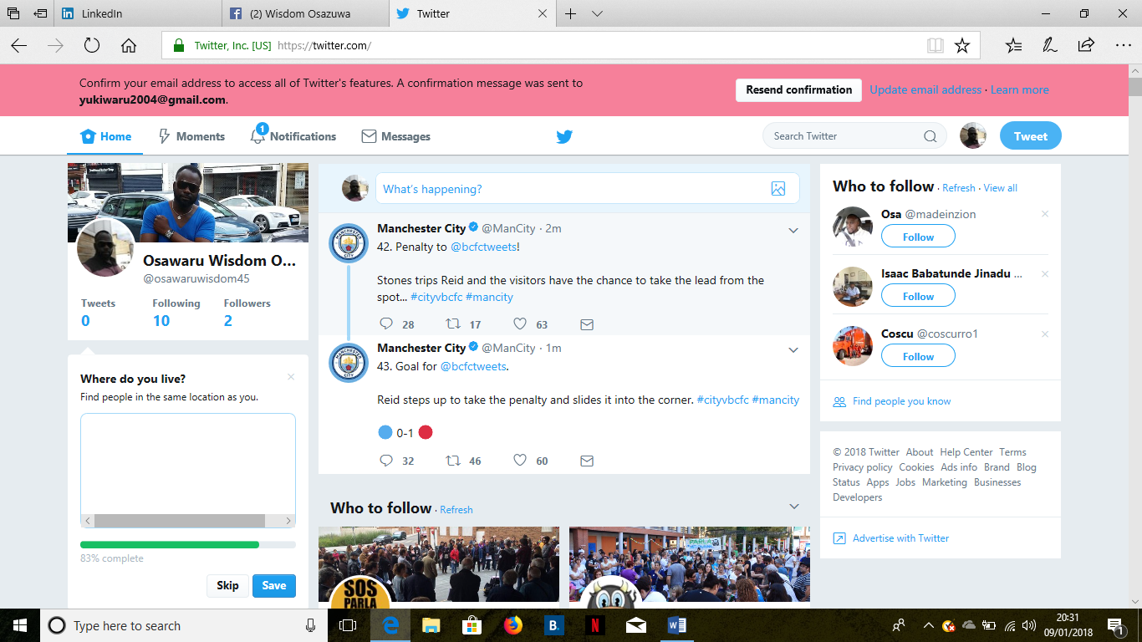
https://twitter.com/


https://www.facebook.com/wisdom.osazuwa.31

APENDIX 2
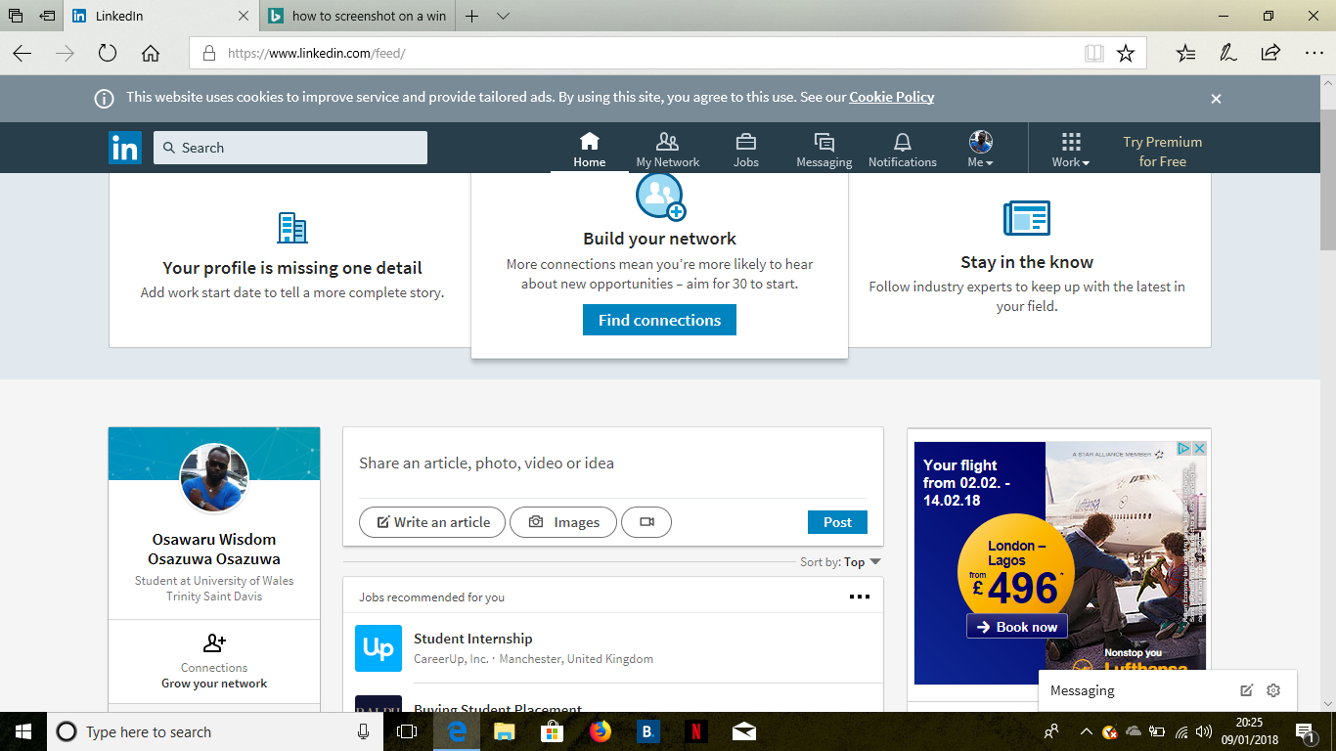
https://www.linkedin.com/feed/

