
Master of Business Administration
LCMB7035 - Dissertation
The Impact of Social Proof on Consumer Trust and Adoption Intention in Fintech Apps.

Supervisor : Dr. Balendran Kandasamy

Student Name: Karan Kumar
Student ID: 2434478
Submission Date: 20/03/2026
Word Count: 2519

Table of Contents
1. Introduction 3
1.1 Background 3
1.2 Rational & Problem 4
1.3 Aim & Objective 5
1.4 Research Question 5
1.5 Research Significance 5
2. Literature Review 6
2.1 Social Proof Theory in Digital Environments 6
2.2 The role of trust-based social proof in decreasing perceived risk 7
2.3 Trust Formation in Fintech Adoption 7
2.4 Role of Reviews, Ratings and Testimonials in Reducing Risk 7
2.5 Literature Gap 8
3. Methodology 8
3.1 Research Philosophy 8
3.2 Research Approach 9
3.3 Research Design 9
3.4 Research Strategy 9
3.5 Sampling Technique 9
3.6 Data Collection Method 10
3.7 Data Analysis Techniques 10
3.8 Ethical Consideration 10
4. Expected findings 11
5. Limitations 12
6. Timeframe 12
7. Conclusion 13
8. References 14

1. Introduction

1.1 Background
Financial Technology (FinTech) has greatly changed how financial services are given because it allows users to receive the banking, payment, and investment services on digital platforms. Due to the fast rise of fintech, there has emerged a set of digital-only service providers of financial services which do not have physical branches (Crossclassify, 2025). Although these platforms are convenient and efficient, there are huge barriers in the establishment of trust in these platforms by the potential users.
Social proof is one of the features that determine consumer confidence in the virtual world. Social proof is a trait that implies that people tend to depend upon the views, behaviours and experiences of others in the decision-making process, particularly in the circumstances of uncertainty. Online contexts commonly use social proof in the form of online reviews, ratings and testimonials, and user-generated content.
In fintech applications, where users are required to provide sensitive financial data, trust is a critically important aspect in terms of defining whether people embraced a service. Research indicates that consumers often base their judgment of digital platforms using peer reviews and ratings. Positive social proof is credible, perceived risk is lowered, and which facilitates adoption behaviour.
Nevertheless, even with the increased significance of fintech services, the reluctance of users is still significant because of the fears relating to the security, privacy, fraud, and reliability. In this respect, social proof indicators can have a significant role in determining consumer trust and intention to use fintech applications. This study specifically focuses on digital-only fintech platforms such as mobile banking apps, e-wallets, and online investment platforms that do not have physical branch presence. In such contexts, users rely more heavily on online reviews, ratings, and testimonials to evaluate credibility and trustworthiness.

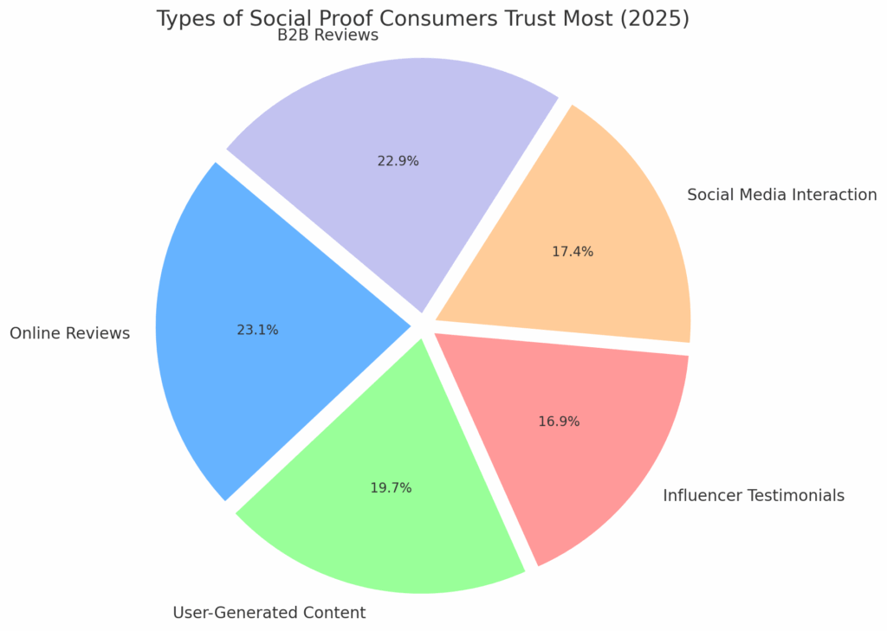
Figure 1: Types of Social Proof Customers Trust Most
(Source: Amraandelma.com, 2025)

1.2 Rational & Problem
Due to the rise in fintech usage worldwide, trust is a significant obstacle of consumers. Fintech companies that operate only online are deprived of the physical facility advantage and long-established reputation inherent in a brick-and-mortar bank. Thus, the social cues that, in many cases, are used by potential users to assess the credibility of these platforms include online reviews, ratings, and testimonials.
They have found that social proof has been largely investigated in the context of e-commerce but little has focused on its role within the framework of fintech adoption with emphasis on users. Moreover, the relationship between social proof and consumer trust as well as adoption intention has not been well supported with adequate empirical evidence.
Thus, the proposed work will investigate the effect of social proof indicators on consumer trust and the impact of this trust on the intention of users to use digital-only fintech applications.

1.3 Aim & Objective
Aim
To examine how social proof indicators influence trust formation and adoption intention among users of digital-only fintech applications.
Objectives
- To examine how social proof indicators (online reviews, ratings, and testimonials) influence consumer trust in digital-only fintech applications.
- To analyse the relationship between consumer trust and adoption intention in fintech services.
- To investigate how social proof reduces perceived risk among fintech users.
- To provide recommendations for fintech companies to improve trust-building strategies using social proof mechanisms.

1.4 Research Question
- How do social proof indicators influence consumer trust in digital-only fintech applications?
- What role does consumer trust play in influencing adoption intention for fintech services?
- How does social proof reduce perceived risk among fintech users?
- What strategies can fintech companies implement to effectively use social proof to increase adoption?

1.5 Research Significance
The study is significant as it highlights the role of social proof. This study is the key area that is directly contributing to fintech marketing. In addition to that, this also contributes to the customer behaviour insights. Furthermore, the study is also providing required practical insights for multiple fintech organisations in order to design multiple trust-building strategies. The findings of the study help in optimising the review management systems and developing strategies for the customer testimonial. At the same time, the study also allows policymakers to gain insight about the factors that have a significant impact on digital financial adoption.

2. Literature Review

2.1 Social Proof Theory in Digital Environments
According to Social Proof Theory, people are likely to trust the actions and opinions of other people in making decisions especially in areas that are marked with uncertainty or least information. Robert Cialdini (2009) argues that social proof is a psychological process in which individuals make assumptions about the behaviours of others by thinking that they have right behaviours. Consumers are often relying on reviews, ratings, testimonials, and user-generated content in digital settings as a measure of the reputation of a product or service. E-media diminishes physical interaction, thereby generating doubt and stimulating people to find reassurance in the experience of their peers. It has been found out that social evidence helps in increasing perceived reliability, decreases ambiguity as well as positively impacts consumer decision-making (Cialdini, 2009). Social proof in the fintech industry is particularly powerful since users have to entrust digital systems with their sensitive financial information. The expression of positive feedback by the existing users is an indicator of legitimacy and reliability, which consequently encourages building trust and enhances the willingness to use digital financial technologies.
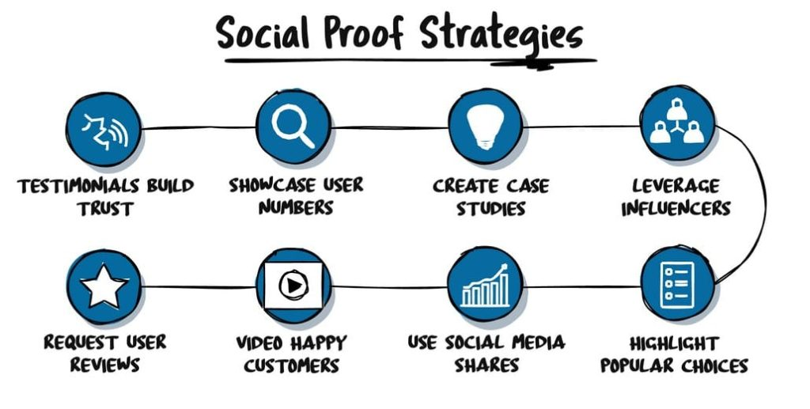
Figure 2: Social Proof Strategies
(Source: Leadalchemists.com, 2025)

2.2 The role of trust-based social proof in decreasing perceived risk
Trust plays a crucial role in the willingness of the users to engage with the FinTech Platforms. It has been identified that perceived trustworthiness directly impacts the adoption decisions of products or services. Trust-based social proof has been a crucial determinant of both user loyalty and user satisfaction within the FinTech context. This help is decreasing the concerns of the user regarding any security and system reliability. Social influence is considered a significant factor in FinTech adoption (Vardari and Hameli, 2025). While the peer recommendations and the reviews, mainly from the opinion leaders, also ultimately help in increasing the likelihood of adopting multiple mobile banking services.

2.3 Trust Formation in Fintech Adoption
Trust is an important factor in deciding the acceptance of fintech services by individuals, particularly when the perceived risk in any financial transaction is high. According to Technology Acceptance Model (TAM), the perceptions of usefulness and perceptions of ease of use determine behavioural intention towards technology adoption (Davis, 1989). Similarly, Unified Theory of Acceptance and Use of Technology (UTAUT2) identifies the following determinants of technology usage as performance expectancy, social influence, and facilitating conditions (Venkatesh et al., 2012). The trust theory also highlights that users consider the credibility, security and reliability of fintech platforms before using them. There is a need to trust more in the digital-only financial settings because of the lack of physical contact and direct confirmation. According to the studies on the topic, perceived trust plays a significant role in determining whether users are willing to use mobile banking systems and online payment systems (Amnas et al., 2023). Thus, the combination of TAM, UTAUT2, and the theory of trust can give a more detailed picture of the development of trust in fintech apps among users.

2.4 Role of Reviews, Ratings and Testimonials in Reducing Risk
According to the Perceived Risk Theory, consumers feel unconfident when buying goods or services, especially when it comes to the use of financial or personal information. In fintech settings, the perceived risk is linked to the fears of security, privacy, fraud, and system reliability. Reviews, rating, and testimonials represent a social proof indicator that can minimize perceived uncertainty to present information regarding the experience of other users. Positive feedback gives more comprehensive information about the quality of the services, usability, and reliability, which increases the perceived credibility of fintech platforms (Uche et al., 2021). Ratings provide easy evaluative indicators, which assist the users in gauging how popular and acceptable an application is whereas testimonials are persuasive stories that enhance confidence. Research reveals that potential users are strongly dependent on the peer opinion in the examination of digital services as it lessens the uncertainty and enhances the trust in the judgment (Albuainain and Ashby, 2025). Thus, the involvement of social proof indicators is an important factor in reducing the perceived risk and motivating the use of fintech.

2.5 Literature Gap
Although previous studies have examined social proof in e-commerce and technology adoption, limited research has specifically analysed the influence of social proof indicators on trust formation among users of digital-only fintech applications. Existing literature mainly focuses on experienced users or traditional banking platforms with established reputations. Therefore, there is a need for empirical research examining how reviews, ratings, and testimonials influence trust development in new fintech platforms where physical interaction is absent. The conceptual framework of this study proposes that social proof indicators (reviews, ratings, testimonials) act as independent variables influencing trust formation. Trust acts as a mediating variable influencing adoption intention, while perceived risk negatively influences trust.

3. Methodology

3.1 Research Philosophy
Positivism is a research philosophy that accurately assumes that reality is objective, independent and even measurable. This further emphasised the observational facts and the statistical testing of any hypothesis (Dudovskiy, 2020). The study will use positivism research philosophy. This is suitable as it allows the statistical validation of the study, and it also allows objective measurement.

3.2 Research Approach
The deductive approach mainly started with the existing theories. After existing theories, it develops hypotheses that are further tested with the assistance of data collection and data analysis (Dudovskiy, 2025). However, the study will use a deductive approach for the whole paper. This approach will be selected as it is very suitable for testing the predefined hypothesis, which mainly involves using quantitative data.

3.3 Research Design
Descriptive research design is a very important part of the methodology. This mainly aims to systematically evaluate the characteristics of the whole population or any phenomenon, even without manipulating any variables (Davis, 2022). The study will choose a descriptive research design. This will be helpful for accurately capturing different patterns and trends. This also captures the relationships as well, which exist among the selected sample.

3.4 Research Strategy
A primary quantitative strategy is a useful research strategy. This strategy mainly involves gathering first-hand numerical information and data, which is directly from the multiple respondents who are involved in the study (Sisinternational.com, 2024). This also aims to analyse the data statistically. The research will employ a primary quantitative strategy.

3.5 Sampling Technique
A random sampling is a significant method in which every member of the whole population has been given an equal chance of being chosen within the study. Using random sampling, it will be helpful in decreasing any selection biases (Taylor, 2023). A convenience sampling technique will be adopted to collect responses from individuals who have limited or no prior experience with fintech applications. Approximately 50 – 80 respondents will be targeted using online survey platforms.

3.6 Data Collection Method
Data will be collected using a structured online questionnaire designed to measure the influence of social proof indicators on trust formation among users of fintech applications. The survey will be distributed through online platforms such as social media, academic networks, and digital communities to reach respondents aged 18 and above who have limited or no prior experience using fintech services. A non-probability convenience sampling technique will be applied due to time and accessibility constraints. The questionnaire will include closed-ended questions measured using a five-point Likert scale to assess perceptions of reviews, ratings, testimonials, trust level, perceived risk, and intention to adopt fintech apps.

3.7 Data Analysis Techniques
Collected data will be analysed using quantitative statistical techniques to examine the relationship between social proof indicators and trust formation. Descriptive statistics such as mean, percentage, and frequency distribution will be used to summarise participant responses and identify general patterns. Inferential statistical analysis, including correlation and regression analysis, will be applied to test the relationships between variables such as reviews, ratings, testimonials, trust, perceived risk, and adoption intention. Statistical software such as SPSS or Microsoft Excel will be used to organise and analyse the data efficiently. The findings will help determine the strength and significance of relationships between social proof and fintech adoption behaviour.

3.8 Ethical Consideration
The study will accurately maintain the rules and regulations. The informed consent will be accurately obtained, that is, before the participation. The confidentiality of the respondents will also be ensured (Alhabsi, 2024). The data from the participants will be used only for academic purposes. The participants are free to withdraw from the study without giving any justification.
AI Use Acknowledgement
I acknowledge the use of ChatGPT in March 2026 to support proofreading and outline generation for this dissertation proposal.
The AI tool was used to assist with improving grammatical accuracy, sentence clarity, academic structure, and organisation of headings. It was also used to generate an initial outline to structure the research proposal.
Prompt(s) used:
- Please help generate an outline for a dissertation proposal on social proof and fintech adoption.
- Please proofread the following paragraphs to improve grammar and academic clarity.
- Please improve the structure of the methodology section.
I confirm that I have not presented AI-generated content as my own work without critical review and modification. I confirm that I have reviewed, edited, and validated all content to ensure originality and academic integrity. I confirm that I have copies of drafts, notes, and other resources used before and after the use of AI tools, which may be provided as evidence if required.

4. Expected findings
The study is expected to demonstrate that social proof indicators such as positive reviews, ratings, and testimonials significantly influence consumer trust in digital-only fintech applications. Increased trust is likely to positively affect consumers’ intention to adopt fintech services (Gordon, 2025). Furthermore, the study may reveal that social proof reduces perceived risk and uncertainty among digital users, thereby encouraging adoption behaviour. These findings will provide practical insights for fintech companies to improve their marketing strategies by incorporating effective review management, user testimonials, and influencer recommendations to enhance consumer trust (Gupta, 2023).

5. Limitations
The study may be limited by a few areas. These areas will be about the limited size of the sample. It may also be about the lack of sufficient geographic area concentration. Furthermore, the self-reported responses may be the reason that further introduces any biases.

6. Timeframe
Tasks | Week 1-2 | Week 3-5 | Week 6-9 | Week 10-11 | Week 12-13 | Week 14-15
Selection of the research topic
Conducting Literature Review
Choosing Research Methodology
Selection of the data collection method
Performing data analysis
Writing Chapters 1 to 3
Write Chapters 4 to 5
Writing of Conclusion & Recommendations
Proofreading & Editing
Table 1: Gantt Chart

7. Conclusion
The above proposal has analysed the direct impact of social proof indicators on trust formation in many users of different Fintech Apps. The above proposal has provided an overview of the significance of social proof. The challenges that may hinder the adoption of Fintech products among users have been mentioned. The paper has explored that primary research will be chosen for the study.

8. References
Albuainain, A. and Ashby, S., 2025. Enablers and barriers in FinTech adoption: A systematic literature review of customer adoption and its impact on bank performance. FinTech, 4(3), p.49. https://www.mdpi.com/2674-1032/4/3/49
Alhabsi, S.S., 2024. Ethical considerations in obtaining informed consent in research participation. International Journal of Educational Contemporary Explorations, 1(1), pp.22-32. https://ijece.virtualrealia.org/wp-content/uploads/journal/published_paper/volume-1/issue-1/8i5Fo3z6.pdf
Amnas, M.B., Selvam, M., Raja, M., Santhoshkumar, S. and Parayitam, S., 2023. Understanding the determinants of FinTech adoption: Integrating UTAUT2 with trust theoretic model. Journal of risk and financial management, 16(12), p.505. https://www.mdpi.com/1911-8074/16/12/505
Amraandelma.com (2025). BEST SOCIAL PROOF MARKETING STATISTICS 2025. Available at: https://www.amraandelma.com/social-proof-marketing-statistics/.
Cialdini, R. B. (2009). Influence: Science and practice (5th ed.). Pearson Education.
Davis, F. D. (1989). Perceived usefulness, perceived ease of use, and user acceptance of information technology. MIS Quarterly, 13(3), 319–340. https://doi.org/10.2307/249008
Venkatesh, V., Thong, J. Y. L., & Xu, X. (2012). Consumer acceptance and use of information technology: Extending the unified theory of acceptance and use of technology. MIS Quarterly, 36(1), 157–178. https://doi.org/10.2307/41410412
Crossclassify.com. (2025). The Hidden Threats in Fintech: Fraud and Cybersecurity Challenges. Available at: https://www.crossclassify.com/resources/articles/hidden-threats-fintech-fraud-cybersecurity/.
Davis, R. (2022). Descriptive Research Design: What It Is and How to Use It. Available at: https://www.qualtrics.com/articles/strategy-research/descriptive-research-design/.
Dudovskiy, J. (2020). Positivism - Research Methodology.. Available at: https://research-methodology.net/research-philosophy/positivism/.
Dudovskiy, J. (2025). Deductive Approach (Deductive Reasoning). Available at: https://research-methodology.net/research-methodology/research-approach/deductive-approach-2/.
Gordon, D.T. (2025). Technology Acceptance Model. Available at: https://www.slideshare.net/slideshow/technology-acceptance-model/20482759.
Gupta, S. (2023). What Is Social Proof? How to Harness Its Power for Marketing Success. Available at: https://www.gartner.com/en/digital-markets/insights/what-is-social-proof.
IBM (2024). SPSS Statistics . Available at: https://www.ibm.com/products/spss-statistics.
Le, M.T., 2021. Examining factors that boost intention and loyalty to use Fintech post-COVID-19 lockdown as a new normal behavior. Heliyon, 7(8). https://www.cell.com/heliyon/pdf/S2405-8440(21)01924-1.pdf
Leadalchemists.com (2025). Social Proof in Marketing: Description, Psychology, and Examples - Quality Lead Generation From The Lead Alchemists Agency. Available at: https://www.leadalchemists.com/marketing-psychology/social-proof/.
SatisFactory. (2022). Online surveys: Benefits and tips. Available at: https://www.satisfactory.fr/en/actualites/enquetes/sondage-ligne-avantages-conseils [Accessed 27 Feb. 2026].
Sisinternational.com (2024). Top 5 Benefits of Conducting Quantitative Market Research. Available at: https://www.sisinternational.com/top-5-benefits-of-conducting-quantitative-market-research/.
Taylor, S. (2023). Random Sampling. Available at: https://corporatefinanceinstitute.com/resources/data-science/random-sampling/.
Uche, D.B., Osuagwu, O.B., Nwosu, S.N. and Otika, U.S., 2021. Integrating trust into technology acceptance model (TAM), the conceptual framework for e-payment platform acceptance. British Journal of Management and Marketing Studies, 4(4), pp.34-56. https://abjournals.org/bjmms/wp-content/uploads/sites/3/journal/published_paper/volume-4/issue-4/BJMMS_TB3XTKPI.pdf
Vardari, L. and Hameli, K., 2025. Perceived benefits, trust and social influence in FinTech: pathways to adoption and satisfaction in a developing economy. Global Knowledge, Memory and Communication. https://www.researchgate.net/profile/Kujtim-Hameli/publication/395409865

