International Business Communications
Student ID:2029761
Student Name:Maxim Popa

Introduction
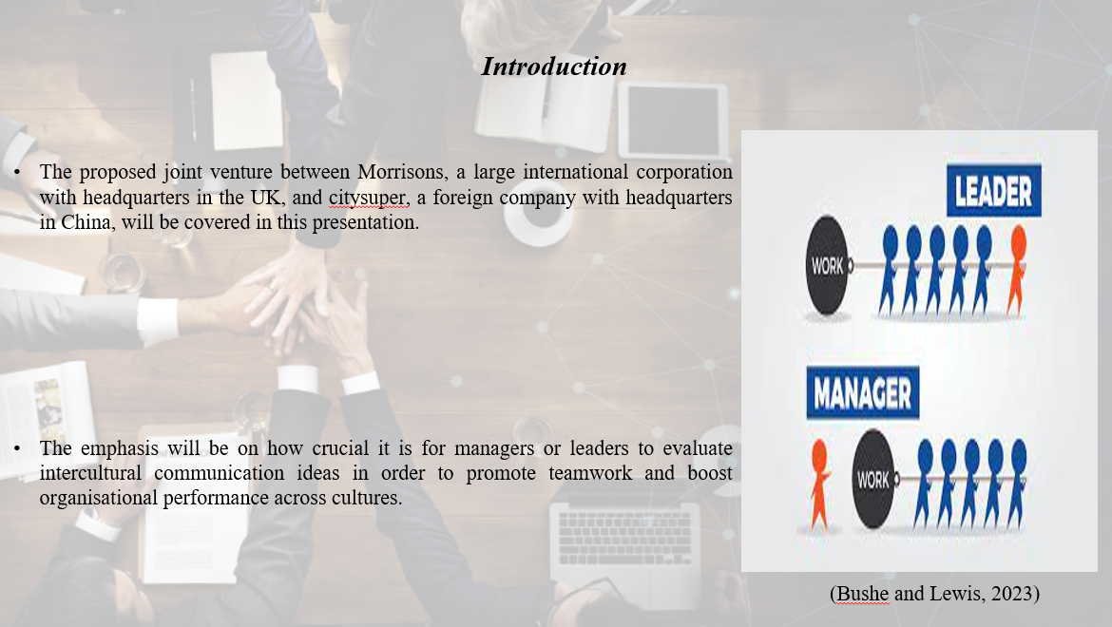
The proposed joint venture between Morrisons, a large international corporation with headquarters in the UK, and citysupplier, a foreign company with headquarters in China, will be covered in this presentation. The emphasis will be on how crucial it is for managers or leaders to evaluate intercultural communication ideas in order to promote teamwork and boost organisational performance across cultures. It will also examine the relevance of various ideas and how managers or leaders have applied them, as well as the variations that may be found among managers or leaders as a whole. The discussion will also describe the significance of comprehending various communication styles in order to strengthen intercultural teams and manage the issues and challenges posed by both firms' respective cultures. Furthermore, suggestions and corporate communication solutions will be offered for successful partnerships.

Reviewing theories of intercultural communication relevant to leaders or managers can improve team working
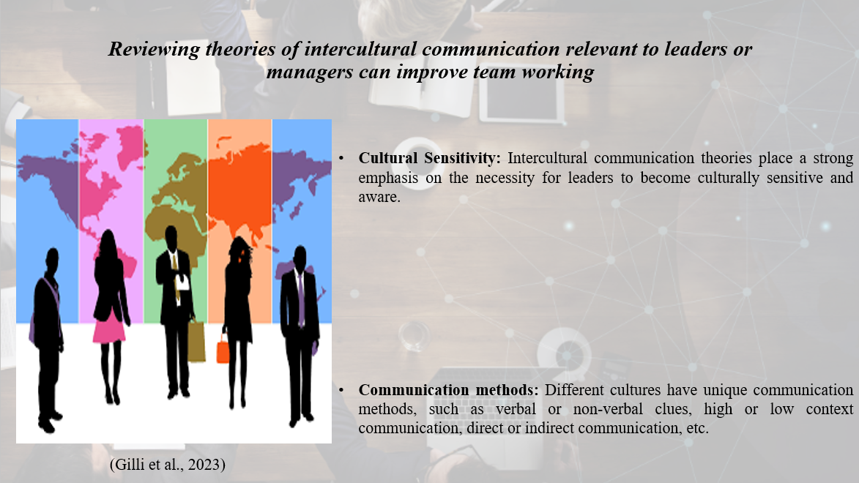
It is crucial for managers or leaders to review intercultural communication theories in order to improve teamwork in a globalised company environment. These ideas offer helpful suggestions on how to collaborate and communicate with team members from different cultural backgrounds. They also shed light on the complexity of cross-cultural relationships. These reviews can greatly enhance teamwork for a number of reasons, including the following:
Cultural Sensitivity: Intercultural communication theories place a strong emphasis on the necessity for leaders to become culturally sensitive and aware. Managers can modify their strategies and foster an inclusive and courteous workplace that embraces diversity by having a thorough awareness of the norms, beliefs, and communication practises of various cultures (Armstrong et al., 2023).
Communication methods: Different cultures have unique communication methods, such as verbal or non-verbal clues, high or low context communication, direct or indirect communication, etc. Leaders can modify their communication tactics to close cultural gaps, reduce misconceptions, and encourage efficient information sharing by being familiar with these variations.
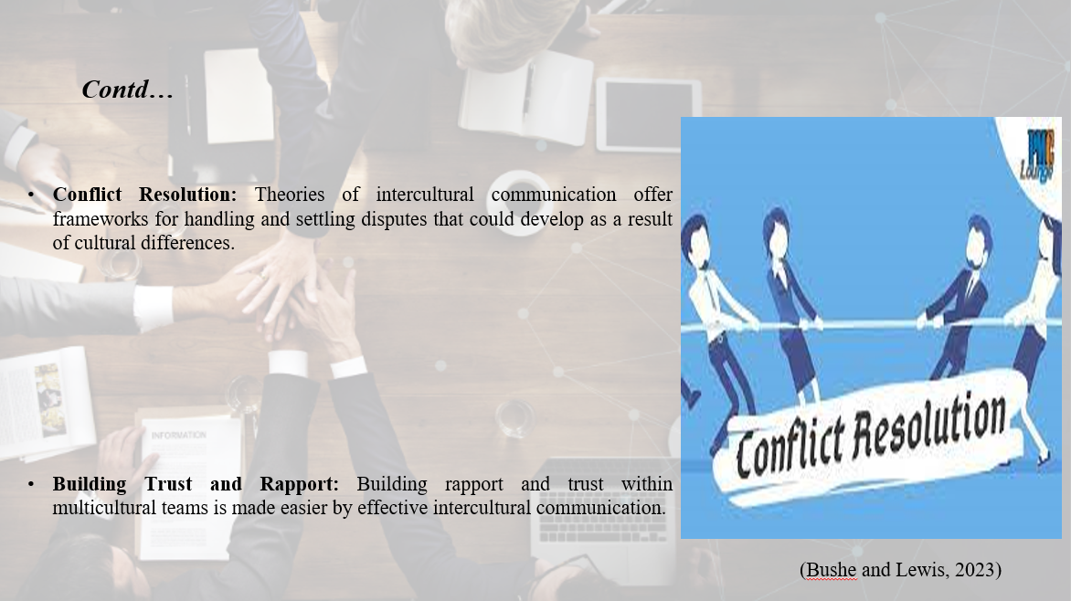
Conflict Resolution: Theories of intercultural communication offer frameworks for handling and settling disputes that could develop as a result of cultural differences. By using culturally appropriate conflict resolution techniques, leaders who are aware of these theories can encourage team members' understanding and cooperation (Oslandn et al., 2023).
Building Trust and Rapport: Building rapport and trust within multicultural teams is made easier by effective intercultural communication. By exhibiting tolerance for cultural differences, actively listening, and encouraging open discourse, leaders who apply intercultural communication ideas can create lasting connections.
Team Cohesion and Productivity: Improved intercultural communication has a favourable effect on the cohesion and productivity of teams. Team members are more inclined to communicate, share ideas, and offer their different viewpoints when they feel appreciated and understood, which promotes better problem-solving and innovation (Deardorff and Berardo, 2023).

Analyse the importance of different theories and different aspects of the way managers or leaders can use them to improve organisational performance in different cultures
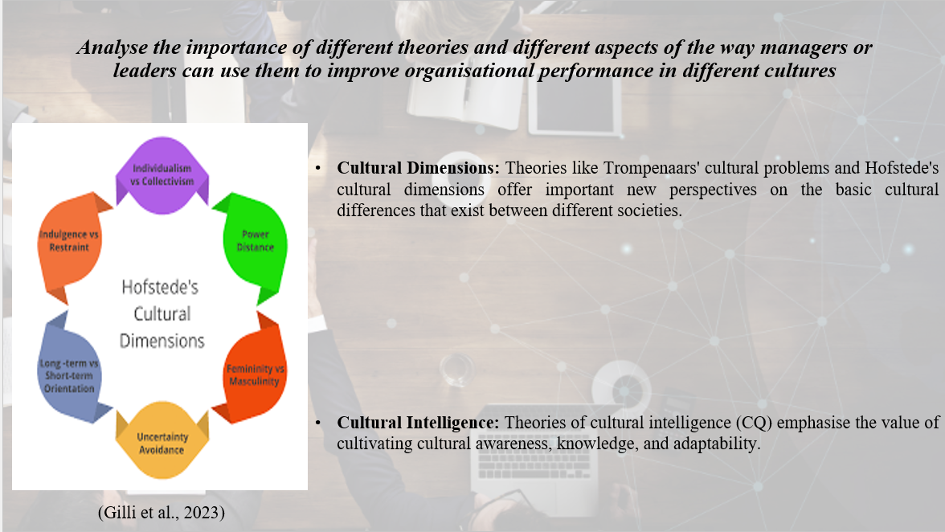
Different intercultural communication theories are significant because they can help managers or leaders navigate the complexity of other cultures, thereby enhancing organisational performance. An examination of these ideas' importance and managerial applications follows:
Cultural Dimensions: Theories like Trompenaars' cultural problems and Hofstede's cultural dimensions offer important new perspectives on the basic cultural differences that exist between different societies. Managers can improve performance by adjusting their leadership style, decision-making procedures, and organisational structures to conform to the cultural norms and expectations of various cultures by understanding these dimensions (Hyken, 2023).
Cultural Intelligence: Theories of cultural intelligence (CQ) emphasise the value of cultivating cultural awareness, knowledge, and adaptability. Managers with high CQ are able to lead teams with cultural awareness and negotiate a variety of cultural environments. By encouraging inclusivity, minimising conflicts, and maximising the potential of a culturally varied workforce, this improves organisational performance (Lee et al., 2023).
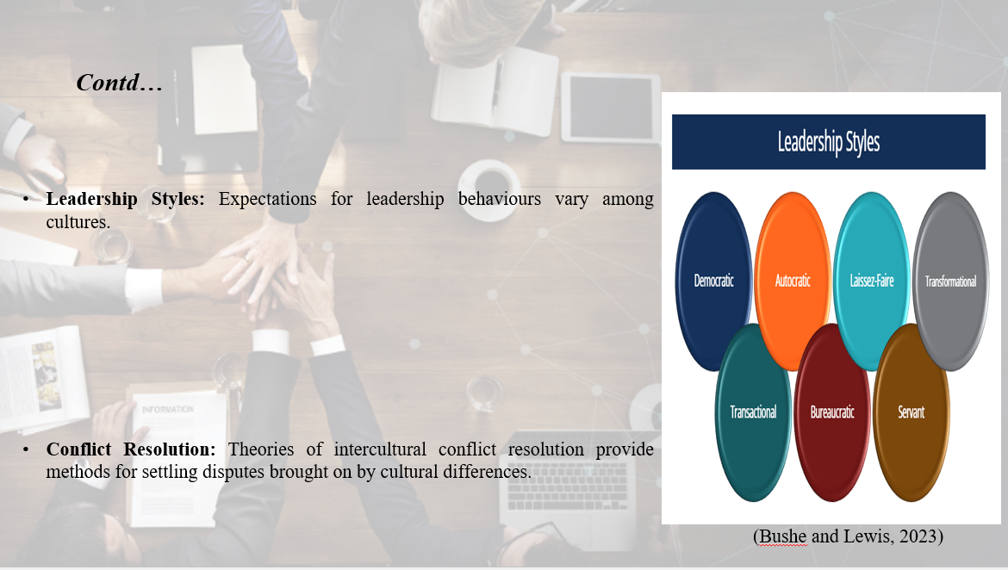
Leadership Styles: Expectations for leadership behaviours vary among cultures. Culture-specific leadership styles can be gleaned from theories like the GLOBE leadership dimensions. Managers that are aware of these characteristics can modify their leadership style to fit cultural norms, fostering trust, inspiring workers, and enhancing output (Lee et al., 2023).
Conflict Resolution: Theories of intercultural conflict resolution provide methods for settling disputes brought on by cultural differences. By utilising cultural perspectives and sustaining team cohesion, managers equipped with these theories can handle disagreements in a constructive manner, improving organisational performance.

Examples of differences in general between different leaders or managers
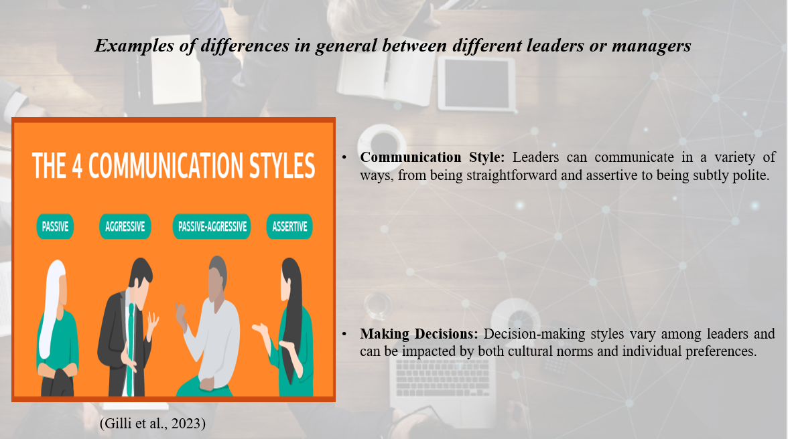
Different managers or leaders may have different leadership philosophies, personality types, or cultural backgrounds. Observable broad differences include the following examples:
Communication Style: Leaders can communicate in a variety of ways, from being straightforward and assertive to being subtly polite. A leader from a low-context culture could prioritise direct and explicit communication, whereas a leader from a high-context culture might rely more on implicit cues and non-verbal communication (Siyal et al., 2023).
Making Decisions: Decision-making styles vary among leaders and can be impacted by both cultural norms and individual preferences. While some leaders may favour a hierarchical method in which they make decisions alone, others may choose a more participative and consensus-driven strategy in which they involve their teams in the decision-making process (Facilitator, 2023).
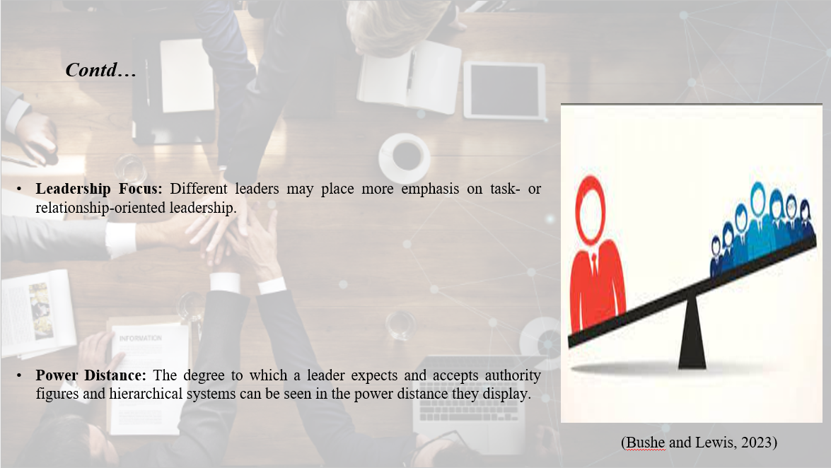
Leadership Focus: Different leaders may place more emphasis on task- or relationship-oriented leadership. While some leaders place more emphasis on accomplishing objectives and results, others place more emphasis on developing solid connections and promoting team cohesion (Ikendi and Retallick, 2023).
Power Distance: The degree to which a leader expects and accepts authority figures and hierarchical systems can be seen in the power distance they display. Leaders may adopt a more hierarchical and authoritarian approach in some cultures while adopting a more egalitarian and collaborative style in others.
Cultural Values: Cultural backgrounds of leaders influence their values and beliefs, which in turn affect how they lead. Leaders from individualistic cultures, for instance, might put more emphasis on autonomy and personal success than leaders from collectivist cultures might.

Importance of understanding the approaches that they have applied in communicating with and improving intercultural team to enhance organisational performance
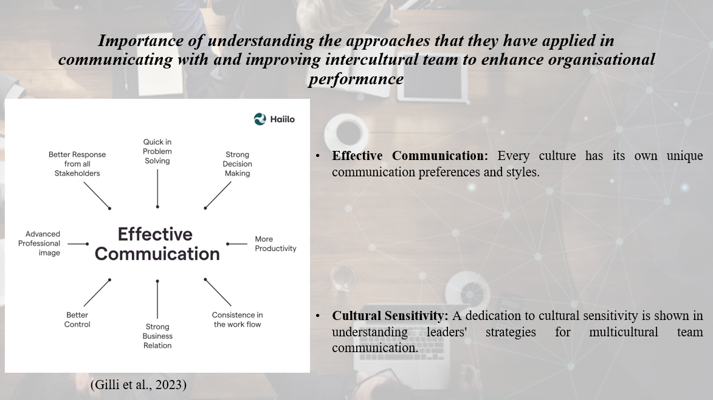
It is crucial to comprehend the strategies leaders have used to interact with and develop intercultural teams if they want to improve organisational performance in a range of cultural settings. For a number of reasons, having this understanding is essential:
Effective Communication: Every culture has its own unique communication preferences and styles. Organisations can modify their communication techniques to bridge cultural gaps, enhance understanding, and reduce misinterpretations by knowing the strategies leaders have used in interacting with intercultural teams. This makes it easier for the team to collaborate, share information, and solve problems (Ogutu et al., 2023).
Cultural Sensitivity: A dedication to cultural sensitivity is shown in understanding leaders' strategies for multicultural team communication. It enables organisations to value and respect the many viewpoints, standards, and conventions, generating a welcoming workplace where team members feel appreciated and understood. Employee involvement, morale, and productivity are thereby improved.
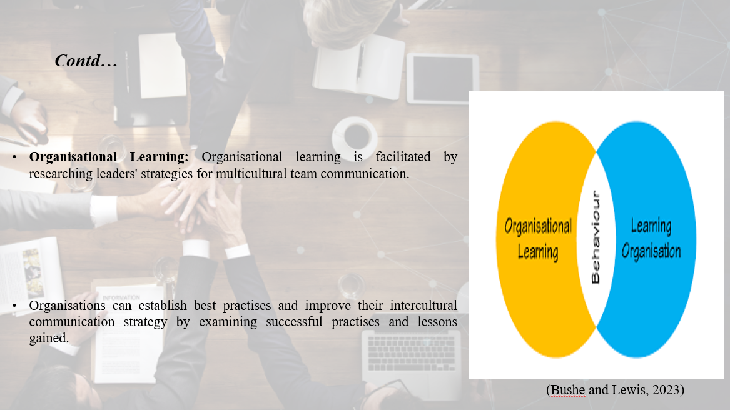
Organisational Learning: Organisational learning is facilitated by researching leaders' strategies for multicultural team communication. Organisations can establish best practises and improve their intercultural communication strategy by examining successful practises and lessons gained. This continuing process of learning encourages innovation, continuous advancement, and the capacity to function well in a variety of cultural contexts (Gilli et al., 2023).

The cultural challenges and difficulties identified for the companies
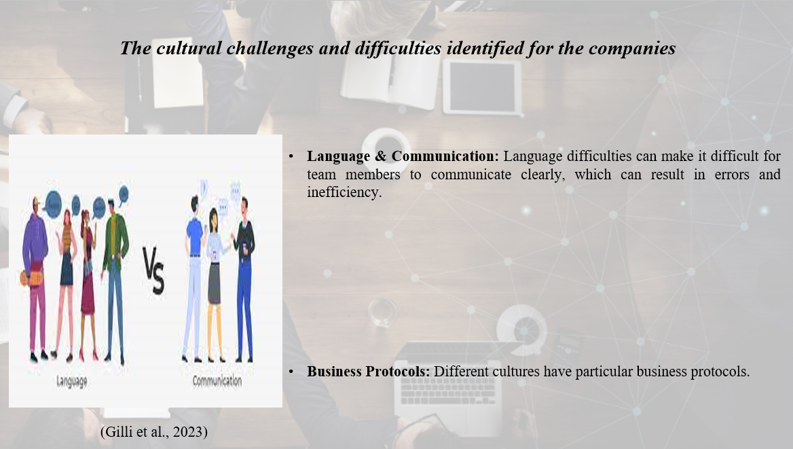
The possible joint venture between Morrisons, located in the UK, and citysuper, based in China, is probably going to run across a number of cultural obstacles and issues. A few of these are:
Language & Communication: Language difficulties can make it difficult for team members to communicate clearly, which can result in errors and inefficiency. Investing in language instruction and putting good translation and interpretation techniques into practise are necessary to overcome these obstacles (Bushe and Lewis, 2023).
Cultural Norms and Values: The businesses may have various cultural norms and values, which could have an impact on how decisions are made, how people work, and how businesses operate. To prevent disputes and guarantee alignment in organisational aims and expectations, it is essential to comprehend and resolve these discrepancies.
Business Protocols: Different cultures have particular business protocols. Businesses must negotiate these variances to prevent unnecessarily offending or confusing customers. Building trust and forging lasting connections with partners and stakeholders requires knowledge of proper business etiquette (Bushe and Lewis, 2023).
Hierarchical Structures: Compared to the UK's flatter organisational structures, China's hierarchical structures may be different. It can be difficult to balance and integrate multiple systems, and leaders and team members must collaborate and communicate openly.
Work-Life Balance: The two cultures may have different perspectives on work-life balance. In order to bridge these gaps, understanding and adaptability must be fostered to take into account various viewpoints on working hours, vacations, and personal duties (Bushe and Lewis, 2023).

Recommendations and business communication solutions to enable the partnership
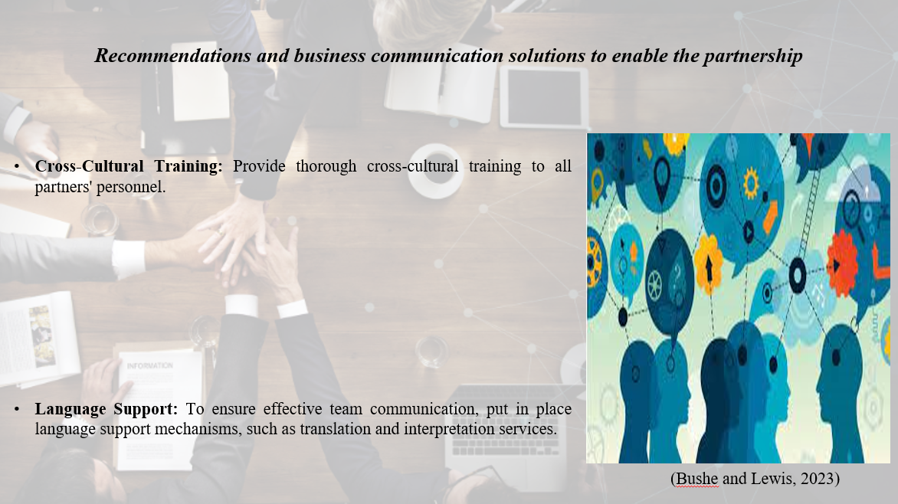
Cross-Cultural Training: Provide thorough cross-cultural training to all partners' personnel. The main objectives of this training should be to increase cultural sensitivity, increase knowledge of cultural differences, and offer useful advice on how to collaborate and communicate effectively across cultural boundaries.
Language Support: To ensure effective team communication, put in place language support mechanisms, such as translation and interpretation services. By ensuring that linguistic barriers are kept to a minimum, this encourages efficient information sharing and comprehension (Kim et al., 2023).
Cultural Liaisons: Select individuals with extensive knowledge of both British and Chinese cultures as intercultural facilitators or as cultural liaisons. These people can assist create a trusting and understanding environment by bridging cultural gaps, facilitating communication, and offering advice on cultural norms and expectations.
Regular Communication Channels: Establish consistent and transparent communication routes between Morrisons and citysupplier to ensure frequent and open channels of information flow. Regular video conferencing, virtual meetings, and online collaboration tools can help to promote in-the-moment communication and collaboration (Kim et al., 2023).
Conflict Resolution Mechanisms: Develop explicit and culturally sensitive conflict resolution processes to deal with disputes that could result from cultural differences. Encourage open communication, attentive listening, and mediation to settle disputes amicably and maintain the partnership.

Conclusion
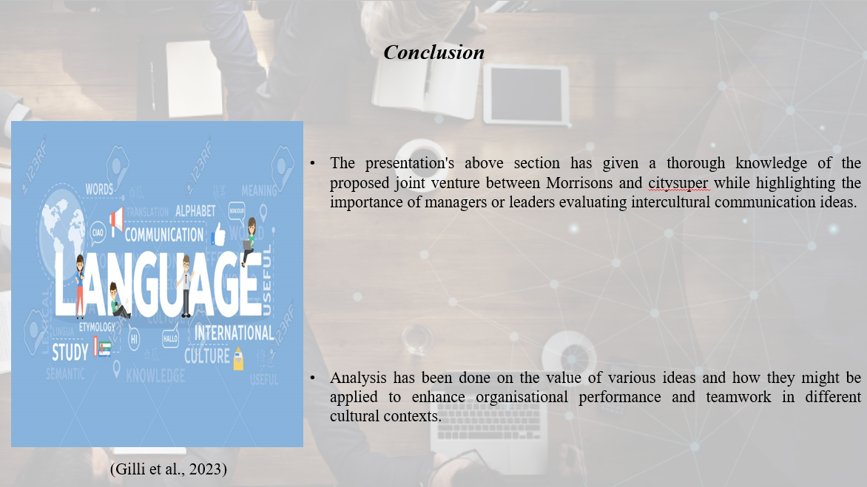
The presentation's above section has given a thorough knowledge of the proposed joint venture between Morrisons and citysuper while highlighting the importance of managers or leaders evaluating intercultural communication ideas. Analysis has been done on the value of various ideas and how they might be applied to enhance organisational performance and teamwork in different cultural contexts. The presentation has also emphasised the variations among managers or leaders generally and the significance of comprehending these variations in order to improve intercultural teams' communication. In order to facilitate a successful relationship, the cultural hurdles and issues that may affect both businesses have been highlighted, along with recommendations and business communication solutions. Morrisons and citysuper may successfully negotiate cultural differences, promote effective communication, and create a solid collaborative basis for their relationship by putting these tips into practise, such as cross-cultural training, language support, and clear communication routes.

References
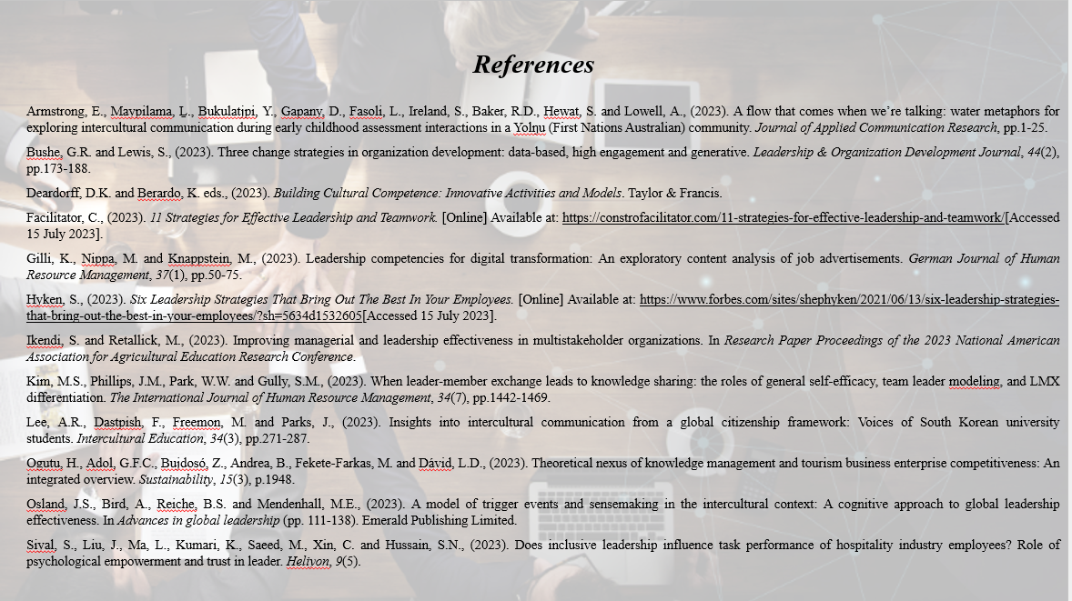
Armstrong, E., Maypilama, Ḻ., Bukulatjpi, Y., Gapany, D., Fasoli, L., Ireland, S., Baker, R.D., Hewat, S. and Lowell, A., (2023). A flow that comes when we’re talking: water metaphors for exploring intercultural communication during early childhood assessment interactions in a Yolŋu (First Nations Australian) community. Journal of Applied Communication Research, pp.1-25.
Bushe, G.R. and Lewis, S., (2023). Three change strategies in organization development: data-based, high engagement and generative. Leadership & Organization Development Journal, 44(2), pp.173-188.
Deardorff, D.K. and Berardo, K. eds., (2023). Building Cultural Competence: Innovative Activities and Models. Taylor & Francis.
Facilitator, C., (2023). 11 Strategies for Effective Leadership and Teamwork. [Online] Available at: https://constrofacilitator.com/11-strategies-for-effective-leadership-and-teamwork/[Accessed 15 July 2023].
Gilli, K., Nippa, M. and Knappstein, M., (2023). Leadership competencies for digital transformation: An exploratory content analysis of job advertisements. German Journal of Human Resource Management, 37(1), pp.50-75.
Hyken, S., (2023). Six Leadership Strategies That Bring Out The Best In Your Employees. [Online] Available at: https://www.forbes.com/sites/shephyken/2021/06/13/six-leadership-strategies-that-bring-out-the-best-in-your-employees/?sh=5634d1532605[Accessed 15 July 2023].
Ikendi, S. and Retallick, M., (2023). Improving managerial and leadership effectiveness in multistakeholder organizations. In Research Paper Proceedings of the 2023 National American Association for Agricultural Education Research Conference.
Kim, M.S., Phillips, J.M., Park, W.W. and Gully, S.M., (2023). When leader-member exchange leads to knowledge sharing: the roles of general self-efficacy, team leader modeling, and LMX differentiation. The International Journal of Human Resource Management, 34(7), pp.1442-1469.
Lee, A.R., Dastpish, F., Freemon, M. and Parks, J., (2023). Insights into intercultural communication from a global citizenship framework: Voices of South Korean university students. Intercultural Education, 34(3), pp.271-287.
Ogutu, H., Adol, G.F.C., Bujdosó, Z., Andrea, B., Fekete-Farkas, M. and Dávid, L.D., (2023). Theoretical nexus of knowledge management and tourism business enterprise competitiveness: An integrated overview. Sustainability, 15(3), p.1948.
Osland, J.S., Bird, A., Reiche, B.S. and Mendenhall, M.E., (2023). A model of trigger events and sensemaking in the intercultural context: A cognitive approach to global leadership effectiveness. In Advances in global leadership (pp. 111-138). Emerald Publishing Limited.
Siyal, S., Liu, J., Ma, L., Kumari, K., Saeed, M., Xin, C. and Hussain, S.N., (2023). Does inclusive leadership influence task performance of hospitality industry employees? Role of psychological empowerment and trust in leader. Heliyon, 9(5).

