

Jack Douglas Twaddle

Study Skills Assignment

University of Wales Trinity Saint David
OME Degree

Academic Year: 2024 - 2025

Supervisor: Jenni Steen
Jan 2025

University of Wales Trinity Saint David
OME Degree

Academic Year 2024 - 2025

Jack Douglas Twaddle

Study Skills Assignment

Supervisor: Jenni Steen
Jan 2025

This thesis is submitted in partial fulfilment of the requirements for the degree of OME
(NB. Remove if the degree award is based solely on examination of the thesis)

© UWTSD 2025. All rights reserved. No part of this publication may be reproduced without the written permission of the copyright owner.

Academic integrity declaration
I declare that:
- the thesis submitted has been written by me alone.
- the thesis submitted has not been previously submitted to this university or any other.
- that all content, including primary and/or secondary data, is true to the best of my knowledge.
- that all quotations and references have been duly acknowledged according to the requirements of academic research.
I understand that to knowingly submit work in violation of the above statement will be considered by examiners as academic misconduct
i
Contents
Academic integrity declaration i
1 Presentation 8
1.1 Brief Overview 8
1.2 Initial PowerPoint Presentation 8
1.3 Key Points 9
1.3.1 Using a design and sticking to it, which made the layout of the presentation easy to read and follow. 10
1.3.2 Being able to structure his slides in a way that makes the presentation flow well and effective. 10
1.3.3 Managing his time efficiently by sticking to the time amount given. 10
1.3.4 To answer questions after the presentation by thinking on his feet. 10
1.4 Future Improvements 10
2 Skills Evaluation 10
2.1 Research 10
2.2 Transferrable skills 10
2.3 Self Evaluation 11
2.3.1 Evaluation Quiz 11
2.4 Where can you improve 12
2.5 Goals 12
2.6 SMART Goals 12
3 Application 14
3.1 Looking after data 14
3.2 Time Management and self-organisation 14
3.2.1 Screenshots of Evidence 15
3.2.2 Completed e-Portfolio 15
3.3 Independent Study 17
3.3.1 Torpex 17
4 Conclusion & Evaluation 19
4.1 Key findings 19
4.1.1 S 19
References 23
Appendices 24

1 Presentation 8
1.1 Brief Overview 8
1.2 Initial PowerPoint Presentation 8
1.3 Key Points 9
1.3.1 Using a design and sticking to it, which made the layout of the presentation easy to read and follow. 10
1.3.2 Being able to structure his slides in a way that makes the presentation flow well and effective. 10
1.3.3 Managing his time efficiently by sticking to the time amount given. 10
1.3.4 To answer questions after the presentation by thinking on his feet. 10
1.4 Future Improvements 10
2 Skills Evaluation 10
2.1 Research 10
2.2 Transferrable skills 10
2.3 Self Evaluation 11
2.3.1 Evaluation Quiz 11
2.4 Where can you improve 12
2.5 Goals 12
2.6 SMART Goals 12
3 Application 14
3.1 Looking after data 14
3.2 Time Management and self-organisation 14
3.2.1 Screenshots of Evidence 15
3.2.2 Completed e-Portfolio 15
3.3 Independent Study 17
3.3.1 Torpex 17
4 Conclusion & Evaluation 19
4.1 Key findings 19
4.1.1 S 19
References 23
Appendices 24
Appendix A Ethical approval letter 24
Appendix B Appendix guidance (Appendix title (use Heading 7)) 25
Appendix C Appendix title (use Heading 7) 27

Presentation

Brief Overview
Jack Twaddle is an 18yr old young man who lives with his parents and 9yr old sister. The family have 2 cats, Oscar and Zorro. They live in Port Glasgow which is a small town in Inverclyde and have lived there since Jack was born. In his free time the student is a keen footballer who also enjoys playing golf, video games, going to the gym and listening to music. As a teenager his first ever job was delivering newspapers, which he done for a few years.

1.2 Initial PowerPoint Presentation
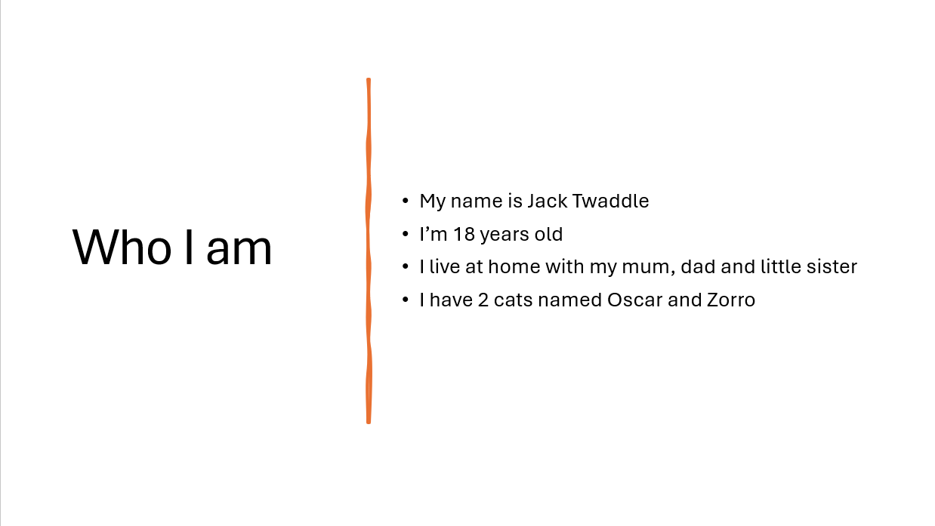
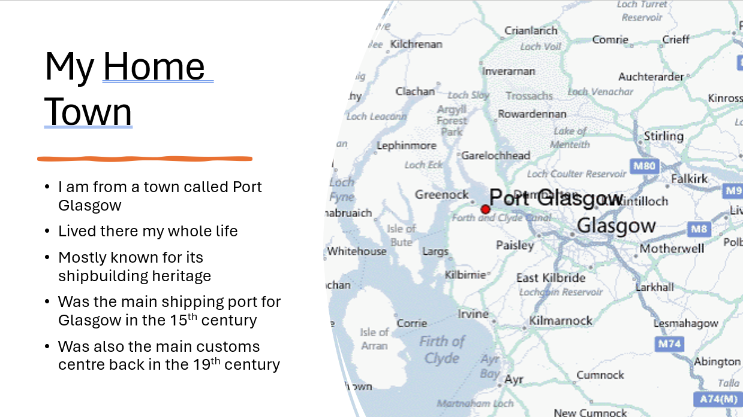

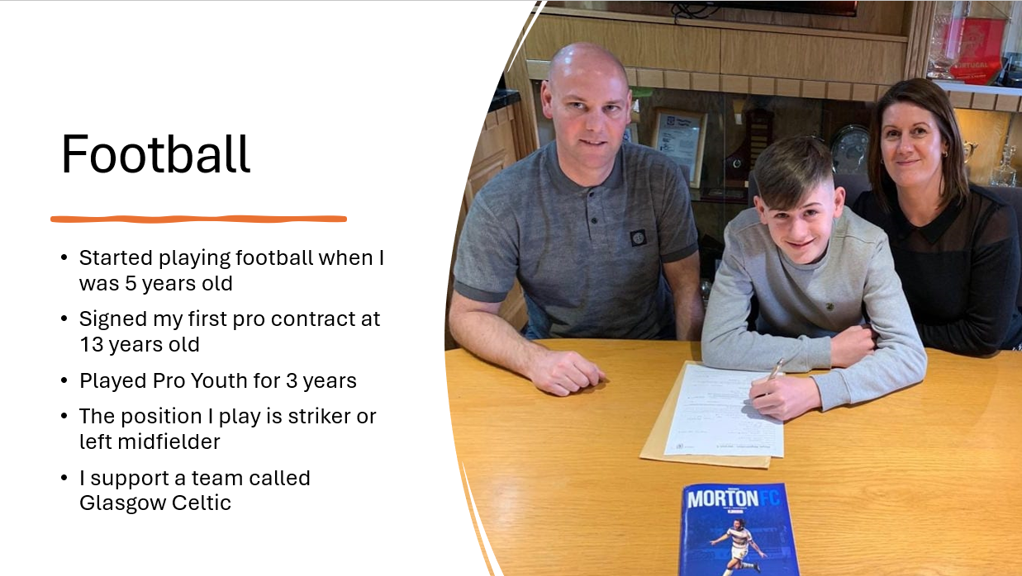
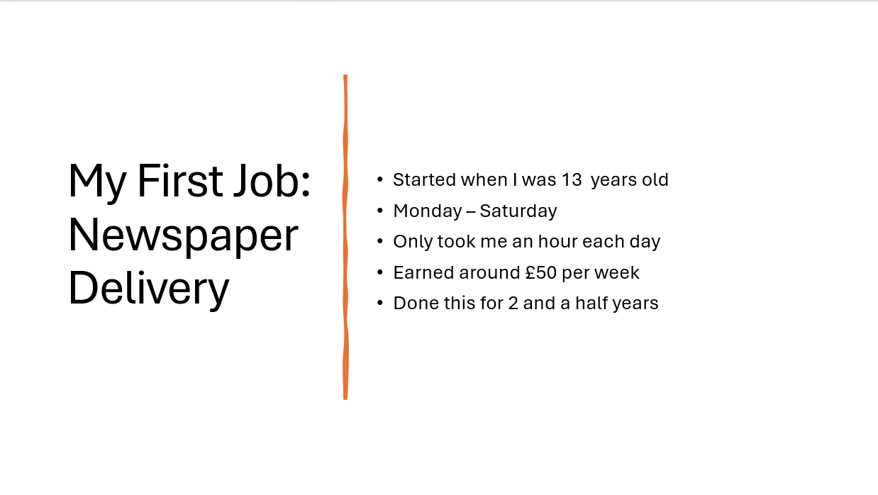

Key Points
The key points the student learned when creating and presenting this presentation was:

Using a design and sticking to it, which made the layout of the presentation easy to read and follow.

Being able to structure his slides in a way that makes the presentation flow well and effective.

Managing his time efficiently by sticking to the time amount given.

1.3.4 To answer questions after the presentation by thinking on his feet.

Future Improvements
Some areas the student felt that he needs to improve on when presenting would be, his eye contact as he felt that he was mostly reading off the PowerPoint rather than facing the audience. Another improvement area would be slowing down when speaking to give the audience a chance to ingest and follow the information being presented to them. A final area for improvement would be speaking louder and clearer so that everyone in the room can hear and understand everything that is said.

Skills Evaluation

Research
Skills required for successful learning in a higher education environment include time management. This is an important skill to enable students to stay in line with the academic calendar and exam preparation.

Transferrable skills
A key skill employers look for in job candidates is communication. This is a key skill because as an employee it is important to be able to communicate well within a team to get tasks complete, solve problems and gain a better understanding. It is also important to communicate to your managers effectively to gain better understandings on topics that are not fully understood.
A second key skill would be organisation. Organisation is a key skill as it shows good understanding of processes and the ability to work to strict deadlines by managing time effectively.

Self Evaluation
The student completed a ‘what type of learner are you’ quiz and received the feedback that he is a visual learner. He has always had the idea that he was a visual learner as he is a practical person and gains a better understanding of instructions quicker when watching a task rather than listening to instructions.

Evaluation Quiz
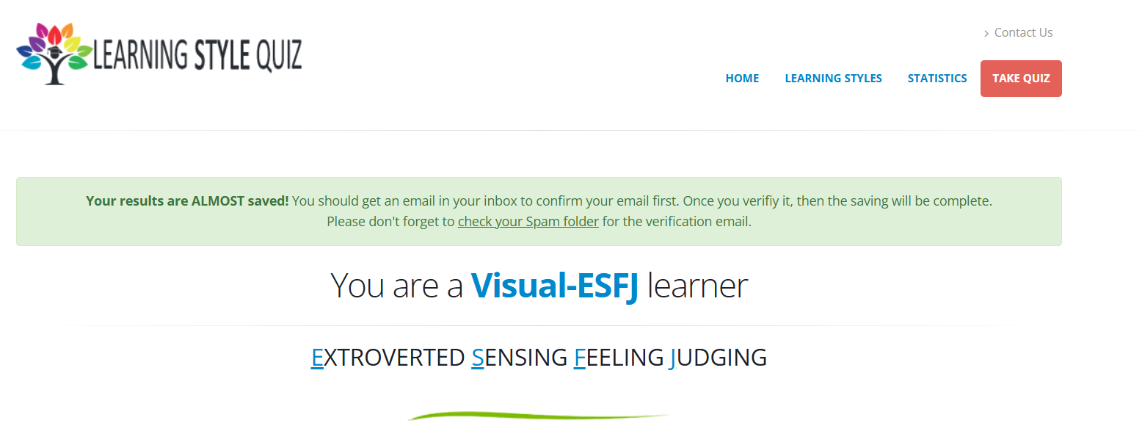
The second quiz the student completed was a ‘People Skills’ quiz and received a 50-80 score. This shows he has good people skills, has an understanding of team dynamics but requires work in specific areas.
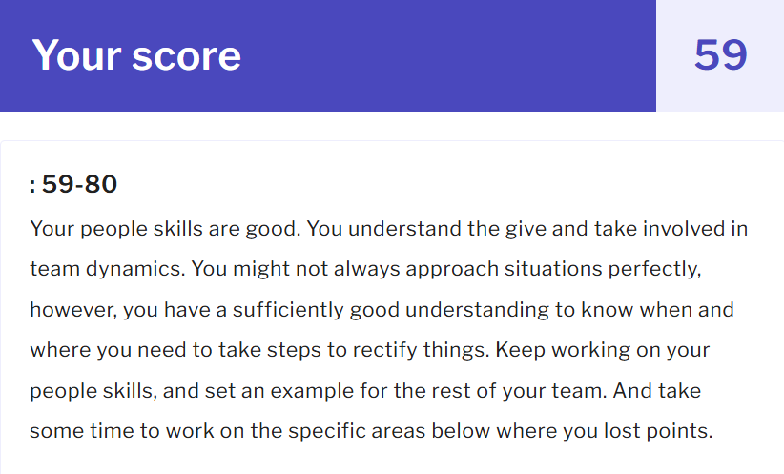

A final quiz the student completed was a ‘Personality Test’ and received the feedback that he is assertive and in charge. Is a logical thinker who has good organisation skills and a confident manner.
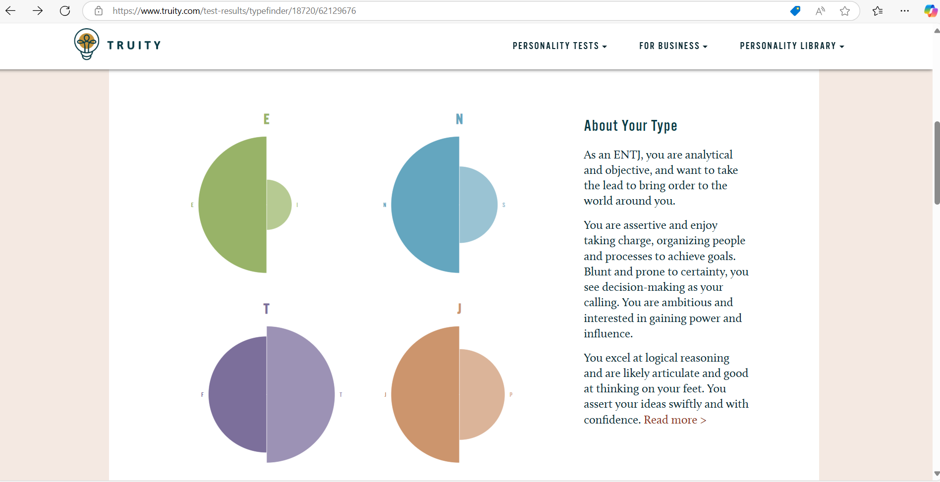

Where can you improve
Improvement in social environments is required, however this will come naturally with maturity and confidence.

Goals
- Get a 60% or higher pass mark in my upcoming maths exam.
- Achieving OME Degree
- Read 1 book every 3 months
- Go to the Gym 5 days per week

2.6 SMART Goals
SMART goals are an easy way to set out clear
S stands for SPECIFIC, this means selecting a goal that is clear and can’t be interpreted in many ways so that everyone is on the same page and is clear of the required outcome.
M stands for MEASUREABLE, this is where tracking progress is decided, so it is easy to tell when the goal has been achieved.
A stands for ACHIEVABLE, where tasks should be broke down into smaller tasks that are more achievable and aren’t too difficult to maintain.
R stands for REALISTIC, goals should be relevant to subject and have key benefits stated.
T stands for TIME-BOUND, in this section picking a desired deadline to achieve the set goal allows the student to evaluate success and set new goals.
2.6.1 SMART Goal – Maths Exam
Specific – The maths exam will be passed by 60% or higher.
Measurable – It is measurable by receiving my final grade after the exam.
Achievable – This is achievable by committing to studying and using the time effectively.
Realistic - 60% pass mark would be acceptable but 70% or higher is preferred.
Time-bound – The maths exam paper 1 takes place on the 14th of February and paper 2 takes place on the 28th of March. So 2 weeks preparation for paper 1 and 8 weeks for paper 2.

2.6.2 SMART Goal - Achieving OME Degree

Specific – Achieve a distinction award for OME Degree.
Measurable – It is measurable yearly by each pass level awarded.
Achievable – Yes, by committing to studying and staying consistent during the course.
Realistic – A merit award would be acceptable but a distinction award is preferred.
Time-bound – The course is part-time and split into learning blocks of 10 days over each year so 5 years is required to gain the degree.
2.6.3 SMART Goal - Read 1 book every 3 months
Specific - Read 1 book every 3 months
Measurable – It is measurable by finishing a book within the set time.
Achievable – Yes, by reading a couple of times each week consistently.
Realistic – Find an interesting book that keeps the student engaged.
Time-bound – Time is restricted due to work and university commitments so 3 months is a reasonable time.

Application

Looking after data
A backup strategy that the student created to look after their data was the in 3 different places rule. This rule is used by storing copies of data on 3 different devices. Types of devices used to store data could include a pen drive, a mobile phone, work laptop, university laptop, home laptop etc. A key reason as to why this strategy is effective is because if there are at least 3 different places storing the data, if one device loses the data there are still another 2 devices with the data. The downside to this strategy is that it can be expensive as storing data on multiple devices or medias can add additional costs including storage fees or purchasing more hard drives.

Time Management and self-organisation
The steps the student intends to take to enhance productivity and improve his organisation will include, using an outlook calendar to create a daily schedule which will help manage all university studies as well as his work assignments. He will split his schedule evenly across the week, be pro-active and prioritise his workload. This will reduce stress levels and allow time for any unexpected tasks that may arise.

Screenshots of Evidence

Completed e-Portfolio
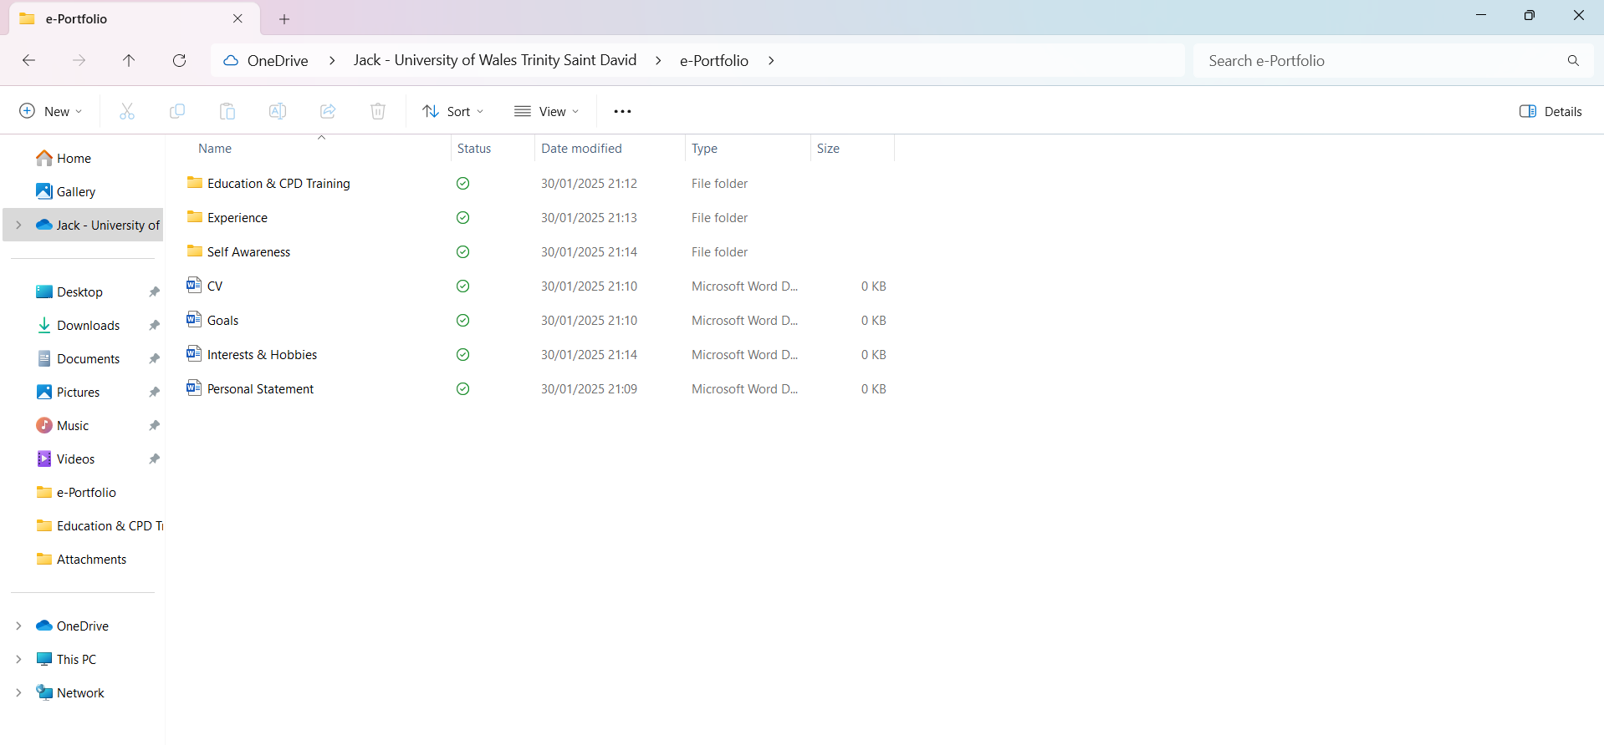
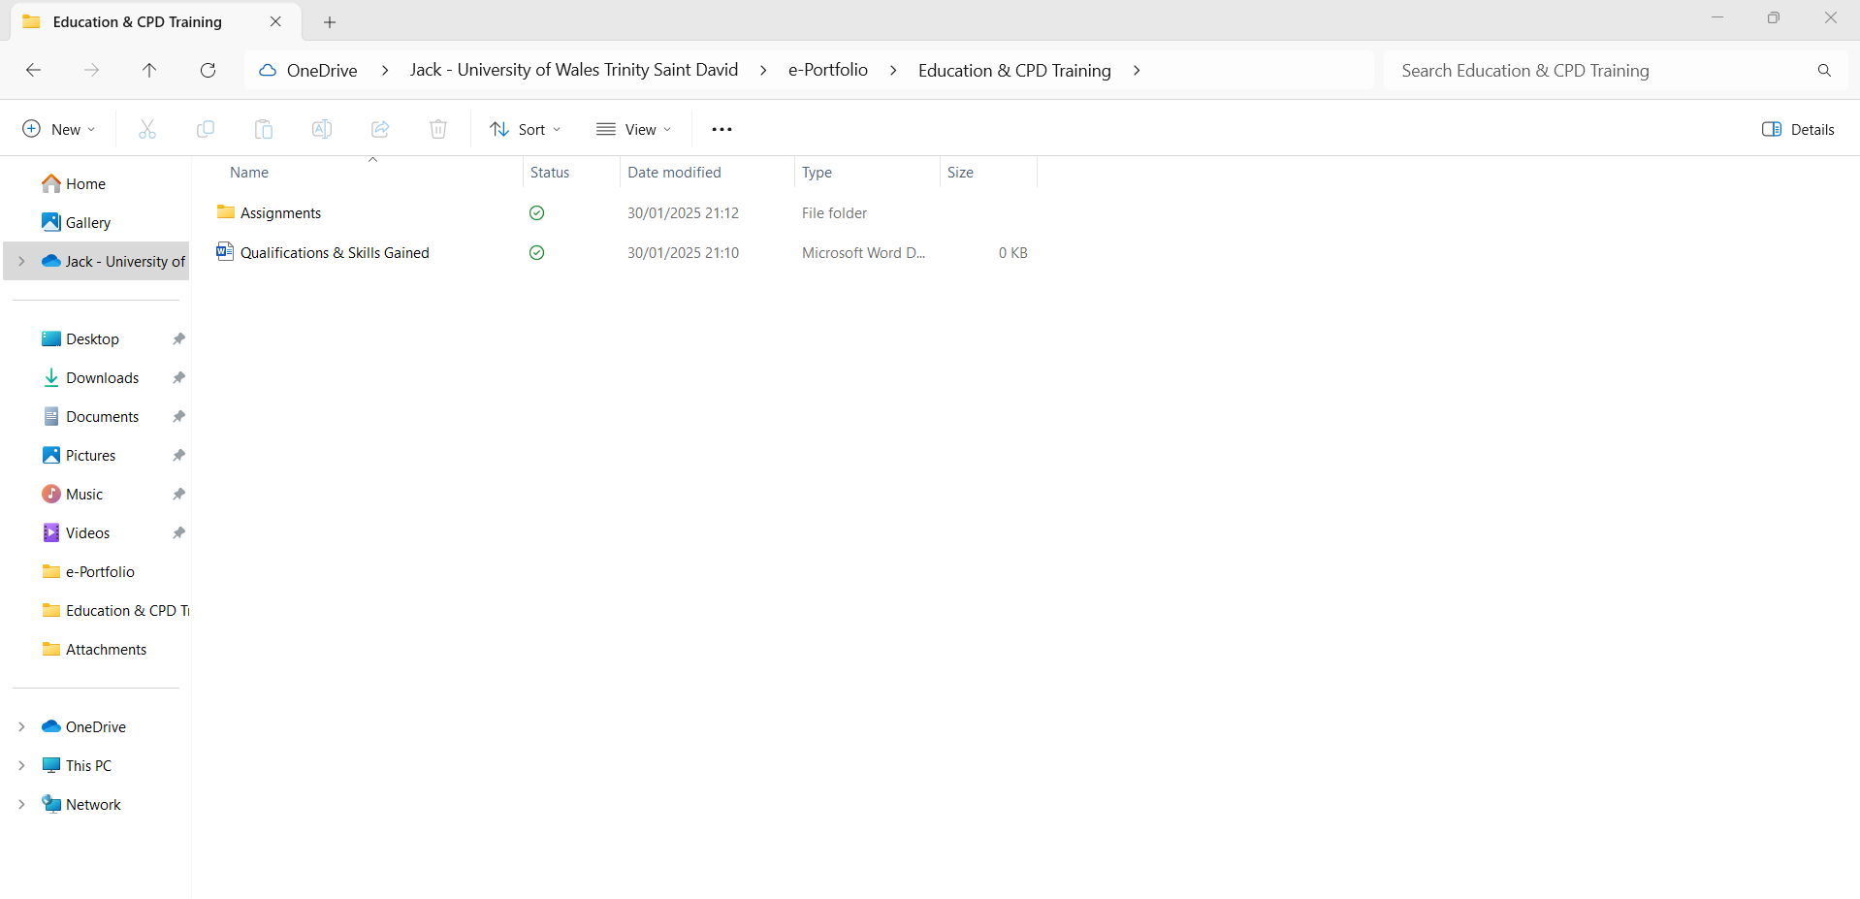
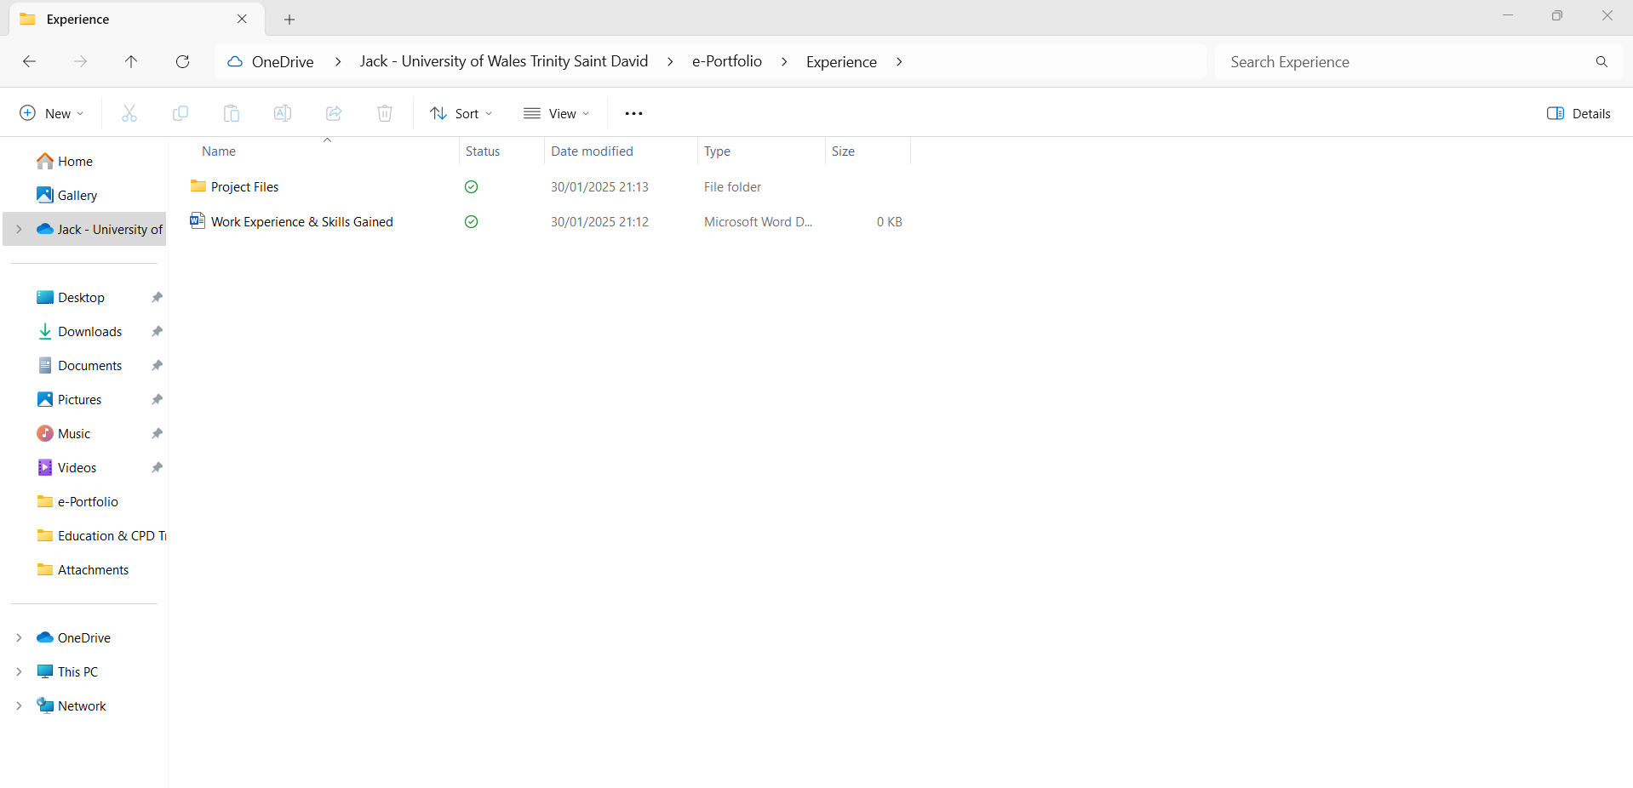
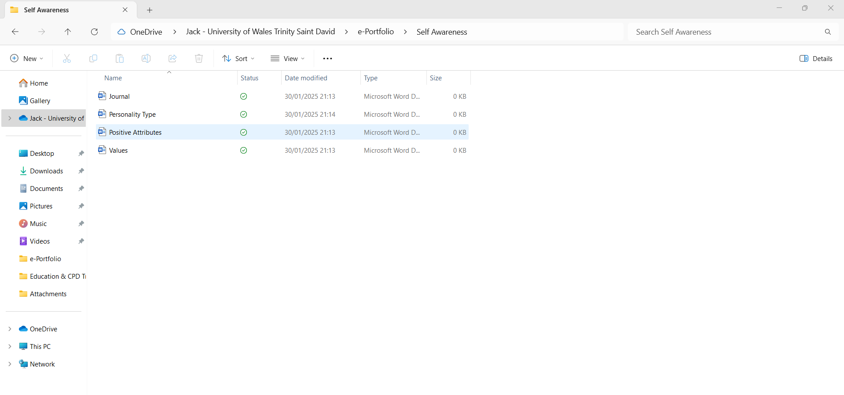

Independent Study

Torpex
In this review the student will be giving an overview on torpex, explaining what torpex is, what it is made of, what it was used for, how it impacted World War 2 and what it has been replaced with now a days.
Torpex is a secondary explosive that was mainly used in the second world war by allied countries like the UK and USA to help fight against the German Army. ‘Tor’ meaning torpedo and ‘pex’ meaning explosive. The creation of torpex was in Waltham Abbey at the Royal Gunpowder Factory in the United Kingdom as an alternative to TNT in fact twice as powerful. The ingredients in creating this torpedo explosive contained 42% RDX, 40% TNT and 18% aluminium powder. This creation was considered to be the strongest underwater explosive in the allies’ weapon locker. Due to the aluminium component this underwater explosive was very useful as the pulse lasted longer, leading to increased destructive power. [1]
Torpex was used to create many threatening bombs that would cause a lot of disruption to the growing German army from 4,000lbs blockbusters and bouncing bombs to 12,000 and 22,000lbs ‘Tall Boy’ and ‘Grand Slam’ which were nicknamed earthquake bombs as they were so powerful.
A blockbuster bomb was one of the biggest conventional bombs operated by the Royal Air Force during the war and had enough power to demolish big buildings and even full streets. [5]
Bouncing Bombs are designed to approach their target by bouncing across the water to avoid barriers such as torpedo nets. Once the bomb came in to contact with its target it would then sink and explode underwater just like a normal naval depth charge. These bombs were used to attack structures like dams. [4]
The ‘TallBoy’ bomb was the largest blockbuster bomb at the time weighing in at 12,000lbs. It was made from high-tensile steel which gave the bomb the ability to survive ground impact before it was detonated. Tallboy was designed to be aerodynamically smooth so that when dropped from the sky it would reach a much higher terminal velocity than any other bomb design. The first use of the Tallboy was in 1994 for an attack on the rail tunnel of Saumur in France, successfully exploding and completely blocking the tunnel. [2]
The ‘Grand Slam’ was used towards the end of the war and weighed in at 22,000lbs. Originally the bomb was known as a Tallboy Large, however this ws then renamed Grand Slam. When the creator Barnes Wallis introduced the idea of the earthquake bomb it was to become the largest and deadliest aerial bomb in the war. [3]
Now a days torpex has been replaced by compositions of H6 and PBX. H6 is made up of 45% RDX, 30% TNT, 20% powdered aluminium and 5% paraffin wax as a phlegmatizing agent. It is less shock resistive than torpex and also has more stable storage characteristics. PBX or plastic-bonded explosive is made up from 90-95% weight of explosive crystals and held together by 5-10% of polymer binder. The advantage of PBX is as its formed of elastomers it becomes shock absorbent making it very insensitive to accidental explosion.
In conclusion, the creation of torpex in the UK was a great invention that became a key factor in defeating the German army. Due to the many shapes and sizes of the Tallboy, Grand Slam, Bouncing Bomb and Blockbuster – these bombs had the ability to cause the biggest impact to anything in their way.

Conclusion & Evaluation
In conclusion the study skills assignment has shown the student areas where he can improve on ranging from presentation skills, setting SMART goals, data storing, time management and independent study research. For future improvements the student will be looking to be more organized, manage his time effectively and dive deeper into research.

Key findings

References
You must use the IEEE referencing standard
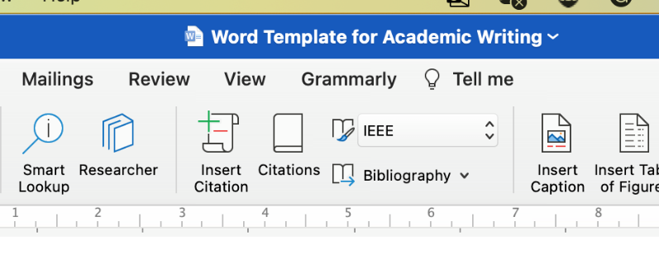

Full Blast – How the High-Explosive Known as 'RDX' Helped the Allies Win WW2 - MilitaryHistoryNow.com [1]
Tallboy (bomb) - Wikipedia [2]
Grand Slam (bomb) - Wikipedia [3]
Bouncing bomb - Wikipedia [4]
Blockbuster bomb - Wikipedia [5]
Polymer-bonded explosive | Military Wiki | Fandom [6]

