Ways of Perceiving

Name: Emma Landek

ID Number: 1803146

Submission deadline: 12th May 2020

Word count:

Programme of study: BA surface pattern and design

Module: ADAD4019

Tutors: Julia Lockheart and Gwenllian Beynon

IMMERSION

“The senses are our source for vital knowledge about the objects and events in the world” (Bacci, 2011) Therefore, in exploring how each of our senses interpret the world differently I intend on curating an exhibition that allows people to engage with the art world through immersive art, allowing the viewers to each inhibit their own experience. This individual experience relates to the theory proposed by John Locke. According to Locke, each human is born as a tabula rasa; also known as a blank slate. He believed that each individual’s knowledge derives from our sensory experiences to the world which ultimately shapes our personalities making each person an individual. (Locke, 1690)
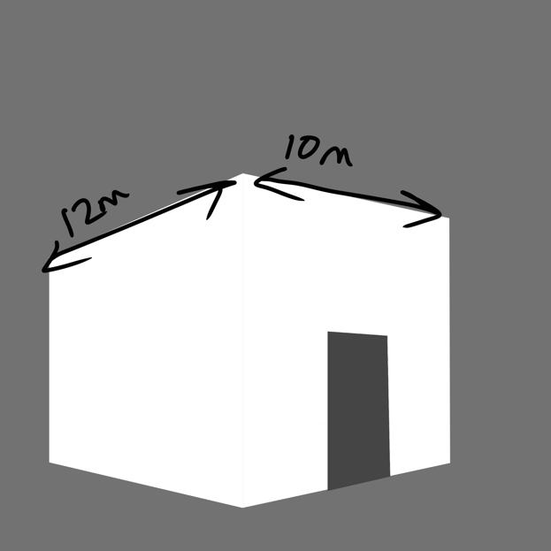
Continuing with the idea of immersive artwork, I have selected relevant artists that have created installations that allow the viewer to feel engaged. Entitled “Immersion”, my exhibition would theoretically be held in a large, empty warehouse. Through curating my exhibition I have chosen 6 pieces of work by 3 different artists whom I feel support my concept. Each piece of work is in installation, therefore within the my chosen warehouse I intend to create 6 plain white blocks using wall structures, each installation being allocated their own room. Here is an example of how I imagine the blocks to appear:

“When artistic objects are separated from both conditions of origin and operation in experience, a wall is built around them that renders almost opaque their general significance… Art is remitted to a separate realm, where it is cut off from that association with the materials and aims of every other form of human effort, undergoing, and achievement” (Dewey, 2009)

I believe that these plain cubic room will allow the installations within each one to speak for themselves. I feel that the plain aesthetic of the outside of the buildings will allow the viewer to have a “break” between each installation enabling them to prepare themselves to re-immerse into the next installation.
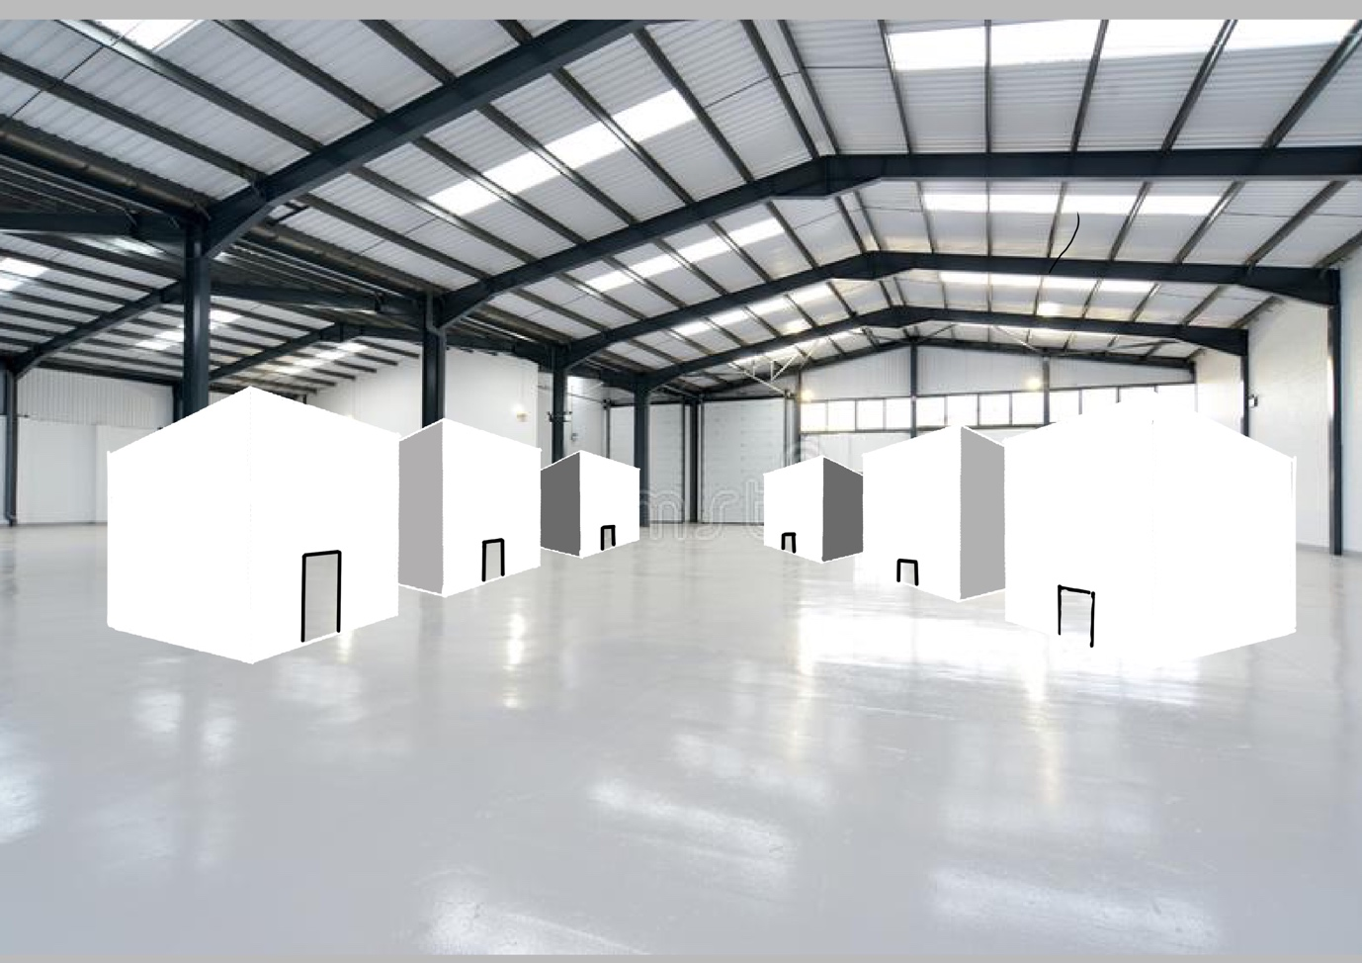
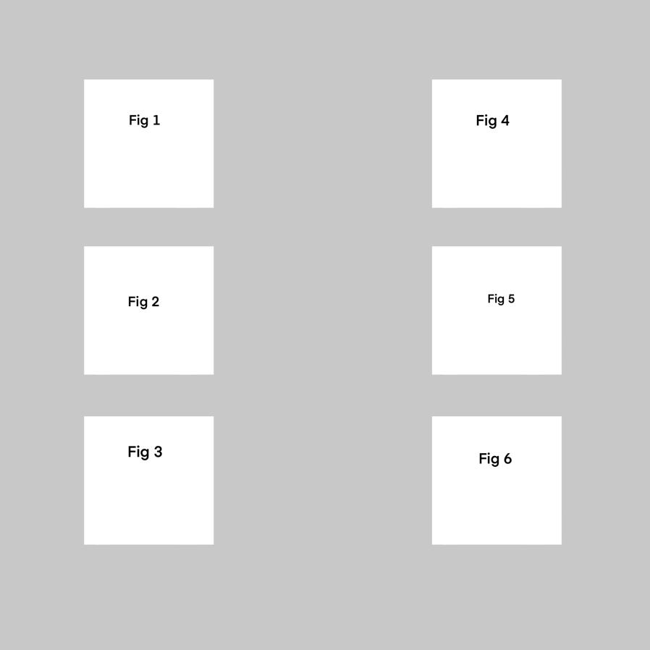
Here I have demonstrated how I would curate the layout.

Fig 1
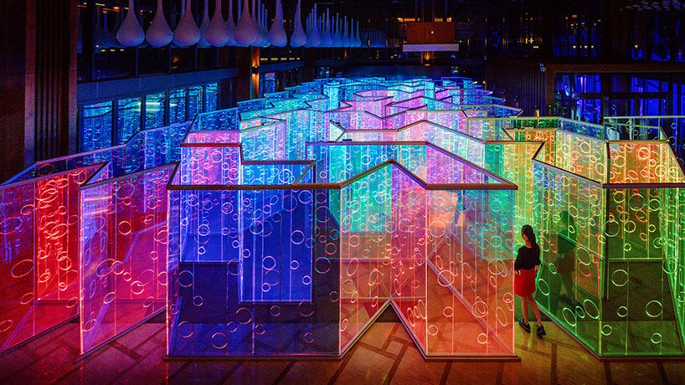

In my exhibition I intend to include this installation by Brut Deluxe named inside. This maze has panels of semi-transparent colours whilst some are mirrored, allowing the viewer to become lost in layers of illuminating colours around them. The only way to experience this is to delve deeper into the technic-coloured maze.

Bibliography

Bacci, Francesca and David Melcher “Art and the senses” (2011)

Dewey, John “Art as experience” (2009)

Locke, John “An essay concerning human understanding” (1690)

