

Course Title: MBA - International Business
Term 2, Group 1

Module Name: Strategic Management
Module Code: LCMB7003

Student Name: Hitarth Girishbhai Sorathiya
Student ID: 2506577

Lecturer’s Name: Dr. Amare Desta

Strategic Management Analysis of McKinsey & Company: Evaluating Competitive Advantage, Corporate Strategy, and Sustainable Growth

Abstract
The report will be a comprehensive strategic analysis of the McKinsey and Company, and how the company has managed to acquire and sustain a competitive advantage in the global management consulting marketplace. The paper employs the significant strategic management theories including the PESTEL, VRIO, SWOT, Ansoff and BCG Matrices and the Balanced Scorecard to examine the external environment, internal resources, corporate social responsibility (CSR) objectives, and strategic decisions of the organisation. The analysis also refers to the brand reputation, intellectual capital and global integration, and premium differentiation strategy as the basic strength of McKinsey. The external environmental forces such as catalysts of technology, regulatory attention, and sustainability demands make a major contribution in the strategic decision-making. The suggestions are to strengthen AI-based consulting activities, governance, and transparency structures, and sustainability leadership to enable business competitiveness in the long-run perspective. The report concludes that the strategy employed by McKinsey is robust and in line with its capabilities, but it must always be innovative and dynamic in managing change in a more complicated and competitive world. The Gibbs Reflective Cycle reflective account further reflects on the research and analysis process that has been adopted in the process of creating this strategic assessment.

Table of Contents
Abstract 3
Introduction 5
Section - 1 5
1.1 Organisational Context and Overview 5
1.1.1 Historical Background, Mission, Vision and Business Model 5
1.1.2 Industry Context, Competitors and Market Position 6
1.2. External and Internal Environment Analysis 7
1.2.1 External Environment Analysis: PESTEL Framework 7
1.2.2 Success Factors and Strategic Challenges 8
1.2.3 Internal Environment: Resources, Capabilities and Core Competencies 9
1.2.4 VRIO Analysis of Strategic Capabilities 10
1.2.5 Contribution of Internal Strengths to Competitive Advantage 11
1.3. CSR and Sustainability Objectives 11
1.4. Comprehensive and Holistic View of the Organisation 12
1.4.1 Application of the Balanced Scorecard Framework 12
1.4.2 Strategic Alignment of Objectives, KPIs, Targets and Initiatives 14
1.5. Strategic Choices and Implementation 14
1.5.1 Business-Level and Corporate-Level Strategic Choices 14
1.5.2 Change Management and Strategic Implementation 16
1.6. Strategic Evaluation and Recommendations 17
1.6.1 SWOT Analysis of Current Strategy 17
1.6.2 Evaluation Ansoff’s Matrix 18
1.6.3 BCG Matrix Analysis 19
1.6.4 Strategic Recommendations 19
Section - 2: Reflective Account (Gibbs’ Reflective Cycle) 20
2.1. Description 21
2.2. Feelings 21
2.3. Evaluation 22
2.4. Analysis 22
2.5. Conclusion 22
2.6. Action Plan 23
Conclusion 23
References 25
Appendix 28

Introduction
The current competitive and volatile business environment of the international business environment requires organisations to experience a continuous change in the strategy to ensure competitive advantage is maintained. The strategic management has significance in the sense that it helps the firms to align their internal strengths with the external market environments. This report is an extensive strategic report of one of the most successful management consulting companies in the world, the McKinsey and Company. This report seeks to critically evaluate the external environment of McKinsey, internal resources and capabilities, corporate social responsibility goals and strategies using the developed strategic management frameworks (Abdullah et al., 2022). Some of the models that are employed in determining how the organisation creates and maintains a long-run competitive advantage are the PESTEL, VRIO, SWOT, Ansoff Matrix, BCG Matrix, and Balanced Scorecard. This analysis in the report forms the key strengths, threats, and growth prospects that McKinsey is challenged by. The analysis will be centered on demonstrating the fact that theoretical concepts would be effectively applied in evaluation of strategic decision-making in a global professional services firm.

Section - 1

1.1 Organisational Context and Overview

1.1.1 Historical Background, Mission, Vision and Business Model
The McKinsey and Company are one of the most desirable management consulting firms that we have today. The company which was established by James O. McKinsey way back in Chicago mainly focused on accounting and management practices. It would later on be strategy-based consultancy, particularly after the professional standards of the firm were reorganized in the middle of the 20 th century by Marvin Bower. Another strategy that Bower adopted is a partnership model, strong moral values, and client-first culture, which remain the primary pillars of the business to date (Abdullah et al., 2022). McKinsey grew at a rapid pace in Europe, Asia and emerging markets as it grew throughout the United States; in more than 65 countries. The mission statement of the McKinsey and Company extends to help organisations make unique, lasting, and meaningful transformations in their performance and also to build a great firm which attracts, nurtures and preserves integrity and great people. Although the company does not publicly emphasize one of its formal vision statements, the strategic emphasis has been aimed at shaping the future of business in the world with the incorporation of the depth knowledge of the industry with the most innovative analyzing skills. High value advisory services are provided by the company to corporations, governments and non-profit making organisations. Its revenue stream would be on the premium charges on the bespoke strategic recommendations, transformation programmes, digital consulting, and analytics solutions (Abdullah et al., 2022). Value proposal by the firm is pegged on intellectual capital of the firm or the consultants, knowledge databases, and perceptions and visions that they gain by research. Competitive advantages It is based on recruitment of talents in leading universities and life-long learning.

1.1.2 Industry Context, Competitors and Market Position
McKinsey operates in the global consulting industry, a highly competitive and knowledge-based industry that assists organisations in their strategy, operations, digital transformation, and organisational change (Celestin, 2024). The rapid technological growth, the growth of the necessity to rely on data when making a decision, and the growth of sustainability and environmental, social and governance consulting characteristics characterise the industry. The key competitors of the company include Bossing Consulting Group (BCG) and Bain and Company also referred to as the MBB firms and the large professional services organisations such as Deloitte Consulting, PwC Advisory and Accenture. Despite such a stiff competition, McKinsey has a favorable position in the market as compared to the other market leaders in strategy consulting, which is traditionally explained by the brand recognition, intellectual excellence, and global visibility (Celestin, 2024). High-end position, the pricing policy, which is highly cost-oriented, and the rapport McKinsey has with its clients in the long term enable this firm to retain a significant competitive advantage.

1.2. External and Internal Environment Analysis

1.2.1 External Environment Analysis: PESTEL Framework
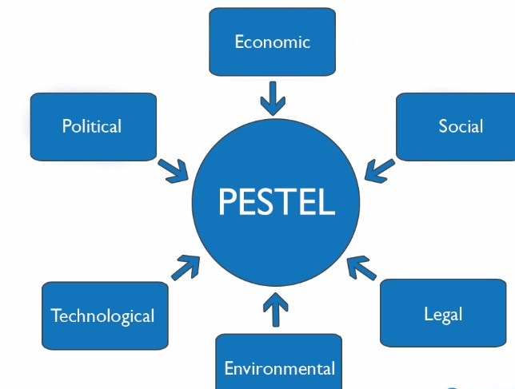
Figure: PESTEL Framework
Source: (Celestin and Sujatha, 2024)

The environment surrounding McKinsey and Company is a very dynamic and difficult to comprehend environment. PESTEL model provides an orderly manner of analyzing the effects of the macro environmental factors on the strategic decisions of the firm.
Political Factors
The country politics is a significant factor in the activities of McKinsey. As an international consultancy providing advice to governments and global corporations, the firm must deal with political instability, geopolitical tensions, trade regulations, and inspections by governmental bodies (Celestin and Sujatha, 2024). Increased government control over the consulting arrangements, especially in the projects of the government affects the organization of engagements by McKinsey, and management of transparency.
Economic Factors
The economic consideration is a direct factor on the demand of the consulting service. When organisations grow, when organisations transform digitally, when innovation occurs, it causes pressure on the strategic consultancy advisory services (Celestin, 2024). When the recessions hit the reverse, the companies require reorganization of costs and provision of operational efficiency.

Social Factors
Social issues entail a growing pressure on diversity, ethical administration and corporate social responsibility. Its clients are also increasingly in need of sustainability and ESG compliance advisory services. In addition, the demands of talents are shifting because the young professionals are seeking meaning in their work and the work-life balance (Celestin et al., 2024).
Technological Factors
Technological factors are considered one of the most radical forces that influence the strategy of McKinsey. The needs of clients and the competition have been transformed by the blistering development of artificial intelligence, data analytics, automation, and digital platforms (Celestin et al., 2024). McKinsey has responded by investing in McKinsey Digital, state of the art analytic platforms and proprietary artificial intelligence.
Environmental Factors
The environmental factors are increasingly affecting the strategic priorities. The climate change regulations, sustainability commitments, and the global net-zero targets are driving the sustainability consulting (Celestin et al., 2024). Environmental advisory is one of the portfolio developed by McKinsey, which is in tandem with the global sustainability strategy and corporate strategy.
Legal Factors
Legal risks include data protection laws, regulatory risks and lawsuits. As a company dealing with a sensitized information of its clients, McKinsey must follow strict data privacy regulations such as GDPR and other domestic legislation (Chan, 2023). Legal attention and reputational risk of controversial interactions is also the determinant of governance policies and internal controls.

1.2.2 Success Factors and Strategic Challenges
The external environment has critical success factors in terms of competitive performance of the consulting industry. Firstly, it involves the requirement of brand reputation and credibility. The nature of consulting services is immaterial and the confidence of a client is the main success factor of acquiring high-value contracts (Chan, 2023). The goodwill of analytical rigour and strategic acumen that McKinsey has earned during a long period serves as a trust asset. Second, the intellectual capital and talent acquisition is among the drivers of success. The profession depends on attraction and desire of good professionals. The experience is valuable since McKinsey selects the top organizations and has an established prototype of professional growth (Chan, 2023). Third, it can accommodate multinational customers in the manner that it is global and networked. International project implementation and the transfer of knowledge is facilitated by a coordinated international network. Fourth, it is an innovation ability, particularly the digital and analytics consulting which has proved to be a strategic need. The firms that do not see the evolving technology risk being out of place over time.

1.2.3 Internal Environment: Resources, Capabilities and Core Competencies
The competitive advantage of McKinsey is based on its internal environment. Resource based view would hold that the strategic resources which the firm possesses are largely intangible. The most significant asset is the human capital. The firm has a highly skilled analytical, problem-solving, and leadership staff of very qualified consultants, partners, and subject-matter professionals (Chmielewska et al., 2022). Selectiveness in hiring enhances intellectual quality and continuing learning programmes enhance expertise. Second, brand equity is a strategic resource that is intangible. McKinsey name is a symbol of prestige and credibility and it becomes easy to attract a client and offer high prices.
Third, knowledge management systems may be considered as a key resource. A rich body of knowledge is made up of hundreds of years of project history, scholarly literature and trade secrets. This business memory contributes toward efficiency and creation of insights. In terms of the capabilities, McKinsey possesses excellent analytical problem-solving capabilities, mechanized consulting practices, and change management capabilities (Chmielewska et al., 2022). Its solutions are unique competence, especially in terms of cross-industry integration of its solutions into customised solutions. Strategic advisory excellence, capability of transformation implementation, and data-driven decision support are some of the core competencies.

1.2.4 VRIO Analysis of Strategic Capabilities
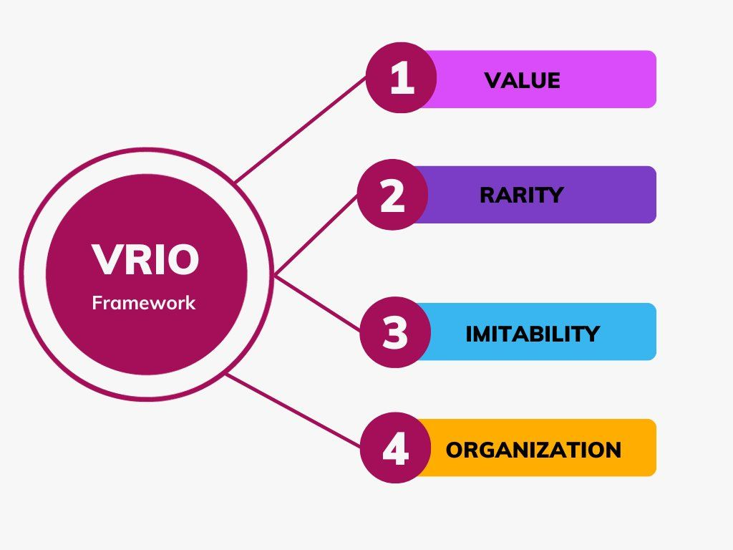
Figure: VRIO Analysis
Source: (Crnogaj and Rus, 2023)

Analysis of the capacity of resources of McKinsey to generate sustainable competitive advantage is done in VRIO.
Value: McKinsey possesses a brand, intellectual capital and analytics that are valuable to the clients. Such resources increase the performance of the clients that prefer high prices.
Rarity: Elite talent networks, information databases and global and long-standing relationships with clients are quite rare in the consulting profession (Crnogaj and Rus, 2023). The competitors also have a similar structure, but the size and the historical reputation of McKinsey are unique.
Imitability: Tacit knowledge, organisational culture, and relational capital cannot be easily imitated but the consulting methodologies concept is easily imitated. Fences to imitation are created as culture of partnership and knowledge systems created within the culture.
Organisation: McKinsey is also organised properly, which can be exploited to exploit the resources (Crnogaj and Rus, 2023). Its governance model of partnership maximizes their incentives and their project teams are designed to provide uniform services across the regions.

1.2.5 Contribution of Internal Strengths to Competitive Advantage
McKinsey has all the internal strengths to help it in its competitive positioning. Its brand name reduces the price of client acquisition, and costs of high stakes, complex advisory projects are more trusted. The differentiated insights made through intellectual capital operate in the favor of premium pricing and profitability. What is more important is that the global network of it creates economies of knowledge sharing, whereby best practices could be shared across industries and regions (Demneh, 2023). The joint venture generates a loyal relationship with the top managers, and the stability and customer retention are enhanced. The digital capabilities and high-order analytics strengthen its differentiation approach that positions the company as a strategic consultant of traditional strategies and an agent of change, which is technology-enabled. This diversification increases the revenues sources and minimizes dangers of upsetting the industry. Important to note, it is the knowledge management along with talent development that assists in keeping the innovation alive.

1.3. CSR and Sustainability Objectives
The idea of Corporate Social Responsibility (CSR) and sustainability has become a relevant strategy of concern as well to McKinsey and Company particularly given that the customers are increasingly demanding responsible, ethical, and sustainable business practices (Demneh, 2023). As the largest global advisory company that may influence big companies and states, the CSR strategy of McKinsey transcends the scope of the compliance and philanthropy and is closely related to the long-term business objectives and reputation management. Considering the environmental sustainability of McKinsey is one of the fundamental elements of the CSR strategy. The company has made a promise to reduce its carbon footprint by cutting down its operations and developing net-zero emissions through emission reduction programs, as well as investing in carbon offset (Demneh, 2023). This follows its increased sustainability and ESG (Environmental, Social and Governance) consultancy.
The concept of social responsibility is implemented in programs that lead towards diversity, equity, and inclusion (DEI). As a gesture of publicity, McKinsey has committed themselves to make sure that they represent underrepresented groups in their workforce. These objectives are consistent with its business model where the various teams are improving the quality of problem solving and level of innovation. The non-discriminative recruitment will increase talent acquisition that is a significant success factor in consulting. The principles of governance and ethics also form the basis of its CSR framework. Considering the historical overhaul of the questionable client relations, McKinsey has upgraded its internal compliance ports, risk treatment, and transparency measures (Ferraris, 2024). This is also a pointer that there is recognition of the fact that ethical governance is a direct cause of long-term competitive advantage. The CSR strategy does not appear to be the peripheral one, it appears to be the strategic component of McKinsey.

1.4. Comprehensive and Holistic View of the Organisation

1.4.1 Application of the Balanced Scorecard Framework
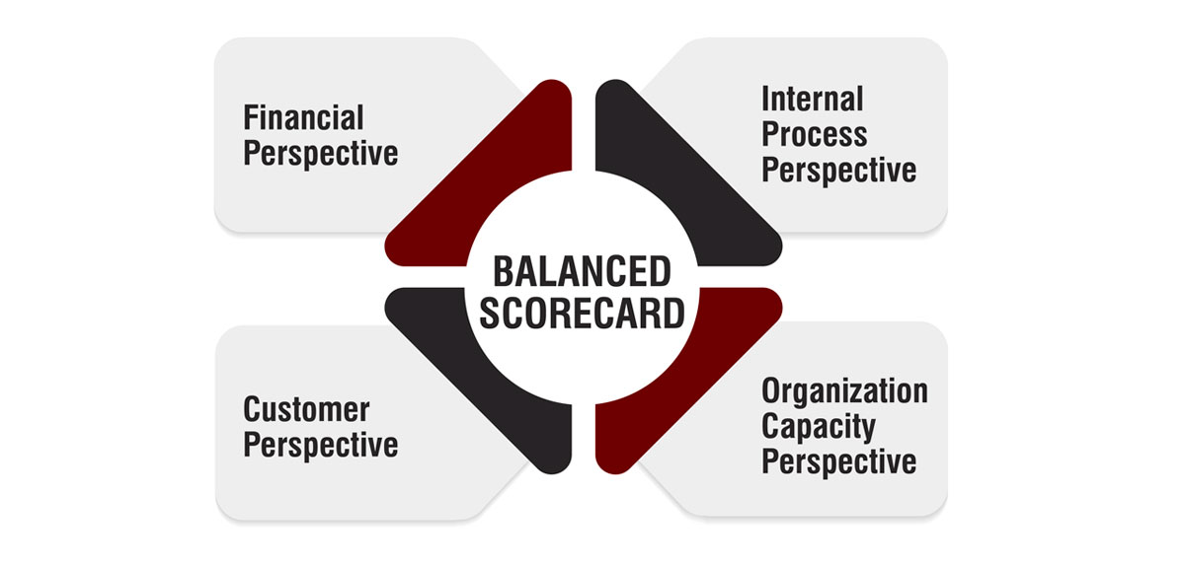
Figure: Balanced Scorecard Framework
Source: (Ferraris, 2024)

The Balanced Scorecard (Kaplan and Norton, 1992) provides a multidimensional performance approach which includes financial and non-financial measures to be achieved to gain strategic alignment. In the example of McKinsey and Company with a mission of helping organisations to achieve some unique and enduring improvements through creation of a great firm, the Balanced Scorecard can enable transformation of strategic intent to measurable outcomes in four perspectives which are interconnected such as, Financial, Customer, Internal Business Processes and Learning and Growth.

Financial Perspective
Financially, the main objectives of McKinsey are to sustain revenues growth, premium profitability, and to possess long-term partner value. The partnership as based on financial sustainability as a consulting firm is necessary to re-invest in talent and innovation. The KPIs will include the rate of revenue growth per year, revenue per partner, project margins, and the cost-efficiency ratios (Ferraris, 2024). The targets are usually focused on the steady annual growth in revenue, extremely high operating margins, and mixture of revenues in regards to geographies and service lines. The strategic initiatives that may be pursued in order to adopt this perspective include expansion to high growth market (i.e. digital and ESG advisory), portfolio diversification, and investing in modern analytics platform.
Customer Perspective
Customer perspective is concerned in value creation to the clients, long term relationship and brand image. Trust and client satisfaction is quite crucial to McKinsey in the competitive advantage. The most important among them are to enhance the influence on clients, enhance the client retention and augment the repeat engagements. Such variables like client satisfaction rates, repeat business rate, project impact rates, and brand ranking according to the consulting surveys should be considered as the KPIs (Ferraris, 2024). The targets are aimed at getting high rate of repeat engagements and measurable performance improvements to the clients.
Internal Business Processes Perspective
At the Internal Business Processes section, McKinsey is concentrated in operational excellence, knowledge management, and frequency in project delivery. To some of the objectives, they will include improvement of efficiency of project execution, expansion of risk management systems and utilization of proprietary tools of research. KPIs may be related to the schedule of the project completion, the efficiency rate of knowledge sharing, the compliance rate, and the utilization of digital tools (Hasan et al., 2024). The targets are directed towards the improvement of productivity and exposure to operational risks.

Learning and Growth Perspective
Learning and Growth perspective shows what intellectual capital and talent have been given by McKinsey. The KPIs will include retention rates of the employees, number of training hours per consultant, rate of diversity representation and rate of output of innovation (Hasan et al., 2024). It is planned to maintain high retention of best performers and also diversify their leadership pipeline. Initiatives such as continuous professional development programmes, worldwide employment opportunities, diversity and inclusion strategy can be used to assist in long-term capability building.

1.4.2 Strategic Alignment of Objectives, KPIs, Targets and Initiatives
Balanced Scorecard shows the level of alignment between the McKinsey operational performance indicators and the entire strategic mission of the company. Financial performance is never purpose but it is related to customer satisfaction and internal excellence. High client satisfaction is the driving factor of repeat business thereby promoting financial sustainability. With the help of streamlined internal operations and improved services, the brand image and customer confidence are empowered (Hasan et al., 2024). In addition, every other dimension is founded on the Learning and Growth perspective. The knowledge management systems are the digital capabilities alongside the investment in training of consultants to ensure that the firm is made adaptable to the ever-evolving consulting environment.
The strategic shift toward digital transformation and sustainability consulting of McKinsey portrays its alignment of all perspectives. These areas enjoy new sources of revenue at financial level. Customer wise they respond to the new customer needs. They need to acquire new skills and train as leaders in terms of learning (Jain and Kansal, 2023). Thus, the Balanced Scorecard is a comprehensive model that includes objective financial outcomes and intangible sources of the competitive advantage. Financial discipline and talent development, innovation and client-centricity are integrated together in the case of McKinsey to form a whole, which is strategic coherence of the system of organisational performance.

1.5. Strategic Choices and Implementation

1.5.1 Business-Level and Corporate-Level Strategic Choices
Business level,
McKinsey Company competes primarily through differentiation strategy as the generic strategies formulated by Porter outline differentiation strategy. The firm is not using the cost leadership strategy, but it is a high-impact strategic advisory firm that provides premium services. It has set itself apart on the intellectual rigour, premium talent, proprietary research, global presence, and a strong brand image (Jain and Kansal, 2023). The company offers high prices which are backed with measurable client value and rising performance in a long period of time. An attempt to use the cost-leadership approach would be a dilution of brand esteem and its differentiation in the upper-end MBBC consulting market. Thus, it is possible to say that differentiation is the most strategically consistent choice. The consulting business has transformed in the area of differentiation. The conventional strategy consulting is now commoditised, and there are clients who build their own capabilities or visit cheaper digital consultants (Jain and Kansal, 2023). This has witnessed McKinsey increase its differentiation through high-order analytics, AI and digital transformation services.
Corporate level
McKinsey has been doing international diversification and international expansion. McKinsey Digital, QuantumBlack (analytics division), sustainability advising service, and risk and resilience consulting development are diversified (Kahveci, 2025). The expansions represent the diversification of the corresponding category since they build upon the existing consulting strengths expanding into the new growth market regions. Corporate strategy has also put emphasis on international expansion and it has offices in over 65 countries. This global destination provides the possibility of exploration of new markets, diversification of the sources of revenues, and multi-national clients. Among the strategic options, the most suitable would be the additional differentiation on the business level and the furthest related diversification to high growth digital and ESG markets on the corporate level (Kahveci, 2025). This is a strategy that coincides with the market trends, builds on the available strengths and enhances the sustainable competitive advantage. Developing non-related industries would make the process complicated and the core expertise as well as cost leadership would be contrary to the premium positioning of the firm.

1.5.2 Change Management and Strategic Implementation
Implementation and change management should also be a success factor in strategy success in addition to choice. McKinsey has been flexible in addressing digital disruption and the evolving demands of clients. The examples of the proactive strategic renewal, rather than the reactionary change, are the creation of McKinsey Digital and the purchase of Quantum Black. The company has been rebranded as a company that does more than just an advisory business by adding data science, artificial intelligence, and digital engineering as part of its consulting model (Kahveci, 2025). The McKinsey partners had the advantage of a partnership governance structure which to align incentives amongst senior leaders as a part of change management. The co-ownership among the partners exists, this creates long-term strategic commitments. In addition, the company possesses an outstanding knowledge sharing culture, which enables the transfer of new practices across global branches quite quickly, which is an aid to coordination activities.
A change management in a professional services firm is not an easy one. The resistance to the culture may be observed in the process of replacing the traditional strategy consulting with the technology-based solutions. In greater extent, reputational crises and domination by the regulatory environment have required changes in governance and increased compliance. Such problems test the organisational strength and the ability to lead (Khan et al., 2024). The general pattern in change management has been very effective since McKinsey has integrated the strategic vision and organisational agility. It has the capability to evolve with the changing environment, since it can also incorporate digital innovation, growth to sustainability advisory, and enhancement of the governance systems. Such productive transformations have enhanced competitiveness, revenue diversification and competitive advantage.

1.6. Strategic Evaluation and Recommendations

1.6.1 SWOT Analysis of Current Strategy
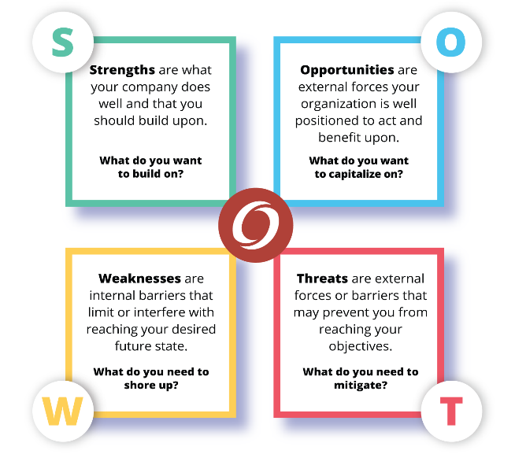
Figure: SWOT Analysis
Source: (Khan et al., 2024)

Strengths: The strengths of this company are its globally recognised brand name, high quality human capital, strong knowledge management systems and its high-end positioning. Being supported by its own research, data-driven advisory services, the differentiation strategy enables the company to charge high fees and have long-term relations with clients (Khan et al., 2024).
Weaknesses: The weaknesses can be linked to reputational risks and high cost of operation. The company has previously faced social and regulatory criticisms because of scandalous work with clients. Compensation and infrastructure worldwide are a source of an expense that implies that McKinsey is not flexible when it comes to economic crises, as it is a high-end consultancy (Pegah Nikzat, 2025).
Opportunities: The potential opportunities are the digital transformation, artificial intelligence, cybersecurity, and ESG advisory services. The increased demand in the sustainability strategy and the net-zero transition consulting creates development opportunities (Pegah Nikzat, 2025). Expansion in the emerging markets is also an option particularly with the governments and corporations working towards economic changes.
Threats: The threat of competition is that the current rival firms (BCG, Bain) become more competitive, as well as consulting firms that are technologically oriented (Accenture). In-house strategy units of corporations are also reducing the number of outsourced consultants (Pegah Nikzat, 2025). In addition, regulatory opportunities and investigation present brand credibility to jeopardy.

1.6.2 Evaluation Ansoff’s Matrix
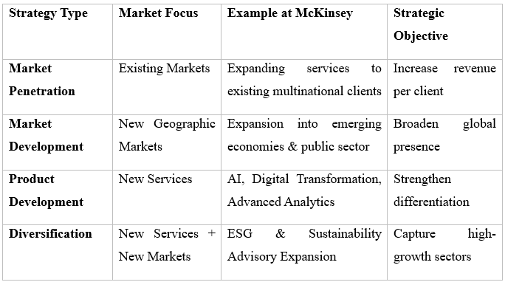
Table: Ansoff’s Matrix
Source: (Roman et al., 2025)

Using the Matrix presented by Ansoff, one can examine the growth strategy of McKinsey in four dimensions on the market penetration, market development, product development, and diversification. McKinsey is also expanding its relationship with the existing multinational customers, in terms of penetrating, by offering more transformation services (Roman et al., 2025). This will increase client loyalty and client turnover. The market can be developed through the growth of the market to emerging markets and advisor to the government. The geographical diversification reduces the reliance on the developed Western markets and risk diversification. The recent strategy of McKinsey, particularly in the development of the digital consulting, advanced analytics (Quantum Black), and sustainability advisory practices, has been based on the product development. These service lines will be based on the evolving client needs and increased differentiation (Roman et al., 2025). The associated diversification has been achieved through the investment in data analytics and technology platforms. Compared to unrelated diversification, this strategy employs the core consulting capabilities and improves the competitive advantage.

1.6.3 BCG Matrix Analysis
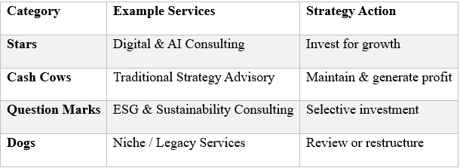
Table: BCG Matrix Analysis
Source: (Sachin Modgil et al., 2024)

The BCG Matrix evaluates the portfolio of the services provided by McKinsey regarding the advancement of the market and market share. Traditional strategy consulting is a Cash Cow because it can generate high-margin and stable cash revenues because of the market leader. Stars (including digital and advanced analytics services (including AI consulting)) are in high-growth markets, and they are of highly competitive positioning (Sachin Modgil et al., 2024). The type of Sustainability and ESG advisory can be characterized as Question Marks, since this category is operating under developing markets but requires further investments to increase market share.

1.6.4 Strategic Recommendations
Deepen AI-driven and technology-enabled consulting capabilities
The Resource-Based View (RBV) also implies that the sustainable advantage is also brought by the valuable, rare, and difficult to imitate resources. The more advanced AI manufacturing and advisory services founded on strategy production can increase differentiation and barriers to entry (Sachin Modgil et al., 2024). The real-life examples of the intensive investment of AI of Accenture testify to the idea that the consulting value propositions can be altered with the support of the technological leadership.
Strengthen ethical governance and transparency frameworks
Based on the reputational risks that are included under the SWOT analysis, brand equity is ensured by strengthening compliance and risk management systems (Tominc, 2023). The stakeholder theory requires that a sense of trust should exist between the clients, the regulators and the society to be sustainable in the long term. Threats of regulation could be reduced through open-minded engagement policies, and legitimacy may be enhanced.
Expand its sustainability and ESG advisory leadership
positioning itself as a strategic business change partner in climate change. Sustainability consulting is an emerging and growing popular field around the world, and governments and companies embrace net-zero ambitions (Tominc, 2023). The intellectual capital of the company can also lead to long-term growth and the utilization of its intellectual capital to develop the most effective ESG strategy is one of the forms of differentiation.

Section - 2: Reflective Account (Gibbs’ Reflective Cycle)
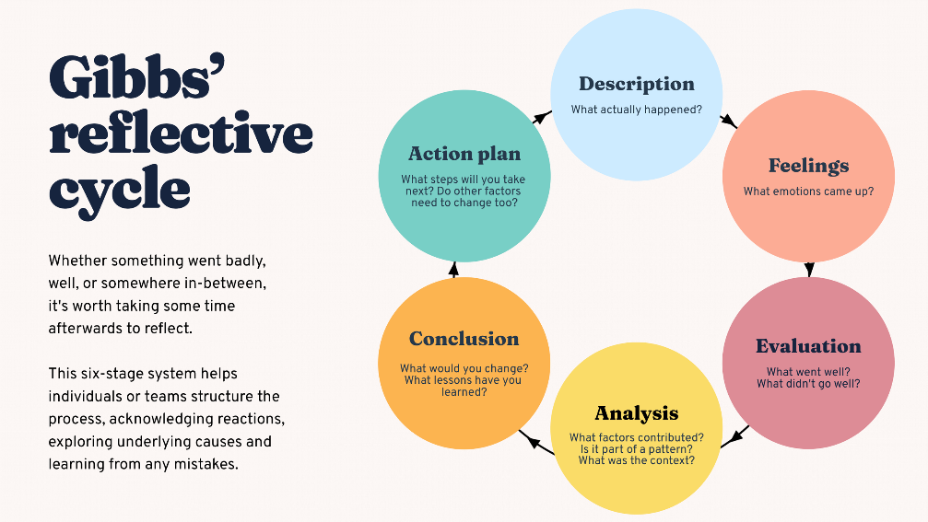
Figure: Gibbs’ Reflective Cycle
Source: (Zavodna, 2022)

This reflection report applies the Reflective Cycle of Gibbs and critically evaluates the process that I followed in the way I conducted research, analysis, and preparation of Section 1 of this strategic management report on McKinsey and Company (Zavodna, 2022). The model that Gibbs provides has six stages and they are: Description, Feelings, Evaluation, Analysis, Conclusion and Action Plan. This critical reflective framework will allow me to critically examine my learning experience and offer the potential areas of professional development.

2.1. Description
In writing part 1 of the current report, I began with McKinsey and Company as my point of focus since it is a major management consultancy firm with an international presence and must deal with the issues of the present-day strategic management (Zavodna, 2022). The research methodology involved reviewing of academic journals, strategic management text books, industry reports and reputable business publications. I also wanted to implement such theoretical frameworks as PESTEL, VRIO, SWOT, Matrix offered by Ansoff and BCG and Balanced Scorecard into the organisational analysis. I structured the report based on the assessment brief, and every section of the content was structured to address the requisite sections: external environment analysis, internal resource analysis, CSR objectives, strategic choices, and evaluation frameworks (Tominc, 2023). I also linked theory to practice in a critical way in the process of not doing a pure descriptive analysis. In the process, I revised my drafts to make them readable, logically, and with academic tone to conform to the requirements of postgraduate level.

2.2. Feelings
I had high confidence in application of strategic frameworks during the commencement of the research process but was somehow insecure when it came to critical evaluation of a globally-known organisation like McKinsey. It did not involve gathering information since there was a lot of content available but it had to be digested analytically and not descriptively. I increasingly got more confident in the practical use of such models as PESTEL and VRIO. However, initially, I was experiencing some challenges with going an extra mile and discussing the frameworks in terms of their critical assessment of implications (Shkalenko and Nazarenko, 2024). I felt more confident in my abilities at bridging theory and practice later in the writing as I felt confident in my ability to build an effective strategic argument. The reflective design encouraged increased knowledge of the content.

2.3. Evaluation
The process of research and writing was quite fine in several aspects. Firstly, the systematic frameworks such as SWOT and Balanced Scorecard also helped in enhancing clarity and rational organisation. These tools provided a rational approach to the investigation of the macro-environmental and internal factors. The implication in the contemporary strategic theories gave the report academic credibility. The relation between the Resource-Based View theory and intellectual capital and brand reputation of McKinsey enabled to support the arguments of competitive advantage more. This would have been better in certain respects (Shkalenko and Nazarenko, 2024). I had over-used the descriptive organisational information and reduced the scope and content to add more critical discussion.

2.4. Analysis
The application of PESTEL framework indicated the direct impact of macro-environmental forces such as technology shaking and legal scrutiny on strategic choices (Shkalenko and Nazarenko, 2024). This further helped me to understand the fact that strategy is not being constructed in a vacuum but multi-layered complex systems. VRIO model was demonstrated to be founded on internal resources that are valuable, unique, difficult to copy, and well-organised to generate sustainable competitive advantage. This kind of analysis on McKinsey has enabled me to appreciate the fact that intangible resources such as brand equity and intellectual capital can be used to create long-term performance. I have learned how financial success and customer satisfaction, operational efficiency, and talent development are related. It is worth noting that the reflective practice helped me realise the fact that strategic management is dynamic (Sergey Kudlaenko et al., 2025). Some of these theories such as the dynamic capabilities are centred on adapting and rearranging resources that are required in the industries that are affected by AI and digital transformation.

2.5. Conclusion
This reflective practice has helped me have a better understanding of the theory of strategic management and how it can be applied in practice. I gained the experience that assisted me in learning the ability to synthesise academic concepts with organisational analysis and critical thinking. I got to know that systematic structures were required to organize in a systematic way the complex information, and it is also necessary to go beyond the description to provide analytical justification. It was also the assignment that improved my academic writing discipline particularly in being objective and coherent. I got to know the way organisations sustain a competitive edge through a balance between the knowledge held internally and the external environment.

2.6. Action Plan
To increase further on my strategic analysis, I would undertake several development actions. First, I will add more academic materials that are reviewed by scholars to make the theoretical base bigger, in particular, in these areas as dynamic capabilities and stakeholder theory. Second, I will educate myself to use less words to synthesise complex information to make the analysis more concise. Third, I will be a more improved evaluator because I will analyze different theoretical positions rather than use one distinct approach (Sergey Kudlaenko et al., 2025). I will also get other colleagues review my analytical writing so that I would know where I can improve the arguments. Systematic frameworks will be systematically applied to the assessment of the organisational strategy allowing my decision-making to be based and critically informed in professional practice. Using the Reflective Cycle developed by Gibbs, I have been capable of evaluating my learning procedure in a methodical manner and identify the measures that can be implemented to enhance my professional growth on a constant basis.

Conclusion
In conclusion, this report has critically examined McKinsey & Company strategic management practices based on the external environment analysis, internal capabilities analysis, CSR objectives analysis, and strategic choices. The findings show that McKinsey sustains its competitive advantage on the basis of high differentiation strategy supported by the elite human resources, esteemed brand image, as well as knowledge management networks in the world. Theories such as the PESTEL, VRIO, SWOT, the Matrix of Ansoff, the Matrix of BCG and the Balanced Scorecard have shown how the company can adjust its resources to suit the environmental demands to be at the top of the market. However, further technological upheaval, regulatory action and competition require constant strategic alteration. Investment opportunities in future development must include investing in AI-based consulting, better governance, and expanded leadership on ESG competencies. Overall, the strategy of McKinsey remains powerful, and its long-term success may be evaluated by the sustained innovation and moral orientation and the successful change management within the ever-evading landscape of the consulting business environment.

References
Abdullah, N.H.N., Krishnan, S., Zakaria, A.A.M. and Morris, G. (2022). Strategic management accounting practices in business: A systematic review of the literature and future research directions. Cogent Business & Management, [online] 9(1). doi: https://www.tandfonline.com/doi/full/10.1080/23311975.2022.2093488.
Celestin, M. (2024). AI’S IMPACT ON CORPORATE STRATEGIES AND EFFICIENCY: RISKS, OPPORTUNITIES, AND ETHICAL CONSIDERATIONS. ResearchGate, [online] 8(2), pp.111–119. doi: https://doi.org/10.5281/zenodo.13955383.
Celestin, M. and Sujatha, S. (2024). IMPACT OF GLOBAL SUPPLY CHAIN DISRUPTIONS ON BUSINESS RESILIENCE: STRATEGIES FOR ADAPTING TO PANDEMICS AND GEOPOLITICAL CONFLICTS. IMPACT OF GLOBAL SUPPLY CHAIN DISRUPTIONS ON BUSINESS RESILIENCE: STRATEGIES FOR ADAPTING TO PANDEMICS AND GEOPOLITICAL CONFLICTS, [online] 9(2), pp.44–53. doi: https://doi.org/10.5281/zenodo.13887198.
Celestin, M., Sujatha, S., Kumar, A.D. and Vasuki, M. (2024). THE RISE OF AGILE METHODOLOGIES IN MANAGING COMPLEX BUSINESS PROJECTS: ENHANCING EFFICIENCY,... ResearchGate, [online] 9(2), pp.69–77. doi: https://doi.org/10.5281/zenodo.13871832.
Chan, J. (2023). Impact of Smart City Initiatives on Urban Planning Strategies in Singapore: An In-Depth Analysis of Technology-Driven Solutions and Their Influence on Sustainable Development and Quality of Life. Journal of strategic management, 7(7), pp.11–21. doi: https://doi.org/10.53819/81018102t4200.
Chmielewska, M., Stokwiszewski, J., Markowska, J. and Hermanowski, T. (2022). Evaluating Organizational Performance of Public Hospitals using the McKinsey 7-S Framework. BMC Health Services Research, [online] 22(1). doi: https://doi.org/10.1186/s12913-021-07402-3.
Crnogaj, K. and Rus, M. (2023). From Start to Scale: Navigating Innovation, Entrepreneurial Ecosystem, and Strategic Evolution. Administrative Sciences, [online] 13(12), p.254. doi: https://doi.org/10.3390/admsci13120254.
Demneh, M.T. (2023). Using Corporate Foresight to Enhance Strategic Management Practices. European Journal of Futures Research, 11(1). doi: https://doi.org/10.1186/s40309-023-00217-x.
Ferraris, A. (2024). Beyond digital transformation: a multi-mixed methods study on big data analytics capabilities and innovation in enhancing organizational performance. Review of managerial science. doi: https://doi.org/10.1007/s11846-024-00768-8.
Hasan, M., Haque, Md.A., Nishat, S.S. and Hossain, Md.M. (2024). Upskilling and Reskilling in a Rapidly Changing Job Market: Strategies for Organizations to Maintain Workforce Agility and Adaptability. European Journal of Business and Management Research, [online] 9(6), pp.118–126. doi: https://doi.org/10.24018/ejbmr.2024.9.6.2502.
Jain, N. and Kansal, J. (2023). Application of McKinsey 7S framework as a strategic tool for a knowledge based Organizational Development | IEEE Journals & Magazine | IEEE Xplore. [online] ieeexplore.ieee.org. doi: https://ieeexplore.ieee.org/abstract/document/10345666/.
Kahveci, E. (2025). Digital Transformation in SMEs: Enablers, Interconnections, and a Framework for Sustainable Competitive Advantage. Administrative Sciences, 15(3), p.107. doi: https://doi.org/10.3390/admsci15030107.
Khan, F.S., Masum, A.A., Adam, J., Karim, M.R. and Afrin, S. (2024). AI in Healthcare Supply Chain Management: Enhancing Efficiency and Reducing Costs with Predictive Analytics. Journal of Computer Science and Technology Studies, [online] 6(5), pp.85–93. doi: https://doi.org/10.32996/jcsts.2024.6.5.8.
Pegah Nikzat (2025). Artificial Intelligence in Business: Driving Innovation and Competitive Advantage. International journal of industrial engineering and operational research, [online] 7(3), pp.50–62. doi: https://doi.org/10.22034/ijieor.v7i3.180.
Roman, P., Ulinici Andrian, Vasylyna Orysia, Bilous Anastasiia and Alla, G. (2025). The Role of Digital Technologies in Creating Competitive Advantages of Modern Entrepreneurship. Theoretical and Practical Research in the Economic Fields, [online] pp.679–690. doi: https://ibn.idsi.md/vizualizare_articol/237355 [Accessed 21 Feb. 2026].
Sachin Modgil, Gupta, S., Kar, A.K. and Tuure Tuunanen (2024). How could Generative AI support and add value to non-technology companies – A qualitative study. Technovation, 139, pp.103124–103124. doi: https://doi.org/10.1016/j.technovation.2024.103124.
Sergey Kudlaenko, Olha Yatsenko, Tetiana Lunova, Oleksandr Iatsenko, Tetiana Sharuk and Daryna Dendeberia (2025). STRATEGIC MANAGEMENT AND IMPROVEMENT OF NATIONAL EXPORT SUPPORT AND PROMOTION SYSTEMS TO ENSURE SUSTAINABLE DEVELOPMENT. Financial and credit activity problems of theory and practice, 4(63), pp.280–295. doi: https://doi.org/10.55643/fcaptp.4.63.2025.4811.
Shkalenko, A.V. and Nazarenko, A.V. (2024). Integration of AI and IoT into Corporate Social Responsibility Strategies for Financial Risk Management and Sustainable Development. Risks, 12(6), pp.87–87. doi: https://doi.org/10.3390/risks12060087.
Tominc, P. (2023). Competitiveness Through Development of Strategic Talent Management and Agile Management Ecosystems. Global Journal of Flexible Systems Management, [online] 24(3), pp.373–393. doi: https://doi.org/10.1007/s40171-023-00344-1.
Zavodna, L.S. (2022). An Insight to the World of Female Entrepreneurship: Systematic Literature Review of the Phenomenon using the Mckinsey 7S Model. Foundations of Management, 14(1), pp.51–66. doi: https://doi.org/10.2478/fman-2022-0004.

Appendix


