My Screenshots/Photos
- Please add 4–6 screenshots or photos of your digital life.
- You can use your phone or laptop.
- For each screenshot, write one or two sentences explaining what it shows.

Screenshot/Photo 1
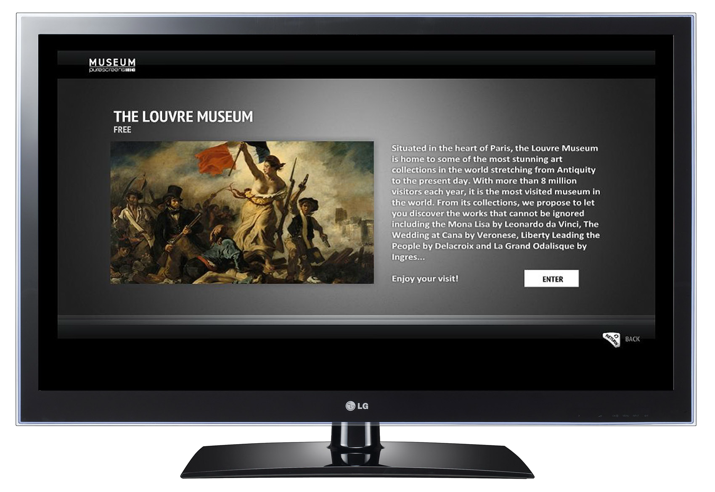Smart tv
streaming online Videos. Run apps,connect to over devices.watch free live catch up,screen mirroring,integrate smart home devices,use voice command.

Screenshot/Photo 2
r
Computer
Communications sending emails,making video calls, using social media apps,and to talk to people world wide also browsing information. Work and productivity. Information research ,entertainment, creative projects.

Screenshot/Photo 3
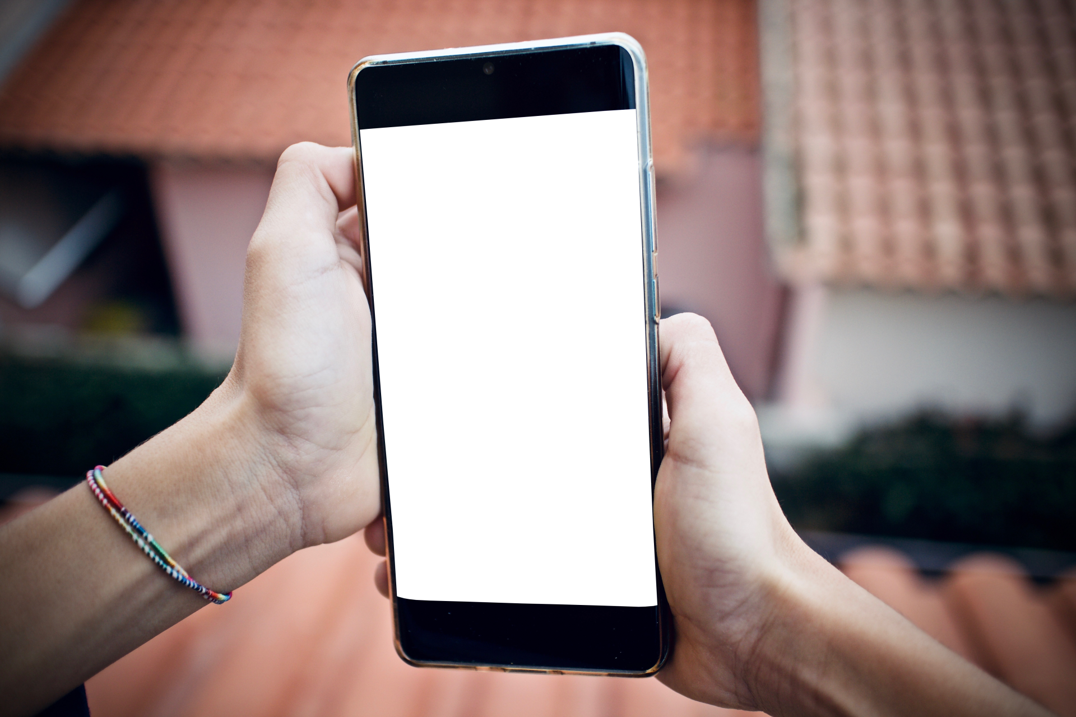
Phone
Communications making voice calls, video calls sending text messages.
Internet email reading and sending , searching websites
Photography and video taking quality photos and video editing.
Navigation and travel can find many apps to help with directions and travel,also walking and public transport.
Entertainment fiance, and also shopping.

Screenshot/Photo 4
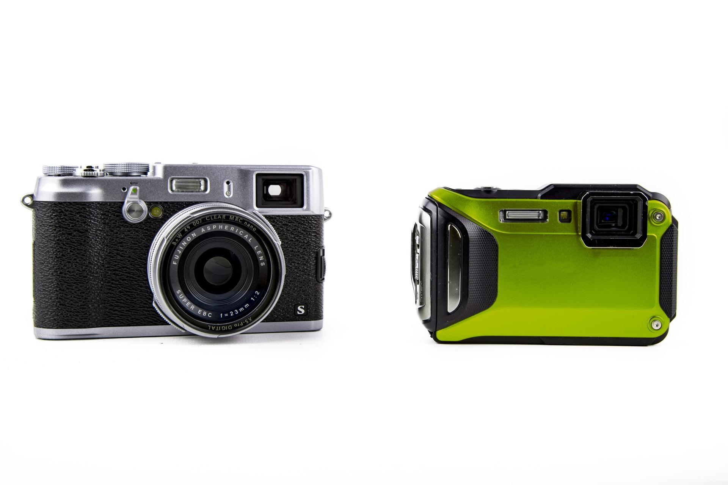
Camera
Video graphing and film making ,record movies,short films ,vlogs, streaming
Portrait and event photography capture family moments
Advertising and fashion commercials images for fashion or brands.

Screenshot/Photo 5
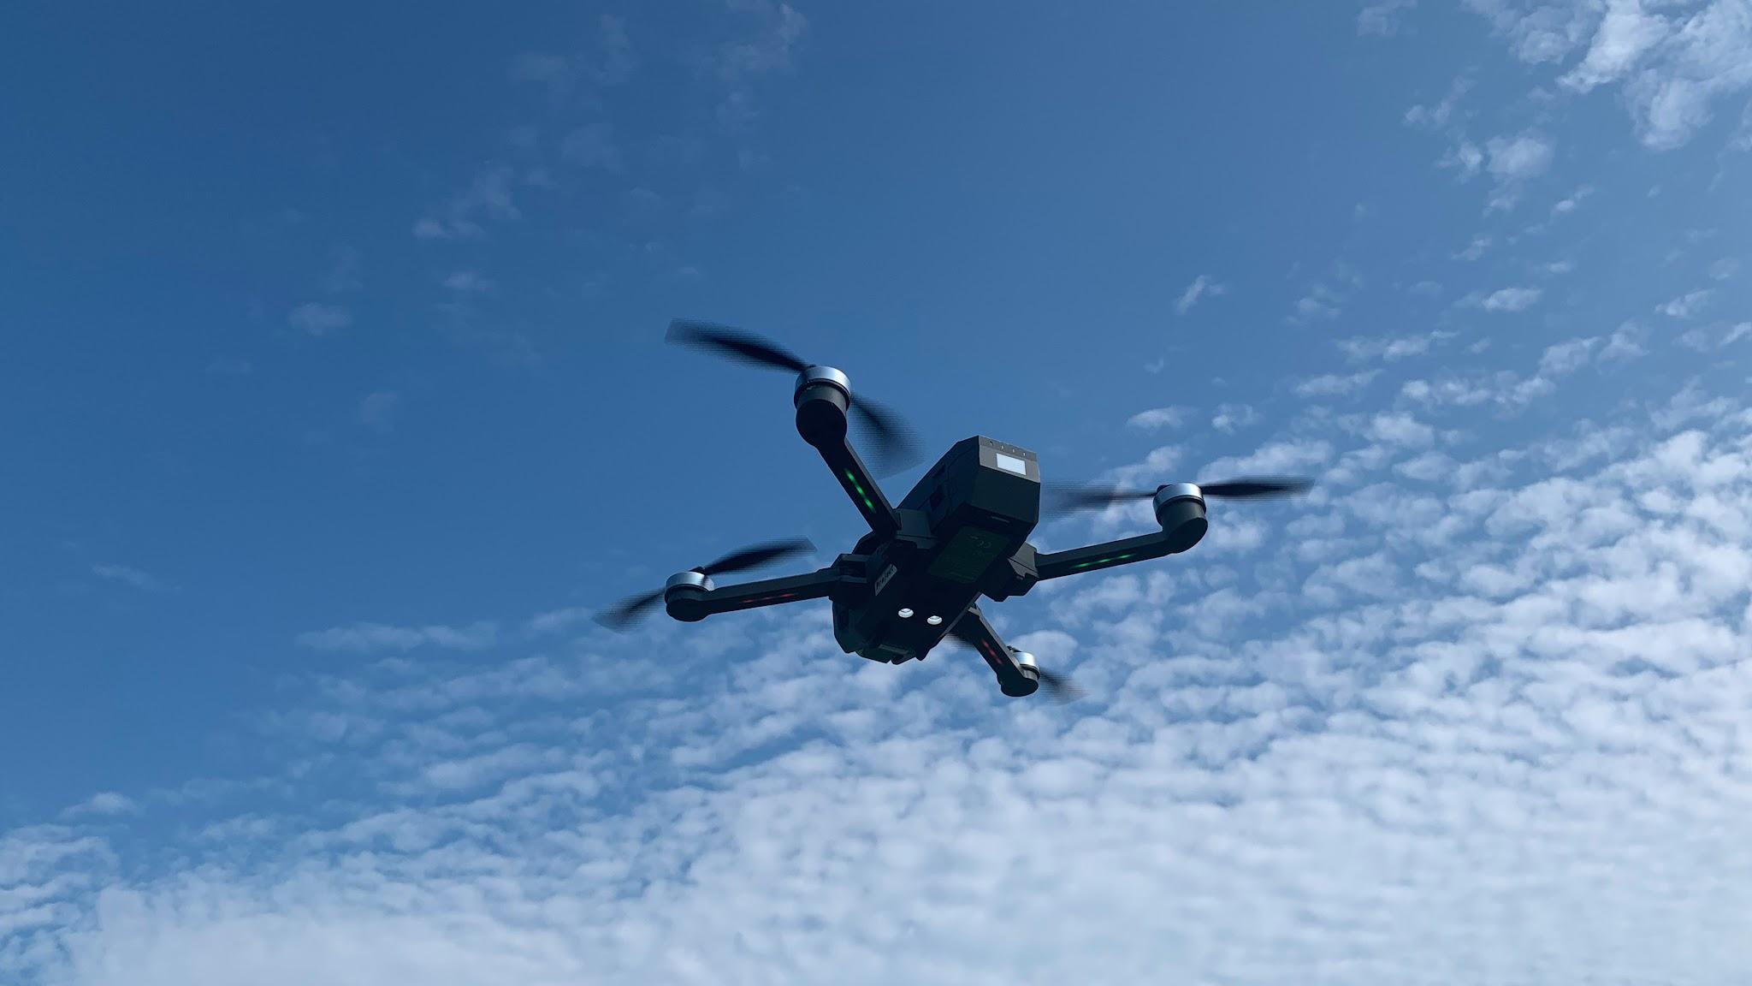
Drone
Consumer and creative use. Commercial and industry application.
Mapping and surveying. Public safety and emergency services. Search and rescue people. Locate missing people.law enforcement fighters can use to see blinded spots or how bad a fire is without accessing the area.

Screenshot/Photo 6
[Insert Photo/Screenshot below]

[Write what this shows of your digital life]

My Short Reflection
- Write 5–8 simple sentences about your digital life.
- You can use the sentence starters below if helpful.
My digital life is a phone < i love using it to stream apps and social media. Also i like to use my phone to keep in touch with family and friends. And to post on social media. I love using apps to edit. I feel confident when i know how to use the device. I would like to prove in my laptop skills.

Sentence starters
- I use digital tools to …
- I feel confident when I …
- I want to improve …
- I often use these tools: …
- I sometimes feel nervous about …
- I hope this module will help me …
- Digital skills are important for me because …
1 Nottinghamshire Police (2026) Warning for drivers using mobile phones to navigate. Available at: https://www.nottinghamshire.police.uk/news/nottinghamshire/news/news/2026/october/warning-for-drivers-using-mobile-phones-to-navigate/ (Accessed: 25 October 2026). [nottingham....police.uk]
2 ottinghamshire Police (2026) Warning for drivers using mobile phones to navigate. Available at: https://www.nottinghamshire.police.uk/news/nottinghamshire/news/news/2026/october/warning-for-drivers-using-mobile-phones-to-navigate/ (Accessed: 25 October 2026).
3 International Organization for Migration (2022) A beginner’s guide to using computers. HARP 2022 – Harmonizing Protection Practices in Greece Supporting Knowledge Inclusion & Life-Long Learning (SKILL) Toolkit, Skills Development Pillar. Available at: https://greece.iom.int/sites/g/files/tmzbdl1086/files/documents/ICT_Guide_1_Skills%20Development_2022.pdf (Accessed: 25 October 2026). [greece.iom.int]
4 Parenthetical: (Centre for Data Digitisation and Analysis, n.d.) [qub.ac.uk]
Narrative: Centre for Data Digitisation and Analysis (n.d.) explains the basic functions of digital cameras, including zoom, focus, flash, and image storage. [qub.ac.uk]
5. Dronarium Academy (n.d.) Drone & UAV Courses in Kyiv and Lviv. Available at: https://www.dronarium.academy/en (Accessed: 25 October 2026)

