

Module: Emotional Intelligence
Title: The importance of EI

Lecture: Julie Thomas
Student: Nicoleta Bichir
Student number:2126694

I confirm that I have not presented any AI-generated materials as my work.
- I confirm that I have copies of my drafts, notes, and other resources I used, which I may be asked to provide as evidence.

Table of Contents
1. Introduction 3
2. The Role of Emotional Intelligence in Post-COVID Management, Employee Well-being, and Performance 3
2.1The Significance of Self-Awareness for Managers in Modern Organisations. 4
2.2 What are the consequences of a lack of self-awareness? 5
3. A critical discussion of the concepts underlying the challenges. 5
4. Explanation of the Gibbs Reflective Cycle 6
4.1 My feelings about the importance of self-awareness 7
4.2 What is journaling, and does it help me? 8
4.3 Practicing Gratitude 8
4.4 Better sleep 8
4.5 Spending time in Nature 9
5. Concluded 9
6. My Development Plan 10
7. Appendixes: 12
8. Reference list: 13

Introduction
I was required to demonstrate my understanding of EI and a critical discussion of the importance of managers developing their self-awareness in a modern organisation.
Furthermore, I have examined the importance of Emotional Intelligence and self-awareness as key concepts in personal and professional growth. The discussion begins by defining EI and emphasizing its role in managing emotions, building relationships, and making informed decisions. Throughout the report, I explore how self-awareness, a vital part of EI, can be developed through reflection, feedback, and mindfulness practices. By understanding and enhancing self-awareness, individuals can improve their emotional responses and interactions, which I further demonstrate with practical strategies and examples in the following sections.
In response, I developed a personal development plan outlining my learning objectives, goals, and specific sources and deadlines.

The Role of Emotional Intelligence in Post-COVID Management, Employee Well-being, and Performance
When defining Emotional Intelligence (EI), it refers to the ability to recognise, understand, and manage one's own emotions as well as the emotions of others. It has become a valuable skill to develop and a good indicator of overall health. In leadership research, EI has been positively linked to leader authenticity, interpersonal effectiveness, and the ability to create cohesive teams. EI may function as an important personal trait, allowing managers to handle the emotional and relational aspects of their role (Tyczkowski et al., 2015). Furthermore, EI might also be a crucial resource that helps leaders adapt their approach, respond to emotional demands, and promote team stability. Recent research has further suggested that trait-based EI, reflecting deeper emotional tendencies, may influence how leaders are perceived and how their behaviour impacts team outcomes (Tommasi et al., 2023). When considering the emotional impact on employees during the COVID-19 pandemic, it is evident that various response tactics employed to mitigate the spread of the virus had a severe effect on their mental and emotional well-being. According to the Global Happiness Report 2021, “The workplace happiness has declined. Happiness and life satisfaction experienced one of the most significant declines during the pandemic, along with declines in mental and physical health, as well as more modest decreases in meaning in life and overall flourishing. (Helliwell et al., 2021)
EI consists of five core skills: self-awareness, self-regulation, motivation, empathy, and social skills, all of which are encompassed in Goleman's model, underscoring the significance of emotional intelligence (EI) in personal and social competence. Moreover, I can identify the gaps in my emotional intelligence (EI) and, as a result, work on and further develop each of the emotional intelligence dimensions (Isabel et al., 2023). Additionally, on the other hand, there are other things commonly referenced as signs of emotional intelligence, including the ability to acknowledge and apologise for mistakes, the ability to accept feedback, the ability to set boundaries, a willingness to ask open-ended questions, and being a good listener (Wicks, Nakisher and Grimm, 2024).

2.1The Significance of Self-Awareness for Managers in Modern Organisations.
In today’s dynamic and often unpredictable organisational environment, particularly in the post-COVID-19 pandemic, self-awareness has become a critical competency for effective management. Self-awareness, a foundational component of emotional intelligence (Goleman, 1995), refers to a manager’s ability to recognise and understand their own emotions, strengths, limitations, and the impact of their behaviour on others.
Managers with a high degree of self-awareness are better equipped to make informed decisions, manage stress effectively, and foster trust within their teams. In modern organisations, where hybrid work models, digital communication, and rapid change are the norm, the ability to remain attuned to one’s emotional state and behavioural patterns is essential(CIPD, 2020). It enables leaders to respond to challenges with clarity rather than reactivity, fostering a culture of openness and psychological safety (Sabrena, 2024).
According to Frontiers in Public Health (2022), authentic leadership, characterised by self-awareness, positively influences both hedonic, which refers to pleasure and happiness, and eudaimonic, which relates to meaning, self-realization, and well-being among employees. The findings indicate that both forms of well-being mediate the relationship between authentic leadership and work engagement, suggesting that managers who cultivate self-awareness foster both types of well-being in their teams, thereby enhancing engagement and adaptability in modern organisations.
Self-awareness involves having a clear understanding of what motivates me, as well as recognising my behavior and feelings. It allows me to have better control over my emotions and my behavior. Getting to know myself better enables me to make changes, develop new habits, and learn new skills. It also allows me to be more accepting of my vulnerabilities so that once I acknowledge them, I can choose to develop strategies to build my resilience (Boyatzis & McKee, 2013).
Self-awareness is the ability to accurately perceive not only our emotions but also to remain aware of them as they occur (Mayer et al., 2008). Research demonstrates that self-aware people are more balanced, confident, maintain positive relationships, and have a greater sense of achievement (Eurich, 2017). Self-regulation is the ability to use awareness of our emotions to stay flexible and positively direct our behavior. Social competence includes motivation, empathy, and social skills. It is the ability to understand other people ‘s moods, behaviors, and motives to enhance the quality of our relationships. Moreover, the ability to accurately pick up on emotions in different people and understand what is happening on the other end is also essential (Hughes and Terrell, 2007). Connecting to my job the social competence is necessary when working with customers, where my role regularly involves interacting with patients who may be frustrated or anxious, working as a locum with EI helps me recognise and respond to patients' emotions, communicate clearly, and show empathy, which builds trust and improves the patient experience (Senćanski et al., 2024).

2.2 What are the consequences of a lack of self-awareness?
COVID-19 is regarded as one of the most significant pandemics of the era, presenting numerous opportunities for study in the field of neuroscience. Social isolation during and after the COVID-19 pandemic has had profound consequences for both physical and mental health. The lack of proper home office furniture and ergonomic setups during lockdowns contributed to increased sedentary behavior and reduced physical activity, leading to mental fatigue and a decline in overall well-being. All this is relevant to EI, as post-COVID-19 has intensified stress, anxiety, and depression in the workplace.
Furthermore, a lack of self-awareness in managers significantly undermines leadership effectiveness in modern organizations, where adaptability and emotional intelligence are crucial. Research indicates that managers who are unaware of their own emotions, biases, and behavioural patterns tend to make poor decisions, struggle with stress management, and exhibit reactive behaviour that negatively impacts team dynamics (Da Fonseca et al., 2022). This deficiency also hinders their ability to receive and integrate feedback, limiting personal growth and reducing their capacity to foster trust and psychological safety among employees. Consequently, teams under such leadership experience lower commitment, increased presenteeism and leavism, decreased morale, and higher turnover (Gacheru & Karimi, 2023)
According to Travis Bradberry, a lack of self-awareness can significantly hinder our ability to develop other skills. The only way to truly understand your emotions and manage them effectively is to spend enough time reflecting on them to identify their origins and reasons. For example, when I started working after COVID, I couldn't recognize the signs of fatigue and ignored stress, which caused me to be unaware of how fatigue or stress were affecting my performance and well-being. This resulted in more frequent mistakes, like dispensing the wrong medication or incorrect dosage. Furthermore, the communication barrier led me to overlook the fact that mask-wearing and social distancing can impede clear communication with patients and colleagues, resulting in misunderstandings or dispensing errors (Bhamra et al., 2021).

A critical discussion of the concepts underlying the challenges.
Challenges serve as powerful tools for boosting self-awareness because they encourage us to recognise our emotional responses and automatic behaviours during tough situations. According to Travis Bradberry, facing challenges helps us discover our strengths and weaknesses by showing how we react under pressure, which is crucial for developing emotional intelligence. This heightened self-awareness enables us to manage our emotions more effectively and make more informed decisions, ultimately leading to personal growth. The challenges I face when practicing self-awareness strategies, such as expressing gratitude, spending time in nature, practicing solitude, getting enough sleep, and pausing before reacting, provide valuable opportunities to enhance my self-awareness. People who are high in self-awareness are clear in their understanding of their strengths, what motivates and satisfies them, and which people and situations trigger their reactions. The main benefit of these challenges is to foster self-awareness by providing high-quality, objective feedback on emotions and behavior. Several factors contribute to these challenges and serve as effective ways to enhance self-awareness, for example:
Reduce anxiety
Lower stress
Reflect on thoughts and behaviors
Improve mood and mental clarity
Enhance happiness
Boost well-being

Explanation of the Gibbs Reflective Cycle
Gibbs’ Reflective Cycle is a framework for reflection, commonly used in learning and professional development. It involves six stages: description, feelings, evaluation, analysis, conclusion, and action plan. By guiding individuals through these stages, the cycle enables them to think critically about their experiences, learn from them, and refine their future practice (McLeod, 2025).
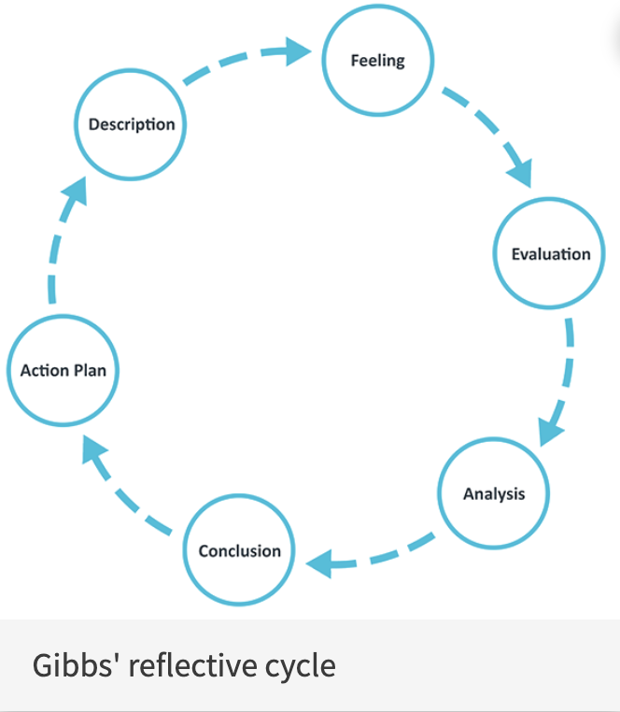
Figure 1: Gibbs, G. (1988).
Approach reflection with a growth mindset, viewing challenges as opportunities for learning rather than occasions for self-judgment.

4.1 My feelings about the importance of self-awareness
When analysing the Gibbs model for personal development, I classified self-awareness and self-regulation as aspects of my competence, which emphasises my individuality over my interactions with others. Personal competence refers to the ability to remain aware of our emotions and manage our behaviour and tendencies. Working as a dispenser assistant is relevant because it enables me to recognise and understand my feelings, stress levels, and behavioural patterns, especially when working in unfamiliar environments. It allows me to identify when my feelings are overwhelmed or uncertain, helping me to pause and reflect. Some days are busy due to staff shortages, and sometimes I become impatient and short-tempered with customers who have multiple questions about their medications. After shifts, I reflect on what went well and what could be improved (Jackson, 2025).

4.2 What is journaling, and does it help me?
Journaling is the act of using a journal for personal purposes. Levesley (2021) suggests expressing your thoughts and feelings through words or illustrations, which can include documenting personal goals or reflecting on people, interactions, and events. Journaling helps me write down my thoughts and feelings, which can lead to a deeper understanding of them. I use a journal to reflect on my emotions, track my progress, and identify patterns in my behaviour. When discussing my job side, the experience of journaling helps me recognize the signs of burnout and be more aware of the symptoms of fatigue. By reflecting on these feelings in writing, I become more adept at identifying them in real-time.
Ackerman (2018) indicates that this kind of writing can serve as a helpful tool for reducing stress, managing anxiety, or working through depression. The act of writing in this manner has the potential to reveal personal fears or problems, as well as possible solutions. I have noticed that I am better at managing busy days and concentrating my attention. I can distance myself from my stress and think through it more clearly, even when I sometimes need to take a deep breath.

4.3 Practicing Gratitude
Gratitude is the appreciation of what is valuable and meaningful to oneself, or a general sense of thankfulness and gratitude for life's blessings. It can also be seen as an attitude of valuing life as a gift, as well as a moral feeling that arises from and inspires actions motivated by concern for others' well-being (Srivastava & Iqbal, 2023). From my perspective, guiding my mind and overall well-being toward a better state has led me to realize the importance of practicing gratitude, improving my sleep, and spending time in nature. When I start practicing gratitude by simply being thankful for the new day and doing a 5-minute breathing exercise before I begin, it helps a lot with focus and waking up more motivated. Moreover, every morning, saying a few words with gratitude, such as "Thank you, world, for everything," makes me feel that every single moment matters and helps me stop having too many expectations from life.

4.4 Better sleep
Getting enough good sleep is an essential part of maintaining your physical and mental health. People with a grateful attitude tend to pursue goals that keep them feeling good, and a positive attitude promotes positive action. Without enough sleep, I struggle to focus, pay attention, or respond quickly (Gupta & Saxena, 2024). A lack of sleep may even cause mood problems. I share an example that happened to me a few years ago; I was struggling with sleep. I tried various actions to improve my sleep, but I didn't notice any noticeable improvement. For example, I started reading a book before bed and exercising every afternoon. It's hard to believe, but I never wanted to sleep. Every morning, I was terrified because I felt no energy; I wanted to cry every morning, but something kept me motivated to wake up. Once I was awake, I drank coffee. I didn't feel physically energised, but I noticed changes in my mood—specifically, a lack of patience in communication and a tendency to ignore people.
One day, I had a doctor’s appointment for a different concern unrelated to sleep. Instantly, the doctor asked if I wanted a blood test for my iron levels. I smiled ironically and said yes, even though I didn't consider it very important at the time. But he was an angel for me because my iron level was so low, which caused my sleep problems. Since I have been taking iron, my sleep has improved, and I fall asleep easily at night.

4.5 Spending time in Nature
Spending time in nature is one of my favorites, as it's a quality time that I can afford in these crowded days at work and in life. According to Meenakshi Sharma, adults who participate in outdoor activities experience renewal, creative expression, and a stronger connection with themselves and nature. The study emphasizes that the time spent outdoors promotes reflection and self-awareness through innovative and adaptable expression. When I have the chance, I always book nature activities with my family. Recently, we took a trip in a canoe, and we loved it so much that we plan to do it a few times a year. This way, our brains are free from phones and stress, allowing us to engage in more meaningful communication as a family. Most of these positive impacts on well-being were psychological, such as reduced stress, increased feelings of happiness and joy, experiences of mindfulness or spirituality, and a sense of competence, self-esteem, or emotional well-being (Lindemann-Matthies et al., 2021).

Concluded
Moving on, the existing evidence I have gathered from my time in nature suggests that engaging in outdoor activities can be beneficial for my well-being. It can make me feel happier, more satisfied with life, or less anxious and depressed.
Throughout the various challenges I have faced, I have noticed significant improvements in my self-awareness. According to the EQ-Academy MBTI, research suggests that individuals with preferences for introversion, intuition, and Feeling (such as INFJ, INFP, or ESFG) report higher scores on self-awareness, which is ultimately a quality developed through intentional reflection and feedback, rather than being strictly defined by personality. Refer to Figure 4. Not only do I feel more in tune with my thoughts and emotions, but I have also experienced better sleep and an overall sense of well-being. Please refer to Fig. 2 and Fig. 3 (Psychology Today, 2025). As a result, spending time in nature has become an essential and non-negotiable part of our family routine. These moments outdoors allow us to recharge, connect, and maintain a healthier, more balanced lifestyle.
As a recommendation, embracing any different type of challenges is taking us out of our comfort zones and promoting personal and professional growth.

My Development Plan
What Do I want/need to learn? | What will I do to achieve this? | What resources or support will I need? | What will my success criteria be? | Target dates for  review and completion
1. I will need to follow up with journaling, because one week I was missed writing. I promise myself to make as a habit because it has Emotional and physical health benefits of expressive writing (Baikie & Wilhelm, 2005) | To keep writing in my journal every day.  I will read a book: The Great Book of Journaling: How Journal Writing Can Support a Life of Wellness, Creativity, Meaning and Purpose.  I will subscribe to the  Habit Tracker: Habit It by Paul Stefan Berbec | Access to the university library to read online books.  Support from the Knowledge Academy members.  Access to my computer and mobile app store. | To improve my self awareness level.  Understanding and recognizing my client’s better emotions.  Not only will I grow personally and professionally, but I will also become more effective. | The book is planned to be finished by  the end of august 2025.  The journaling will take  about a few months, which means I am so confident about writing in my journal. Moreover, I will try to make as a habit in my life.
2. To keep an eye on my sleeping patterns and to keep improve my sleep quality. Additionally, to do the Journaling before bed can reduce stress and racing thoughts, which often interfere with falling asleep (Scullin et al., 2018).  According to Rebecca Robbins wearable technology offers promise for measuring sleep continuously, less intrusively, and more naturally, making it a more scalable solution for sleep measurement | To create a new sleep journaling, it will help me to record the bedtime and wake-up time, estimated time to fall asleep and the number and duration of awakenings. | To Weare a device like Fitbit, Oura Ring, to monitor sleep stages, duration, and quality automatically. They provide detailed reports and trends over time.  My new journaling.  I will ask my husband to wake up during the night for our son needs. | To Improve my sleep quality, it will help me to wake up feeling more rested and refreshed.  The positive mood on waking up it will start my day with improved mood and energy.  With the tracking these criteria in my sleep journal and with a sleep tracker will help me to objectively measure the progress. | Because it is expensive tracker, I must plan to bay an Oura ring by 01/11/2025.  To get a few sleep classes until 01/11/2025 form https://sleepcycle.com/
3. What I was impressed during the above challenges that when I am Engaging in outdoor activities is a highly effective way to improve my self-awareness (Richardson et al., 2021). | Facing new challenges: for example, activities like hiking, which I am afraid of a such experience, but this will push me out of my comfort zone, requiring me to adapt, solve problems, and confront fears. This process helps me learning more about my strengths, limitations, and reactions under pressure, deepening self-understanding.  Firstly, I will start with The Cascades Walk: Short, accessible riverside walk. | Comfortable wearing outfit, like to wear strong walking shoes or boots.  Additionally, to take a windproof and waterproof layers | With Hiking requires me to pay attention to my body, breath, and surroundings, fostering mindfulness and helping me notice my thoughts and feelings as they arise.  As I start hiking, I become more attuned to my physical state—recognizing signs of fatigue, stress, or calm—which enhances my understanding of how my body responds to different situations. | I have already started hiking activities, but I wish to follow up every month for the next 6 months.  To get feedback from my colleagues in the next 3 months.

Appendixes:
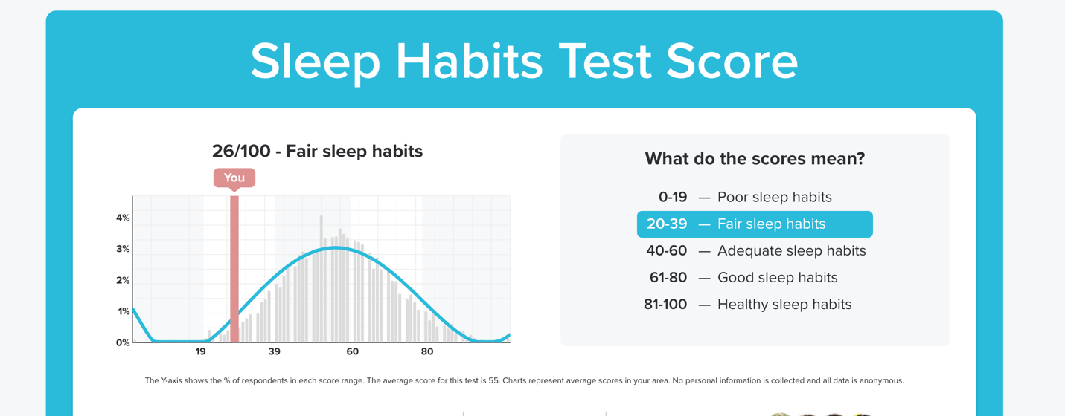
Figure 2: (Psychology Today, 2025), Accessed [02/06/2025].
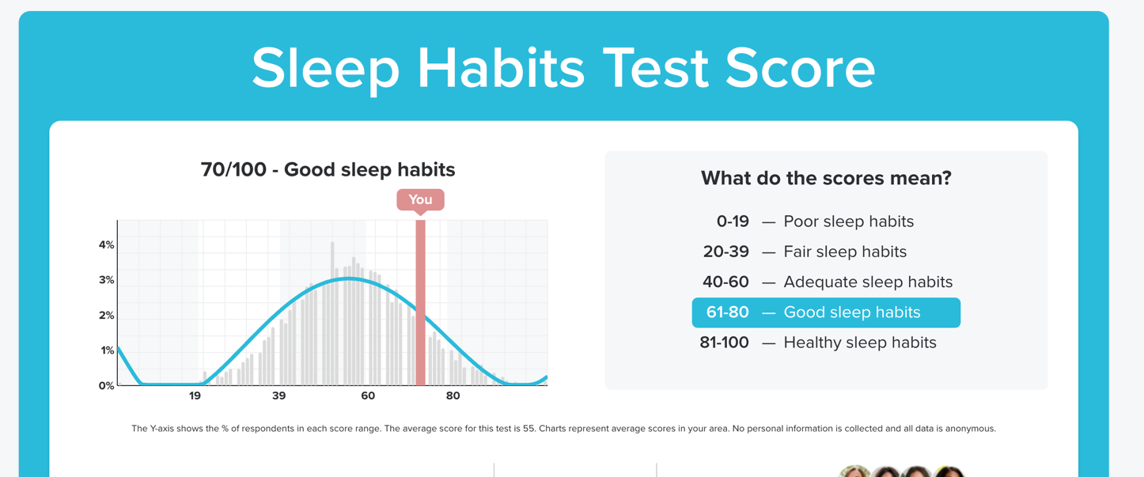
Figure 3: (Psychology Today, 2025), Accessed [03/07/2025].

Figure 4: Eq-Academy.com, Accessed on [03/07/2025]

8. Reference list:

- Ackerman, C.E. (2018). What is journaling? How to start journaling, benefits of journaling, and more, PositivePsychology.com, 20 May. Available at: https://positivepsychology.com/benefits-of-journaling/ (Accessed: 19 June 2025).
- Arora, N. & Arora, P. (2023) ‘Analyzing post COVID-19 effects on self-consciousness and awareness toward health: A neuroscience framework’, in Neuroscience and the COVID-19 Pandemic. Elsevier, pp. 825–836. doi:10.1016/B978-0-443-21870-5.00055-8.
- Arshad, M. A., Arshad, D., & Zakaria, N. (2023). Mediating role of well-being among organizational virtuousness, emotional intelligence, and job performance in post-pandemic COVID-19. Frontiers in Psychology. https://doi.org/10.3389/fpsyg.2023.1105895
- Artyukhov, I., et al. (2022). Evaluation of Medical Education Quality about Sustainable Development Goals. Frontiers in Public Health. https://doi.org/10.3389/fpubh.2024.1385350
- Ashley, G.C. & Reiter-Palmon, R. (2012) ‘Self-Awareness and the Evolution of Leaders: The Need for a Better Measure of Self-Awareness’, Journal of Behavioral and Applied Management, 14(1), pp. 2–17. Available at: https://doi.org/10.21818/001c.17902 (Accessed: 21 June 2025).
- Bhamra, S. K., Parmar, J., & Heinrich, M. (2021). Impact of the coronavirus pandemic (COVID-19) on the professional practice and personal well-being of community pharmacy teams in the UK. The International journal of pharmacy practice, 29(6), 556–565. https://doi.org/10.1093/ijpp/riab062
- CIPD (2020) The business case for wellbeing. Chartered Institute of Personnel and Development.
- Coronado-Maldonado & Benítez-Márquez, D. (2023). Emotional intelligence, leadership, and work teams: A hybrid literature review. Heliyon, 9(10). Accessed on [19/06/2025] https://doi.org/10.1016/j.heliyon.2023.e20356
- Craft, Sabrena. (2024). Role of Emotional Intelligence in Leadership (Capstone project, M.S. in Leadership). University of New Hampshire.
- D., Boyatzis, R., & McKee, A. (2013). Primal Leadership: Unleashing the Power of Emotional Intelligence. Harvard Business Review Press.
- Da Fonseca, D., et al. (2022). Harnessing Emotional Intelligence for Success. International Journal of Innovation and Applied Psychology, 2(4), 45-59. Retrieved from https://psychopediajournals.com/index.php/ijiap/article/download/753/549/1428
- EQ Academy (n.d.) Welcome. Available at: https://eq-academy.com (Accessed: 3 July 2025).
- Gacheru, W., & Karimi, J. (2023). The Influence of Leaders' Self-Awareness on Employee Commitment in Agencies Implementing Public Financial Management Reforms in Kenya. The University Journal, 5(2), 194-211. https://doi.org/10.31274/tuj-180813-2427
- Gupta, A., & Saxena, T. (2024).
Gratitude and Sleep Quality Among Young and Middle Adults: A Comparative Study. International Journal of Interdisciplinary Approaches in Psychology, 2(4), 339–353. https://psychopediajournals.com/index.php/ijiap/article/download/216/154/527
- Hughes, M. & Terrell, J.B. (2007). The Emotionally Intelligent Team: Understanding and Developing the Behaviors of Success. San Francisco: Jossey-Bass.
- Jackson, S. (2025). "Emotional Intelligence and Self-Awareness." MentalHealth.com. Medically reviewed by Dr. Jennie Stanford.
- Levesley, D. (2021) ‘The eleven steps to becoming a better man via journaling’, GQ, 7 March. Available at: https://www.gq-magazine.co.uk/lifestyle/article/journalling-for-mental-health (Accessed: 19 June 2025).
- McLeod, S. (2025, March 26). Gibbs Reflective Cycle. Simply Psychology. https://www.simplypsychology.org/gibbs-reflective-cycle.html
- Psychology Today (n.d.) Sleep Habits Test: Results. Available at: https://www.psychologytoday.com/gb/tests/health/sleep-habits-test/results (Accessed: 2 June 2025).
- Psychology Today (n.d.) Sleep Habits Test: Results. Available at: https://www.psychologytoday.com/gb/tests/health/sleep-habits-test/results (Accessed: 3 July 2025).
- Richardson, M., McEwan, K., Maratos, F., & Sheffield, D. (2021). Joy and calm: How an evolutionary functional model of affect regulation informs positive emotions in nature. Emotion Review, 13(1), 21–32. https://doi.org/10.1177/1754073920944517
- Scullin, M. K., Krueger, M. L., Ballard, H. K., Pruett, N., & Bliwise, D. L. (2018). The effects of bedtime writing on difficulty falling asleep: A polysomnographic study comparing to-do lists and completed activity lists. Journal of Experimental Psychology. General, 147(1), 139–146. https://doi.org/10.1037/xge0000374
- Senćanski D, Tadić I, Jocić D, Marinković V. Perceived importance of emotional intelligence for clinical pharmacy practice and suggested improvements: a focus group study of postgraduate pharmacists. International Journal of Clinical Pharmacy. 2024 Oct;46(5):1152-1162. Doi: 10.1007/s11096-024-01748-4. PMID: 38861045
- Srivastava, S., & Iqbal, N. (2023). Gratitude exercise and well-being about spirituality: A mixed-method study. International Journal of Wellbeing, 13(3), 111–133. https://doi.org/10.5502/ijw.v13i3.3281
- Wicks, J., Nakisher, S., and Grimm, L. (2024). Emotional intelligence (EI). EBSCO Research Starters. (Accessed: 19 June 2025).

