Independent project – Amy Ferguson (1802235)

What was intended by the addition of bulls as a motif in the production of Askos during the Late Cypriot II period?

_____________________________________________

Introduction
The guiding theory for my study of late Cypriot ceramic bulls, is that of materiality. I have chosen this as the duality of the theory is extremely relevant, with physical properties of materials taking precedence; the secondary aspect to this is the engagement of agency within the realm of material culture. (Boivin, 2008). Materialities focuses on shifting away from a human centric understanding of the world, while also acknowledging the multiple layers of agency and how it differentiates between object and person. With that in mind I will use an example of these artefacts to try and explain this animal’s frequent appearance in this particular form and what purposes made it desirable specifically during the Late Cypriot II period. I will also try to explain the presence of agency these ceramics hold and whether that is independent from human interaction or a direct product of it.

Theory of Materialities
For the basis of my work I found myself using the ideas of anthropologist Alfred Gell who claimed objects of art had such agency they should be considered social agents (Gell,1998). From his work, I saw these ceramic bulls fit into the category of ‘secondary agents’ to be used as a medium for human agency to be shared through. Material culture is how we engage with our world and each other, it is through this ‘stuff’ often from daily life that we learn how to function. In an archaeological sense the material culture of humans predates written history and that alone can inform us of what people felt the need to create for themselves to have a better experience of their world. When talking about material such as this it is imperative to understand objects, almost in a personified way. Are they individual or communal agents which is something I found difficult to determine with my particular case study. Another concept under this theory I found myself drawing upon was ‘Life history’ of objects. (Kopytoff, 1986) When applying theory to my chosen object I found it made sense and allowed me to gain a different perspective of the artefact.
An additional characteristic of materiality is the idea of passive and vibrant matter which is what I think bridges the two biggest halves of this theory of physical properties and object agency. We tend to see human agents as the active subject and assume that which is inanimate as being stable (passive). This dichotomy between life and matter tends to ignore the liveliness of material. (Bennett,2010) It is easy to limit ‘things’ to their own physical confines, which would be naïve as every object has power outside itself. Objects of little size or value can hold memories or so much sentiment that we cannot contain or replace even with another object that is exactly the same. Stuff of necessity allows us to survive but we have the added benefits of things that we do not need that makes life so much more enjoyable such as all forms of artistic expression.
This material had to be gathered and manipulated by human hands and what is hard to discern is whether that individual took that clay and knew that it would take shape as a bull or whether the clay in its raw form instead inspired the artists with what to craft. As clay-based materials can be difficult at several stages in pottering I would like to believe the clay was in control of the shape it would eventually take. However, I am not in the same position as a specialised potter and cannot push this narrative, when it is possible the crafter of this item knew exactly what to do to manipulate the material to their design. Ultimately It can best be explained as a recursive relationship we have between materials – humans make things, but these things ‘make’ people and the human experience. As this design of the bull is fairly decorative that trait would ostensibly relegate it from regular usage, which will be discussed further. It does seem to have at one point in its life served a purpose; the interpretation that I reach in favour of is that the vessels shape was designed with practicality in mind while the anthropomorphic aspect provides profounder implications to the Askos.
The physicality of objects is a concept we are much more familiar with in contrast to that of material culture having agency. This half of the theory is best described as the difference between ‘the materiality of objects as opposed to the properties of materials’ (Ingold,2007). What makes an object and when does something become an object are two questions, I have found myself asking during this research. We do not seem to think of raw material as an object as much as we do the product of raw materials. Once the physical properties are changed, it alters our perception of it and ability to use it - does that mean the physical properties are what gives an object its agency? Physicality is defined as the “predominance of the physical” which makes it easier to conceptualise, as it is what you can sensually interact with. Socially our senses are restricted for different objects and impact the interactions we can have with them. Interacting with material teaches us as we develop what senses we can utilise with different things and in what scenarios they are acceptable. _____________________________________________
Presenting my Case Study
My case study is of an example I found located in the British museum, excavated at Maroni, tomb 15 (Larnaka district) by the museum in 1898 and is dated circa 1450-1150 BCE. It is a terracotta Base-Ring ware Askos from the Late Cypriot II period that has been decorated with lines of white paint in a ‘binding’ pattern. It measures in at 17cm to the handle and 24cm in length. (British Museum, 2018) In previous research analysing similar Askos, I found by holding a replica that it is typically of a handheld size yet not necessarily portable or for casual usage. Size also indicates its storage capabilities are limited and not for the storing of mass quantities of say ‘common’ liquids. Could it be useful to undertake scientific analysis of what residually may remain on the inside of the Askos? In hopes of creating a clearer picture of what it was used for as unglazed ceramics like this tend to be porous.
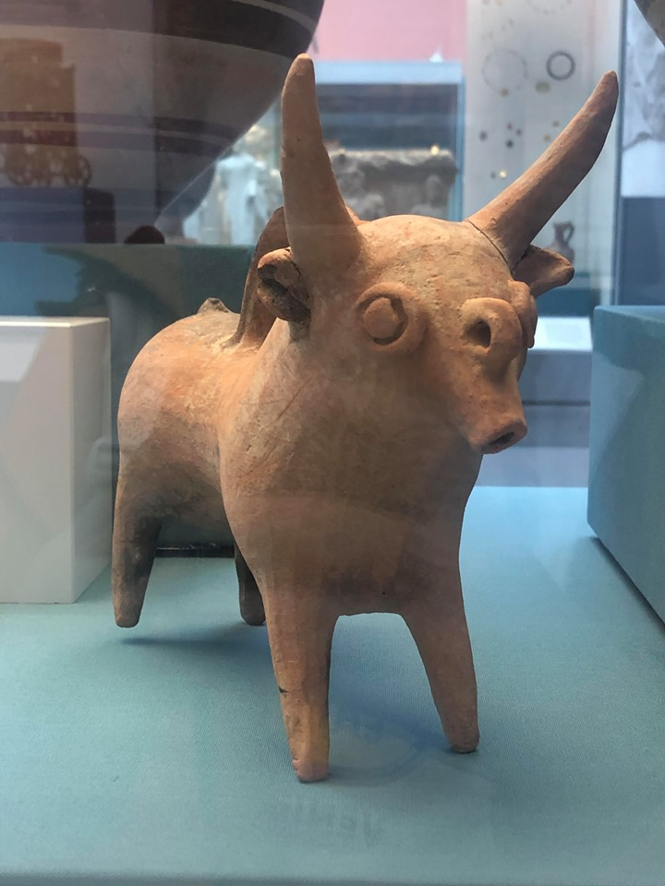 Image of the Artefact as it currently sits on display
The production of this particular ceramic has been placed within Cyprus although at the time bulls were a common symbol in the Mediterranean and synonymous with power. One feature that is distinctly Cypriot in design is the rounded eyes used on representations of people and animals. With the importing of goods comes the introduction of new styles, so was the bull motif brought into ceramic production with a Cypriot demographic in mind from elsewhere? It is hard to pinpoint an exact location that this first appeared as you could dispute bulls are a symbol that have developed artistically over time, these ceramics are noticeably of Cypriot stylistic choices. Indicating they were likely first produced within Cyprus then adopted outwardly. This ceramic form clearly could be situated into its own typological group as it is relatively unique in comparison to styles of other Mediterranean ceramics from the Late bronze age. The frequency in which it appears at this time would suggest it was well received and signifies to a certain extent the cultural importance of bull’s as a symbol. Its ability to be understood by multiple peoples is arguably what makes it such an iconic symbol, it is simple to understand even by people now meaning its’ agency (as long as its physical representation remains preserved) will transcend time. Although we can understand the artefacts physical presentation, properties and purpose we may not truly understand its meaning contemporary to when it was made. In past work I argued that these could have been used ritualistically or in daily life, however I am now in favour of this object having ties to ritual and religion. As stated, these were quite common items found in graves and sanctuaries; some credit the appearance of the bull motif by connecting it with the social importance of fertility-based ideologies of the time. (Ferguson, 2019) Although new shapes of animals were emerging in the pottery at this time the bull was the most exploited. Due to where they were found it seems they held some significance in embodying a link between the living, dead and potentially deities.
Terracotta is an accessible material therefore I was led to ask, is this an imitation of finer goods that held the same purpose, making smaller cheaper versions could have allowed people to privately enact libations. These forms are base ring ware II, handmade and are technologically quite difficult to make implying some specialism of potters. Seemingly beyond the abilities of household production, that does not mean they were not in demand for households. The clay is not refined and is worked until it is very thin. Interestingly a design feature that separates it from predecessor base ring ware I is the paint decoration, base ring ware I seemed to favour relief work instead. This could be seen as a devolution in style or somewhat less impressive, which I would dispute.

At the time in the Late bronze age this period falls under, we know that Cyprus was beginning to manufacture copper and these objects often reflect the colours of fine copper in their outer appearance. Intriguingly the colouration from these artefacts can vary and could be caused by several reasons such as: the source of raw material, the firing process, age or level of preservation. The vast majority have copper tinges and white details on top, this might have led to the picking of terracotta as the medium of choice as it is already orange in nature. Skeuomorphism encapsulates this idea that objects “resemble their real life counterparts” and with that I think the Cypriots realised the worth of their blossoming metallurgical production and wanted to bring those themes into their pottery. (Hardin, 2013) The Askos was not necessarily a mirror image of bulls, perhaps more of a figurehead for the Cypriot peoples and as copper was so crucial to them it makes sense to combine their separate imagery into one stylised creation. Whilst simultaneously keeping the copper in circulation rather than using it for these vessels, showing the understanding for the value of copper outweighs the need for more expensive vessels. This in turn, I would argue supports claims that these items were not for numerous usages.
Similar objects have been discovered dubbed as Rhytons, the feature that seems to distinguish the two is the liquid it holds and then the interaction between holder, ceramic and liquid. Rhytons are defined as drinking vessels while Askos are designed for pouring, associating them with the act of offering libations. Although the definitive definitions are not entirely agreed upon, with similarities of examples often outweighing the variations.
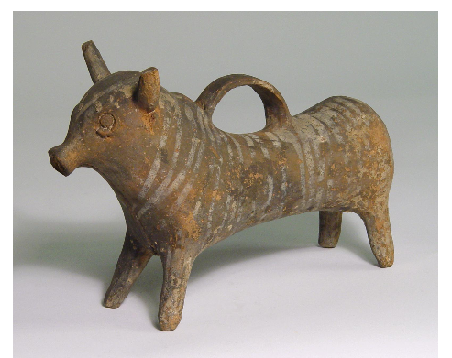example of a Cypriot Rhyton (British Museum)
Another ‘determining’ feature of an Askos is its “short flanged spout” along with a “thin handle that extends in an arc to join the back of the vessel”. (Ferguson, 2019) These bull ceramics beautifully demonstrate this feature, of a thin handle supporting a robust body that could have been quite heavy with the added weight of liquids. This bull also has an added element at the top of the handle that looks like a rounded stump designed as a place to rest your thumb when pouring in comparison to the Rhyton.
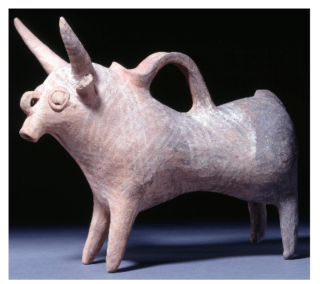Better image of the Askos (British Museum,2018)
Contrary to that I could also contend, the motif was chosen not because of what the bull represented instead because they are simply interesting to look it. The shape of the ceramic perfectly emulates the striking features and strangeness of bulls. Known for their strength they are seen as an animal to be feared and with killing them comes prestige. Epitomised as representing masculinity alongside Lions in more modern cultural terms. Similar to cows their only real differences are thicker bones, higher muscle mass, larger hooves and their horns, all features used to establish dominance in the herd. In some species of bull females will also have a set of horns, all be it smaller than the males the idea of gender associations with the object changed for me. Divine feminine forms are more heavily associated with fertility due to reproduction and childbirth. Yet in terms of livestock one prized male would produce optimal offspring with multiple females of the herd. I could understand representing both genders in these ceramics but from what is presented I see these objects sexed as male.
_____________________________________________
Applying Theory to the Case Study
These ceramics have agency however I believe the entirety of their agency is entangled with humans, which is what defines them. As a ceramic to be viewed now I would like to say it has independent agency; that is what I find captivating about them and when I look at them, I see a bull first. However, when thinking about the life history of the object I understand that it could not exist in this form without the intervention of a human agent. What I find particularly endearing about the Cypriot ceramics is that it projects a simpler and softer idea of this animal which is much more palatable. The smoothness of the clay and roundness of its body and horns is a beautiful contradiction to how they are understood in a majority of western ideals now. This may not have been intentional of the artist and perhaps the medium used would not allow for sharper details. Nevertheless, the actual position the bull is modelled in is an indication that it is not seen as aggressive.(Albright, 2000) Usually if a bull feels a threat is in front of them they lower their head to charge whereas this bull’s head is in a relaxed upright position. It is a common misconception that these animals are aggressive in nature due to bullfighting and that they are ‘triggered’ by the colour red which is not the case as bulls are red/green colour blind it is simply the motion of the cape that provokes a reaction. I found it notable that red and green are often the colours associated with the animal – green for fertility and red for aggression.
Drawing upon sensual experiences in relation to the Askos, I would compare this to the action of buying a bottle of perfume for instance – you would see it first, then hold it, spray it, hear it disperse and then smell it. Taste is missing as we know through socially and culturally acquired knowledge that it is not to be ingested and you would not lick the actual bottle that holds the perfume as that would be deemed ‘weird’. Yet bottles are appealing in design disguised as tempting fruits or bright flowers and sweets, to indulge your desire to taste what said bottle is presenting to your other senses. I want to emphasize that in this example the bottle is what provides the sensory experience and is deemed an object; whereas I would insist the perfume plays the part of ‘raw material’ instead classified as a liquid it is still luxurious but without the bottle is an entirely different experience. With my case study in mind I feel the Askos has a similar role comparable to the aforementioned perfume bottle. It provides a body to be used as a tool by people looking to engage with liquids, a substance which controls our engagement with it.
Water does not adapt for us, hence the creation of this vessel, it acts as a mediator over the interaction. Whatever the purpose of the Askos maybe, we know it was designed for pouring. The Askos itself is not the most practical vessel so if this were just for daily life, I believe it would have quickly been obsolete. The added anthropomorphic element holds significance, putting forward the importance of wanting things to look nice. Typically, practical pottery used for storage or cooking would look unassuming. Purpose over presentation, that is not to say it is any less significant or important than finer ornate pieces.
Physically our interaction with these artefacts is rightfully limited so we cannot experience them in their entirety. As previously said, I was fortunate enough to engage with a replica that allows me to create my own interpretations of what the real object might have been like to interact with. It is definitely a captivating experience they provide, and I could understand the desire to use it as a performative social tool. I explained in my theory how objects should be looked at as serving an individual or communal role. From that interaction I had a very personal and unique experience, yet the context these bulls were originally found in seems to be communal. Finding them in tombs and sanctuaries I believe they were potentially used in offering libations at burials, to then be left with the individual. I think this was a communal object at the point it was used, juxtaposed to this the creation process I believe would be a private experience with the individual who moulded the bull and possibly a second agent who painted it. As for when it was used, it is my understanding that it was used as a physical link between multiple parties. I would also posit that these objects were connected to the individual that had passed on, and subsequently left in their tomb as a personal item. Another plausible idea is that it was wanted for its charming aesthetic and used for decorative purposes to hold perhaps precious liquids for the afterlife whether that be for the deceased or a deity (deities).
If the Askos was not used as a drinking vessel and instead used for ritual or burial practices, physically this would not be needed to survive, however people embraced it, that it has now entangled itself in life. People contemporary to the objects earliest physical existence, may have felt the need for this to live and adopted habitual practices involving it as a key part in their day to day life. I would affirm that this was not an object crucial to these people’s physical survival moreover their intangible experiences and feeding their minds in building a world around them that they could engage with. Each person’s mentality is individual yet formed on the basis of what is around us, in recent years mental health has been more openly discussed and I would argue that plays a huge role in shaping our material world. It is my belief that the power of material rests within our basic needs to find enjoyment, comfort and deeply emotive experiences. Even mundane things have the ability to spark an emotional response and that is something that cannot be undermined or restricted to the merely physical properties.
Material culture is older than written history and these objects have their own explanatory power. Such is the nature of reading, each individual will read and interpret the source in front of them differently with material as no exception from this. Trying to piece together undocumented aspects of history purely from the physical trace left behind it undeniably challenging. If this Askos was used for religious practices, we have something tangible that cannot fully explain all the intangible aspects surrounding it. An idea that comes under agency theory is that of trying to read ‘material’ to build our understanding of the past, which in archaeology is a useful tool however we cannot expect to understand the intricacies of a past we do not know. So as significant as finding physical ‘readable’ history is, we must acknowledge the intangible that which we cannot see. A large problem caused by this is the discovery point of this artefact which implies to some extent religious or significant cultural practices. Without having any documentation this cannot be said with certainty. Although I do believe as we have multiple interpretations of the symbolism of bulls and we can replicate the physical properties of the Askos; we could use ethnoarchaeology to perhaps gain a more conclusive idea of how people could have used these artefacts.
During the process of writing I found myself presenting alongside my object, bulls as animals and their behaviours under my case study. Deciding the object has more importance in this discussion it is not to be had without bringing in the animal it represents. Bulls are so intrinsically linked with the earth and are throughout many systems of belief. The zodiac symbol of Taurus for instance (represented by a bull) is classified as an earth sign, falling between the months of April and May. (Benton, 2008) The season of spring seems fitting - as the time of year associated with rebirth, growth and fertility. Equally, in witchcraft it is deeply associated with the earth, virility, agriculture, fertility and abundance. (Brokaw, 2013) It also carries solar and lunar associations, derived from the horns resembling a crescent moon while it recognisable for its laboured ploughing of the fields under the sun. The Cypriot understanding of bulls would predate both these examples, perhaps these insights are derivatives from these older unwritten ideologies. I cannot present an object just as a physical form as I have mentioned prior an objects reach extends much further than that. Clearly something is to be said about the animal that also has a reach beyond itself for people to want to commemorate it in a form that can last.
_____________________________________________

Conclusions
People must have been living a life that heavily intertwined with the lives of these creatures and I believe these artefacts are an embodiment and reflection of that experience. Currently the above-mentioned bull I have presented as a case study is seemingly at a fixed point in its life as an object. As it is now at this point in its life, this is the point of existence most easily understood by us as we are living the experience alongside the object likewise the object lives alongside us. It was not designed for preservation, but maybe it was destined to end up on display at a museum as a tool for us to learn from. Is this the start of a second life for the object? After its main purpose contemporary to creation is fulfilled, has the strength of its agency allowed for it to find a new purpose. I believe so, much like a person, we find our own purposes to bring value to our existence and we share that through our experiences. This object holds knowledge and value as it has lived so long despite being made of seemingly uninteresting materials that are easily perishable.
To conclude the Askos is artistic in nature despite the likelihood that this was not its primary purpose; furthermore, I believe it is not passive matter as such a beautifully made object it outwardly effects people with its agency. Bringing this motif into Cypriot pottery to me is deeply validating and helps create a sense of identity setting apart their style and ideas at the time. As I mentioned I can also theorise the ties this design had to the production of metals. Upon further research I would invest time into presenting religious aspects more and if bulls played any role in that industry. Alongside this I hope my interpretations and thoughts have been demonstrated clearly throughout.

References
Albright, J., 2000. Why And How To Read A Cow Or Bull. [online] Nature.berkeley.edu. Available at: <https://nature.berkeley.edu/ucce50/ag-labor/7article/article29.htm?fbclid=IwAR3Ywr9btnUAcm0mJbvW8rdhIavpizajxN70EpxWVXqoOWYSjRnhKNTQlzE>
Bennett, J., 2010. Vibrant Matter. Durham: Duke University Press.
Boivin, N., 2009. Material Cultures, Material Minds. New York: Cambridge University Press.
Britishmuseum.org. 2018. Collections Online | British Museum. [online] Available at: <https://www.britishmuseum.org/collection/object/G_1898-1201-142?fbclid=IwAR0mkOg5lTstD1ekeaRhWFuSSFHLINF4wDhvLzxz6bDk31oZH3Px7Efc--8>
Britishmuseum.org. 2020. Collections Online | British Museum. [online] Available at: <https://www.britishmuseum.org/collection/object/G_1897-0401-1323>
Brokaw, M., 2013. Gods And Bulls. [online] Witchesandpagans.com. Available at: <http://witchesandpagans.com/pagan-culture-blogs/from-the-oak/gods-and-bulls.html?fbclid=IwAR2m72QuwunFY4l3PcOGb25Oa-_oK-spKESpyC631GAQPaMC3-3AAqTrAB8>
Dornan, J., 2002. Agency and Archaeology: Past, Present and Future directions. Journal of Archaeology method and theory, 9(4).
Ferguson, A., 2019. Object Analysis. Paper for Pharaohs, Phoenicians and peoples of the sea
Gell, A., 2013. Art And Agency. Oxford: Clarendon Press.
H. Benton, T., 2008. The Academic Zodiac. [online] The Chronicle of Higher Education. Available at: <https://www.chronicle.com/article/The-Academic-Zodiac/45720>
Hardin, J. (2013). Cypriot Base Ring Ware | Johns Hopkins Archaeological Museum. [online] Archaeologicalmuseum.jhu.edu. Available at: http://archaeologicalmuseum.jhu.edu/other-stories/symposium-2013-2/cypriot-base-ring-ware-2/
Ingold, T., 2007. Materials Against Materiality. [online] Cambridge.org. Available at: <https://www.cambridge.org/core/journals/archaeological-dialogues/article/materials-against-materiality/018549D1821007A427BA0324E1FF03C5?fbclid=IwAR06ntra85dPLjyPT3_o9usod0DlBZsBx0Siwzx-v41ijj7qvfOlOlfONQo#>
Kopytoff, I., 1986. The Cultural Biography Of Things: Commodification As Process. Cambridge University Press, pp.64-91.
Shriver-Rice, M., 2009. Materiality, Objects, And Agency: Examples From Archaeology And Anthropology A Brief Overview. [online] Research Gate. Available at: <https://www.researchgate.net/publication/312376598_Materiality_Objects_and_Agency_Examples_from_Archaeology_and_Anthropology_A_Brief_Overview?fbclid=IwAR3GadN7fGSO6GdL6o0x2_d5V5Isy4vUZo1_BWi-W590JdMFDHhbyCaJChw>
Steel, L., 2008. Book Review of The Chronology of the Base-Ring Ware and Bichrome Wheelmade Ware, edited by P. Åström. American Journal of Archaeology, [online] 112(2). Available at: <https://www.ajaonline.org/book-review/554>.

