

Methods and Search Strategy Academic Poster

Student name: XXXXXXX
Student ID:XXXXXXX
Lecturer name:
Module code: BHMP6020

The impact of post-traumatic stress disorder (PTSD) on UK medical center employee’s mental health status after the COVID-19 epidemic.
01 Introduction and Research Aim  The Methods Chapter outlines how research was conducted to answer specific research questions and fulfill the purposes of the study. It provides a clear roadmap to conducting research so that the results can be valid, reliable, and systematic (Sobočan, et al., 2019) (Dalati & Gómez, 2018).  Research Aim  The study examines the impact of PTSD on UK medical care staff post-COVID-19, focusing on psychological, professional, and interpersonal effects. It aims to identify contributing factors, assess symptoms, and inform future policies and interventions. | 02 Search Strategy  In secondary research, a search strategy is a structured approach to the identification and extraction of relevant information from the extant corpus of literature. Accomplishing this involves the use of specific keywords, databases, and filters to realize comprehensive and accurate results (Stansfield, 2018).  How I used this technique:
03 Searching for Information  This will cover the strategy employed in identifying relevant information on PTSD among UK healthcare workers post COVID-19 pandemic (Bocanegra-Valle, 2017). | 04 Visual Aid – Understanding the Data  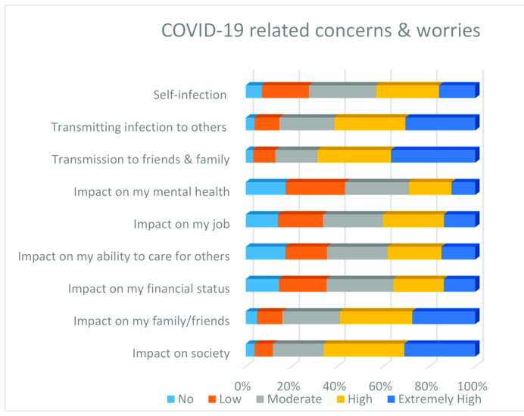  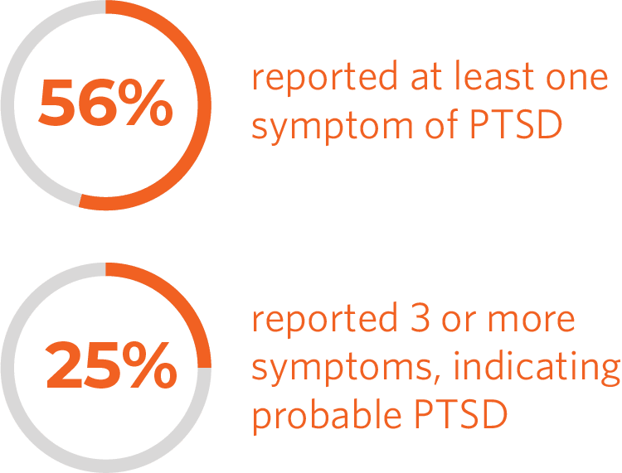  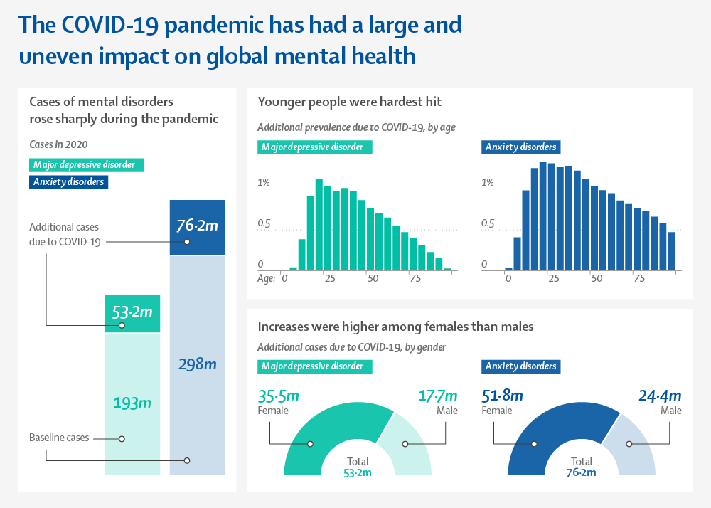  This section presents graphs and tables for visualizing post-COVID-19 PTSD prevalence and risk factors among health workers. These aids aid in identifying data patterns, supporting statistical analysis, and identifying variables and demographics needing further focus, ensuring simple, evidence-driven insights.  (debeaumont, 2022); (Yoch & Sirull, 2021); (Pappa, et al., 2021)
05 Research Validation and Analysis
Validation confirms that the dissertation is based upon reliable research, and analysis aids in finding key variables upon which to base conclusions. This can include a review of peer study performance, fact-checking, along with an evaluation of the quality of the research.

06 Inclusion Criteria  - Studies published within the last 10 years (2013-2023).  - UK-Focused  - Full Online Accessibility  - Sources considered were peer-reviewed to ensure that the credibility and accuracy of the paper are upheld.  - Related to Healthcare & PTSD  - Focused on studies that dealt with PTSD, mental health, and how COVID-19 has affected healthcare professionals. | 07 Exclusion Criteria  - Research conducted outside of the UK was excluded based on relevance to the UK healthcare system.  - Inaccessible Articles  - Sources that are non-peer-reviewed will be eliminated, as only credible and accurate sources should be used.  - Irrelevant Focus  - Studies not focused on PTSD, COVID-19, and healthcare workers.
08 Ethical Considerations
Proper citation and acknowledgement of all sources to avoid plagiarism. | Transmissions in the course of research, and maintaining the confidential nature of personal data derived from secondary sources. | The researcher utilizes sufficient, reliable, and valid data sources by way of truthful presentation of research findings. | Adhering to all institutional policies and legal requirements applicable to the research.

09 Additional Information
- Sources in this study have been evaluated by several important steps:

- Peer-Reviewed sources: Included are only those articles published in peer-reviewed journals so that scrutiny by experts is ascertained regarding the data presented.
- Recent and relevant studies: The review focused on studies published within the last decade so as to take into account current trends, specifically in regard to the COVID-19 pandemic.
- Credibility of source: Evaluated the reputation of journals and the publishers associated therewith, giving more emphasis to well-established platforms like PubMed, JSTOR, and Google Scholar.
- Data accuracy: Verification of whether the data presented is credible by analysis that involves consistent findings from studies and cross-referencing of results to ensure any bias is identified.
- Comprehensive analysis: Critically evaluated research methods to determine whether biases were mitigated, sample sizes were adequate, and the conclusions were statistically valid.

- Respect for information about mental health:

- The applied studies were ensured to be according to data protection laws such as the General Data Protection Regulation of the UK.
- Adhered to the UWTSD Harvard Referencing Guidelines and BPS ethical guidelines on doing secondary research involving issues of mental health.
- Prioritized sources that had done an ethical review, ensuring that the research methods they used were within the bounds of consent and confidentiality for participants.
- Acknowledged that data on PTSD is emotionally touching for health workers; therefore focused on studies that handle sensitive topics with empathy and tact.
- Evaluated sources on the ethical and empathetic handling and reporting of sensitive findings.

References

Bocanegra-Valle, A., 2017. How credible are open access emerging journals. Publishing Research in English as an Additional Language. p. 121.
Dalati, S. & Gómez, J. M., 2018. Surveys and questionnaires. Modernizing the Academic Teaching and Research Environment. Methodologies and Cases in Business Research, pp. 175-186.
debeaumont, 2022. https://debeaumont.org. [Online]
Available at: https://debeaumont.org/news/2022/new-ph-wins-data-de-beaumont-and-astho-find-that-public-health-workers-are-stressed-burned-out-and-considering-leaving/
Pappa, . S., Athanasiou, . N., Sakkas , N. & Patrinos , S., 2021. From Recession to Depression? Prevalence and Correlates of Depression, Anxiety, Traumatic Stress and Burnout in Healthcare Workers during the COVID-19 Pandemic in Greece: A Multi-Center, Cross-Sectional Study. International Journal of Environmental Research and Public Health.
Sobočan, A., Bertotti, T. & Strom-Gottfried, . K., 2019. Ethical considerations in social work research. European Journal of Social Work, Volume 22(5), pp. 805-818.
Stansfield, C., 2018. Exploring search strategy design to identify diverse literature for inclusion in systematic reviews. (Doctoral dissertation, UCL (University College London).
Yoch, M. & Sirull, R., 2021. https://www.healthdata.org. [Online]
Available at: https://www.healthdata.org/news-events/insights-blog/acting-data/new-global-burden-disease-analyses-show-depression-and

