James Dunhill (1800349)
1800349@student.uwtsd.ac.uk
Enterprise & Innovation
Eceipt - Group Project


Enterprise & Innovation - Team Eceipt
Abstract 3
Introduction 3
Creation 4
Ideation 4
Illustration 4
Database Design 4
Design 5
Design Documentation 5
Wireframe diagrams 5
MVP 5
Requirements 6
Differentiation 6
Development 6
Stages of Development 6
Key Features 7
Evidence 7
Database 8
Code 9
Website Design 10
File Structure 12
Conclusion 13
Reference 13
Appendix 16
Reflection 16
Networking Events 16
Emails 17
From: Alexandra Frean <alexandra.frean@starlingbank.com> Sent: 04 March 2020 18:07 To: James Dunhill (1800349) <1800349@student.uwtsd.ac.uk> Subject: Re: Recent Phone Call - University Project 17
From: Alexandra Frean <alexandra.frean@starlingbank.com> Sent: 04 March 2020 17:41 To: James Dunhill (1800349) <1800349@student.uwtsd.ac.uk> Subject: Re: Recent Phone Call - University Project 18
From: Alexandra Frean <alexandra.frean@starlingbank.com> Sent: 04 March 2020 16:45 To: James Dunhill (1800349) <1800349@student.uwtsd.ac.uk> Subject: Re: Recent Phone Call - University Project 19
All Images + Screenshots 35
Code 35
Database 46
Structure 53
Backend 53
Frontend 53
Website 54
Desktop 54

Abstract
Creating and Innovating is what the industry is constantly doing, this report will look in the project of a new way to innovate paper receipts and make them digital, helping the environment, creating new solution for biasness and enterprises. The area of the report talks about the idea in detail and the development processes that followed though its creation.

Starling does not endorse this project.

Introduction
In history there are moment that are viewed as the start, like the growth of the first industrial revolution and how it took from 1760 to 1840 to grow and move on the next stage in advancement to the second industrial revolution. [10, 23] This took 1870 and 1914 to finish and thus move to the digital revolution, this started in the 50s and exploded with high impact across the 70s. Today in the early 20s the start of the next fourth revolution the “connected age”. If you look at the date, each revolution is getting faster and quicker, these are closing the gap between each age, and creating more and better technology than in the past.

The revolution is getting faster and better, but for the project, the idea was to create something that has not had an updated since it was first created. To create something that would bring multiple benefits to the user, and the operators. Using goals to create a road map that users can follow and join in with along the way.

This project is about updating the way consumers and business deal with receipts to create Eceipt a digital frontier with dealing in paper receipts.

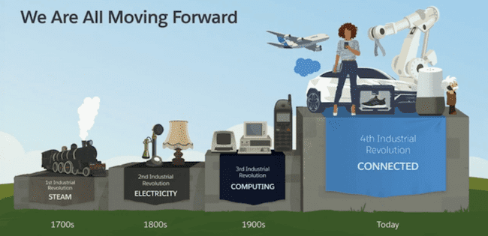
(Figure 1) - (Source: Salesforce) - (Image show progression though each revolution)

They created the idea over the space of 2 years, and how it works is like this, at the end of a customer shopping a receipt is presented to the customer once the items have been purchased. This paper receipt is old and outdate, also very bad for the environment. Eceipt is designed to make receipts digital, it would take a copy of the receipts you have and store it on your bank app though open banking capabilities.

Creation

Ideation
Like mentioned in the introduction this idea would work on taking physical receipts and making them into digital receipts that are stored in the user’s bank account.

How this would work in simple terms: Make a purchase at a shop or online with any card you that is parented bank, link it with Eceipt service, once that is done make a purchase from a partner shop. This will then record the transaction with a copy of the receipt and log it into the user account, you will be able to see the Eceipt from the user account that was need to be created with Eceipt or the user is able to access the bank account and check from there (third-party area).

Illustration

Database Design
This was a design of the database; this was designed in a real MYSQL environment to simulate the design for speed and also to allow the team member that was working to have quick access to development. [15]
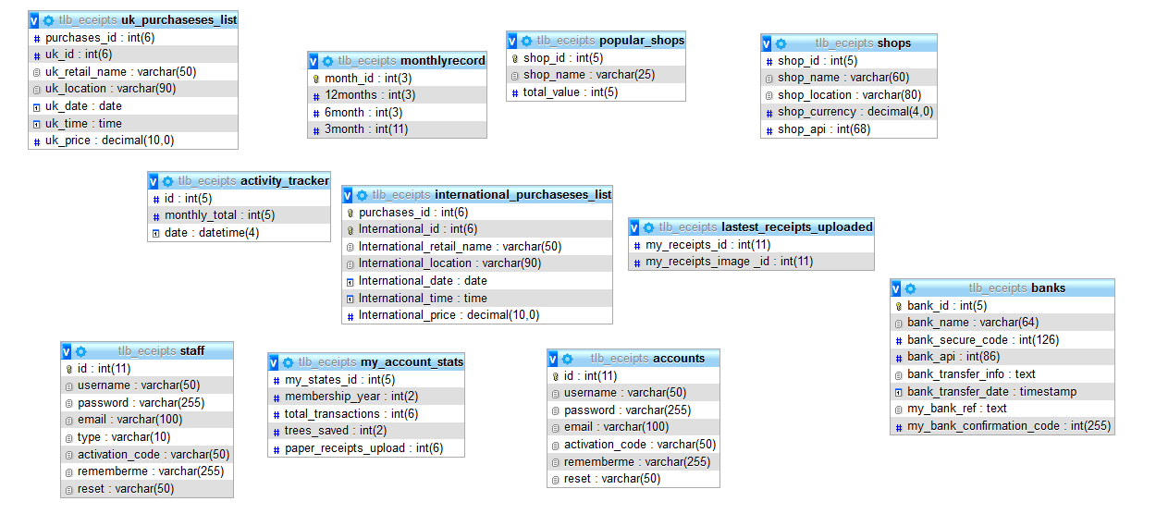
Website Design

Latest.php
Scan.php
Home.php
Login.php
Aboutus.html
Contact.html
Banks.html
News.html
Index.html

Design

Design Documentation

Wireframe diagrams
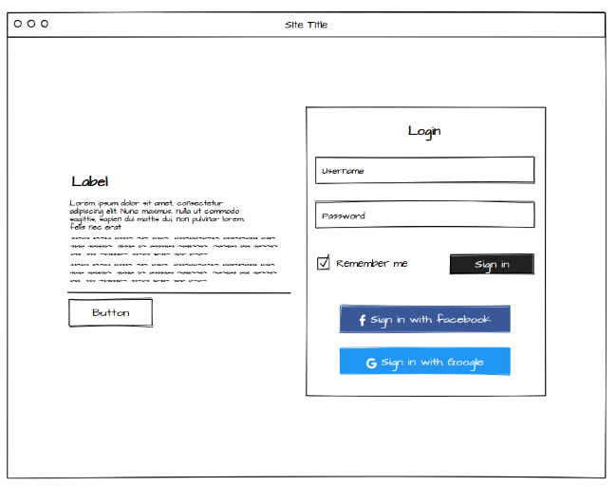
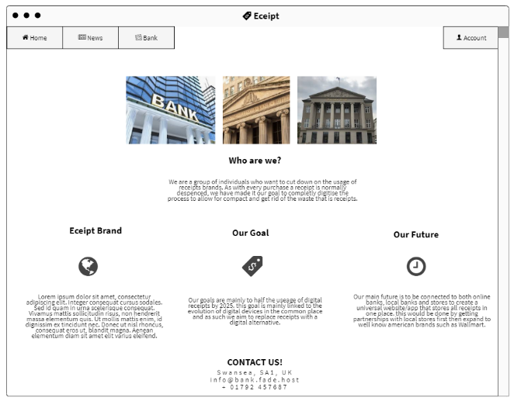

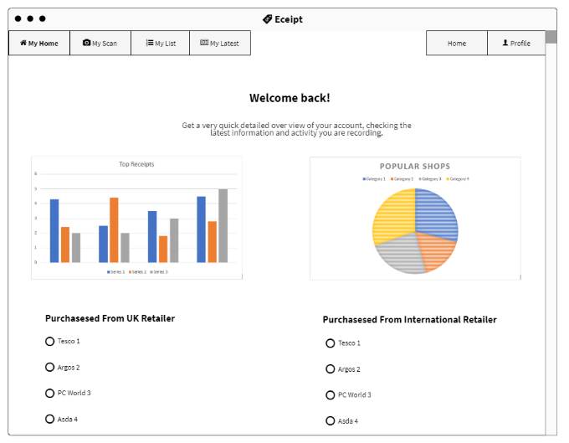
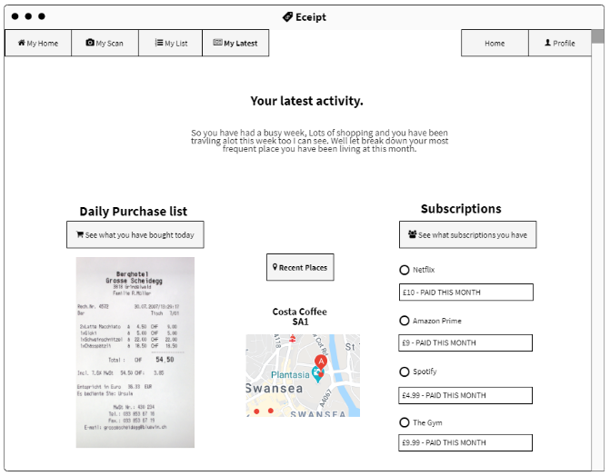
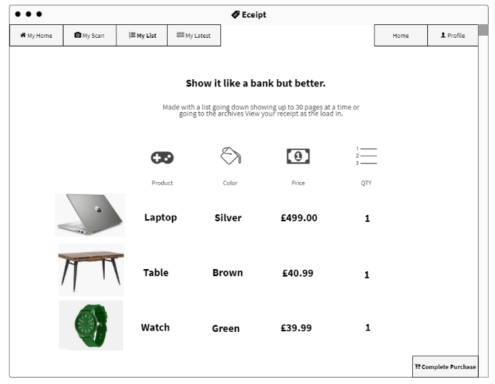
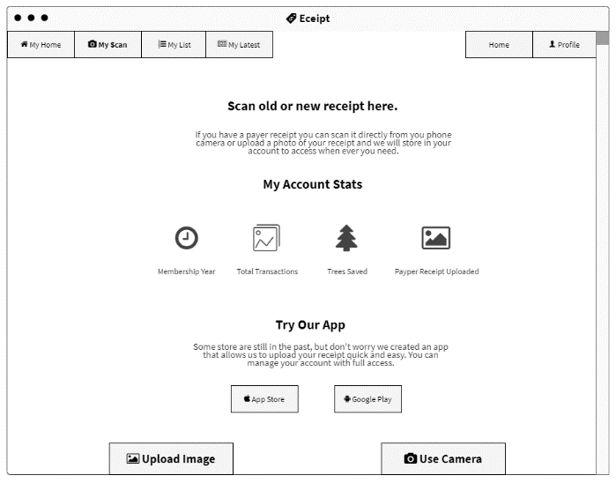
(Images 1 – 6 created by team member Aida) – (Images show design layout in the mocks before development)

MVP
[16, 17] Eceipt is a large project, that needs more time to have fully working by the project’s deadline, but to able to give to a user at its current state would not be ideal, as it would not be functionating correctly, causing impacted on the user experience. The problems lie with in the backend of the website and the database, these areas are not connected, with trying to find time and team availability to understand the errors.

However, the front end of the website is done, and the backend of the user control panel is created. Time and skill these could be accomplished.

Requirements
The requirement to use this project is restricted to new mobile only banks as listed below: [12,13,1
- Starling
- Monzo
- Revolt
Once a user has account with one of these banks then there will be able to navigate to the user marketplace and sign up for Eceipt within the banking app. Once all the sign up is done the user will be able to store their receipts in there banking app.

Differentiation
[18] When looking into the market, there was only a handful of company’s out there that was offering the same services as Eceipt. This made it easy to find the USP, the first-place area was biasness and enterprise, and the second place was the environment. [19] Yes, some companies have talk about the environment but Eceipt shows the user how they are saving the plant with small updates and info bit in the user control panel.

Biasness’s won’t need to have paper invoices anymore, all company card payment will be track and sent to the accounting department date, time, location and amount. This will save company time and money, Sales reps that travel, use company’s cards to pay for hotel, fuel and food. All the receipts must be kept safe, Eceipt remove that by having them all tracked to the company’s account. This will also prevent any illegal account too they could take place.

Development
The development of this project has been built in stages, each stage follows the next layer of development and task to complete. This has been broken down in to 3 section, timeline of development, Key features of the Product, and evidence with screenshots.

Stages of Development
Stages | Dates | Task 1 | Task 2 | Task 3 | Task 4
Stage One | 06/11/2019 – 20/11/2019 | Initial Meeting | Market research | Team Activity Recorded
Stage Two | 27/11/2019 – 18/12/2019 | Mock Designs | Mock Prototype | Team Meeting | Contact Banks
Stage Three | 03/01/2020 – 30/01/2020 | Start creating artwork and designs | Start Building the Database | Start Building Frontend of the Website | Start Building Backend of the Website
Stage Four | 01/02/2020 – 29/03/2020 | Reiteration Meeting on the Design + Layout | Start connecting the database to the website | Start implementing designs into the website
Stage Five | 01/03/2020 – 11/03/2020 | Implementing API access from the banks in to Eceipt systems | Finish off any area that are left

Key Features
- Environmentally Friendly
- Quick access to over 7 year of receipts
- Biasness supported
- Easy for End user
- Seamless bank integration

Evidence
Screenshot have been taken, of the development. All the screenshot that are not used is this section can be found in the appendixes.

Database
The database was created in a MySQL software, it was kept on the local server for security and can only be accessed from internal use. This was created over a week with design being made to help the build and document the implantation, the follow screenshot is taken from the database.

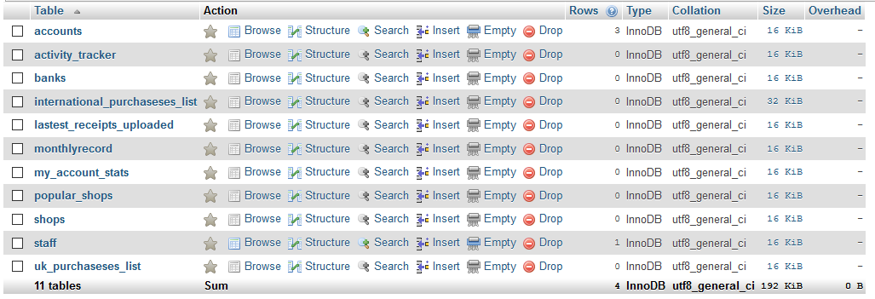
This screenshot is taken as the overview as all the website, it shows all the tables.
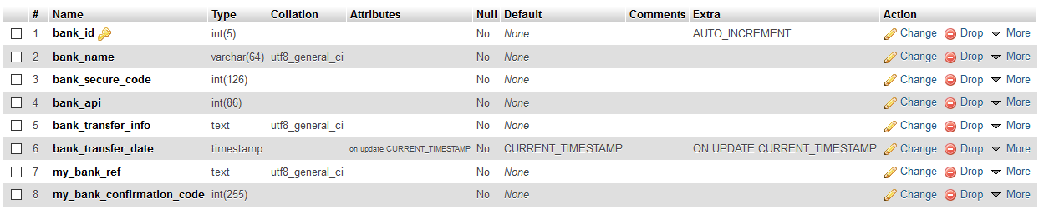
This show how the data would be used to store the bank data and store customer data that bank would need from this table.
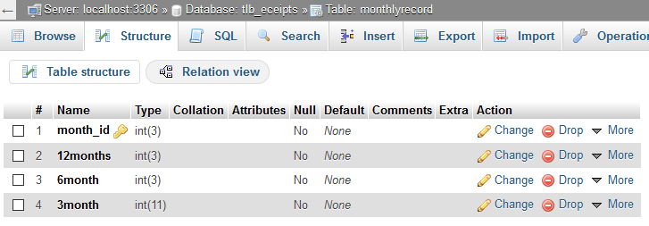
Monthly data for the user, Code would update the tables every 3, 6 and 12 months.
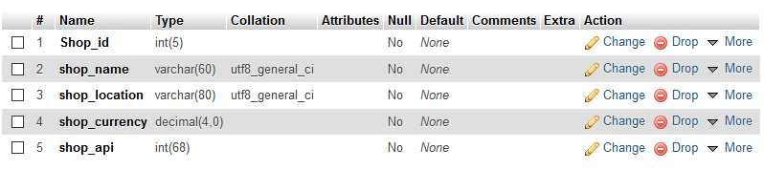
Create a database of shops makes it easy when needing to reference the shop that user purchased an item at so this would store all the information about the shops and pull it up in a quarrel when a user makes a purchase.

Code
The backend of the code took more time than other parts and was never able to be completed by the deadline.
Some tools and frameworks was used to create and help make this project. [1,2,3,4,5,6,7] This are the bootstrap for the framework to help speed up time and also the use of adobe products to help with the creation of graphics.
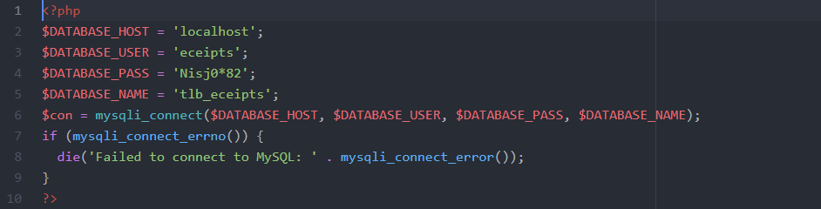
Connection to the database, allow for user to login and check there account details
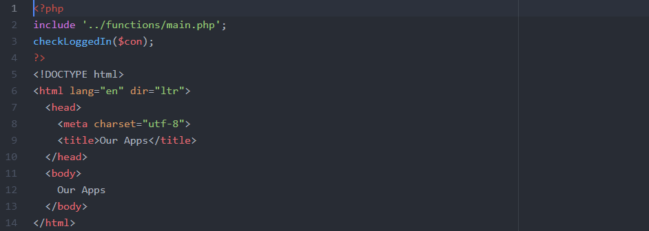
Basic setup for a page setup, this check to make sure the user is logged in with a session.
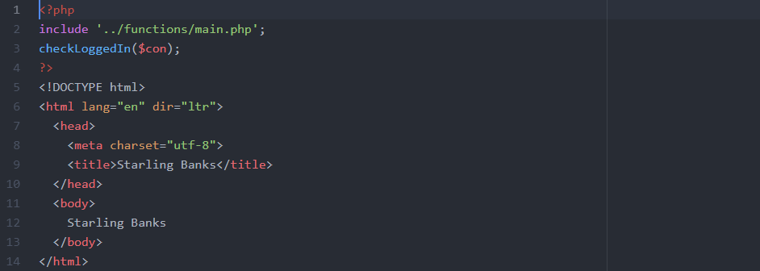
Bank page would have information about how to link with that bank process
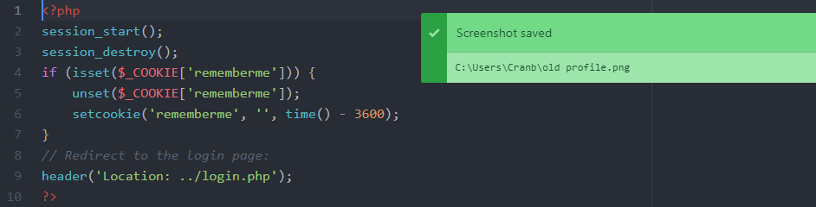
Login out page for user that wish to leave.

Website Design
This is the website finale design; the pages have had gone through a fair amount of development from the original mock designs and

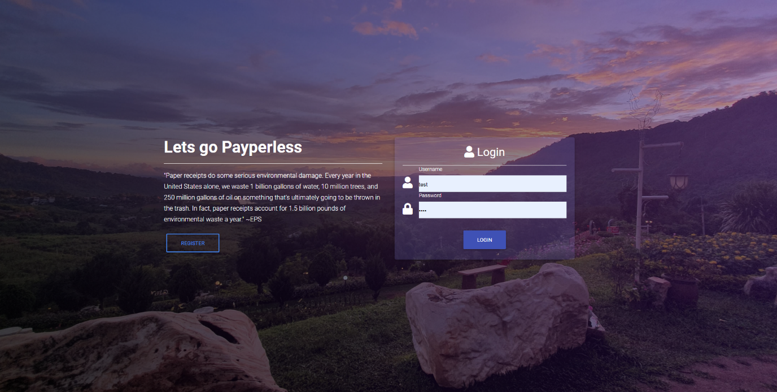
Login screen for used, this was made so the user would login to gain access to their account
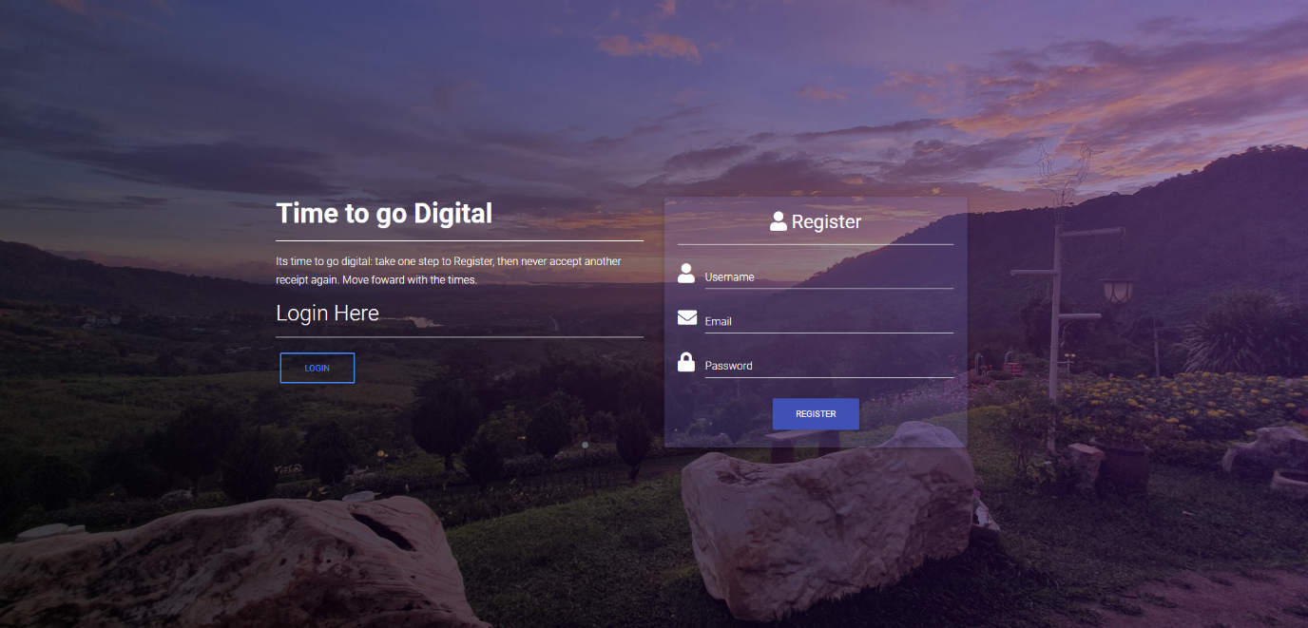
This is the register page,
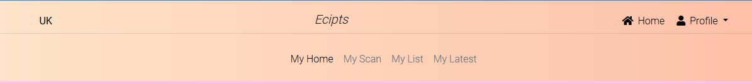
User Navigate to navigate around the website.
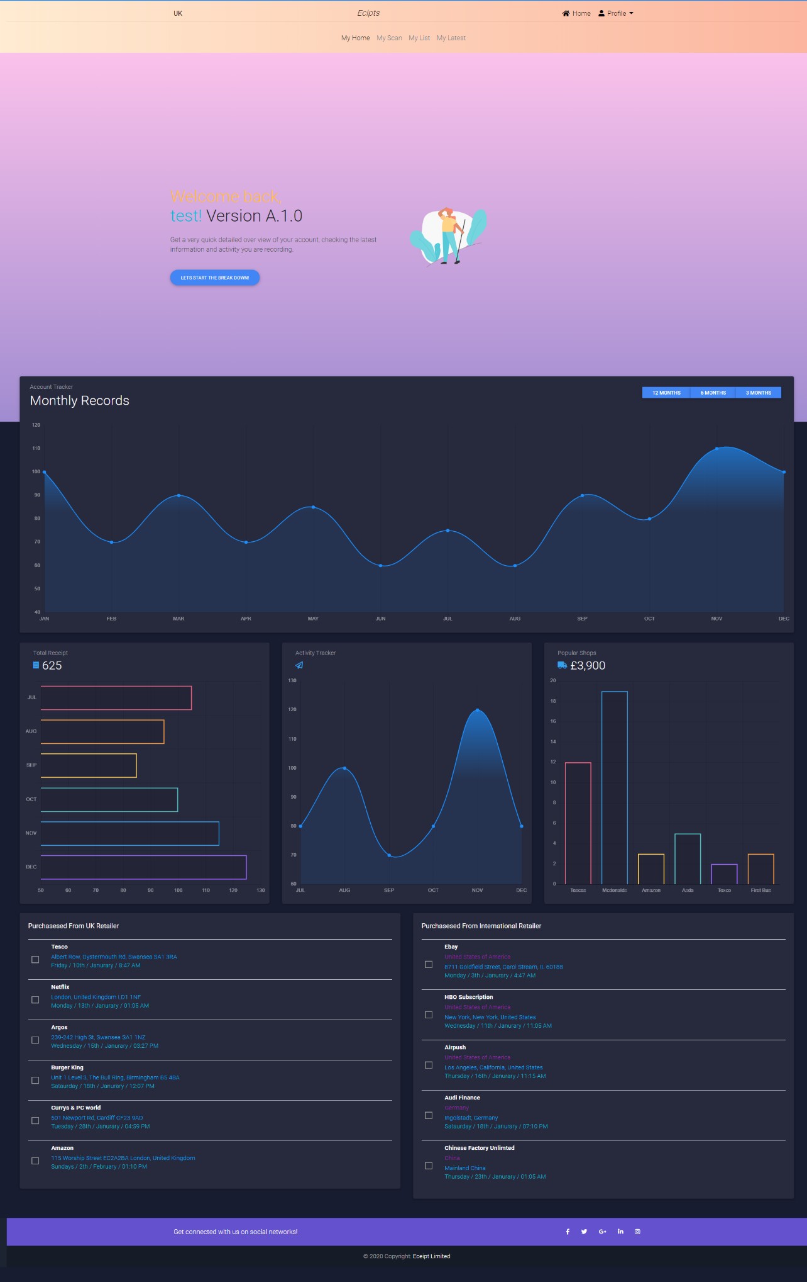
Home show user all the data about their account. This uses data from the database to show how their account is being used.

File Structure
The file sutures for this system was designed for growth and to allow multiply developer to work on this project at the same time the screenshot bellow is taken to show the layout.
Frontend
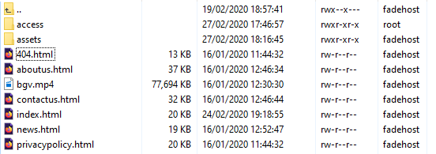
Backend
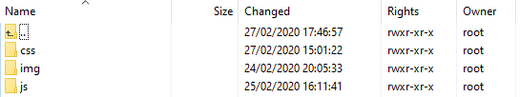
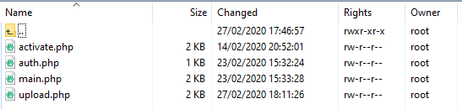
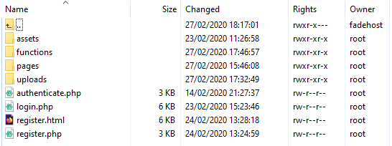
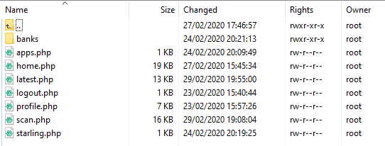

Conclusion
This project has been able to create now paths and also new opportunity, learn paths and maybe job an opportunity, Lots of skills in computing and business has been developed over these last few months and now this team should be able to stand better with the skills set that has been acquired from all the hard work. Plenty of problems have been had and plenty have been fixed, as a team you get learn how to deal with these problems from a more professional stand. This team failed this at time but learned how to overcome this on the next problem and was able to handle this better.

Overall the team has learned to be better and overcome all its problems and to come to gather and finish and present this project with the help of starling bank that was nice to donate 5 hoodies to the team. Starling does not endorse this project in anyways.

[20, 21, 22]

Reference
[1]
M. Otto, “Bootstrap,” Getbootstrap.com, 2020. [Online]. Available: https://getbootstrap.com/. [Accessed: 26-Feb-2020].
[2]
mdbootstrap ltd, “Material Design for Bootstrap,” Material Design for Bootstrap, 2013. [Online]. Available: https://mdbootstrap.com/. [Accessed: 26-Feb-2020].
[3]
php.net, “PHP: PHP Manual - Manual,” Php.net, 2020. [Online]. Available: https://www.php.net/manual/en/. [Accessed: 26-Feb-2020].
[4]
w3schools, “PHP Tutorial,” W3schools.com, 2020. [Online]. Available: https://www.w3schools.com/php/. [Accessed: 26-Feb-2020].
[5]
Adobe, “Photoshop apps - desktop, mobile, and tablet | Photoshop.com,” Photoshop.com, 2020. [Online]. Available: https://www.photoshop.com/en. [Accessed: 27-Feb-2020].
[6]
https://www.facebook.com/GitHub, “A hackable text editor for the 21st Century,” Atom, 2020. [Online]. Available: https://atom.io/. [Accessed: 27-Feb-2020].
[7]
winscp, “WinSCP :: Official Site :: Download,” Winscp.net, 2020. [Online]. Available: https://winscp.net/eng/download.php. [Accessed: 27-Feb-2020].
[8]
O. Smith, “In The Hunt For Growth, Digital Banks Are Embracing The High Street,” Forbes, 22-Nov-2018.
[9]
O. Smith, “Starling: The first ‘proper’ digital challenger bank account is here,” Forbes, 22-May-2018.
[10]
History.com Editors, “Industrial Revolution,” HISTORY, Jul-2019. [Online]. Available: https://www.history.com/topics/industrial-revolution/industrial-revolution. [Accessed: 27-Feb-2020].
[11]
“Flux - Receipts that live in your banking app,” Tryflux.com, 2020. [Online]. Available: https://www.tryflux.com/. [Accessed: 28-Feb-2020].
[12]
“Changing banking for good - Starling Bank,” Starling Bank, 2019. [Online]. Available: https://www.starlingbank.com/. [Accessed: 28-Feb-2020].
[13]
“Banking made easy,” Monzo.com, 2020. [Online]. Available: https://monzo.com/. [Accessed: 28-Feb-2020].
[14]
“Revolut - A better way to handle your money,” Revolut.com, 2020. [Online]. Available: https://www.revolut.com/. [Accessed: 28-Feb-2020].
[15]
“MySQL,” Mysql.com, 2020. [Online]. Available: https://www.mysql.com/. [Accessed: 28-Feb-2020].
[16]
“What is a Minimum Viable Product (MVP)? - Definition from Techopedia,” Techopedia.com, 2020. [Online]. Available: https://www.techopedia.com/definition/27809/minimum-viable-product-mvp. [Accessed: 29-Feb-2020].
[17]
“What is a Minimum Viable Product (MVP)?,” Agile Alliance, 27-Jun-2017. [Online]. Available: https://www.agilealliance.org/glossary/mvp/#q=~(infinite~false~filters~(tags~(~’mvp))~searchTerm~’~sort~false~sortDirection~’asc~page~1). [Accessed: 29-Feb-2020].
[18]
M. Rouse, “unique selling point (USP),” WhatIs.com, 2017. [Online]. Available: https://whatis.techtarget.com/definition/unique-selling-point-USP. [Accessed: 29-Feb-2020].
[19]
“Unique Selling Proposition (USP) Definition - Entrepreneur Small Business Encyclopedia,” Entrepreneur, 2020. [Online]. Available: https://www.entrepreneur.com/encyclopedia/unique-selling-proposition-usp. [Accessed: 29-Feb-2020].
[20]
C. Landau, “8 Steps to Starting Your Own Business,” Bplans Blog, 30-Oct-2017. [Online]. Available: https://articles.bplans.com/business-ideas/7-steps-to-starting-your-own-business/. [Accessed: 29-Feb-2020].
[21]
Government Digital Service, “Set up a business,” GOV.UK, 17-Jul-2016. [Online]. Available: https://www.gov.uk/set-up-business. [Accessed: 1-Mar-2020].
[22]
J. Rampton, “50 Signs You Need to Start Your Own Business,” Entrepreneur, 11-Mar-2019. [Online]. Available: https://www.entrepreneur.com/slideshow/299775. [Accessed: 12-Mar-2020].
[23]
N. Johnson, “What Is the Fourth Industrial Revolution?,” Salesforce Blog, 2018. [Online]. Available: https://www.salesforce.com/blog/2018/12/what-is-the-fourth-industrial-revolution-4IR.html. [Accessed: 12-Mar-2020].
[24]
L. Videnova, “The DVLA Botathon - Notbinary,” Notbinary.co.uk, 19-Nov-2019. [Online]. Available: https://notbinary.co.uk/the-dvla-botathon/. [Accessed: 12-Mar-2020].

Appendix

Reflection
Skill that been gained though out this project have been vast, new skills have been learned but also skill have been improved upon:
Team working – Having to work with a team, make you must be able to delegate your time, communication and to be able to problem solve any problem that team are struggles with.
Time Management – Being able to keep a record of deadlines and team activity
Laws – There are a lot of laws to understand, and having a better knowledge of laws that area in the industry
Understanding weaknesses and Strengths – Knowing where my strength is but also knowing where my limitations are too.
Communication skill – Having to talk to the team and company’s over email and phone has greatly improved my communication skill set

Networking Events
All events can be found in the zip folder, it will contain screenshot of events I was in for proof of attending.

DVLA Hackathon – November 2019
This event offered opportunities to meet industry professionals and collaborate in a hack phone by creating bots. Over a two-day event of enjoyment and frustration moment a lot of skills was learned and potentially connections have been made through networking.
the team that was entered did not win or have a working bot like most of the other teams, but a good understanding of skills and new areas to research into was benefited for the entire team has everyone had a chance to figure out new areas that they are lacking in or want to develop skilled in.
[24]

AWS Networking Event Cardiff – 20/11/2019
The a WS networking event in Cardiff allowed for networking between fellow networks and cyber security industries and professionals they are currently working. A lot of the night was talking about new technologies and further development in underrated areas that a WS systems offer with guest lectures talking about these areas opened opportunities and understanding about certifications that industries are now asking for that use Amazon Web Services.

These events have not been attended to but have been registered to go and visit. All information about the upcoming events can be found in an attached document uploaded.
- AWS Networking Event Swansea – 24/11/2020
- Cyber Security Expo Bristol – 02/04/2020

Emails
Email Convocation with Alexandra Frean from Starling Bank.

This is brilliant, as I will be in Cardiff on Monday, so will be able to pick them up.
I’ll send you a text message,
Thank you so much.

Best Regards,
James

From: Alexandra Frean <alexandra.frean@starlingbank.com>
Sent: 04 March 2020 18:07
To: James Dunhill (1800349) <1800349@student.uwtsd.ac.uk>
Subject: Re: Recent Phone Call - University Project

Right - I'm in Cardiff on Monday and will put the hoodies aside for you to pick up from reception when you can. The office is Brunel House, Fitzalan Road, Cardiff, CF24 0EB.
If you send me a text message around midday on Monday, I'm more likely to remember.
Best,
Alex

Alexandra frean
Head of corporate affairs
STARLING BANK
+44 7973 668363
Download from App Store or Google Play and apply for an account in minutes.
We’re hiring - click here to discover more.
Starling Bank is registered in England and Wales as Starling Bank Limited (No.09092149), 3rd floor, 2 Finsbury Avenue, London, EC2M 2PP. We are authorised by the Prudential Regulation Authority and regulated by the Financial Conduct Authority and the Prudential Regulation Authority under registration number 730166. Starling Bank Limited is a member of the Financial Services Compensation Scheme and the Financial Ombudsman Service

On Wed, 4 Mar 2020 at 17:56, James Dunhill (1800349) <1800349@student.uwtsd.ac.uk> wrote:
I am based in Swansea but travel to Cardiff a few time a month so I would have no problem picking them up and the presentation would be held on the 26th of march.

I fully understand that you are not endorsing our project and will put a disclaimer on the presentation and also on the website.

Best Regards,
James Dunhill

From: Alexandra Frean <alexandra.frean@starlingbank.com>
Sent: 04 March 2020 17:41
To: James Dunhill (1800349) <1800349@student.uwtsd.ac.uk>
Subject: Re: Recent Phone Call - University Project

I'll see what I can do with the hoodies. Are any of you based in Cardiff - we have an office there and maybe you might be able to pick them up from there. When do you need them by?
You will have to make clear that Starling is not endorsing your project, so I need an assurance that you will explicitly make it clear in the presentation.
Alex

Alexandra frean
Head of corporate affairs
STARLING BANK
+44 7973 668363
Download from App Store or Google Play and apply for an account in minutes.
We’re hiring - click here to discover more.
Starling Bank is registered in England and Wales as Starling Bank Limited (No.09092149), 3rd floor, 2 Finsbury Avenue, London, EC2M 2PP. We are authorised by the Prudential Regulation Authority and regulated by the Financial Conduct Authority and the Prudential Regulation Authority under registration number 730166. Starling Bank Limited is a member of the Financial Services Compensation Scheme and the Financial Ombudsman Service

On Wed, 4 Mar 2020 at 16:53, James Dunhill (1800349) <1800349@student.uwtsd.ac.uk> wrote:
Hello Alex,
Thank you or the fast response,

The presentation is to a panel of judges that are from the university and also some tech sponsors.

Hoodies sizes if possible,
1 2XL
2 Large
2 Mediums

Best Regards,
James

From: Alexandra Frean <alexandra.frean@starlingbank.com>
Sent: 04 March 2020 16:45
To: James Dunhill (1800349) <1800349@student.uwtsd.ac.uk>
Subject: Re: Recent Phone Call - University Project

Hello James,
Who is the presentation to? What size hoodies do you need?
Best,
Alex

Alexandra frean
Head of corporate affairs
STARLING BANK
+44 7973 668363
Download from App Store or Google Play and apply for an account in minutes.
We’re hiring - click here to discover more.
Starling Bank is registered in England and Wales as Starling Bank Limited (No.09092149), 3rd floor, 2 Finsbury Avenue, London, EC2M 2PP. We are authorised by the Prudential Regulation Authority and regulated by the Financial Conduct Authority and the Prudential Regulation Authority under registration number 730166. Starling Bank Limited is a member of the Financial Services Compensation Scheme and the Financial Ombudsman Service

On Wed, 4 Mar 2020 at 16:31, James Dunhill (1800349) <1800349@student.uwtsd.ac.uk> wrote:
Dear Alexandra,

Thank you for the phone call early today, it was lovely to talk with you.

My name is James Dunhill, I am 22 years old and really love starling bank.

Am the moment I am in my second year of studying with the University of Wales Trinity Saint David (UWTSD), for my degree in Networking and Cybersecurity.
On the second year of our course we have a module called Enterprise & Innovation, I have attached some link below to give you some more insight to this module/ competition.
https://uwtsd.ac.uk/wisa/competition/

The consumer sector
This Idea was originally created by myself, and taken forward by the team. The idea was to create digital receipts and storing them as a addon though starling marketplace, to which user would be able to access at any time a digital copy of their receipts, this could then be processed in to a graph form to represents spending on individual category’s and display weekly, monthly and yearly spending trends.

The business sector
Our idea for company with field personal to be able to use to use there company starling card with receipt option built-in, this would have predefined limits in certain area i.e. Fuel, Accommodation and daily allowance of food. These item would normally take 6 to 8 weeks to arrive at the accounts department, where our concept would make this instant and any discrepancies could be taken up straight away. The benefit for company and personal are faster financial reporting, less paperwork time for employees and would also help company’s reduce waste and hit there environmental targets.
The whole system will prevent fraud as from the employee making the purchases, to entering the company accounts could be untouched by human hand.

The team is comprised of 5 members, to which 3 members are male and 2 are female. This was done to make the team stand out with more diversity.
I am the team leader of this project.

We started to creating a website to create the concept, I have enclosed a link, with access to the website that I have created,
This is only a brief over view of what we believe can be created at this time from our skill level, as we are not developers but more networks and security based student.
But I believe the concept, has a great future as the banks integrate more with consumer spending on the high street and online

We are doing our presentation on the 26th of march In Swansea IQ waterfront campus, and was wondering if there would be a chance of doing our presentation with starling hoodies?

Thank you for taking the time reading my email on our project we hope you find it exciting as we do.

Contact me on +44 07432591708
Student Email: 1800349@student.uwtsd.ac.uk
Personal Email: James@fadein.cc

https://bank.fade.host/access/login.php - This is the website that I have create for concept
Username – test
Password - test
https://www.uwtsd.ac.uk – This is my university website

Best Regards,
James Dunhill

Enterprise and Innovation Project
Team Name: E-ceipts
Team Member Names & Roles: James, Harry, Becky, Connor, Aida.
JD: James Dunhill– Project leader
HB: Harry Byrne- Coding of application and Research
RR: Becky Ryall – Creating front end development of the application and coding
CO: Connor Osborne – Research and Web development
AL: Aida Lamer - Concept Art

Weekly Progress report 1:
Date: 13/11/19
In-Attendance: CO. HB. Absent: JD. RR. AL.
Team Goals:
Initial research
> Individual Updates:
HB Update: Sent emails to Starling and Monzo banks as well as to Visa, Mastercard and Amazon. Awaiting replies.
CO Update: Has written a product questionnaire, awaiting replies.
> Team discussion:
Notes: Discussed the impracticalities in the time frame of linking to banking app and suggested making a standalone app.
> Individual Actions:
CO Actions: Will complete a PEST analysis by next week.
HB Actions: Will carry out competitor analysis by next week.

HB-Competitor’s Name: Flux receipts
> Product Name and brief description:
> Product key features and USP:na
> Product’s Price: na

HB-Competitor’s Name: Smartreceipts
> Product Name and brief description: App based receipt scanner
> Product key features and USP: Uses phone camera to scan receipts then converts into spending reports
> Product’s Price: Free with ads, paid version available. Even released source code

HB-Competitor’s Name: MobileXpense
> Product Name and brief description: Business expense management via receipts
HB-Competitor’s Name: Concur
> Product Name and brief description: Business Expenses control
> Product key features and USP: Improved Compliance/connected travel
> Product’s Price: POA

Weekly Progress report 2:
Date: 20/11/19
In-Attendance: CO. RR. Absent: JD. AL. HB.
Team Goals:
Build ideas
> Individual Updates:
RR Update: researched best way to create application
CO Update: Created charts from questionnaire analysis
> Team discussion:
Notes: Listed the objectives, values and some of the slogans for the tech start-up.
> Individual Actions:
CO Actions: Scribed and discussed tutorial work
RR Actions: Discussed tutorial work

Weekly Progress report 3:
Date: 22/11/19
In-Attendance: CO. HB. RR. Absent: JD. AL.
Team Goals:
Research and presentation
> Individual Updates:
HB Update: Only had email response from visa, with vague points towards their website, and issues with confidentiality.
CO Update: Has been researching business side of the venture.
RR Update: created Gantt chart and looked into android studios for application
> Team discussion:
Notes: Discussed how we will break up initial presentation. Agreed to make just a standalone app with possible integration of smartphone camera to take pictures of receipts.
> Individual Actions:
JD Actions: Write idea part of presentation.
HB Actions: Write marketing part of presentation.
AL Actions: Write business part of presentation.
CO Actions: Write planning and production part of presentation.
RR Actions: Write teamworking and management part of presentation.

Weekly Progress report 4:
Date: 27/11/19
In-Attendance: JD. CO. HB. RR. AL. Absent:
Team Goals:
Produce a professional presentation
> Individual Updates:
HB Update: Working on marketing research, will make weekly progress sheets I attended more concise.
CO Update: Has done diagrams for survey, expanded on pest repot, now started work on PowerPoint presentation.
JD Update: Writing up initial idea, documents will be uploaded to one drive soon.
AL Update: Working on logo, concept art is complete.
RR Update: Working on Gantt chart as well as starting on PERT diagram.

> Team discussion:
Notes: Once again the presentation was the main topic discussed. Discussed delivering concise presentation in allocated time, limited to max 3 minutes per person.
> Individual Actions:
JD Actions: Continue writing idea part of presentation.
HB Actions: Continue writing marketing part of presentation.
AL Actions: Continue writing business part of presentation.
CO Actions: Continue writing planning and production part of presentation.
RR Actions: Continue writing teamworking and management part of presentation.

Weekly Progress report 5:
Date: 29/01/20
In-Attendance: CO. HB. Absent: AL. JD. RR
Team Goals:
Work on final presentation and individual reports. Get working prototype.
> Individual Updates:
HB Update: Working on marketing research, will look into FB and Instagram marketing.
CO Update: Has been doing some website building.

> Team discussion:
Notes: Have broken down the report into individual roles. J.D will cover Ideation and development, A.L Tech start-up. H.B will cover marketing and marketing plan. C.O will cover financial plan and RR will cover management and operations. We will be setting a week in the next month to intensively at getting the prototype working.
> Individual Actions:
JD Actions: Continue research.
HB Actions: Continue research, set up business page on FB and Instagram
AL Actions: Continue work on areas above.
CO Actions: Continue work on areas above.
RR Actions: Continue work on areas above.
Weekly Progress report 6:
Date: 05/02/20
In-Attendance: CO. HB. RR. JD Absent: AL
Team Goals:
Work on final presentation and individual reports. Get working prototype.
> Individual Updates:
HB Update: Apologises for falling behind with group project.
CO Update: Has been doing some website building.
JD Update: Has been working on PHP aspect of website.
RR Update: Apologies for absence due to illness previous week.

> Team discussion:
Notes: Majority of team members now have seen and agreed to aspects delegated out from the main report writing and presentation. Will discuss via WhatsApp group to arrange intense brainstorming sessions in coming weeks to get a working prototype.
> Individual Actions:
JD Actions: Continue research.
HB Actions: Continue research, set up business page on FB and Instagram
RR Actions: Will work on aspect of report and presentation.
CO Actions: Continue work on areas above.

Weekly Progress report 6:
Date: 12/02/20
In-Attendance: CO. RR. JD Absent: AL. HB
Team Goals: Aim to get a fully working project.
> Individual Updates:
CO Update: licked bricks
JD Update: Worked on design and coding of website and main coding.
RR Update: Has worked towards getting front end coding working

> Team discussion.:
Notes:
All efforts for group members who are present are to finalize the coding and design.

> Individual Actions:
JD Actions: work on areas above as well as developing the website.
RR Actions: Will work on front end development for the application.
CO Actions: looking into the finances and cost for the project.

Weekly Progress report 6:
Date: 19/02/20
In-Attendance: CO. RR. JD Absent: AL. HB
Team Goals: To finishing all aspects of the prototype and to have a rough template of the presentation.
> Individual Updates:
CO Update: working on project finances, creating new revenue sources / consistent income thought subscriptions.
JD Update: Creating the foundations of the internal data-structure, for user access to the database.
RR Update: Finalizing the app design and interface, also trying to integrate features for the final app.

> Team discussion:
Notes:
With the continuation of group members being unable to participate, the team has continued to make development progress updates. The team has moved forward with the final stages of the development.

> Individual Actions:
JD Actions: work on areas above
RR Actions: work on areas above
CO Actions: work on areas above

Weekly Progress report 7:
Date: 26/02/20
In-Attendance: CO. AL. JD Absent: RR. HB
Team Goals: To finish all aspects of the prototype and to have a rough template of the presentation.
> Individual Updates:
CO Update: continue project finances, creating new revenue sources / consistent income thought subscriptions.
JD Update: Talking to Starling bank.
AL Update: N/A

> Team discussion:
Notes:
Nothing much was updated in this week, just small updates in team progress.

> Individual Actions:
JD Actions: work on areas above
AL Actions: work on areas above
CO Actions: work on areas above

Weekly Progress report 8:
Date: 04/03/20
In-Attendance: CO. RR. HB. JD Absent: AL
Team Goals: To finish all aspects of the prototype and to have a rough template of the presentation.
> Individual Updates:
CO Update: continue project finances, creating new revenue sources / consistent income thought subscriptions.
JD Update: Starling bank continue.
RR Update: Finishing the app design and integration
HB: Aiming to catch up after illness

> Team discussion:
Notes:
Everyone is getting ready to finish and finish the finale product

> Individual Actions:
JD Actions: work on areas above
AL Actions: work on areas above
CO Actions: work on areas above
HB Actions: work on areas above

Weekly Progress report 9:
Date: 11/03/20
In-Attendance: CO. HB. JD Absent: AL. RR
Team Goals: Check code for glitches and report writing.
> Individual Updates:
CO Update: finishing the finances for the report to then be implemented into the powerpoint.
JD Update: Had meeting with Starling bank, have had promotional Hoodies for presentation given.
HB: Explained may miss the presentation due to ongoing hospital appointments.

> Team discussion:
Notes:
Everyone is getting ready to finish and finish the finale product

> Individual Actions:
JD Actions: work on areas above
CO Actions: work on areas above
HB Actions: work on areas above

All Images + Screenshots

Code
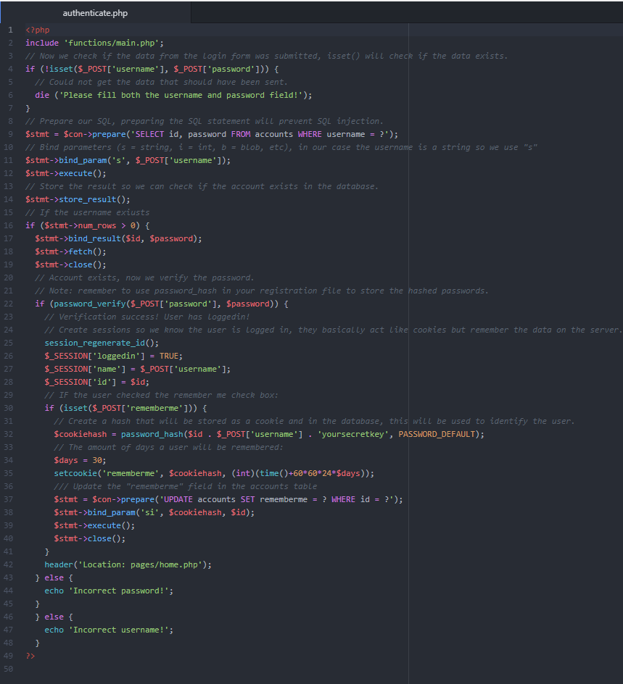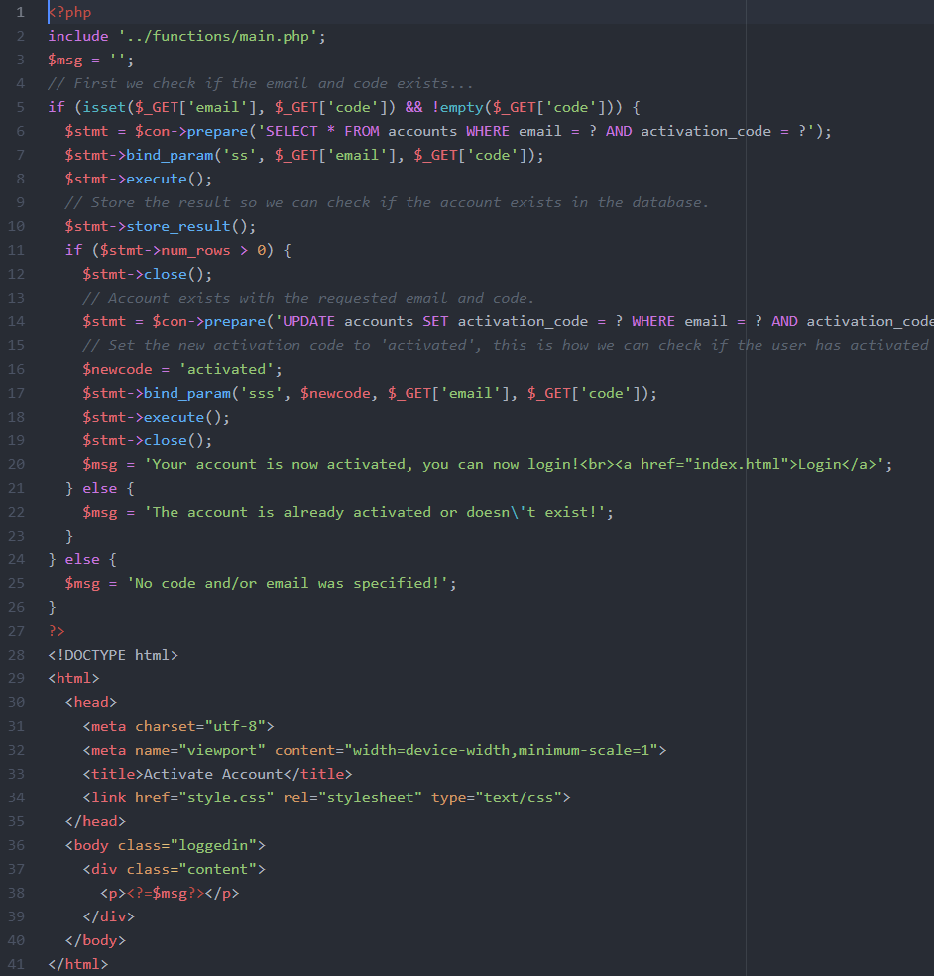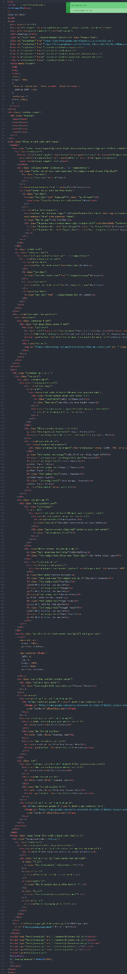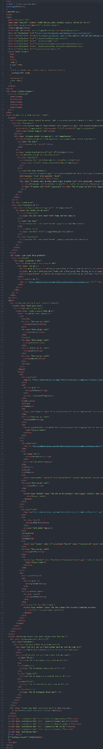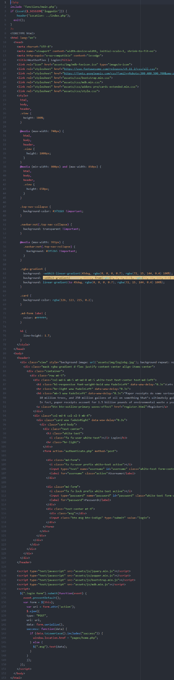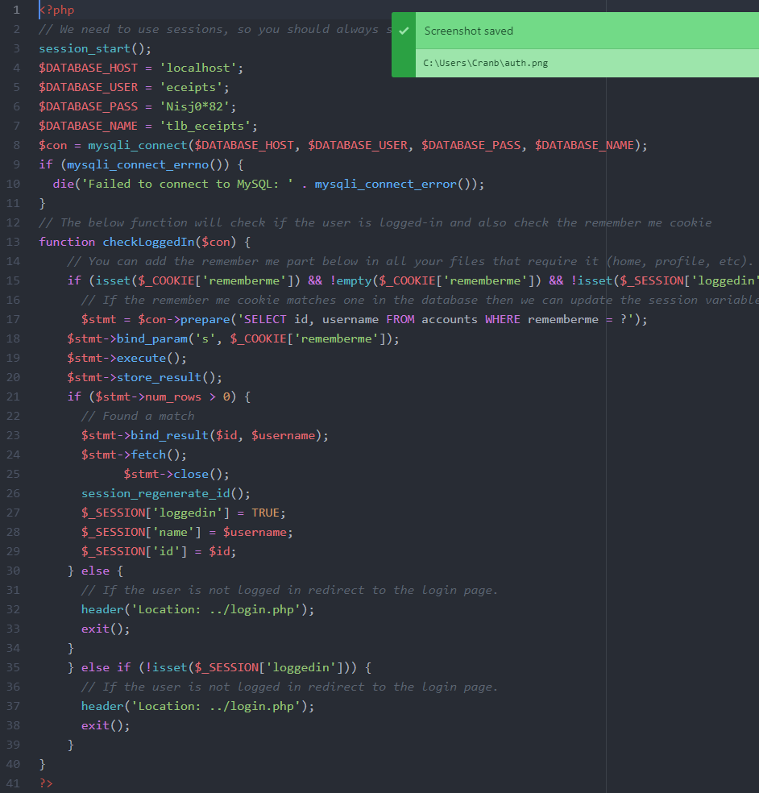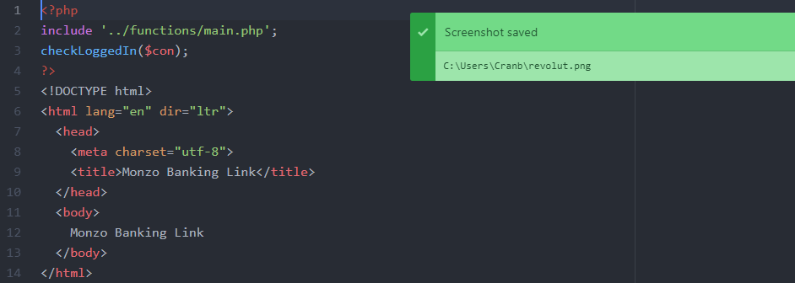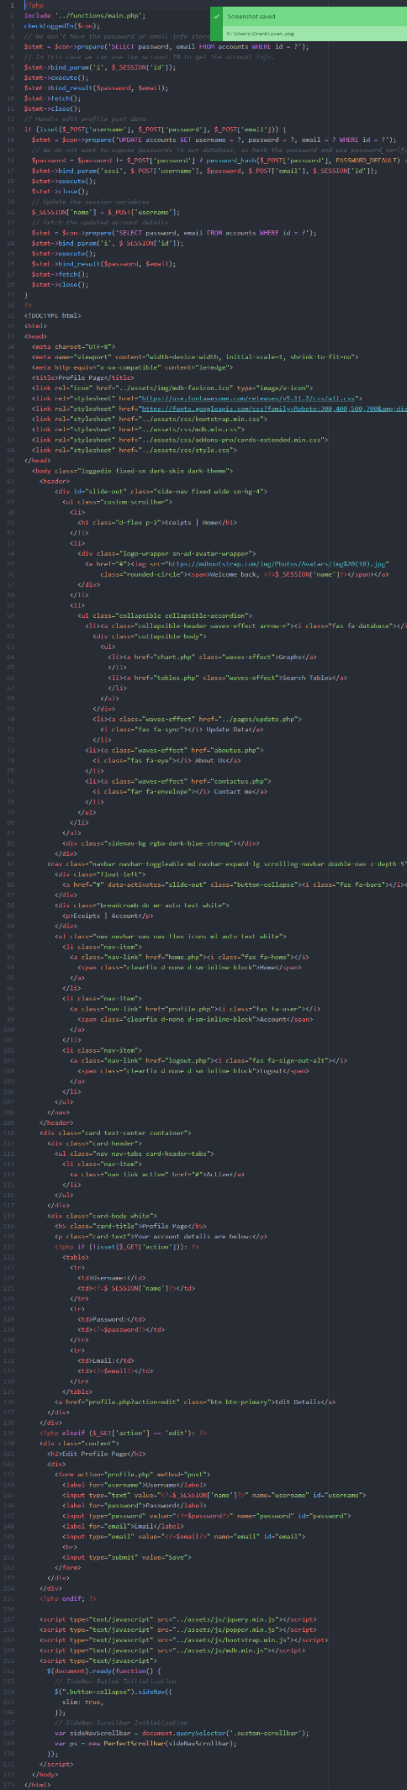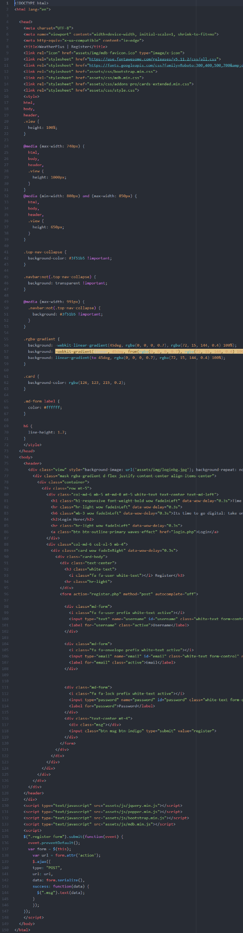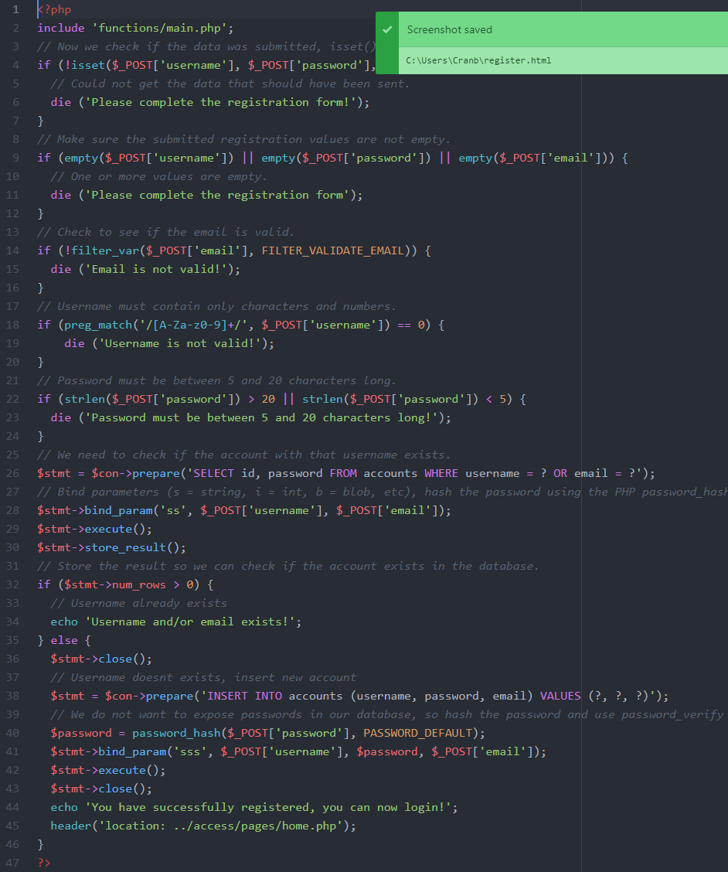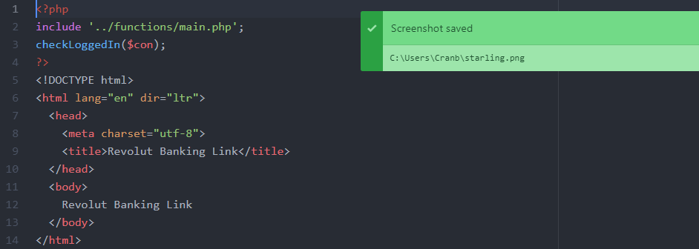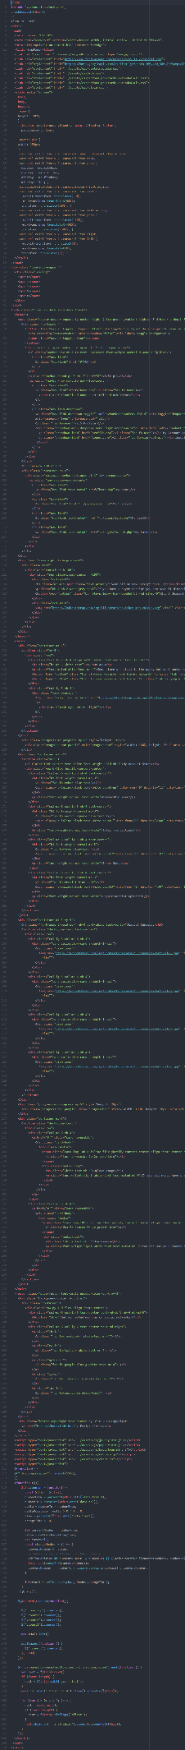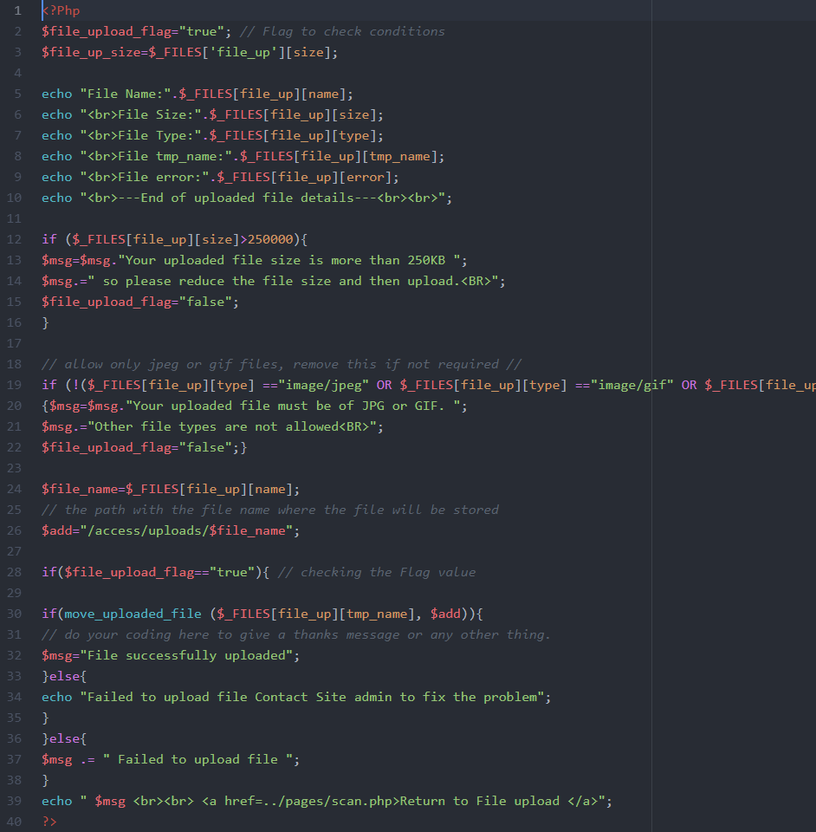

Database
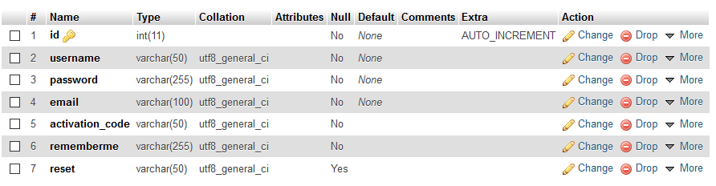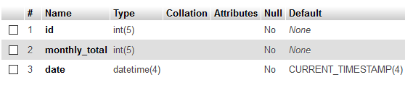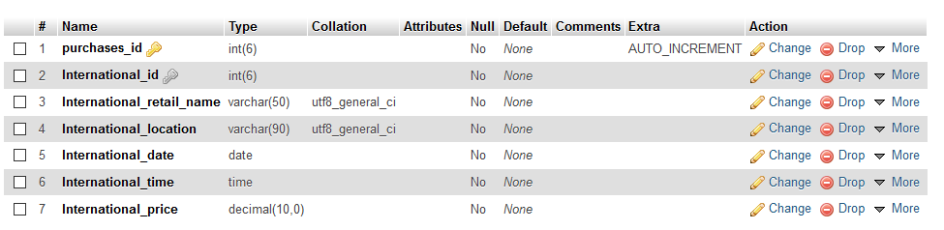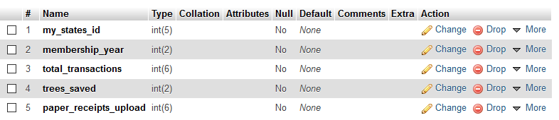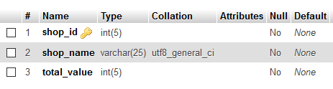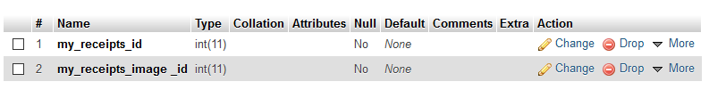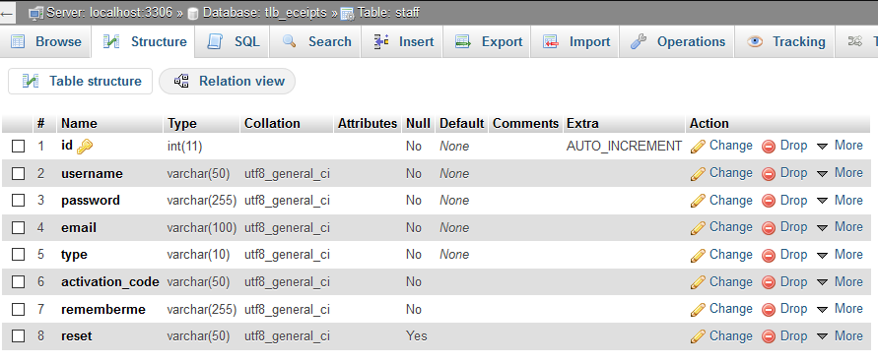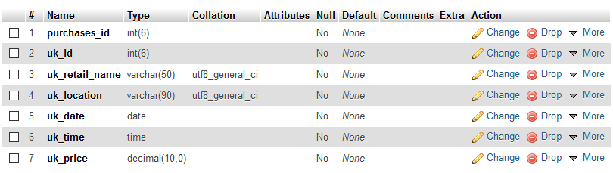

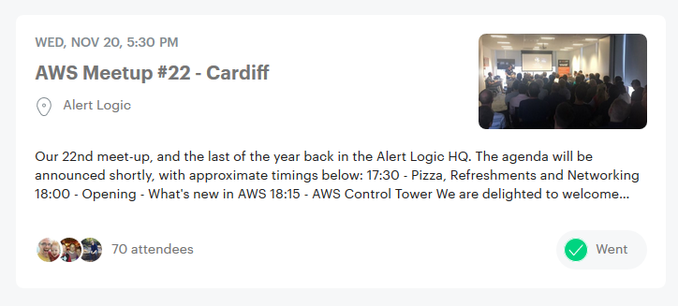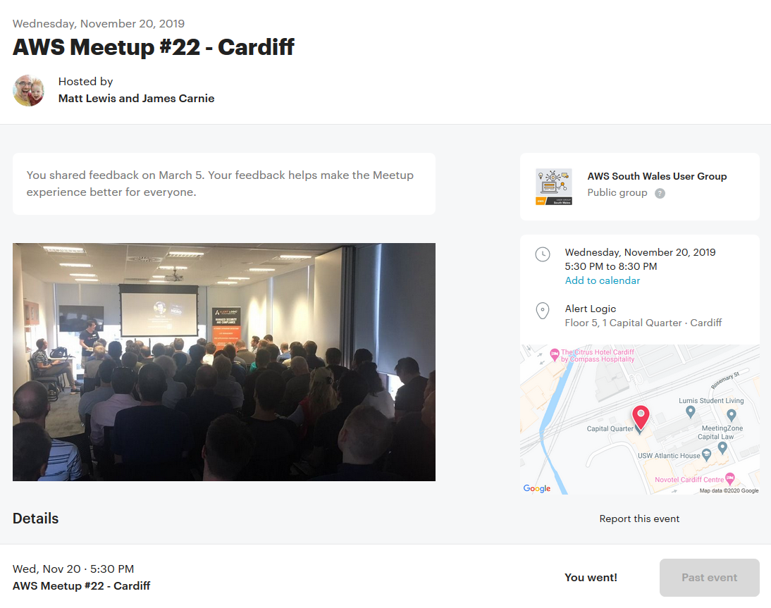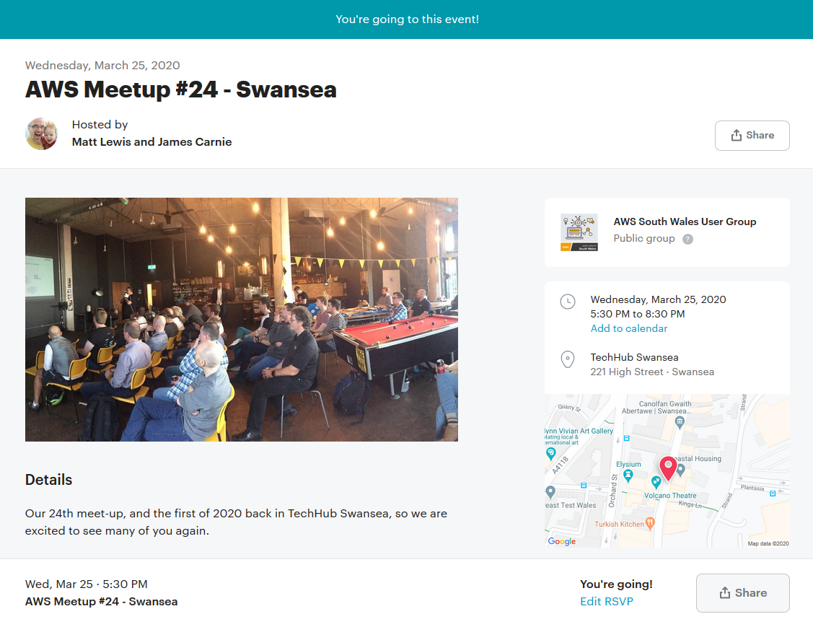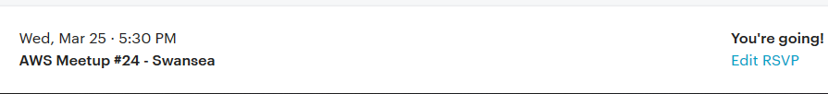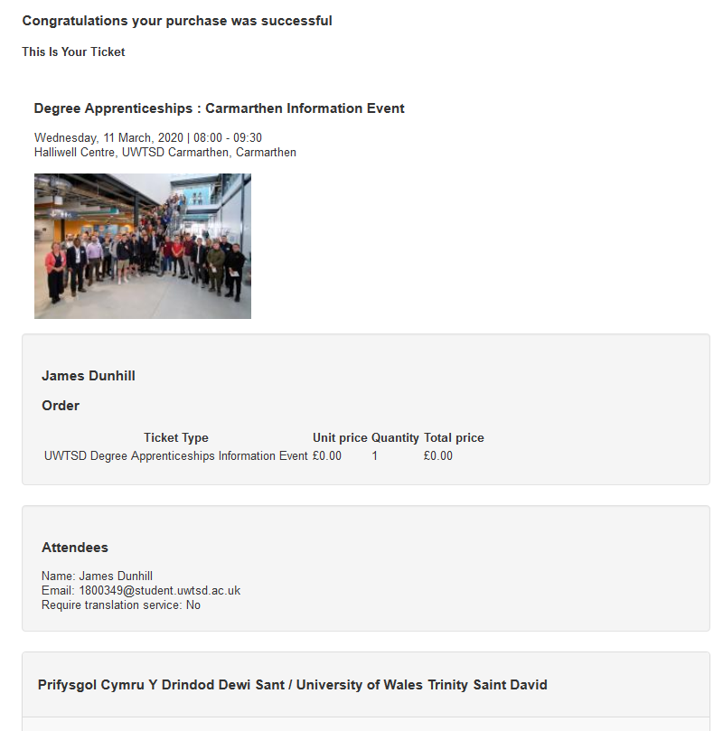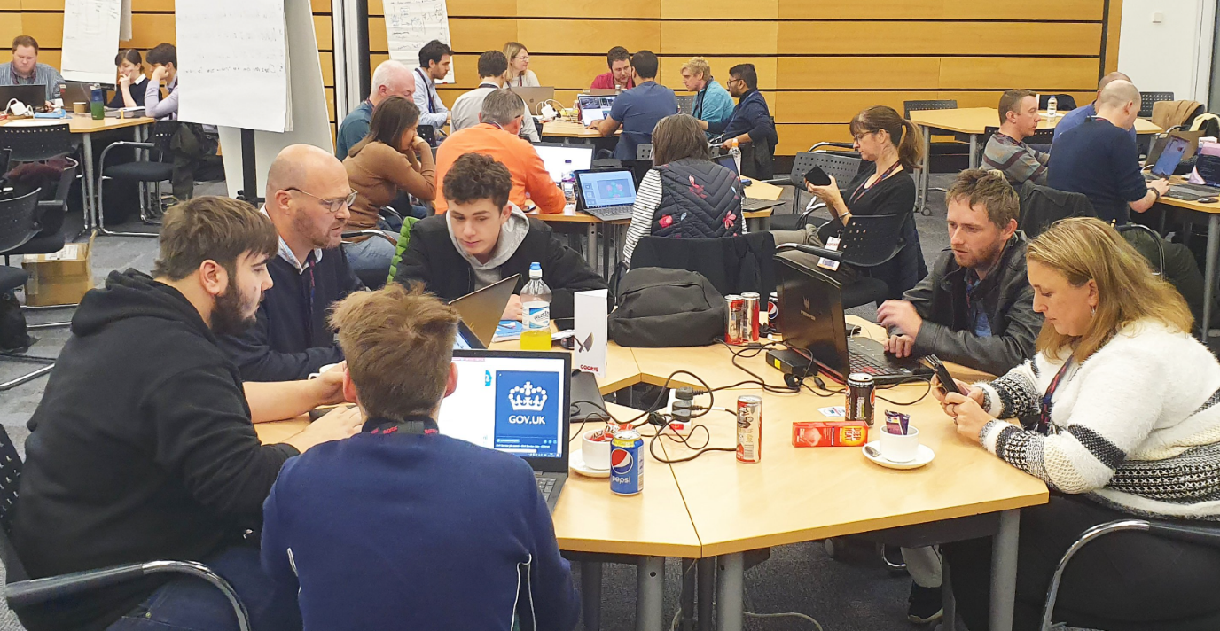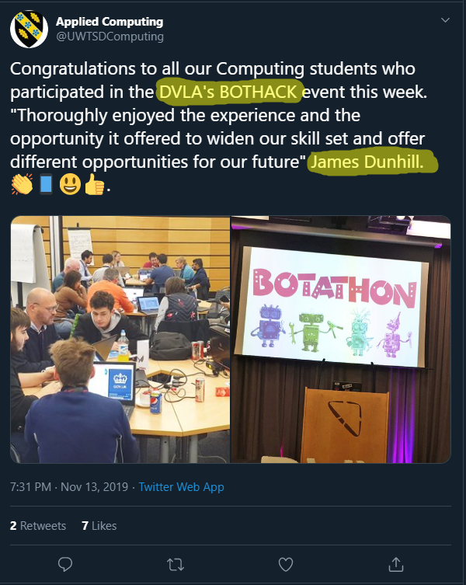

Structure

Backend

Frontend

Website

Desktop


