Catalin Ionel Mirica (1920075)
BUSINESS PLAN
(BMSW4006_CARD)
University of wales triniti saint david
2021
Table of Contents

1.Business name and Legal Identity 2
2. Mission statement/aim and Business Objectives 4
3. Product description and Services 7
4. Physical location and the Equipment required 9
5. Human Resources 12
6. Marketing and PR Strategy 13
7. Financial resources 17
8. SWOT Analysis 18
9. CASH FLOW FORECAST 20
10. REFERENCES 22

1.Business name and Legal Identity

Business name

I chose to name my business Dreamy Ice cream, because first this name gives the idea of a tasteful ice cream and people can enjoy and forget about their problems for a short while and second because this is all about a business that gather al kind of people together to share their love for a delicious ice cream.
Bloonsbuny (2013) p.72 said that the name of a company should be placed outside in a place where every customer should see it being ,,clear, visible and easy readable”
Dreamy Ice Cream is a family business and family is at the heart of the story of our business.

Legal Identity
“A leadership mind is a great mind, when it sees a problem, it will seek alternatives and find ways and means to get out of it. It often challenges itself.’’ (For the entrepreneur in you, 2018)
For my business to run smoothly I chose that my legal identity to be a Sole Trader.
Diane and Stephanie Wallace (2001) p.14 define that a sole trader business is a business that has only an owner and he is fully responsible for his own business.
Being the only owner of this business and running it only for me and for my family, I will invest all my economies and I will be running this business along with my wife, she will keep the accountability and she will sale when needed, because she will be the only employer that I will have.
According to Sole Trader (2021), most of the advantages of being your own boss are described by the word “control’’ and the disadvantages are described by running a “small’’ company, which brings many inconveniences.

As a sole trader I will have some advantages and some disadvantages that I will list them below:

Advantages:

- Easy steps to set up for becoming a Sole Trader
- I will be my own boss having flexible working hours
- I will decide about my working schedule
- Being a sole trader, the regulation is less
- Less taxes to pay and less costs.
- All the profit will be mine
- Having my own business, I am the only one who take all the decisions
- Adding and removing products
- Possibility to change prices without asking nobody else

Disadvantages:

- Being a sole trader, my personal assets could be at risk, having no share profit with anyone
- Not so much time to spend with my family
- Less holidays
- Less money for my family if I am getting sick, because I would be unable to work

2. Mission statement/aim and Business Objectives

Mission Statements:” Little things make us happy”

According to Emil Angelica (2001) p5, a good mission statement is a short explanation that describe the company’s purpose and should be clear easy and concise for anyone to understand it.

I am offering to all my customers small things that make their lives happier and I am trying to put a smile on their face also, with my creamy and delicious ice cream. Selling ice cream in a van, the experience of buying it is different, only when the kids hear the noise coming from the ice cream van, the excitement will be bigger having the opportunity to buy their own ice cream and the adults will feel like children remembering that jingle sound is still here for everyone.

Because I also have children, I know what is good for them and how good it is, so I care about your best interest, having sugar- free products and homemade ice cream.

Business Aims

Dransfield et.al. (2004) mention that for a business to be in the first place, to survive, to have a good name and quality services must have aims.

My main purposes for my business are the following:

- invest in quality ice cream tools
- offer for all my customers the best services in town at reasonable prices
- be able to stay in business for more than 1 year after I opened it
- be able to satisfy all the taste of my customers, so each customer can opt for the desire ice cream, such as dairy ice cream, non-dairy ice cream, vegan ice cream and homemade ice cream
- create new partnership with the special events organizers to be presents at concerts, festivals.

This business is more aimed at children, I cannot say old people does not enjoy ice cream, but the little hearts want one as soon as they see the ice cream van.

Business Objectives

Fresh Perspectives (2005) p.23 stated that objectives define the plan of a business, and only setting those goals you will know step by step how to achieve those objectives.

When we say objectives of the business, we know that those are the goals of the company, and mine are to make profit and make all the customer happy and having set these goals I need to come with a plan to achieve these objectives.

- to make sure that my business is known by everyone by marketing strategies like using social media.
- make a website to ensure that more people know about my delicious ice cream.
- maintain a good relationship with all my customers
- be competitive on the market
- create new flavours and new toppings
- become one of the big ice cream brands from the country

3. Product description and Services

Product description and Services

Product-service is a value proposition that consist of a mix of tangible products and intangible service designed and combined so that they jointly are capable of fulfilling final customer needs. (New Business for Old Europe 2017, p 31)

Dreamy Ice Cream provide a multiple choice of whippy and scoop ice creams with a variety of flavours such strawberries, vanilla, chocolate, rainbow sherbet mint, bubble-gum, peanut butter, creambrulle, cotton candy, banana caramel and a variety of toppings as marshmallows, M&Ms, Oreos, rainbow sprinkle, chocolate, caramel and strawberries syrup, for all the people who wants a Scoop of Joy. 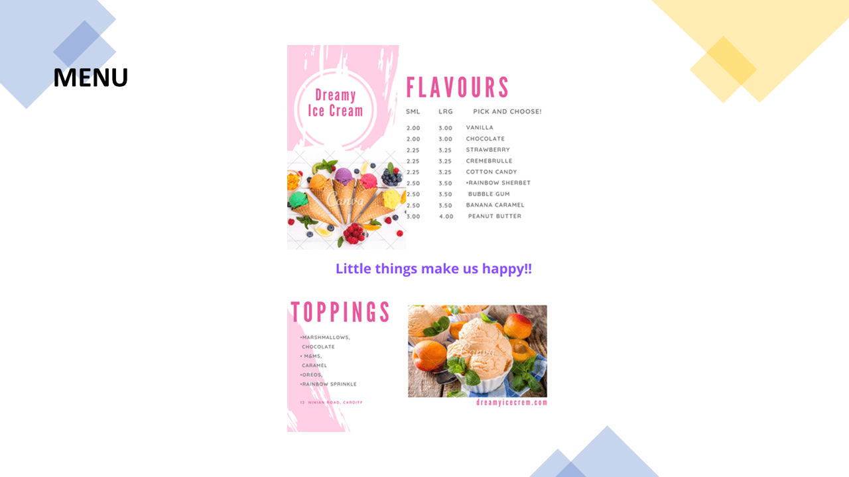

I am also having a diverse range of products for all the tastes and ages starting from dairy milk ice creams to non-dairy ice cream and vegan ice cream and ending with the most requested homemade ice cream.

Also, my Dreamy Ice Cream van is available to any kind of events, like concerts, special events, like birthday parties or weeding, festivals and food truck events for a unique touch of glamour and an unforgettable day.

4. Physical location and the Equipment required

Physical Location
Emmanuel (2010) p.24 mention that is very important for a business to have a good location, because this will lead to higher profits and less costs.

Finding the perfect location for my ice cream van is one of the most important steps to having a successful business, and in addition I must follow some regulations and get permits from the town hall, which allow my ice cream van to work with all the documents up to date and at the same time to be in the perfect place.

For my business to be profitable in finding the right location I need to follow some steps:
- be sure the parking is allowed in that place
- find where the most children/people would be
- decide if I will have a prime location or multiple location
- Do I want to be near my competition?

Having this in mind, the location of my ice cream van, will be situated in a busy area on Ninian Road having Park Roath close by, school, libraries, playgrounds, and being ready for everyone who wants to indulge with a creamy ice cream either after school or when relaxing in the park.


Equipment required
All the equipment necessary to run this business is:
Van
Ice Cream Equipment: - ice cream dispenser,
- freezers and refrigeration unit,
- syrup pumps,
- ice cream cone dispenser,
- toppings dispenser
Utensils: - ice cream scops
- ice cream spades
- ice cream dipper
- toppings spoon
Sales and Display: - cash register
- point of sales system
- menu board
Additional equipment: -hand sink
- organizer for lids, straw and utensils
- cleaning supplies
- cabinets
- decorations
Ingredients: - double cream
- milk eggs
- sugar
- vanilla pod
- ice cubes
- cones
- toppings
Marketing: - adverts
- website
- logo
- flyers

5. Human Resources

For my business to work smoothly, I will only need the help of my wife, who has an extraordinary experience both in sales and in communicating with people, and at the same time she is a good accountant least, she has excellent communication with children.

In other words, I will be in charge of sales and my wife will be my only employee in charge of accounting and sometimes when is busy, with sales.

Moreover, I will make the ice cream, take care of the supply and be the driver of the ice cream van.

Considering my wife will be an multi skills employee, bookkeeper and a sales assistant I will try to offer her a starting salary of £1500 and after next 3 months, depending on the income, to increase her salary up to £1800.

6. Marketing and PR Strategy

Schenck, B.F. (2011) p.135 stated that having a good marketing can make a brand to the liking of all customers and at the same time to be successful.
In the ice cream van industry is plenty of competition, that is why I came with a marketing plan for selling and promoting my products.
In order to sell my products, I need to create a menu with my delicious assortments of ice cream for all my customers who would like to enjoy them, whether it is a sunny, cloudy or rainy day.
To promote my business, I must first start by offering flyers and making discounts.
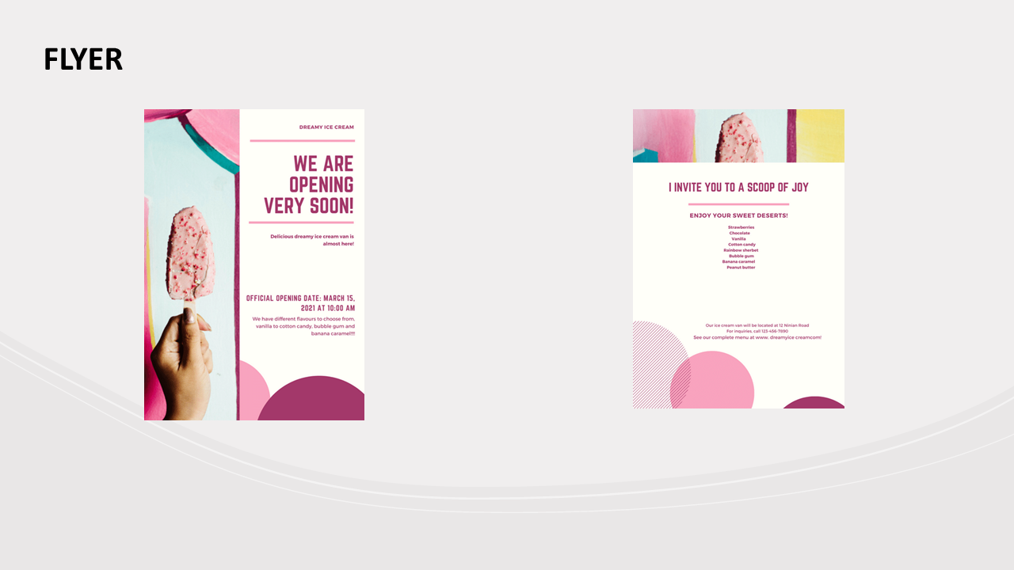

One of the most important area that cannot be neglect is social media and I will make sure to advertise on all the online media to post all the information, images, videos, discounts about all my variety of delicious ice cream I offer at my magic van.
Another idea for promoting my business is to offer ice cream van catering service for all different kind of events, birthday parties, product lunches, fundraisers, reunions, corporate parties, they only need to tell me what type of ice cream they want, and everything is solved quickly and happily.
To promote my business, I create a website www.dreamyicecream.com, as this will help my business grow more and be more successful, to help the customers to choose the right ice cream flavour and showing them that we prepare our ice cream with passion and all handmade.
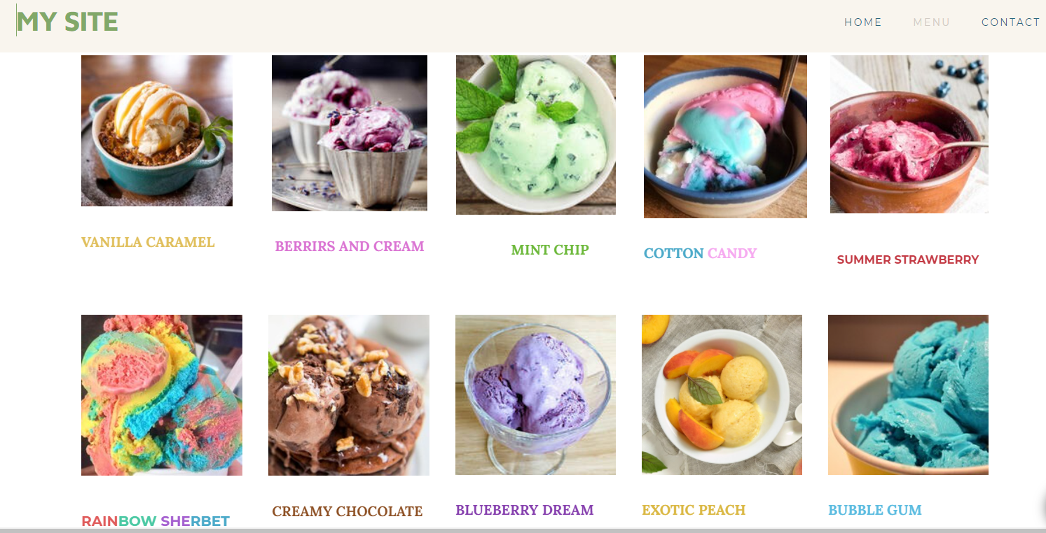
Meghan Kavanaugh (2018) mention that one of the factors is now successful is due to the creation of new assortments of tasty ice cream.
Furthermore, I have prepared a lot of promotion and benefits for our small and older customer, which consist of the following:
- everyone celebrating his birthday can make his own special ice cream by
being able to press the magic lever
- for every four ice creams they buy, the fifth will be free
- anyone who celebrates their birthday can have an ice cream bonus for the whole family

Market research
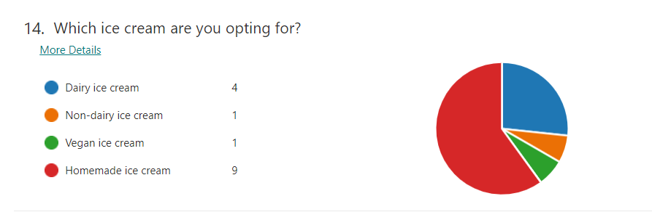
Based on market research, I was glad to know, that one of the most requested ice creams, which is to everyone taste, is the homemade one, which I serve to my customer from an old recipe, and this has to be the main concept for my business to be successful and a bonus for my customers.

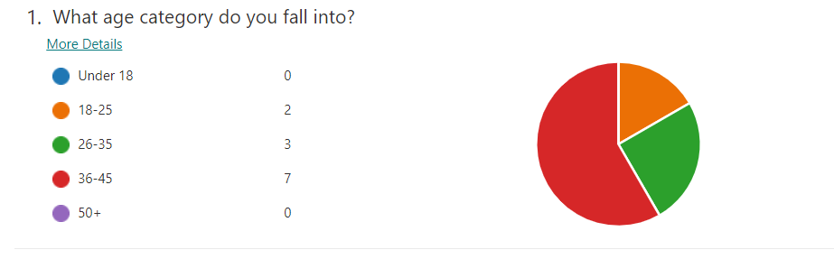
Based in the result of the questionnaire we can see that we have valuable insights from the result to what age category we should target with the business, 58% falls in to the 36/45 age category and only 17% in the 18/25 category.

7. Financial resources

Business Organisation (2020) mention that the financial resources to manage a business are very few or insufficient and this is due to the little experience that the owner has in taking care of his business, moreover he has to fall within his limited money being too risky to borrow or invest big capital.
Being a sole trader, I will invest my money in this business, all my savings, which are a total of £40.000.

Therefore, I do not need to borrow money from the banks, knowing exactly the budget I have, just to focus on my business to move forward because I am the only one who has all the control over my business, and I do not have to relay on banks or investors.

On the other hand, by putting all my savings into the business I could lose everything I have gathered in a lifetime and I would disappoint both my family and all those who believed in me and supported me.

8. SWOT Analysis

STRENTHTS
“Strengths are capabilities that enable your company or unit to perform well, capabilities that need to be leveraged.’’ Luecke.R (2005)
- available prices for everyone
- wide variety of various ice cream flavours
- homemade ice cream products
- good advertising and marketing strategies
- good location
- hights demand in consumption from young population

WEAKNESSES
Ward, J. L., Carlock, R. S. (2001). p.163 stated that when we analyse investments in our business, there is the possibility of discovering some weaknesses and because of these weaknesses, revenues and sales may fail. He also said that we need a strategic and well-developed plan to get rid of them as soon as possible.
- Competition on the market is growing
- Less experience on the market
- Competitors selling the same products
- Less demand on the bad weather

OPORTUNITTIES

Dunn, J. P., et al. (2013) said that opportunities are found in all businesses and can be influenced by several factors such as external, internal and financial.

- Hight demand of consumption
- The opportunity to add a new product to diversify my menu
- The chance to have a growing business
- Being in the best location, at all local events

THREATS
Threats are possible events or forces outside of your control that your company or unit needs to plan for or decide how to mitigate. (Richter, A., Pahl, N. 2009)

- Local ice cream shop
- Supermarkets
- Bad publicity can affect sales
- Changes in regulation may restrict the ice cream industry
- Bad weather

9. CASH FLOW FORECAST

Robin Booth (2020) define cash flow as a movement of the money that are coming and going from a business.

Based upon some market research that I made, I expect that my sales on a year
to be as following:
I will invest £6000 for my start-up cost in Month1.
Month1-£2000, Month2-£2500, Month3-£2800, Month4-£3500, Month5-£3650, Month6-£3800, Month7-£4200, Month8- £5000, Month9-£3700, Month10-£3000, Month11-£2700, Month12-£2500
My only employee will be paid with £1500 in the first 3 months, and then in the rest of the months I will rise his salary to £1800
On the Month3 I take £2000 and on the Month7 £1000 in drawings
Monthly I need to pay £400 for the rent
The Electricity costs me in Month3-£165, in Month6-£180, in Month9-£200 and in Month12-£170
I pay £30 for the phone every 3 months
Material costs are estimated as following:
Month1-£100, Month2-£120, Month3-£150, Month4-£200, Month5-£300, Month6-£250, Month7-£350, Month8-£300, Month9-£300, Month10-£310, Month11-£280, Month12-£120
For the National Insurance I pay £15 each month
For the adverts on radio, I pay in Month1-£400, in Month2-£100, Month6-£300 and in Month8-£200
Fuel costs are £120 monthly
Licenses are paid in Month1-£80 and Month6-£70
I pay in Month2-£200 and Month9-£250 for the rented van.

CASH FLOW FORECAST – DREAMY ICE CREAM

10. REFERENCES

Angelica, E. (2001). The Wilder Nonprofit Field Guide to Crafting Effective Mission and Vision Statements. United States: Amherst H. Wilder Foundation.

Business Organisation. (2020). Australia: SBPD Publishing House.

Dransfield R. et al. (2004) Business. Oxford: Heimmann Educational Publishers

Dunn, J. P., Stevens, R. E., Winston, W., Sherwood, P. K. (2013). Market Analysis: Assessing Your Business Opportunities. United Kingdom: Taylor & Francis.

Emerging Business Opportunities: For the Entrepreneur in You (2018). (n.p.): Notion Press.

Fresh Perspectives: Business Management. (2005). South Africa: Pearson Education South Africa.

Good Small Business Guide 2013, 7th Edition: How to Start and Grow Your Own Business. (2013). United Kingdom: Bloomsbury Publishing.

Luecke, R. (2005). Strategy: Create and Implement the Best Strategy for Your Business. United Kingdom: Harvard Business School Press.

Mathew Emmanuel (2010) Methodology of Business Studies, India: Pearson Education.

Meghan Kavanaugh (2018) Ice Cream Marketing Ideas to Treat Your Customers This Summer .Available at: https://upserve.com/restaurant-insider/3-ice-cream-marketing-strategies-for-tourist-season/

New Business for Old Europe: Product-Service Development, Competitiveness and Sustainability. (2017). United Kingdom: Taylor & Francis.

Richter, A., Pahl, N. (2009). Swot Analysis - Idea, Methodology and a Practical Approach. Germany: GRIN Verlag.

Robin Booth (2020) A Beginner’s Guide to Forecasting Business Cash Flow for Startups. Available at: https://www.brixx.com/a-beginners-guide-to-forecasting-business-cash-flow-for-start-ups/

Schenck, B. F. (2011). Small Business Marketing for Dummies. United States: Wiley.

Sole Trader (2021) Available at: https://www.smallbusinesspro.co.uk/small-business-finance/sole-trader.html

Wallace, S., Wallace, D. (2001). GCSE Business Studies. United Kingdom: Pearson Education.

Ward, J. L., Carlock, R. S. (2001). Strategic Planning for The Family Business: Parallel Planning to Unify the Family and Business. United Kingdom: Palgrave Macmillan.

Power Point Presentation



