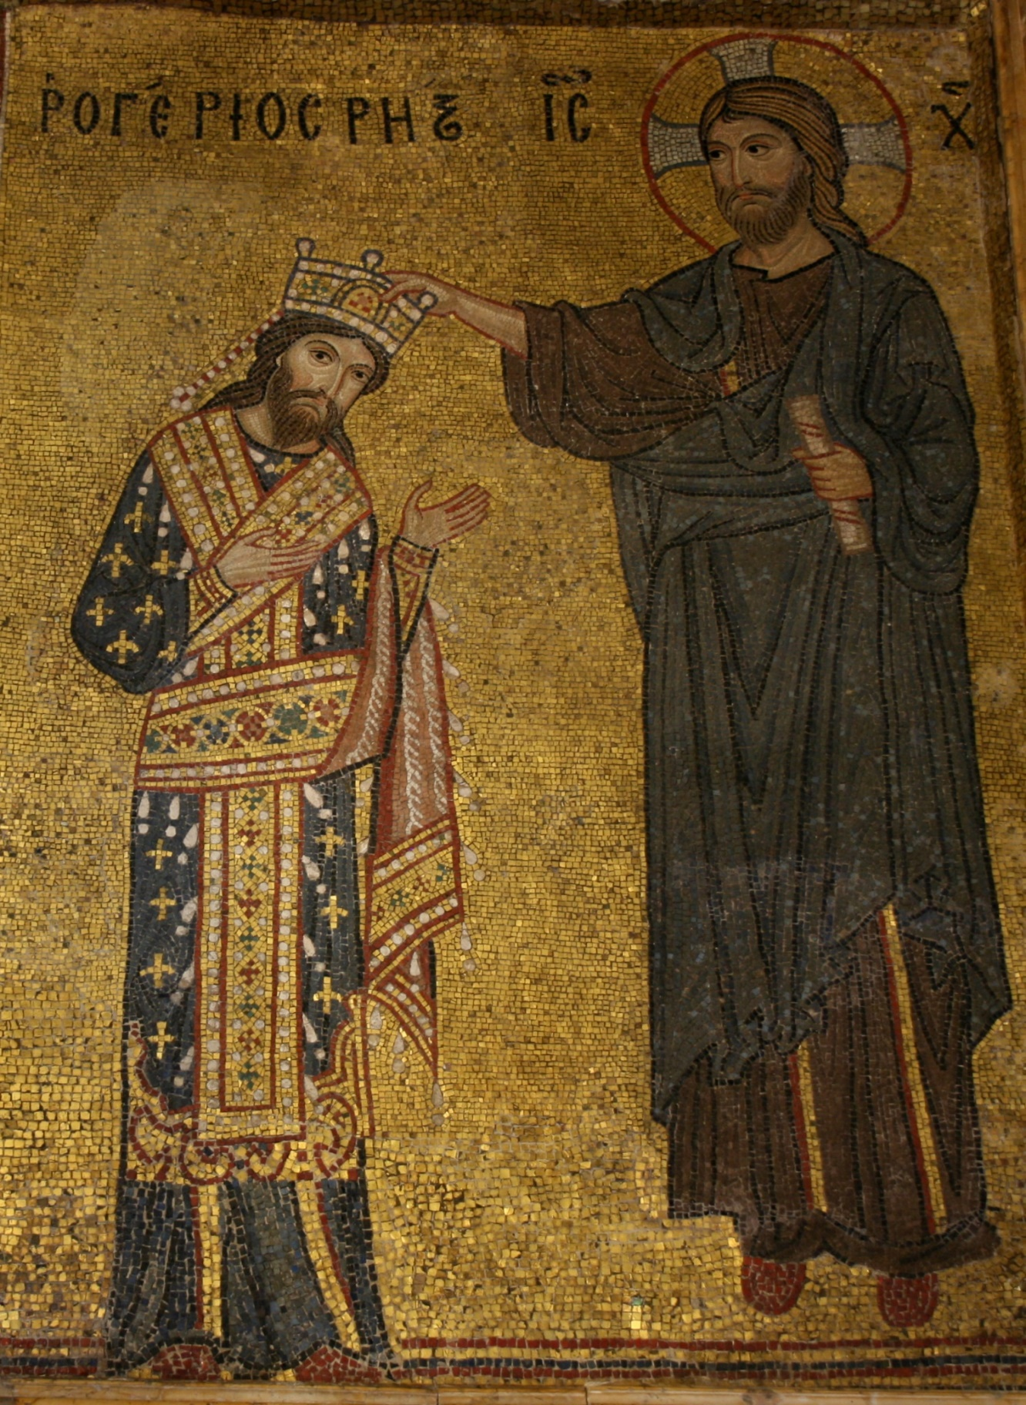
In Palermo, Sicily, there is a church with a gorgeous mosaic featuring Roger II being crowned by Christ. It shows how Roger wanted to be seen by his subjects when they visited the church, called Martorana. The mosaic paints him as a God-fearing man, but there is a narrative it tells that undercuts this humility. Additionally, while the Byzantine cultural elements in the mosaic help Roger relate to his Greek subjects, they also are a picture of the instability of the Norman rulers in their desire for more power, as well as their distrust of their own culture. There is a reason why many Normans in Sicily were not upset when Germany conquered them, and why their identity disappeared soon after. Alongside being a commentary on how Roger wanted to be perceived, the mosaic is a window to some of the causes of the demise of Norman identity in Sicily.
The mosaic portrays Roger as a humble man, at least in some of its elements. Roger’s figure is physically smaller than Christ's, which is further emphasized by Christ floating above the ground. While he wears a crown, his bowed head and smaller size signify a humble man accepting the temporal power divinely given to him. Instead of a conqueror fighting for the throne, he is shown as having been given the responsibility by Christ. This is important because, in this time, if a king was not believed to have been given the throne by God, people would not think he had a right to the throne.
However, certain elements of the mosaic write a narrative counter to one of humility. In their time, people didn't think that God directly invested temporal power to kings, as portrayed in the mosaic. Instead, the Pope was supposed to be the one investing kings, through God’s authority. However, there is no Pope in the mosaic, thus undercutting his power. Additionally, Tronzo points out that Roger's face is very similar to Jesus'. He further adds that this is the first time we have known of that happening in the style of the mosaic, the Byzantine style. Finally, Roger's clothes convey strong statements. First, they are more lavish than Christ's. Roger is bedecked in jewels, while Christ wears no ornaments. Secondly, as Roger’s clothes are lighter in color, the eye is drawn to him first. Roger is the one who captures the viewer’s attention, not the Son of God he receives his crown from. These details all present a subversive narrative in the mosaic, where Roger seems to be subtly putting himself in front of Christ—and certainly the Pope. The mosaic speaks of Roger in a more nuanced way than simply saying he is humble.
Another message is conveyed through the use of Byzantine elements in the mosaic. When Roger I conquered Sicily, he saw that it was financially successful. Instead of suppressing the Muslim and Byzantine cultures living there, risking insurrection and financial ruin, he decided to incorporate their cultural elements into his kingdom. This attitude continued with his son, Roger II, and resulted in buildings like the Martorana church having elements of Arabic and Greek culture, which was uncommon at the time. Through portraying symbols and languages from their respective cultures, the kings hoped to keep Sicilians happy and content. Roger II went further than his father with interest in Byzantine culture, however. As Albu states, “[A]s he grew to covet Byzantine lands and powers, he also affected the court ritual and the autocratic ways of an emperor.” In the mosaic, we see this interest, as he is wearing a Byzantine emperor’s clothes. It is unlikely Roger wore them in real life, however, as his outfit was outdated by nearly 100 years at the time of the mosaic’s creation. He may have wanted to convey something through his choice of an older clothing style. Perhaps he wanted to connect himself to the past Greek traditions. Maybe he wanted to show the Greeks that he was not a new king who happened to take a passing interest in their culture, but that he was deeply invested in their past. The connection he may have wished to draw is deeper than his own background in Sicily and was connected to who the Greeks were before his father, Roger I, came.
One may wonder how the Normans living in Sicily took this infatuation with another culture. After all, it does not seem unreasonable to suppose they would want their king to portray their own culture, and not one of the people he conquered. They were joined in their dislike by the Pope and the German Emperor. In fact, when Sicily rebelled against Roger in 1131, they supported the rebellion. Tronzo paints Roger II as a king who did not focus on bringing his own Normanness to his kingdom but used symbols of cultures around him to bolster his power. Both the Normans and the Byzantines had plentiful reason to take offense to this, as they saw it as a severe disuse and misuse of how they saw their respective identities.
The situation for the Norman identity in Sicily was complicated by how they were treated by their kings. Roger I did not trust other Normans and preferred to appoint Muslims and Byzantines to court positions, and the later kings continued in this spirit. Regardless of whether they were paranoid or honest about their people, it bred an attitude of hostility among the Normans to their kings. They felt like their identity was under attack. Two generations about Roger II, Sicily was overtaken by the Germans. Instead of being upset, “[M]any Norman nobles welcomed the German invaders, whose presence soon exterminated any Norman cultural identity still remaining in the Kingdom of Sicily.” The attitude of the Normans to their conquest paints a sobering picture of how their identity was treated by their kings. Even aside from the insurrection in 1131, they had resisted throughout the reigns of William I and II. So, when they were conquered, they rejoiced that they were not under Norman rule, although lack of Norman rule soon led to lack of Normanness altogether. The mosaic shows Roger’s infatuation with Byzantine culture, and when taken in context of the larger picture of the Norman identity crisis, it is a sobering reminder of Roger’s attitude towards the Byzantine and Norman identity, and of what led the Normans to rejoice when they were captured.
The mosaic in Martorana of Roger II being crowned by Christ is full of nuance, especially when taking the historical context into account. The artwork shows us as Roger wanted himself to be seen: humble, subservient to God, and wielding kingly power that was divinely appointed. Yet perhaps it shows us more than Roger wanted us to see. Certain elements in the mosaic undermine the narrative of the God-fearing king, such as the lack of a Pope. Additionally, it is a snapshot of attitudes he had towards Byzantine power that contributed to an insurrection, and that we can connect to a continual lack of visibility of the Norman culture in Sicily. While the Germans were the ones who conquered the Normans and led to the disappearance of their culture, the Norman kings may have been the ones who were among the first to put their identity in danger of disappearing.

Bibliography
Primary Sources:
Unknown photographer, Photograph of Christ Crowning King Roger II.
Modern Scholarship:
William Tronzo, ‘ON THE ARTISTIC CULTURE OF MEDIEVAL SICILY’, Muslim Sicily: Encounters and Legacy, ed. Nuha Alshaar, (Edinburgh: Edinburgh University Press, 2024) pp. 206–22. available at http://www.jstor.org/stable/10.3366/jj.15478407.15, (Accessed: 18th October 2026).
Albu, E., The Normans in their Histories: Propaganda, Myth and Subversion (Woodbridge: The Boydell Press, 2001), Chapter 6.

Albu, E., The Normans in their Histories: Propaganda, Myth and Subversion (Woodbridge: The Boydell Press, 2001), Chapter 6, p. 222.
William Tronzo, ‘ON THE ARTISTIC CULTURE OF MEDIEVAL SICILY’, Muslim Sicily: Encounters and Legacy, ed. Nuha Alshaar, (Edinburgh: Edinburgh University Press, 2024) pp. 206–22 (p. 208). available at http://www.jstor.org/stable/10.3366/jj.15478407.15, (Accessed: 18th October 2026).
Albu, E., The Normans in their Histories, Chapter 6, p. 222.
William Tronzo, ‘ON THE ARTISTIC CULTURE OF MEDIEVAL SICILY’, p. 214.
Albu, E., The Normans in their Histories, Chapter 6, p. 222.
William Tronzo, ‘ON THE ARTISTIC CULTURE OF MEDIEVAL SICILY’, p. 218.
Albu, E., The Normans in their Histories, Chapter 6, p. 222.
Ibid, p. 222.
Ibid.

