TASK DESCRIPTION:
- Create a report that answers all tasks below.
- The report should be approx. 2500 words.
- Demonstrate your research activities. Include several citations in each task.

Computer Architecture and Operating Systems Report
Module Name: Computer Architecture and Operating Systems
Module code: ACCA402
Student Name: Catherine Gordon
Student ID: 2435425
Group: 1
Lecturer: Redhwan Al-Amri

Table of Contents
Introduction 3
Task 1. Key functions of general Operating Systems I 3
Task 2. Use of Windows OS CLI commands. 3
Task 3. Use of Linux OS CLI commands. 3
Task 4. Use of Windows OS scripts. 3
Task 5. Use of Linux OS scripts. 3
Conclusion 4
References 5
Appendices 6
Appendix 1: Draft work 6

Introduction page:
This report examines the essential functions of operating systems, focusing on Windows and Linux. It aims to introduce and analyze the common functions these operating systems provide while documenting key commands used within each system. Furthermore, this report will showcase their important features and conclude with a summary of the findings. By delving into these functions, this report aims to provide a thorough understanding of how operating systems operate and their significance in maintaining a stable environment for users and applications. The comparative analysis between Windows and Linux will highlight the unique approaches each system takes in fulfilling these essential functions.

Task 1.
- Introduce and analyse the key and common functions of modern general Operating Systems with screenshot evidence (with brief accompanying narration) showing where the functions can be managed from an OS you
are currently using. TASK DESCRIPTION:
- Create a report that answers all tasks below.
- The report should be approx. 2500 words.
- Demonstrate your research activities. Include several citations in each task.

Computer Architecture and Operating Systems Report

Introduction page:
This report will provide an in-depth examination of the essential functions of operating systems, with a particular emphasis on the capabilities and features of Windows and Linux.
The report will introduce and analyze the common functions and document the use of key commands.

Task 1. Key functions of general Operating Systems
- Introduce and analyse the key and common functions of modern general Operating Systems with screenshot evidence (with brief accompanying narration) showing where the functions can be managed from an OS you
are currently using. - Approx. 500 words, images/visuals can be used, cite several reference sources.

An operating system is the main software that manages the core functions of a computer and allows users and applications to work together.
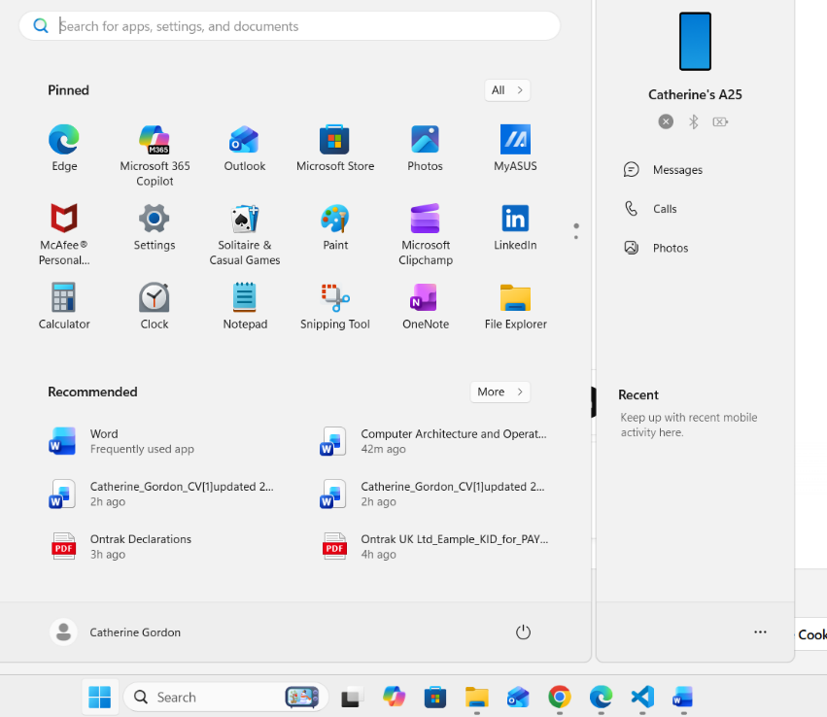

The User Interface enables users to interact with the operating system through windows, icons, menus, and a pointer.

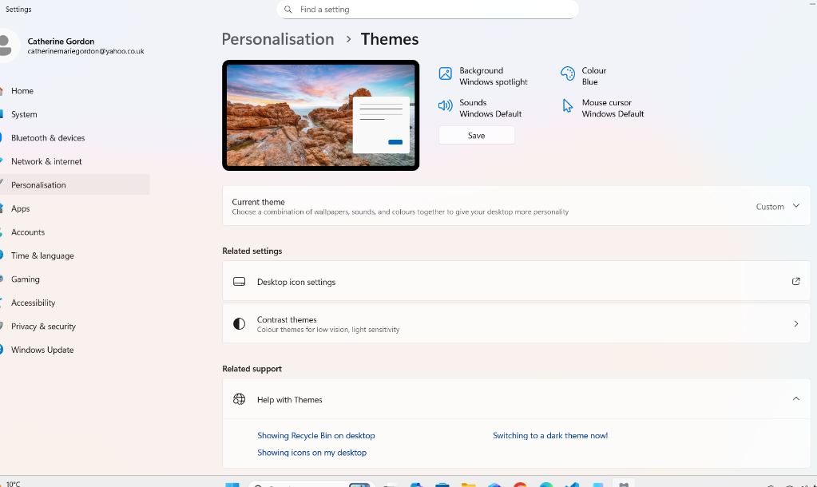
The graphical user interface (GUI) is crucial for my interaction with operating systems, using icons, menus, and windows. In Windows 11, it is managed through the desktop, start menu, and Settings app, enabling me to customize themes and the taskbar for a better experience.

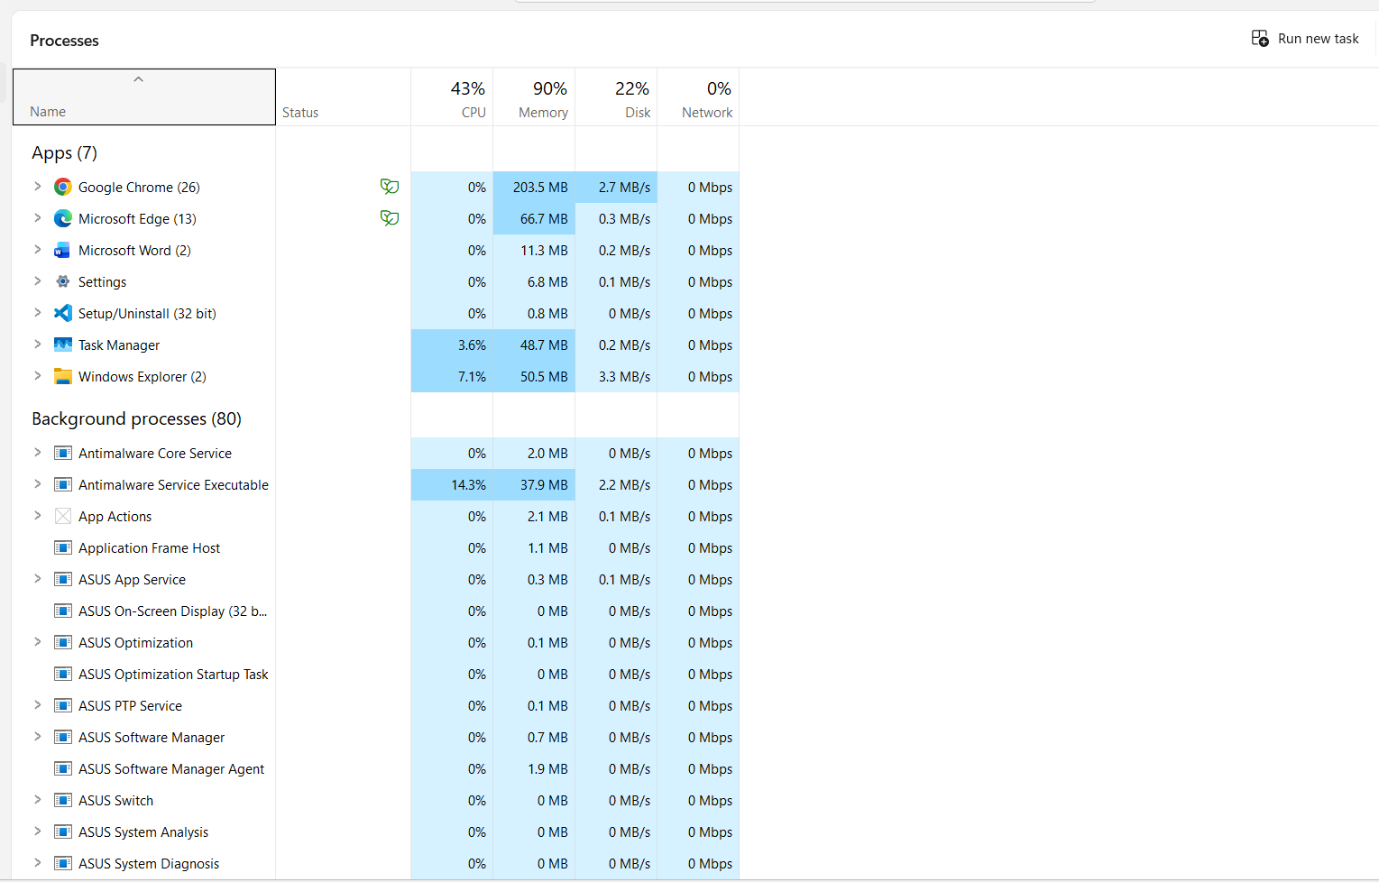

Process management is a critical function of an operating system that enables me to oversee and control running applications and background processes efficiently. In Windows 11, I can manage these tasks using the built in Task Manager, which provides a comprehensive overview of all active processes. Through the Task Manager, I can monitor resource usage, such as CPU and memory consumption, and can terminate unresponsive applications when necessary.

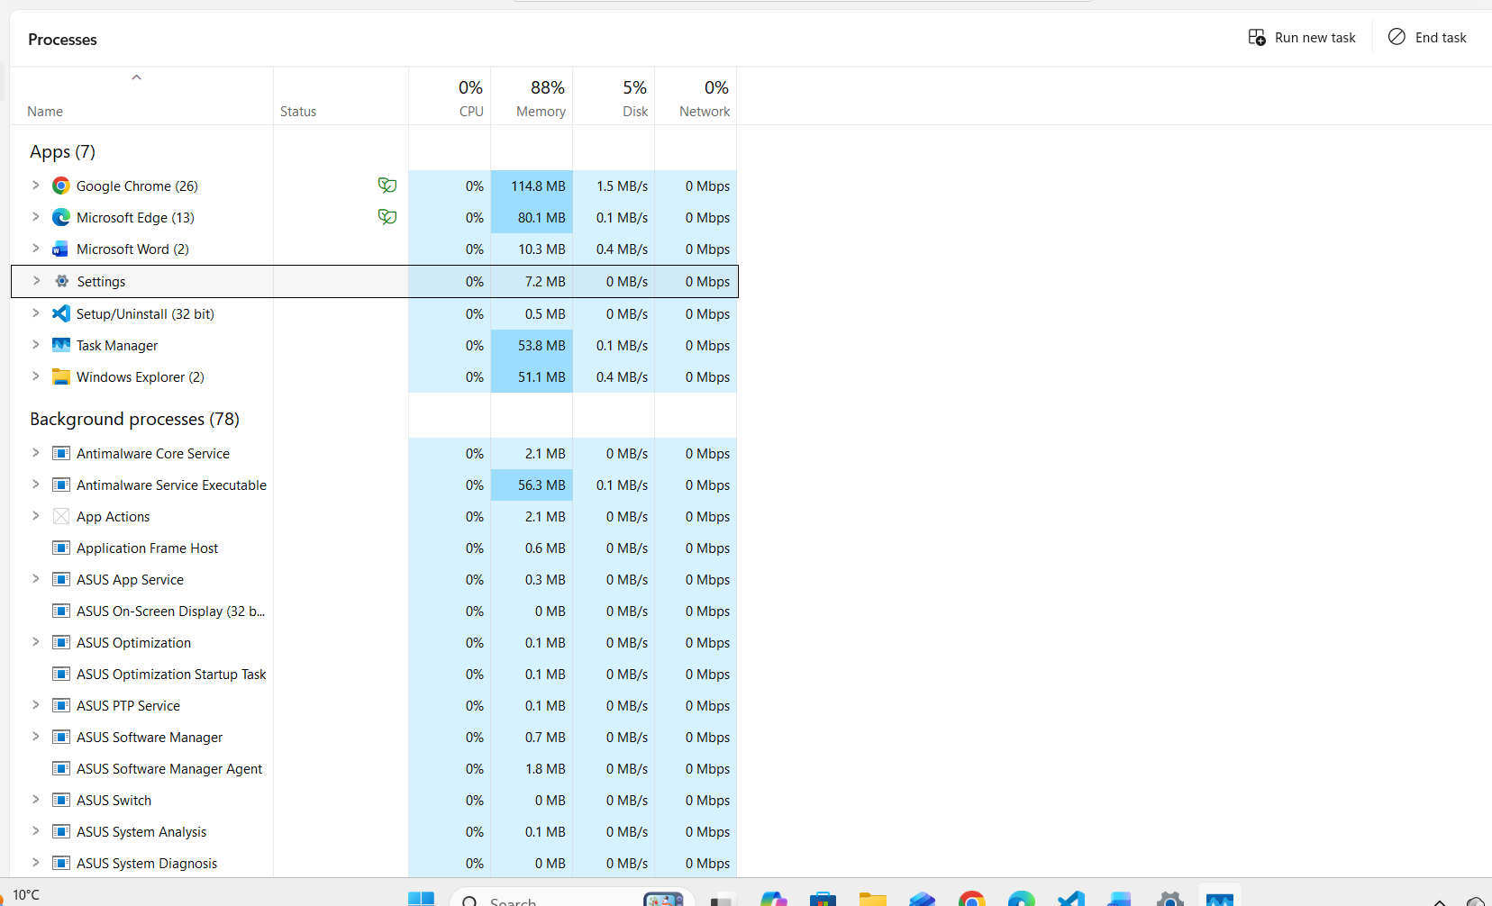

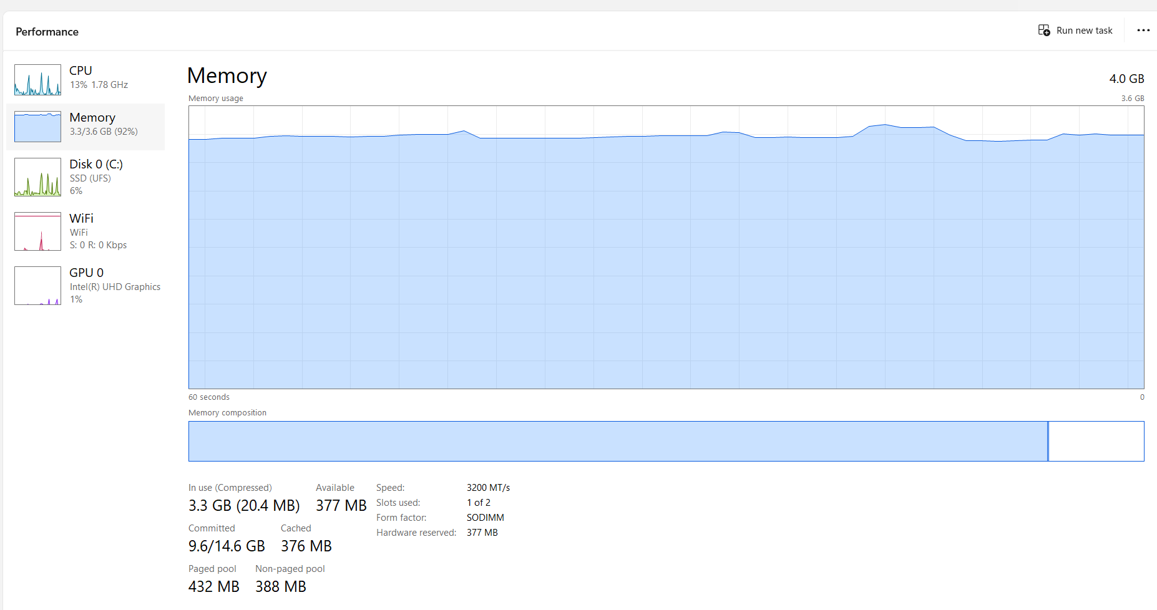

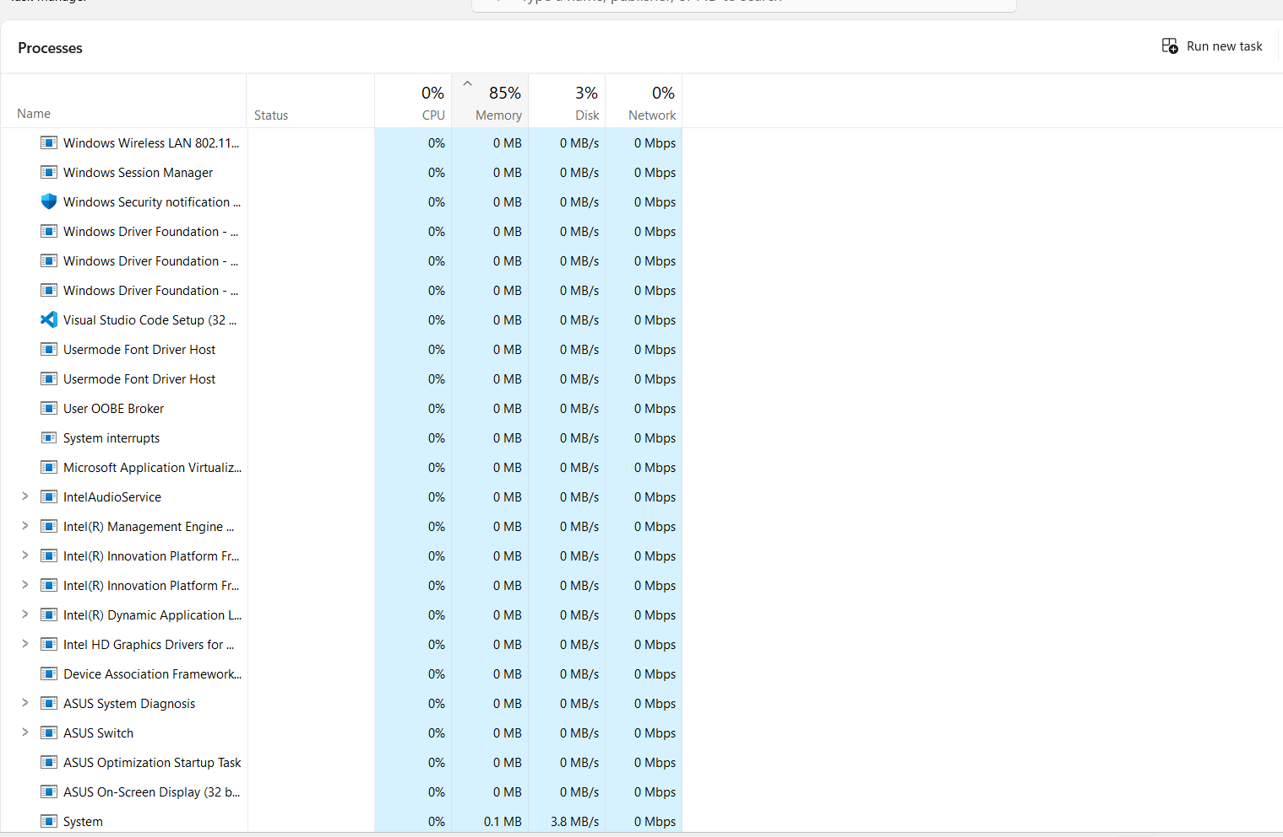

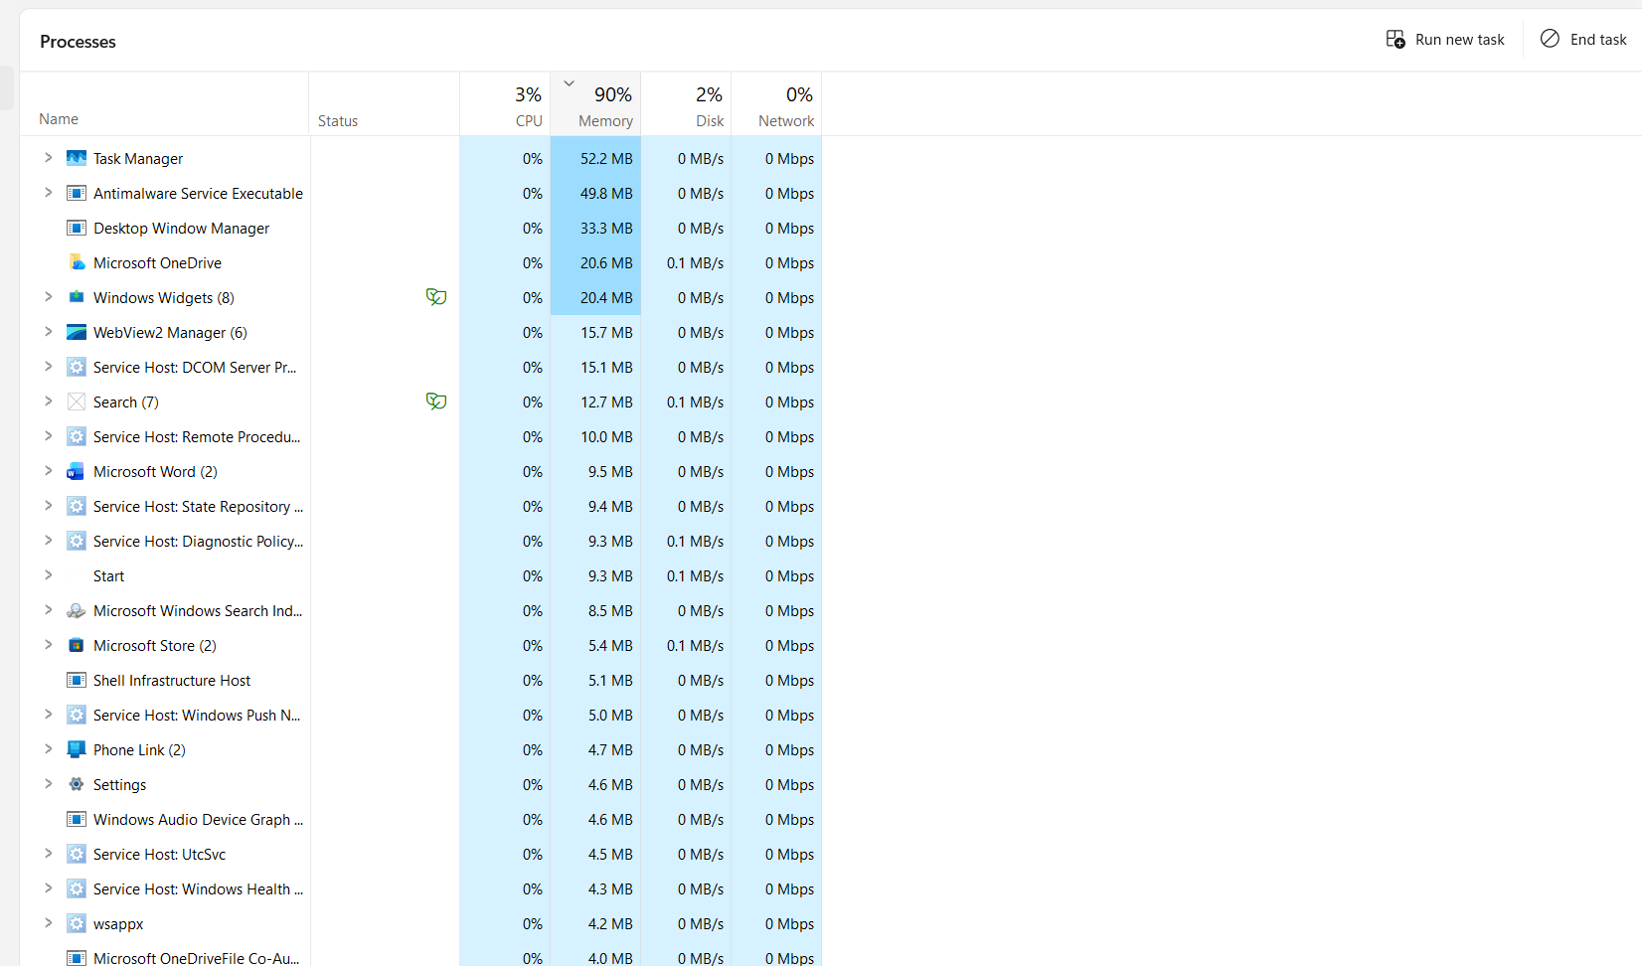
In Windows 11, memory management can be observed through the Task Manager, which offers a clear interface for monitoring the memory usage of each application. By accessing the Task Manager (Ctrl + Shift + Esc), I can view a list of all active processes along with detailed information about how much RAM each application consumes. This visibility allows me to identify resource-heavy applications and make informed decisions, such as closing unresponsive programs or optimizing memory usage.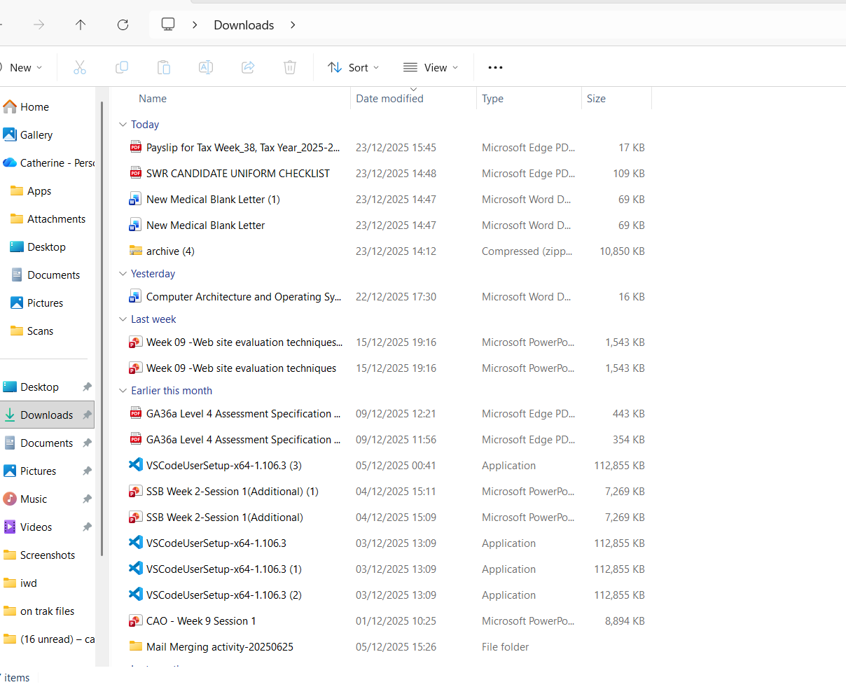

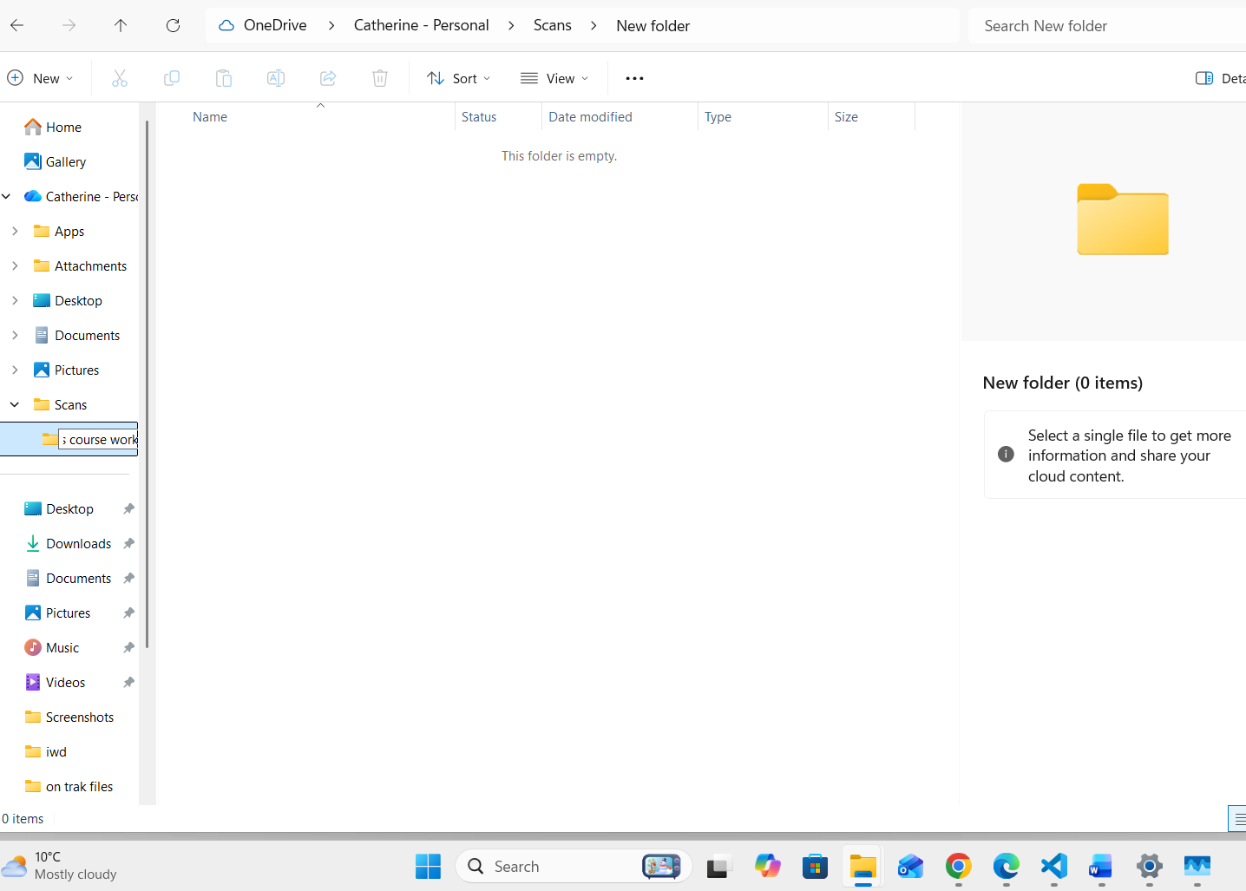

To create a new folder, I can click within a directory, select "New," and then click "Folder." This simple process enables me to organize my files into dedicated folders quickly, enhancing data retrieval and management. Additionally, features like the search bar at the top of File Explorer enable quick access to specific files by entering keywords, while the ability to sort files by name, date, type, or size enhances content organization.

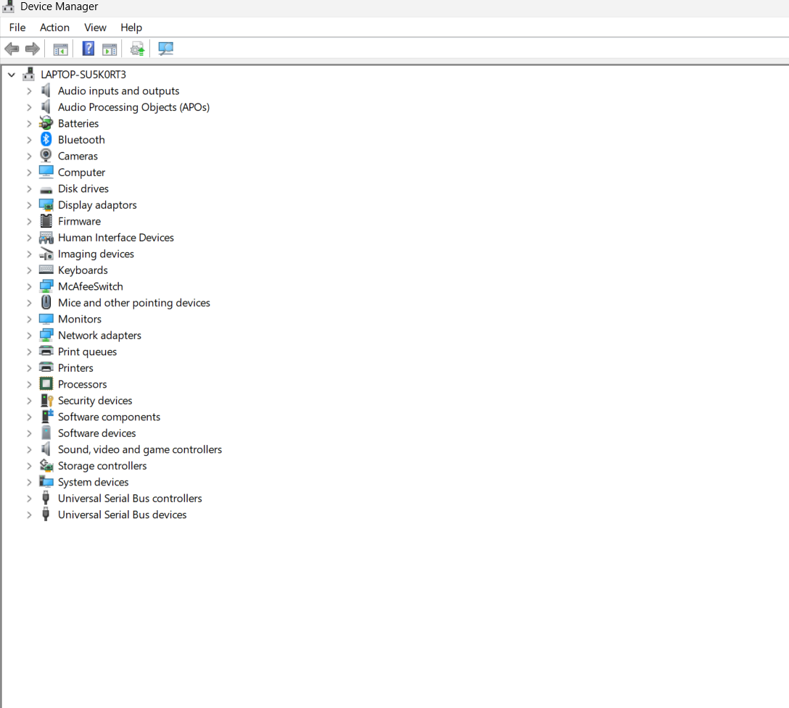

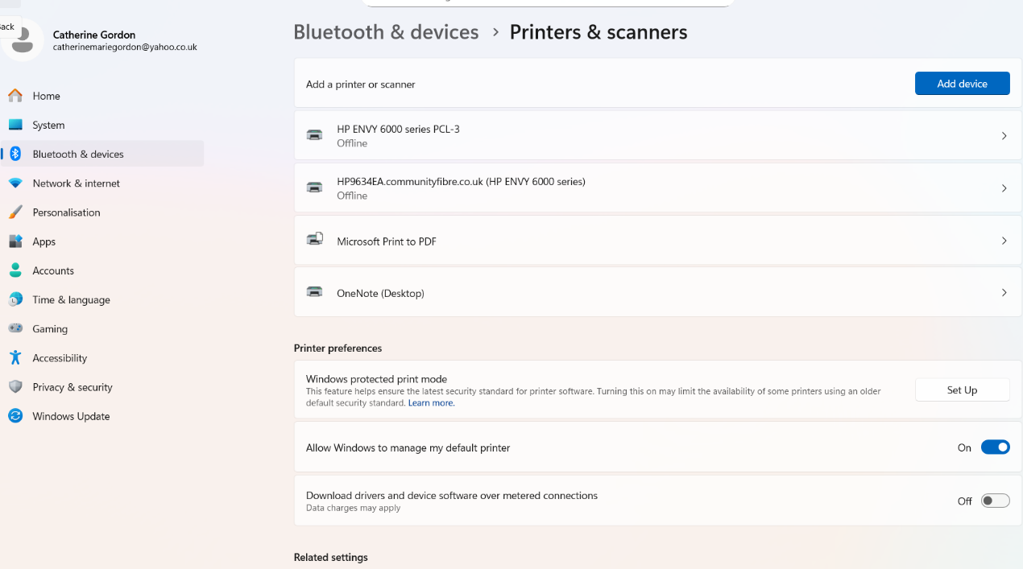
Windows 11 allows me to easily add and configure devices, such as printers and scanners, through the Settings application. By crossing to Settings and devices, I can view all connected hardware, add new devices, or troubleshoot existing ones.
To install a new printer, I can access the Printers & scanners section, click Add a printer or scanner, and Windows will automatically search for available options. This streamlined process enhances device management and reinforces Windows 11's user friendly approach.

Task 2. Use of Windows OS CLI commands.
- Document the use of approx. 10 Batch or PowerShell commands, with screenshots and accompanying narration.
- Approx. 350 words, cite several reference sources.
- 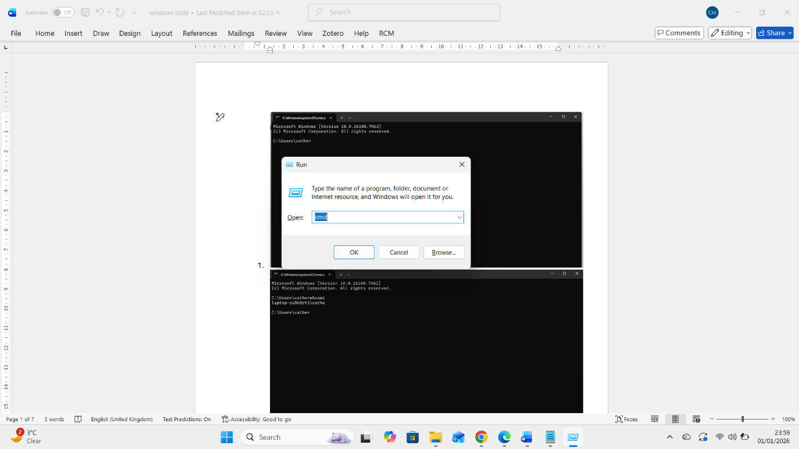 **Open Run Dialog: This is where I start. Press `Windows + R` on my keyboard. 2. Enter Command Type the name of the program, folder, or website I want to open. Here are some examples.

- 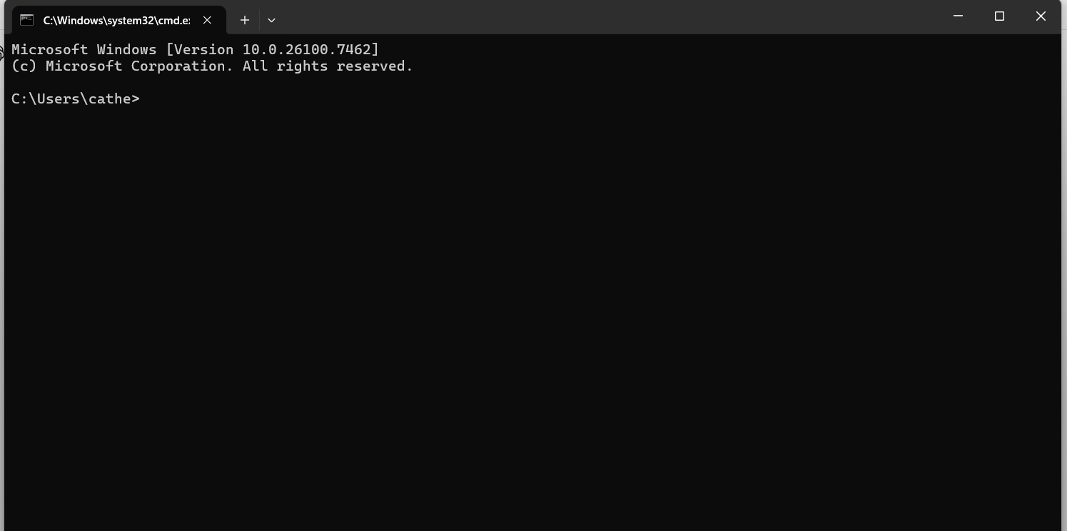

- the (whoami) Displays the currently logged-in user account. This command is useful for verifying which user account is currently active, especially in multi-user or administrative environments.

command, can be used in used in command prompt and powershell the Purpose of this command is to
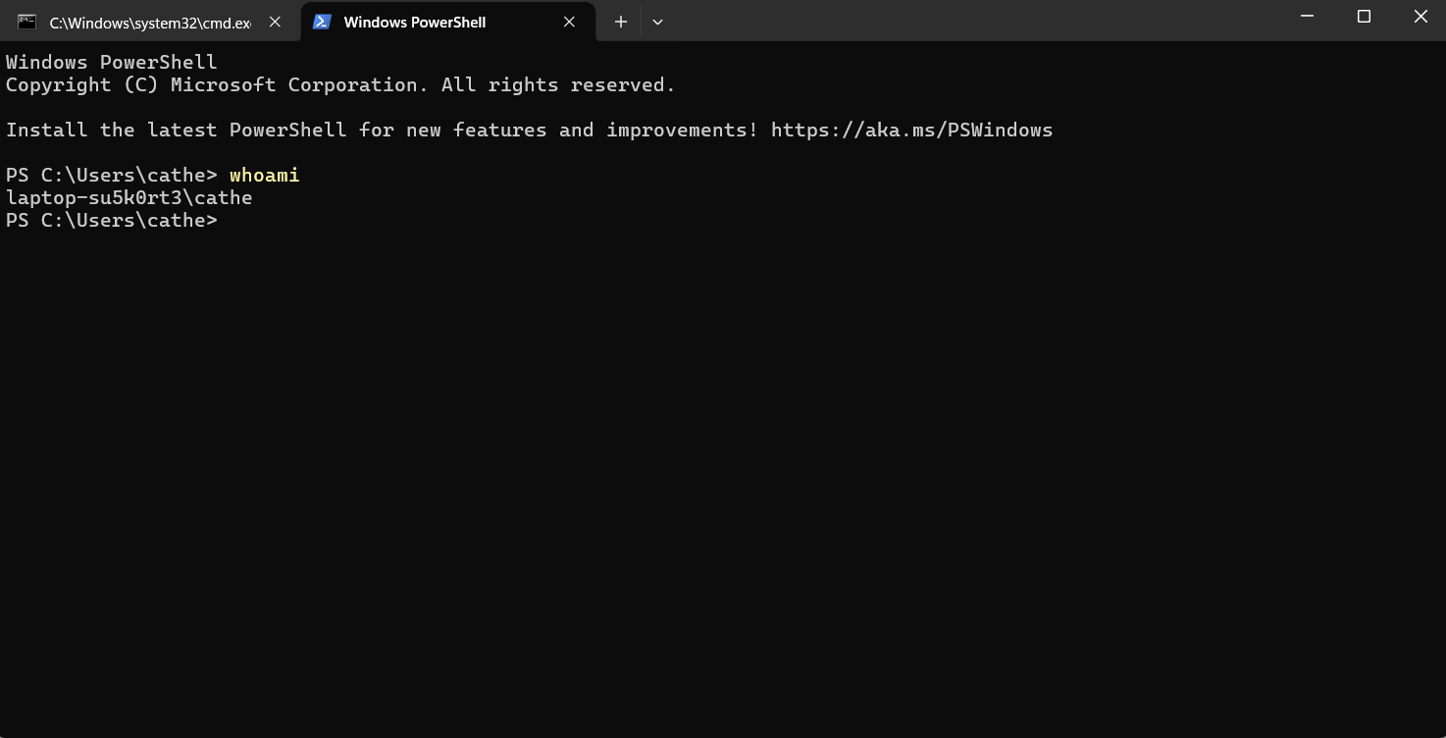

- the (hostname) command, can be used in used in command prompt and powershell the Purpose of this command is to Show the name of the computer and can help identify the machine on a network.

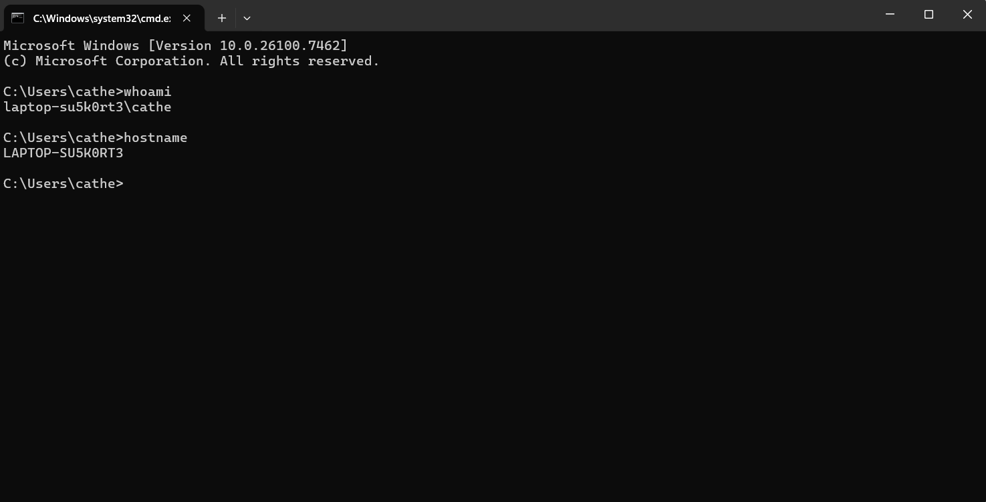

- The (dir) command, can be used in used in command prompt and powershell the Purpose of this command is Used to view contents of a directory Lists filesin the current folder.

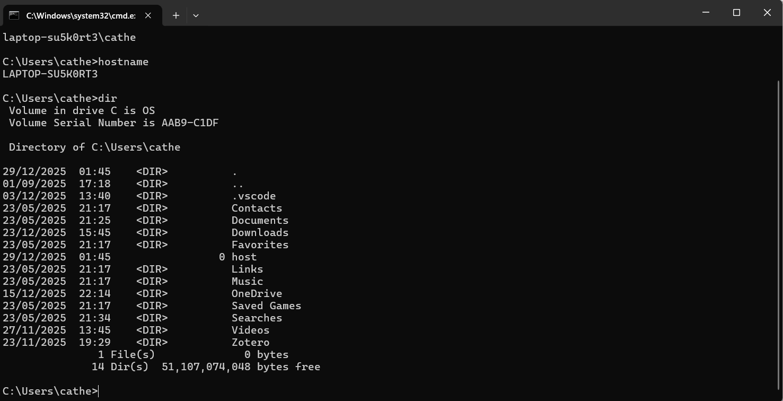

The (cls command, can be used in used in the command prompt and powershell the Purpose is to clear the page

The (cls command, can be used in used in the command prompt and powershell the Purpose is to clear the page
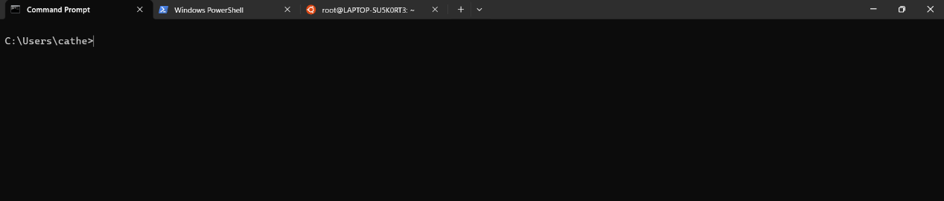

Change directory
Command (cd) can be used in used in the command prompt and powershell the Purpose is to Changes the current directory

The (mkdir) command, can be used in used in the command prompt and powershell. the Purpose of this command is to create new directories and Navigates into the new created folder.
The command, can be used in used in the command prompt and powershell. the Purpose of this command is to Create a content text file and by using (sample.txt)containg “hi am Catherine Gordon this is my prensentation”

The (type sample.txt) command, can be used in used in the command prompt and powershell. the Purpose of this command is to Displays the contents of the text file, it also Reads and outputs the content of sample.txt to the screen
The (del) command, can be used in used in the command prompt and powershell. the Purpose of this command is to delete all the contents in the file and buy typing in (Y) in the commend prompt it will delete the intended content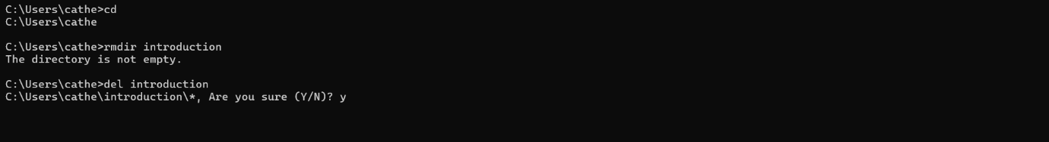
The (rmdir) command, can be used in used in the command prompt and powershell. the Purpose of this command is to delete the intended directory
And then juust to conforme its been deleted use the (dir) command in the command prompt
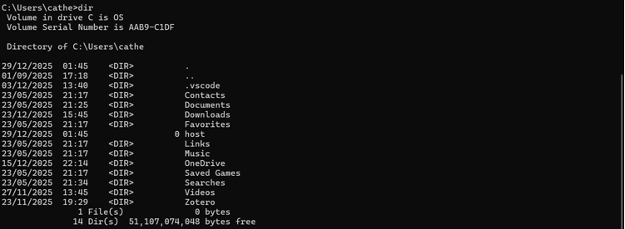

Task 3. Use of Linux OS CLI commands.
- Document the use of approx. 10 Bash commands, with screenshots and accompanying narration.
- Approx. 350 words, cite several reference sources.
(pwd))= command Displays the full path of the current directory you are working in.
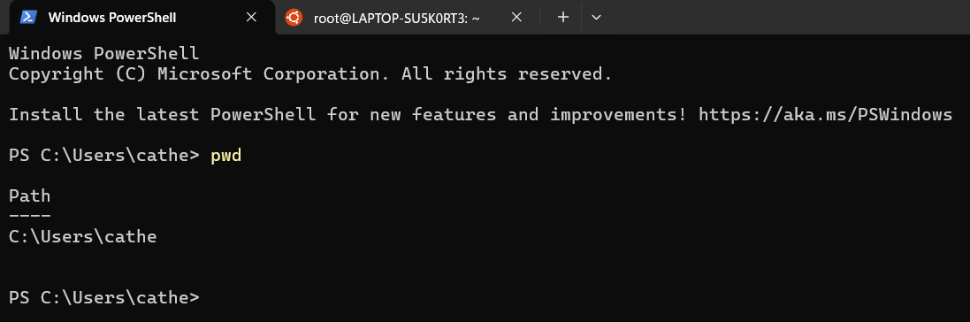
The (dir) command displays all directories
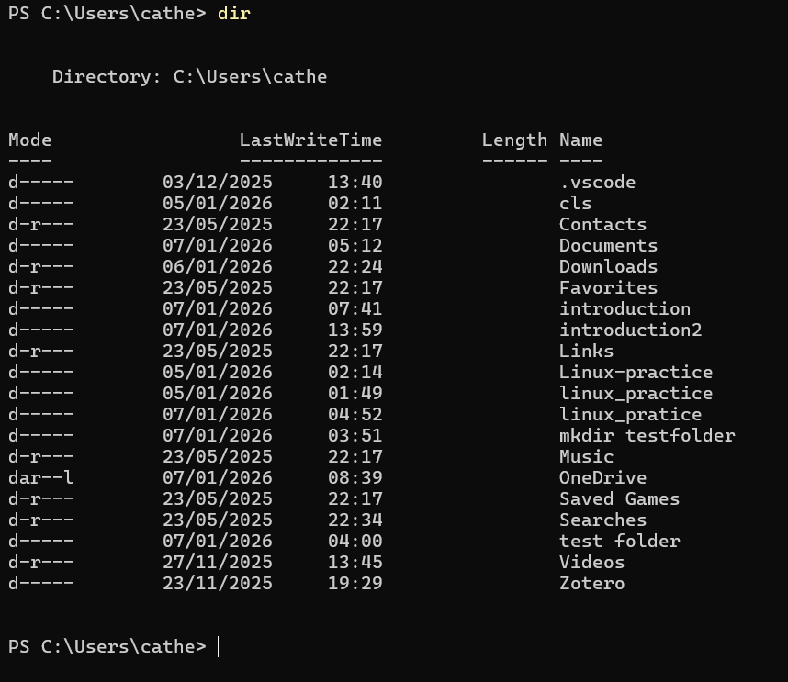

The (ls) command list all contents in directory

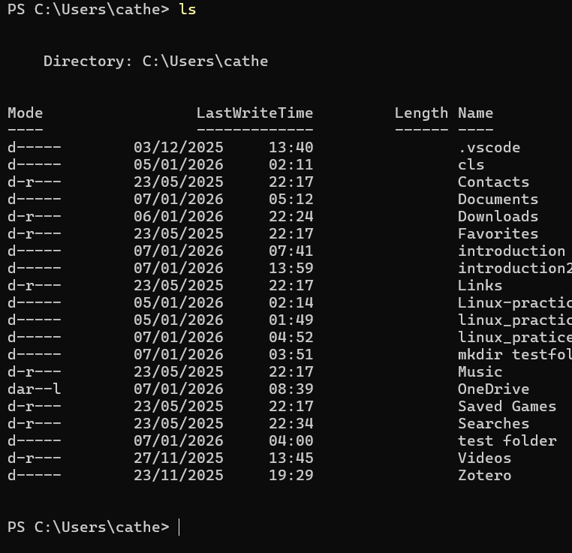
The (cd) command “change directory” changes your directory
The (mkdir) command makes the directory in powershell
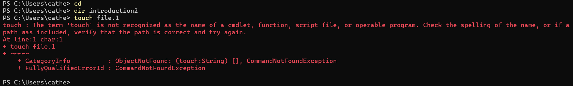
Displays the contents of a file in the terminal. If empty, no output is shown.
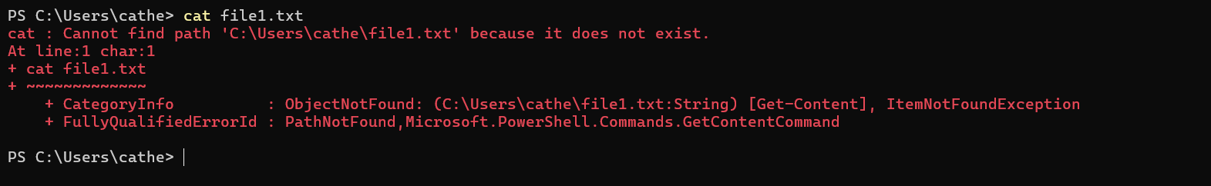
The (Echo) Writes text into file1.txt. The > symbol overwrites existing content , the (cp) command copies the file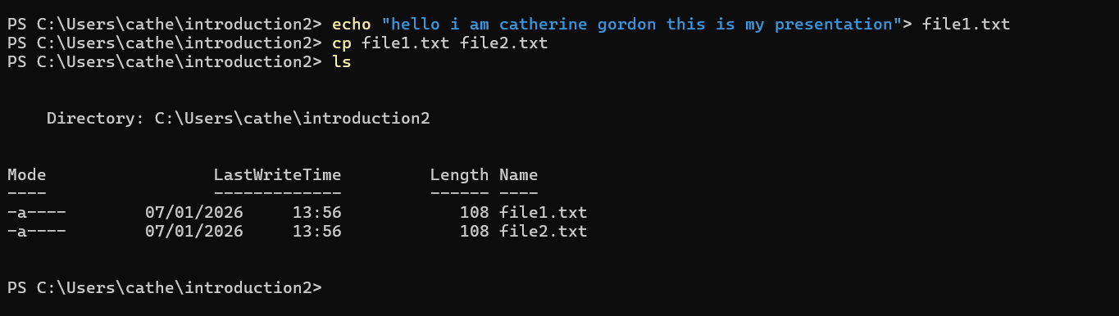
(Ls) command lists current files in the directory
Command (rm) Deletes the file file2.txt. Use with caution as deletion is permanent.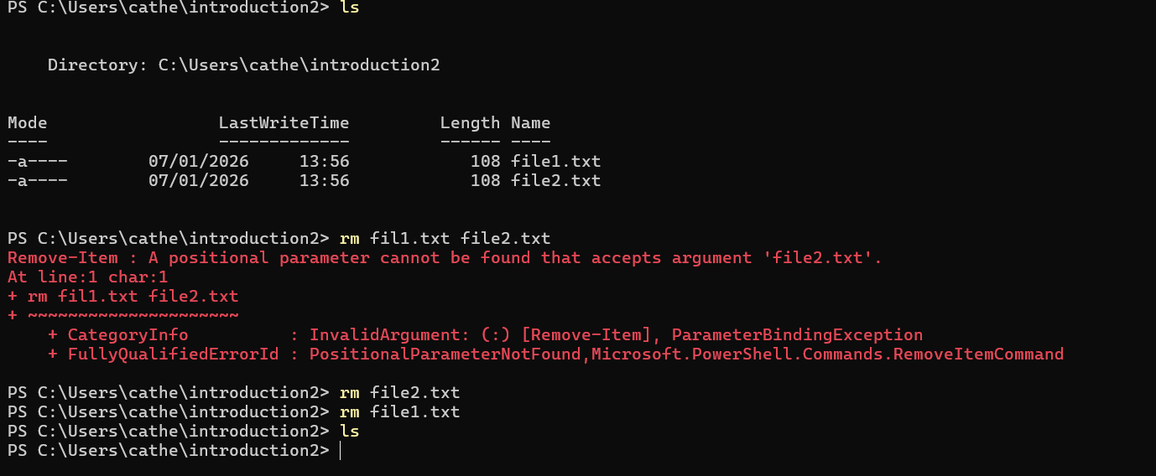

Task 4. Use of Windows OS scripts.
- Demonstrate key features of a Win. OS scripting language by documenting the use of Batch or PowerShell scripts, with screenshots and accompanying narration.
- Approx. 350 words, cite several reference sources.

PowerShell is a framework for automating tasks and managing configurations, created by Microsoft. It employs cmdlets (command-lets) that provide objects instead of simple text, enhancing its capabilities compared to conventional batch scripting.
Main characteristics consist of Command-line and scripting capabilities, Object-oriented pipeline, Windows Management Instrumentation (WMI) access, File system and registry control, System administration automation

- 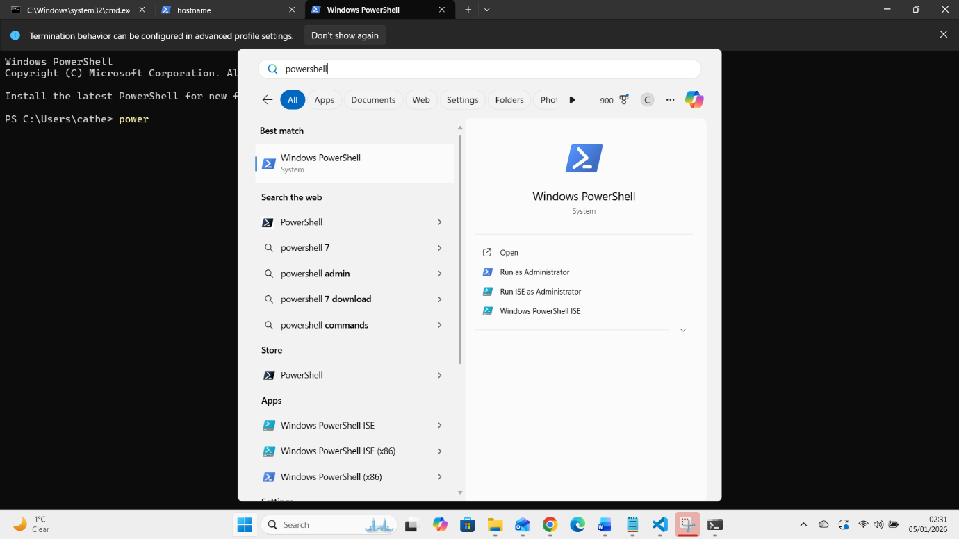

This command retrieves the current system date and time. It demonstrates how PowerShell cmdlets follow a Verb-Noun naming convention.
- 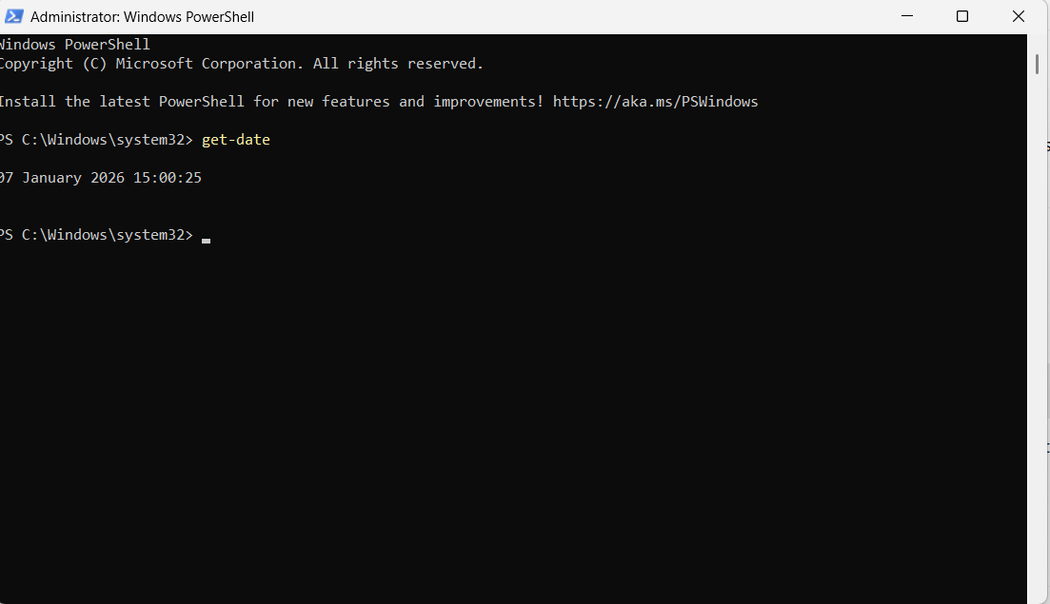
- This command lists all files and folders in the current directory. Unlike traditional commands, the output is returned as objects with properties such as name, size, and last modified date.
- 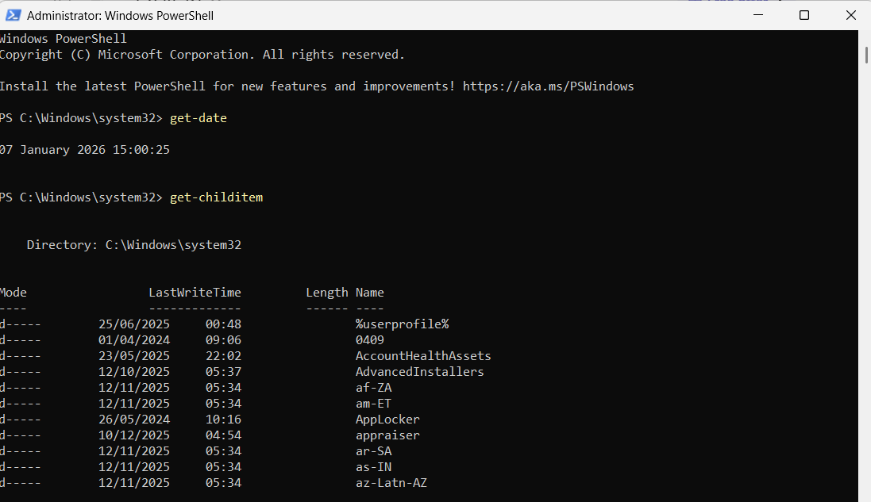

This script creates a new folder and generates a report of files located in the Windows directory. It demonstrates automation, file handling, and output redirection.
- 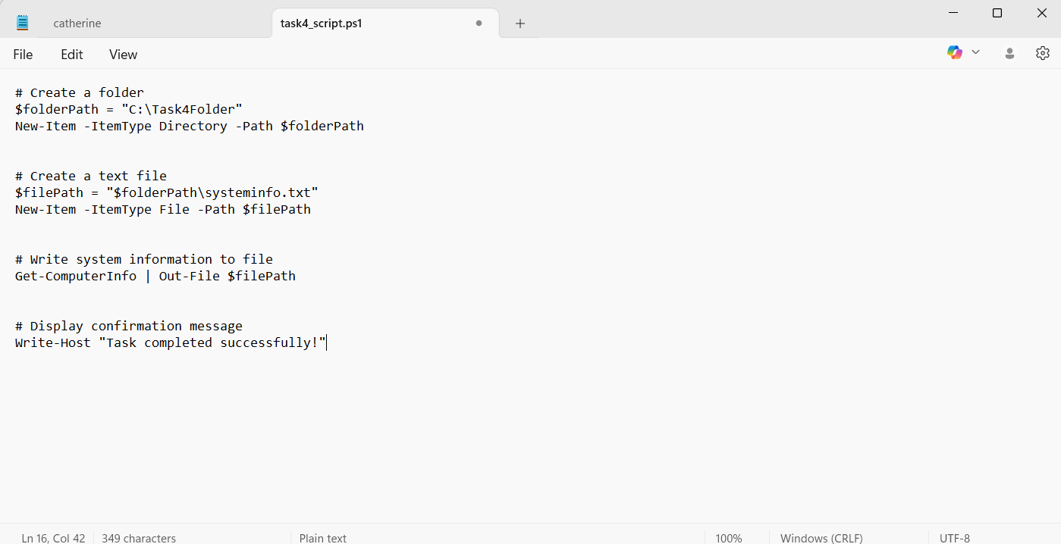

- 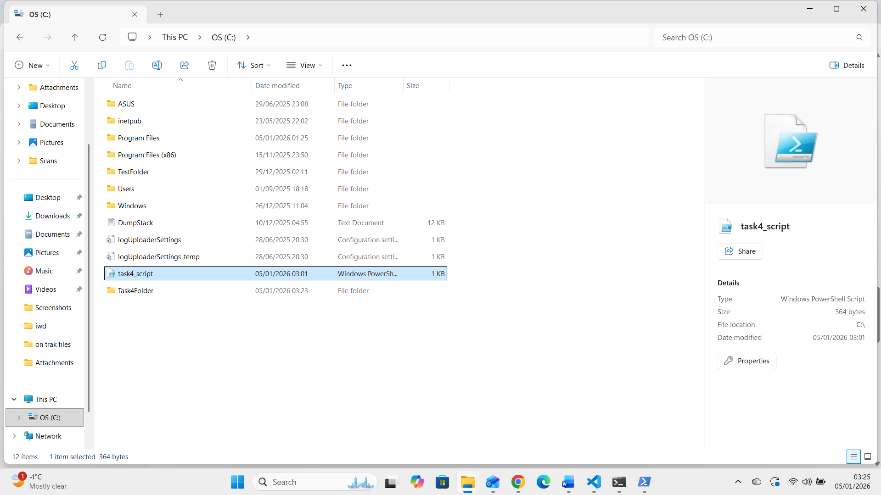

This script shows how PowerShell accepts user input and stores it in variables. This is useful for interactive scripts.
- 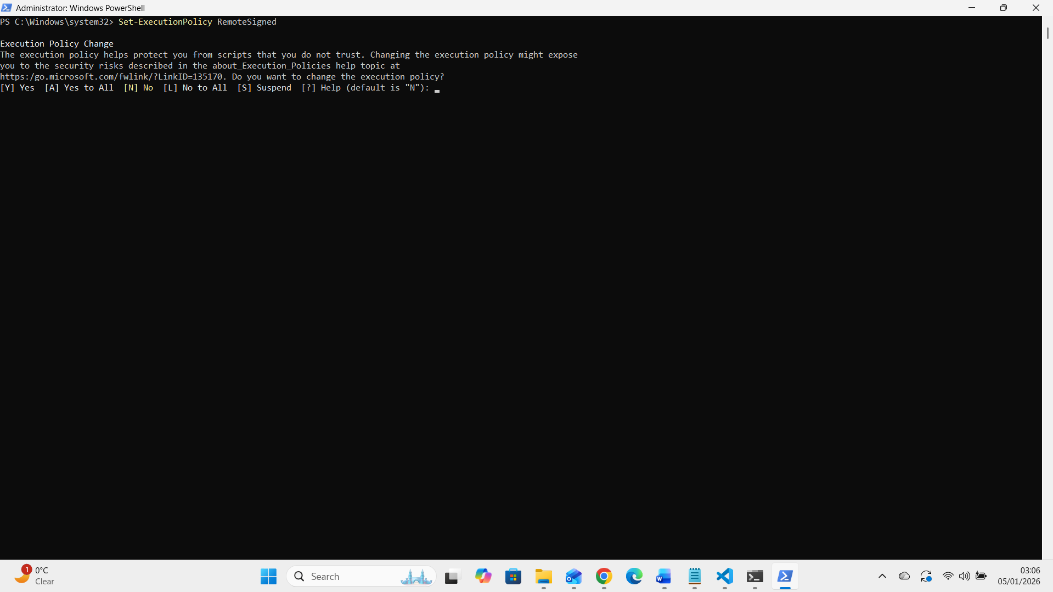
This script demonstrates decision-making using conditional statements. It checks whether a file exists before performing an action.
- 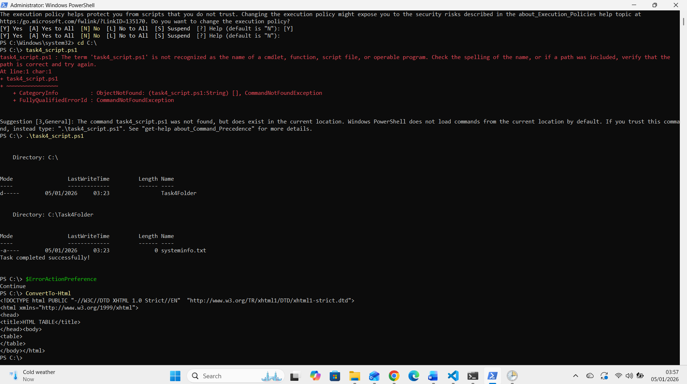

Task 5. Use of Linux OS scripts.
- Demonstrate key features of a Linux OS scripting language by documenting the use of Bash scripts, with screenshots and accompanying narration.
- Approx. 350 words, cite several reference sources.
- 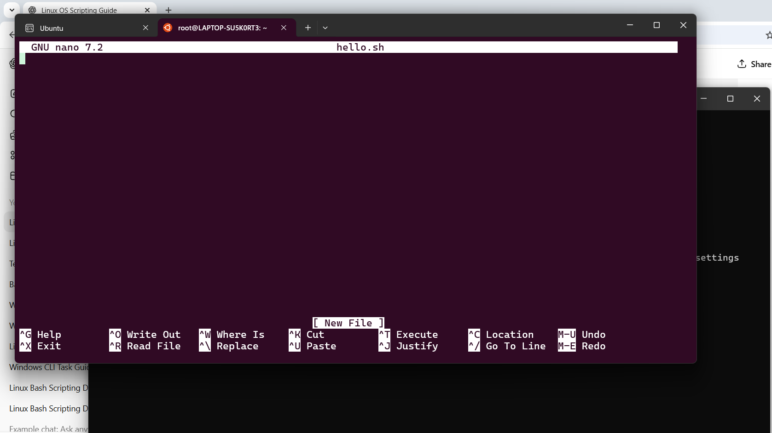Bash (Bourne Again Shell) serves as the foundational scripting language for most Linux distributions. Scripts, which are simple plain text files, contain a series of commands that the shell executes in order. To kick off my scripting journey, to begin I start by creating a script file using a text editor such as nano or vim. This hands-on approach will help me understand how to automate tasks effectively.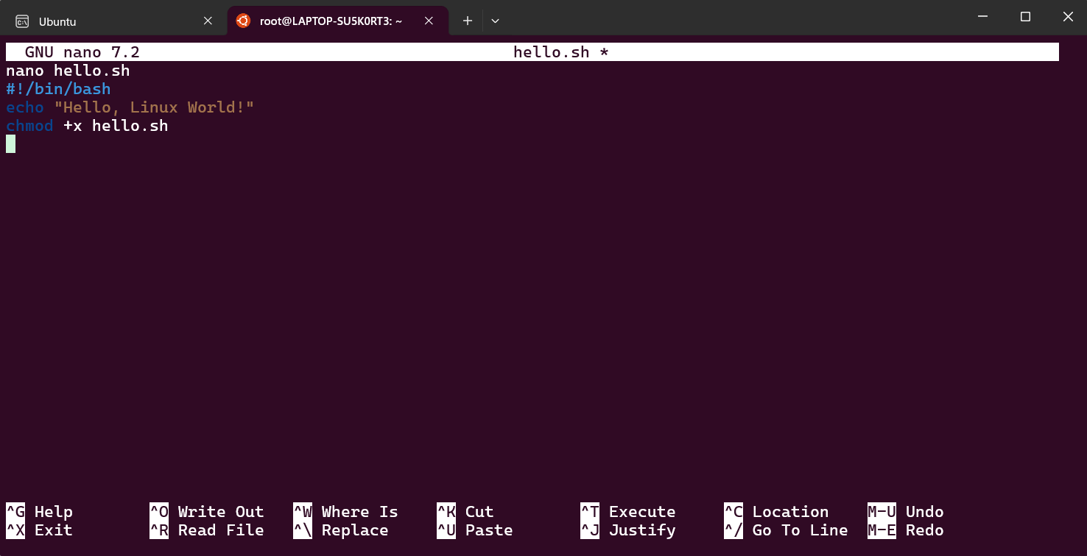Linux enforces file permissions as a key aspect of its security model. By default, scripts are not set to be executable, which means I won't be able to run them until I modify their permissions. To do this, the `chmod` command is used to grant execution rights to a script.
If I have a script named `hello.sh`, I can make it executable by running the following command:

bash
chmod +x hello.sh
This command adds the executable permission to the script, allowing me to run it as a program. This step is essential as it highlights Linux’s permission system, a core feature of the operating system that safeguards files from unauthorized execution. 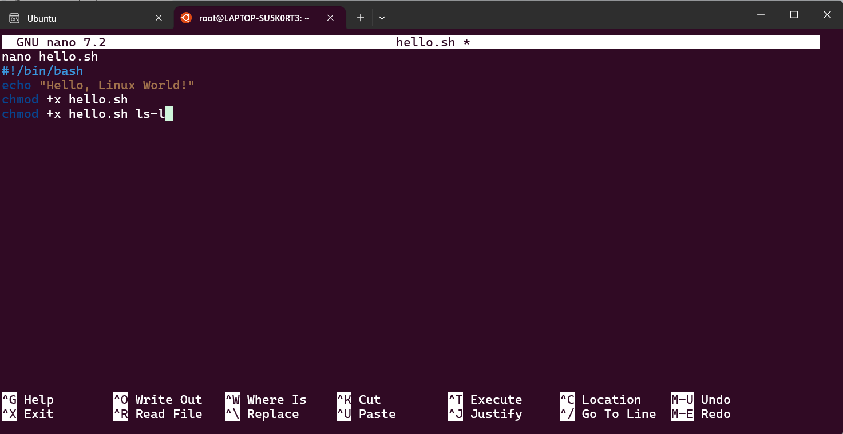Once the script is made executable, I can run it from the current directory. This step demonstrates how Bash scripts automate command execution effectively. I can execute my script with the following command:

``bash
./hello.sh
After running this command, the terminal will output the message defined in the script, confirming that it has executed correctly.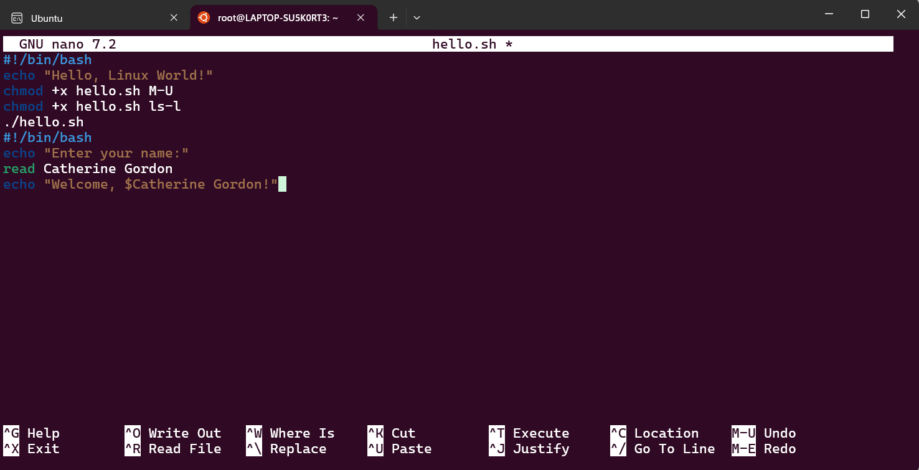Bash is a versatile scripting language that provides powerful features, including support for variables and interactive input, which significantly enhance the scripting and automation capabilities.
In this script, the `echo` command prompts me for my name, and the `read` command captures that input. By using the `$name` variable, the script can personalize the greeting, effectively demonstrating how Bash incorporates user input and variable substitution. This approach not only enhances my user experience but also empowers the creation of more dynamic and interactive automation tasks. 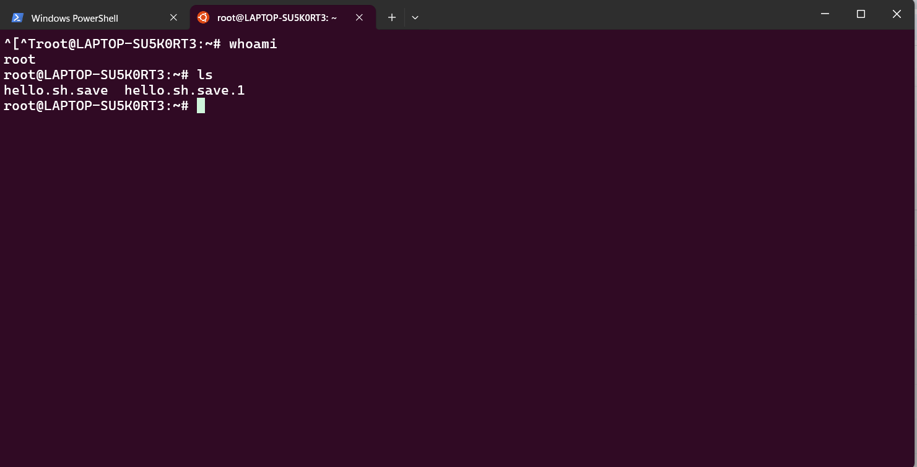

This feature is particularly valuable in system administration and monitoring tasks.
In Bash, the use of `if`, `else`, and `elif` keywords. By incorporating these into a script, I can check whether specific conditions are true and execute different commands accordingly. I can create a script that checks for the existence of a file before attempting to access it, ensuring that the script runs smoothly without encountering errors
By leveraging conditional statements, I can enhance the functionality of my scripts to respond intelligently to various scenarios, making them powerful tools for both system administration and monitoring tasks. This flexibility allows me to create more robust, reliable, and user-friendly automation solutions.

Conclusion In summary, both Windows and Linux operating systems fulfill essential functions that enable the smooth operation of computers. While Windows is known for its user-friendly interface and ease of use, Linux is favored for its flexibility, security, and powerful command-line capabilities. Ultimately, the choice between them often comes down to user preference, specific use cases, or organizational needs. Each OS provides unique advantages that cater to different audiences, highlighting the diversity and robustness of operating systems in computing.

Reference list:
[1] S. T. Andrew and B. Herbert,Modern operating systems, Pearson Education, 2015.
[2] R. Fox, Linux with operating system concepts, Chapman and Hall/CRC, 2021.
[3] A. S. Tanenbaum and H. Bos,Modern operating systems, Pearson Education, Inc., 2015.

Appendices:
- Append to the report relevant supplementary information including:
Tutorial Activity on OS Types from OS Tutorial 1
Evidence of engagement with one online certified course (several screenshots can be used) e.g.:
- Cisco course: Linux Unhatched.
- Microsoft Learn course: Automate administrative tasks by using PowerShell.
- LinkedIn Learning course: Learning PowerShell or PowerShell Essential Training
- PowerShell course available via LinkedIn learning

