University of Wales Trinity Saint David
School of Engineering
Report
ACCA4018
Jericho Uzzell
1702201
12/12/19


Context menu
- Introduction
- Requirements
- Implementation
  - Site
  - Validation
- Evaluation
  - Usability
  - Accessibility
  - Search engines
- Conclusion
- Reference
- Appendices

Introduction
This report will go over the requirements, implementation and evaluation of the site. We will also go over the html and css from the index page to validating the sites code. If certain browser(s) are not compatible with the site, how does the site deal with it, how to improve the compatibleness of the site.

Comparisons about the site from real world expectations of websites, what should be done and how it is done will be assessed.

Requirements
The name of the website is Supreme hosting and its purpose is to offer customers hosting for their site. The hosting comes in four packages, one being light weight, the second being standard, the third being medium weight and the fourth being heavy weight.
Between these packages there are profound differences, one being the price, which is reasonably priced, the customer is told the number of users it caters to, for example, at the moment the lightweight package can cater to one hundred users at one time.
The target audience for this website are gaming communities and people that want to host a couple of pages for their e-portfolio.

Implementation

3.1. Site
Home page
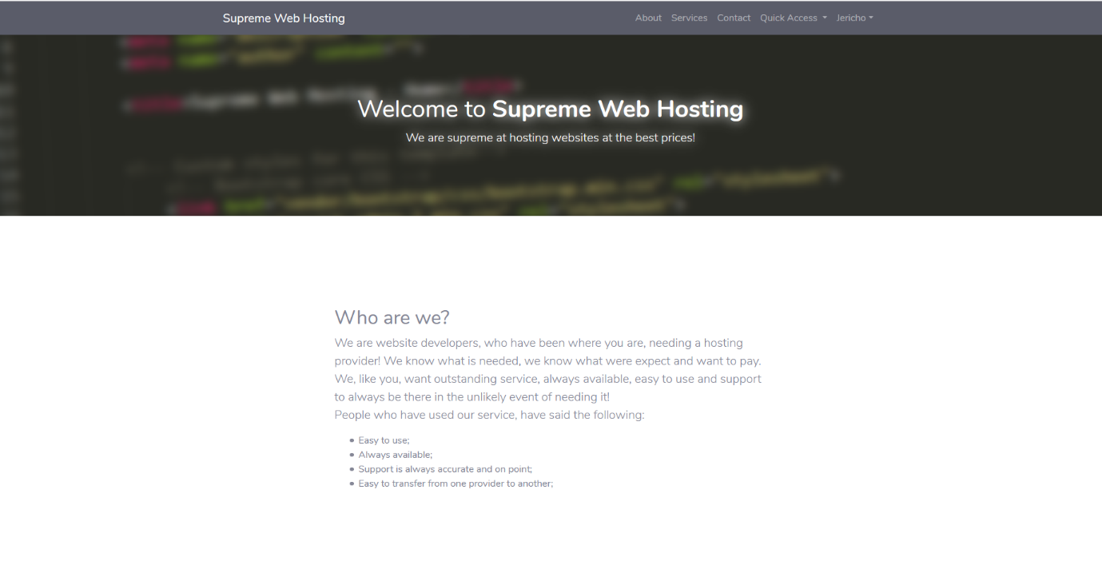
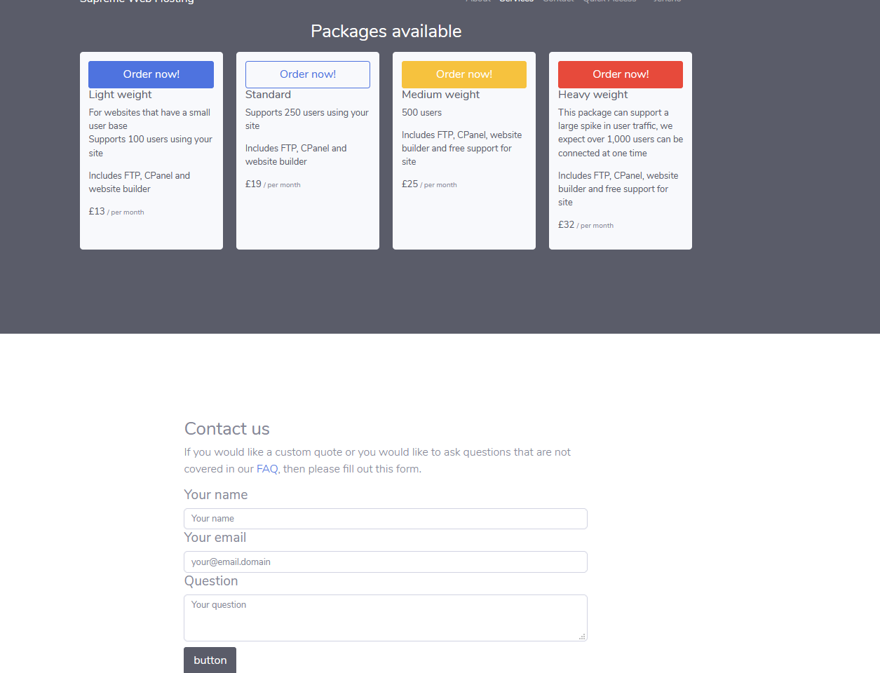
The home page has information about the site and who they are, the packages available and a contact form if needed – the contact form has some validation which will be spoken about below.

FAQ.
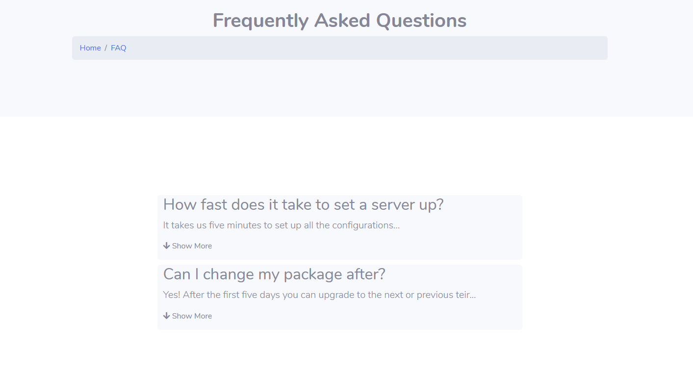
The frequently asked questions page is a page that goes over the question’s customers have asked a lot or questions the people at Supreme expect to have posed to them.
Packages.
The packages pages consist of all the available packages with a description of them and the pricing. The buy button is available for users logged in or out however purchase must be done by users logged in.

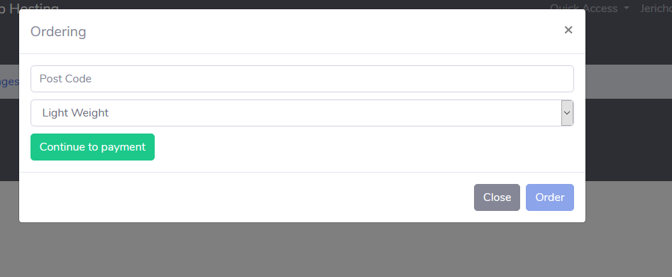
The ordering modal is just a template, the order button is disabled, the post cost does not play any role within order, once it is ready the payment can be authorised and then the order button will be ready.
The team.
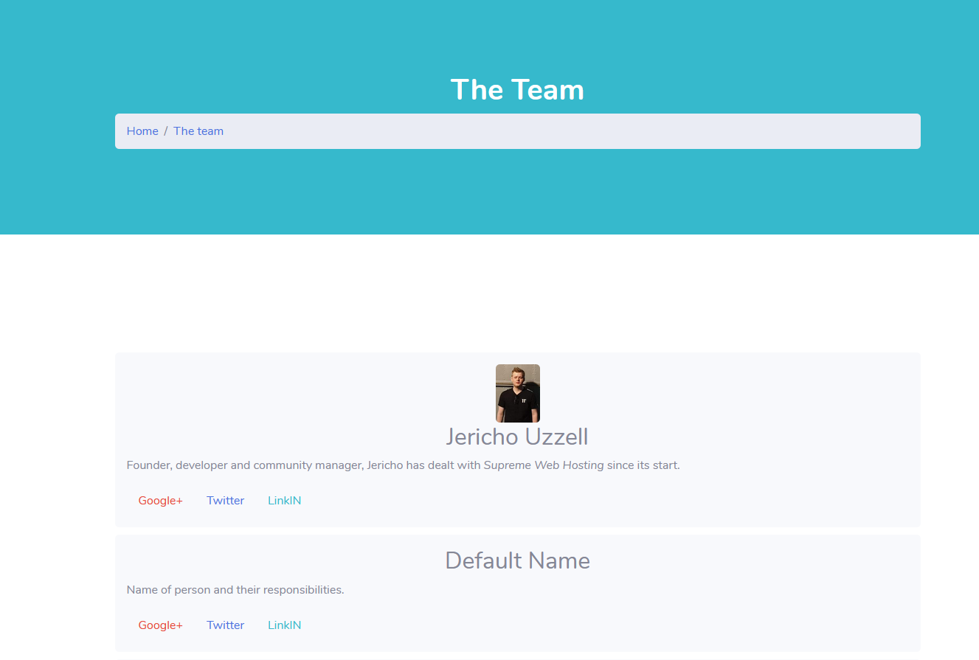
The team page is a list of the members of Supreme, any staff member, any developer etc. are listed here with a description of what they do and links to their social medias.

Social
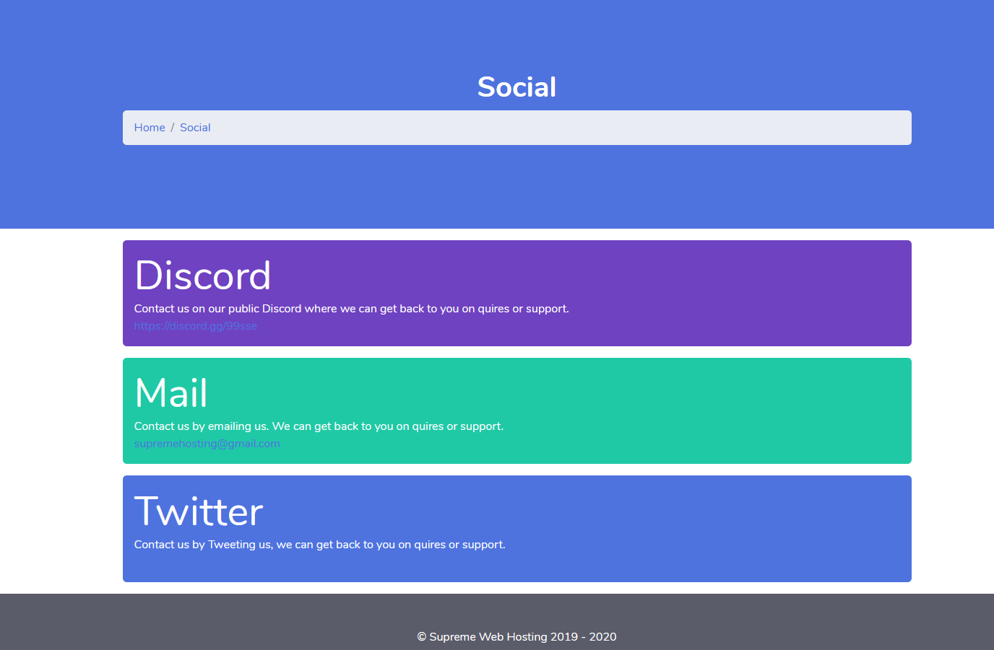
The social page is a contact us page, these are ways and means for customers or potential customers to contact Supreme, Supreme has three main ways to be contacted, Discord, Email and Twitter.

Admin
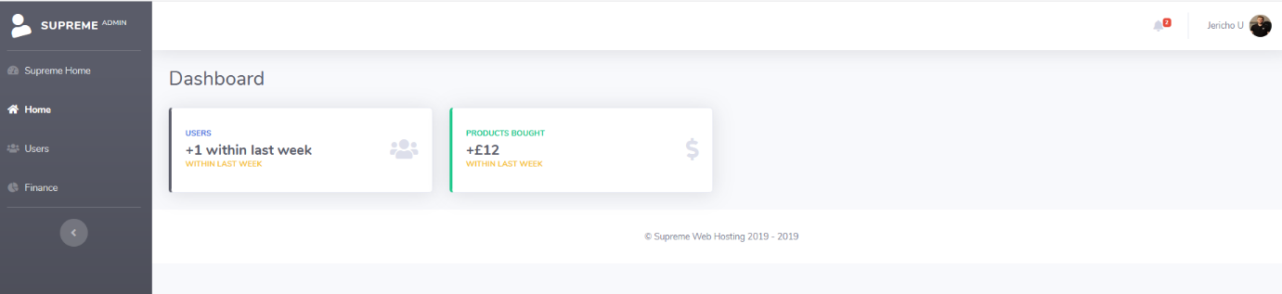
Admin pages are for staff to monitor users joining and purchases. It is also intending to expand to allow for admins to know how many users are connected to each site, offer statistics to the finance department about peak times and more. These pages can only be seen if you are logged in with admin permissions.
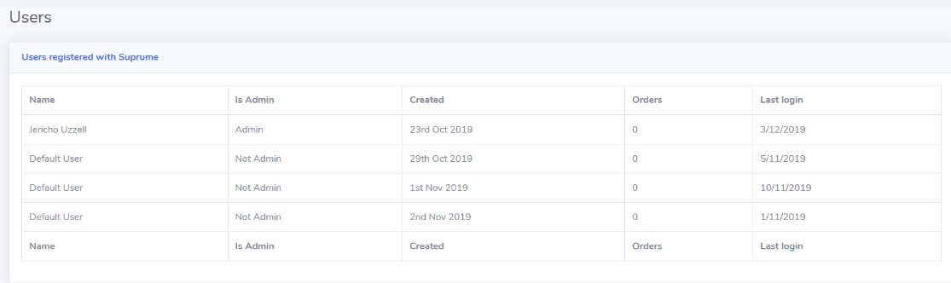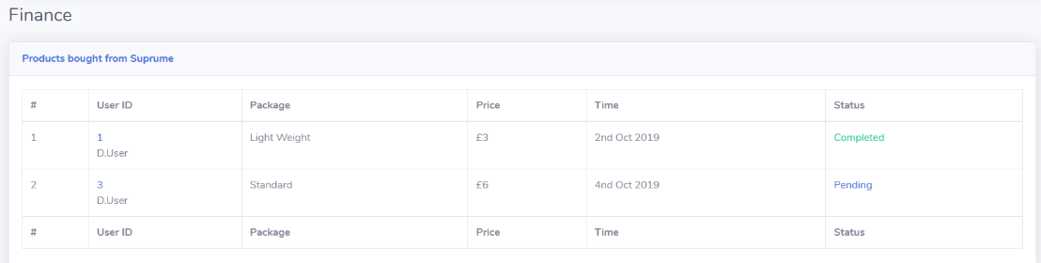

Register.
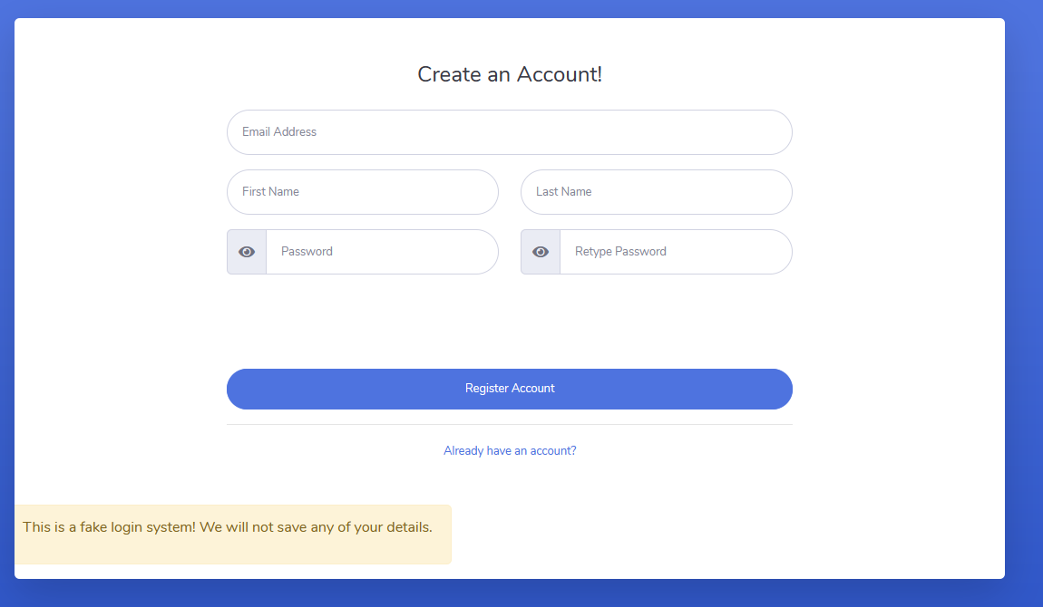
This page allows users to register to the site if they do not have an account, this page cannot be seen if you are logged in.
Login.
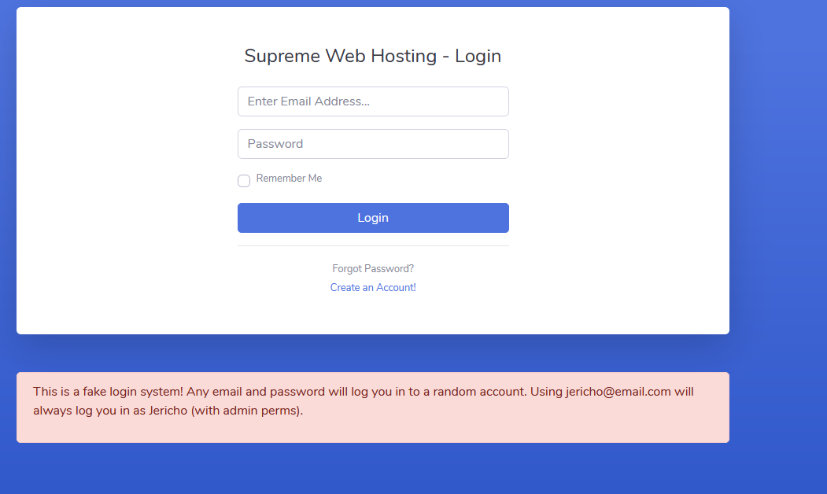
This pager allows users to login if they have an account. For the reasons of proving concept, by clicking the email at the bottom logs the user in as an admin, this page cannot be seen if you are logged in.

If you are not logged in the navigation bar changes.
The top image is when the user is not logged in, the bottom one is when they are. This shows the admin area and client area, this user is an admin so they can see the admin area – the login and register buttons are not relevant to this user so they are removed.
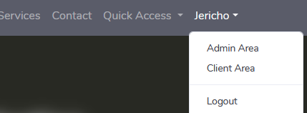
This site has very limited validation, if the name is left empty, if the email is not a valid email or the text is less than twenty characters on the contact form, then the site will inform the user of this error.
The same applies for logging in and out of the site, the page will automatically refresh you if your session has changed – this is so that it shows you the correct information, for example, if you logged in then you would want to see your client area and admin area if you have access.

3.2. Validation
Validating the html code for the index page revelled two errors, these being both related to an element known as arial-labelledby.
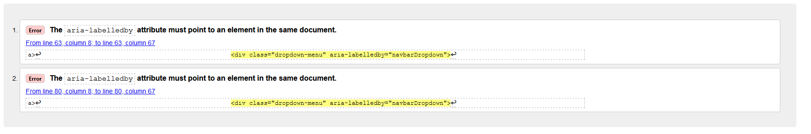
To fix this, you must have a correct and valid id that this links to label links to, in this case using the headers id of the drop-down known as loginarea fixed the second area and then adding a id to the header of the first area fixed that.
For the css, the files style and homepage were used and for both of them there was no reported issues. This is a good thing however the css files did not contain much styling as the document used a lot of the bootstraps built in features.
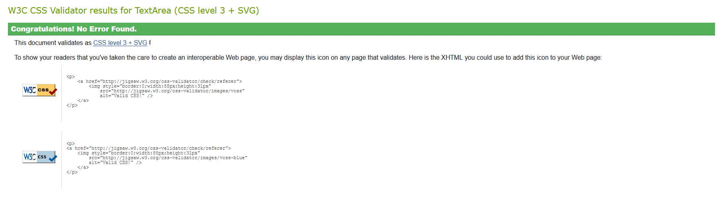

4. Evaluation

4.1. Usability
The website now is great for new and returning users. Having quick access links to the separate pages, having the information available about what Supreme is with the estimated users it could support tells potential customers and existing customers what they need to consider before purchasing a package.

The content on the site is rather brief, it is a bare bones site that is intended to show a concept of what the site could be. The site is responsive as it can support mobile, tablet and desktop devices without losing, information or accessibility. The site correctly deals with how the information is dealt with, only allowing scrolling to occur on the vertical and not the horizontal.

To improve the site, you would need to add the functionality to it, to pay for a package, to edit the site within the site and not by editing the html and by adding more content. Another to improve the site would be to offer the customer the ability to select what they wanted within their site, to support 150 users instead of going straight to 250 for more money and to pay for what you want.

4.2. Accessibility
According to [1] there are four principals to web development, these being:
- Perceivable
  - Provide text alternatives for non-text content.
  - Provide captions and other alternatives for multimedia.
  - Create content that can be presented in different ways, including by assistive technologies without losing meaning.
  - Make it easier for users to see and hear content.
- Operable
  - Make all functionality available from a keyboard.
  - Give users enough time to read and use content.
  - Do not use content that causes seizures or physical reactions.
  - Help users navigate and find content.
  - Make it easier to use inputs other than keyboard.
- Understandable
  - Make text readable and understandable.
  - Make content appear and operate in predictable ways.
  - Help users avoid and correct mistakes.
- Robust
  - Maximize compatibility with current and future user tools.

Perceivable principle, within this site, there are not many images to replace the text as the site is mostly text, where we could see pictures of servers or something that could resemble each package, the site just offers text and a small run down of that package.
Moving away from not having many images, the site does not have any graphs to display performance of a package – with this said the site does off some tables for administrators to view users and finances. The site could offer a text to speech functionality, but nothing is offered or hinted at to be worked on.

The operable principles are to allow functionality to be used on a keyboard, which this site offers. Input fields to contact the site, login forms and so on offer the same function, however on the FAQ page the site does not offer an alternative to open all hidden fields, instead you must click the show more button. The site does offer enough time for users/customers to read text as no redirects happen unless you have logged in/logout and there is another tab opened of the same site, this simply refreshes to show the logged in/logout version of you.
Other parts of the operable principle are not used, the site is plain and offers no videos or other functions that could cause the user to have a physical reaction, helping users to find content is not a feature but due to the size of the site the content is not that difficult to find – with this said on the main home page if you click on a package it does redirect you and selects the package you wanted to buy. The last is to make inputs easier to use other than keyboard which the site does even though it is not much.

The next principle is understandable which covers the readable and understanding of text/content, Supreme has managed to make their site understandable and readable, but not having colours that make reading text almost impossible and having customers and users who have never used the site, use it and to give feedback. I we said before, not much happens in this site however, the user knows that the text they click on will be a redirect which they would expect, there are no images or text that is out of place and once clicked it takes you somewhere you do not want to be. Further, once you do click on to buy something the user does expect some sort of dialog to pop up or a redirect.

The last principle is robust which is the use of current tools to make compatibility best, this can be to use the latest css and css that would work across different browser’s, this applies to html and ensuring that there are no code errors.

4.3. Search engines
SEO techniques applied to supreme and examples of them applied.
According [2] they say that search engine optimization (SEO) can often mean to make small edits to your website, they advise to create a “robots.txt” with instructions for robots to either “crawl” your site or not too. They also suggest that your site should not allow results crawled by a search engine to land you onto a search page, instead to take you directly to the content.
Within Supreme, they do not have a search feature so they do not need to worry about that, however adding the robots text file can help link other pages to search engines such as the products, contact us page so on.

[2] goes on to say that having correct titles can help snippets of search results, by having “Home – Supreme” or “Products – Supreme” is best instead of having “new site” and to stay away from using the same title access each page. Sticking with the head element, adding a description, author and what browsers the site supports is something the search engine can use, telling the person who searched, the authors and description of the site and also whether if it should display that search result if that site can support the browser.
To compare this with Supreme, they have unique titles, the description is set and authors field is also filled in. They do not have what browsers the site is compatible with however that is something they could do to enhance their SEO.

[2] also states that having a navigation bar can help users navigate the site, following a natural flowing hierarchy, to avoid linking every single page on the site and navigations based off images or animations
Supreme does list all of the pages does not require you to be logged in, however pages that are not relevant to said user, whether due to them no being logged in or not having relevant permissions are not shown.

Last, speaking about images, [2] states that using the elements img or picture is best practice, use attributes such as loading to make page load faster, use the alt attribute if the image is not found, this can offer what the image should have been. They go on to say to not use name images like “image1.jpg” if your site has a lot of images, even so they say not to write extremely long file names or to copy and paste sentences into alt text, it should be brief.
Supreme does not use that many images, however it does incorporate the alt attribute and the naming convention does follow the gist of the image.

5. References
[1] Shawn Lawton Henry and Wayne Dick, “WCAG 2.1 at a Glance”, 5 June 2018 [Online]. Available: http://www.w3.org/WAI/standards-guidelines/wcag/glance/ [Accessed 07 January 2020]
[2] Google, “Search Engine Optimization (SEO) Starter Guide)”, 2020 [Online]. Available: https://support.google.com/webmasters/answer/7451184?hl=en [Accessed 07 January 2020]

