University of Wales Trinity Saint David

Design Portfolio - Systems Thinking Design Report
ACDA 5021: Level 5 Systems Engineering

Name - Luke Brown (ID-2309075)
Course – Ordnance, Munitions and Explosives (OME)
Lecturer – Dave Holley
Submission Deadline – 4th May 2026

Table of Contents:

Section 1 – Introduction

  - Background of the operational scenario ………………………………………………………. (Page 1)
  - Role of test and evaluation within the design team ……………………………………… (Page 1)
  - Scope of the report ……………………………………………………………………………………… (Page 2)

Section 2 – Systems thinking approach

  - Overview of systems engineering methodology …………………………………………… (Page 2)
  - Relevance of systems thinking to the mine clearance problem …………………….. (Page 3)
  - Integration with other team functions …………………………………………………………. (Page 3)

Section 3 – Key customer requirements

  - Identification of stakeholders ………………………………………………………………………. (Page 3)
  - Operational requirements ……………………………………………………………………….. (Pages 3-4)
  - Derived test and evaluation requirements …………………………………………………… (Page 4)
  - Requirements importance ranking ………………………………………………………………. (Page 5)

Section 4 – Critical system functionality

  - Functional breakdown of the system ……………………………………………………………. (Page 5)
  - Test and evaluation functions ………………………………………………………………………. (Page 6)
  - Functions importance ranking ……………………………………………………………………… (Page 6)

Section 5 – Concept derivation and design choices

  - Overview of considered concepts ……………………………………………………………. (Pages 7-8)
  - Selection of the drone-based approach …………………………………………………… (Pages 8-9)
  - Test and evaluation input into design choices ………………………………………………. (Page 9)

Section 6 – Potential failure modes

  - Identification of failure modes ………………………………………………………………. (Pages 9-10)
  - Impact on mission success …………………………………………………………………………. (Page 10)
  - Testing strategies to identify and mitigate failures ……………………………………… (Page 11)

Section 7 – Critical design features

  - Type of carrier system ……………………………………………………………………………….. (Page 11)
  - Mine detection mechanism …………………………………………………………………. (Pages 11-12)
  - Mine defeat mechanism …………………………………………………………………………….. (Page 12)
  - Safety features for operators and civilians…………………………………………………… (Page 13)
  - Design features driven by test outcomes ……………………………………………………. (Page 13)

Section 8 – Manufacturing process

  - Requirements and functions for manufacturing ………………………………….. (Pages 13-14)
  - Overview of considered techniques …………………………………………………………… (Page 14)
  - Selection of the hybrid approach ……………………………………………………………….. (Page 15)
  - Manufacturing techniques and controls …………………………………………………….. (Page 16)

Section 9 – Critical process steps

  - System assembly ………………………………………………………………………………………… (Page 17)
  - Pre-deployment testing procedures …………………………………………………………… (Page 17)
  - Field deployment process ………………………………………………………………………….. (Page 17)
  - Post operation validation …………………………………………………………………………… (Page 17)

Section 10 – Process control measures

  - Quality assurance in manufacturing …………………………………………………………… (Page 18)
  - Operational safety controls ………………………………………………………………………… (Page 18)
  - Testing protocols and acceptance criteria …………………………………………………….(Page 18)

Section 11 – Waste and end of life disposal

  - Disposal techniques for explosive material ………………………………………………… (Page 18)
  - Disposal techniques for non-explosive equipment ……………………………………… (Page 19)
  - Environmental considerations in mine clearance ……………………………………….. (Page 19)

Section 12 – Conclusion

  - Summary of key findings ……………………………………………………………………………. (Page 19)
  - Effectiveness of the proposed system ………………………………………………………… (Page 19)
  - Final remarks on systems thinking application …………………………………………… (Page 20)

Section 13 – References

  - All referenced citations …………………………………………………………………………. (Page 20-21)

List of Figures:

Figure 1 – Rocky desert environment [2] …………………………………………………………………. (Page 1)
Figure 2 – V-model [5, p. 254] …………………………………………………………………………………. (Page 2)
Figure 3 – Generic requirements pairwise result ……………………………………………………… (Page 5)
Figure 4 – T&E requirements pairwise result …………………………………………………………… (Page 5)
Figure 5 – Generic functions QFD 1 result ……………………………………………………………….. (Page 6)
Figure 6 – T&E functions QFD 1 result ……………………………………………………………………… (Page 6)
Figure 7 – Generic design feature QFD 2 result ……………………………………………………….. (Page 9)
Figure 8 – Generic system P diagram …………………………………………………………………….. (Page 10)
Figure 9 – Generic system control factors importance result …………………………………. (Page 10)
Figure 10 – Generic system noise factors importance result …………………………………. (Page 10)
Figure 11 – Manufacturing functions QFD 1 result ………………………………………………… (Page 14)
Figure 12 – Manufacturing design feature QFD 2 result ………………………………………… (Page 15)
Figure 13 – Manufacturing processes QFD 3 result ………………………………………………… (Page 16)
Figure 14 – Manufacturing quality controls QFD 4 result ………………………………………. (Page 16)

List of Tables:

Table 1 – Generic requirements set …………………………………………………………………………. (Page 4)
Table 2 – T&E requirements set ………………………………………………………………………………. (Page 4)
Table 3 – Generic functions ……………………………………………………………………………………… (Page 5)
Table 4 – T&E functions …………………………………………………………………………………………… (Page 6)
Table 5 – Flail system FMA ………………………………………………………………………………………. (Page 7)
Table 6 – Plow system FMA …………………………………………………………………………………….. (Page 7)
Table 7 – Tumbleweed system FMA ………………………………………………………………………… (Page 7)
Table 8 – Drone system FMA …………………………………………………………………………………… (Page 8)
Table 9 – Generic system Pugh matrix …………………………………………………………………….. (Page 8)
Table 10 – Generic system FMEA …………………………………………………………………………….. (Page 9)
Table 11 – Carrier system comparison …………………………………………………………………… (Page 11)
Table 12 – Mine detection comparison …………………………………………………………………. (Page 12)
Table 13 – Mine defeat comparison ………………………………………………………………………. (Page 12)
Table 14 – Manufacturing requirements set ………………………………………………………….. (Page 13)
Table 15 – Hybrid system FMA ………………………………………………………………………………. (Page 14)
Table 16 – Manufacturing Pugh matrix ………………………………………………………………….. (Page 15)

Section 1 - Introduction:

1.1- Background of the operational scenario:

The operational scenario involves a humanitarian aid mission requiring a ground convoy to traverse a hazardous desert cliff pass contaminated with anti-personnel [1, p. 14] and anti-vehicle [1, p. 31] mines. A MANPAD threat prohibits aerial support, while vehicle constraints limit transport to light platforms such as pickup trucks. Due to the risk of terrorist capture, only limited explosives are permitted. The mission objective is to safely clear and maintain a route for repeated aid deliveries to isolated civilians in challenging terrain, as shown in Figure 1, cited in [2].


Figure 1 - Rocky desert environment [2]

1.2- Role of test and evaluation within the design team:

Test and evaluation (T&E) plays a critical role in validating that the proposed system meets operational requirements and performs reliably within the defined constraints [3]. Within the design team, T&E supports research and development (R&D) by verifying concept feasibility, informs manufacturing through identification of tolerances and quality requirements, assists the safety team by quantifying risk and failure modes and guides the disposal team by assessing end of life considerations and system behaviour after use.

1.3- Scope of the report:

This report outlines the application of systems thinking to the development of a drone-based mine clearance solution within the defined operational scenario. It examines key design considerations, system functionality and constraints, while demonstrating how systems engineering tools support design decisions, validation and mission effectiveness, with particular emphasis on the role of T&E.

Section 2 - Systems thinking approach:

2.1- Overview of systems engineering methodology:

Systems engineering methodology provides a structured, iterative approach to developing complex systems by integrating stakeholder requirements, functional analysis and design synthesis. It ensures that all subsystems operate cohesively while addressing constraints, risks and performance objectives. This approach supports informed decision making throughout the lifecycle, from concept development to validation and deployment, improving overall system effectiveness and reliability [4]. The V-model systems engineering framework can be utilised to structure the development process, as illustrated in Figure 2, cited in [5, p. 254].

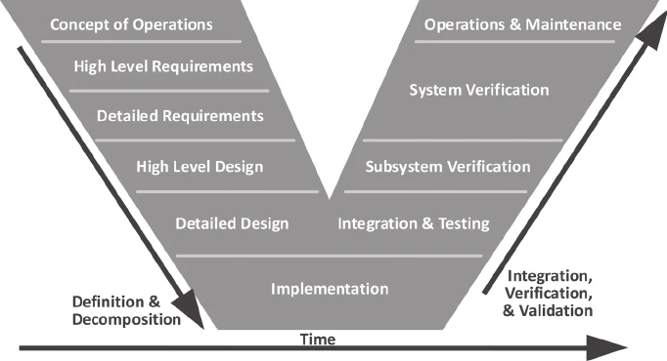
Figure 2 - V-model [5, p. 254]

2.2- Relevance of systems thinking to the mine clearance problem:

Systems thinking is highly relevant to the mine clearance problem due to the complex interaction between detection, neutralisation and operational constraints. It enables a holistic understanding of how subsystems, such as drones, sensors and deployment mechanisms, function together within a hazardous environment. This approach supports the identification of risks, interdependencies and trade-offs, ensuring a safe, efficient and sustainable route clearance solution.

2.3- Integration with other team functions:

Systems engineering ensures effective integration between team functions by providing structured tools such as requirement traceability, interface management and functional decomposition. These enable clear definition and control of interactions between subsystems and teams. This approach ensures alignment of design decisions, minimises integration risk and maintains consistency across all engineering functions [6].

Section 3 - Key customer requirements:

3.1- Identification of stakeholders:

Stakeholders were identified using a systems thinking approach, analysing all parties interacting with or affected by the system across its lifecycle. Key stakeholders include the Ministry of Defence (MoD), end users, logistics teams, manufacturing, civilians, T&E, R&D and disposal teams, each influencing requirements and design decisions.

3.2- Operational requirements:

Operational requirements were structured hierarchically, with Level 1 defining high-level needs and Level 2 breaking these into measurable requirements. This ensures clear understanding of stakeholder needs before design begins. For example, a “safe route created and indicated” satisfies MoD verification and civilian aid access, translated into mine clearance and clearly marked pathways. This is visualised in Table 1.
Table 1 - Generic requirements set
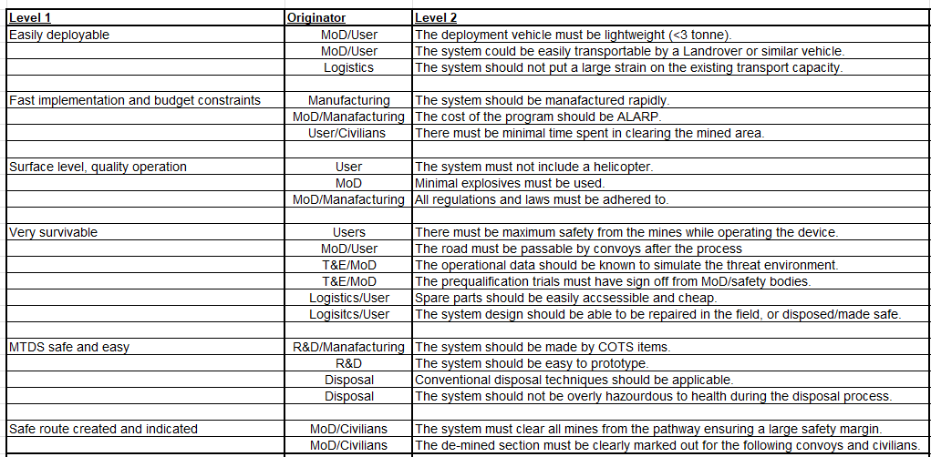

3.3- Derived test and evaluation requirements:

Derived T&E requirements follow the same hierarchical structure, translating high-level verification needs into measurable criteria. Level 1 defines assessment areas, while Level 2 specifies quantifiable metrics, such as detection probability>0.99. This ensures system performance can be objectively validated through structured trials, supporting requirement compliance, risk reduction and operational confidence. This is seen in Table 2.

Table 2 - T&E requirements set
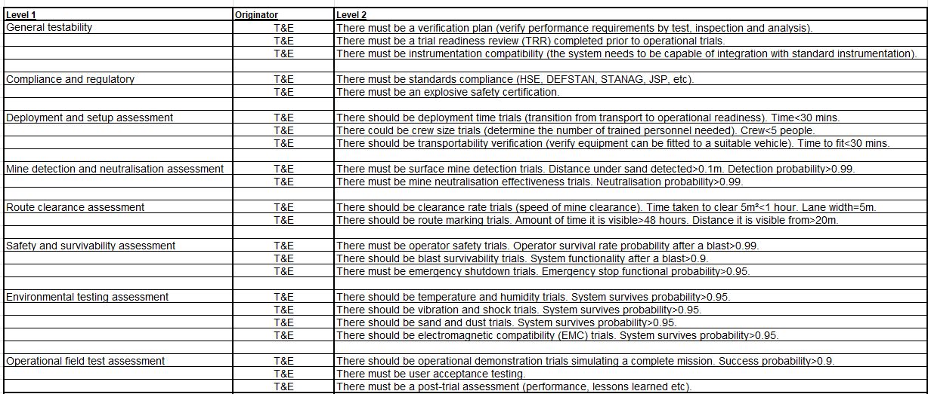

3.4- Requirements importance ranking:

Requirements importance was determined using a pairwise comparison, where each requirement is systematically compared against others to establish relative priority. This process produces a weighted ranking, highlighting the most critical requirements [7, p. 1704]. These high-ranking areas can then be prioritised during generic design (Figure 3) and T&E (Figure 4), ensuring focus on performance aspects most critical to mission success.

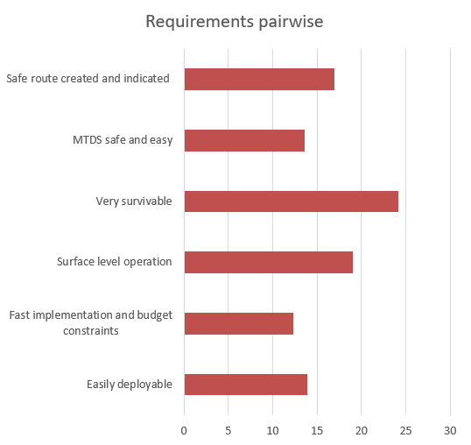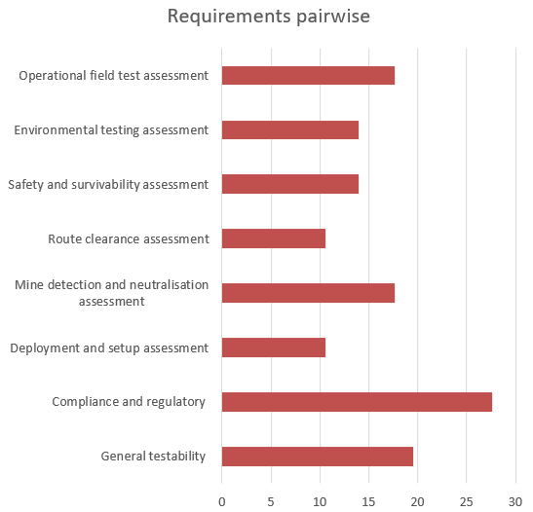
Figure 3 - Generic requirements pairwise result Figure 4 - T&E requirements pairwise result

Section 4 - Critical system functionality:

4.1- Functional breakdown of the system:

Functional breakdown defines what the system must do to meet the identified requirements. For the generic system, functions are derived from Level 1 requirements, translating stakeholder needs into clear system actions. Their purpose is to structure the design and ensure all requirements are addressed. Functional metrics are included in the “how much” column to quantify performance, as shown in Table 3.

Table 3 - Generic functions
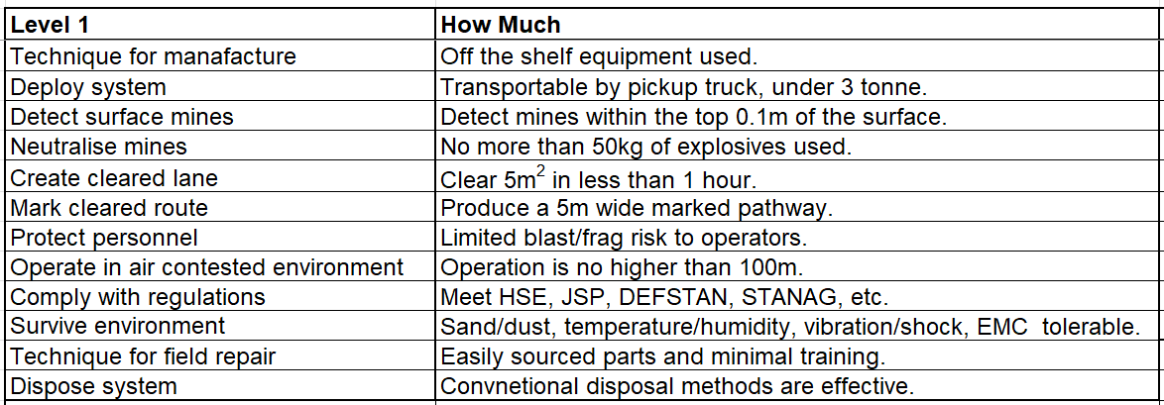
4.2- Test and evaluation functions:

T&E functions define the activities required to verify system performance and compliance. Derived from requirements, they focus on planning tests, assessing performance and validating operational effectiveness. These functions are structured similarly to the generic system functions, with Level 1 tasks and “how much” criteria, as shown in Table 4. More detailed functional metrics were captured within the requirements, ensuring measurable and objective evaluation of system performance.

Table 4 - T&E functions
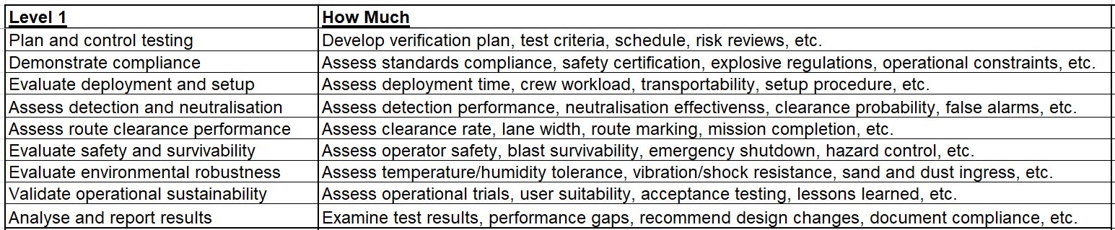

4.3- Functions importance ranking:

Function importance was determined using Quality Function Deployment (QFD 1), a structured method that maps customer requirements against system functions to identify those most critical to overall performance. This enables prioritisation of key functions for further design focus and evaluation [8]. The graphical results are presented in Figure 5 for the generic system and Figure 6 for the T&E functions, indicating that survivability, detection and neutralisation are of highest importance.

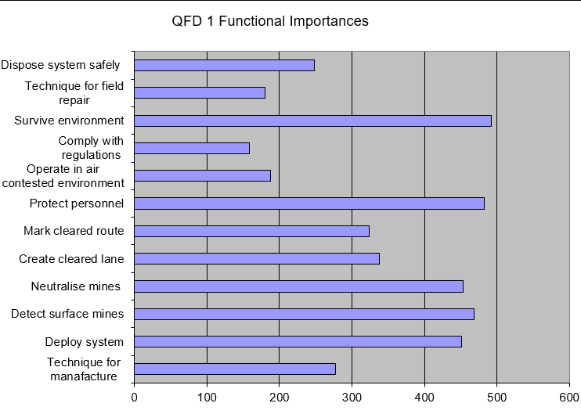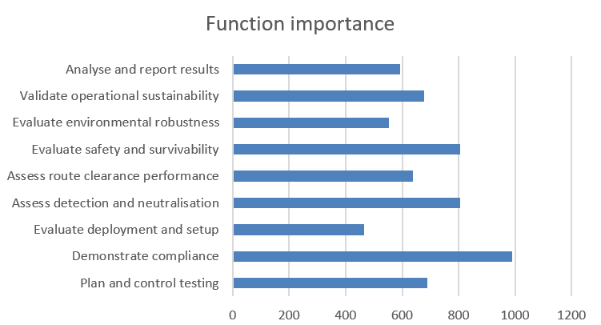
Figure 5 - Generic functions QFD 1 result Figure 6 – T&E functions QFD 1 result

Section 5 - Concept derivation and design choices:

5.1- Overview of considered concepts:

Function Means Analysis (FMA) was used to generate and evaluate potential solutions by linking system functions to possible means of achieving them. Its purpose is to explore multiple design concepts before selection. Concepts considered included a flail system (Table 5), plow system (Table 6), tumbleweed concept (Table 7) and a drone-based solution (Table 8).

Table 5 - Flail system FMA
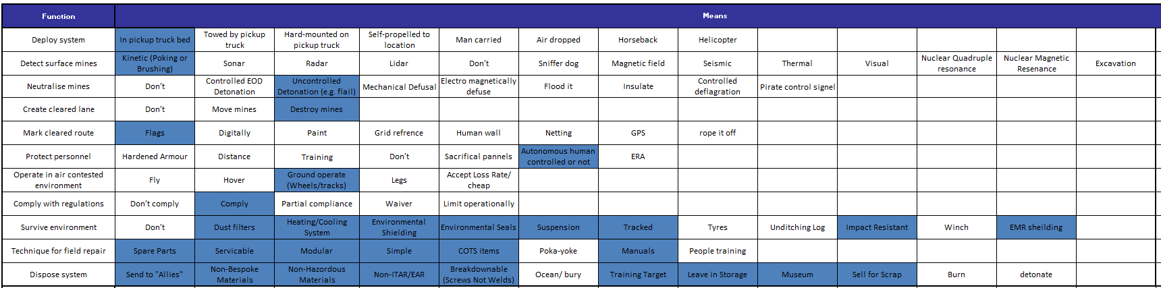

Table 6 - Plow system FMA
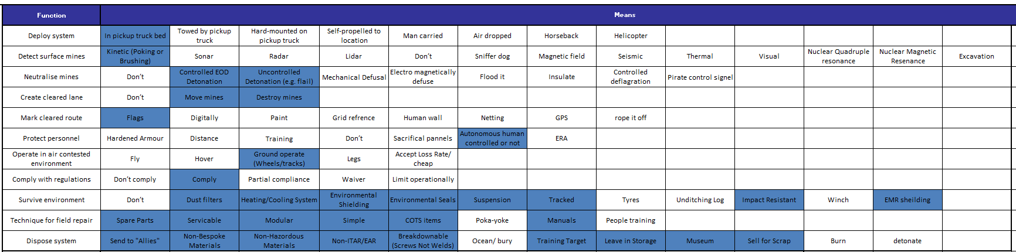

Table 7 - Tumbleweed system FMA
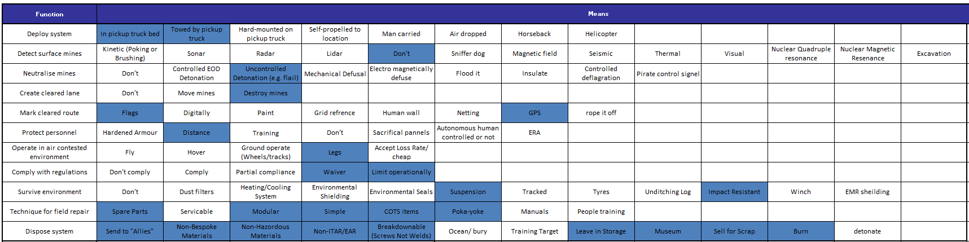
Table 8 - Drone system FMA
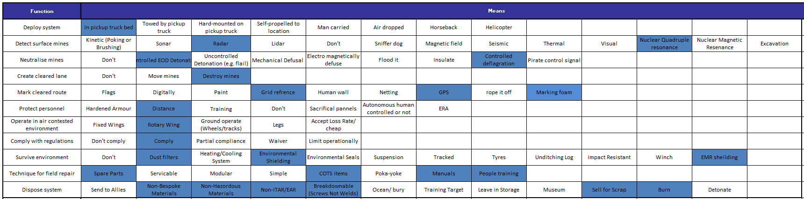

5.2- Selection of the drone-based approach:

A Pugh matrix was used to compare concepts against an EOD specialist baseline, scored as zero. Weightings were taken from the earlier pairwise analysis. Flail and plow concepts performed well but were limited by weight, while the tumbleweed may not reliably detonate anti-vehicle mines. The drone concept achieved the highest score and was selected, as shown in Table 9.

Table 9 - Generic system Pugh matrix
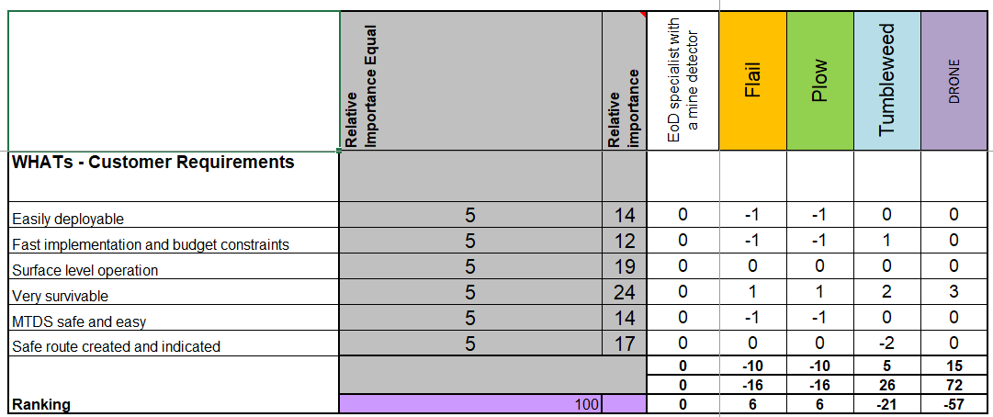

Design feature importance was determined using Quality Function Deployment (QFD 2), a structured method that maps system functions and requirements against specific design features to identify those most critical to overall performance. This enables prioritisation of key design elements for further refinement and development [8]. The graphical results are presented in Figure 7, indicating that regulatory compliance, mine neutralisation and system robustness are of highest importance.

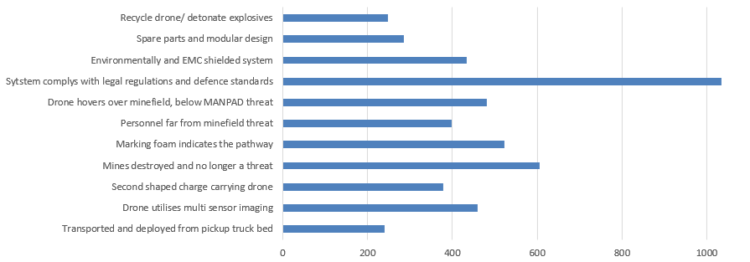
Figure 7 - Generic design feature QFD 2 result

5.3- Test and evaluation input into design choices:

T&E influenced design selection by informing the weighting of requirements used within the Pugh matrix and defining measurable performance criteria for QFD 2. This ensured the drone concept was prioritised based on testable performance, such as detection accuracy, survivability and operational effectiveness.

Section 6 - Potential failure modes:

6.1- Identification of failure modes:

Failure Modes and Effects Analysis (FMEA) was conducted to systematically identify potential failure modes, their causes and effects on system performance. This enables risks to be mitigated or designed out using the hierarchy of controls [9]. In this context, FMEA improves safety and reliability of the drone system, as shown in Table 10.

Table 10 - Generic system FMEA
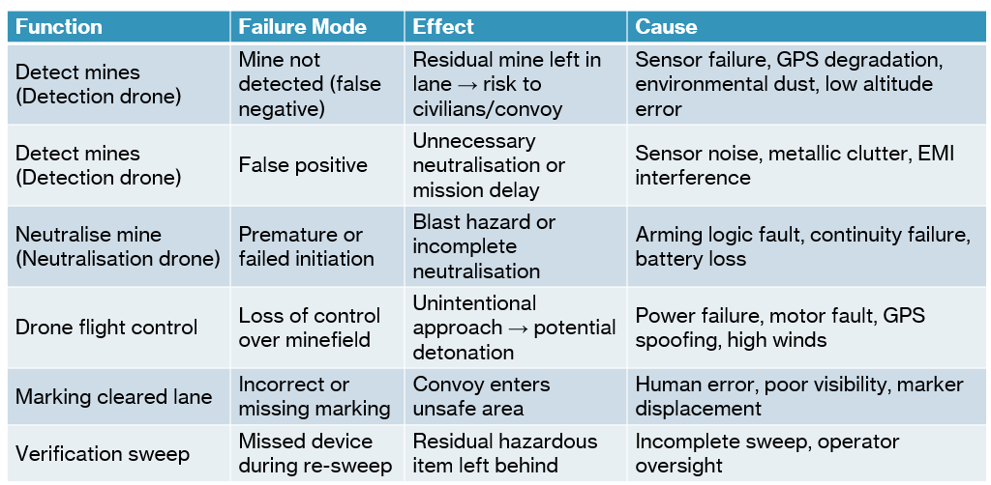
A P diagram (Figure 8) identifies signal inputs, system outputs, control factors (design variables) and noise factors (uncontrolled influences). A ‘What Why’ analysis was then used to rank these, producing control (Figure 9) and noise factor charts (Figure 10). This highlights key drivers of performance and potential failure, guiding design focus.

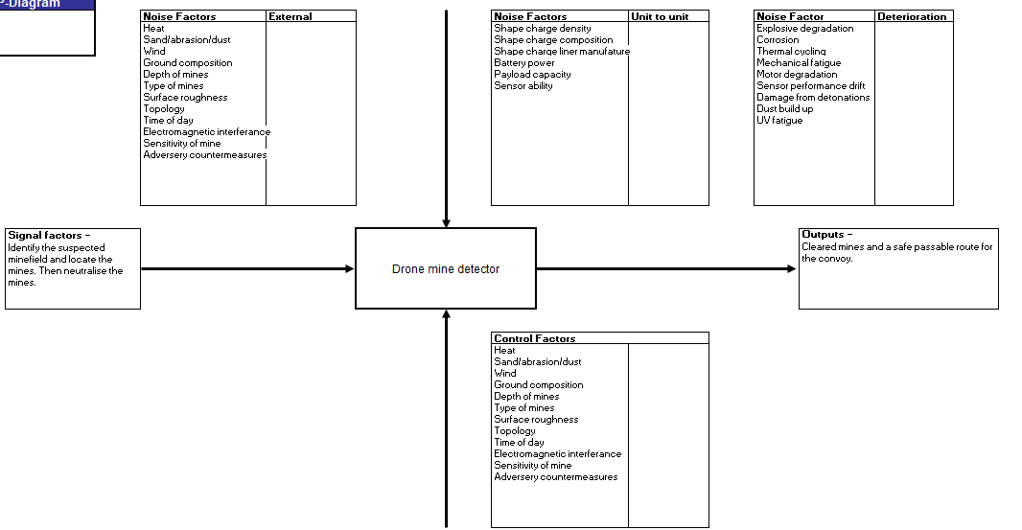

Figure 8 - Generic system P diagram

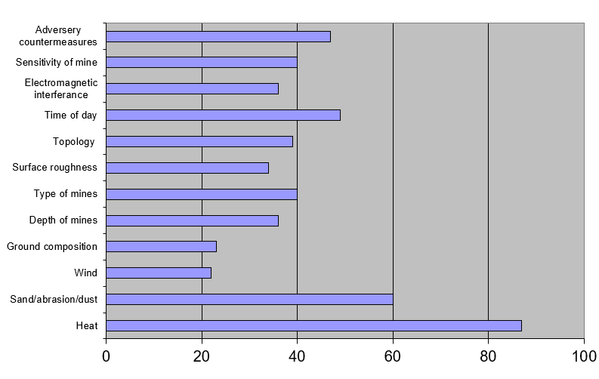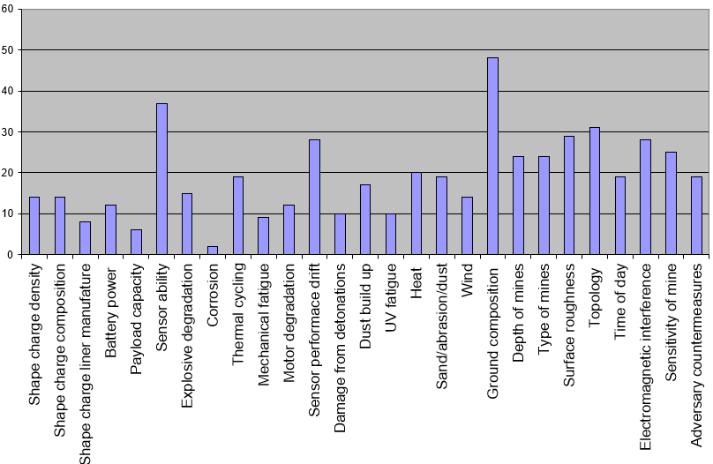
Figure 9 - Generic system control factors importance result Figure 10 - Generic system noise factors importance result

6.2- Impact on mission success:

Failure modes identified through FMEA directly impact mission success by affecting safety, reliability and operational effectiveness. Undetected mines or failed neutralisation increase risk to civilians and convoys, while system failures may delay clearance. Additionally, key noise and control factors influence system performance, and if not properly managed, can increase the likelihood of failure and reduce overall mission effectiveness.
6.3- Testing strategies to identify and mitigate failure:

Testing strategies were developed to identify and mitigate failure modes through structured trials, including detection accuracy tests, neutralisation effectiveness trials and environmental testing. These tests validate system performance under realistic conditions, allowing issues to be identified early and mitigated through design improvements, calibration and operational controls.

Section 7 - Critical design features:

7.1- Type of carrier system:

A comparison (Table 11) was conducted to select the most suitable carrier system. Due to differing subsystem requirements, a dual-platform approach was adopted. 10-inch FPV drones were selected for shaped charge deployment due to agility and low cost [10], while heavy lift commercial drones were chosen for sensor deployment due to stability and high payload capacity [11].

Table 11 - Carrier system comparison
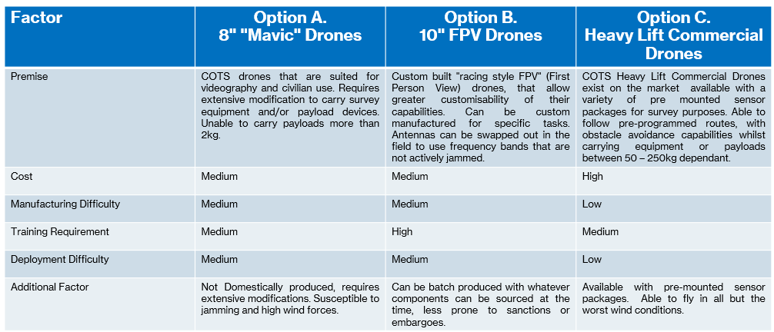

7.2- Mine detection mechanism:

A comparison of detection methods (Table 12) was conducted between Nuclear Quadrupole Resonance (NQR), Ground Penetrating Radar (GPR) and metal detection. A dual sensor approach using GPR [12] and NQR [13] was selected, utilising EM and RF wave emissions to detect subsurface density and conductive discrepancies, improving detection reliability across varying mine types.
Table 12 - Mine detection comparison
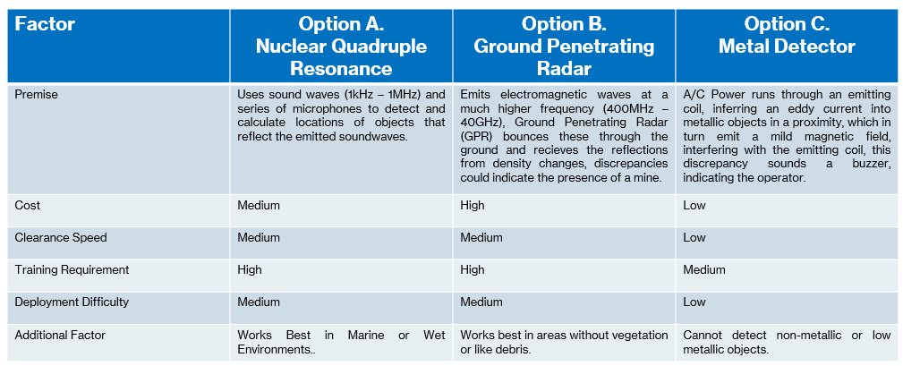

7.3- Mine defeat mechanism:

A comparison of mine defeat mechanisms (Table 13) was conducted between melt-cast, pressed powder and plastic bonded shaped charges. A shaped charge solution was selected, with melt casting chosen for the explosive fill, deployed by drone and initiated via a detonator with a firing line. This enables precise, successful neutralisation of mines while minimising collateral damage and supporting controlled, repeatable clearance operations.

Table 13 - Mine defeat comparison
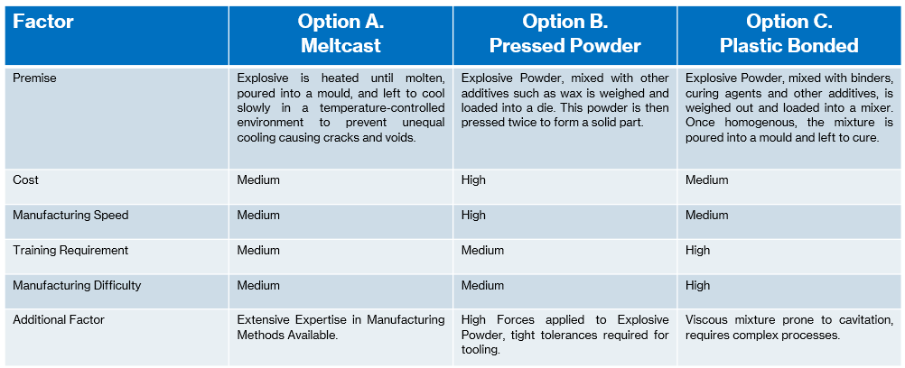

7.4- Safety features for operators and civilians:

Safety features were incorporated to protect operators and civilians, including remote drone operation to maintain safe standoff distances, controlled detonation using firing lines and minimised explosive quantities. Additional measures include clear route marking, fail-safe mechanisms and system shutdown procedures, ensuring safe clearance operations and reducing risk to personnel and surrounding areas.

7.5- Design features driven by test outcomes:

Test results are fed back into R&D and manufacturing to inform redesign activities. The updated design is then reintroduced to testing to verify performance improvements. This iterative loop continues, with pass/fail data analysed to identify weaknesses and drive progressive, evidence-based design refinements.

Section 8 - Manufacturing process:

8.1- Requirements and functions for manufacturing:

Table 14 presents the manufacturing requirement set. Defining these requirements is essential to ensure efficient production, maintain quality standards and guarantee the final product meets design and performance expectations.

Table 14 - Manufacturing requirements set
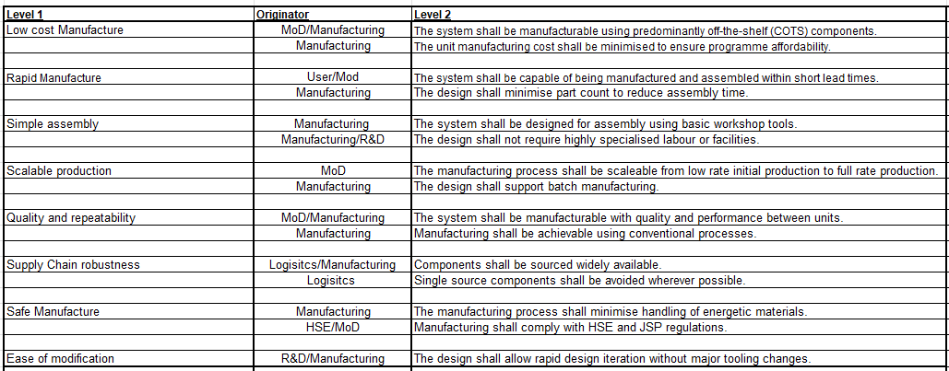

Figure 11 presents the Manufacturing QFD 1 result after the key functions had been defined. In practice, more detailed requirement and function sets would be developed for each in-house manufacturing element, such as shaped charges and other critical subcomponents, to ensure accuracy, quality control and performance consistency.
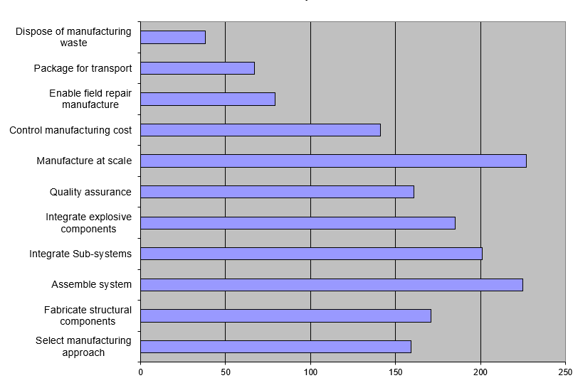
Figure 11 - Manufacturing functions QFD 1 result

8.2- Overview of considered techniques:

FMA was used to explore manufacturing techniques by linking required functions to possible methods. While multiple FMAs were considered, including COTS and bespoke approaches, only the hybrid FMA is presented in Table 15. In practice, this process would be repeated for each manufacturing stage or component.

Table 15 - Hybrid system FMA
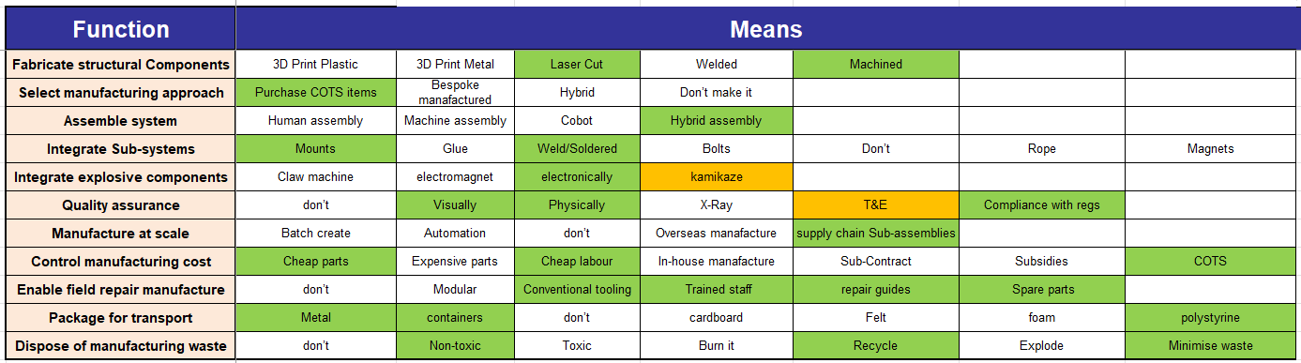

8.3- Selection of the hybrid approach:

A Pugh matrix (Table 16) was used to compare manufacturing approaches. The hybrid solution achieved the highest ranking and was therefore selected for implementation.

Table 16 - Manufacturing Pugh matrix
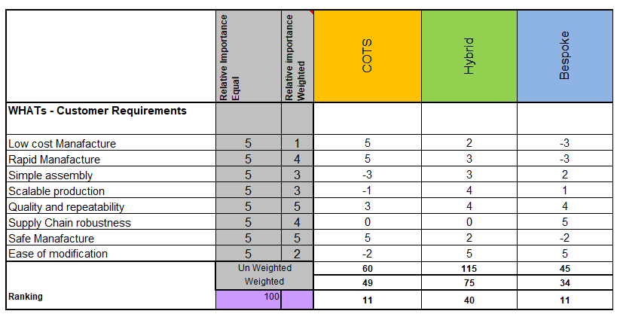

Figure 12 presents the manufacturing QFD 2 results, where higher scores indicate more critical design features, enabling prioritisation of key areas such as compliance, COTS use and hybrid assembly.

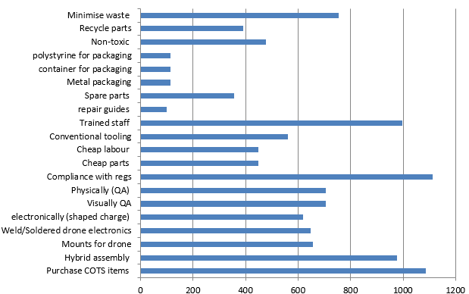
Figure 12 - Manufacturing design feature QFD 2 result
8.4- Manufacturing techniques and controls:

QFD 3 translates key design features into manufacturing processes, identifying the most critical techniques required for production [14]. Results show mechanical assembly and integration as dominant processes, guiding focus toward robust and repeatable manufacturing methods, as seen in Figure 13.

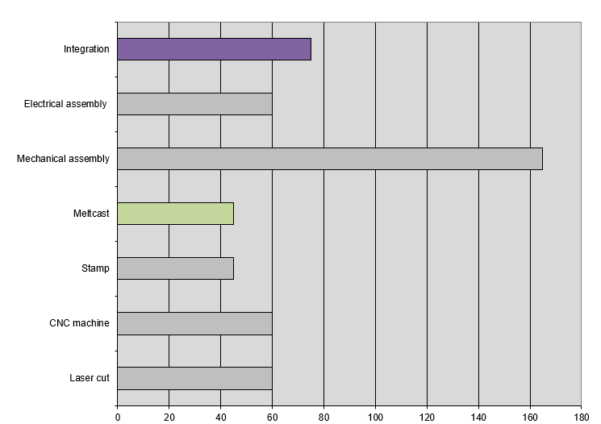
Figure 13 - Manufacturing processes QFD 3 result

QFD 4 maps these processes to quality controls, defining inspection and testing requirements [14]. Results highlight mass verification, RF testing and geometry inspection as critical, ensuring product quality and compliance throughout manufacturing, as seen in Figure 14.

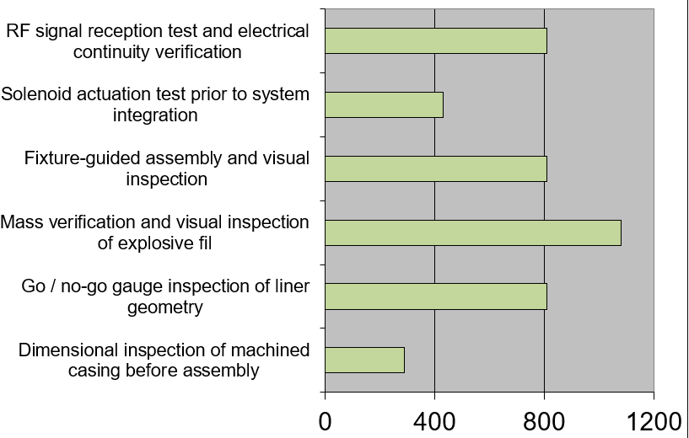
Figure 14 - Manufacturing quality controls QFD 4 result
Section 9 - Critical process steps:

9.1- System assembly:

System assembly involves manufacturing, integrating and calibrating all components to ensure correct functionality. This includes mechanical and electrical assembly, sensor integration and verification of system interfaces. Calibration ensures detection accuracy and control reliability, providing a fully operational system ready for deployment and subsequent testing.

9.2- Pre-deployment testing procedures:

Pre-deployment testing procedures are structured in three phases. Phase 1 validates individual components, including sensors, drone platforms, shaped charges and safety systems. Phase 2 focuses on subsystem integration and communication. Phase 3 involves controlled system trials, assessing detection, neutralisation, operational procedures and environmental performance prior to deployment [3].

9.3- Field deployment process:

Field validation represents the final testing phase 4, involving operational field trials under realistic conditions. This includes environmental performance validation, human factors assessment and safety verification. These activities ensure the system performs effectively in real-world scenarios, confirming readiness for deployment and identifying any remaining limitations prior to operational use [3].

9.4- Post operation validation:

Post operation validation involves assessing system performance after mission completion to ensure all objectives were achieved. This includes confirming complete mine clearance, verifying route safety and reviewing system reliability. Data analysis and lessons learned are used to identify improvements, supporting continuous refinement of design, procedures and future operational effectiveness.

Section 10 - Process control measures:

10.1- Quality assurance in manufacturing:

Quality assurance in manufacturing ensures components meet specified standards and performance requirements through inspection, testing and verification at key stages. QFD 4 is used to identify critical control measures, highlighting which processes require the most attention. This supports consistency, regulatory compliance and reduces defects impacting overall system performance and reliability.

10.2- Operational safety controls:

Operational safety controls focus on managing risk during system use through defined procedures and protocols. This includes controlled mission planning, operator training, communication between subsystems and adherence to safe operating limits. Monitoring system performance and enforcing procedural compliance ensures hazards are minimised, supporting safe, repeatable and controlled mine clearance operations.

10.3- Testing protocols and acceptance criteria:

Testing protocols and acceptance criteria operate similarly to design feedback processes but at a broader manufacturing and system level. Performance is assessed against defined thresholds, with data used to identify failures and process issues. Findings are fed back to R&D and manufacturing, enabling system-wide improvements, iterative validation and ongoing in-life surveillance testing to ensure sustained performance and reliability [15].

Section 11 - Waste and end of life disposal:

11.1- Disposal techniques for explosive material:

Disposal techniques for explosive material are considered during design, including dilution with solvents, chemical destruction, burning and detonation. Shaped charges are most likely disposed of through controlled burning at MoD approved sites in accordance with Defence Code of Practice (DCOP) 104 [16]. During T&E, disposal may involve dilution or in-theatre open burning for materials unsafe to transport.

11.2- Disposal techniques for non-explosive equipment:

Disposal of non-explosive equipment is conducted through the Defence Recycling and Disposals Team (DRDT) [17], which can accommodate items containing explosive residue. Equipment returned from service must be certified free from explosives (CFFE) prior to transport. This ensures safe handling, regulatory compliance and appropriate disposal or reuse within defence frameworks.

11.3- Environmental considerations in mine clearance:

Environmental considerations focus on minimising impact during mine clearance operations. The drone-based approach reduces ground disturbance compared to traditional methods, limiting damage to desert terrain. Controlled use of low yield explosives minimises environmental harm, while reusable drone platforms reduce waste and carbon footprint. End of life recycling and responsible disposal further support sustainable operations.

Section 12 - Conclusion:

12.1- Summary of key findings:

The report demonstrates a viable drone-based mine clearance solution developed through systems thinking. Key performance drivers, including detection, survivability and neutralisation, were prioritised and validated through structured methods. Integration of T&E, safety and lifecycle considerations ensures a robust, effective and practical system aligned with operational and stakeholder requirements.

12.2- Effectiveness of the proposed system:

The proposed system provides an effective method for mine clearance using a pickup-mounted drone deployment approach. A heavy lift drone conducts aerial surveys using GPR and NQR to detect subsurface mines, transmitting GPS coordinates to the operator. Smaller drones then deploy shaped charges with detonators and trailing firing lines onto identified locations. Once positioned, charges are detonated simultaneously, cracking the mine casing and promoting deflagration rather than detonation. After clearance, a safe route is confirmed and marked using GPS and biodegradable spray foam, enabling convoy passage. The system meets operational constraints by minimising explosive use, reducing risk to personnel and avoiding ground disturbance. Overall, it offers a controlled, repeatable and scalable solution corresponding with mission objectives.

12.3- Final remarks on systems thinking application:

Systems thinking enabled a structured and traceable design process, linking requirements to functions, concepts and detailed features. This holistic approach ensured all lifecycle aspects were considered early, reducing risk and rework. It supported informed decision-making, improved system integration and resulted in a coherent, efficient solution aligned with operational and stakeholder needs.

Section 13 - References:

13.1- All referenced citations:

[1] | Geneva International Centre for Humanitarian Demining (GICHD), “Explosive Ordnance Guide for Ukraine Third Edition,” GICHD, Geneva, 2025. [Online]. Available: Link. [Accessed 20th April 2026].
[2] | G. Van Dyke, “Toyota’s New 2026 Tacoma Proves Once Again Why Boring Can Be Best,” Gear Patrol, 13 November 2025. [Online]. Available: Link. [Accessed 20th April 2026].
[3] | Department of Defense, “Test and Evaluation Management Guide, Fifth Edition,” The Defense Acquistion University Press, Fort Belvoir, 2005. [Online]. Available: Link. [Accessed 20th April 2026].
[4] | National Aeronautics and Space Administration (NASA), “NASA Systems Engineering Handbook, Rev 2,” Washington DC, 2016. [Online]. Available: Link. [Accessed 20th April 2026].
[5] | W. C. Elm, J. W. Gualtieri, B. P. McKenna, J. S. Tittle, J. E. Peffer, S. S. Szymczak and J. B. Grossman, “Integrating Cognitive Systems Engineering Throughout the Systems Engineering Process,” Journal of Cognitive Engineering and Decision Making, vol. 2, no. 3, pp. 249-273, 2008. [Online]. Available: Link. [Accessed 20th April 2026].
[6] | J. Whyte and A. Davies, “Reframing Systems Integration: A Process Perspective on Projects,” Project Management Journal, vol. 52, 2021. [Online]. Available: Link. [Accessed 20th April 2026].
[7] | S. März, “Assessing the fuel poverty vulnerability of urban neighbourhoods using a spatial multi-criteria decision analysis for the German city of Oberhausen,” Renewable and Sustainable Energy Reviews, vol. 82, no. 2, pp. 1701-1711, 2018. [Online]. Available: Link. [Accessed 21st April 2026].
[8] | M. Barad, “Quality Function Deployment (QFD),” in The 23rd International Conference on Production Research, Tel Aviv, 2018. [Online]. Available: Link. [Accessed 21st April 2026].
[9] | National Institute for Occupational Safety and Health (NIOSH), “Hierarchy of Controls,” CDC, 10 April 2024. [Online]. Available: Link. [Accessed 22nd April 2026].
[10] | Wild Hornets, “Wild Hornets 10-Inch FPV Drone (Analog).” [Online]. Available: Link. [Accessed 23rd April 2026].
[11] | FlyingBasket, “Lift Up to 100kg with Drones - Lifts Up To 100kg.” [Online]. Available: Link. [Accessed 23rd April 2026].
[12] | JB Unmanned Aerial Systems (JBAUS), “What is Drone Ground Penetrating Radar (Drone GPR)?” [Online]. Available: Link. [Accessed 23rd April 2026].
[13] | H. Itozaki and G. Ota, “Nuclear Quadrupole Resonance For Explosive Detection,” International Journal on Smart Sensing and Intelligent Systems, vol. 1, no. 3, pp. 705-715, 2008. [Online]. Available: Link. [Accessed 23rd April 2026].
[14] | L.-K. Chan and M.-L. Wu, “Quality Function Deployment: A Comprehensive Review of Its Concepts and Methods,” Quality Engineering, vol. 15, no. 1, pp. 23-35, 2002. [Online]. Available: Link. [Accessed 24th April 2026].
[15] | J. H. Yang and Y. S. Kim, “Optimized Environmental Test Sequences to Ensure the Sustainability and Reliability of Marine Weapons,” Sustainability, vol. 6, no. 12, pp. 8662-8678, 2014. [Online]. Available: Link. [Accessed 24th April 2026].
[16] | Defence Safety Authority, “Manufacture to Target or Disposal Sequence (MTDS),” DSA 03.OME Part 1: Defence Code of Practice (DCOP) 104, no. 2.0, 2026. [Online]. Available: Link. [Accessed 24th April 2026].
[17] | GOV.UK, “Disposal Services Authority,” 19 December 2024. [Online]. Available: Link. [Accessed 24th April 2026].

