Feasibility study into the use of on machine gauging on high explosives
George Goddard

Contents
Abstract 3
Report classification 3
Background 3
Production timings 5
Key customer requirements 5
Stakeholders 6
Operational requirement 6
Requirements 6
Quad of aims 7
Literature review 8
Lean manufacturing 8
On machine inspection 9
Probing forces 11
Hardware 12
Chiron 1250 5 axis mill 12
Renishaw OMP 400 probe 13
Schmit ds- force meter 14
Force meter stand 14
QC20 ball bar 14
Software 15
Test plan 16
Safety test 16
Performance test 17
On machine testing 17
Test set up 17
Daily plan 17
Issues 18
PE testing 18
Results and discussion 19
Future research 19
Complex measuring 19
Fixture and work offset setting 19
Update tool offsets 20
Automatic measuring cycles 20
Ultra-low trigger force probes 21
ATEX rated probe 21
Latheing 21
Laser measurement 22
Summary 22
Appendices 22
Appendix 1 – Probe programs 23
Appendix 2 – OEE data 23
Appendix 3 – OMP400 specifications 23

Abbreviations

AWE – Atomic weapons establishment
CMM – Co-ordinate measuring machine
DAP – duly appointed person
HEFF – High explosives fabrication facility
MAM – Multi axis machine
OEE – overall equipment effectiveness
OMG – On machine gauging
RPM – revolutions per minute
TPM – Total preventative maintenance
QMAS – QinetiQ munition accounting system

Abstract

The aim of this report is to determine if on machine gauging can be implemented into high explosive precision machining within HEFF (high explosive fabrication facility) at AWE (atomic weapons establishment). Increasing production and improving safety are the two aims of this project. Production will be improved by reducing the time spent waiting for components to be measured on a CMM (co-ordinate measuring machine) by measuring components in situ. Safety will be improved by the reduction of set up, handing, and moving of explosive components. First the report will explore the customer requirements, ensuring all stakeholders are involved in generating requirements.
Safety and performance tests will be carried out to determine the suitability and accuracy of on machine gauging. The safety tests will involve probing a force gauge and measuring the force applied by the probe. Performance tests will involve measuring an artifact several times to ensure the probe is giving accurate and reliable results.

Background

Quality control is a key aspect of any production facility however this can cause bottlenecks and hold up production while components are waiting for inspection. AWE’s high explosive fabrication facility (HEFF) uses the batch production system to manufacture components. This
increases efficiency as components need to be inspected at each stage. While a component is being inspected or waiting to be inspected the machine sits idle waiting on results. Batch production means once the first component has been inspected the machine can continue with production of all components in the batch on that operation. The machine will then be cleaned, fixturing and tooling changed for the next operation. The cycle then begins again with the first component in the batch being inspected for the second operation and the machine waiting on quality control.

Getting a component measured in HEFF is not as simple as carrying it to the quality department and having it measured on a coordinate measuring machine (CMM). First the component must be removed from the machine, cleaned, weighed, and packed in a suitable container. The explosive accounting database must be updated to reflect the new weight of the component and the weight of swarf collected in the vacuum system. The material will need to be moved on the database before it can be physically moved, and a new sheet printed out displaying what material is present in the processing cell. Once all of that has been completed the move must be booked in with the operations room who coordinate all explosive moves within the facility. This requires contacting the operations room manager and giving them the details of the move including; where the material is moving from, where the material is being moved to, the weight of the material, the unique identifier and who is carrying out the move. They will then organize the move and remove any non-explosive workers from the facility before the move commences. After all the preparations are complete the move can take place, however the main blast door between the process building and support building must be closed first. Confirmation will then be given via phone call that the move can take place.

After confirmation has been received the first blast door can be opened and the material moved into the lobby, this door must be closed before the door into the central corridor can be opened. Each door takes up to 7 minutes to open and close. Once in the central corridor the material is moved to the appropriate lobby where the doors are opened and closed to gain access to the process cell. Once the material is in the process cell the move has been finished and all restrictions are lifted once the main blast door has been opened.

In a perfect scenario each move takes approximately 45 minutes, however this can easily be increased due to factors out of the machinist’s control. If another move is taking place this prevents the operator from leaving the process building to access the explosive database. Two duly appointed people are required for a move to take place, if no one is available then the move will be postponed until the required people are present. Factors such as lightening evacuations and weather warning can prevent you entering the process building stopping the move from taking place.
The component will then need to be returned to the processing cell for re machining if it does not meet drawing tolerances or returned for the next operation once all components in the batch have been machined.
The next bottleneck is the measurement of the component. Before any component measurement can take place the CMM must be calibrated, this can take between 15 minutes to an hour. Once in the inspection cell the component will be unboxed, cleaned and placed onto the CMM. The CMM will then measure the component and output an inspection report detailing if the component meets the drawing or not. If the component fails it will need to be moved back to the machining cell, re machined then moved back and re inspected.

The whole process can take as little as two hours but can take up to 4 hours or longer if there are delays in moving material or a higher priority component needs to be measured. Other CMM operations can take up to two hours, and only one operation can be carried out at a time. Therefore if radiography is taking place no CMM operations are permitted.

Production timings

The time saving to be had by using on machine gauging will be the same with every batch of components made. As every first component needs to be inspected, the approximate timing of this are detailed in Table 1.

Process | Time taken (hours) | Eliminated by on machine gauging
Remove component from machine, clean and pack | 0.5 | N
Manually measure component | 0.5 | Y
Carry out explosive move | 0.5 | Y
Update QMAS & holding boards | 0.5 | Y
Calibrate CMM if required | 1 | Y
Measure component on CMM | 2 | Y
Measure component on MAM | 1 | OMG
Carry out explosive move | 0.5 | Y
Update QMAS & holding boards | 0.5 | Y
 | 5.5 hours per batch minimum
Table 1 - shows the time taken to complete operations within HEFF

These timings are based on a perfect scenario, unfortunately things don’t always go this smoothly. All of these processes require people to be in the correct place when required, to complete an explosive move two duly appointed people (DAP’s) are required, if one is unavailable the move cannot take place. Other work can take priority on the CMM causing the measuring of the component to be delayed sometimes by weeks to enable high priority work to be completed.

Key customer requirements

Stakeholders

To ensure the implementation of OMG is carried out in a safe and practical way numerous stakeholders must be involved. These are individuals or groups of people that will have a requirement for the project. The stake holders for this project are shown in FIGURE…
Manufacturing engineer
Machinists (User)
ESH
Explosive safety
Quality
Project manager
Finance
SQEP ME
Technical authority
Facility engineering
Facility management
Supply chain
External training supplier
Requirements
Risk assessments
Explosive advice
Requirements
Safety requirements
Budget
Authority to operate
Interface with machines
Order hardware
Deliver training
Training requirements
Update QCP
Write process
Process approval
Business case
Write process
Quality inspectors
Quality engineers
External suppliers
Supply hardware

Operational requirement

The operational requirement for this project is ‘To increase production by accurately measuring components without removing the component from the machine tool.’

Requirements

- Cheap – The budget holder requires the system to cost less than £10,000
- Safe – ESH and explosive safety require the system to be safe for the user and the material
- Accurate – The user required the system to be accurate to within +- 10µm
- Easy to use – The user required the system to be easy to use
- Work with existing machine tool – The system is required to interface with the existing machine tool
- Reliable – The user requires the system to function as required when required
- Apply an acceptable probe force – Explosive safety & the technical authority require the system to deliver a probe force of less than 23g
- Easy to maintain – The user & facility engineering require the system to be maintainable
- Easy to calibrate – The user requires the system to be easy to calibrate
- Simple to program – The user requires the system to be easy to program
- Interpretable results – The user requires the results to be easy to read and understand
- Compatible with existing tool holder – The system is required to use the existing tooling
- Futureproof with new machine tool – The system is required to be compatible with any new machine tools purchased
- Save production time – The system must cut production time
- Not dent or mark the component – Explosive safety & quality require the system not mark or dent the component
- Remote operation – Safety require the measuring operation to be carried out remotely

Quad of aims

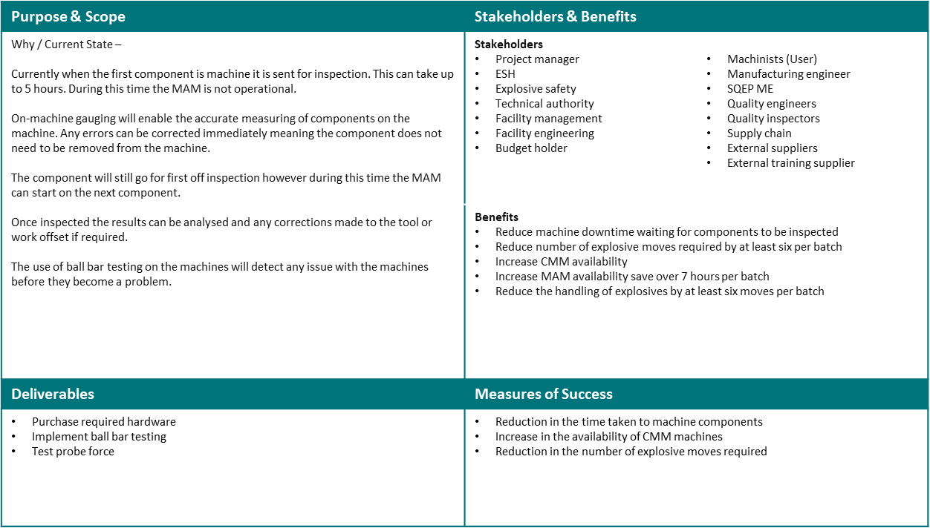

This quad of aims gives a quick overview of the project, showing the aim of the project, the stakeholders, deliverables and measures of success. This is a useful tool to used to

Literature review

Lean manufacturing

The term lean manufacturing applies to a range of tools and practices used to improve production in a manufacturing setting. Using lean production methods saves time, cut costs, eliminate waste, and improve quality. Lean manufacturing processes were developed in the early 20th century when mass production began to take off and the demand for efficient production grew. These process are still relevant today and techniques such as 5 or 6 S, overall equipment effectiveness (OEE), and total preventative maintenance TPM are still implemented into manufacturing and production settings.

A method used to measure productiveness is OEE. This metric uses data collected on the shop floor to determine how well a machine, process or production line is running. It involves the machinists or operators recording what the equipment is doing at set intervals. This data can be used to identify bottlenecks and losses in production because each data entry is set against a specific loss. These trends can be monitored and an OEE score awarded to each machine. A score of 40% is common where no improvements have been made to production, a score of 60% is average for a standard manufacturing area with lean production practices. A score of 80% and above is regarded as a world class manufacturing process, and 100% being a perfect score which is practically unachievable.

Total preventative maintenance or total productive maintenance (TPM) is an approach to equipment maintenance that get the user involved maintaining their own equipment. These maintenance activities include checking fluid levels, lubricating moving parts, checking machine accuracy and cleaning of the machine. The aim of TPM is to reduce machine downtime due to easily avoidable breakdowns and putting responsibility on the user to report any abnormalities that could lead to a failure. TPM checks can be carried out daily, weekly monthly or a combination of all depending on the maintenance task. Full training is provided to keep the operators and equipment safe.

On machine inspection

Holub et al carried out a capability assessment on the use of machining centers as inspection devices. To do this they milled a slot in a piece of material and measured it using a touch probe, to validate this data they used a laser interferometer linked into the machine software to validate the results. The laser was fitted with an environmental monitoring unit that enabled it to compensate for thermal and humidity changes in the machine area. Before the measurements were carried out the machine underwent a thermal warm up cycle to bring the axis and spindle up to operating temperatures that would be found under normal machining procedures. In the experiment the slot was measured 69 times, the true value of the slot was deemed to be 41.93813mm. After the 69 measurements the average reading from the touch probe was 41.9202mm, however using the laser to help compensate for any thermal expansion the actual average measured size was 41.9379mm. The report concludes that the machine tool can accurately and repeatedly measure components with a tolerance of 0.015mm. This method of on machine inspection could reduce the cost of inspection and time taken to manufacture components. One disadvantage Holub noted is that a calibration cycle must be run before each measurement. However, this time will be minimal compared to the time saved by not having components measured on a CMM. [1]

One potential issue with using on machine gauging to measure components is you are using the same machine that made the component to measure it. If there is an error on one of the axis and it is machining 0.5mm too large that same axis will measure that dimension 0.5mm too large. These errors are known as kinematic errors. To ensure the machine is accurately machining and measuring components an independent check must be carried out. This can be done via laser alignment or ball bar testing. A report by Dr Muelaner details how these errors can go undetected with regular checking and calibration of the machine tool. Ball bar testing is a common way machine accuracy is verified and can be carried out in as little as 20 minutes. A laser can also be used to calibrate machine tools; however, this process takes longer and the equipment is very expensive. Measuring a known artifact like a calibration sphere after the machine has been calibrated and before machining a component check that any kinematic errors are within tolerance before work commences. The artifact can be measured before measuring the machined component giving further confidence in the on machine gauging. [2]

A project was carried out by HARDPRECISION Europe to investigate the possibility of removing CMM machines. Zeleny and Janda measured a calibration sphere using two different on machine probes to test the accuracy of the probe and the machine. The report concludes that over three tests the OMG accurately and reliably measured the component to within microns each time. It was noted in the report that repeatability was poor. This study was carried out in 2008 and on machine measurement accuracy and repeatability has improved greatly. [3]

Inter axis parameters can affect a machines accuracy when it is being used for on machine gauging. Rashman and Mayer used a 5 axis machine and a calibration sphere to test the machines accuracy. In the first test the sphere was probed at 20 B- and C- positions used for machine calibration, the second test used 21 new B- and C-axis orientations. The touch probe used was a Renishaw MP700 touch probe. A mathematical simulation was carried out to calculate the stylus tip positions using the data from the two tests. All the data was input to a model sphere with anything not on the perfect sphere calculated to give the estimated errors. The data output from the machine was compensated using the estimated error parameters from the model. The machine had an out of sphericity of 267.27µm however when using the model this was reduced to 60.51µm for test one and 71.12µm for test two. The standard deviation was 10.36µm and 11.3µm for the two tests. From the simulations it was seen that offsets and alignment errors between the axis and linear axis strongly affected the sphericity. The report concludes that although a simple technique it is a good way to assess a machines measuring ability. [4]

Cauchick-Miguel et al. explored the parameters that affect touch probe performance on CMMs. The report looked at approach direction, spring pressure, probe angle, measuring speed, and length of the probe. Each experiment was carried out 10 times to ensure accurate data was recorded. Keeping the probe length as short as possible can help reduce the probe bending on contact with the component. The reliability of the measurements can be improved by repeating touch points and taking the average, this removes any spurious data. [5]

A study into the feasibility of using using OMG to eliminate the need for CMM measurement was carried out by Choi et al. The study involved machining a component, measuring it then finish machining it using the measured data. The finished component was measured on the machine again before being measured on a CMM. The difference between the machine measured values and the CMM vales differed by 4.4 and 3.3µm for the two components tested. This shows a very accurate on machine measurement, however the report does not mention the temperature conditions of the work shop and this could cause errors if it is not consistent with the inspection department. [6]

Numerous reports written on the topics of on machine measurement and CMM performance [7], [8], [9], [10] note that the temperature of the workshop and machine affect the accuracy of OMG and CMM performance. Most inspection departments have a separate temperature-controlled facility that is kept at a constant temperature and out of direct sunlight. Whereas many workshops, especially older facilities have large temperature fluctuations depending on the time of year and the current weather conditions. Other factors such as roller shutter doors being open and ceiling windows allowing sunlight to heat up machines can affect the thermal stability of the machine.

Probing forces

Wang researched the ‘influence of measuring force on CMM accuracy’ to understand the bending and contact deformation of the component. He used mathematical calculation to calculate the deformation on thin walled and U-shaped parts. The calculations showed that the force applied by the probe affected the component deformation. The highest force applied was 150 N/m which gave a calculated deformation of 6.2 µm. Another conclusion drawn from Wang’s report is that the length of the probe affects the force applied by the probe, with longer probes applying less force than a shorter probe. [11]

The force applied by a probe could mark or dent the component in the process of measuring it, this could affect the component when it gets to final inspection especially if it a soft material. The precision engineering department (PED) at AWE conducted titled ‘On Machine Gauging Assessment of probe force and probe indentation of soft materials’. The experiment in this report was carried out on a horizontal lathe in two stages. The first experiments used a test setup to measure the force that was applied to the component using four different probe configurations. These were, straight probe, offset crank, 90° crank and straight probe at 45°. Each probe configuration was tested in two machine directions, x and z at various feed rates. The force measured varied from 4.090N to 0.49N, these measurements were taken using a Imada DS2 force gauge. The indentation left behind by the probe head was the second set of tests carried out by the PED team. Two ductile materials were chosen for these indentation tests, annealed copper, and antimonial lead. These materials were machined prior to the test to give an accurate representation of a machined component. As with the force measurement various feed rates were used on each material, however only the standard probe configuration was used. The copper tests showed an indentation of 0.6µm to 1µm with the lead values ranging from 0.38µm to 3.45µm. These indentations were visible to the naked eye however were best seen under a microscope. A scanning electron microscope SEM was used to measure the depth of the indentations. One of the main conclusions from the report was the indentations left by the probe was smaller than expected and they would pass quality control.

Hardware

Chiron 1250 5 axis mill

The five axis milling machines used in HEFF are Chiron 1250’s. These machines are fully customizable with a choice of five axis options depending on the needs of the machine. There are five bed options and two head configurations and 5 tool chain options. A standard machine has a tool change time of 1.5 seconds, a maximum spindle speed of 20,000 RPM, and a rapid traverse speed of 75 meters per minute (mm/min) [12].
Because machining explosives is not a standard procedure these machines have been designed and heavily modified to reduce the risk of fire, explosion, and damage to the material. One of the design choices made was to fit a fixed rotary C axis and a swivel B axis, Figure 1 shows the axis of a CNC machine. This design choice was made as it keeps the material on the bed with the tool swiveling rather then the material. A chain tool changer is fitted as standard however this was changed to cassette tool changer within the enclosure of the machine. This modification was made to ensure no material entered the technical area where there is a risk of pinch, crush, and live electrical cables. The whole machine is unrecognizable from the factory design due to the outer casing being replaced to allow space for the tool changer, cameras, and the inside of the machine painted in an explosive compatible paint.

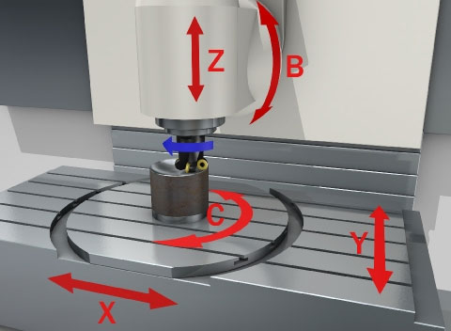
Figure 1 - shows the five axis of a CNC mill [13]

The feeds and speeds at which the machine can operate at have been greatly reduced. The maximum allowable spindle speed is 1000 RPM for milling operations and 500 RPM for turning operations using the C axis. These limits are set through the machine software and cannot be overridden by any means. If a program is written with a spindle speed of 5000 RPM the machine will only run it at 1000 RPM. The speed at which the machine axis move is called the feed rate. The feed rates of the machine are limited to a rapid feed of 600 mm/min by the software and physically limited by gearboxes fitted to each axis. If a brake or motor were to fail the gearbox would limit the speed the axis would move or fall at to a safe allowable speed. As well as being limited the axis speeds are monitored by the software and if the feed rate is exceeded the machine will shut down. A rubber diaphragm is fitted to the rear of the machine, this acts as a physical barrier stopping any material getting trapped in the concertina cover. The diaphragm is changed every 11 months to prevent failure. This also acts as a secondary barrier to the technical area at the rear of the machine, stopping any material getting into the exposed lead screws of the machine.
All explosive machining is carried out remotely therefore cameras are required so the process can be monitored from a remote location. These cameras are located within the machine enclosure and therefore need to be ATEX rated. An ATEX rated component has passed tests that approve it for use in explosive and hazardous environments. There are three cameras used to remotely monitor machining, two pan tilt zoom (PTZ) cameras are fitted within the machine and a small fixed view golf ball camera. The golf ball camera is mounted on a magnetic base and arm and positioned to give a different view that cant be seen by the PTZ cameras. A fortress key interlock system is fitted to each machine. When this unique key is turned in the remote control station (RCS) the machine can operate, when the key is in the RCS the door into the production cell will not open stopping anyone entering a hazardous work area.

Renishaw OMP 400 probe

There are several Renishaw probes on the market each designed for a different applications and environments. Standard accuracy probes use kinematic technology to trigger the probe. RENGAGE™ technology probes use ‘precise silicone strain gauge sensors with ultra-compact electrics to deliver superior performance’ REF RENISHAW. SPRINTTM technology probes can touch probe and scan components. Scanning is where the probe touches the material and moves across the surface measuring as it moves.
The majority of Renishaw probe comes in two sizes, the 40 or 400 series is for small to medium machine tools with the 60 or 600 series designed for medium to large machines. Optical, radio and hard wired are the transmission options. Best practice when working with explosives is to avoid radio transmissions at all costs so the radio probes were discounted.

The high accuracy optical OMP 400 has been chosen as it fits the necessary safety and accuracy criteria. The SPRINT probes were not chosen to the scanning ability as dragging a probe over explosives is not desirable. The RENGAGE™ probe was chosen due to its high accuracy and repeatability vs the standard probe as ‘it offers a repeatability better than 0.5 µm and the 3D lobing error is around ± 2 µm for a 100 mm stylus length’ The standard feed rate recommended by Renishaw for on machine measurement is 30 mm/minute [14].

Schmit ds- force meter

Two force meters will be used to measure the force applied by the probe. Bot will be schmit force meters, the first having a 0-500N range, with the second having a 0-5N range. The higher range meter will be used to ascertain the peak force applied, this is done to ensure the force isn’t too high and damage the more sensitive force meter. Due to the large range on the 0-500N meter the resolution is 0.1N, meaning a less accurate measurement is taken. The resolution on the 0-5N meter is 0.001N, therefore giving a more accurate measurement.

Force meter stand

A fixture was additive manufactured to hold the force gauge, the material used was ABS-ESD7. This material is an electrostatic discharge safe material (ESD), although not required to be an ESD safe material as there was no explosive material in the production cell the material was chosen to future proof the fixture against any further tests. A Fortus 900mc fused deposition modelling (FDM) additive printing machine was used to print the fixture. The 3D CAD models of the fixture can be seen in APPENDIX… The fixture enable the force gauge to he held horizontally and vertically to allow testing in the three standard machine axis X, Y & Z. Figure 1 shows these axis in relation to a milling machine.

QC20 ball bar

The QC20 ball bar is used to check the accuracy of machine tools. It uses a telescoping linear sensor with a precision ball at each end. These balls sit in precision magnetic cups, one mounted to the machine spindle with the other mounted to the machine table or tool holder. Once set up the machine follows a circular path while the sensor measures deviations and small vibrations. This data is then shown as a report that shows ‘sphericity’ and maximum and minimum values for the circular path followed.
Regular ball bar testing has several benefits including:
- ‘Ensure accurate parts, first time, from CNC machines
- Reduce machine down-time, scrap and inspection costs
- Demonstrate compliance with machine performance and quality management standards
- Implement fact based predictive maintenance’ [15]

Ball bar can be used to catch issues with machines before they become bigger issues, a small vibration picked early can be monitored and if the issue deteriorates maintenance engineers can be called in to diagnose the problem before the machine fails. Another key use of ball bar testing is independent machine verification, as Dr Muelaner writes without independent verification errors can go undetected. AS CNC machines use the same axis for machining and on machine gauging any kinematic errors will be carried across from machining to measurement potentially giving incorrect results. Regular ball bar inspections validate that the machine is performing accurately and prevent scrapped components due to kinematic errors.

Software

Two software options were considered for this report, Renishaw SOFTWARE NAME and PC-DMIS SOFTWARE NAME. Both software packages are compatible with Renishaw probes, and both are compatible with the Siemens 840d controller fitted to the Chiron.

Each software has its own advantages and disadvantages. The PC-DMIS software offers better measurement options and cycles using more touch points. However specific training is required to operate the software. Another disadvantage of PC-DMIS is that a laptop is required to run the software rather than the machine tool. This means that a laptop will need to be plugged into the machine each time a measurement or calibration is taken. Using a laptop does make interpreting results easier as laptops are easier to use than a machine tool. It also means the results can be interpreted away from the machine and data analysis can take place without stopping the machine from working.
Renishaw’s INSPECT PLUS software is built into the machine controller eliminating the need for a laptop to measure components. Using the machine softkeys measuring cycles can be programmed on the 840d controller. The use of measuring cycles makes the programming simple and intuitive and therefore reducing the need for long training courses to use the software. Cycles are already heavily used in machine programming for drilling, milling cycles, boring holes etc. Because these cycles are built into the machine controller they can be run as stand-alone measuring programs, or they can be integrated into machining programs. The ability to write these cycles into machining programs enables the machinist to create complex programs of machining and measurement with ease.
As the software is build into the machine it enables the machine to self-update after a measuring cycle. This means that if a measuring cycle is run and the measured dimension is different from the expected dimension the machine will update the tool offset and re machine the component, if possible, to the correct size. This is only possible if the measurement cycle has been run before the component is finished, as if the component is machined too small the error cannot be corrected. These cycles can be programmed in during the roughing stage of machining before the component reaches its finished size.
Because a laptop is not used with the Renishaw software it means that all measurement report have to be viewed and interpreted on the machine or removed from the machine using a portable hard drive to be viewed on a computer. This means comparing results and reports can be time consuming as the machine interface is designed for running programs not comparing reports. Another disadvantage of the Renishaw software over PC-DMIS is the complexity of measurements that can be taken. Renishaw’s software while simple and easy to program is also simple in its measurements whereas PC-DMIS can probe complex shapes and features.

Test plan

To ensure the on-machine gauging is safe for use on explosives and is accurate a series of safety and performance tests must be carried out to satisfy the relevant stakeholders. These tests consist of measuring the force the probe will apply to a component and measuring an artifact of a known size. The pass-fail criteria for each test is decided by the stakeholders responsible for that area, should the system fail any tests it cannot go be used on any live material until the issue is solved and all stakeholders are satisfied the system is safe.
Temperature plays a major part in manufacturing and inspection of components due to expansion and contraction. This does not need to be considered as HEFF is temperature and humidity controlled with an ambient temperature of 20°c with a tolerance of plus or minus 3°c for storage and machining, while inspection cells have a tolerance of plus or minus 1°c.
Standard Renishaw cycles use a two touch system where the probe contacts the component at high speed, backs off then measures at a reduced speed. This technique speeds up the measuring process, however we do not want to contact the component at high speed. To alleviate this, basic move cycles were written into the program to which we could adjust the feed used.

Safety test

Safety testing will underpin the safety case enabling on machine gauging to be used on live explosives. This test will ensure the force being applied by the probe will not insult or damage the component endangering people’s safety and the production facility. They are also to protect the material from a quality perspective and ensure the probe will not mark or dent the component causing it to fail quality inspection.
A force gauge will be used to measure the force applied by the probe in different axis and orientations. The positions will be determined by how the components will be measured, the main use will be to measure component heights and diameters. This will involve probing in the X and Z axis with X measuring diameters and Z the component height. The allowable force applied by the probe is 17-23 grams of force. This figure comes from the risk assessment for CMM measurement which is a similar process to on machine gauging.
These tests were designed to replicate how the machine will measure components by placing the test ring in the positions where components will be measured. For Z height measurements this will be directly above the center of the C axis spindle, for diameter measurements in the x axis these will be taken off the center of the C axis.
The results from the tests will be recorded in a table and then input into an excel spreadsheet. From this data, graphs can be drawn showing the force applied on each test, average forces and maximum force applied can be calculated ready to be presented to the safety stakeholders.

Performance test

Knowing the machine is accurately measuring components is critical to on machine gauging, as if it is not accurate or giving unreliable results it would render the use of on machine gauging unsuitable. The user must have full confidence in the system or they will not use it. Therefore a performance test will be carried out to give the machinist and stakeholders confidence that the system is functioning as required and is accurate.

As this initial trial is to see if on machine gauging is viable for use on explosives only simple features will be measured. These are the height of a component and the length or diameter of a component. As these features do not require complex measurements the artifact used to validate the probe will be a granite parallel. A parallel is a precision manufactured bar made from hardened steel, ceramic or granite. The probe will measure the height and length of the parallel which will be compared to the calibrated length and height. The parallel will be placed in different areas of the machine and measurements taken, this will prove if the probe is measuring accurately and reliably over the machining envelope.

On machine testing

Test set up

The force meter will be bolted to the test stand with the whole assembly being bolted to the C axis of the machine. The test assembly will be bolted to the centre of the C axis for the Z axis tests, and clamped off centre using a clamping kit to measure the force in the X axis.

Daily plan

Three days were allocated in the production plan to allow the on-machine force measurement to take place.
The plan was as follows:
Monday
- Remove all material from cell
- Clean the cell and machine
- Remove all tools and fixtures from machine

Tuesday
- Write programs
- Set machine offsets
- Familiarisation of software and hardware
- Set up fixture and force gauge
- Demonstrate on machine gauging

Wednesday
- Carry out on machine gauging tests

Issues

A fault with the machine’s pneumatics system delayed the start of the preparation activities on Monday while a machine tool engineer investigated the issue. While resolving the pneumatics issue a coolant leak was identified the needed urgent repair. Machine tool engineers attended the machine Tuesday morning to fix the leak and pneumatics issue, while making progress with the repairs a thunderstorm was identified within the area meaning all work had to cease until the storm has passed, thus delaying the repairs further. The thunderstorm evacuation delayed the engineers by an hour and a half into Tuesday afternoon. Unfortunately, this meant the on-machine gauging specialists could not attend the facility and their visit had to be pushed back to Wednesday afternoon. Wednesday morning was spent carrying out Tuesdays planned work, writing the programs and getting the hardware set up ready for the precision engineering teams arrival. Due to the delays the full team couldn’t attend the facility due to prior commitments.
Once set up a serious problem was discovered. The machine would not run any of the calibration or measuring programs. The software works by calling up sub programs or cycles and running these within the main part program. An issue was identified that the machine would not run any of the Renishaw cycles. This stopped the testing and without an external Renishaw engineer attending site the issue could not be resolved within the allocated time.

PE testing

The precision engineering team conducted the testing on a Hemburg Microturn 100 CNC. The tests carried out were similar to the ones planned in HEFF but were carried out on a lather rather than a 5 axis mill. APPENDIX… shows the test set up used. The same force meter was used however the 3D printed test bracket was not used. The results are shown in Table 2 for the performance test. For this test the force gauge was used as the artifact. Each time the probe was triggered the machine position was noted down, allowing the repeatability of the probe to be calculated.

 | Standard Configuration
 | Radial |  |  | Axial
Feed (mm/min) | 5 | 10 | 30 | 5 | 10 | 30
Range over 20 hits taken (μm) | 0.55 | 0.39 | 0.53 | 0.24 | 0.21 | 0.44
SD (μm) | 0.14 | 0.12 | 0.14 | 0.06 | 0.06 | 0.11
Force (N) | 0.054 | 0.072 | 0.143 | 2.710 | 3.010 | 4.090
Table 2 - shows the results from the PE testing

Results and discussion

Due to the issue with the machine no data could be collected, however data has been collected by the PE team. The data collected by PE was collected on a lathe rather than a 5 axis mill, however the principle is the same. For the PE testing all the standard parameters were used, the MAM testing would have been carried out in the same way using the default parameters and different feed rates. Because the default parameters were used this data is accurate and reliable machine data.

Appendix… shows the raw data collected from each test run. These were done at three feed rates in each axis, X and Z. The average data is shown in Table 2 The data that was collected shows the higher the feed rate the greater the force applied. This was to be expected as a higher impact speed means the probe has to react quicker to the trigger signal and stop the machine axis without overtravel which will apply more force. If the feed rate were to be slowed further the probe could not register the trigger giving incorrect measurements.

Future research

Complex measuring

Many of the components manufactured from high explosives are designed with complex forms and features, and many of these have tight tolerances. As the machinists can only measure basic heights, lengths and diameters is where on machine gauging has started. However The probes and software have the ability to measure complex designs, shapes and features. Measuring these complex design features will use the full ability of the probes and software. To achieve this, complex programs will need to be written fully utilizing all the features available within the software packages. New probe heads could be required to ensure accurate measurements are taken. As seen from the timing calculations large amounts of time are spent moving material and waiting for inspection. If it can be achieved that a component can be measured from start to finish on machine and given full CMM inspection when finished this will give a large time saving. PC-DMIS software will likely need to be used for these complex measuring cycles which will require extra training and potential machine upgrades, or a laptop being plugged in to use the advanced PC-DMIS software.

Fixture and work offset setting

The Renishaw on machine measuring package has several features that currently aren’t used within HEFF. One of these features is using the OMP 400 probe to set fixture and work offsets. Currently the work offset is set using the standard method using a tool of a known length and a slip gauge to set the height of the fixture. The probe can be used to set this fixture height, the probe will measure the height of the fixture and automatically update the relevant work offset in the work offset table. This has the advantage of ensuring the correct work offset is set for each fixture, with multiple work offsets in the table the wrong value can be changed by mistake. With several fixtures used for each process ensuring the fixture height is set correctly is very important to ensure the tool follows the correct path and does not collide with the fixture or component. The probe can also be used to set the angular C axis work offset. This is used when milling sample components currently this offset is set by running a clock along the fixture and indexing the C axis until the fixture is square with the X axis. The probe can take two points, one at each end of the axis and automatically calculate the correct orientation of the fixture.

Update tool offsets

Both 5 axis machines are fitted with a Renishaw tool measuring probe and a blum tool measuring laser, these are used to measure and orientate tools. These are used measure new tools, measure a tool if the indexable tool tip has been changed and periodically measure tools to check for tool wear. The OMP 400 can also be used to adjust tool offsets due to tool wear. This is done by machining a component, measuring it and comparing the measured value to the machined value. This is all done by the software and no operator intervention. Currently tool wear is compensated for by measuring the component with a micrometer and adjusting the tool offset manually. This has two areas for error, the first being the measurement taken and the second being the math’s done to adjust the offset, both potential areas for error are eliminated by using the probe.

Automatic measuring cycles

For this project the programs and measuring cycles that have been written and used were all stand alone programs. This means the program is selected and run by the machinist to measure the artifact or force gauge. Programs have also been written to measure real components however this cannot happen until the ACR has been completed. These measuring programs and cycles can be incorporated into machining programs. By doing this the machine will count how many components have been machined and every x components a measuring cycle will be triggered. This will measure the component and tell the machinist if the tool tip has worn and needs changing or an offset needs updating. The advantage of this is the machinist doesn’t have to do anything to trigger the measurement, they don’t have to count how many have been produced and remember when to measure a component. Another advantage is this gives traceability of when a component was measured and what it measured. If a component fails final inspection it can be traced back to the machine it was manufactured on and any components manufactured after that can be re-machined or scrapped if they are also out of tolerance.

Ultra-low trigger force probes

The probes used in this trial were standard Renishaw off the shelf probes. Renishaw could be contacted to inquire about modifying the standard probe, or having a bespoke probe manufactured for use on sensitive material. This will lower the force required to trigger the probe, doing this will reduce the risk of the probe marking or damaging the material.

ATEX rated probe

As on machine gauging probes are used in an environment where metal working fluids are used the probe is designed stop the ingress of water but not dust. As ingress of liquid is the main concern for the sensitive electronics held within the probe it has only been tested for liquid ingress. The probe has an IP rating of IPX8, this means the probe can withstand being submerged in 1 meter of water [16] but has not ben tested for ingress of dust.
Ensuring explosive dusts do not enter the probe is a key safety requirement. As the probe is not ATEX rated it cannot stay within the machine while machining is taking place, meaning it will need to be put in and taken out of the machine before and after use. It is recommended that the probe is tested and given an IP rating. If a high enough rating is given it could be deemed acceptable by explosive safety that the probe can stay in the machine thus saving time.
An alternative probe manufacturer could be identified that sells an ATEX rated probe, however none have been found. Manufacturers could be approached with a view of designing and producing an ATEX rated probe. This would come with high costs and cost benefit analysis would need to be carried out to determine if it is viable.

Use on horizontal lathes

HEFF also uses two horizontal lathes to produce high explosive samples and components, these machines could also benefit from the use of on machine gauging. The probes used on the lathes will be RENISHAW>>> probes that operate in the same way the probes work on the Chiron 1250. They can be used for setting work offsets, measuring components and used to set and adjust cutting tools. As with the MAM’s the lathes suffer from the backlog caused by inspection, and the associated time losses such as moving material and waiting for the component to be inspected. Most components manufactured on the lathes are simple cylinders that are easily measured using micrometers and verniers. However certain components have internal features that are difficult to measure by hand. This is where on machine gauging would save time as these components have to go for interim inspection to ensure the tool is cutting correctly. Being able to measure the component in situ and adjust the tool accordingly will save hours of time as often components manufactured on the lathe have a lower priority than service components.

Conclusion

Although the full OMG test program could not be carried out, the data that was acquired has given confidence that on machine gauging can be used on explosives once the full verification program has been carried out and approved by every stakeholder. The repeatability tests showed a maximum range of 0.55µm with a maximum standard deviation of 0.14µm over the 20 tests run. These results are far more accurate and repeatable than the current method using micrometers. A machinist with a micrometer can measure to 10µm so for the machine to accurately measure to less than a micron is a great improvement with fantastic reliability.
Once on machine gauging is approved any fully operational it will be a great asset to the facility and will save hours in machine down time. The time gained will enable the facility to increase throughput. The extra time in the production schedule will also be used to carry out more operator lead maintenance including the regular ball bar checking of the machines.
There are more ways that the OMP400 probe can be used to help machinists and reduce human error. Using the probe to set work offsets in Z and C orientation for milling applications will save time and ensure that there has been no error while calculating and setting the work offset.
In an ideal manufacturing facility, there would be no CMM machines and all inspection would take place on the machines. Due to the complex nature of the components produced in HEFF this will not be the reality however the use of on machine gauging will reduce the total inspection operations from four plus final inspection to just final inspection delivering a huge time.

Bibliography

[1] | M. H. T. M. R. J. F. M. J. S. M. M. Petr Blecha, “Capability of measurement with a touch probe on CNC machine tools,” Measurement, vol. 118, pp. 52 -60, 2018.
[2] | D. J. Muelaner, “On-machine measurement removes CMM bottleneck and cuts inspection time,” Professional engineering, p. N/A, 11 October 2019.
[3] | M. J. Jaromir ZELENY, “ON-MACHINE MEASUREMENT SYSTEMS FOR HIGH-PRECISION WORKPIECES, PRODUCED ON FIVE-AXIS MILLING MACHINES,” Journal of Machine Engineering, vol. 8, no. 1, pp. 11-18, 2008.
[4] | M. M. R. a. R. MAYER, “Performance of a five-axis machine tool as a coordinate measuring machine (CMM),” Journal of Advanced Mechanical Design, Systems, and Manufacturing, vol. 10, no. 5, pp. 1-14, 2016.
[5] | P. A. C.-M. a. T. G. KING, “FACTORS WHICH INFLUENCE CMM TOUCH TRIGGER PROBE PERFORMANCE,” Int. J. Mach. Tools Manufact, vol. 38, no. 4, pp. 343-354, 1998.
[6] | B. M. S. L. J.P. Choi, “Reduction of machining errors of a three-axis machine tool by on-machine measurement and error compensation system,” Journal of Materials Processing Technology, Vols. 155-156, pp. 2056-2064, 2004.
[7] | C. R. L. J. Mou, “A method for enhancing the accuracy of CNC machine tools for on-machine inspection,” Journal of Manufacturing Systems, vol. 11, no. 4, pp. 229-237, 1992.
[8] | M. H. T. M. R. J. F. M. J. S. M. M. Petr Blecha, “Capability of measurement with a touch probe on CNC machine tools,” measurement, vol. 195, 2022.
[9] | R. toole, “Controlling the Accuracy of a Shop Floor CMM,” Quality magazine, 1 19 2017.
[10] | S. F. A. L. Naeem S. Mian, “Reducing the latency between machining and measurement using FEA to predict thermal transient effects on CMM measurement,,” Measurement, vol. 135, pp. 260-277, 2019.
[11] | W. Bin, “Influence of measuring force on CMM accuracy,” MATEC Web of Conferences 208, Tianjin, 2018.
[12] | “MILL Series Universal precision machining centers for high-performance cutting from small parts to large workpieces,” 09 2020. [Online]. Available: https://chiron-group.com/products/mill-series. [Accessed 15 10 2022].
[13] | 3. R. P. Limited, “How 4-axis and 5-axis CNC machines can produce complex parts,” 3E rapid prototyping, 2022. [Online]. Available: https://www.3erp.com/blog/5-axis-cnc-machining/. [Accessed 1 11 2022].
[14] | Renishaw, OMP400 optical machine probe systems - installation guide, Renishaw, 2011.
[15] | Renishaw, “QC20 ballbar,” Renishaw, 2022. [Online]. Available: https://www.renishaw.com/en/qc20-ballbar--11075. [Accessed 12 09 2022].
[16] | Clarion, “IP Ratings Explained,” Clarion, 2022. [Online]. Available: https://clarionuk.com/resources/ip-ratings/#:~:text=An%20IP%20Rating%20(also%20known,and%20accidental%20contact%20(2022).. [Accessed 15 10 2022].
[17] | Schmidt, Schmidt DS specifications, Schmidt, 2022.
[18] | PED, “On machine gauging, Assessment of probe force and probe indentation of soft materials,” AWE, Reading, 2020.

Appendices

Appendix 1 – Probe programs

Z axis probe measurement

T=Probe
M6
SAFEPARK
G517
G0 X0 Y0 Z300
L9832
L9800
L9810
R26 = 50
L9811
R26 = 0
L9810
R26 = 50
L9810
G0 Z300
L9833
SAFEPARK

X axis probe measurement

T=Probe
M6
SAFEPARK
G517
G0 X100 Y0 Z100
L9832
L9800
L9810
R24 = 50
L9811
R24 = 30
L9810
R24 = 50
L9810
G0 Z300
L9833
SAFEPARK

Appendix 2 – PE data

Appendix 3 – OMP400 specifications

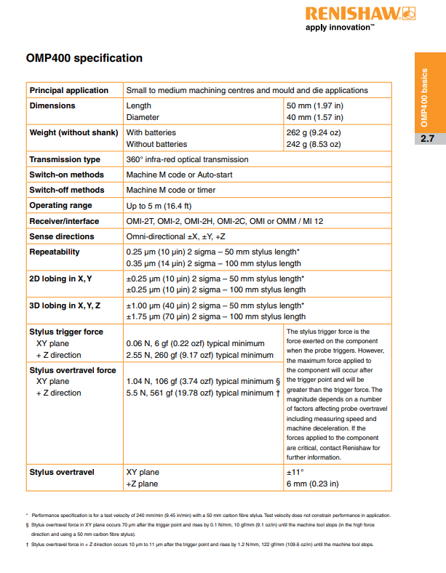

[14]

Appendix 4 - Schmidt DS force gauge specifications

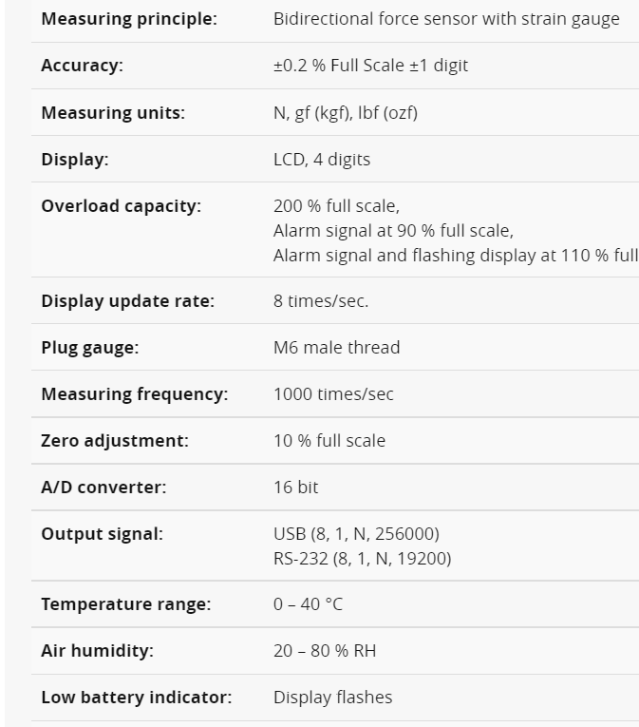

[17]

Appendix 5 – test rig models

DAP’s are trained staff who oversee explosive moves and are responsible for ensuring the move is carried out correctly and only authorized people are in the facility.
mm/min is the speed that a machine moves at described as the distance travelled per minute, mm per revolution is also used as a machine feed rate.

