Future trends in Cyber Security
Student Name: Dale Griffiths
Student P Number: P146062
Module Code: ACCA6000 Advanced Cybersecurity
Lecturer Name: Dr Carlene Campbell

Abstract – This report is split into two parts. The first part of this report will cover future trends in cyber security. The second part will be used to design and implement a secure university campus network. The implementation will be completed in cisco packet tracer to simulate the network.

Keywords – Cyber Security, Cyber Attacks, Cyber Defences, Security Policy, IPS, Firewalls, Encryption, Virtual Private Networks, DoS, Browser Attack, Brute Force attack, Anti-Virus, IPS, IDS, Physical Security.

- Introduction
The first section of this report will cover future trends in cyber security. This will look at what is cybercrime, cyber security and what cyber laws are there. The author will then talk about different attacks that are commonly used to gain unauthorised access to systems and devices. Solutions will then be provided for the threats talked about. The author will then provide security recommendations to help protect data in any computer network.

The second part of this report will be used to document the design and implementation of the network. The network that will be designed is for the newly build SA1 smart university campus. The design will then be created in Cisco Packet Tracer. The implementation will include security countermeasures including firewalls, intrusion prevention system, access control encryption and cryptography.

- Related Work
In this section of the document the author will be conducting research on cyber security and its future trends. This will be done by researching what are the current cyber security trends. This will give the author the background knowledge to provide information on what is believed to be the future trends in cyber security.

- Cybercrime
“Cybercrime is a crime that involves in a computer and a network.”[1] A cyber device is classified as any device that connects to the internet include mobile phones, computers, tablets. These devices then can be used by hackers to attack other cyber devices. The main reason for cybercrime is to generate profit, this is usually achieved using ransomware, identity theft and fraud. Cybercriminals try and target big corporations as they obtain more information what can be stolen and sold for profit [2].

- Cyberwarfare
According to the report [3], cyber warfare usually involves two nations or countries. The first would be the attacker and the second the target. This demonstrates how different the world is becoming as wars are being fought behind screens. The report [4], states that cyberwarfare is a cyberattack on critical infrastructure. This would include attacks on power stations, transportation, food and water supplies, communications, and banking. The report [5], states that over 200 Chinese government websites experience sophisticated cyber-attacks on a daily basis.

- Cyberterrorism
Cyberterrorism is like cyberwarfare in attacks being against critical infrastructure however, unlike cyberwarfare this these attacks are conducted by terrorists. This is a bigger issue than cyberwarfare as countries will consider retaliation when conducting attacks whereas terrorists wont, they just want to cause mass disruption. The report [6], looks at how the terrorists use cyberspace to spread threats and influence to the world [7].
- Cyber Security
Cybersecurity is the process of securing devices and systems form different threats and vulnerabilities. The report [8], states that cybersecurity is the process of protecting information from unauthorised access. This report also looks at risk mitigation planning, this is a plan to minimise the cyber security risks. It would also include a backup plan in the case of unauthorised access into a system. The report [9], looks into emerging risks in cybersecurity. The paper states that in 2018 over 50% of internet of things (IoT) manufacturers will not be able to address the threats from the weak authentication on the IoT devices[10].

- Cyber Laws
Cyber laws are made by each state by which their citizens should abide by, failure to follow these laws will result in prosecution. Some countries including the United Kingdom (UK), Russia, India, and the United States (US) have specific cyber laws to abide by. One of the laws within the UK is the computer misuse act 1990. “international law should provide rules under which the state under the threat of a cyber-attack can react resorting to lawful means”[11]. This report shows that there may be some cyber laws in certain countries however, there are no international rules that every county agrees to apply to.

- Cyber Attacks
This section of the report will cover cyber-attacks. It will document some of the most common attacks and explain what they are and how they are effective. The author will additionally provide solutions to each of the attacks documented.

- Browser Attack
A browser attack can sometimes be known as a man in the browser attack. The attack begins by installing a trojan on the victim’s computer, this trojan will have the capability to intercept any transactions made over the internet. The attack happens within the victim’s web browser, so it is very difficult to detect this type of attack.

The security mechanisms on the third parties site will not detect any modifications as all the data came from the user’s web browser. The report [12], states that there is no single method to prevent a browser attack. However, a real time anti-virus with threat detection and basic user education on performing updates will reduce the risk of this type of attack.

- Denial of Service Attack
A denial of service attack is commonly known as a DoS attack. A DoS attack is performed by installing malware onto a victim’s device to make it a zombie. This will be performed on thousands of other devices to allow the attacker to start a DoS attack. The attacker will then get the zombie devices to send fake requests to the victim’s resource, thus forcing the device to crash. DoS attacks are normally performed against large businesses to stop them from operating.

According to the report [13], more than 5 billion IoT devices were sold within 2017. Majority of these devices are being produces with no security consideration and only the basic authentication. This means that with more IoT devices being launched daily, the risk of a DoS attack is increasing. The solutions to this type of attack are firewalls, intrusion prevention system, intrusion detection system. These defences will be covered in the next section of this report. In the report [14] the author looks at how intrusion prevention systems and intrusion detection system can be used to effectively stop a DoS attack.

- Keylogger
A keylogger is sometimes known as a keystroke logger. It is a software that is installed onto a device that can record every keystroke in order that it is input into the device. These are then put into a log file which is emailed to an attacker. The attacker can then use the information that is logged to gain unauthorised access to accounts, bank details, and other confidential information. Solutions to this threat include firewalls, password managers, software updates, and frequently updating passwords. The report [15], states that keyloggers are detected through the behaviour of the software, this provides evidence that a real-time scanning antivirus software can also detect a keystroke logger.

- Brute Force Attack
A brute force attack is a method that can be used when conducting password cracking. It is a very good method at breaking passwords however, it can be very slow. This is because it uses a password file and tests each password within the list, so it is very time consuming. This method of password cracking will only work if the password file has the exact password. Brute force attacks are commonly used to test the strength of passwords and identify weak passwords within organisations.

Solutions for this type of attack would be to use complex passwords, this can be done using by creating a password policy. A password policy ensures that all passwords are a certain length, have lower and upper-case letters and include symbols and numbers within them. The report [16], states that it is not just the password that is important but how securely it is stored.
- Cyber Defences
This section of the report will cover cyber defences. It will document the different cybersecurity countermeasures that can be put into place to defend cyberattacks.

- Passwords
Passwords are a string of characters used for authentication to gain access to a resource or system. There are two common mistakes that users make when using passwords using simple passwords and using one password for everything. The issue is using a simple password for example “password”. When someone is trying to crack the password in the example it is a very common unsecure password, so it will be very fast to crack. However, if that password was changed to P@sZ-w0Rd! it would be a complex password, and this would take a lot longer to break. The report [17], looks at how one time passwords can be used to provide better authentication.

- Firewall
A firewall is very good at helping to secure a network from unauthorised access. A firewall can be set up to allow and deny specific packets, this can be done by creating rules. A firewall can also be used to close different ports within the network again minimising the risk of unauthorised access. The report [18] looks at three different firewall types Simple, Dynamic and Scalable. A simple firewall is a firewall that used linked lists to manage rules, this type of firewall is very simple. A dynamic firewall is a firewall that groups can be created to allow certain rules for different groups, these can be added or removed anytime very easily. However, this type of firewall is more complicated to configure than the simple one. A scalable firewall doesn’t have any restrictions on what type of data can be checked and filtered. This is an advanced firewall that is one of the most difficult to configure however, it is also the most secure firewall the author has talked about.

- Anti-Virus
Antivirus software was originally designed to protect against viruses and malware however, nowadays it is also used to defend against ransomware, keyloggers, spyware, adware, trojans etc. Antivirus software usually runs in the background scanning the device it is installed on for these threats. Some anti-viruses include real-time scanning, this type of anti-virus scans everything including what the user is doing and prevents the user from running into vulnerabilities by warning the user of the danger[19].

- Physical Network Security
Physical security is very important in securing a network as a physical attack could be the most catastrophic attack to the network. If there was no physical security anybody could just walk into the server room and reset, damage or steal any devices, this could end up costing a company a large amount of money. Physical security implementations would include perimeter fencing, security cameras, RFID readers, motion detectors, alarms, locked doors, no windows within the server room and biometrics for access to the server room.

- Updates
Updates are a very important in security, therefore when a notification for updates pops up it is essential to install the update as soon as possible. The reason that updates are so important is they often include patches to security vulnerabilities. The report [20], provides a secure way to remotely update vehicle’s software. The security method covered in this paper is designed specifically for vehicles software updates to be performed securely.

- Virtual Private Network
A virtual private network (VPN) is a security mechanism that can be used to encrypt traffic between a client and a destination over the internet. A VPN can be used to prevent a man-in-the-middle attack. The report [21], states that IPsec VPN is more suitable for multi-campus connections however, L2TP VPN is more suitable for remote access.

- Intrusion Prevention System
An intrusion prevention system (IPS) is used to identify and respond to potential threats to the network. An IPS is used to monitor the traffic on the network, this allows the IPS to detect abnormal traffic and then chose a prevention depending upon the type of attack. “As traffic DDoS attacks rise higher, the complexity and stability of IDS/IPS takes an important parameter”[22]. This report investigates how important an IPS is in detecting and stopping DDoS attacks.

- Intrusion Detection System
An intrusion detection system (IDS) is again used to monitor the network traffic however unlike an IPS it does not react to the traffic. An IDS is used to analyse the protocols being used within the network. IDS can be used to find viruses, information leaks, configuration errors, unauthorised clients, unauthorised software like scanning tools. The report [23], looks at four different attacks an IDS can identify. These are DoS attack, Root attack, Remote to local attack, and probing attack. This shows that an IPS and an IDS are very different however, both are essential in a network to ensure it is secure.

- Security Policy
The security policy is used to cover the university network if users misuse the network. Users must agree to abide by the terms of the policy to be allowed to connect to the network. Failure to agree to the security policy will result in network access being denied.

User policy
- Acceptable use policy
- Lock devices when left unattended
- Do not attempt to install any software, this must be done by the network management team
- Do not tamper with any device belonging to the university
- Do not attempt to access any other account without permission

Password Policy
- Passwords must be changed every 4 weeks
- Passwords must be a minimum of 8 characters
- Passwords must contain a minimum of one number
- Passwords must contain a minimum of one special character (symbol)
- Passwords must contain a minimum of one lower case character
- Passwords must contain a minimum of one upper case character
- Passwords must be kept confidential and not shared

Data Policy
- Users are allowed 2GB of data storage on the network
- Users must not upload any malicious files
- Users must not download any data without the correct permissions
- Data is confidential and must not be shared

Failure to follow this security policy will result the suspension of the user account and could result in further action against the individual.

- Problem Formulation
This section of the report is primarily to cover the design of the network however, this section of the report will investigate different problems that exist within the universities current network and state how these issues can be resolved. This will also cover other what is required within the network to meet the requirements of the scenario.

The network that is being created is being designed for the new SA1 campus. Figure 1 the blueprint for the network design. The scenario states that the design should include security countermeasures including firewalls, IPS/IDS, access control encryption, and cryptography.
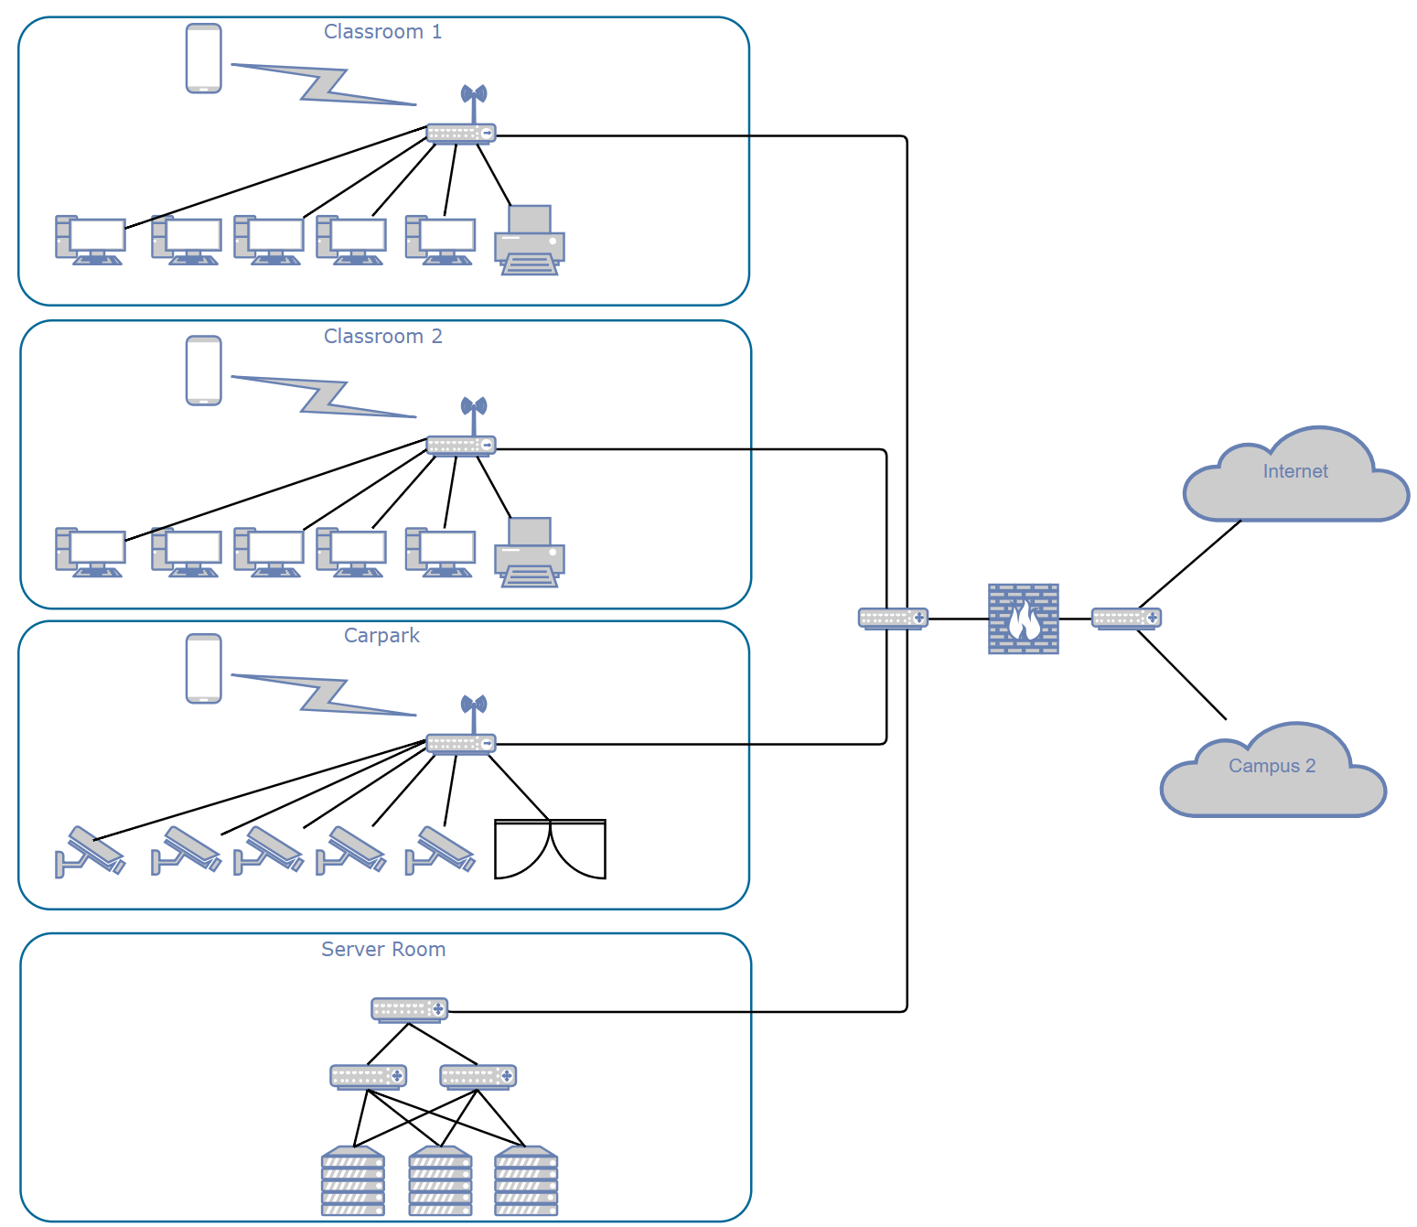
Figure 1 – Network Blueprint

One of the issues that exists within the current network is traffic is not encrypted, thus making it easy for an attacker to capture packers and look at what is going on within the network. Figure 2 is a demonstration of a Wireshark packet capture; the source and destination are easily identified. Additionally, it shows exactly what type of packet is being sent. This is one of the reasons that the author would like to implement cryptography within the network. This will be achieved by implementing a VPN. This encrypt the network traffic, ensuring that traffic can not be read on the route from the source to the destination over the internet.
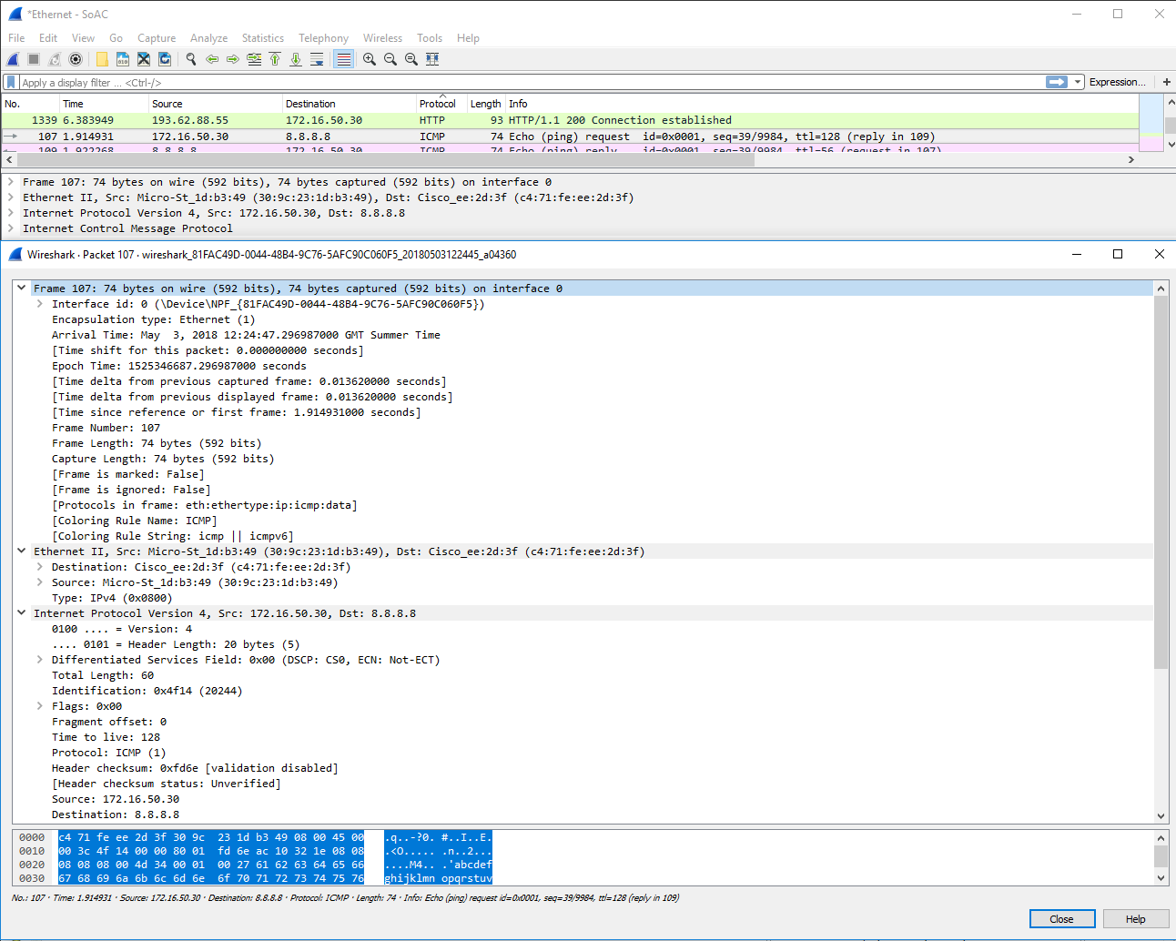
Figure 2- Wireshark Packet Capture

- Implementation

Figure 3 shows the first classroom that has been created within the simulation. This classroom has 20 student pcs and 1 staff pc. There is also an access point for staff, students and guests.
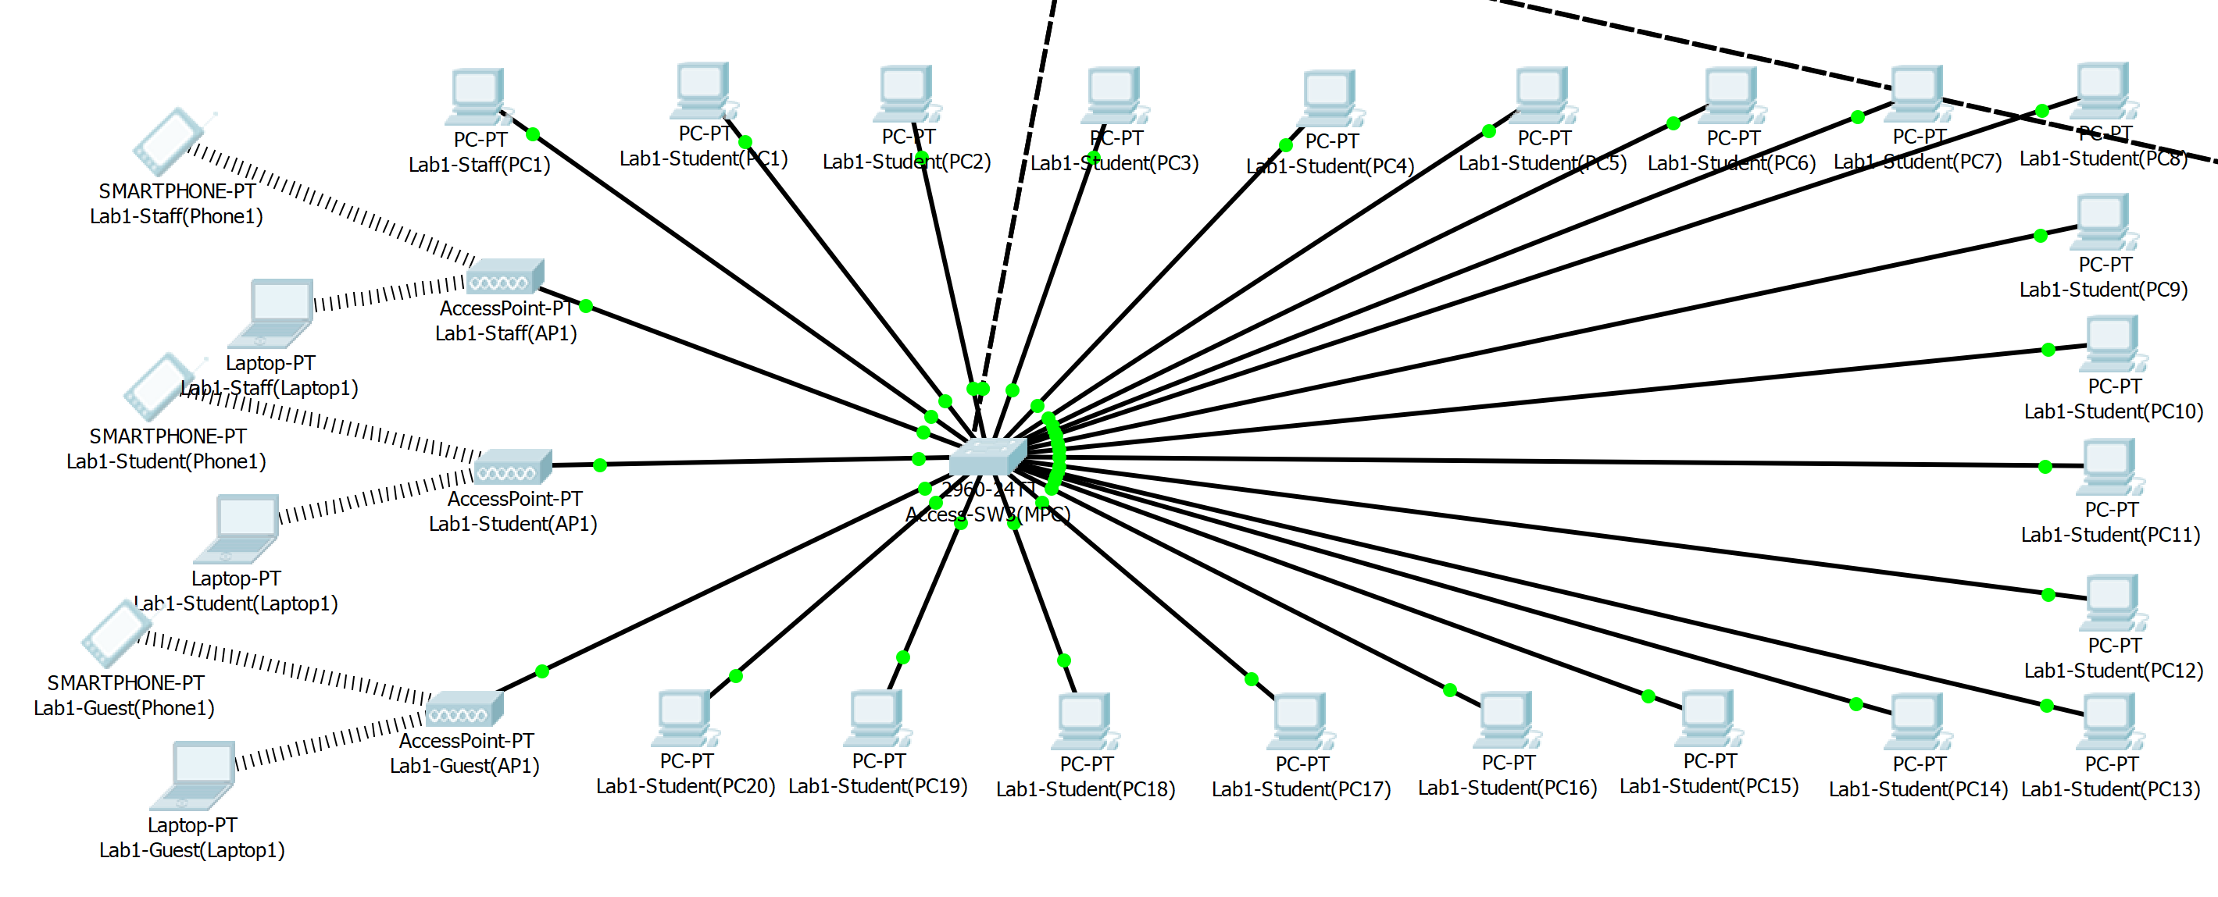
Figure 3 – Lab1 workstations

Figure 4 shows the first classroom IoT devices that have been added to the network. These include motion detector, door, CCTV, RFID, fire sprinkler, smoke detector, window, light, thermostat, furnace and air conditioning. These devices will have the ability to be controlled either locally within the classroom, or remotely by lectures with the correct login authentication to the online portal that can be used to manage the network.

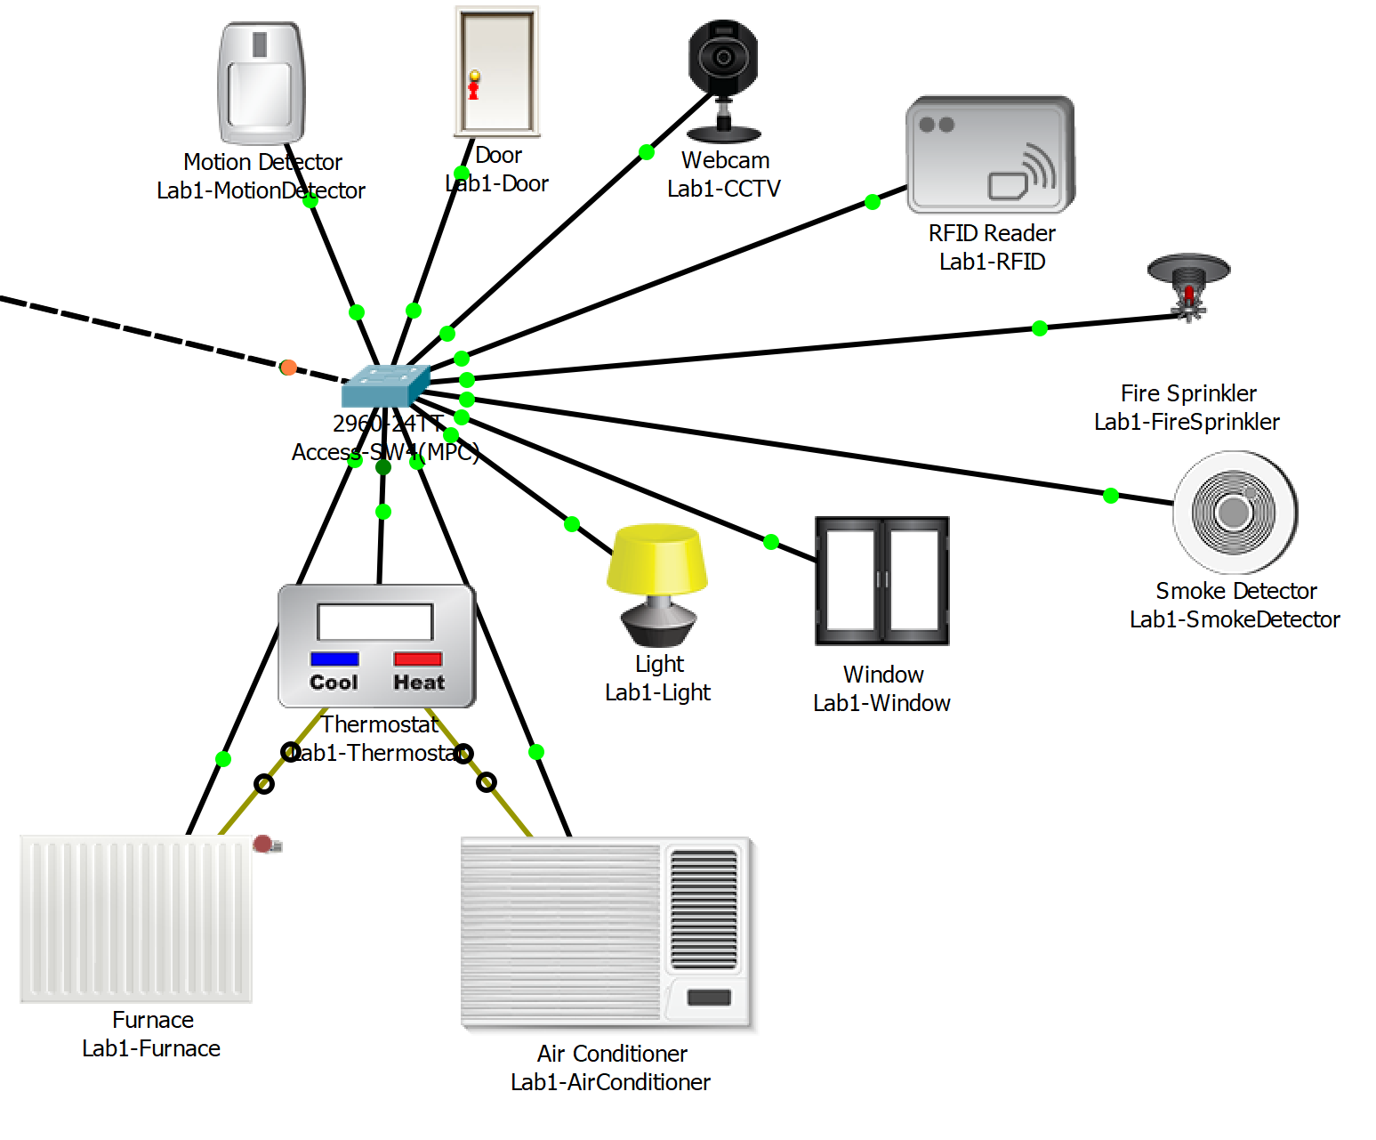
Figure 4 – Lab1 IoT devices

Figure 5 is used to show that the wireless access pint has been set up for the staff SSID. It uses the password UwTsD@2018-Staff with WPA2 encryption. The guest and student access point that can be seen in figure 1 also have this setup with a different password.
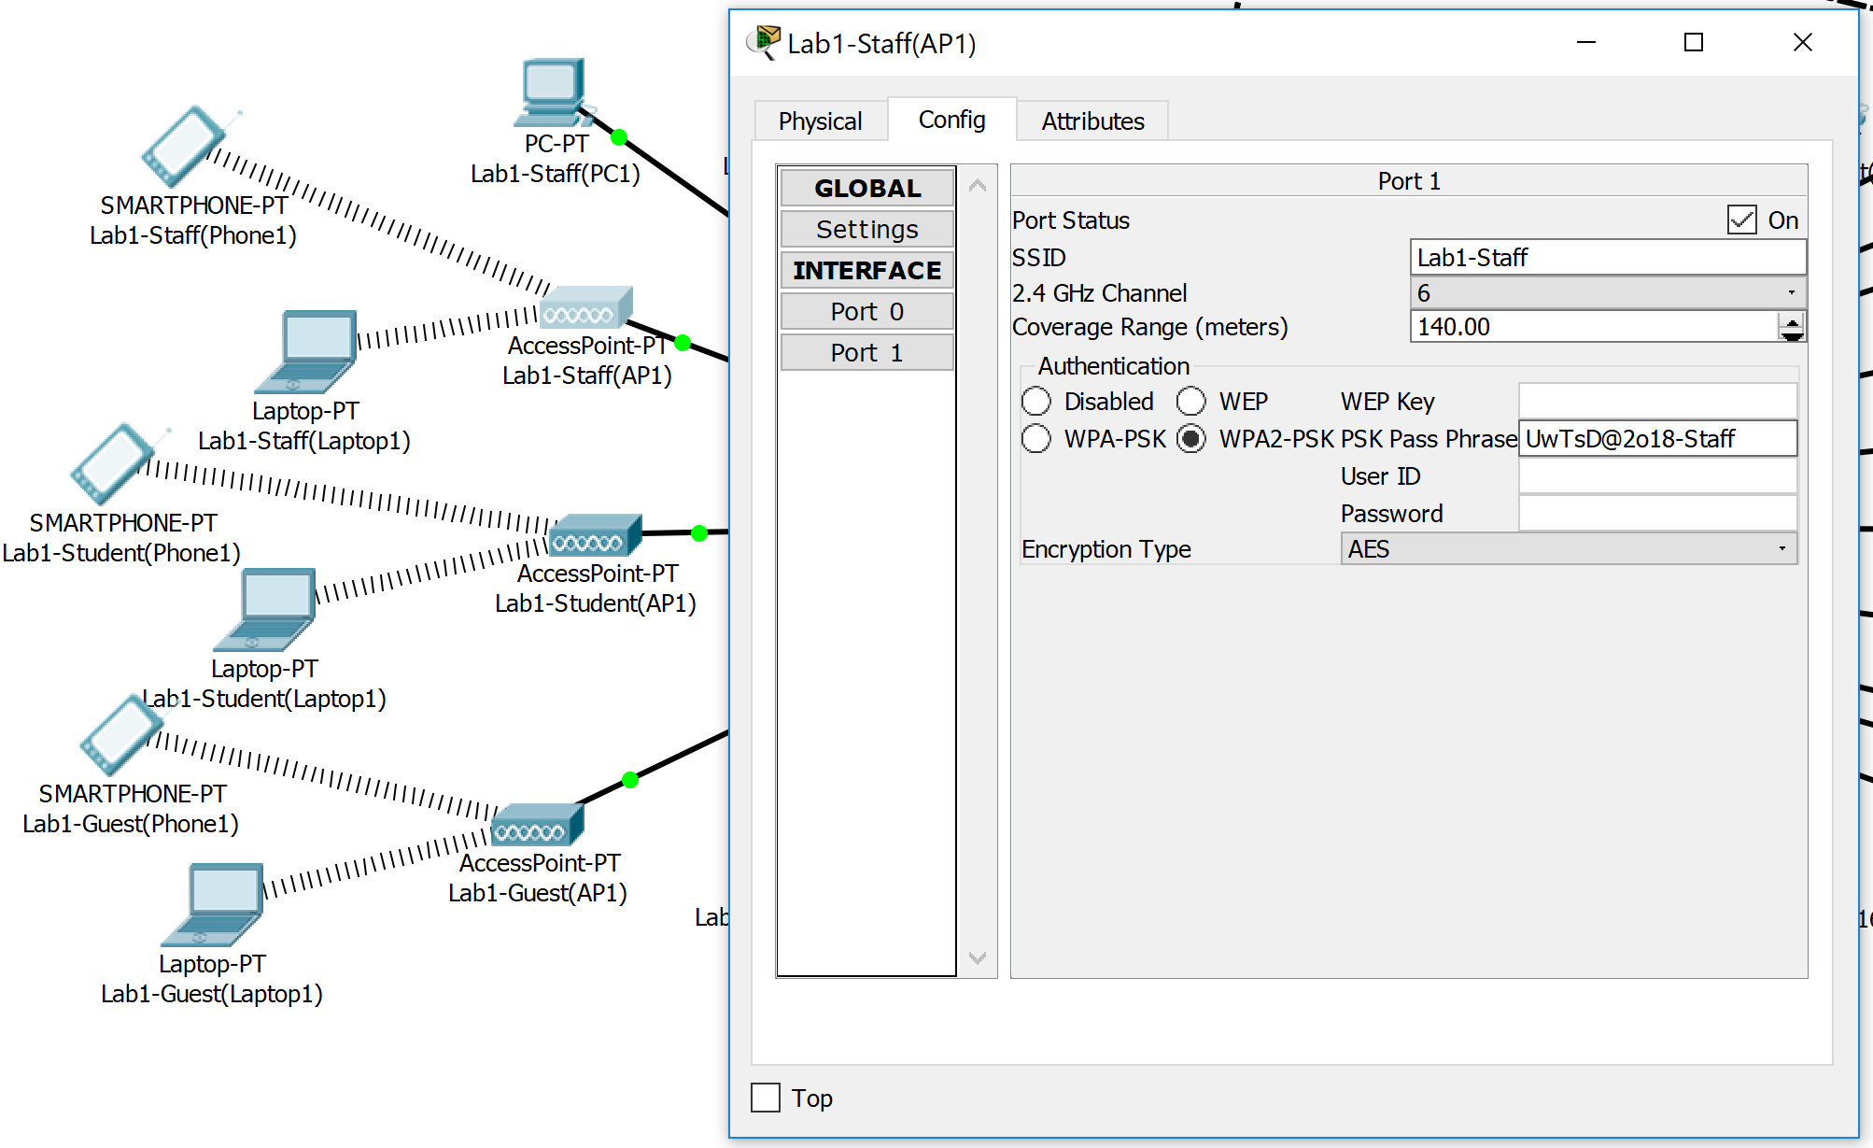
Figure 5 – Lab1 Staff Access Point

Figure 6 shows the IoT management login page. Each area of the IoT devices has its own login. This reduces the risk of unauthorised access as there are fewer devises on each login. Lab1 has a username and password of lab1. Lab2 has a username and password of lab2. The carpark has a username and password of garden. If this was to be implemented as a physical network these passwords would need to be complex. This screenshot also shows that the DNS server has been configured correctly as www.uwtsdiot.com takes the author to 10.10.20.8 the registration server address. It additionally provides evidence that the login works for lab1.
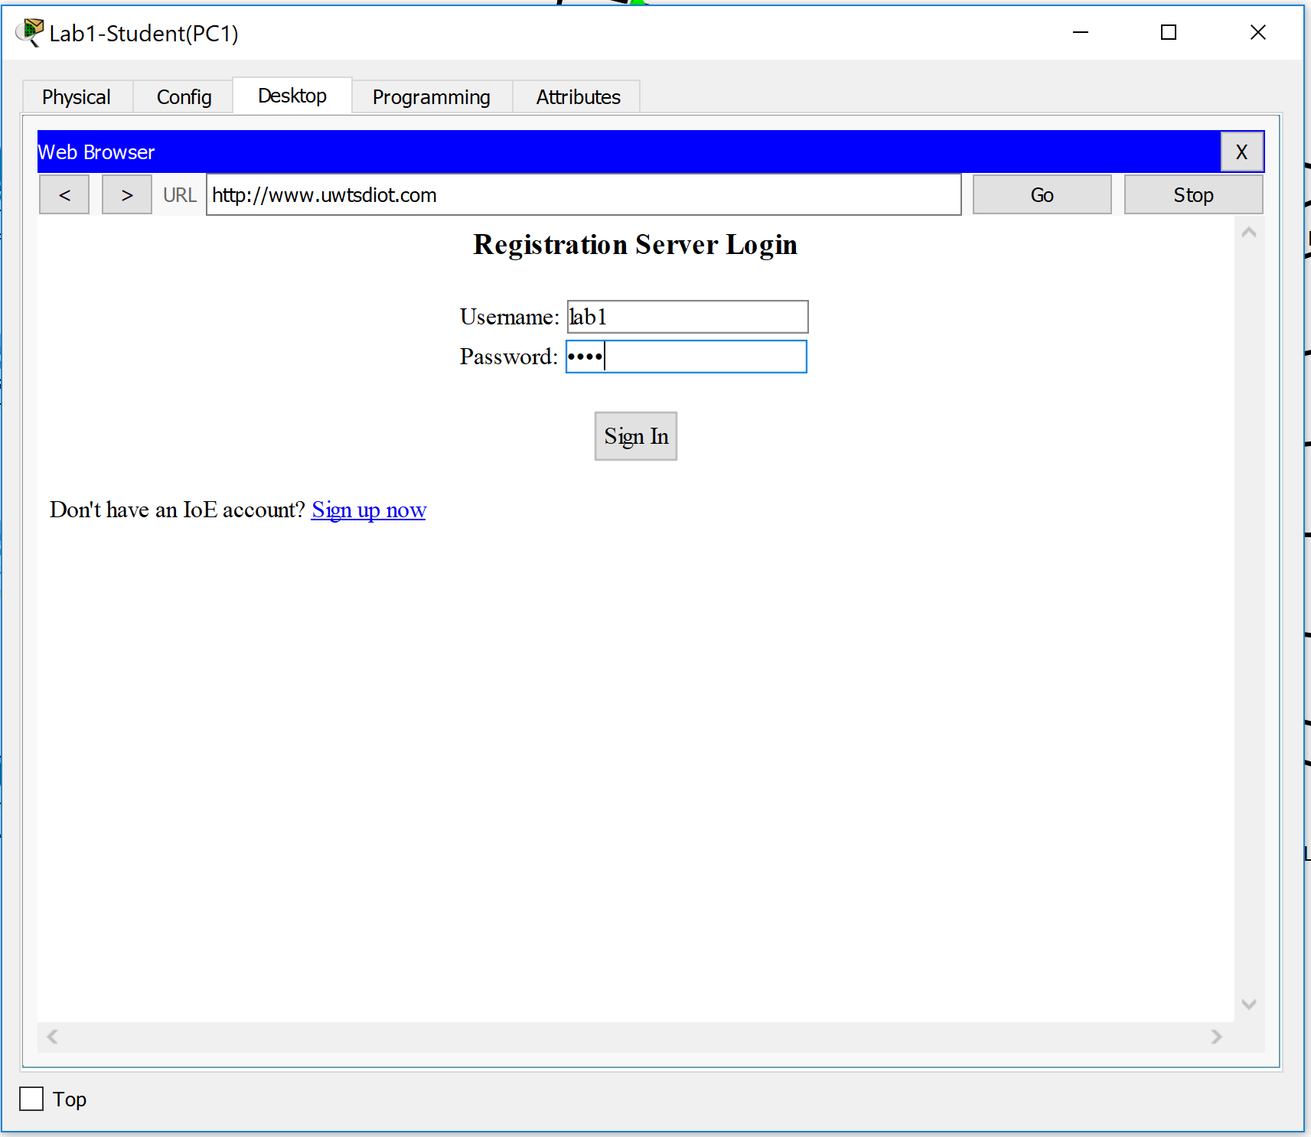
Figure 6 – IoT Management Lab1

Figure 7 is used to show that the IoT devices in lab1 are connected to the online controller. This should allow for the devices to be controlled over the internet however due to limitations in packet tracer it is not giving the author the option to control the devices remotely. Normally each device would have the ability to be controlled using the online portal.
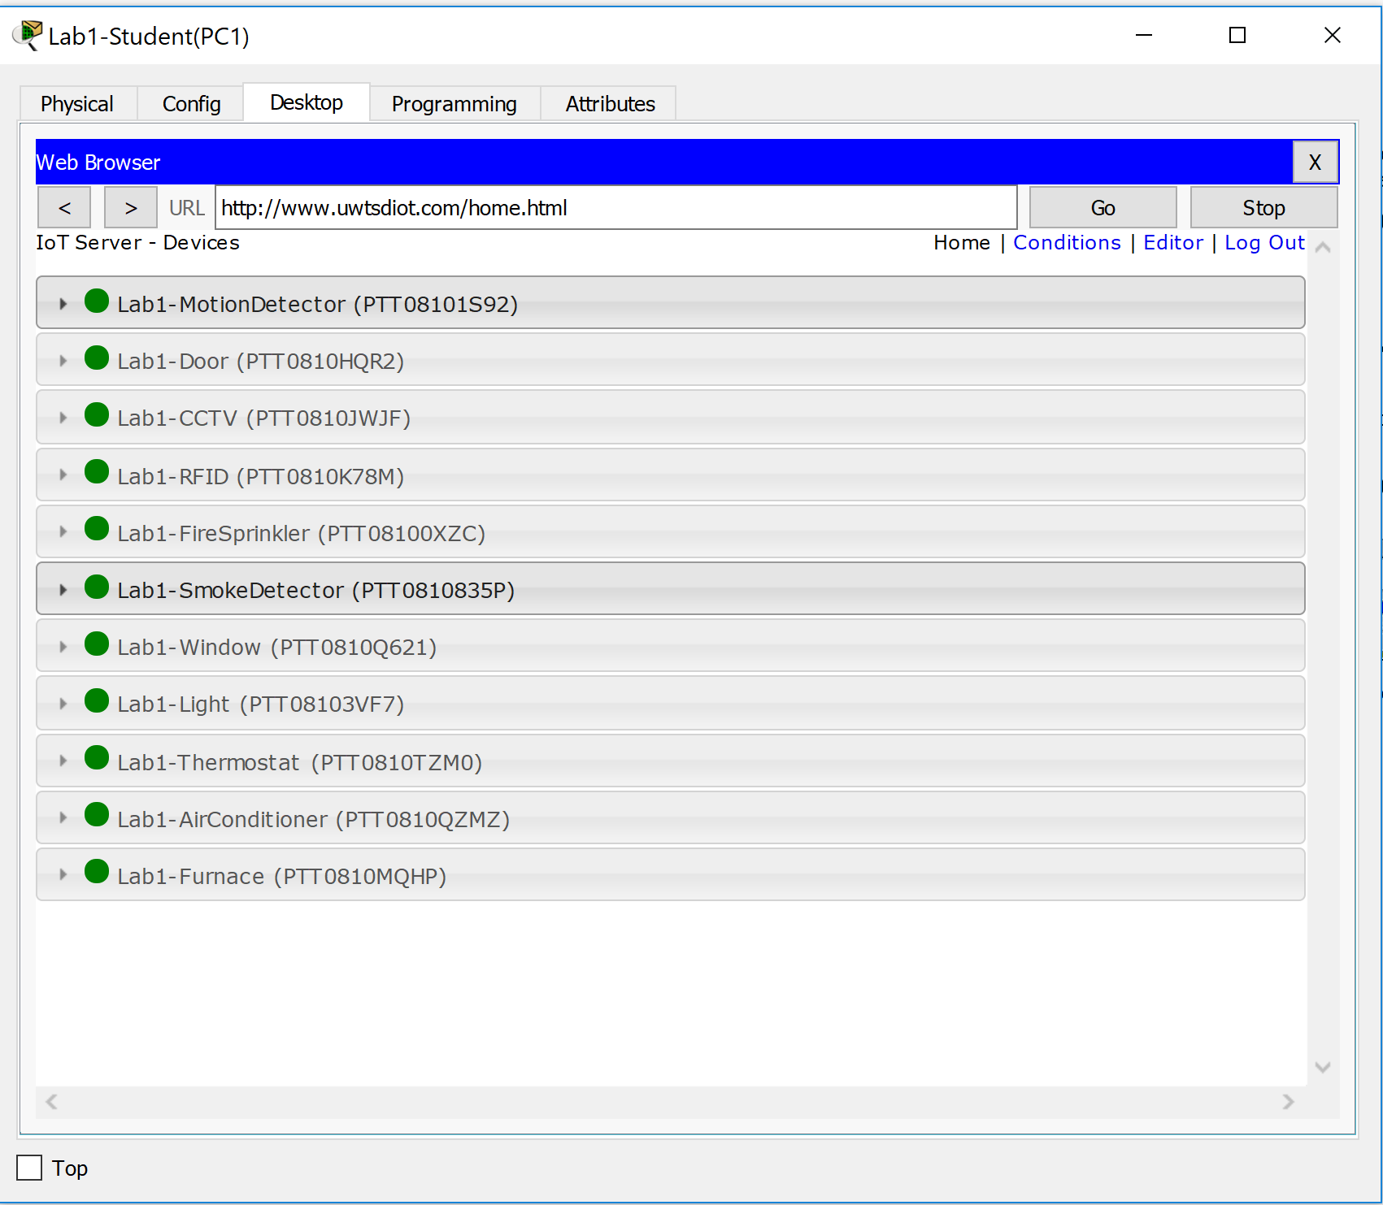
Figure 7 – IoT Management Lab1
Figure 8 is used to show that the DHCP is working as expected. The student pc is receiving an IP address within the student VLAN that is VLAN 50. All devices within the lab use DHCP, the author is only going to document the one to provide clear evidence that it is working as expected. Lab2 has the same features as Lab1 so the author is not going to document these, however it is the same details as lab1 but the log information for the IoT management is lab2 and password lab2.
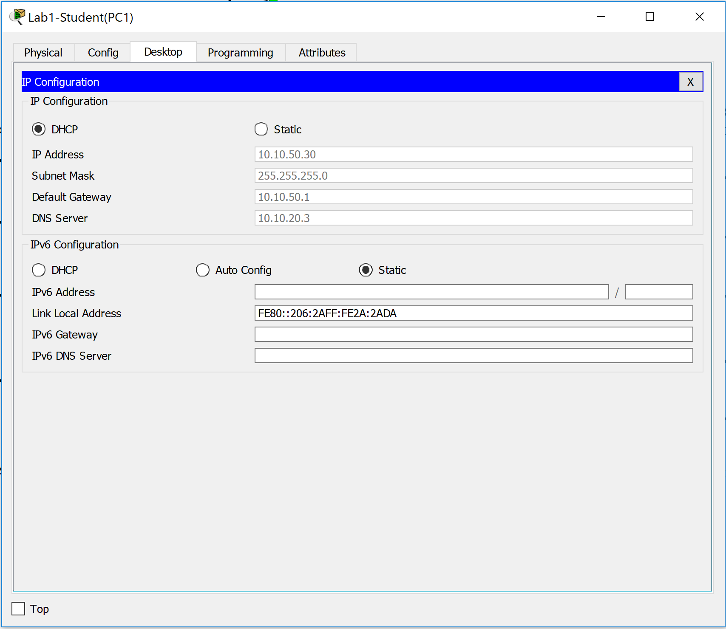
Figure 8 – DHCP Lab1

Figure 9 is used to show the smart carpark. The carpark has an entrance and exit, lighting and then each of the 10 spaces has a CCTV camera with motion detection and motion detector. These will detect when a car is parked in the space and then it will be unavailable in the online portal. This will enable the university to advertise how many parking spaces are available in any of its carparks.
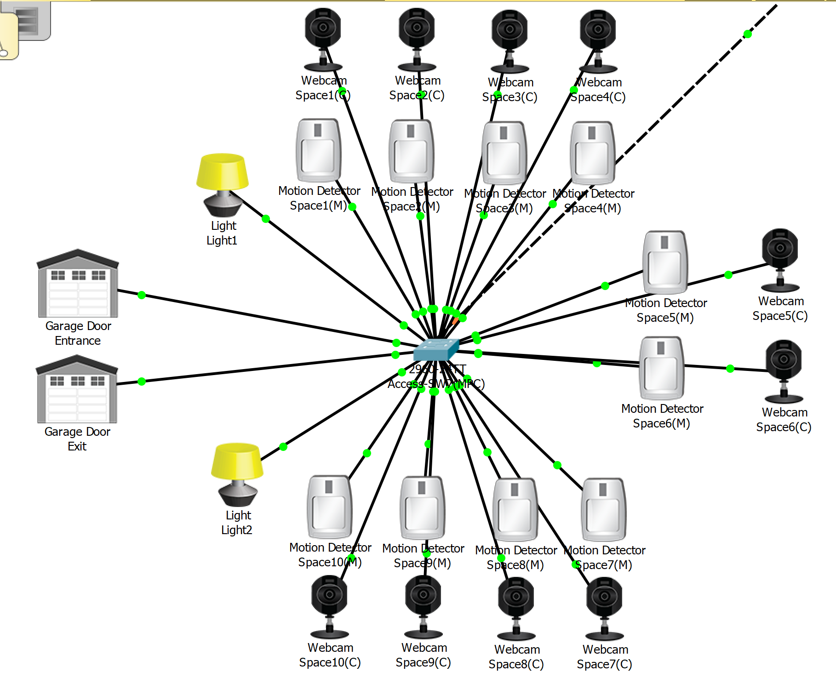
Figure 9 – Smart Carpark

Figure 10 shows that DHCP has been used for the IoT devices within the smart carpark. DHCP was implemented to allow for easier management of the university network.
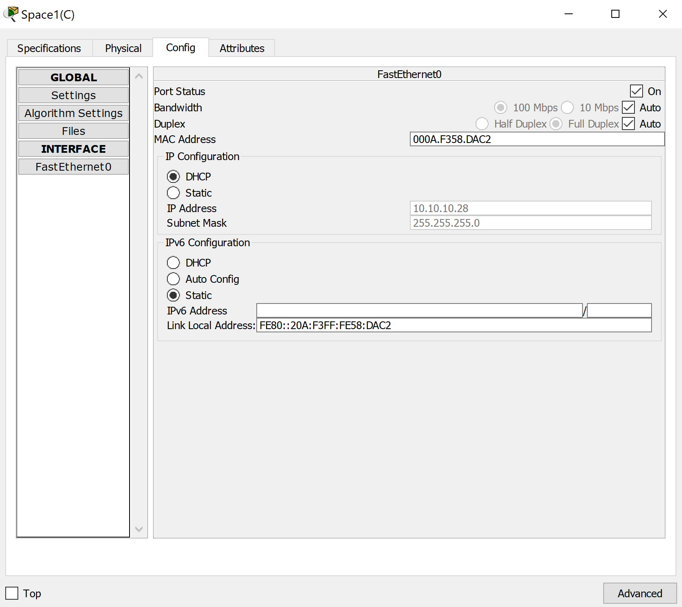
Figure 10 – Smart Carpark DHCP

Figure 11 shows the online control centre for the carpark; the username and password are both carpark. The green lights within the application show available spaces and would turn red if a space is taken, this alerting the individual checking for the parking spaces that the space is taken.
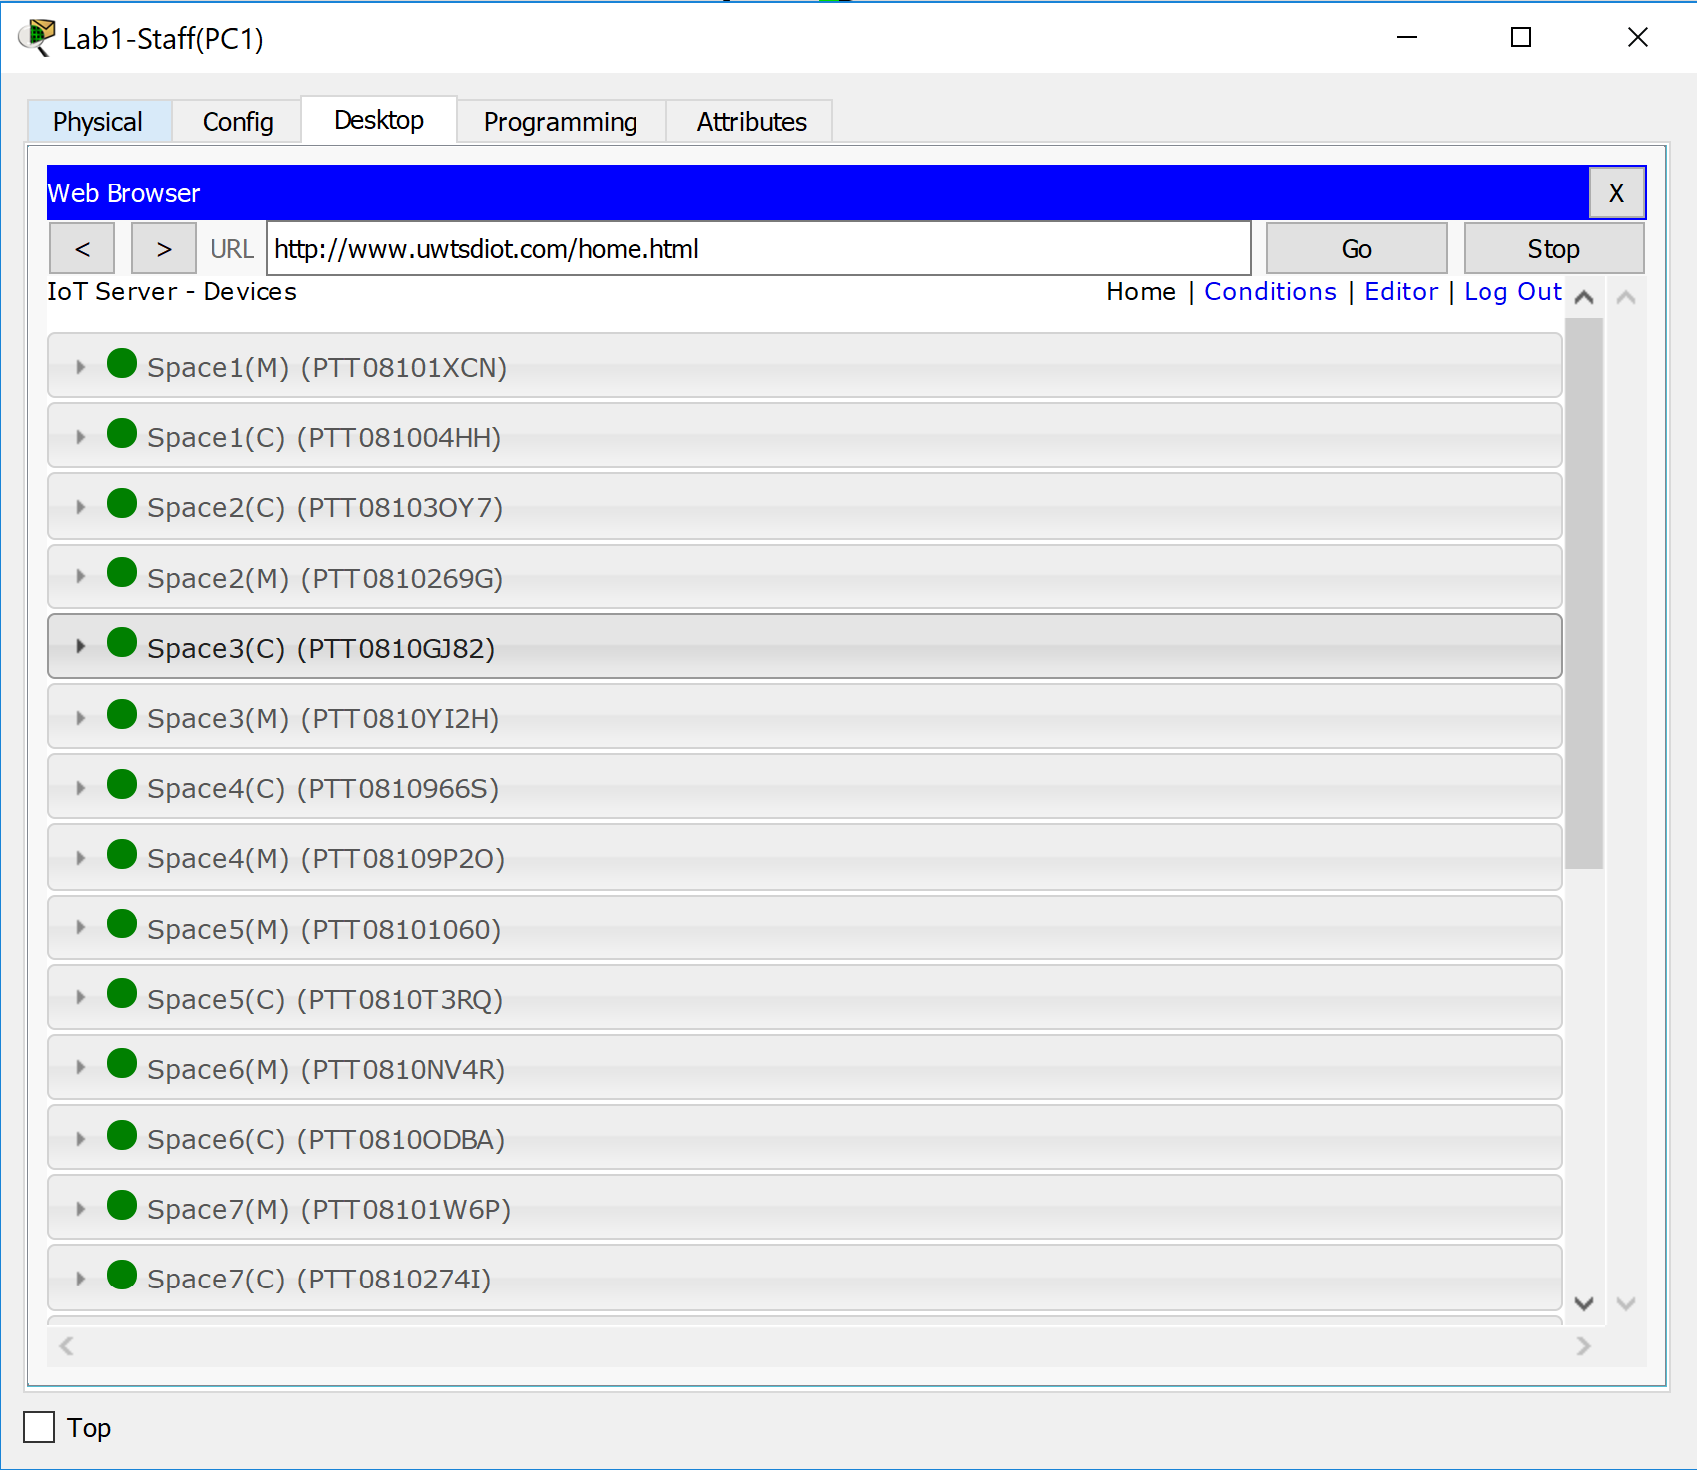
Figure 11 – Smart Carpark Control

Figure 12 shows that the network tropology. It shows that the network is designed in a hierarchical design method. This was done to ensure that traffic loads are balanced across the network to avoid bottle necks.
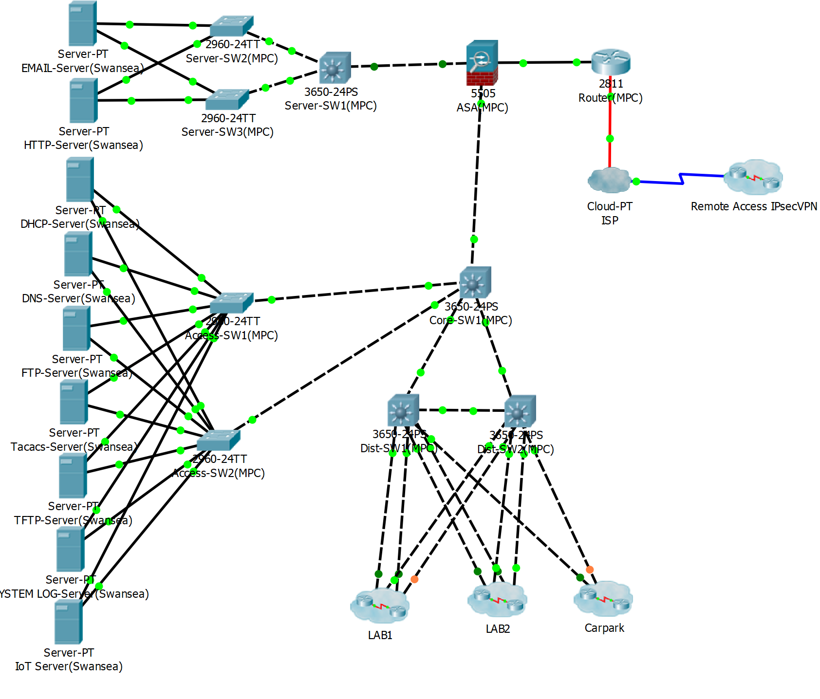
Figure 12 – Network Design

Figure 13 shows the three different security levels that are set up on the cisco ASA firewall. The inside is set to security level 100, DMZ is set to security level 70 and the outside is set to security level 0. However, due to a packet tracer firewall limitation the outside has had to be set up at security level 100 to allow remote access to the network.
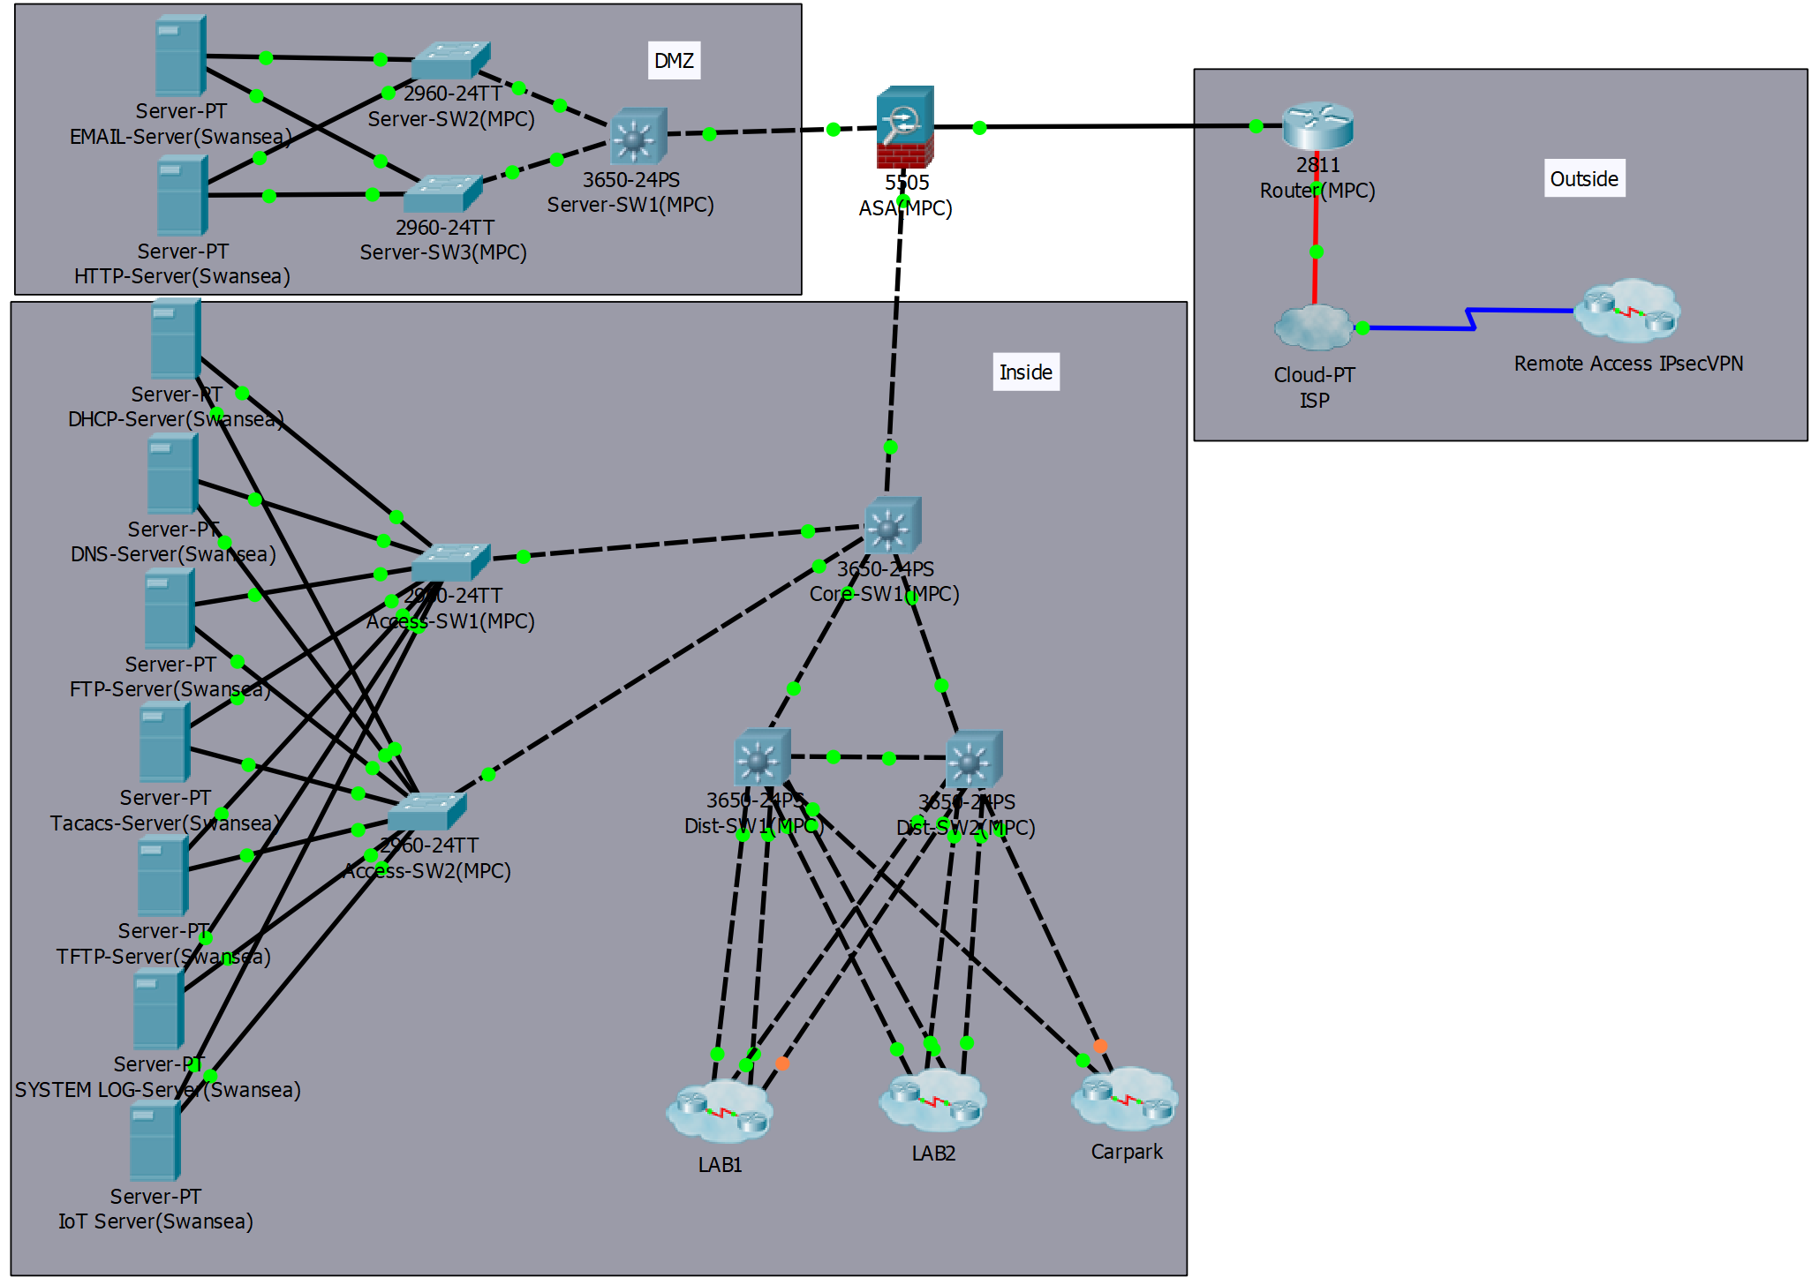
Figure 13 – Firewall Zones

Figure 14 below is used to provide evidence that different security levels have been setup. However, it shows that the outside interface is connected to a VLAN for the inside to provide remote access. This limitation was documented at the last part of the report.
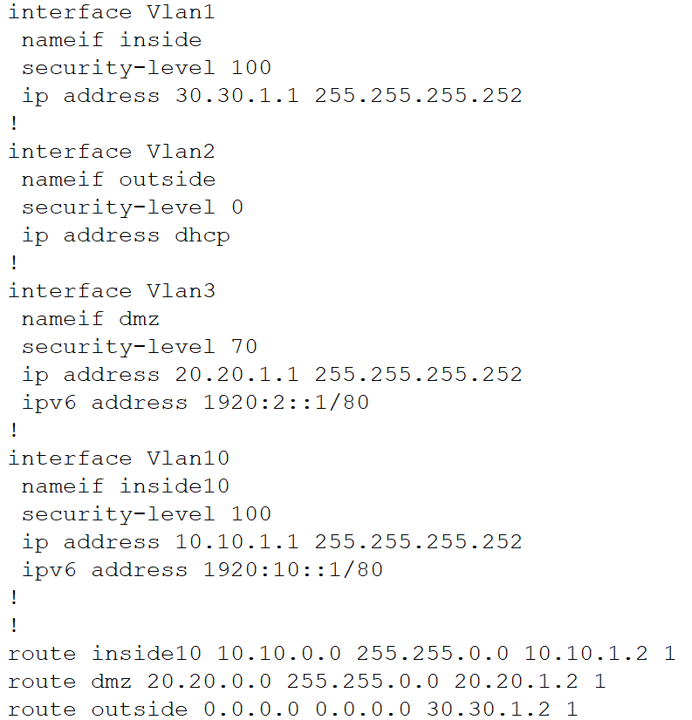
Figure 14 – Security Levels

Figure 15 is used to provide evidence traffic can travel through the firewall. This screenshot shows a staff pc on VLAN 40 pinging the email server at the IP address 20.20.20.2.
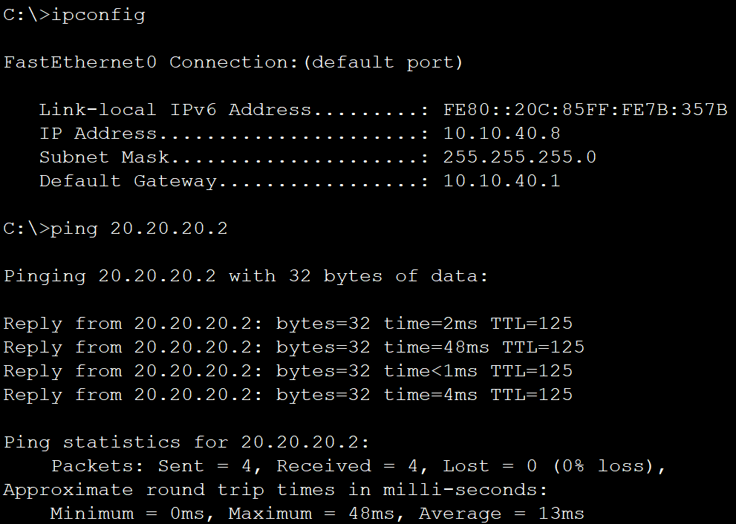
Figure 15 – Ping test through firewall (1)

Figure 16 is used to provide evidence that the firewall can block traffic. This screenshot shows the email server in the DMZ zone of the firewall with security level 70. Attempting to ping the staff pc that was able to ping the server on VLAN 40 at the Ip address 10.10.40.8. This packet was successfully dropped by the firewall demonstrating that the firewall within the network is used for filtering traffic.
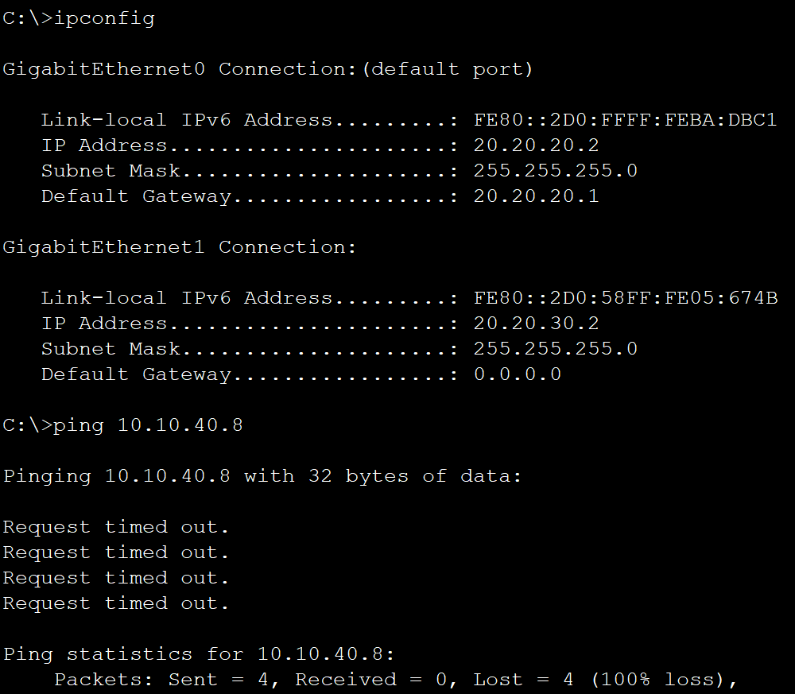
Figure 16 - Ping test through firewall (2)

Figure 17 shows that a VPN for remote access has been created. This VPN ensures that remote access is provided through a secure encrypted tunnel.
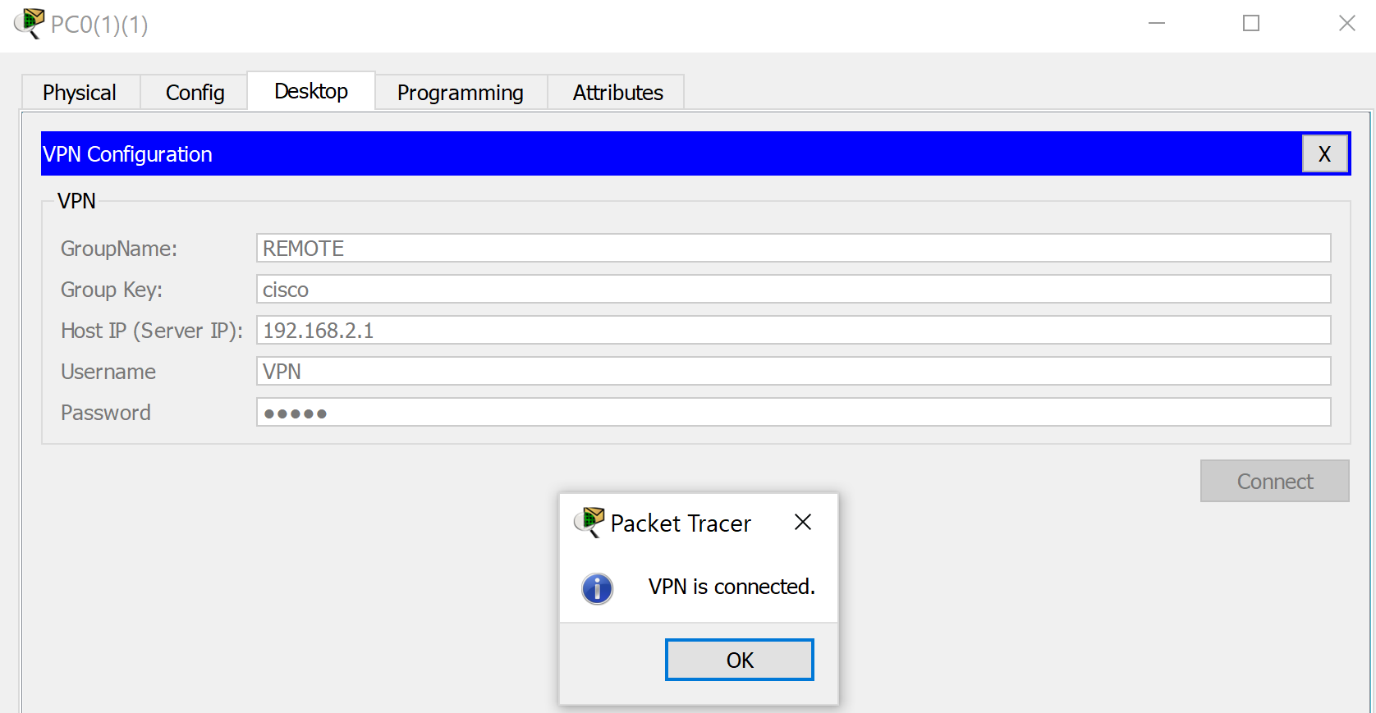
Figure 17 – VPN (1)

Figure 18 shows that the client has got a new IP address that is used for the IPsec VPN. This will remain active until the disconnect button is clicked.
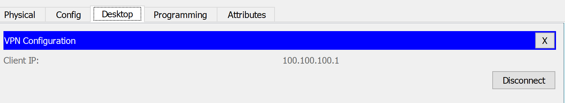
Figure 18 – VPN (2)

Figure 19 shows evidence that the VPN has been configured correctly within the network. It is using the Ipconfig command to provide information about the devices IP address.
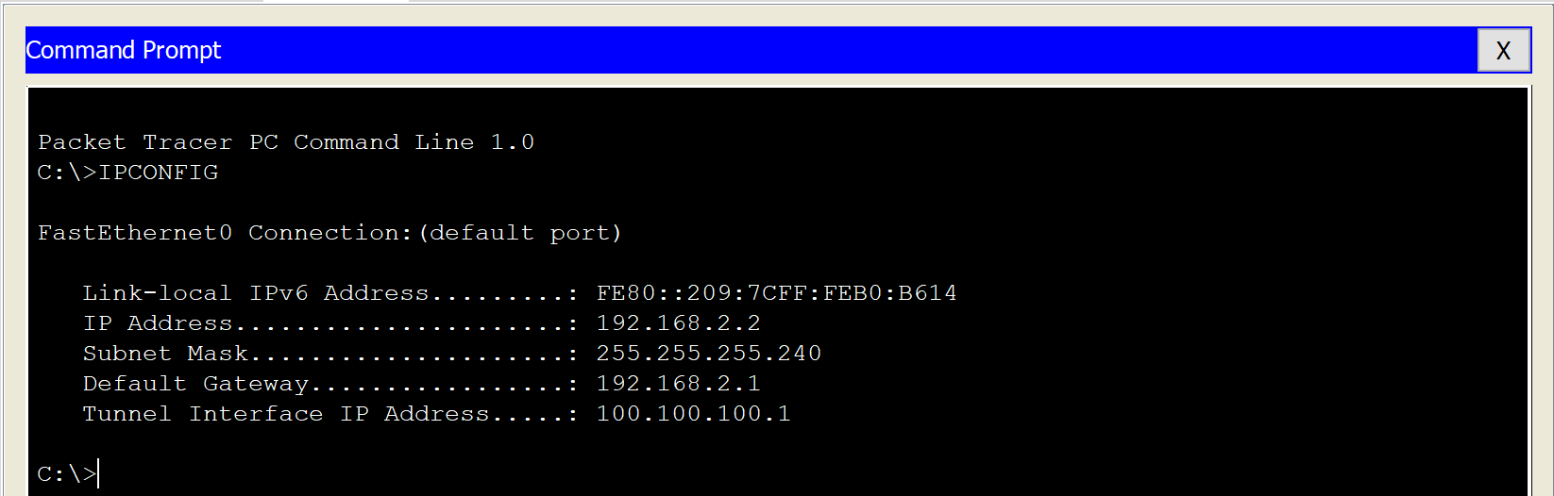
Figure 19 – VPN (3)

Figure 20 shows how the VPN has been created for remote access. It shows that the VPN is connected to the internet service provider (ISP). This demonstrates that the VPN is connecting to the network over the internet using an encrypted IPsec tunnel. This ensures that the remote access session is secured from unauthorised access. This ensures that the university campus network is kept secure at all times.
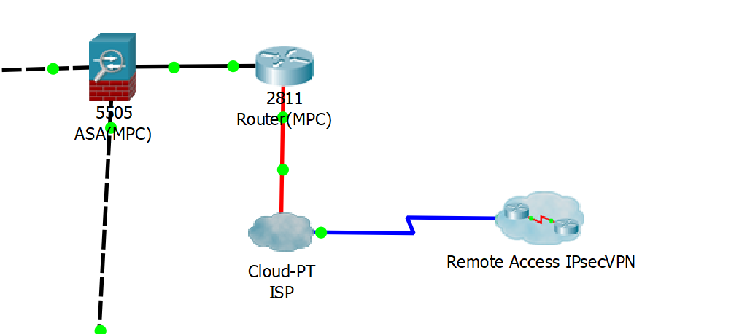
Figure 20 – VPN (4)

Figure 21 shows that the author has set up both usernames and passwords on the switches and routers, it also shows that password encryption has been enabled by the password not being stored in plain text. This screenshot also provides evidence that the author has implemented different privilege levels for different users. The user admin has a privilege level 15 and the user cisco has a privilege level 7.
Figure 21 – Username & Password

Figure 22 is used to provide evidence that the command service password-encryption has been used, this command allows plain text passwords to be stored with encryption.
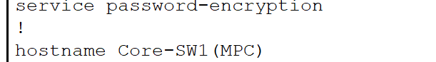
Figure 22 – Service Password Encryption

Figure 23 is used to provide evidence that the no IP domain-lookup command has been enabled to stop the domain being found.
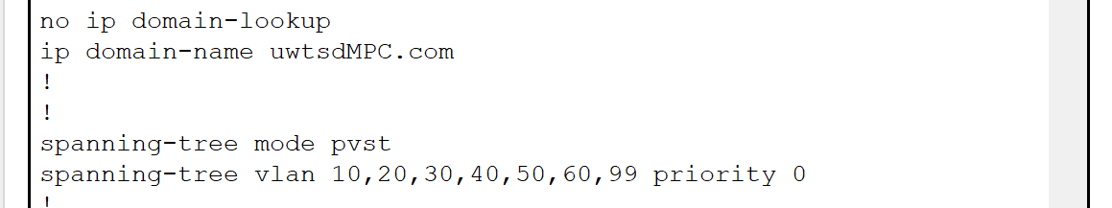
Figure 23 – No IP domain-lookup

Figure 24 is used to provide evidence that a banner message has been implemented for both local and remote access to the network. This is a requirement to legally state that unauthorised access is prohibited.
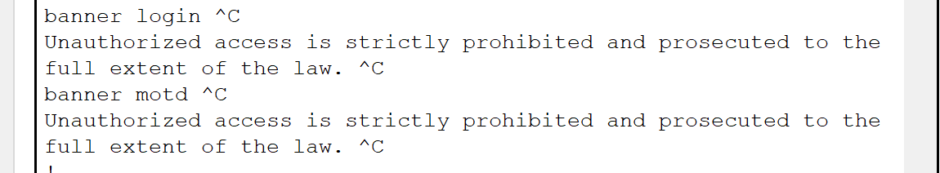
Figure 24 – Banner MOTD

Figure 25 is used to provide evidence that both the local login and remote access have authentication on them to prevent unauthorised access to the devices. This additionally provides evidence that an exec timeout has been set to automatically log the user out. This provides an additional layer of security to the network.
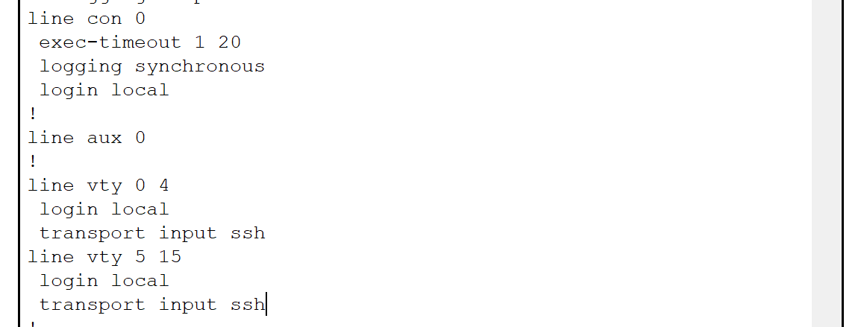
Figure 25 – Login Authentication

Figure 26 is used to provide evidence that a registration server has been setup. This is where the IoT devices are communicating with to provide remote access.
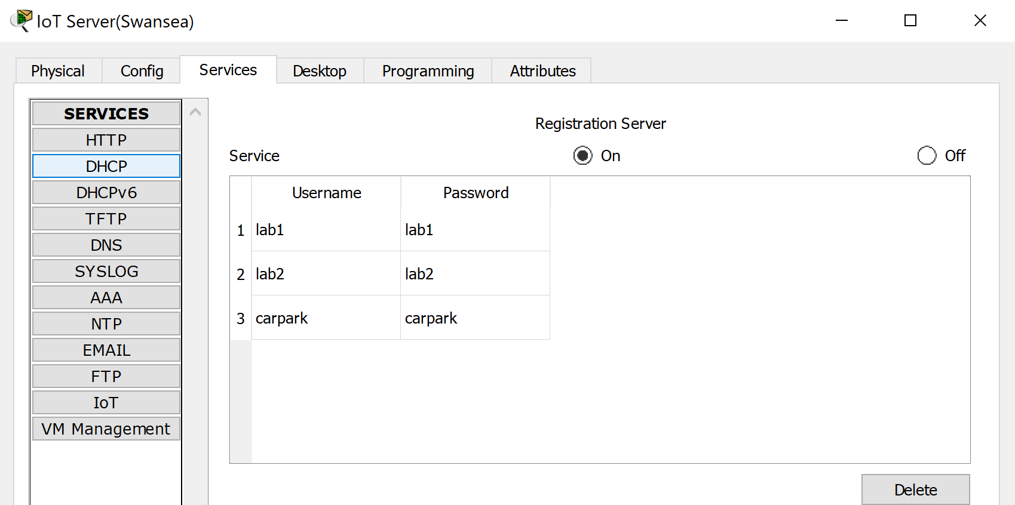
Figure 26 – Registration Server

Figure 27 is used to provide evidence that the IoT devices have been connected to the registration server correctly. This shows the server address is 10.10.20.8 and the login information for this device username is lab1 and password is lab1.
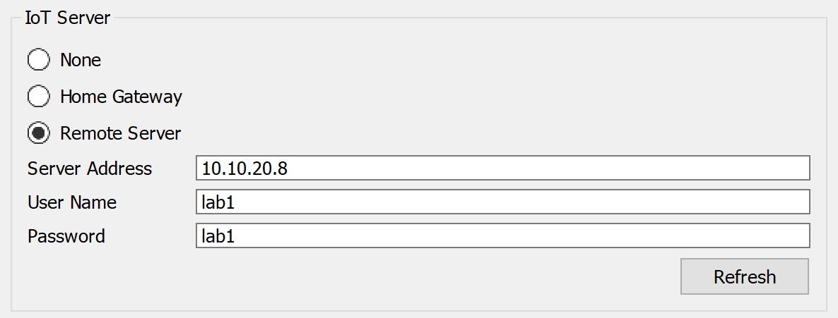
Figure 27 – IoT Connectivity to Registration Server

Figure 28 is used to provide evidence that system logging was enabled within the network. This screenshot shows the system log server.
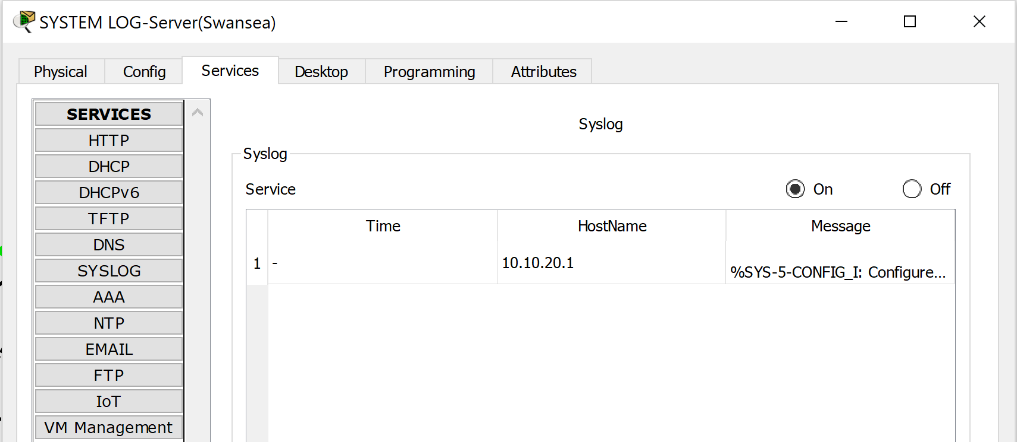
Figure 28 – System Log Server

Figure 29 is used to provide evidence that device logging was setup on the devices within the network.
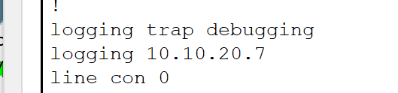
Figure 29 – Device Logging

Figure 30 is used to show that the author has set up a TFTP server to back up the configuration files to.
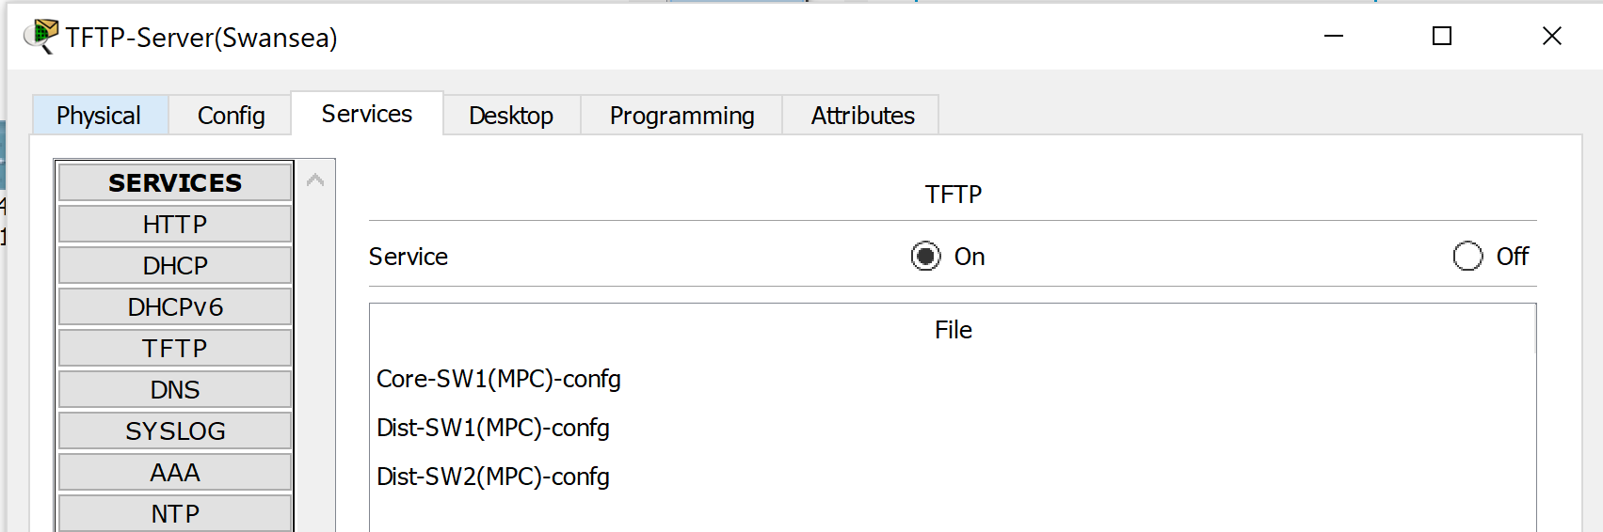
Figure 30 – TFTP server

Figure 31 is used to show that configuration files can be copied to the TFTP server correctly. This allows them to be restored in the case of a device failure. 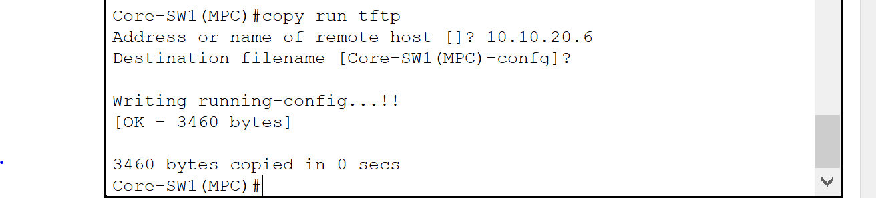
Figure 31 – Copying Config to TFTP

Figure 32 shows that an FTP server has been created within the network for files to be stored on. It shows the login username and password are cisco.
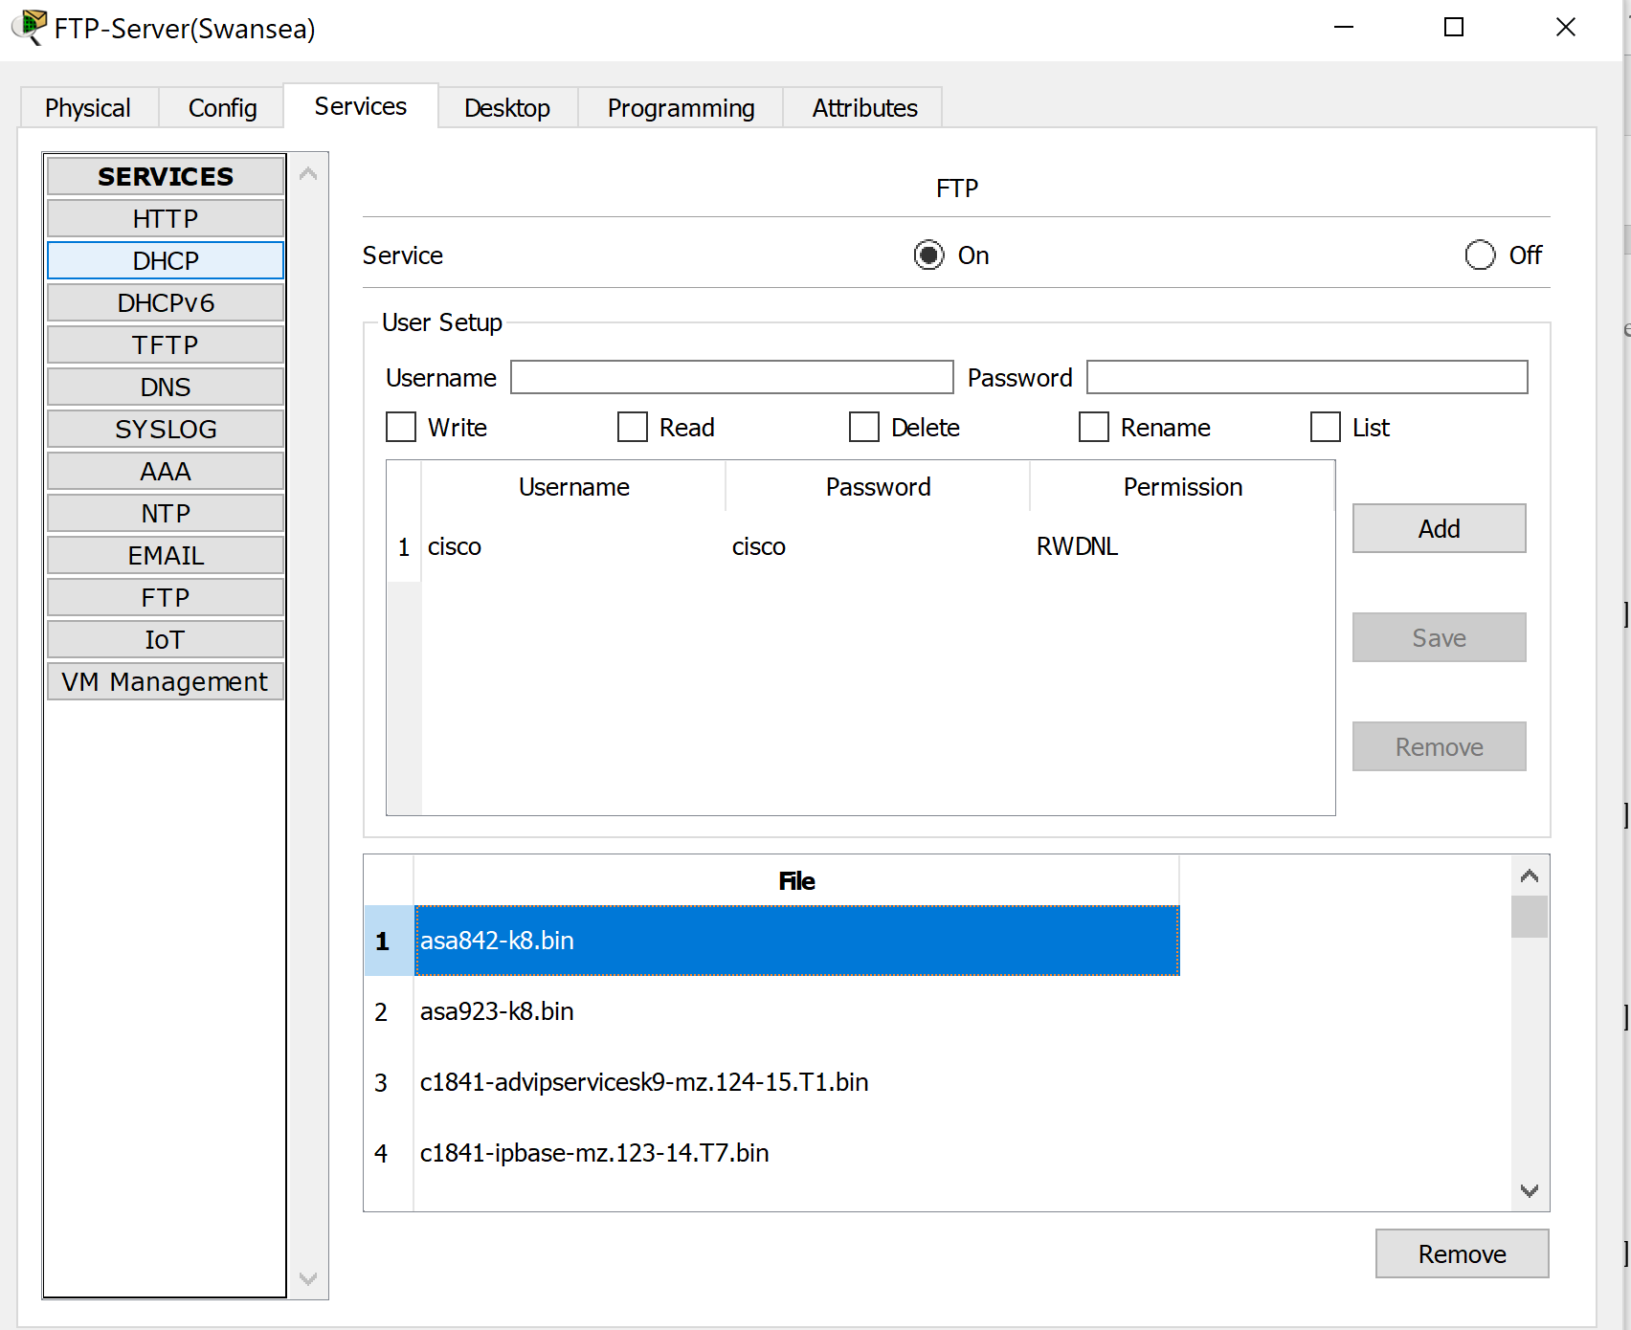
Figure 32 – FTP Server

Figure 33 shows that users can back their files up to the FTP server and retrieve files from within the server.
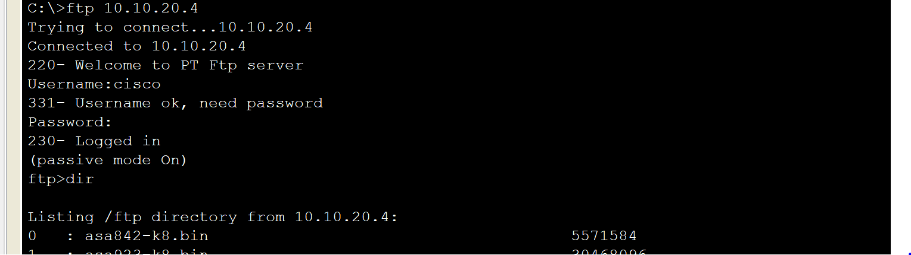
Figure 33 – Using the FTP server from a client

Figure 34 is used to demonstrate that a DNS server has been configured and is working within the network. It has two records, the IoT control centre and the university website.
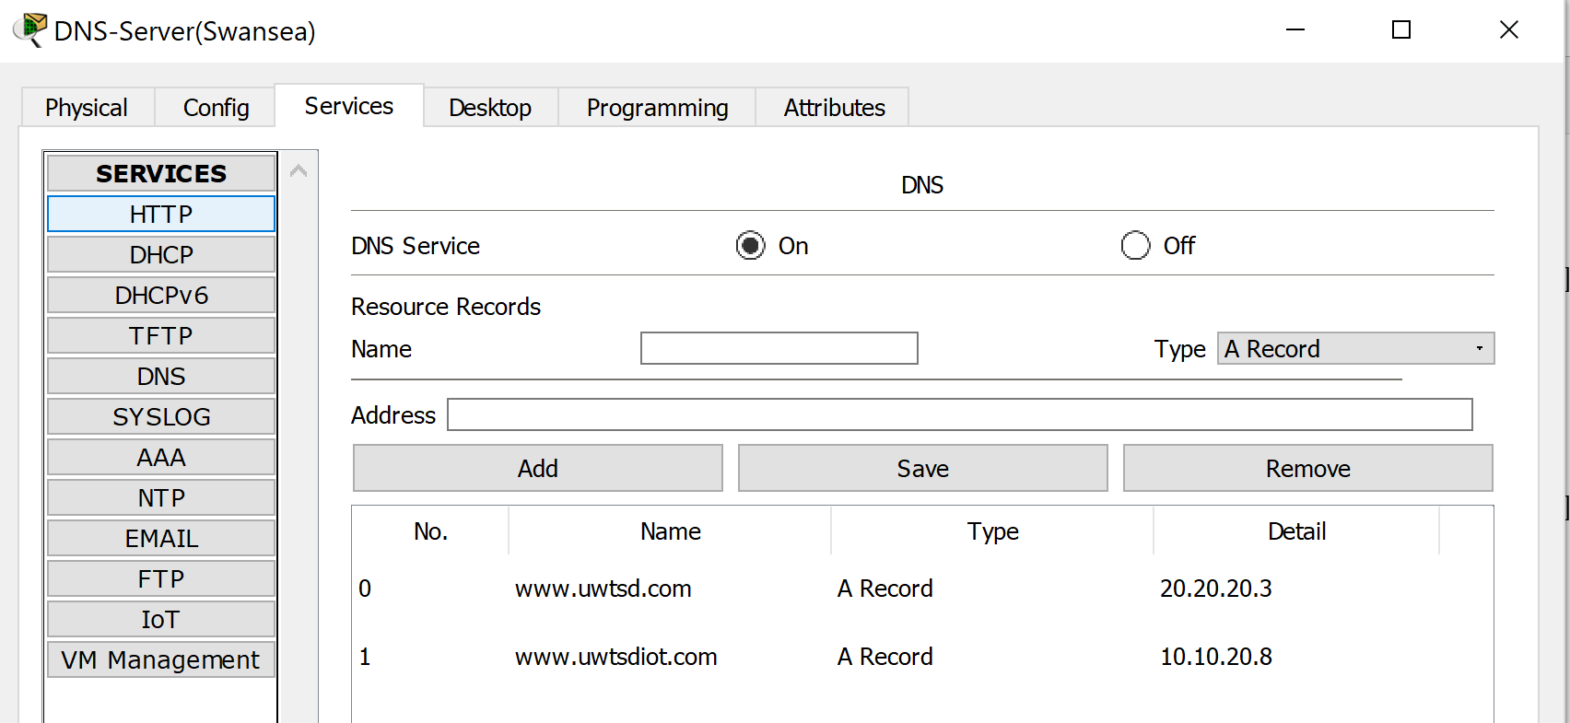
Figure 34 – DNS Server

Figure 35 is used to provide evidence that the DNS server has been set up correctly along with the HTTP server. This shows when the name www.uwtsd.com is typed into the browser the DNS convers it correctly into the IP address 20.20.20.3 the HTTP server that is used to host the website.
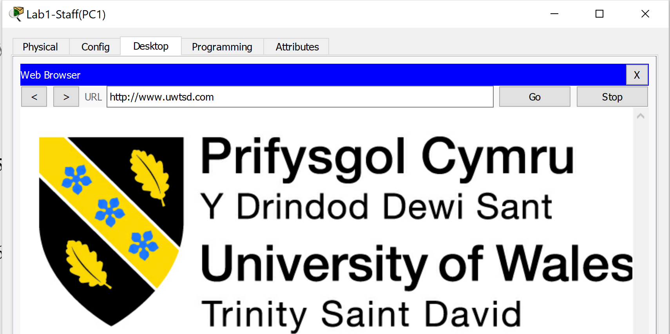
Figure 35 – UWTSD Website

Figure 36 is used to show that the HTTP server that was seen working in figure 35 is configured within the network.
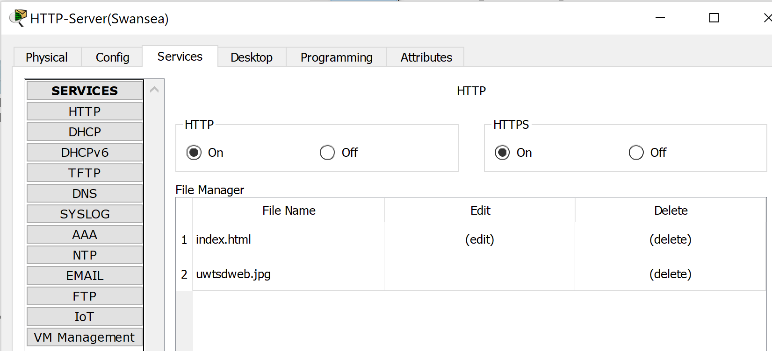
Figure 36 – HTTP Server

Figure 37 is used to show the configuration of the DHCP server, this is used to give most network devices IP addresses within the university network. The DHCP server can be seen in figure 10 working.
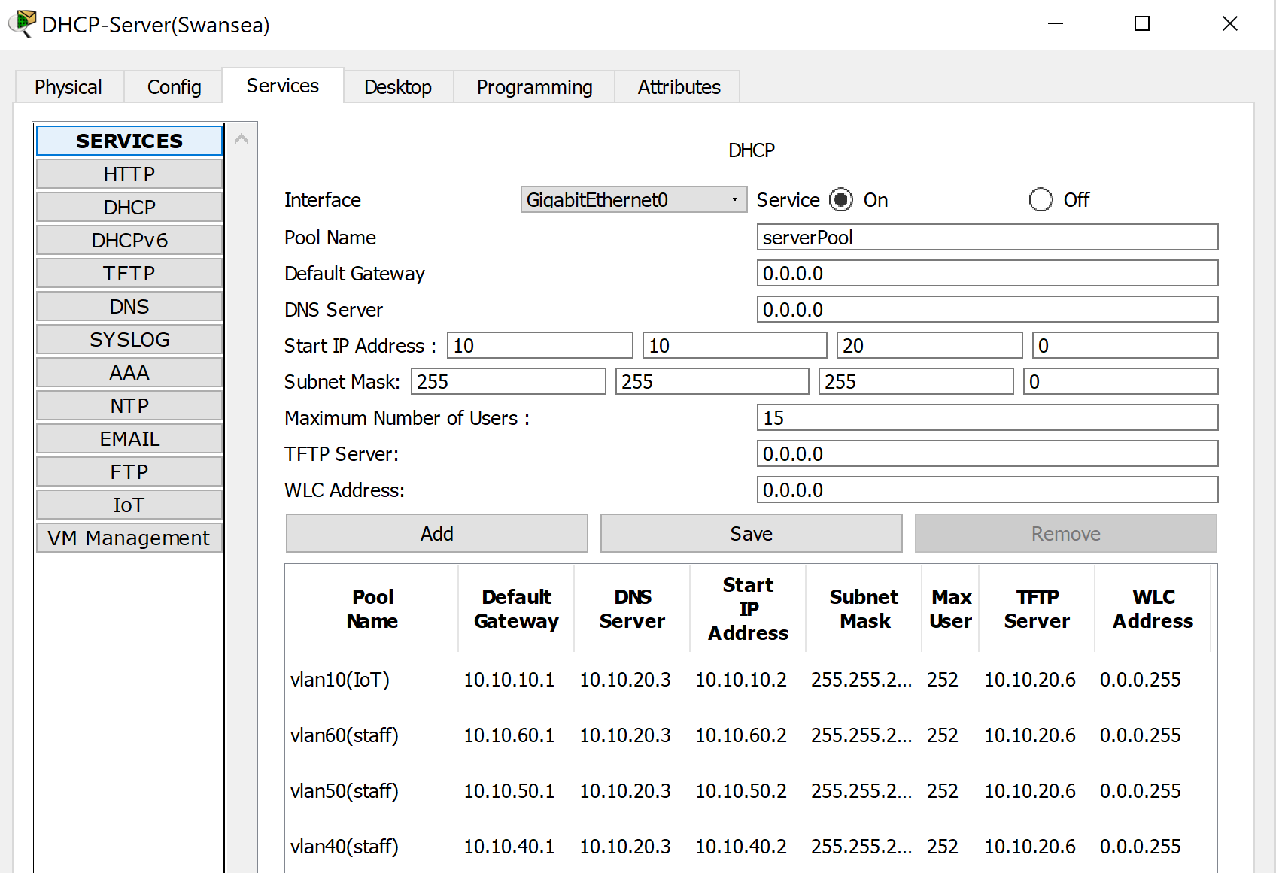
Figure 37 – DHCP Server

Figure 38 is used to show the email server that has been set up on the network. This server can be used to send emails to other users within the network. The Email server is configured correctly however, due to cisco ASA limitations it will not have the ability to send or receive mail.
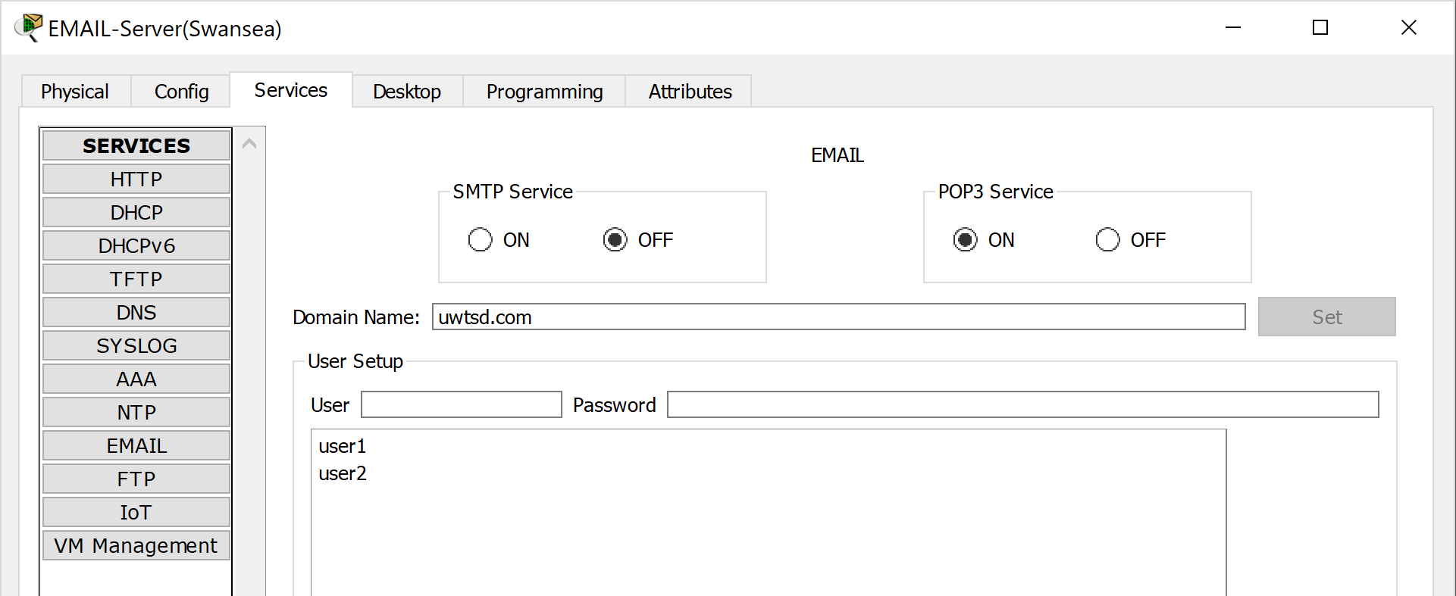
Figure 38 – Email Server

Figure 39 is used to show that Intrusion Prevention system IPS is created within the network. The author identified within the research how essential it is to include an IPS into the network.
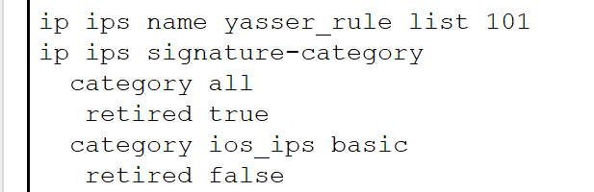
Figure 39 – Intrusion Prevention System (1)

Figure 40 shows that the IPS is implemented onto the interface that is connected to the internet. 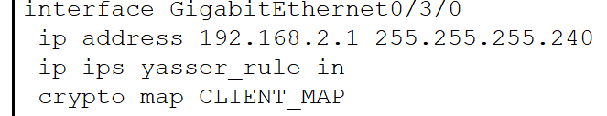
Figure 40 - Intrusion Prevention System (2)

Figure 41 is used to show that SSH has been implemented onto the network devices for remote management. This provides a secure remote connection into the devices so that they can be managed remotely.
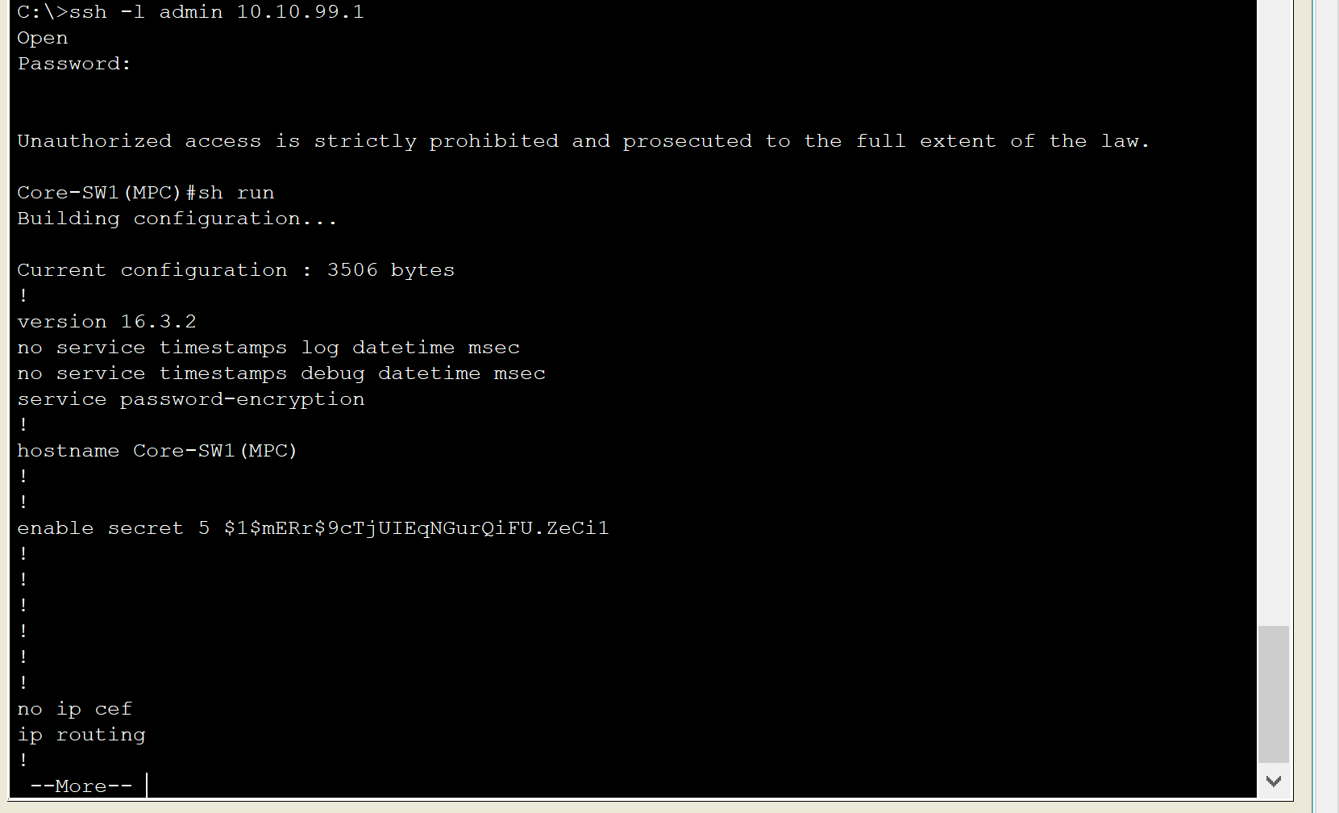
Figure 41 – Using SSH

- Results/findings & Discussion
The author found that this network design was very successful. The author wanted to implement different security countermeasures to protect the network. The research that was conducted in the first section of the report has helped the author identify different security threats and how to implement countermeasures to protect the network.

The author wanted to implement a firewall into the network to allow traffic to be filtered. The simulation includes a cisco adaptive security appliance (ASA) that has been used as a firewall. The author has successfully configured the firewall within the simulation. The next thing that the author wanted to implement was access control encryption. The author has implemented this on all the devise other than the cisco ASA due to the limitations that it is not possible to secure the ASA within packet tracer. The author has implemented passwords to gain access to the network devices and then encrypted them so that they cannot be read as plain text.

The author wanted to create a remote access VPN to for remote access to the network. This has been implemented successfully within the network. This allows staff and partners to remotely access the network while using a secure encrypted tunnel. The VPN that was implemented was an IPsec VPN as it was one of the best identified within the research of the report.

- Conclusion
In conclusion the author thinks that the project was very successful, there were two parts to this report related work where the author investigated future trends in cyber security. This involved looking at what are the current threats. This enabled the author to learn that the future trends in cyber security are that there will be more vulnerabilities within devices in the future leading to an increased amount of attacks.

The second part of the project was to design and create a simulation for a new SA1 campus network. The author also thinks that this was successful and that the simulation met the scenario requirements that were set out within the report. The author did find a few limitations within the configurations and software Cisco Packet Tracer. The main issue was that the cisco ASA was very buggy when configuring it and sometimes the ASA broke with the correct commands being implemented.

Recommendations for future work would be to investigate more vulnerabilities within a network, this would allow the author to provide additional information on how to prevent each attack. This would then allow the author to create a simulation that would have the ability to defend from further attacks to ensure that the university network is kept secure always. The second thing that the author would like to look at for future work is to develop a better understanding of how firewalls work. Again, this will allow for a more secure network design to be configured within the simulation.

- Table of Figures
Figure 1 – Network Blueprint 5
Figure 2- Wireshark Packet Capture 5
Figure 3 – Lab1 workstations 5
Figure 4 – Lab1 IoT devices 6
Figure 5 – Lab1 Staff Access Point 6
Figure 6 – IoT Management Lab1 6
Figure 7 – IoT Management Lab1 6
Figure 8 – DHCP Lab1 7
Figure 9 – Smart Carpark 7
Figure 10 – Smart Carpark DHCP 7
Figure 11 – Smart Carpark Control 8
Figure 12 – Network Design 8
Figure 13 – Firewall Zones 8
Figure 14 – Security Levels 8
Figure 15 – Ping test through firewall (1) 9
Figure 16 - Ping test through firewall (2) 9
Figure 17 – VPN (1) 9
Figure 18 – VPN (2) 9
Figure 19 – VPN (3) 9
Figure 20 – VPN (4) 10
Figure 21 – Username & Password 10
Figure 22 – Service Password Encryption 10
Figure 23 – No IP domain-lookup 10
Figure 24 – Banner MOTD 10
Figure 25 – Login Authentication 10
Figure 26 – Registration Server 10
Figure 27 – IoT Connectivity to Registration Server 11
Figure 28 – System Log Server 11
Figure 29 – Device Logging 11
Figure 30 – TFTP server 11
Figure 31 – Copying Config to TFTP 11
Figure 32 – FTP Server 11
Figure 33 – Using the FTP server from a client 11
Figure 34 – DNS Server 12
Figure 35 – UWTSD Website 12
Figure 36 – HTTP Server 12
Figure 37 – DHCP Server 12
Figure 38 – Email Server 12
Figure 39 – Intrusion Prevention System (1) 12
Figure 40 - Intrusion Prevention System (2) 13
Figure 41 – Using SSH 13

- References
[1] P. Sharma, D. Doshi, and M. M. Prajapati, “Cybercrime: Internal security threat,” in 2016 International Conference on ICT in Business Industry & Government (ICTBIG), 2016, pp. 1–4.
[2] I. Nadir and T. Bakhshi, “Contemporary cybercrime: A taxonomy of ransomware threats &amp; mitigation techniques,” in 2018 International Conference on Computing, Mathematics and Engineering Technologies (iCoMET), 2018, pp. 1–7.
[3] V. A. F. Almeida, D. Doneda, and J. de Souza Abreu, “Cyberwarfare and Digital Governance,” IEEE Internet Comput., vol. 21, no. 2, pp. 68–71, Mar. 2017.
[4] R. Loui and W. Hope, “Information Warfare Amplified by Cyberwarfare and Hacking the National Knowledge Infrastructure,” in 2017 IEEE 15th Intl Conf on Dependable, Autonomic and Secure Computing, 15th Intl Conf on Pervasive Intelligence and Computing, 3rd Intl Conf on Big Data Intelligence and Computing and Cyber Science and Technology Congress(DASC/PiCom/DataCom/CyberSciTech), 2017, pp. 280–283.
[5] N. Kshetri, “Cyberwarfare: Western and Chinese Allegations,” IT Prof., vol. 16, no. 1, pp. 16–19, Jan. 2014.
[6] M. J. G. Lapayese, “Terrorism and its Transition to Cyberspace,” in 2015 European Intelligence and Security Informatics Conference, 2015, pp. 178–178.
[7] M. Kilger, “Integrating Human Behavior Into the Development of Future Cyberterrorism Scenarios,” in 2015 10th International Conference on Availability, Reliability and Security, 2015, pp. 693–700.
[8] D. Gheorghica and V. Croitoru, “A new framework for enhanced measurable cybersecurity in computer networks,” in 2016 International Conference on Communications (COMM), 2016, pp. 285–290.
[9] D. Galinec and W. Steingartner, “Combining cybersecurity and cyber defense to achieve cyber resilience,” in 2017 IEEE 14th International Scientific Conference on Informatics, 2017, pp. 87–93.
[10] V. E. Urias, B. Van Leeuwen, W. M. S. Stout, and H. W. Lin, “Dynamic cybersecurity training environments for an evolving cyber workforce,” in 2017 IEEE International Symposium on Technologies for Homeland Security (HST), 2017, pp. 1–6.
[11] A. Rotondo, “Countering cyber threats: answers from international law,” in 2016 International Conference on Cyber Conflict (CyCon U.S.), 2016, pp. 1–7.
[12] S. Biedermann, T. Ruppenthal, and S. Katzenbeisser, “Data-centric phishing detection based on transparent virtualization technologies,” in 2014 Twelfth Annual International Conference on Privacy, Security and Trust, 2014, pp. 215–223.
[13] V. Adat, A. Dahiya, and B. B. Gupta, “Economic incentive based solution against distributed denial of service attacks for IoT customers,” in 2018 IEEE International Conference on Consumer Electronics (ICCE), 2018, pp. 1–5.
[14] D. C. Grant, “Distributed detection and response for the mitigation of distributed denial of service attacks,” in 2018 International Conference on Information Networking (ICOIN), 2018, pp. 495–497.
[15] A. Solairaj, S. C. Prabanand, J. Mathalairaj, C. Prathap, and L. S. Vignesh, “Keyloggers software detection techniques,” in 2016 10th International Conference on Intelligent Systems and Control (ISCO), 2016, pp. 1–6.
[16] K. S. M. Moe and T. Win, “Improved hashing and honey-based stronger password prevention against brute force attack,” in 2017 International Symposium on Electronics and Smart Devices (ISESD), 2017, pp. 1–5.
[17] O.-M. Latvala, C. Peng, P. Honkamaa, and K. Halunen, “&quot;Speak, Friend, and Enter&quot; - Secure, Spoken One-Time Password Authentication,” in 2018 9th IFIP International Conference on New Technologies, Mobility and Security (NTMS), 2018, pp. 1–5.
[18] N. Maheshwari and H. Dagale, “Secure communication and firewall architecture for IoT applications,” in 2018 10th International Conference on Communication Systems & Networks (COMSNETS), 2018, pp. 328–335.
[19] J. Cao, L. Drabeck, and R. He, “Statistical network behavior based threat detection,” in 2017 IEEE Conference on Computer Communications Workshops (INFOCOM WKSHPS), 2017, pp. 420–425.
[20] T. K. Kuppusamy, L. A. DeLong, and J. Cappos, “Uptane: Security and Customizability of Software Updates for Vehicles,” IEEE Veh. Technol. Mag., vol. 13, no. 1, pp. 66–73, Mar. 2018.
[21] S. Jing, Q. Qi, R. Sun, and Q. Li, “Study on VPN Solution Based on Multi-campus Network,” in 2016 8th International Conference on Information Technology in Medicine and Education (ITME), 2016, pp. 777–780.
[22] Y. Purwanto, Kuspriyanto, Hendrawan, and B. Rahardjo, “Multistage process to decrease processing time in intrusion prevention system,” in 2017 3rd International Conference on Wireless and Telematics (ICWT), 2017, pp. 54–59.
[23] E. Ariafar and R. Kiani, “Intrusion detection system using an optimized framework based on datamining techniques,” in 2017 IEEE 4th International Conference on Knowledge-Based Engineering and Innovation (KBEI), 2017, pp. 0785–0791.

marking criteria and Student FEEDBACK

This section details the assessment criteria. The extent to which these are demonstrated by you determines your mark. The marks available for each criterion are shown. Lecturers will use the space provided to comment on the achievement of the task(s), including those areas in which you have performed well and areas that would benefit from development/improvement.

Common Assessment Criteria Applied (Assignment 1) | Marks available | Marks  awarded
1. Research-informed Literature
Extent of research and/or own reading, selection of credible sources, application of appropriate referencing conventions.
Excellent research informed literature. Referencing skills applied throughout the research aspect. (Grade mark: 93.33%) | 15 | 14
2. Knowledge and Understanding of Subject
Extent of knowledge and understanding of concepts and underlying principles associated with the discipline.
Demonstrated knowledge & understanding of the main theories and concept (Grade mark: 93.33%) | 15 | 14
3. Analysis
Analysis, evaluation and synthesis; logic, argument and judgement; analytical reflection; organisation of ideas and evidence
Your research aspect covered well but it would be good to use the related work to strengthen the practical discussions. You have discussed and explained your practical design as well as demonstrated in your discussion tested results. Conclusion done with future recommendations. (Grade mark: 73.33%) | 30 | 22
4. Practical Application and Deployment
Deployment of methods, materials, tools and techniques; application of concepts; formulation of innovative and creative solutions to solve problems.
A strong implementation that shows excellent configuration of security protocols. The use of ACLs would have improved the network to prevent unwarranted access to the network. The only area missing from the design is the smart garden otherwise further marks could have been achieved. Basic security has been implemented throughout and the shutdown of ports on all devices backs up your approach. (Grade mark: 86.67%) | 30 | 26
5. Skills for Professional Practice
Attributes in professional practice: individual and collaborative working; deployment of appropriate media; presentation and organisation.
Excellently presented and professionally done. (Grade mark: 90.00%) | 10 | 9

Assignment Mark (Assessment marks are subject to ratification at the Exam Board. These comments and marks are to give feedback on module work and are for guidance only until they are confirmed. ) | Late Submission Penalties (tick if appropriate) |  | 85%
 | Up to four weeks late |  | 85%
 | First Attempt? |  | 85%

