DIGITAL SKILLS
VIRTUAL LEARNING ENVIROMENT
Impact Of Virtual Learning Environment On Students Learning
Florence Odonkor
1-7-2020

Student Name: Florence Odonkor
Student ID: 1818734
Lecturer: Koushik Modak
Assignment: Digital Skills

TABLE OF CONTENT

1. INTRODUCTION

2. LITERATURE REVIEW

3. RATIONALE

4. OBJECTIVES

5. METHODOLOGY
. Primary Data Analysis
. Secondary Data Analysis

6. FINDINGS

7. CONCLUSIONS

8. RECOMMENDATION

8. REFERENCES

9. APPENDIXES
Appendix 1
Appendix 2

INTRODUCTION
A Virtual Learning Environment is a tool designed help and support student learning. The technology has made a significant improvement in student learning; hence, it is very important to look at the changes it has brought to the learning environment. Therefore, the purpose of this research is to investigate the impact it has on students learning.

LITERATURE REVIEW
The literature review for this research has been taken from the
BARKER & GOSSMAN: THE LEARNING IMPACT OF A VIRTUAL LEARNING ENVIRONMENT: STUDENTS’ VIEWS
Every material and information have been used in accordance with the policy of the university of Cumbria’s institutional repository, hence, the content has not been amended or changed as stated in their policy document.
Citation: Barker, J., Gossman, P. (2013) ‘The learning impact of a virtual learning environment: students’ views ‘ Tean Journal 5 (2) July [Online].Available at: http://bit.ly/AtMwtr (Accessed 29th Dec. 2019).
Past discovery on the application of virtual learning environment has made it difficult to determine how long virtual learning have been in use. Open University has been using computers for learning since the 1970s but it was in 2000 that the commercial computer based virtual learning environment called ‘Blackboard’ was patented. By 2010 the Blackboard software was widely used by a vast number of institutions in more than 60 countries (Blackboard, 2011). The other most popular virtual learning environment system is ‘Moodle’, it was introduced in 2001, (Ofsted, 2009).
The original purpose was to help educators create an online course with a focus on interaction and collaborative construction of content (Ofsted, 2009) and by 2011, Moodle had a user base in 212 countries with 49,365 active sites in more than 75 languages (Moodle, 2011). (Sero, 2009).

Each question was rephrased to form a testable hypothesis (followed here by the null hypothesis). H1- The use of a VLE does have a positive impact on student learning (H0 – The use of a VLE does not have a positive impact on student learning). H2-The use of a VLE helps to develop student independent learning (H0 – The use of a VLE does not help to develop independent learning). H3-The use of a VLE for teaching and learning increases students’ motivation to learn (H0 – The use of a VLE for teaching and learning does not increase students’ motivation to learn).
Before the survey went ‘live’ an online pilot was conducted with a randomly selected first year tutor group. As a result the wording of one question was amended. The questionnaire was constructed in two sections. The first, questions 1 to 5, utilised closed, multiple choice questions that asked the respondents about their use of Moodle. The second, questions 6, 7 and 8, asked closed questions linked to the topics of the three RQs. Each questions consisted of four sub-questions to which respondents selected a point on a Likert scale. (Strongly Disagree - 1, Disagree - 2, Neither agree nor disagree - 3, Agree - 4 and Strongly Agree - 5). An overall score was calculated for each question, 6, 7 and 8 respectively from the sum of the four sub-questions. The neutral response i.e. ‘neither agree nor disagree’ was rated 3 therefore any aggregated value in the results higher than neutral (3), e.g. 3.4, denotes extent of agreement
All questionnaire results were anonymous, and students were informed of this before completing the survey. An information sheet was given to the students during tutorial time and was available on the SFC VLE. Survey completion was taken as informed consent for data to be used in the study. The survey was ‘open’ for completion for two weeks and the group tutors were asked to encourage completion to ensure a sufficiently large sample was obtained.
Impact of VLEs on Independent Learning and Students’ Motivation to learn In 1990 Hiltz reported on a study in New Jersey with data collected, via pre and post course questionnaires, from a total of 132 high school students undertaking online courses, 96 in mixed-mode courses and 89 in traditional classroom settings. The evaluation goals of the project were: to describe the nature of the educational experiences and outcomes comparing a VLE to the traditional classroom, and determine those conditions associated with good or poor outcomes. The survey reported that 55% of respondents agreed that their motivation was increased because other students read their posted comments, 56% agreed that they felt more involved in taking an active part in the course through collaborative tools such as forums and 65% considered online courses to be more convenient. The word ‘fun’ was frequently used by those students who reported high levels of interest and involvement.
Citation: Barker, J., Gossman, P. (2013) ‘The learning impact of a virtual learning environment: students’ views ‘ Tean Journal 5 (2) July [Online].Available at: http://bit.ly/AtMwtr (Accessed 29th Dec. 2019).

RATIONALE
The rationale for this research is to evaluate the impact of Virtual Learning Environment on student learning, the experience and improvement it has made to the learning environment and if possible, any challenges or difficulties in the system.
The research also looks at ways to improve the technology to make it more accessible and user friendly to all students regardless of their background, age or program of study.

OBJECTIVES
The objective of this research is to analyse and evaluate the impact of Virtual Learning Environment on student learning, this research is produced to answer the following questions;
. Has VLE produced a positive or negative impact in student learning?
. Does VLE in student learning help develop an independent learning style?
. Has VLE for student learning increase student motivation to learn?
. Is Virtual Learning environments more effective than traditional learning environments?
. Does virtual learning environment give more advantage than the traditional learning environment

METHODOLOGY
The research method used for this report is to collect, analyse and evaluate two types of data from an in-class questionnaire and a published material on the impact of virtual learning environment.
. Primary Data Analysis
Based on the attached questionnaire and it shown the majority of student on campus, were in favour of the virtual learning as they find it useful, helpful and effective, all though, most students were in favour of the web based system of learning, there were a few students who expressed concern over security, poor internet connections and lack of coordination or team work amongst students.
. Secondary Data Analysis
The outcome of the published material on the impact of virtual learning environment on student learning has shown that the virtual learning environment has enormous positive impacts from different contexts; that is to promote reflection, accommodate the needs of students, increase enthusiasm and confidence, improved readiness to learn.
The research also showed that, as effective as the virtual learning environment is there are some element of missing links, it does not allow for the social and emotional interaction that takes place in traditional classrooms

FINDINGS
To answer the initial objectives set for this research, the result of my findings confirm the virtual learning environment produce a positive impact to in student leaning, helps to develop and promote an independent learning style, increases student motivation to learn and is a more effective tool for student learning than the traditional learning environment.

CONCLUSIONS
In conclusion, this research has shown that virtual learning environment has enormous positive impacts form various contexts. They can; promote reflection, accommodate the needs of students, increase enthusiasm and confidence, improved readiness to learn, and broadly reported above improved course assessment performance.
The outcome of the research could be used to improve, facilitate and broaden the use of virtual learning in various educational programs especially, health and social and begin to migrate some of the basic skill courses to virtual learning environments. The findings also may have implications for training organizations as they seek efficient and effective ways to satisfy their needs.

RECOMMENDATION
Although the use of the web-based system is perhaps inevitable, investments in its deployment for education must be justified. To provide that justification, it must be proven effective through vigorous research under a wide range of learning situations.
Maximum care and attention should be given to security and cost of maintenance as this could be more expensive than initially thought.
There should be sufficient government legislation to protect the use and the collection of data, to deter users from abusing the system under the freedom of information act.

REFERENCES

Arbaugh J. B. (2000) Virtual classroom characteristics and student satisfaction Journal of Management Education, 24, 32-55. Becta (2009) The impact of digital technology (Coventry, Becta).
Becta (2010) Harnessing Technology Review 2009 The role of technology in further education and skills (Coventry, Becta).
Blackboard (2011) About Bb. Available online at: http://www.blackboard.com/About-Bb/Company.aspx (accessed 18 February 2011). Carter, L. (2008) Harnessing technology: Realising the benefits The cultural landscape of successful colleges (Coventry, Becta). Creanor L., Trinder
Conole, G., de Laat, M., Dillon, T. and Darby, J. (2006) LXP: Student Experiences of Technologies – Final report of the LXP project. Available online at: http://www.jisc.ac.uk/media/documents/programmes/elearningpedagogy/l xp_project_final_report_nov_06.pdf.
Citation: Barker, J., Gossman, P. (2013) ‘The learning impact of a virtual learning environment: students’ views ‘ Tean Journal 5 (2) July [Online].Available at: http://bit.ly/AtMwtr
Downing, K., & Chim, T. M. (2004). Reflectors as online extraverts? Educational Studies, 30(3), 265-76.
Hiltz, S.R. (1990) Evaluating the virtual classroom in LM Harasim (edn.) Online Education: Perspectives on a New Environment (New York, Praeger)133– 184.
Jewitt, C., Hadjithoma-Garstka, C., Clark. W, Banaji, S. & Selwyn, N. (2010) School use of Learning Platforms and associated technologies (London, London Knowledge Lab, Institute of Education).
Moodle (2011) Moodle. Available online at http://moodle.org/ (accessed 6 February 2011). Muirhead, B. (2001) Enhancing social interaction in computer-mediated distance education, United States Distance Learning Association Ed at a Distance Magazine and Ed Journal, 15(40). Available online at: www.usdla.org/html/journal/APR01_Issue/article02.html. NIACE (2009)
Harnessing Technology Survey 2008/09: Adult and Community Learning (Coventry, Becta). Ofsted (2009) Harnessing technology – transforming learning and children’s services (1296-2005DOC-EN), DfES 2005. Available online at: www.dcsf.gov.uk/publications/e-strategy.
Robertson, T. J. & Klotz, J. (2002) How can instructors and administrators fill the missing link in online instruction, Online Journal of Distance Learning Administration, 5(4). Available online at: http://www.westga.edu/∼dist ance/ojdl a/winter54 /roberson54.htm.
Citation: Barker, J., Gossman, P. (2013) ‘The learning impact of a virtual learning environment: students’ views ‘ Tean Journal 5 (2) July [Online].Available at: http://bit.ly/AtMwtr

Rogers, G. (2004). History, learning technology and student achievement: Making the difference? Active Learning in Higher Education, 5, 232-247.
Scardamalia, M. & Bereiter, C. (1996) Scardamalia & Bereiter’s Computer Supported Intentional Learning Environment (CSILE) Studies (USA, CSILE Learning Gains).
Schacter, J. (1999) The Impact of Education Technology on Student Achievement -What the Most Current Research Has to Say Milken Exchange on Education Technology. Available online at: www.milkenexchange.org .
Sero (2009) Harnessing Technology: Annual Sector Survey of FE Colleges 2008/09 – Report (Coventry, Becta). Vygotsky, L.S. (1978) Mind and society: The development of higher mental processes (Cambridge, MA: Harvard University Press).
Wernet, S. P., Olliges, R. H., & Delicath, T. A. (2000) Postcourse evaluations of WebCT (Web Course Tools) classes by social work students. Research on Social Work Practice, 10(4), 487-505.

APPENDIXES
Appendix 1

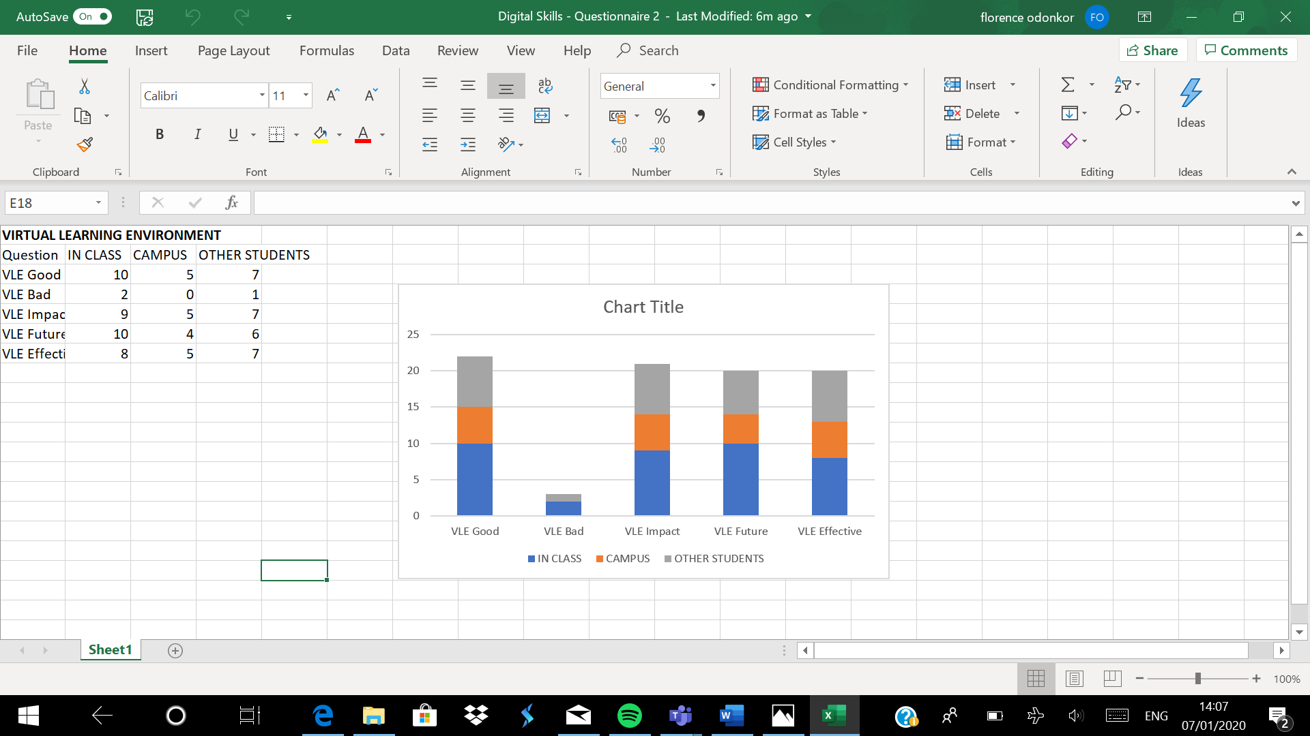

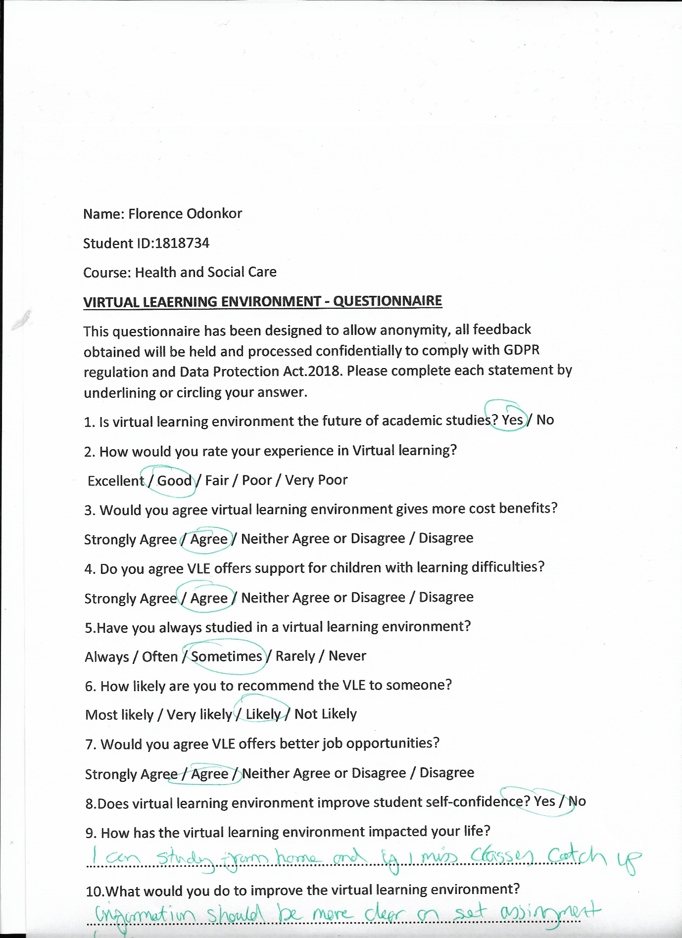

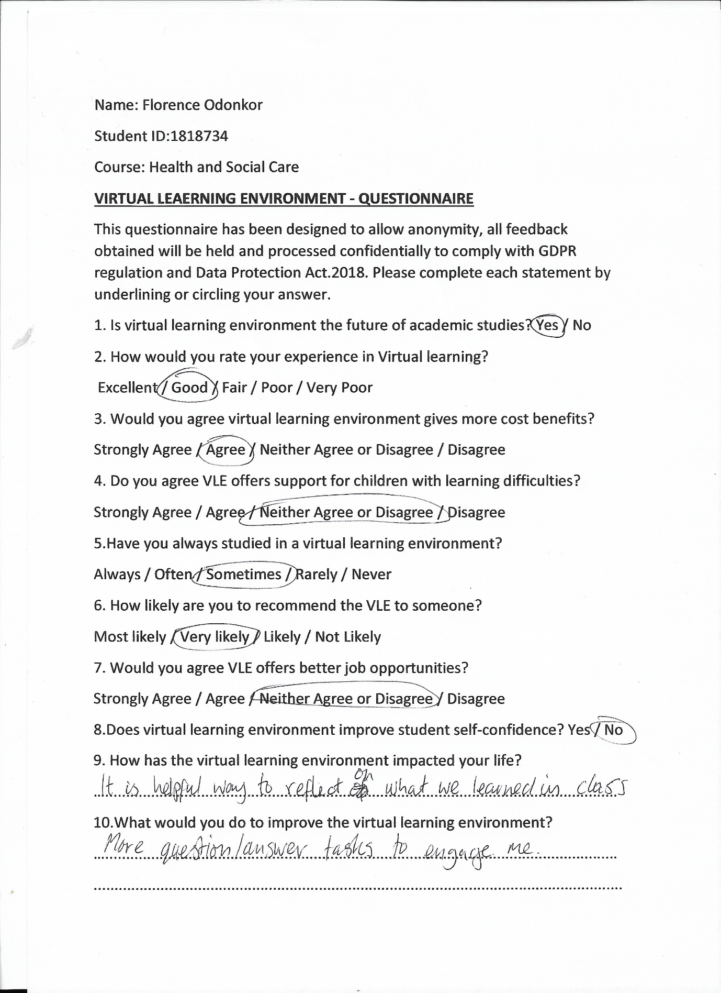

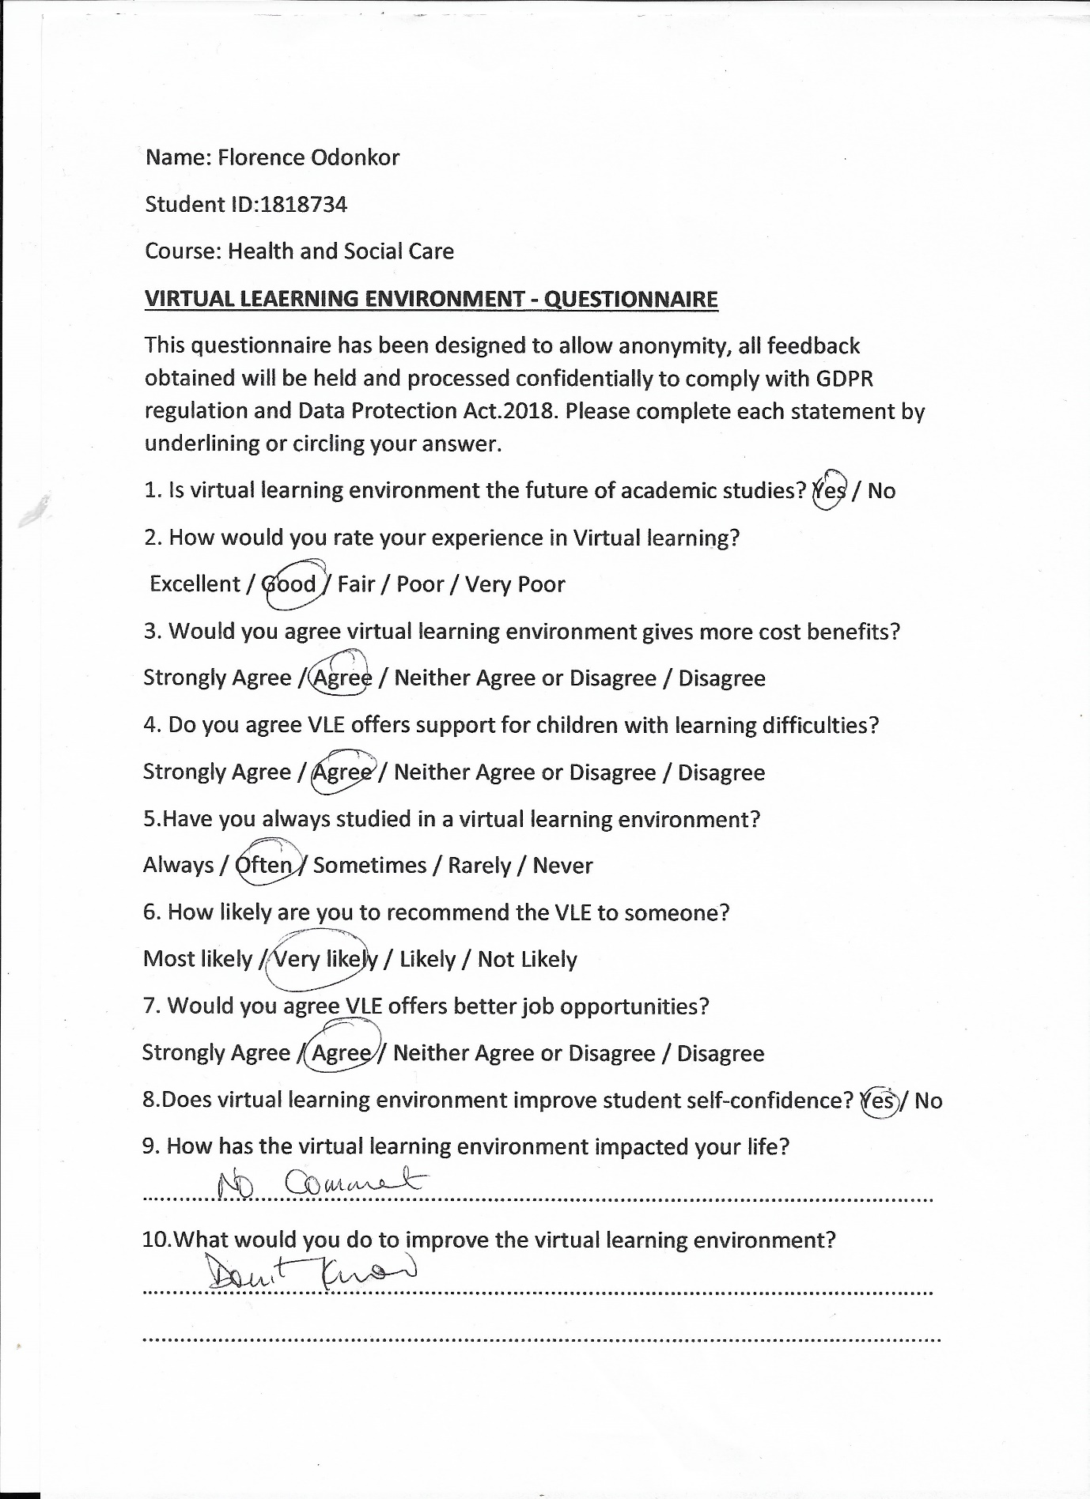

Appendix 2

BARKER & GOSSMAN: THE LEARNING IMPACT OF A VIRTUAL LEARNING ENVIRONMENT: STUDENTS’ VIEWS
Citation: Barker, J., Gossman, P. (2013) ‘The learning impact of a virtual learning environment: students’ views ‘ Tean Journal 5 (2) July [Online].Available at: http://bit.ly/AtMwtr (Accessed 29th Dec. 2019).

