Tom Walters

Developing an MS Access Database for Coastal Tourism Management
Introduction to Web and Database Concepts
Databases

Contents
Section A 2
Query 1 – Types of Users 2
Query 2 – Departments 2
Database Design and Implementation 3
Entity Relationship Diagram 3
Relationship Database Schema 4
Application of Database Management System 4
Reports Design 4
Revenue Report for specific timeframe 4
Report for Guest Feedback and Reviews 4
Forms Design, User Interface and Menus 4
Tourist Reservation form for tourists 4
Update Events by Owner 4
Menu for DBMS 4
Section B 5
Importance of DBMS to improve efficiency and effectiveness of Coastal Tourism 5
Challenges to transition from manual to computerised systems. 5
References 6

Section A

Query 1 – Types of Users
Users required from the product brief:
- Database Admin
- Business
- Customers

From the three types of users listed above there are specific requirements:
Database Admins – Requirement to be able to oversee the database and create users/amend forms/queries and tables.

Business / Rental Owners – Requirement to be able to create a new property record and add descriptions/upload images to the record. View feedback related to their properties.

Customer – able to view holidays and book, then provide feedback after the event.

Query 2 – Departments
This question is extremely close to the above question whereby the users within Coastal could be further broken down into groups such as the following:
Branch Manager – Full sales access and the ability to create users within that company/
Branch Sales – Ability to register properties on behalf of a business and upload images, also able to check availability of properties for a customer.
Branch Facilities Management – if a user specifies that a full managed option is required then facilities would be able to view properties and date_to within package bookings allowing the ability to plan cleaning requirements for a property.

Database Design and Implementation

Entity Relationship Diagram
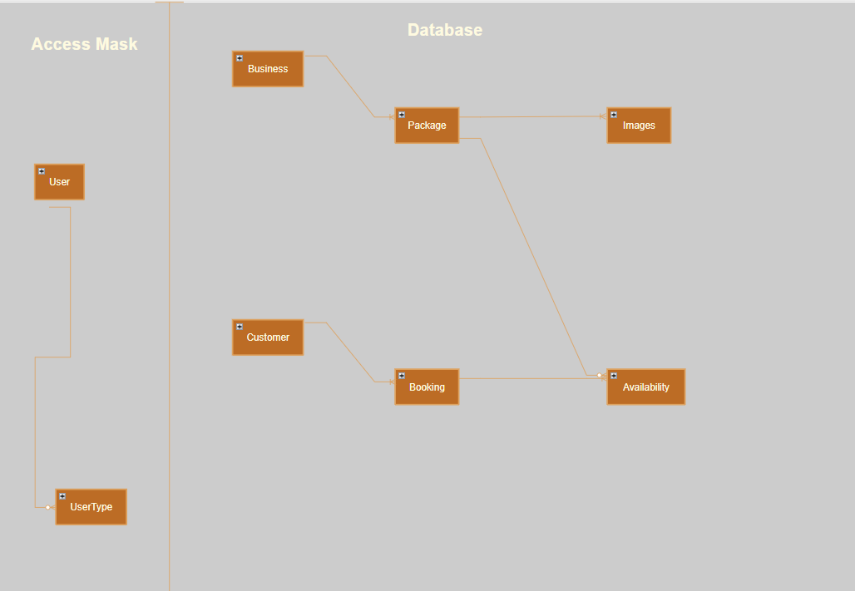
The ERD comprises of two parts – the Database itself and the Access Mask, The intent would be to create a macro which would cause the database to automatically launch a login form which would place the user into one of three masks – DB Admin, Business or Customer. Once a login path is chose, the user is able to follow through either the booking process or viewing the property feedback and availability.

Relationship Database Schema
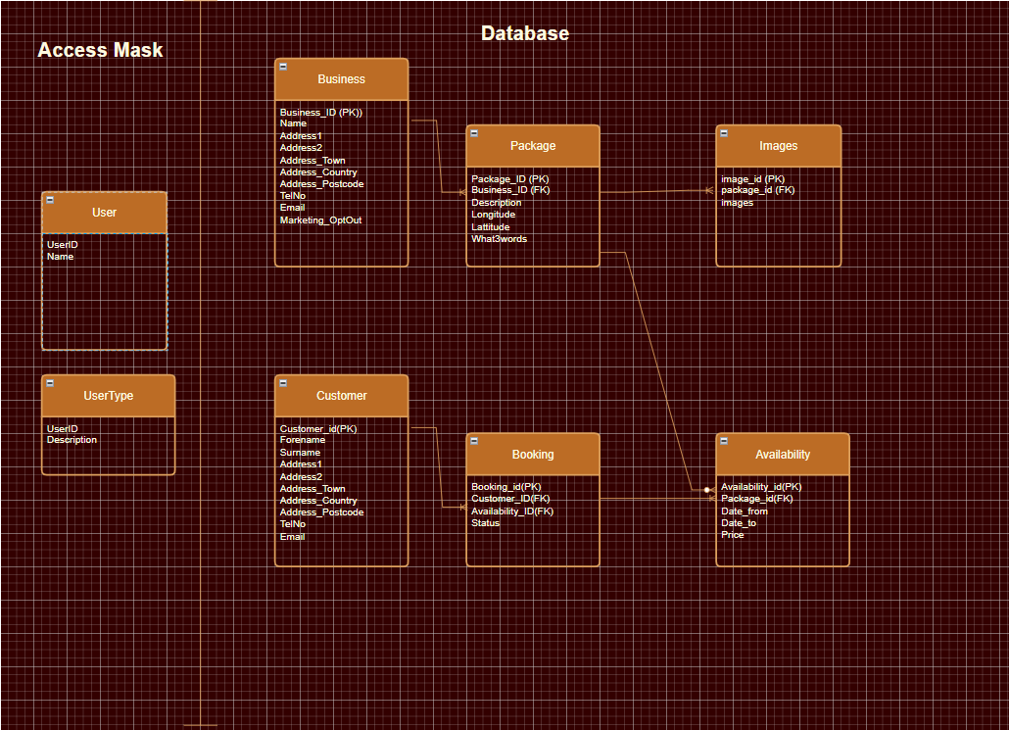

Application of Database Management System

Reports Design

Revenue Report for specific timeframe

Report for Guest Feedback and Reviews

Forms Design, User Interface and Menus

Tourist Reservation form for tourists

Update Events by Owner

Menu for DBMS

Section B

Importance of DBMS to improve efficiency and effectiveness of Coastal Tourism
With respect to justification of moving Coastal Tourism booking system from manual data entry onto a centralised booking system, there are a number of aspects to be considered:
As can be seen a brief comparison document within LinkedIn [1]. Having a spreadsheet (or a manual filing card system) in this type of environment may work on an extremely small scale, but once additional functionality is required, or scalability to allow more users to edit/view properties and availability.

Challenges to transition from manual to computerised systems.
When changing any form of system, there are a number of key parts to transition to a computerised system.
Prior to the creation of the system, there should be a mapping of all functions the database is anticipated to complete in addition to a statement of needs. During the creation of the database, there should be regular reviews to ensure all requirements are met. After the database is complete, training documentation should be provided to show how to perform all steps to ensure full functionality is achieved.
One of the biggest challenges when collating data for insertion into a database, either from manual filing systems or a spreadsheet is to ensure that the data is normalised [2]. This is to reduce duplication of data and ensure that the calculations performed are efficiently done. It should however be recognised that it is not always possible to follow the rules of normalisation perfectly, and as such are considered levels, first/second/third normalisation.

From a personal aspect of observing system cutovers, often the issue that appears, is when migrating the data from the old system to the new one is determining when the old data is considered to be read only/historical and the new system should be utilised. With a final sunset date on the retired system.

References

[1] | LinkedIn collaboration, “LinkedIn,” 25 08 2023. [Online]. Available: https://www.linkedin.com/advice/0/how-can-you-compare-spreadsheet-database-software. [Accessed 03 01 2024].
[2] | “Description of the database normalization basics,” Microsoft.com, 14 07 2023. [Online]. Available: https://learn.microsoft.com/en-us/office/troubleshoot/access/database-normalization-description. [Accessed 05 01 2024].

