

Module name: Professional Career Development
Module code: BMBS4005
Student name: Katie Tulloch
Student number: 2537698
Lecture: Antoinette Milne
Deadline: Monday 26th October 2026
23.59PM

Contents
Element 1: Career Sector Investigation 3
1.1 My Chosen Sector or Business Area 3
1.2 Sector / Business Area Research 3
1.3 Skills, Qualities and Attributes Valued by Employers 3
1.4 Current Trends Affecting the Sector 3
1.5 Personal Career Fit 4
Element 2: Skills Audit and Professional Development Plan 5
2.1 Personal SWOT Analysis 5
2.2 Emotional Intelligence and Professional Behaviour 5
2.3 Applying Theories or Models 5
2.4 SMART Development Goal 6
Element 3: Recruitment Application Pack 7
3.1 Selected Job Role 7
3.2 Tailored Curriculum Vitae (CV) 7
3.3 Cover Letter 8
3.4 LinkedIn Profile 8
3.5 Application Rationale 8
Reference List 8

Element 1, Business Investigation- Hairdressing
The hairdressing industry
Hairdressing is a big part of the hair and beauty industry according to (Policybee,2026). Hairdressers can work from a salon, mobile, at home or even bigger such as television films and theatres. Hairdressers can do a lot with hair. Hairdressers should also give good advice on what products to use. There are lots of different ways to become a hairdresser, hairdressing can be studied at a college, by completing an apprenticeship or learning while being in a salon from starting at the bottom and working right to the top. A hairdresser can become a senior stylist, a salon manager or could even open their own shop.
Skills and qualities
The skills that are important for a hairdresser include communication and listening. These are the main skills needed because a hairdresser needs to know and understand what style or cut the customer would like done (Baden and Prasad, 2016). Hairdressers need good customer service skills so that the customer feels comfortable with them and always feels welcome (Garzniti, Pearce, and Stanton, 2011). As a hairdresser it is important to be creative, have good attention to detail and to be good with working with their hands. It is also very important as a hairdresser to be organised, flexible and be able to work independently or as part of a team. Time management is very important in a salon. A hairdresser would need to manage appointments and make sure they allow enough time for each customer. They would also need time to clean around the salon, check all stock, clean towels, answer messages, and do paperwork. Good time management would help the salon run smoothly (Professional Beauty Direct, 2023). Customer experience management is very important so that every customer feels welcome and listened to. Communication with customers about the hair style or colour they want is also important to make sure they are happy and happy with the services. Good customer service can help build trust and encourage customers to return (ICM, 2026).
Current trends in hairdressing
The hairdressing industry is changing social media is changing and showing us how to use the most out of social media according to (josie Jackson 2025). Social media is an important way for hairdressers and salons to advertise their work such as doing before and after photos and videos. There are so many platforms to share on such as TikTok, Instagram and Snapchat which can be used to show hairstyles, colours, and new trends. (Research reported by the National Hair and Beauty Federation 2026) also shows that social media influencers on YouTube are an important source of information for young people interested in the hair and beauty industry. Sustainable salons are trying to reduce waste and recycle more. They can recycle foil, plastic and hair. Salons can also use eco-friendly products and save water and electricity (Ingram, 2023).
Personal career fit
With hairdressing I’ve always been interested in hair especially in afro/curly hair. I went to Cardiff & Vale College and studied hairdressing for 4 years. I have all my qualifications and my certificates for my hairdressing course. When I was in college, I had to find a work placement once a week in a hair salon, and I enjoyed the physical work but wasn’t very good in class as I struggle academically. Hairdressing is a career that needs creativity, communication, good customer service and practical skills. I am interested in this career because I enjoy making people happy and confident in themselves, and I am creative with my hands and love working with others. I understand that the industry is changing, so I will need to keep up learning all the new skills. Another important part of being a hairdresser is building a good relationship with customers. Customers like to feel they are listened to and respected. A friendly and positive attitude can help customers feel relaxed. Making a good relationship with clients will make them want to come back.

Element 2, Skills Audit and Professional Development Plan
STRENGTHS  . Strong communication & listening effective at active listening and exchanging ideas clearly  . Punctuality & reliability: always on time and reliable  . Teamwork: works well collaboratively with others | WEAKNESSES / AREAS FOR DEVELOPMENT  . Public speaking & speaking in front of crowds: lack of confidence when addressing groups  . Academies reading; struggling with fast/heavy reading lodes  . Task management: difficulty staying on top of all tasks and responsibilities
OPPORTUNITIES  . Learn new hair skills and techniques  . Get college, work or salon experience  . use social media to develop and promote your work | THREATS / CHALLENGES  . hairdressing is always changing so I need to keep learning  . competition from other hairdressers  . balancing uni , child, deadlines, and just practical work.
SWOT ANALYSIS
STRENGTHS:
One of my strengths is good communication I love to talk and explain things clear this will help me communicate well with my clients. I am good at listening to people and understanding what they say or want. This is very important in the hairdressing industry because I need to understand all my clients. I am reliably and on time, I work very well as part of a team and I’m happy to help others out when needed. I am willing to learn new skills and to improve in my hairdressing skill this will make me better and more confutable in myself for the future I know myself that some tasks take time and practice.
According to (SWOT analysis, 2026)
WEAKNESS:
One thing I do need to improve on is my confidence when speaking in public or in a group. I start to feel nervous when I’ve got to stand up and speak, I’m more of a practical person. I really want to improve in my reading and managing my work and my deadlines. I doubt myself all the time with my confidence I want to put my self over that and believe in myself.
OPPORTUNITIES:
hairdressing gives me the opportunity to learn more skill and to be comfortable in myself. I can learn new hairstyles and techniques at college and through work experience. With my confidence it helps as I’ve got to speak to the clients and make then comfortable.
THREATS:
hairdressing is a competitive job. I need to keep up learning and improving my skills. Also, another challenge I’ve got to keep up with is managing my uni work and my deadline. There is a lot of competition in hairdressing my work will need to stand out so that means lots of practise and just keeping up with everything.
EMOTIONAL INTELLIGENCE:
I need to understand my clients feeling and my own as in hairdressing the emotional intelligence is important because we work closely with customers. If a client is unhappy, I need to stay calm and listen to what they have to say and speak to them respectfully and politely.
JOHARI WINDOW:
The Johari windows can help me understand myself and others see me Johari window has four areas: the open area, blind area, hidden area and unknown area. In hairdressing it will help me understand my strengths to improve my weaknesses and learn from feedback. Getting feedback from others and my tutors will help me see what I’m good at what I’m not so good at and what I need to improve on.
GIBB’S REFLECTIVE CYCLE:
I can also use Gibbs reflective cycle to reflect on things that happen. I can look at what happened, how I felt and what went well, and what I can do better next time according to. (The University of Edinburgh, 2026).
SMART GOAL:
My smart goal is to improve my confidence when speaking in front of people. Over the 5 weeks, I will practise in front of small groups maybe ONCE A WEEK. I will ask my classmates or tutor for feedback to help me understand what I’m doing well and what I need to improve. To help me I’m going to build a record of my progress every other week. This goal will help me become more comfortable in myself and will prepare me for my future career in hairdressing. I need to improve more on my communication, confidence and hairdressing skills buy using my feedback from others. I will be asking for feedback after each practical, activity and could even record it could choose one improvement each week. I’m going to be working on this goal for a couple of weeks and review my progress at the end.

This part of my assignment, Ill prepare and application for a hairdressing job. I will show my skills, strengths, education and career goals. My application will include my CV, Cover letter and a LinkedIn profile and a 1000- word rationale explaining how I have tailored my application to the job.
Job role
Job Title | Full-time hairdresser
Organisation | Bella hair and beauty
Location | Cardiff
Where the vacancy was found | indeed
Job Role URL | https://uk.indeed.com/cmp/Bella-Hair-and-Beauty?campaignid=mobvjcmp&from=mobviewjob&tk=1k5335c98iagi800&fromjk=d64b676de97c1c01

(CV)

Katie Tulloch
Cardiff, Wales
Email: katietulloch1@icloud.com
Phone: 07364 172963
Personal Profile
Hard-working and friendly university student with strong communication skills and excellent time-keeping. I enjoy meeting new people because it helps me build my confidence. I have a passion for hair and beauty and experience working in salons and a care home. I am looking for opportunities to develop my professional skills and grow in the business and beauty industry.
Skills
- Good communication
- Friendly and welcoming
- Great time-keeping
- Hard-working
- Hairdressing skills (wash, blow-dry, cuts, colour)
- Client care
- Digital skills (Word, PowerPoint, Excel)
- Teamwork
Education
University of Wales Trinity Saint David Business Degree 2026 – Present
Cardiff and Vale College Hairdressing & Beauty 4 years
- Qualified in hairdressing
- Qualified in spray tanning
- Completed all certificates
Work Experience
Care Home Worker
- Supported residents with daily needs
- Communicated clearly with staff and residents
- Helped keep the environment clean and safe
Hair Salon Assistant – Llanrumney (Placement)
2019
- Welcomed clients with tea, coffee, and magazines
- Cleaned and prepared the salon
- Washed hair, blow-dried, assisted with cuts and colour
- Enjoyed making clients happy and comfortable
Interests
- Hair and beauty
- Meeting friends
- Getting my work done
- Learning new skills
- Building confidence

Cover letter
Katie Tulloch
Cardiff, Wales
Katietulloch1@icloud.com
Dear manager,
I’m writing this to apply for the hairdressing advertising within your salon, Ive got a 4-year experience of training hair dressing from Cardiff and vale college, were I learnt theory and practice such as wash & blow-dries, cuts, colours. I love to make my clients happy with my work and would want them to return to the salon. As part of my college study, when I was study in college, I had to find a workplace once a week which helped me build my confidence working with clients and supporting the team. I am very passionate about hairdressing, and I love to see my clients happy when they leave. I’m very good with communication and always makes my clients feels comfortable and happy, always offering teas and coffee, keeping the salon clean and helping create a welcome environment. I’m a very hard worker a genuine, reliable person who is always willing to learn different skills. I believe I will bring positive addition to your salon commitment and genuine love for the hairdressing industry.
I am now currently in university studying business, which is helping me develop new skills and gaining more confidence I believe all my skills will support me in the hair industry and will help me grow into a confident and capable person. I am keen to learn more continue developing my hairdressing skills. I would love to be given the opportunity to work in your salon to gain more experience and be part of your team.
Thank you for taking time to read threw my application I would be grateful for the chance to discusses the role further and how I can be a great fit to your team
Kind regards
Katie Tulloch
LinkedIn learning
Katie Marie | LinkedIn
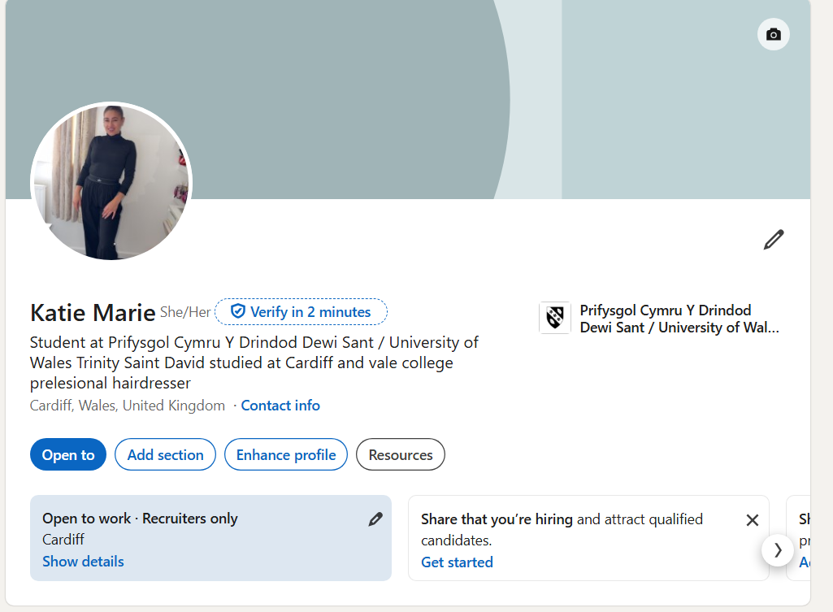

Application Rationale
I made sure that my CV, cover letter and my linked in learning profile is all matching the hairdressing job I have chosen. I have looked at the job description, and I see they are looking for someone with good communication, good time keeping, and always being friendly to the customers, helping to wash blow dry’s, styling hair, and keeping on top of the salons. These parts are the most I focused on in my CV; I wrote clear about my hairdressing training at Cardiff and vale college. I added all the skills Ive learnt while I was in the college. When being in the college I had to find a placement once a week to help you become professionally on a salon floor. I found the placement myself and it was in the Llanrumney area. The placement was looking for a apprenticeship at the time for a level 2 trainee in hairdressing they were looking for the standards I was trained for.
In my cover letter I talked about why I enjoy hairdressing and working with different people. I said I like to meet new people because it helps me build my confidence and grow in myself by meeting new people every day its challenging, but it helps myself and my clients. I also write about greeting clients, offering tea, coffee, cold drinks to clints, helping the stylist and keeping on top of the salon so it’s clean. Ive mentioned how reliable I am and how much I will try my best at anything. As part of the job description, it says about time keeping and how you will presence yourself.
For my LinkedIn learning profile, I have shown that I am currently studying in Cardiff University and a full trained hairdresser with real salon experience and experience from Cardiff and vale college. In my summary, I wrote about how much passion I have for the hair industry. Ive also added my education and placement so it all matches my CV I’ve added my communication, time keeping so everything should be matching.

References
‘Applying Behavioural Theory to the Challenge of Sustainable Development: Using Hairdressers as Diffusers of More Sustainable Hair-Care Practices’, Journal of Business Ethics, 133(2), 335–49.
CIPD (2026) SWOT analysis. Available at: SWOT analysis | Factsheets | CIPD
Garzniti, I., Pearce, G., and Stanton, J. (2011) ‘Building friendships and relationships: The role of conversation in hairdressing service encounters’, Managing Service Quality: An International Journal, 21(6), 667–87.
ICM (2026) Customer Service in the Hairdressing Industry. Available at: https://www.icm.education/cbq-units/customer-service-in-the-hairdressing-industry
Ingram Bee (2023) How can you embrace sustainability in hairdressing? Available at: https://www.protectivity.com/knowledge-centre/sustainability-in-hairdressing/
National Hair & Beauty Federation (2026) Top 50 Hair Influencer 2026. Available at: https://www.nhbf.co.uk/media/nhbf-events/top-100-awards/nhbf-top-100-influencers-awards-2026-winners/top-50-hair-influencer-2026/
Policy Bee UK (2026) UK hair and beauty industry statistics. Available at: UK hair and beauty industry statistics 2026 | PolicyBee
Professional Beauty Direct (2023) How to manage your time efficiently as a salon owner. Available at: https://online.professionalbeautydirect.co.uk/blog/how-to-manage-your-time-efficiently-as-a-salon-owner
The best way to use social media as a hairdresser (2026) How To Get The Most Out Of Social Media as a Hairdresser.
The University of Edinburgh (2026) Gibbs’ reflective cycle. Available at: https://reflection.ed.ac.uk/reflectors-toolkit/reflecting-on-experience/gibbs-reflective-cycle

