Sarah Prosser

Student Number: 0650593

CONSTRUCTIVISM & BEHAVIOURISM
What is Constructivism ?

We all learn through experiences that influence us in some way some experiences can leave a profound effect on us. This is exactly what Constructivism is, “Activating prior Knowledge” it is the process of thinking things through, seeing if they really make sense, comparing and contrasting them to what they already know, and coming to your own independent conclusions.

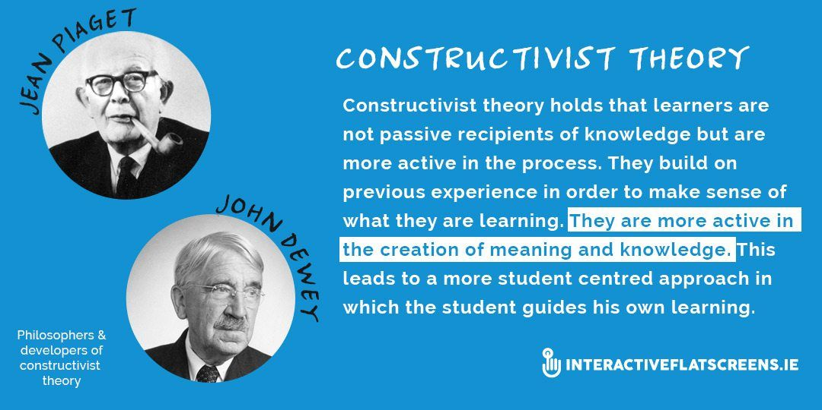

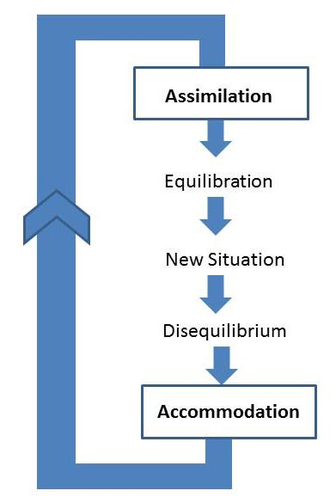
“Children should be able to do their own experimenting and their own research. Teachers, of course, can guide them by providing appropriate materials, but the essential thing is that in order for a child to understand something, he must construct it himself, he must re-invent it. Every time we teach a child something, we keep him from inventing it himself. On the other hand that which we allow him to discover by himself will remain with him visibly for the rest of his life.”
― Jean Piaget, Play and Development: A Symposium,

Simply Psychology
More on Constructivism: Vygotsky felt social learning precedes development. He states: “Every function in the child’s cultural development appears twice: first, on the social level, and later, on the individual level” Vygotsky (1978).

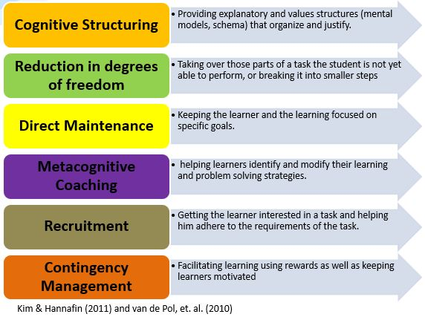
Examples of how it’s used in schools: Vygotsky’s theory promotes learning contexts in which students play an active role in learning. Roles of the teacher and student are therefore shifted, as a teacher should collaborate with his or her students in order to help facilitate meaning construction in students. Learning therefore becomes a reciprocal experience for the students and teacher.

What is Behaviourism?

It is a known fact that behaviour can have an effect on a pupils learning. Some parents might look at a behaviour system of rewards and punishment the carrot and the stick principal. B.F Skinner studied a system called Operant Conditioning.

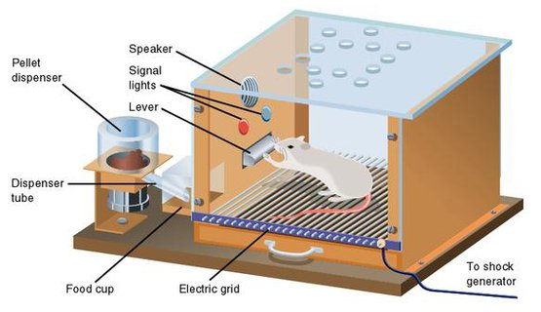

“Operant conditioning is a method of learning that occurs through rewards and punishments for behavior. Through operant conditioning, an individual makes an association between a particular behavior and a consequence” (Skinner, 1938). In summary Operant conditioning looks at the principals of cause and effect such as the likelihood of repeated behaviour when there is a reward on offer each time, a motivating factor if you will. In the same way there is less chance of repeated and is shown in the Rat and food experiment. “Skinner is regarded as the father of Operant Conditioning, According to this principle, behavior that is followed by pleasant consequences is likely to be repeated, and behavior followed by unpleasant consequences is less likely to be repeated. Skinner introduced a new term into the Law of Effect - Reinforcement. behaviour which is reinforced tends to be repeated (i.e., strengthened); behavior which is not reinforced tends to die out-or be extinguished (i.e., weakened). Skinner (1948) studied operant conditioning by conducting experiments using animals which he placed in a 'Skinner Box”

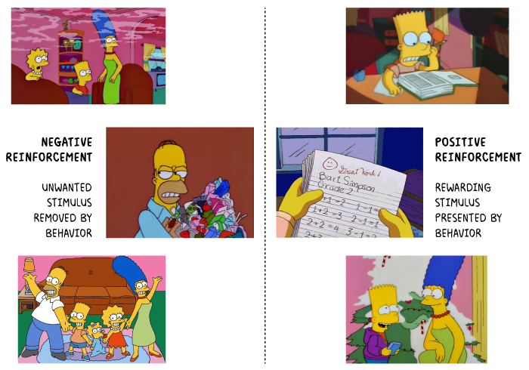
https://www.psychestudy.com/
Negative reinforcement- standing outside of the classroom for disruptive behaviour, missing play, phone-call home, after school detention,

Positive Behaviour Reinforcement System (PBRS) https://kestrelhouseschool.co.uk
- More on Behaviourism : Positive reinforcement- house points, freedom to choose an activity, ticks, stars/stickers, certificates, verbal/ public praise

CONCLUSION
Critics of the application of behaviourist approaches make two main points. First that rewarding children for all learning is likely to cause the child to lose interest in learning for its own sake. Studies have suggested that using rewards with children who are already well motivated may lead to a loss of interest in the subject. Second,using a reward system or giving one child increased attention may have a detrimental effect on the others in the class. Using a behaviourist approach in the classroom seems to be most effective when applied in cases where a particular child has a history of academic failure; where there is very low motivation and high anxiety; and in cases where no other approach has worked. (Pritchard, 2009)
The best teaching will often integrate ideas from constructivist and behaviorist principles. (Steele, 2005)

References

- https://www.simplypsychology.org/constructivism.html

- Grace, E (2019, Oct 16) B.F. Skinner's Behavioural Theory. Kids Development. Available at http://www.kidsdevelopment.co.uk/bfskinnersbehaviouraltheory.html

- Pritchard, A. (2009) Ways of Learning: Learning Theories and Leaning Styles in the Classroom. Second Edition. Routledge, Oxon. Available at https://pdfs.semanticscholar.org/7592/ae2eb5bdc35c3fd48839bcee96928db37c0c.pdf?_ga=2.142463922.143696394.1589061099-1017582755.1589061099

- Steele, M. (2005) Teaching Students with Learning Disabilities: Constructivism or Behaviorism? Current Issues in Education. Volume 8, Number 10. University of North Carolina Wilmington. Available at file:///C:/Users/Admin/AppData/Local/Packages/Microsoft.MicrosoftEdge_8wekyb3d8bbwe/TempState/Downloads/1607-Article%20Text-6879-1-10-20150521%20(1).pdf

- https://www.psychestudy.com/

- Positive Behaviour Reinforcement System (PBRS) https://kestrelhouseschool.co.uk

- Vygotsky, L. (1978). Interaction between learning and development. Readings on the development of children, 23(3), 34-41.

