What is the role of the designer in the 21st Century and how might this role change in the next 10 years?

Catrin Walsh
P146361
Surface Pattern Design
2040 Words (Including quotations)
Julia Lockheart & Rodney Bender

Giving our future a future through design
‘If I were given one hour to save to save the planet, I would spend 59 minutes defining the problem then one minute resolving it.’ – Albert Einstein (Micheal Braugnart, 2013: 3)
The question of sustainability is a question of design. Who is better equipped to answer this question but the designer? Undoubtedly it would take a shift of enormous proportion to bring about the change needed for a sustainable planet. In world of cradle to grave thinkers, something has to give. Currently, the role of the designer and design itself has been devaluated to a superficial level that looks only at aesthetics, while denying it’s power to affect change. In order for us as humanity to face the problem of depleting natural resources requires serious transformative action (Fry, 2014). To carry out a solution, the role of the designer itself must be redesigned.
‘irrespective of how you currently think and feel about design, you need to measure your own understanding against what follows and the fact of design’s continually growing importance as a decisive factor in our future having a future. Nature alone cannot sustain us: we are too many, we have done too much ecological damage, and we have become too dependent upon the artificial worlds that we have designed, fabricated and occupied’ (Fry, 2014: 3).
In his book ‘Design Futuring’ Fry also challenges the way we think of sustainability. By breaking the word down to ‘sustain-ability’ redefines what we think it means to be sustainable. It starts with us, and our abilities and action to sustain lives. Fry (2014) asks us to not only consider the ‘sustain-ability’ of nature but our knowledge, ideas and understanding. This way of thinking is all encompassing including the sustainment of culture, societies, food, water and air, in fact every aspect of life. In it’s most basic form; this reconceptualization begins with the biomimetic design approach of ‘cradle to cradle’ also referred to as C2C. (Stahel, 1980; Braungart & McDonnough, 2002). Swiss architect Walter R Stahel coined the phrase in in the 1980’s. The regenerative tactic of C2C models our human industry around nature’s own processes. Cradle to cradle is a foundation, a fulcrum against which we can lean levers of desirable change (McDonough, 2017). The formal rules and informal norms of society that are set in place are just two barriers that prohibit cradle to cradle living from being realised.
A battle is taking place against humanity and our serious addiction to living in a throwaway society. Our unhealthy overconsumption and the production of disposable products are rapidly exhausting the earth’s finite natural resources. Our obsession with the new caused Britons to send an estimated 235m pieces of clothing to landfill last spring (Buchanan, 2017). Some reasons why an object might be thrown away are because they are beyond repair, too expensive to fix and simply cheaper to buy new. In our western culture, the idea that something that functions, but is no longer new should be thrown away is so ingrained into us that no one dares to questions it. We are moving along a linear path of extracting resources, production, distribution, and consumption and ultimately waste. However, it isn’t only our over indulgent consumerist habits that are to blame for prohibiting an eco effective system, but the way in which we design. Our design choices are conditioned by what we already know and at present are not very future-oriented. The way we as both consumers and designers currently think the way things should be designed needs a complete rewiring, possibly even down to the way in which we perceive beauty.
Take this comparison for example: Western beauty is radiance, majesty, grandness and broadness. In comparison, Eastern beauty is desolateness, humility and hidden beauty (Shozo Kato-Way of the Sword, 2013). The word desolatness is used in the video subtitles, but what is actually said is the Japanese phrase ‘wabi-sabi’. Undeniably difficult to translate, in its essence, the philosophy of wabi-sabi is about accepting the natural imperfections and inevitable wear of time. Its origins lie within Zen Buddhism and the traditional tea ceremonies in which masters celebrated the bowls that were irregular, had cracks or showed imperfections (Roberts, 2017). Wabi-sabi occupies roughly the same position in the Japanese pantheon of aesthetic that is, the philosophy of beauty values, as do the Greek ideals of beauty and perfection in the West (Koren 2008: 21).
Self-taught textiles practitioner Tom of Holland’s practice of mending and not overlooking the wear and tear of items is very reminiscent of wabi-sabi. He is directly addressing the very problem of unsustainability, with a focus on fashions ‘throwaway culture’ in a very tangible way (tomofholland, 2017). In his work Tom takes worn out or damaged garments and textiles and carefully repairs them, adding vitality and a sense of time. Not hiding the imperfection but highlighting with coloured threads or patches the fact that the cloth has a history. He reinvents the items, adding value to the design. He sees the garments with time written into them and understands that things are not fixed or static but are always somehow in the process of becoming (Kate Davies, 2014). On his website he asks us to consider which objects you tend to throw away and how to give it a second life as an interior product, toy or item of clothing with a high design value. For example, a curtain shaded by the sun, worn clothes, a carpet that’s been walked on over and over again etc. Think about ways to repair, decorate, embroider, unravel, trim, smear, refurbish or customize textiles or apply textile techniques to non-textile materials (tomofholland, 2017).
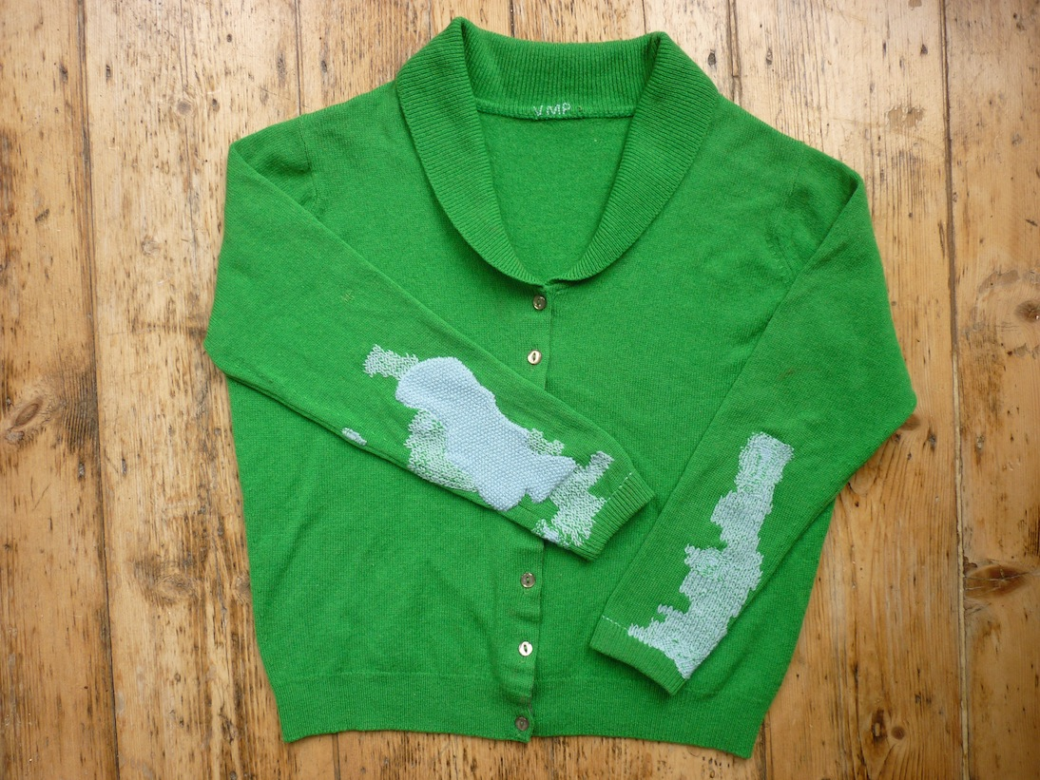
(Tom of Holland, 2015)
This localised, inner activism is good for addressing the problems of now, but what about the problems of the future. Recycling and upcycling are certainly not new concepts and have been common practice in some way throughout human history. However, recycling is an aspirin, alleviating a rather large collective hangover that is overconsumption (Lilinfield & Rathje, 1998). Instead of simply being satisfied with making things less bad, how could we make things good (Braugnart & McDonogh, 2002)?
In their book ‘Cradle to Cradle: Remaking the way we make things’ Michael Braugnart and William McDonogh (2002) put forward a manifesto or framework that can be characterized by three main principles. The first being ‘everything is a resource for everything else’, the second ‘use clean renewable energy’. And the third ‘celebrate diversity’ (William McDonogh, 2017). Within the book, we are given a beautifully thought provoking illustration of what a C2C world could look like:
Consider the cherry tree: thousands of blossoms create fruit for birds, humans and other animals, in order that one pit might eventually fall onto the ground, take root and grow. Who would look at the ground littered with cherry blossoms and complain, “How inefficient and wasteful!” The tree makes copious blossoms and fruit without depleting its environment. Once they fall on the ground, their materials decompose and break down into nutrients and nourish microorganisms, insects, plants, animals and soil. Although the tree actually makes more of its ‘product’ than it needs for it’s own success in an ecosystem, this abundance has evolved to serve rich and varied purposes. What might the human-built world look like if a cherry tree had produced it (McDonough & Braungart 2002: 72-73)?
The simple image of a cherry tree gives insight into how a naturally occurring regenerative cycle works in harmony with it’s surrounding. The process is life giving not life taking. As romantic as this sounds, it is achievable but how exactly can humans be actively engaged and involved in our eco-system and enriching it not destroying it? Having more control over waste we produce is not good enough. When we recycle an object, the same amount of materiel will end up in the dead-end state of the cradle to grave system, as the original product would have gone a few years previously. When you throw things ‘away’ do you ever question or take the time to think where is ‘away’ (McDonough & Braungart 2002). The ‘out of sight, out of mind’ attitude is a dangerous one to have. This one-way system has an end, a destination and one day we will arrive there if we continue on this path. Instead of creating a problem why not go back to the very beginning. How can we be like that cherry tree and maximise economic gain while minimizing environmental damage. Recycling and reusing, as we know them, are steps we take which can actually downgrade the value of a product. A designed product after it’s intended purpose and use is fulfilled, is taken and usually broken down into a lower grade materiel and used in a different way. Despite good intentions, this downcycling of materials can be harmful to the biosphere as toxic chemicals are often added to help purify and refine the end product. It only slows the journey to destruction of the natural world. However, recycling is not to be condemned as completely ineffective but it is limited in what it can achieve in the long run. The longevity of life on earth is more than preservation or saving it’s about thriving.
The Welsh office furniture company ‘Orangebox’ is one example of a company dedicated to this way of designing and making. They have also introduced a ‘remade’ system whereby products that are approaching the end of their lifespan are fully restored to ‘as good as new’ condition and sold. The company aims to offer their customers a truly closed loop approach, which sets down an important marker for the future of manufacturing in a circular economy (orangebox.com, 2017). Other companies like Orangebox are also joining the move towards a circular economy where economic growth is detached from a system that uses finite resources in production. It differs from the linear manufacturing route of extracting raw materials, fabrication, marketing and throwing away. A circular economy is based around making products that are more easily disassembled, so that the resources can be recovered and used to make new products, keeping them in circulation (Vince, 2017). Another example of where a company has taken initiative is that of the high-end outdoors clothing company Patagonia. They supplied a guarantee that it will repair any of its products for free over their lifetime, and employs a team of seamstresses to do just that. And in 2011, it actually ran an advertising campaign asking consumers to buy less of the stuff they don’t need, to curb waste and environmental damage (Vince, 2017). British yachtswoman Dame Ellen MacArthur known for her record breaking sailing trip around the world is a strong advocate of the concept of a circular economy. She said in an interview with wired ‘the strongest commonality between my sailing and the circular economy is that both have a clear goal. You set smaller goals on the way’ (Turk, 2017). While sailing around the world Ellen had to be thoughtful of what materials she was using of which there was a limited supply, just as global citizens must be mindful of it’s own consumption of limited resources. Not only to be mindful but take action.
It may seem like a distant utopian future of 0% waste and 100% sustainability but it is achievable despite the long and complex relationship we have with the earth. The role of the designer in the next ten years could be that of ‘designer as fusionist’. Rather than prescribing remedies and medicines for our environmental ailments the designer has the power to create preventative measures that stop complications from initially occurring. Acting as the seamless fusion between art, research, engineering and science. Working in a multi-disciplinary way more than ever before to tackle the problems we face today. Design is more than simply a matter of aesthetics or problem solving, dealing with intervention. Its substance is in prevention, prevention of problems, of waste and of damage. Critical thinking and collaboration will allow us to regain a dynamic interdependence with our natural environment. It is and will continue to be the responsibility of the designer to inform, inspire and captivate consumers. We understand stand why we must change so, why not?

References
Fry, T. (2014). Design futuring. London: Bloomsbury Academic, p.3.
Koren, L. (2008). Wabi-Sabi. California: Imperfect, p.21.
Lilienfeld, R. and Rathje, W. (1998). Use less stuff. New York: Ballantine Pub. Group, p.74.
McDonogh, W. and Braugnart, M. (2008). Cradle to Cradle: Remaking the way we make things. London: Jonathan Grape Vintage, pp.4,72,73.
Orangebox.com. (2017). Welcome to Orangebox. [online] Available at: https://www.orangebox.com/about/responsibility/remade [Accessed 14 Dec. 2017].
Roberts, G. (2017). Wabi Sabi Your Life: 6 Strategies for Embracing Imperfection - Whole Living Balance. [online] Whole Living. Available at: http://www.wholeliving.com/133628/wabi-sabi-your-life-6-strategies-embracing-imperfection [Accessed 14 Dec. 2017].
Shozo Kato - Way of the Sword. (2013). [video] Directed by B. Welch and C. Sonner.
Tom of Holland (2015). Vintage cardigan commission, repaired with vintage wool. [image] Available at: https://tomofholland.com/portfolio/ [Accessed 14 Dec. 2017].

tomofholland. (2017). ABOUT. [online] Available at: https://tomofholland.com/about/ [Accessed 14 Dec. 2017].
Turk, V. (2017). Ellen MacArthur launches $2 million prize to help solve plastic pollution. [online] Wired.co.uk. Available at: http://www.wired.co.uk/article/ellen-macarthur-foundation-plastics-prize-circular-economy [Accessed 14 Dec. 2017].
Vince, G. (2017). The high cost of our throwaway culture. [online] Bbc.com. Available at: http://www.bbc.com/future/story/20121129-the-cost-of-our-throwaway-culture [Accessed 14 Dec. 2017].
William McDonough. (2017). Cradle to Cradle | William McDonough. [online] Available at: http://www.mcdonough.com/cradle-to-cradle [Accessed 14 Dec. 2017].
Additional Reading List
C2ccertified.org. (2017). Get Certified - Cradle to Cradle Products Innovation Institute. [online] Available at: http://www.c2ccertified.org/get-certified [Accessed 14 Dec. 2017].
Ellenmacarthurfoundation.org. (2017). What is a Circular Economy? | Ellen MacArthur Foundation. [online] Available at: https://www.ellenmacarthurfoundation.org/circular-economy [Accessed 14 Dec. 2017].
Fuad-Luke, A. (2009). Design activism. London, UK: Earthscan.
Kenniskaarten - het Groene Brein. (2017). How is a circular economy different from a linear economy? - Kenniskaarten - het Groene Brein. [online] Available at: https://kenniskaarten.hetgroenebrein.nl/en/knowledge-map-circular-economy/difference-circular-linear-economy/ [Accessed 14 Dec. 2017].
Reeves, S., Goulden, M. and Dingwall, R. (2017). The Future as a Design Problem.
the Guardian. (2017). The rise of mending: how Britain learned to repair clothes again. [online] Available at: https://www.theguardian.com/lifeandstyle/2014/may/19/the-rise-of-mending-how-britain-learned-to-repair-clothes-again [Accessed 14 Dec. 2017].
William McDonough. (2017). Cradle to Cradle | William McDonough. [online] Available at: http://www.mcdonough.com/cradle-to-cradle/ [Accessed 14 Dec. 2017].

