

Academic and Employability Skills
Report
Term 1

Student: Dragos-Cristian Sorica
1906082
Timothy Hopkims
02.01.2020

Table of content:
- Aknowledgments………………………………………………………………………………page 3
- Summarising……………………………………………………………………………………..page 3
- Introduction………………………………………………………………………………..…….page 3
- Methodology…………………………………………………………………………………..…page 4
- Reflective report from the first week of term to the last week………..…..page 4
- Leadership & management………………………………………………………………. page 4
- Problem solving & decision taking……………………………………………………. page 4
- Time management skill…………………………………………………………………….. page 5
- Practical exercise…………………………………………………………………………...…..page 5
- Personal development plan(PDP)……………………………………………………... page 5
- SWOT Analysis………………………………………………………………………………….. page 6
- Paraphrasing Skills…………………………………………………………………………….. page 8
- Summarizing Skills…………………………………………………………………………….. page 10
- Conclusion…………………………………………………………………………….…………...page 10
- Refferences……………………………………………………………………..…………...…...page 11
- Appendices ……………………………………………………………………………..…….…..page 12

Aknowledgments
The main support that I received is from my parents at home, my lecturers and teachers at univeristy and then my supervisors and managers at work. Aswell my colleagues from university helped me to practise my skills during this term from the very first week and I would like to thank you all.
Summarising
I have made this report based on self analysis of both my personal and profesional progress to identify my academic and employability skills and to develop them in a way which can help me in my career and academic life.
Introduction
Skills are the capacity to carry in an successful and effective manner any task which an individual plans to finish. The efficiency and effectiveness are terms which are more important in a business operations to mantaint it’s standards or quality investigation in professional ground (Jeston, 2014).
Figure1: Hierarchy of skills
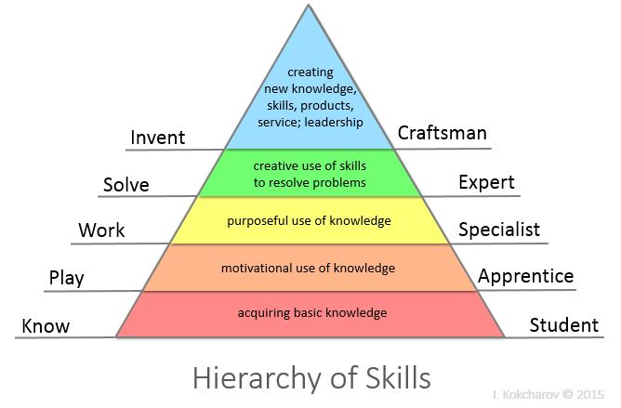
Source: (Fallows, and Steven, 2013).
Abilities of representatives go through a few steps to create total in viable field of proficient arrange and finally usage of aptitudes totally different areas of operations of management. First hierarchy of aptitude is securing essential information shape distinctive sources and after that motivational utilize of information beneath an experienced one. Employee get opportunity to utilize aptitudes in work or for intentional work after past step and after that worker get opportunity as an employee to execute aptitudes in creation or settling issues emerging in commonsense region of profession (Wilding R., Wagner, 2012). At last, representative able to create unused items or administrations, unused information, encounters or gives lessons to others to create aptitudes.
Methodology
In this section I would like to mention what helped me to do this report. First of all, the references which are presented at the end of this report
Reflective report from the first week of term to last
My aptitudes which are required in professional area represents an extraction of different skills such as personal, academic, administrative, managerial and professional summation into field of business profession or in highest professional ground. Skills required in proficient range must be supported and created by workers by taking initiatives for progressing or maintain quality according to organization standards, here some quality or skills of employee must be designed or required organization, or sometimes employee, professional or student set their targets or career targets according to future plan and goals and try to make skills according to carried plan (Brewer, 2013).
Leadership & management:
In this report with investigation of aptitudes in both academic and professional fields, individuals are more concern about developing in their carrier. The administration, management and leadership skills are extremely imperative in terms of leading a team or team-working and to contribuit in a business. For example, Bill Gates, Mark zuckerberg or Steve Jobs, have thei perspective as leaders and in terms of managing a business their professional skills make them distinct and they lead other people by examples.
Time management skill:
If the responsibility is executed in a specific time increases trustworthy, makes people happy, builds strong relations with parteners involved in a business and create dynamic organization in all. In order for this to be done I need to prioritize the work , my schedule of tasks and jobs and avoids procrastination in professional life.
By mentioning this skill I need to say that during this term I have learned about The Eisenhower Method of Stephen Covey in which you just create a Matrix by the importance and urgency of the activities that you are planning to do. That is a method that helps you to analyse which one is more or less important and more or less urgent and in the figure bellow it is explained really well how to do it.
Figure 2. Time Management Matrix
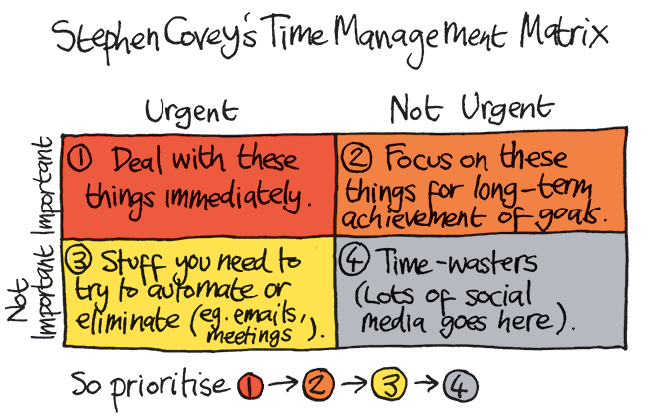
President Dwight D. Eisenhower developed this "Eisenhower Matrix" because he wants to teach people what is important versus what is urgent. This method was featured in Stephen Covey’s book named ‘’ The 7 Habits of Highly Effective People’’. There he teaches people that the main goals is to be able to spend time effectively on tasks by importance and time allocated for a maximum productivity.
Practical exercise: Personal development plan(PDP):
A PDP is a Personal Development Plan which expresses a written self-reflection and improvement which wants to act like a detailed action plan based on goals and used to satisfy on academic, personal or career plan. I have created this plan to considering a development and works in a successfully way for me by allowing myself to establish which are my aims, objectives and goals, to identify my strengths and weaknesses and my need for improvement.
I have placed my objectives in an order based on the areas that I would like to see a progress or to improve something in my life and my PDP consists in my personalised actions made in an order and these actions are helping me to achieve them in a period of time depending if it is a short-term goal, middle-term goal or long term goal.
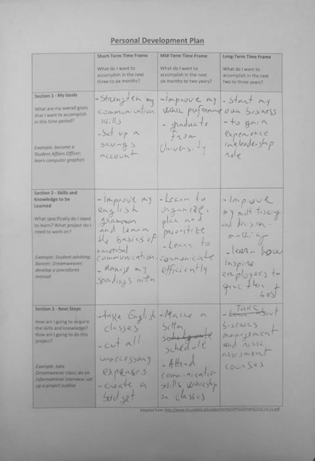
SWOT ANALYSYS I created a SWOT analysis which helped me to analyse myself and my both academic and employability skills. With this analysis I am able to explore my strengths, weaknesses, opportunities and the challenges which I am facing in both personal and professional area. In the figure bellow I will demonstrate how I manage to do a SWOT analysis about myself.

Figure3: Individual SWOT analysis
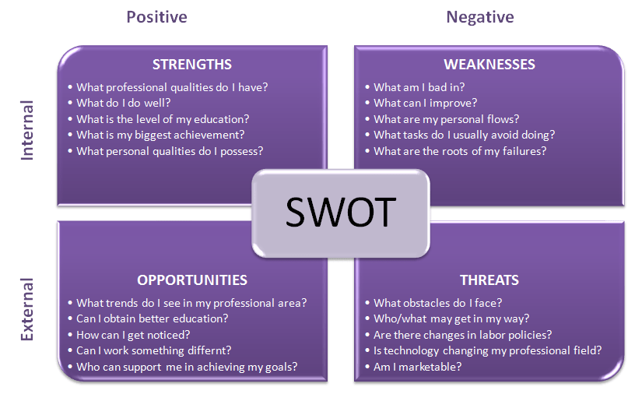
Source: (Grant,2016)
I managed to do a SWOT Analysis about myself and it is attached bellow and in Appendices aswell because it was an in-class exercise which I have been made during this term.
That is how I descovered which are my strenghts and which skills I already have like to be a team-worker and a flexible person.
I observed my weaknesses and even if I discovered I had a poor personal organisation I proposed myself to use the Eisenhower Method to change my weakness in a strenght and to gain time-management skills.
For opportunity I found out the possibility to extend my knowledges or to level up in my carrier, to work under experienced leaders, training opportunity and different facilities (Marston, et al. 2011). Along with those it comes up the opportunity for better earning prospects.
In order to reach my goals and by analysing my professional area and my employability skills I want to open my business but I am financial unstable and the economic environment is uncertain. That’s why I want to use my opportunities and my PDP to rich my goals and to get face this challenges in a succesfully way.
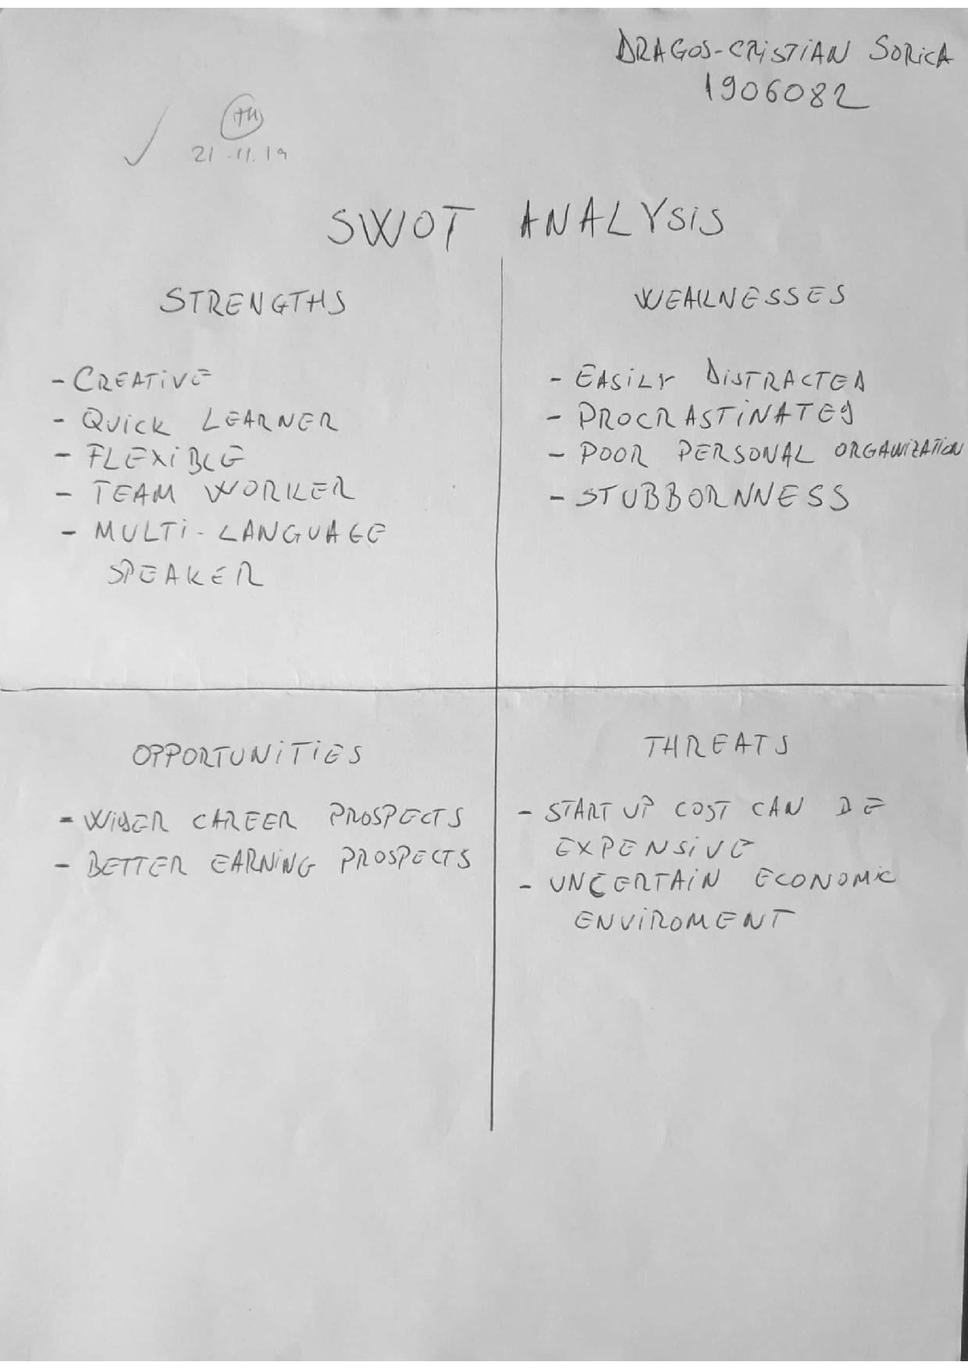
However, the overall academic period of this first term was challenging and learning these academic and employability skills it was a difficult journey but in time during these 10 weekes and with the help of my lecturers and class fellows I managed to learn them all, which I believe they will help me in my academic and professional life.

Paraphrasing Skills
Paraphrasing means showing the thought of another individual in my own words and it is considered one of the most important skills in the scholarly life because in this process of changing over the genuine content in my dialectt I am transmiting a message that I simply and cleary understood because of the real content and I am able to communicate the actual content as well(Shapiro, 2011). In any case, in my scholarly experience, I have realized that is basic to be able to acomplish an effective paraphrasing because is the interpretation of one’s thought into my claimed words concurring to my understanding.

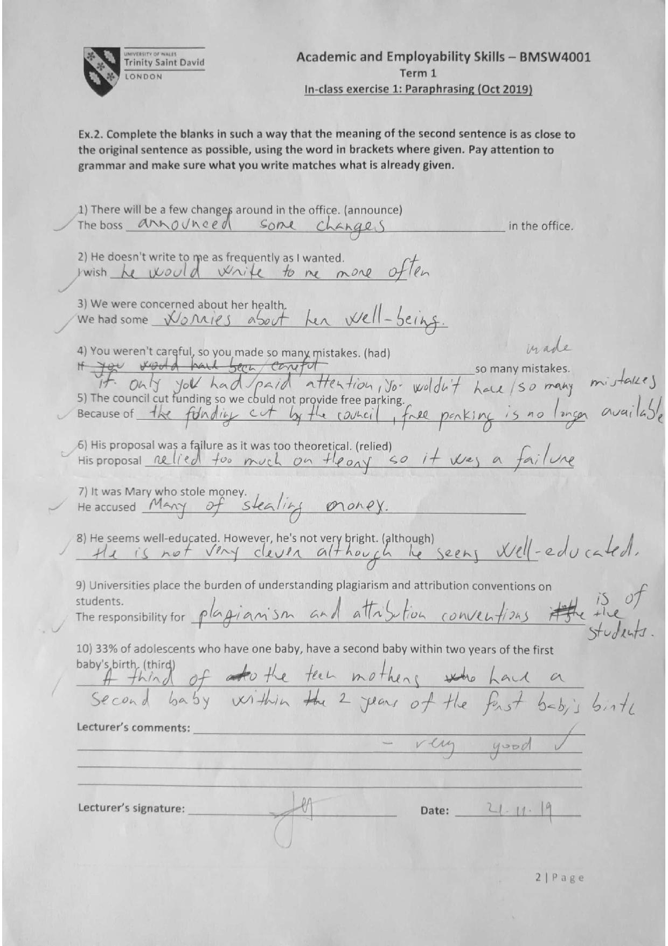

This is a in-class exercise which helped me to practise my paraphrasing skills.
Summarizing Skills
Summarizing is mulled over as a vital ability for the study because it has been instructed to the academic environment that “Less is More”. The summarizing skills offer assistance in improving the reading skills since they supposed to explain the most thoughts of the perusing and after that abbreviate it to communicate it within the same subject. In addition to this, it makes a difference to the lexic and it’s improving academic speaking and writing (Shapiro, 2011).
Conclusion
Proficient capabilities agreeing to needs of organization totally different locales of trade capacities & administration. In assembly carrier destinations and organizational destinations person must set carrier targets concurring to targets of callings and making methodology of professions in scholastic life. Aptitudes, employability aptitudes in numerous organizations, in deed for their goals of trade clear the way of representative to select their carrier by creating abilities for distinctive levels in organization. I found out that personal SWOT examination and personal development plan (PDP) based on opportunity and carrier targets are the best way to extend my abilities which are requested either by an organization or by univeristy. Academic abilities and proficient aptitudes must be facilitated by an person to urge most extreme benefits of proficient destinations and to manage to focus on their goals in order to be in a continuously development.

References
- Brewer, L. (2013). Enhancing youth employability: What? Why? and How? Guide to core work skills. ILO.
- DeCenzo, D.A., Robbins, S.P. and Verhulst, S.L. (2016). Fundamentals of Human Resource Management, Binder Ready Version. John Wiley & Sons.
- Fallows, S. and Steven, C. (2013). Integrating key skills in higher education: Employability, transferable skills and learning for life. Routledge.
- Grant, R.M. (2016). Contemporary strategy analysis: Text and cases edition. John Wiley & Sons.
- Jeston, J. (2014). Business process management: practical guidelines to successful implementations. Routledge.
- Marston, S., Li, Z., Bandyopadhyay, S., Zhang, J. and Ghalsasi, A. (2011). Cloud computing—The business perspective. Decision support systems, 51(1), pp.176-189.
- Noe, R.A., Hollenbeck, J.R., Gerhart, B. and Wright, P.M. (2017). Human resource management: Gaining a competitive advantage. New York, NY: McGraw-Hill Education.
- Stahl, G., Björkman, I., Farndale, E., Morris, S.S., Paauwe, J., Stiles, P., Trevor, J. and Wright, P. (2012). Six principles of effective global talent management. Sloan Management Review, 53(2), pp.25-42.
- Wilding, R., Wagner, B., Gligor, D.M. and Holcomb, M.C. (2012). Understanding the role of logistics capabilities in achieving supply chain agility: a systematic literature review. Supply Chain Management: An International Journal.
- Baker, G. and Henson, D., 2010. Promoting employability skills development in a research-intensive university. Education+ Training, 52(1), pp.62-75.
- Diamond, A. and Lee, K., 2011. Interventions showed to aid executive function development in children 4 to 12 years old. Science, 333(6045), pp.959-964.
- Harris, A.J. and Ashton, J.L., 2011. Embedding and integrating language and academic skills: An innovative approach.
- John, J., 2009. Study on the nature of the impact of a soft skills training programme on the soft skills development of management students. Pacific Business Review, pp.19-27.
- Miller, P. and Votruba-Drzal, E., 2013. Early academic skills and childhood experiences across the urban-rural continuum. Early Childhood Research Quarterly, 28(2), pp.234-248.
- Shapiro, E.S., 2011. Academic skills problems: Direct assessment and intervention. Guilford Press.

Appendices


