Appendices
Context

Lesson Plan 2

Resources 4

Consent Forms 6

Assent Forms 12

Work Produced 18

Observation Schedule 19

Leuven Scale 22

Gibbs Reflective Cycle 25

Participant interviews 26

Lesson Plan
Lesson Plan – Step 1 Cynllun Gwers – Cam 1

Student-teacher | Mari Roberts / Taylor Fender | Class: | Year 2
AoLE or Subject | Literacy | Date: | 03/2/2020 & 04/02/2020
Lesson Focus: | Helping local Wildlife
Meaningful links to Curriculum
Meaningful links to:  Cross Curricular Responsibilities | Show understanding and express opinions about language, information and events in texts.  Use talk to plan writing  Speak audibly, conveying meaning to listeners beyond their friendship group  Extend their ideas or accounts by sequencing what they say and including relevant detail and presenting information and ideas  Contribute to discussion, keeping a focus on the topic and taking turns to speak  Identify steps to complete the task or reach a solution
Personal Targets (Linked to QTS and identified in weekly review)

Learning Objectives (focus on Learning- use accessible vocabulary):
The pupils will learn to:
To respond to a book by creating of mind-map of solutions in groups.

Success Criteria (clearly linked to each Learning Objective and related to the process and/or product of learning) | Assessment of Pupils’ Learning  Evidence  (What have the learners to say/write/do/produce – to demonstrate learning)
To listen and engage into a book ‘Dear children of the Earth’.  To understand the rules of groupwork  To respond appropriately to the book and discuss ideas in groups.  To share opinions and present ideas on a mind map. | Listen and engage when question arise.  Go through and show good practice while working (observer).  Discuss ideas for solutions in groups and justify with reasons.  On A3, work together to create a mind map of solutions.

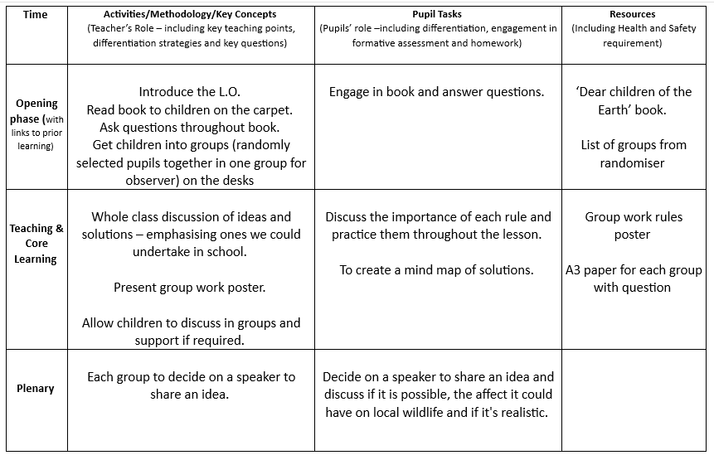

Lesson Resources
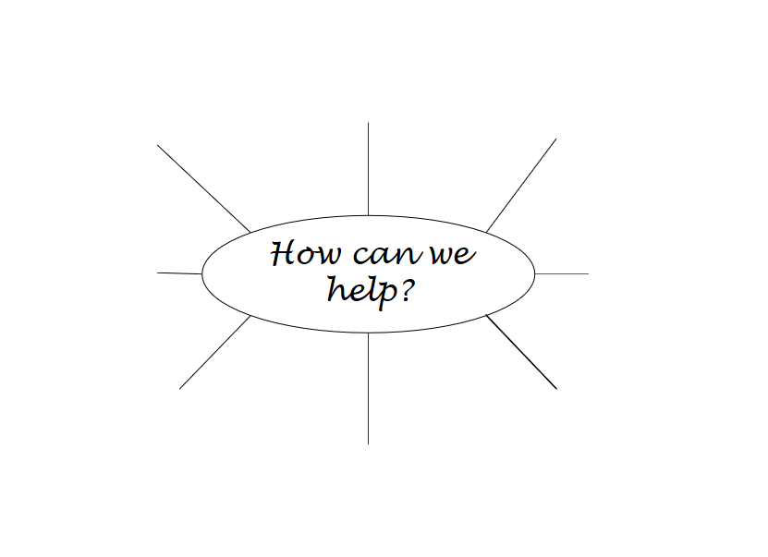
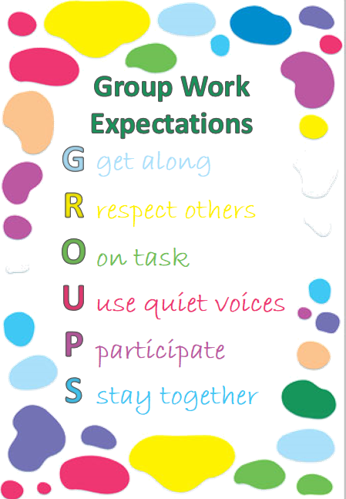


Consent forms
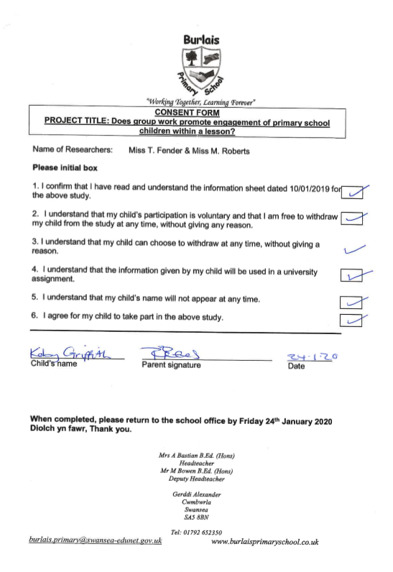
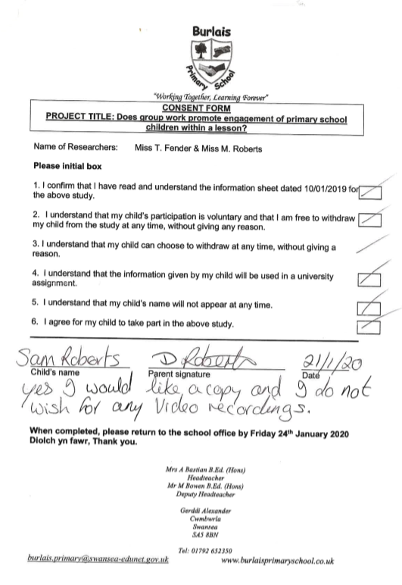
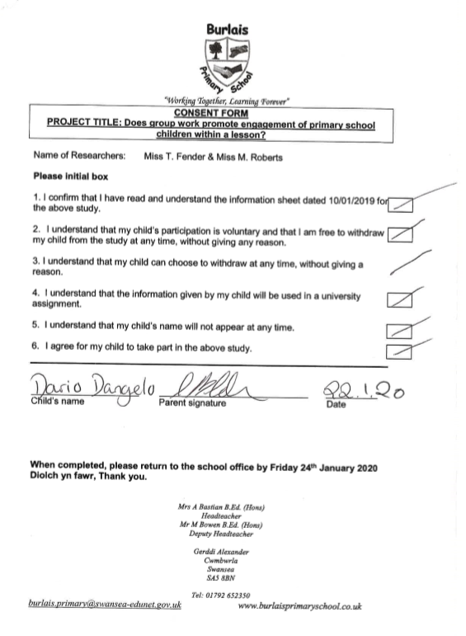
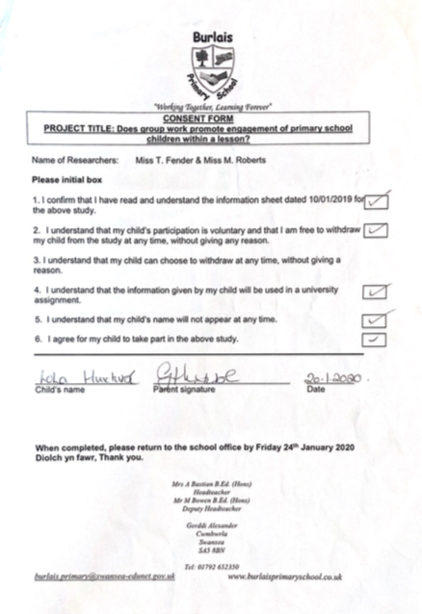

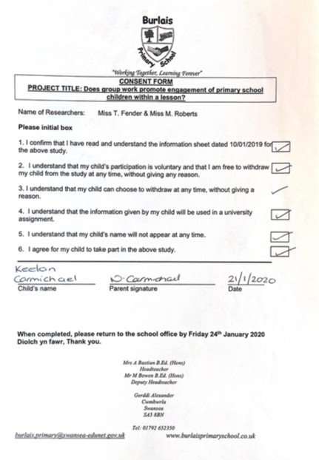

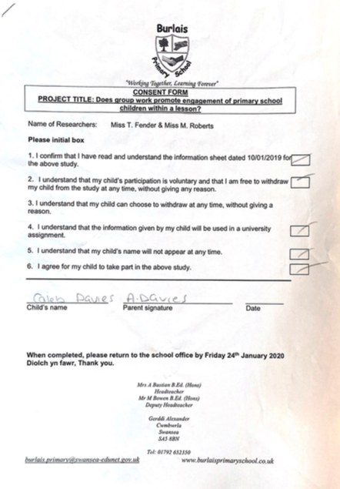Assent Forms
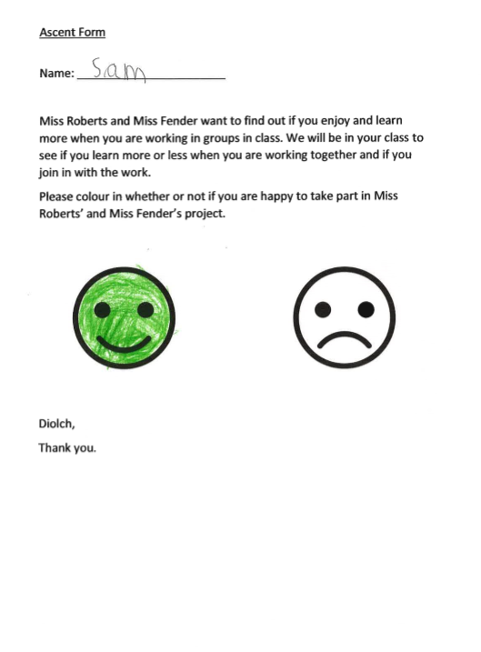
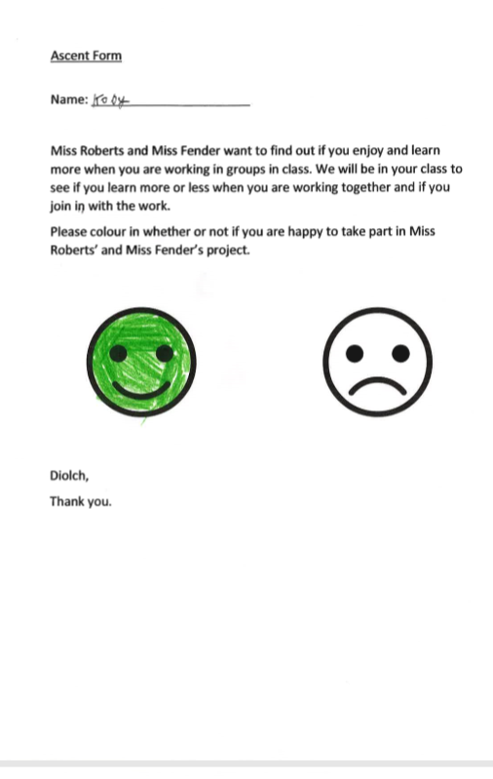
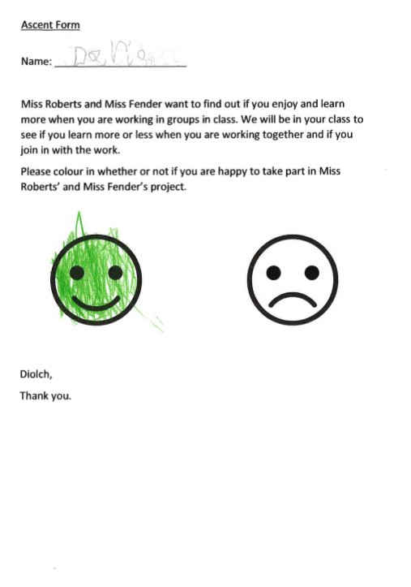
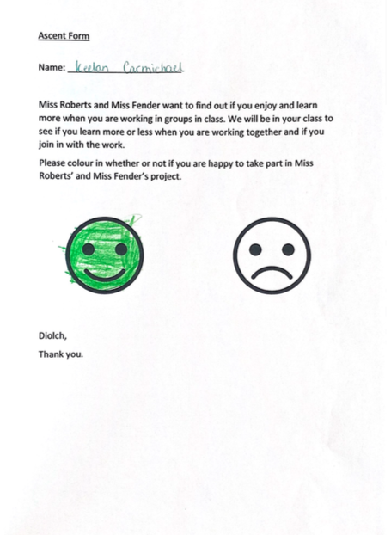

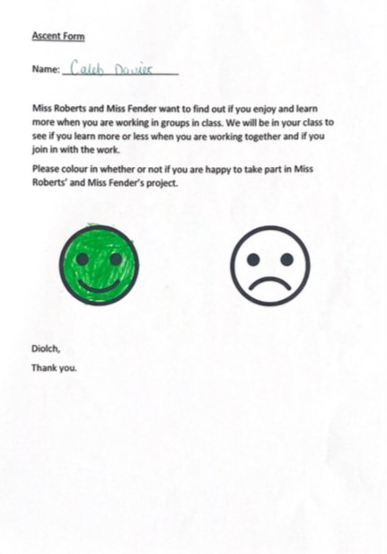

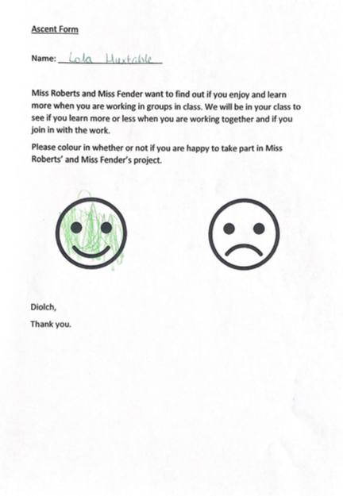

Work Produced
Lesson study 1
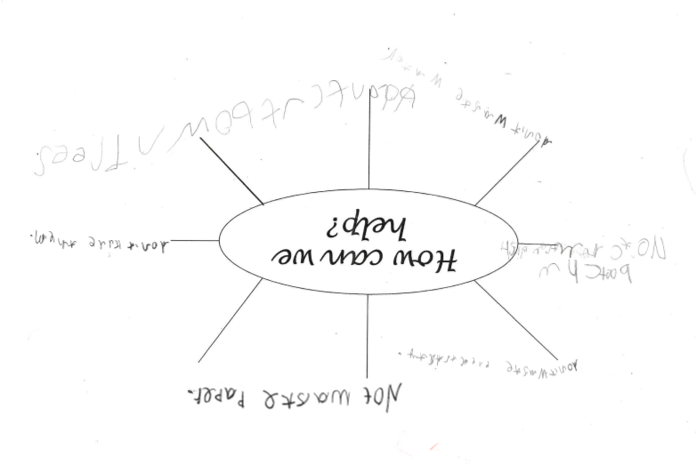
Lesson Study 2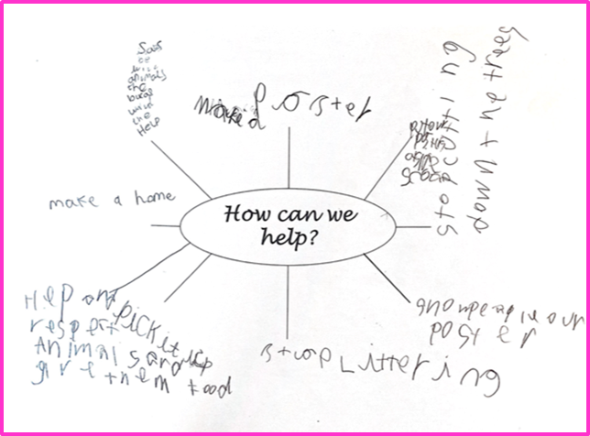

Observation Schedule
Lesson Study 1
Observation schedule:
- Are the children communicating with each other?
Yes, the children are helping each other with spellings. The children passed the paper around and wrote one idea each, they did not discuss it.
- Are the children taking it in turns to speak?
At first, children were shouting over each other. Children then took it in turns to speak, however they didn’t discuss ideas after someone said an idea.
- Are the children discussing things that are relevant to the task?
Mostly, at points the children were off task.
- Are the children confident when talking to their group?
Two of the children were confident to speak, one child was having difficulty spelling but was not confident enough to ask the group for help. One child was disengaged and did not join in discussion.
- Are the children looking at the person who is talking in their group?
Sometimes, however not always.
- Are the children getting on with their work?
Yes mostly, however children did go off task a few times.
- Are the children asking each other for help if they are stuck?
One of the children asked the others for help with spelling. One child was struggling to spell but would not ask for help as he did not feel confident. He accepted help once it was offered to him.
- Are the children showing understanding and explaining the task to each other?
One child could not think of what to write and did not understand. The other children said ‘write anything’.
- Who is writing?
The children took it in turns to pass the paper around and write one thing each. They did not discuss ideas before writing them.
- Who is speaking?
All children spoke over each other or said their idea but did not discuss ideas as a group.
- Do the children seem interested in what others are saying?
They agreed once on what they thought was a good idea, this was the only discussion. Children sometimes looked at each other when they were talking.
- Does every pupil have an opportunity to share their thinking verbally, visually or through writing?
Yes, all children were able to write down their ideas.
- Are desks or seats arranged to facilitate discussion or collaboration?
Yes, desks were suitable for discussion.

Lesson Study 2
Observation schedule:
- Are the children communicating with each other?
Yes, observer had to remind children to talk to each other not adult.
- Are the children taking it in turns to speak?
Some interruption(5) and some off task at times in their own conversation (4)
- Are the children discussing things that are relevant to the task?
On task majority of the time – see leuven scale.
- Are the children confident when talking to their group?
Every child shared at least one idea, (6) wasn’t confident but did share one.
- Are the children looking at the person who is talking?
Yes, (5) ensured that they were all paying attention when he was talking. Children were reminded twice to talk to each other and not the adult.
- Are the children getting on with their work?
Work was completed with time to spare. 4 then got distracted. 5 carried on thinking of more ideas even after work was completed.
- Are they asking each other for help if they are stuck?
5 was thinking out loud, always on task. 4 went off task when he was stuck, and 6 didn’t ask for any help but only came up with one solution. 4 helped 5 with spelling even though 5 didn’t ask for help – 4 identified the spelling error.
- Are they showing understanding and explaining the task to each other?
Yes, but had to reinforce how
- Who is writing?
Children didn’t appear to work as a team and liked to take ownership of their ideas, write their own ideas and didn’t think of solutions as a group.
- Who is speaking?
5 took over and did most of the speaking.
- Do the children seem interested in what the other children are saying?
Yes, they added comments to one anothers ideas.
- Is there evidence to suggest that pupils feel safe respectfully sharing an unpopular opinion or view that may challenge their teacher?
N/A
- Are pupil successes celebrated?
5 encouraged other group members, (could appear competitively?)
- Are pupil voices heard as often as the teacher’s voice?
No teacher intervention – only pupils voices during discussion.
- Does every pupil have an opportunity to share their thinking verbally, visually or through writing?
Every child has the opportunity to discuss their ideas verbally however some took this opportunity more than others. Children did appear to take turns at times when k realised that L didn’t share anything. 5 was very dominant in discussion and written. Some conflict with 5 and 6 when it came to writing which lead to 6 disengaging for some time – then came back again.
- Does classroom discussion move from peer to peer, allowing them to respond to peer thinking, instead of always moving between teacher and pupil?
There is no teacher intervention, children were discussing. Some one task and some in and out of concentration (see Leuven scale).
- Has the work bee differentiated based on pupil needs to allow participation?
There is no obvious differentiation but a child has the advantage of choice whether to participate in discussion.
- Are desks or seats arranged to facilitate discussion and/or collaboration?
Desks are set in groups – however, as the groups are smaller, there is more than one group on each desk.

Leuven Scale
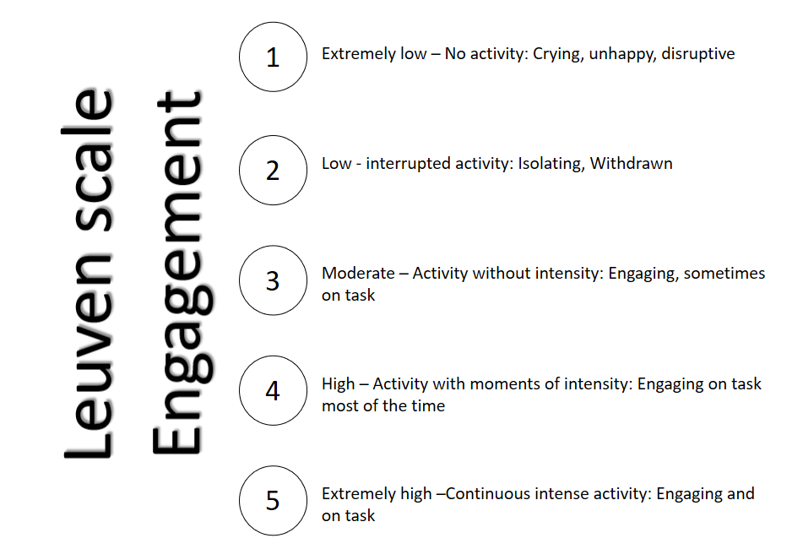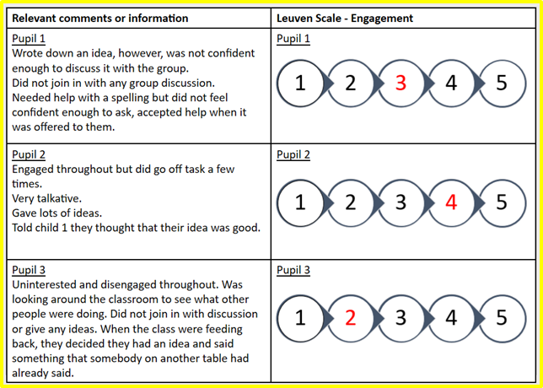
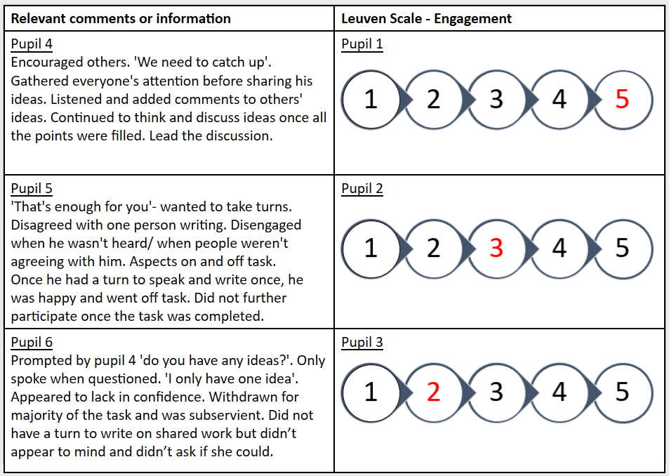

Interviews with participants
Lesson Study 1
- What did you learn in the lesson? How to be nice to animals and the earth and ways to help them.
- Did you find the lesson fun? What part? Yes, all of it.
- How do you find your concentration when working with others? Hard – very hard because people keep talking. Easy – I could get more ideas.
- What did you discuss in your group? No cutting down trees, don’t be mean to the animals and take care of them.
- Did you take turns in your group? Who wrote / spoke? - We took it in turns to write and speak.
- How does group work make you feel? Why? Prefer to work as a group because I get to work with my friends, people give me ideas, my friends help me and there is less work.
- What is the difference between working on your own and within a group? A group is nosier, my friends help me in a group.
- Did you feel confident to talk in your group? Why? I felt happy and confident to talk because it was with my friends. I felt a little bit shy (2 children).
- Do you prefer to discuss as a class or in a small group? I prefer in a little group, it is quieter, I get shy in a big group, there is less shouting out in a small group.
- Who could you ask for help if you are stuck? I could ask my friends.
- Did you complete the task? Yes.
- Could you have completed the task on your own? No, there is no discussion and no one to help you if you are stuck.
Lesson Study 2
- What did you learn in the lesson? We have to help animals who are our brothers and sisters of the world and we have to stop littering and take care of the world.
- Did you find the lesson fun? What part? Yes, everything.
- How do you find your concentration when working with others? Hard because I am shy. Hard because someone may say your answer before you, it is noisy, people talk over each other, people shout out. Easy because there is more ideas and it is easy to talk to your friends.
- What did you discuss in your group? Ways to help the earth and animals and what might happen if we don’t.
- Did you take turns in your group? Who wrote / spoke? Some people didn’t take turns. C + L wrote 1, K wrote 4. everyone spoke but C was off task sometimes.
- How does group work make you feel? Happy, I like it. / I am shy so I don’t like it.
- What is the difference between working on your own and within a group? There is no one to help when you work on your own. It is lonely on your own (2 children). I prefer to work on my own because there is not as much noise.
- Did you feel confident to talk in your group? Why? K – yes. L – no, I was shy. C – yes, but only to some people.
- Do you prefer to discuss as a class or in a small group? Little group, it is quieter and there are more chances to speak and give your opinion (1 child). Whole class, there is more help and more ideas (2 children).
- Who could you ask for help if you are stuck? I could ask my group or a teacher.
- Did you complete the task? Yes.
- Could you have completed the task on your own? No, it was nice to share ideas and answers, I would not have enough ideas to fill the sheet on my own.

Gibbs reflective model
Lesson study 1
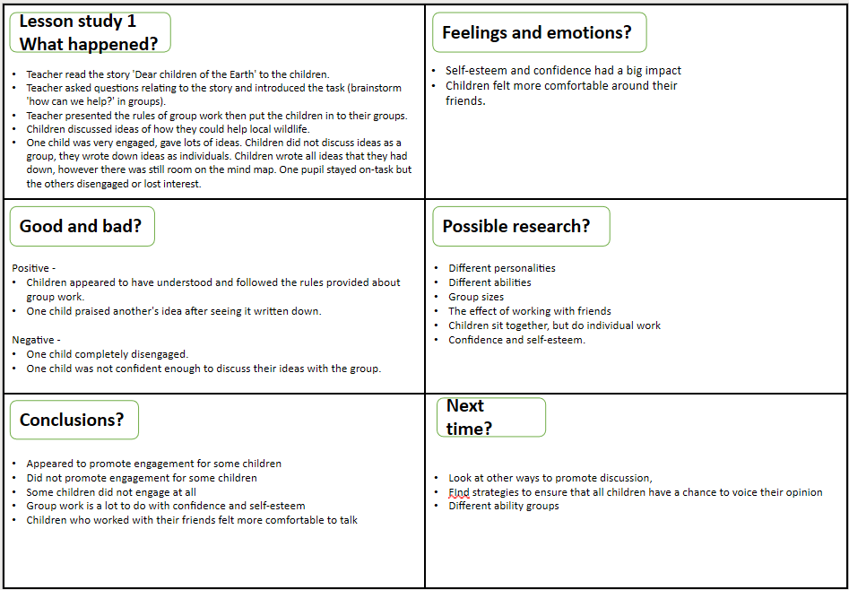
Lesson Study 2


