The Book of Kells: An Analysis about Madonna and Child Imagery by Joseph Chaput
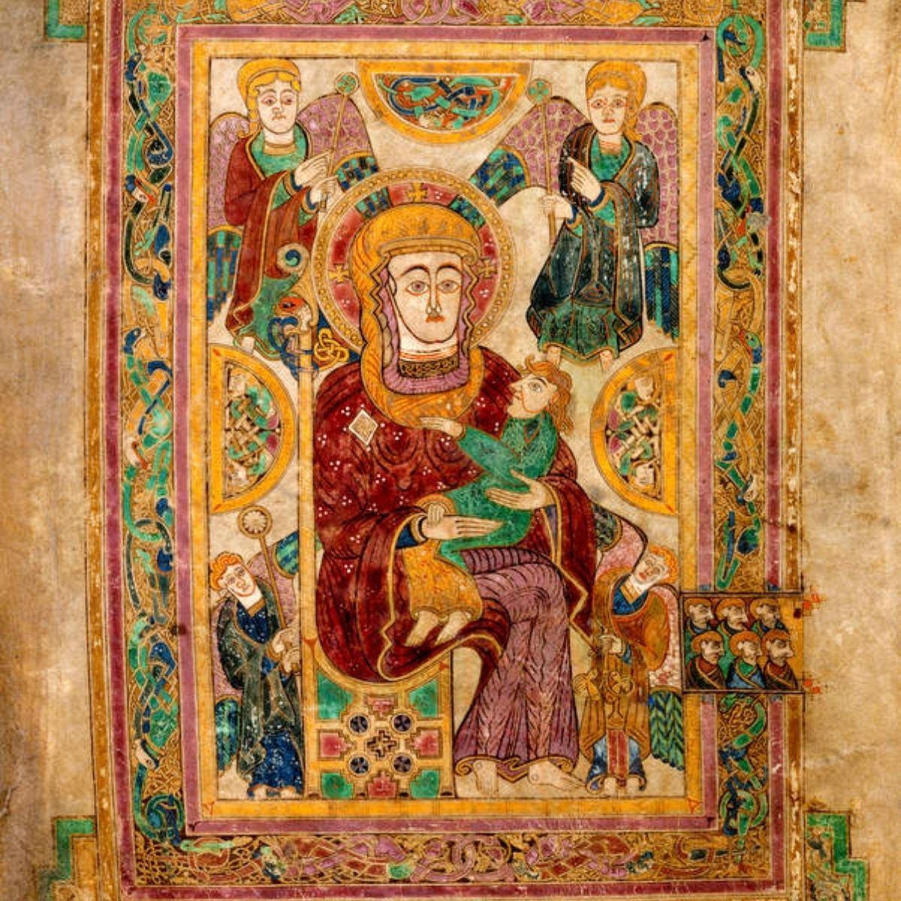

There are few images more iconic or more Christian than that of St-Mary holding the baby Jesus in her arms. This image has almost along with the Cross come to be the most common of all the images utilized by Christianity across the centuries. Those of the Medieval Age were in particular prone to putting it everywhere, and holding it up in reverence. The Scots were in this regard no different, with the Book of Kells being one of if not the finest collection of Christian images ever printed/painted in the northern British Kingdom. In the above shown image one can discern the rather strong-jawed mother holding her child in a tender embrace, as she is encircled by winged-angels. A common enough image, however what is most remarkable about this particular depiction is how it was done in the 9th century, using a different kind of position and visual style than what most might expect. As this image presents a far more Celtic variation stylistically but also in terms of colours, which play a large role in all Celtic images, especially that of Madonna and Child presented in this essay.
The monks clearly took great pains to gain expensive materials, and to portray the saintly ‘mother’ of their God in the best possible light. The encircling colours and angels are not the only way they honoured her and her child; but with a high golden throne. As to their minds this was no ordinary child, but the foremost King of Kings. Thus, their giving him and his mother a golden throne, one which places also the Church in many ways in a higher position than the secular lords in a way, as the image of ‘Madonna and Child’ and an enthroned Jesus in this manner, has always been used to convey the supremacy of the clergy. With the Book of Kells serving as much as proof of faith on the part of the monastery in the abbey of Kells, as it did a reminder to the local lords to behave themselves. As they may rule the people of the land in which they lived (and on the mainland ruled the land itself legally), but in the eyes of the Christian society of the time, Jesus ruled the souls of all of Christian-Europe. And by extension, the Church commanded all, and had as obligation to curb the worst excesses of the secular nobles of Europe. What is more is that the mindset of the era was a fairly depressed one as Viking depredations had caused a great deal of devastation throughout not only Britain but all of Western Europe. With one of the beliefs of the time-period being that the Vikings were essentially God’s punishment for their ‘sinful nature.’ As it was believed at the time that the people of Europe, had fallen from God’s intended vision for them, with priests treating the invasions and violence of the period as a just-reward for sinfulness, as in the case of Archbishop Wulfstan of York’s sermon, of ‘Sermo Lupi ad Anglos.’
The fact that it was painted in the 9th century, a period when the north of Britain was under attack by Viking raids, by southern British kingdoms, and was a period when Europe was going through a crisis of faith. With the book’s vivid imagery, a kind of re-affirmation of the classic faith, with the book evidently being written in the abbey of Kells. Which belonged to the same branch of Catholicism as the isle of Iona, and is thus a celebration of the Gaelic faith’s art as well as that of St-Columba for this reason. The book’s first possible reference though is from the entry about the year 1007 A.D./C.E. of the Annals of Ulster, where it is possible that the book was stolen for a time, before it was ultimately recovered (if without its original cover). An incident that rocked all of the British Isles, and that if it was the Book of Kells, could have been a symbolic blow in the eyes of the Church (along with their many ‘subjects/followers’).
What is also noteworthy about the paint and the colour choices in this image is how many greens and blues there are. Gold is a given to an extent as the colour pairings of gold and white are often representative of Jesus and his mother. Blue and green are not ordinarily what is used in paintings of angels who are typically painted with brighter colours. Mary is not only painted without her usual blues (for her dresses), white or her gold but with red (another royal colour), but it is the angels and Jesus who get most of the green and the odd blue in the case of the right-most angel. Jesus sports a bright-green outfit, with green being the colour of faith, and a fairly popular colour in Celtic art. As the colour green had possible divine connotations, and with it being another popular choice in Celtic art. This whilst, the right-most angel almost drowning in blues and greens. Where the left-most one is depicted in red and green, so that the image almost screams of eternity and royalty, which makes it quite the powerful message for the medieval mind as those of the Middle-Ages might have been excused for being a tad over-awed by the symbolic political statement made in this image alone. The borders at the same time also bear a considerable amount of greens and blues. In all the choice of colours outside of the typical gold plays an important religious role as well, as it also helps to an extent to identify the source of the artwork as a major Celtic one. What is more though, is that there are Celtic knots in the image, which is a rather popular symbol in Celtic culture. One that looks akin to a chain and that apparently is a symbol of Celtic faith, and has long been connected in the modern mind to Ireland. Ireland was at this time in the midst of colonizing the western isles of Scotland, with their cultural influence to seep farther eastwards between the time of Kenneth I (Cinaed I) and Causantin II’s reigns. As the kings of this period sought to complete a fusion of the Pictish (which lay in the region of the heartland of modern-day Scotland) and that of Dalriata, which was an Irish set of colonies in the Argyll region. The picture of Mary and Jesus here also tells something of the tale of Iona, and its influence over Scotland in the 9th through to the 11th centuries. With this influence one that was destined to be undone by Margaret and her children, as Malcolm III’s wife favoured Roman-Catholicism over the Catholicism of Ireland. But the Book of Kells was issued in the age when Iona and its influence were at its peak, a time-period when all of Europe necessitated reassurance. As it had rather like an abused house-wife become a terribly depressed, broken place with none more-so to an extent than the British Isles, due in part to the Vikings’ and their many raids and invasions. Pictland had notably been plundered and reduced to a feeble state, until Cinaed MacAilpin came along to claim the throne and his descendants rebuilt it in their images, just as the north of England was torn apart and rebuilt, over the course of several generations by Norsemen.
This dependence on imagery has much to do with the fact that much of Europe was illiterate, and thus depended upon images alone to tell stories rather than the written word. Understanding this was crucial to the survival of the Church, which did its utmost to maximize its symbolic power with the finest of images. The beauty of this depiction of Madonna and Child likely had an effect on even those in the know, such as the monks and those heads of the clergy such as the archbishops, cardinals and the popes of that period. Beauty in this case likely enhanced the piety of the clergy as much as it did those peasants, who were to set eyes upon the Book of Kells. This effect was useful not only in Ireland and Scotland, but over on the mainland where the Truce and Peace of God movements began to take shape and truly gain momentum in the 10th century, just as the clergy was hoping to make a push for civilizing and mitigating the brutality of the diverse barons and lords of Europe.
Therefore to sum up the whole of the arguments herein; the image of the mother Mary with the baby Jesus upon her knee, is a powerful image. One that though of a different branch of Christianity from the primary Roman Catholic one, of the time-period the book of Kells was printed and painted in, was one that they were not blind to. With the image involving a great diversity of paints/colours and was replete with a great many messages for the different branches of society. Reassurance for the clergy that Mary and Jesus were still with them, reassurance to all that great feats of art could still be produced even with Rome’s fall centuries prior. The reminder to the political classes of the power of faith but also of their limits, as God was still ‘High-King’ of all men and their souls. With true power stemming from him, and not from any other sources, with the book also a re-affirmation of the Church’s self-appointed mission as arbiter over all of Europe, and as the chief cultural power in the continent. Regardless of the depredations in the past century by the Scandinavian pirates, who had made short work even in half a century of a great many of the kingdoms of Great Britain and Ireland. The golden embroidery in the book of Kells along with the other rosy, almost ‘angelic’ images and calligraphy supposed to also serve as a reminder of the boons that awaited, in heaven all those who died meritoriously or rather with pure, pious souls. Therefore, it is as much a promise in return for the peasants, accepting their miserable lot in life as it was a reminder of the Church’s position as supreme overlord of all.

Alan Orr Anderson (Translator). “Early Sources of Scottish History A.D. 500. To A.D. 1286: Annals of Ulster, vol I, p. 518, s.a. 1006 or 1007,“ Windham Press (May 30 2013): pg 526
Alan Orr Anderson (Translator). “Early Sources of Scottish History A.D. 500. To A.D. 1286: Annals of Ulster, vol I, p. 518, s.a. 1006 or 1007,“ Windham Press (May 30 2013): pg 526 Fordham University (latest revision on the site 20 January 2021), “Medieval Sourcebook: Peace of God - Synod of Charroux, 989,” https://sourcebooks.fordham.edu/source/pc-of-god.asp Herron Michael W & Brown, Shirley, “Christ in Celtic Christianity: Britain and Ireland from the Fifth to the Tenth Century: The Representational Image of Christ,” Boydell Press, 2002, Pages 244-245
Magnus Magnusson. “Vikings! Chapter 3: From the Fury of the Northmen,” New York: E.P. Dutton. (1980) (Kindle Edition). Pages 62-63 Wulfstan (author), Lewis, Stephen M (translator). “The Sermon of the Wolf to the English,” Academia.edu, February 2014. https://earlybritishlit.pressbooks.com/chapter/wulfstan-sermon-of-the-wolf-to-the-english/
Werner, Martin. “The Madonna and Child Miniature in the Book of Kells, Part II,” The Art Bulletin 54, no. 2 (1972): 129–39. https://doi.org/10.2307/3048962.
Alan Orr Anderson (Translator). “Early Sources of Scottish History A.D. 500. To A.D. 1286: Annals of Ulster, vol I, p. 518, s.a. 1006 or 1007,“ Windham Press (May 30 2013): pg 526
Gage, John, “Color and Culture: Practice and Meaning from Antiquity to Abstraction: Chapter 4: A Dionysian Aesthetic,” University of California Press, 1999, Pages 82-83
Marsden, John, “Alba of the Ravens: In Search of the Celtic Kingdom of the Scots: Chapter 1: The Picts and the Scots,” Constable and Company Ltd; 1st Ed. Edition (1997), Pg 4-7
Walker, Ian, “Lords of Alba: Chapter 2: The Kingdom of Alba,” Sutton Publishing Limited, Page 34-39 Marsden, John, “Alba of the Ravens: In Search of the Celtic Kingdom of the Scots: Chapter 1: The Picts and the Scots,” Constable and Company Ltd; 1st Ed. Edition (1997), Pg 4-7 Maclean, Fitzroy, “A Concise History of Scotland: Chapter 1: ‘Polished from the Rust of Scottish Barbarity’,” Thames and Hudson (2nd Edition) (1970), Pg 14-22 Lynch, Michael, “Scotland: A New History: Chapter 4: The MacAilpin Kings and Alba,“ Pimlico (1992), Pg 41-44 Kenneth Veitch. “The Alliance between Church and State in Early Medieval Alba,” Albion: A Quarterly Journal Concerned with British Studies 30, no. 2 (1998): 193–220. https://doi.org/10.2307/4053521.
Lynch, Michael, “Scotland: A New History: Chapter 6: The MacMalcolm Dynasty,“ Pimlico (1992), Pg 76-77. Oram, Richard, “David I: The King Who Made Scotland: Chapter One The Founding of the Canmore Dynasty,” Tempus; New edition (2009), Pages 26-29. Maclean, Fitzroy, “A Concise History of Scotland: Chapter 1: ‘Polished from the Rust of Scottish Barbarity’,” Thames and Hudson (2nd Edition) (1970), Pg 24-25
Walker, Ian, “Lords of Alba: Chapter 1: Viking Onslaught,” Sutton Publishing Limited (2006), Pages 22-23 Herron Michael W & Brown, Shirley, “Christ in Celtic Christianity: Britain and Ireland from the Fifth to the Tenth Century: The Representational Image of Christ,” Boydell Press, 2002, Pages 244-245 Townend, Matthew, “Viking Age Yorkshire: Chapter 2: The Early Viking Kings of York,” Blackthorn Press, (2014) (Kindle-Edition), Pages 39-40 Jones, Gwyn, “A History of the Vikings: Part 3 The Viking Movement Overseas: Chapter 3: The Movement South and South-West to 954: the British Isles, the Frankish Empire, the Mediterranean,” Oxford University Press (Second Edition), 1984, Pages 220-226
Fordham University, “Medieval Sourcebook: Peace of God - Synod of Charroux, 989,” (latest revision on the site 20 January 2021), https://sourcebooks.fordham.edu/source/pc-of-god.asp “Bradbury, Jim, “The Capetians: Kings of France 987-1328: Chapter 4; The first Capetian kings, 987-1031,” Hambledon Continuum Press, (2007), Pg 76
Fordham University (latest revision on the site 20 January 2021), “Medieval Sourcebook: Peace of God - Synod of Charroux, 989,” https://sourcebooks.fordham.edu/source/pc-of-god.asp

