University of Wales Trinity Saint David


Title: Marketing Environment Analysis
Student Name: Chiya Feyzullah
Student ID: 2208596
Module: Marketing Management
Module Code: LCMB70024
Name of Lecturer: Ejike Udeogu (Birmingham)
Internal verifier: Vasilios Tavlaridis
Hoang Dang Nguyen

Pioneer and Follower Organizations in The UK Fashion Retail Industry- The case of Boden (Pioneer) and M&S (Follower)
BODEN
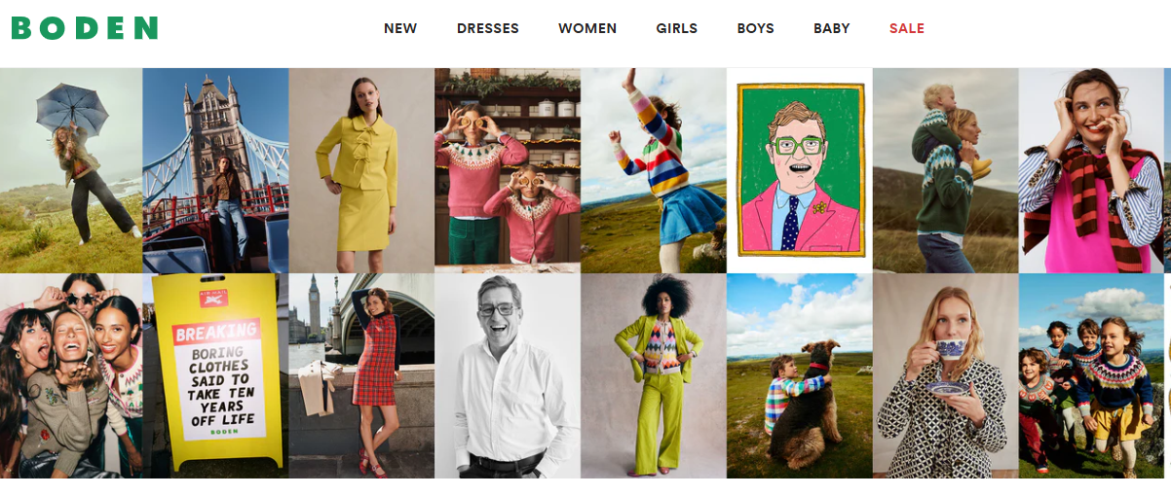

M&S
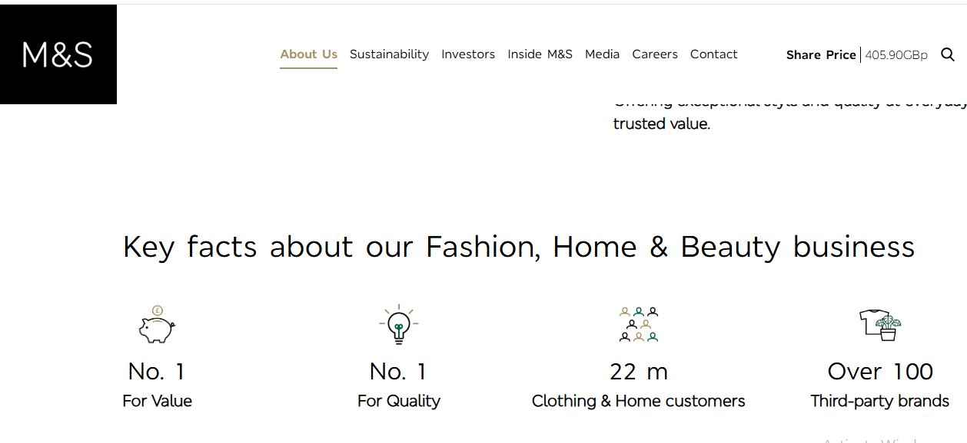

Contents
1.0 Introduction 1
1.1 External macro marketing actors 1
1.1.1 The Economic Environment 1
1.1.2 The Socio-Cultural Environment 2
1.1.3 Critical Analysis and Conclusion 3
2. Strategic response to Macro-environmental factors 4
2.1 Introduction 4
2.2 Strategic Responses to Economic Volatility 5
2.2.1 Boden's Defensive Agility and Offensive Brand Reinforcement 5
2.2.2 M&S's Strategic Leverage of Scale and Value Recalibration 6
2.3 Strategic Navigation of the Socio-Cultural Shift 6
2.3.1 Boden's Deep Integration of Sustainability and Evolving Inclusivity 7
2.3.2 M&S's Scalable Sustainability and Brand Reinvention 7
2.4 Critical Evaluation 8
1. Conclusion 8
References 10

1.0 Introduction
Strategic marketing management is fundamentally concerned with understanding and adapting to the external environment in which an organisation operates. Analyzing the macro-environment, which consists of broad forces that are mostly out of a single firm's control but that significantly influence the opportunities and threats landscape, is an essential part of Strategic marketing management (Kotler and Keller, 2016). This study will critically examine how changes in the sociocultural and economic environments—two significant macro-environmental actors—create distinct, often asymmetrical opportunities and challenges for both pioneering and follower organizations. The UK fashion retail industry provides a compelling context for this exploration, with Boden serving as an exemplar of a pioneer in distinctive, quality British design, and Marks & Spencer (M&S) representing a formidable, long-established follower.

1.1 External macro marketing actors

1.1.1 The Economic Environment
A powerful force that determines market vitality is the economic environment, which includes elements like inflation, disposable income, and consumer confidence (Qian, Y. and Xi, X., 2025). Its fluctuations do not impact all players uniformly, there is a dynamic interaction between opportunities and threats for leaders and followers.
A according to Bouvet ( 2025), strong economy presents a big opportunity for a pioneer like Boden, which positions itself on design, quality, and premium pricing. Rising disposable income and increased consumer confidence during economic expansion promote "premiumization," the process by which buyers upgrade from entry-level goods to ones with higher aesthetic or qualitative value (Lumina, R., 2024). By doing this, Boden is able to strengthen its brand identity and draw in clients prepared to spend money on fashionable, long-lasting apparel, increasing its market share and defending its pricing policy. As online spending rises in tandem with economic optimism, its direct-to-consumer business model—a trailblazing feature of its early days—also becomes more lucrative.
On the other hand, a recession poses a severe threat (Shavshukov, V.M. and Zhuravleva, N.A., 2020). During recessions, discretionary spending is the first to be cut (Office for National Statistics, 2023). Boden's premium products are particularly vulnerable as consumers grow more price-sensitive. Customers may defer purchases, switch to less expensive options, or look for sales, all of which would negatively impact Boden's profitability and core value proposition. In a challenging economic environment, the very qualities that make it a pioneer turn into its liabilities.
The economic environment presents a different set of dynamics to a follower such as M&S who deals with a wider range of prices and possesses a huge store portfolio. M&S is under the risk of being stuck in-between in a booming economy. Its various clothing lines are neither unique enough to fight aspiration spenders among pioneers in the fashion business nor affordable enough to fight value spenders such as Primark. Those with greater disposable income can afford to shop at other brands that are more specialized instead of M&S, a trend that has long bedevilled the retailer (Rigby, 2019). Nonetheless, during a recession the size and history of M&S can be turned into strength. Its image of quality and value-for-money, especially in its classic most popular products such as lingerie and basic knitwear can be utilized by customers who trade down to even higher quality brands. Its widespread physical presence which is frequently quoted to be a cost, brings with it convenience and assurance.

1.1.2 The Socio-Cultural Environment
Socio-cultural environment which includes values, lifestyles, and beliefs in the society are changing at an unprecedented rate and this is due to the impact of digital media and generational changes (Stephenson, J., 2023)
. At this, a change can make a brand positioning obsolete quickly or push it to the new relevance. To a revolutionary such as Boden, the contemporary socio-cultural transformation into sustainability and ethical manufacturing is a massive opportunity. Its original philosophy of producing quality and sustainable clothes perfectly coincides with the trend toward the rejection of the so-called fast fashion among consumers and its adverse impact on the environment (Niinimaki et al., 2020). Boden can further engage its ethically-conscious customers with its focus on quality over quantity, longevity, and visibility in its supply chains. This enables it to strengthen its pioneering image as not only being stylish but being responsible, develops a strong, justifiable brand story. However, this same shift is a threat if not managed authentically. With the emergence of sustainability as a mainstream issue, their adherents such as M&S are making a huge commitment to sustainability in their Plan A sustainability program, tapping into their size to effect a shift (M&S, 2022). Unless Boden is constantly innovative and communicates its ethical credentials in the best way, it runs the risk of being outperformed by bigger competitors, which have more resources to spend on marketing and research and development. Moreover, the socio-cultural shift to casualization, which is galloped by the pandemic, is a threat to the traditionally more upscale and formal Boden aesthetic, which has to modify its designs without losing its brand image.
To the follower M&S, the socio-cultural environment is a mine field of threats. The conservative, old-fashioned brand image has not been able to appeal to younger audiences who prefer authenticity, digital brands and more inclusive and diverse marketing (Wissinger, 2021). M&S has been seen as a slow adopter of fashion trends, and thus can be challenged by more manoeuvrable innovators and fast-fashion merchants who understand social media and influence culture. This waning of the traditional high street as a social area also poses a risk to its immense physical estate which is a remnant of a found dead socio-cultural age. However, in these threats there are great opportunities. The socio-cultural impact of the strong British heritage and nostalgia is a trump that can be used to its advantage by M&S as a national institution. It can also use its 130 years history and established brand name to elicit emotions of quality and reliability that other new brands cannot. The cultural change to slow fashion and investment fashion also works in the favor of M&S, assuming that it will be able to justify its old lines as sustainable and timeless, and not as mere safe. The recent partnerships with younger designers and influencers are an effort to tap into socio cultural trends to revitalize its image (Marks & Spencer, 2025), and is an indication of the ability of a follower to learn and copy the approaches of the players who operate more innovatively.

1.1.3 Critical Analysis and Conclusion
The economic and socio-cultural environments have been critically analyzed in terms of which the boundary between pioneer and follower is dynamic rather than fixed, which means that a strategic position was continually redefined by the external forces. The effect of change in the macro-environment is asymmetrical in nature (Xiong, S., et al., 2025). The strength of a pioneer in a stable, flourishing socio-cultural environment can turn into its most critical vulnerability in an economic recession, and the size and tradition of a follower which many might see as a liability, becomes critical barriers to instability.
In the case of Boden, the pioneer, the success depends on agility and brand purity. It will have to overcome economic backlash with a possible addition of more affordable sub-brands or payment methods without losing its identity, and redoubling its socio-cultural commitment to sustainability to justify its price premium. The danger of it is inertia; that it is doomed to become a relic should it not keep up with the cultural tendencies it was the first to represent.
In the case of M&S, the follower, the issue is that of relevance and transformation. It needs to use its financial strength to finance an extensive social-cultural repositioning. This would be abandoning its image that has become obsolete and genuinely aligning it with the current values of sustainability, diversity, and digital interactions. Its opportunity is in leveraging its massive resources and credible platform to implement a not-merely-imitative, but also adaptive and scale-efficient follower strategy.

2. Strategic response to Macro-environmental factors

2.1 Introduction
In the previous discussion of the economic environment and socio-cultural environment, this analysis is a critically evaluated analysis of how pioneer and follower organisations can respond to these external forces, in a strategic manner to remain competitive. The strategies that Boden (pioneer) and Marks and Spencer (M&S) (follower) use demonstrate a radically different approach: pioneers need to secure a niche value proposition; followers can build on scale to change and innovate. Their reactions are not simply reactions but some probing moves based on their unique market positions and organisational strengths.

2.2 Strategic Responses to Economic Volatility
Both pioneers and followers have been forced to adopt defensive and offensive positions in the post-pandemic economic environment in the UK, which is characterized by a severe cost-of-living crisis and high inflation (Dorling, D., 2025).

2.2.1 Boden's Defensive Agility and Offensive Brand Reinforcement
Being an early adopter who is subject to the discretionary spending cuts, Boden has had a combination of both defensive retrenchment and offensive brand support (Boden, 2025). On the defensive side, the company has been compelled to do more intensive and intensive discounting, as compared to its conventional policy of safeguarding the full-price sales. Its parent company has recorded a 6% decline in sales in 2023, which it directly contributed to the difficult economic climate that decreased demand especially of more formal and occasion-wear (The John Lewis Partnership, 2023). This denotes the change of strategy to clear inventory following the decline in demand. However, its fundamental offensive approach is to enhance its perceived brand value to the extent that it can afford its premium. This is executed through:
- Value-Centric Marketing: The marketing has changed slightly in the message to focus on cost-per-wear, fabric quality, and durability. There are campaigns emphasizing on clothes one will wear forever (Wightman-Stone, 2023), a direct appeal to the consumer who is increasingly spending less with the willingness to spend more on clothes that have a long life.
- Supply Chain Investment: Boden still invests in its supply chain even though it is economically pressured to counter future shocks and increase in cost (Boden UK, 2025). Although this is not a quick solution, it is a long-term perspective at ensuring its quality offer, which is one of the distinguishing features of its innovative identity.
The key problem that Boden has to balance is these tactics. Over-discounting will destroy the brand equity, and will condition customers to hold on until it is on sale, which will hurt its premium positioning. One of its strategies therefore is a high-wire act of creating demand without lowering the value of its core product.

2.2.2 M&S's Strategic Leverage of Scale and Value Recalibration
M&S being a follower has taken advantage of the economic downturn to capitalize on its size and re-establish its value credentials. Its approach is not as much retaliation of a niche but rather an expansion of a greater price-sensitive audience.
- Price Investment and "Remobilization": M&S have formed an investment strategy that aims at reducing the price of major staple products. In 2023, it said it was investing PS20 million to reduce the price of more than 300 of its family-popular foods and clothing items including school uniforms and pasta for 32 Mn customers (Globaldata, 2025). This is a conventional follower strategy to its financial strength to win on value in high-visibility categories, which create footfall and supports its reputation of fairness.
- Store Estate Rationalization: This is a very important aspect of the M&S economic response as it has been very vigorous in speeding up its store renewal and closure programme. It is directly responding to the potential economic threat of its traditional physical presence by closing down less profitable high street outlets and moving to retail parks with higher footfall and lower operating expenses. It plans to have 105 full-line stores by 2028, a reduction of 247 stores in the year 2018 (M&S Corporate, 2024). This is a painful and yet crucial restructuring, which the company has been able to make through its robust balance sheet, as a strategic response to the two economic forces of increasing costs and changing consumer shopping habits.
This strategy has been effective as is seen in its performance in the recent past. M&S has seen 4.8 growth in the 13 weeks to December 2023 in clothing and home revenue, which compares much better than the market, which they credited to a better value and a more appealing offering (M&S, 2024). This indicates that a crisis can help a follower streamline its work and sharpen its value proposition, and poach customers to weaker competitors.

2.3 Strategic Navigation of the Socio-Cultural Shift
The strategic responses to the socio-cultural trends of sustainability, inclusivity, and casualization demand genuine and immensely built-in responses.

2.3.1 Boden's Deep Integration of Sustainability and Evolving Inclusivity
As a pioneer, Boden’s socio-cultural strategy is to embed these values into its core brand story, making them a point of differentiation.
Authentic Sustainability Storytelling: Boden does not just market its products as it incorporates sustainability in its product development. Its Well-Loved platform advances repairing and worn-out clothing, and it directly interacts with the circular economy. It also publishes measures, including the goal of having 100 percent of its cotton more sustainably sourced by 2025 (Boden, 2023). This openness will create a relationship of trust among a morally-sensitive group of consumers and affirm its leadership role as a responsible brand.
Aesthetic Adaptation to Casualization: Boden has acknowledged the permanently switched casualization dynamics, as it has diversified its product range to more of the so-called elevated casual wear, including high quality jersey wear and other trendy loungewear and denim, keeping its signature prints and colours (Boden UK, 2019). This enables it to remain topical without forgetting its identity and this will be a key adaptation of a pioneer.

2.3.2 M&S's Scalable Sustainability and Brand Reinvention
In the case of M&S, the socio-cultural issue is titanic: to transform the rooted consumer attitudes towards its brand. Its tactics are thus massive, company-driven plans.
Plan A as a Corporate Pillar: This Plan A sustainability programme by M&S is a scale-based reaction. One of the most important initiatives is its "M&S Respill" collaboration with Oxwash, which is a circularity service of its school uniforms, and plans to reuse one million garments by 2025 (M&S, 2023). This uses its massive clientele to generate influence that a smaller pioneer would not be able and makes its size its scale an asset within the sustainability discussion.
Aggressive Marketing of Inclusivity and Modernity: M&S is hard at work to rid itself of the conservative image. This can be reflected in its marketing which now has a wider variety of models in terms of age, size and ethnicity. Its extremely successful partnerships with other brands such as Nobodys child and early usage of the social shopping app "Trove" are calculated actions to draw in a younger, more technological demographic, and add fashion credibility. CEO Stuart Machin explained that it aims to make M&S more relevant, more frequently, and more to more families (M&S, 2024), which, of course, is an obvious consideration of the socio-cultural threat and an effort by a follower to expand its market presence.

2.4 Critical Evaluation
These strategic reactions of Boden and M&S bring out an important conflict in strategic marketing: the conflict between focus and flexibility. The approaches made by Owen are rather protective. They are made to wrap its core brand equity, quality, design, and hint of British quirkiness against the external shocks. Its socio-cultural reactions are combined with its economical ones; its sustainability story is one of the primary instruments to explain its economic premium. The danger is that this narrow strategy may cause inflexibility. The niche position will be exposed as unsustainable in case the economic downturn is sustained or its effort to extend its aesthetic to capture its main customers backfires. On the contrary, strategies at M&S are volume-oriented and transformative. It plays on its economies of scale to offer price competition and finance an extensive programme of store modernisation. At the same time, it leverages its brand name to bring about a socio-cultural re-invention. The benefit of this to the follower is the chance to experiment; a collapsed clothing line or promotion plan is not as harmful to a diversified giant as to a niche pioneer. But the threat is watering down and insincerity. The perceived sustainability of its efforts by consumers could be seen as greenwashing or its trendy partnerships as false unless supported by a cultural change of some kind within the organisation.

Conclusion
In conclusion, both pioneering and a follower strategy are not better or worse. Their success is dependent on an extensive and acute comprehension of the macro-environment and a callous coordination of strategic reaction and fundamental organisational strengths. Boden manages to stay a cherished, focused brand for a specific consumer, even at the cost of smaller scale. M&S is successful in its approach of using its vast resources to be adaptive, develop and cater to mass market even at the expense of pure brand identity. In the volatile arena of UK retail, their ongoing battle illustrates that competitiveness is maintained not by resisting change, but by crafting a strategic response that turns external threats into a reaffirmation of what the brand, at its core, represents.

References

- Boden (2023) Our Responsibility. Available at: https://www.boden.com/pages/sustainability-mission. Accessed (October 20, 2025).
- Bouvet, P., (2025). Forest Green Rovers Football Club: A model for tomorrow's golf clubs. Sustainability and Sports Science Journal, 3(2), pp.125-143.
- Boden UK. (2019). Our people. [online] Available at: https://www.boden.com/pages/our-people [Accessed 22 Oct. 2025].
- Dorling, D., (2025). Visualising the 2020s UK cost‐of‐living crisis. Social Policy & Administration, 59(2), pp.197-220.
- GlobalData (2025). M&S reduces prices on 300 family-favourite products. [online] Yahoo Finance. Available at: https://finance.yahoo.com/news/m-reduces-prices-300-family-114549691.html. Accessed (October 21, 2025).
- Kotler, P. and Keller, K.L. (2016) Marketing Management. 15th edn. Harlow: Pearson.
- Lumina, R., (2024). The premiumization opportunity: enhancing Italian SMEs value proposition through three dimensions.
- Marks & Spencer. (2025). M&S launches young designer competition with Youngminds to support young people’s mental health. [online] Available at: https://corporate.marksandspencer.com/media/press-releases/ms-launches-young-designer-competition-youngminds-support-young-peoples-mental.
- Marks & Spencer. (2023). M&S Launches First Pre-Loved Back-to-School Uniform Shop in Partnership With Oxfam and Ebay. [online] Available at: https://corporate.marksandspencer.com/media/press-releases/ms-launches-first-pre-loved-back-school-uniform-shop-partnership-oxfam-and. Accessed (October 18, 2025).
- Marks & Spencer. (2024). 2023/24 Christmas Trading Statement. [online] Available at: https://corporate.marksandspencer.com/node/2939 [Accessed 21 Oct. 2025]. Accessed (October 18, 2025).
- M&S Corporate (2024) Store Estate. Available at: https://corporate.marksandspencer.com/about-us/store-estate (Accessed: 20 October 2025).
- M&S (2022) Plan A Report 2022. Available at: https://corporate.marksandspencer.com/plan-a (Accessed: 19 October 2025).
- Niinimäki, K., Peters, G., Dahlbo, H., Perry, P., Rissanen, T. and Gwilt, A. (2020) 'The environmental price of fast fashion', Nature Reviews Earth & Environment, 1(4), pp. 189-200.
- Office for National Statistics (2024). Cost of Living Latest Insights . [online] www.ons.gov.uk. Available at: https://www.ons.gov.uk/economy/inflationandpriceindices/articles/costofliving/latestinsights.
- Qian, Y. and Xi, X., (2025). Evaluating the policy effect of the “Broadband China” strategy—From the perspective of urban entrepreneurship vitality. Journal of the Knowledge Economy, 16(3), pp.10993-11019.
- Shavshukov, V.M. and Zhuravleva, N.A., (2020). Global economy: New risks and leadership problems. International Journal of Financial Studies, 8(1), p.7.
- Stephenson, J., 2023. Cultural change. In Culture and sustainability: Exploring stability and transformation with the cultures framework (pp. 125-151). Cham: Springer International Publishing.
- www.johnlewispartnership.co.uk. (n.d.). John Lewis Partnership - John Lewis Partnership unaudited interim results for the 26 weeks ended 29 July 2023. [online] Available at: https://www.johnlewispartnership.co.uk/media/press/jlp-unaudited-interim-results-for-the-26-weeks-ended-29-July-2023.html.
- Wissinger, E. (2021) 'Authenticity and the Branded Self in the Age of the Influencer', in The Routledge Companion to Fashion Studies. London: Routledge, pp. 105-114.
- Wightman-Stone, D. (2023). Boden celebrates 30th anniversary with capsule collection. [online] FashionUnited. Available at: https://fashionunited.in/news/fashion/boden-celebrates-30th-anniversary-with-capsule-collection/2021090630430 [Accessed 22 Oct. 2025].
- Xiong, S., Paulraj, A., Dai, J. and Irawan, C.A., (2025). Digital integration capability asymmetry and buyer product innovation: the contingent roles of environmental dynamism and innovative climate. International Journal of Operations & Production Management, 45(3), pp.756-782.
.

