Changemakers- building your personal brand for sustainable employment
Saba Parveen 2014411
BMHP5015_BIRM
Tayo Korede

Saba Parveen
129 Wash Lane, B25 8PX
07453389379
xsx786@hotmail.com

Adrian King
Hiring registered nurse
123 Elm Avenue
Marston Green
B19 8PA

Dear Mr King
I am writing with great interest in response to the registered nurse position being advertised on your website. You will see from my CV as a qualified nurse with 10years’ experience and currently hold a BSC nursing degree, I have no doubt that I would be an excellent choice for the position you have available. I believe that I have the appropriate mix of abilities, experience, and education to perform the job and all the accompanying responsibilities as a nurse that required many different roles which I carried out.
I have worked with patients and staff for more than five years in the health and social care sector and have the ability to lead a team of junior nurses to provide excellent patient care. With a calm and patient demeanour, I am an outstanding health care professional and have a strong desire to deliver the best possible care to my patients. In my present role at Avery medical centre, I am responsible for monitoring the health of up to 15-20 patients per day. I have designed and implemented a rotational system for patient care and personnel management that I have overseen. I have gained a reputation for being self-motivated, ambitious, and dependable and for being able to work well under pressure.
In addition, my years of experience as a nurse in the medical centre assisted me in realising and carrying out clinical duties which I acquired through studying. I was complimented for handling challenging circumstances with patients and their families with the skill.
I believe I would be a great candidate for your organisation as I’m looking for a work setting where I can use my skills to their full potential in a fast-paced setting. I eagerly wait your response and the opportunity to discuss my qualifications in greater detail with you.
Sincerely
Saba Parveen

SABA PARVEN
SENIOR REGISTERED NURSE
ABOUT MYSELF
Passionate and caring nurse with over 8 years’ experience. Confident in caring for patients and leading junior nurses. Experience treating a wide variety of medical issues. Communicating well with other medical professionals and teaching patients how to take care of their conditions.
SKILLS
PROBLEM SOLVING
TEAMWORK
HEALTH ASSESSMENTS
CARE PLANNING
FLEXIBLE AND RELIABLE
LEADERSHIP
COMPASSION

MY CONTACT DETAILS
Phone
07453389379
Email
xsx786@hotmail.com
Address
129 wash lane, Yardley, B25 8PX

EXPERIENCE
Senior registered nurse at Avery medical centre 2015-2022
- Leading a nursing team including clinical training and staff development
- Supervising junior nurses and helping with care planning
- Complaints handled promptly according to policies
- Medication safety
Registered nurse at Shaw Hill medical 2012-2015
- Treated patients with care
- Changed dressings and inserted catheters
- Evaluation of patient’s conditions and implemented effective treatment

EDUCATION
2005-2007 Health and social care level 3
Stockland Green technology college
2007-2011 BSC nursing
University of Wales Trinity Saint David

REFERENCES
Available upon request




The effects of Lockdown during COVID-19 Pandemic on the mental health
TV DOCUMENTRY PROPOSAL


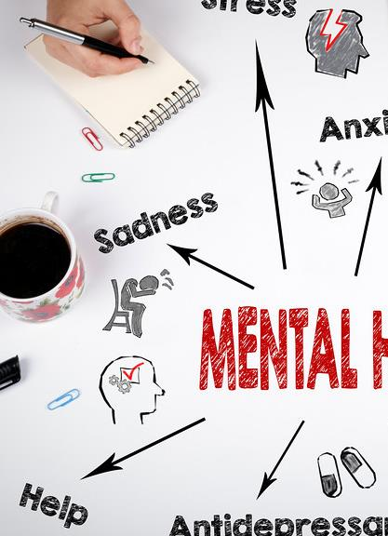
Through the idea of this proposal, I wish to motivate and educate the audience about the critical significance of mental health and the network of support services that are readily available.
As a direct result of the widespread of COVID19, concerns regarding people's mental health and emotional well-being have risen to the forefront of the worlds public health agenda (Khan et al., 2020).

The aim of this TV documentary would be to raise awareness on the effects of lockdown during COVID-19 Pandemic on mental health of families.
COVID-19 has impacted many across the world and with social distancing measures put in place, resulted in many suffering mental health.
Anyone who is subjected to quarantines or lockdowns find them to be unpleasant and psychologically disturbing (Panchal et al, 2021).

WHAT IS THE AIM AND WHY IS IT I

The contents of the documentary
- The contents of this documentary will include 4 episodes, based on a family. A single mother of 2 children. Each episode will show the struggles of each individual. First you will get to see how lockdown is impacting the mother and the struggles she is facing on her own. In the next 2 episodes viewers will see how the children are being impacted individually. Finally, in the last episode viewers will see how they all come to terms with their struggles and all the help and support that is available. By going through each episode, viewers will become more mindful of the growing threat posed by ignoring mental health. It is essential for an individuals well-being that he/she maintains good mental health (Srr and Bipeta, 2012).

- People will get to see this series as if it is real life as COVID-19 is still around and impacting people. By the end, viewers will see that there is a lot of support available for anybody suffering or know of anybody suffering with mental health and signs to look out for.


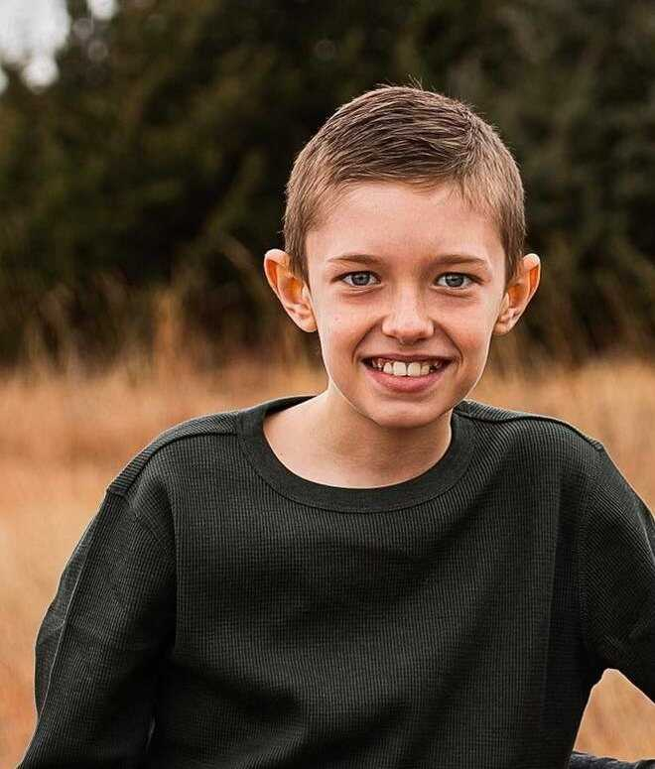

Sarah- daughter
Episode 2- begin to understand some of the struggles Hannah is facing by not being in school and away from friends and missing out on exams.

Episode 4-
All the main characters journeys’ will be shown and how they get through a part of their struggles. Lastly, signs and symptoms of mental health will be conversed and the available help and support

James- son
Episode 3- James has just transitioned from primary to secondary school when Lockdown was implemented. He is now having to be indoors with his mother and sister and we get to see how this is impacting him.

Suzie- Mother
Episode 1- look at the daily struggles Suzie is facing being a single mother who has lost her job as a hair stylist as the company she worked for has shut down. All whist trying to care for her 2 children.

MAIN CHARACTERS

TARGET MARKET AND BENEFIT OF THIS
DOCUMENTARY

The BBC is the main public service broadcaster in the UK. It is responsible to serve all audiences by providing them with information, education and entertainment of the highest quality and uniqueness (National Audit Office, n.d.).
In todays society everyone has access to TV’s and live streaming so it will be accessible to view to a large number of viewer's. This is the perfect time for this documentary to be show cased as COVID-19 is still current and many are still suffering. It will immediately raise awareness and help eradicate the stigma linked with mental health. By encouraging individuals to discuss mental health, we can eliminate the stigma associated with something that affects everyone (Berrie, nd).

REFERENCES
- mental health images - Google Search
- bbc 1 logo - Google Search
- mental health - Google Search

- National Audit Office. (n.d.). The BBC’s understanding of its audiences and users visualisation. [online] Available at: https://www.nao.org.uk/other/the-bbcs-understanding-of-its-audiences-and-users-visualisation/.

- Khan, K.S., Mamun, M.A., Griffiths, M.D. and Ullah, I. (2020). The Mental Health Impact of the COVID-19 Pandemic Across Different Cohorts. International Journal of Mental Health and Addiction. doi:10.1007/s11469-020-00367-0.

- Srr, S. and Bipeta, R. (2012). AP J Psychological Medicine, [online] 13(2). Available at: https://mhi.org.in/media/insight_files/aagt12i2p80.pdf.

- Berrie, A. (n.d.). The importance of Time To Talk Day - Mental Health At Work. [online] www.mentalhealthatwork.org.uk. Available at: https://www.mentalhealthatwork.org.uk/blog/the-importance-of-time-to-talk- day/#:~:text=For%20people%20with%20mental%20health.

- Panchal, U., Salazar de Pablo, G., Franco, M., Moreno, C., Parellada, M., Arango, C. and Fusar-Poli, P. (2021). The impact of COVID-19 lockdown on child and adolescent mental health: systematic review. European Child & Adolescent Psychiatry. doi:10.1007/s00787-021-01856-w.

