Study Skills: Assignment 1
Daani Nayyar, QinetiQ
UWTSD

Abstract

Table of Contents

Abstract 2
Table of Contents 2
The Ice-Breaker Presentation 4
How to Deliver a Successful Presentation [1] 4
Improvements 4
Skills Evaluation 5
Learning [2] 5
Employment [3] 6
Self-Evaluation [4, 5] 6
Application 9
Looking after your data [6] 9
Time-management and self-organisation [7] 9
Independent study [8, 9, 10] 10
Conclusion and Evaluation 10
References 11

The Ice-Breaker Presentation
The apprentice’s name is Daani Nayyar, and he currently works for QinetiQ as an OME apprentice in their Shoeburyness site in Essex, amongst the ammunition team. Previously, he lived in Southampton with his parents and moved for the apprenticeship. These are a few screen grabs from his presentation:

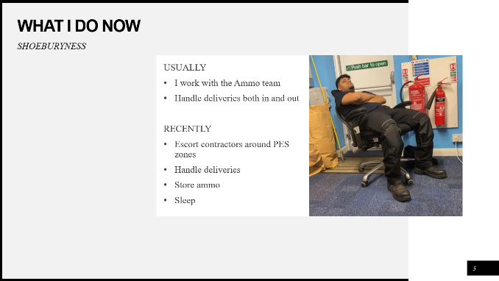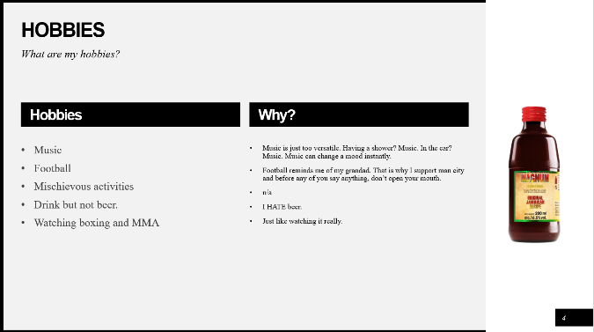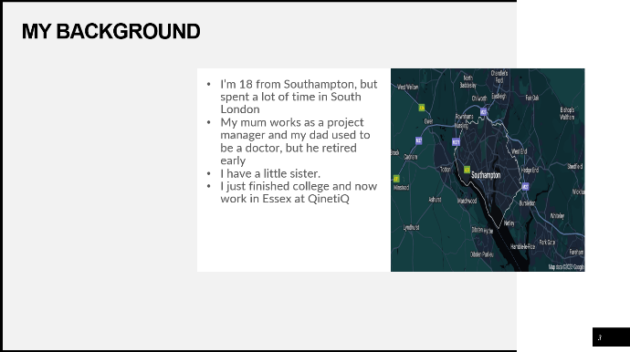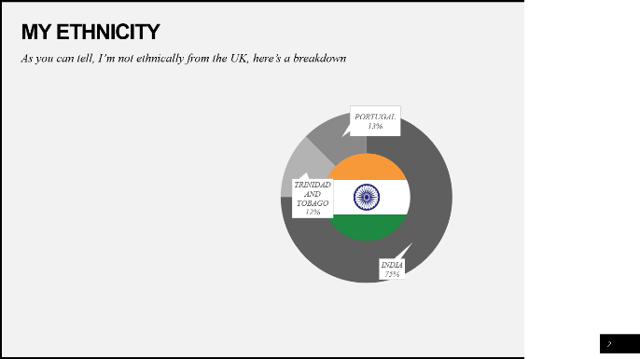

How to Deliver a Successful Presentation [1]
- Speak in a clear and concise voice.
- Write minimal amounts and elaborate further yourself.
- Engage with your audience.
- Maintain good eye-contact and open body language.

Improvements
In his presentation, he took an extremely laid-back approach because, and we can only assume, that is the kind of person he is. In future presentations, he should make it more professional and present it in a way that can be presented to all rather than friends. He needs to pace himself slower and not get too excited as he finished the presentation before the four-minute mark.

Skills Evaluation

Learning [2]
Some of the skills needed to succeed in a higher learning environment can be learnt and some can come naturally to others.
- Time-management – the ability to have time for all activities including university work. Setting aside time for certain activities and having a regime is an example of time management.
- Critical-thinking – evaluating information to a higher standard, being able to critique professional research and contradicting your own points to create counterpoints.
- Scanning – being able to seek out required information and disregard irrelevant information. Skimming is an example of this, and comprehensions are good practice for scanning.
- Communication – these are essential to excel whilst learning. Communication can range from asking professors for help or working well in group projects or even presenting.
- Academic writing – Writing to a professional standard with a good grasp on the English language is needed. Being able to write in simple language, concise and clear.

Employment [3]
Transferrable skills that employers look for when hiring can range from personality traits to academic accomplishments.
- Leadership – Being able to take control and inspire other members of a team is extremely employable.
- Teamwork – Working well within a team, listening and incorporating ideas.
- Problem-solving – Identifying and then finding a solution towards an issue.
- Critical-thinking – This is a heavily sought after skill in the job market as analysing information and deciding based on that is more reliable.
- Adaptability – Adapting to new roles, responsibilities and circumstances is imperative in succeeding in a workplace environment.
- Computational skills – In times like these, basic familiarity with spreadsheets, presentations, and other forms of presenting data, are looked for by employers.

Self-Evaluation [4, 5]
These are some of the strengths and weaknesses the apprentice portrays. He has noteworthy computational skills, due to his academic background where he studied ‘Computer Science’ at both GCSE and A Level. He has exceptional interpersonal and communication skills due to his sociable personality and previous customer-facing experience. In team exercises, the apprentice seems to naturally feel inclined to lead given his history with captaincy in multiple team sports. Although there are more strengths, the apprentice seems to lack a moderate level of critical thinking as he makes decisions quickly as opposed to thinking them through. This can often get him into trouble and/or very occasionally into a bigger problem than he started with. Even while lacking a high level of critical thinking, he can adapt to a wide range of activities and challenges very easily. Another weakness of his, is his indecisiveness when it comes to decisions about himself. He can get overwhelmed by bigger decisions and not know what to do in the moment and panic. However, both problems can be easily improved and even rectified with the correct influence. Here are some online evaluations of the apprentice’s personality type and what career path he is suited towards:
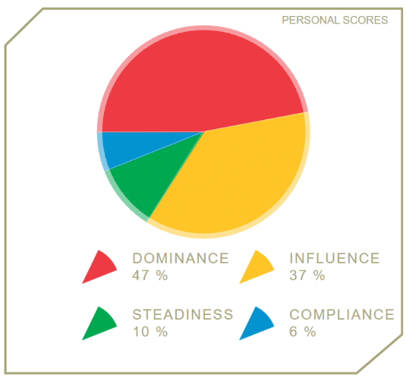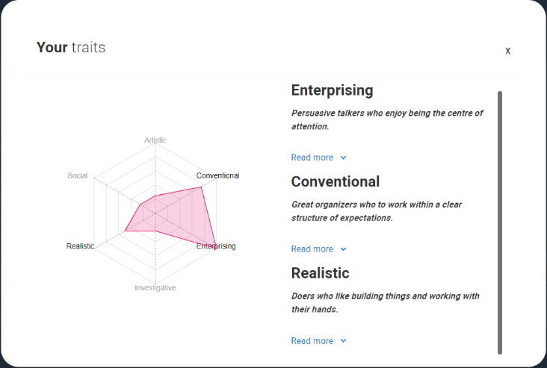

The apprentice took part in two questionnaires, and these are the results. It shows that he is more business and sales-minded, whilst also maintaining a lot of dominance and leadership. He has a very entrepreneurial mind and that can be backed up from his past ventures such as shoe reselling and being a door-to-door salesman for a short period of time. The apprentice has questioned whether he is in the right line of work for some time and is now there is more uncertainty regarding that matter, due to these quizzes. He needs to take some time to think about where he wants his future to be and whether it is something related to what he is currently doing or something more suited to him as well as changing his professionalism in formal presentations and meetings.
The short-term goals for this apprentice are:
- To understand where he would like his career to go.
- Make the most of the opportunity given to him.
- Act in a professional manner both on and off the job.
- Pass his upcoming maths exam to a good standard.
- Engage and maintain in a healthier lifestyle.
- Start exercising more frequently.
The long-term goals for this apprentice are:
- Be heading in the right career direction for him.
- Achieve his weight loss target.
- Passing his university course (if that is the chosen career path).
- Prioritising the important things as opposed to having fun first.
- Created a daily routine.
- Get his driving license.
S.M.A.R.T goals:
- Get his driving license before the start of June.
- Choose what career path is and start going into the process of switching (if needed), by the end of his first academic year.
- Create and start to abide by his daily routine by the end of this month (January).
- Revise and achieve a good mark in his upcoming maths test (January).
The plan is to prioritise his maths and revise so he can do well in his test, then start creating a healthy daily routine and incorporating it into his life. Once that is done, he would like to take his driving test and pass. Leaving a substantial period for him, to focus on thinking about where he wants to go with his career.

Application

Looking after your data [6]
There is an advised rule for looking after and backing up your data named the 3-2-1 rule and it consists of: backing up at least three copies of the data so that it has a very slim chance of being lost, keep two copies in separate locations and one copy being kept off-site. For his presentations and reports, the apprentice backs up his files onto a USB stick, the cloud, his personal laptop, and his work laptop. This is a precaution he uses to remain on top of his work without losing it. He uses it in both his personal and academic life, however only using two locations for his personal data. By using this method, he is almost immune to his files being lost and therefore running over a deadline and reduces the risk significantly of failing the assignment or even module. As the apprentice works under the Official Secrets Act, his work laptop and mobile have extra layers of security and protection provided by his company. This is because there is classified and sensitive information on both which cannot be accessed by the public.

Time-management and self-organisation [7]
As of right now, the students’ organisation and time-management are sub-par as he leaves most tasks till the last minute. However, he is hoping to turn that around by implementing a few new rules into his life. He has his work calender so he knows what work he is doing and how busy he will be on that day, and he will also start to create a weekly tasks list on a whiteboard at home and tick them off as he goes. The apprentice independently researched ways to be more productive and found five rules: stop multitasking and getting distracted from the tasks and eventually taking longer than doing them separately: taking small breaks helps the brain stay active instead of it being worn out: break down bigger projects and task into smaller ones and complete it as such; do the bigger tasks when you are most alert/awake and finally to implement the two-minute rule. The two-minute rule is where if a job can be done in less than two minutes, complete it immediately. All of these will help the learner adapt to a new level of discipline and be on top of his workload instead of leaving it till late.

Independent study [8, 9, 10]
In this section, the apprentice has researched an obsolete secondary explosive named Torpex, or torpedo explosive. Torpex, a military explosive, blends 40% TNT, 42% RDX, and 18% aluminum powder. It merges TNT's stability, RDX's potency, and aluminum's shattering force, proving highly effective in munitions and bombs, notably in World War II. It was first used in late 1942 and was 50% more powerful than TNT by mass. It was mainly used in underwater and nautical munitions such as naval mines and depth charges however it was also used in bouncing bombs as well as earthquake bombs. Torpex played a pivotal role in the development of bouncing bombs during World War II. These innovative weapons were designed to skip across water surfaces before striking their targets, notably used in Operation Chastise by the Royal Air Force's 617 Squadron against German dams in 1943. Torpex's stability and explosive power were instrumental in the construction of these specialized bouncing bombs. The combination of Torpex's high explosive content and its stability made it ideal for the bouncing bomb's complex requirements. Its ability to withstand the impact and subsequently detonate with immense force upon contact allowed for the successful destruction of enemy infrastructure. The deployment of bouncing bombs equipped with Torpex showcased the adaptability of this explosive in unconventional wartime applications, demonstrating its effectiveness beyond traditional uses in naval warfare. The student wrote that Torpex isn't defined by a singular chemical formula; it's a composite explosive blend. It combines TNT (C7H5N3O6), RDX (C3H6N6O6), and aluminum powder (Al). TNT adds stability, RDX contributes explosive power, and aluminum enhances shattering effects. It has been preceded by something called PBX, polymer-bonded explosive. PBX superseded Torpex because PBX bombs are stronger and have less volatility, and therefore are a safer alternative when storing and transporting the munition itself. These factors are the reason that Torpex is rarely used in today’s military arsenal. However, torpedo explosive is still used in the Sting Ray lightweight torpedo. The student concluded that Torpex played a pivotal role in the second world and was used in an effective way. Especially the use of it in Operation Chastise.

Conclusion and Evaluation
In summary of this assignment, the apprentice needs to work on his time-management and organisational skills. He also should find out about himself in a deeper context in the upcoming few months. He has a vast array of current skills and puts them to use, he backs up his data effectively and needs to maintain a level of professionalism in his work and life, if he wishes to achieve more and go further in this line of work or the next.

References
[1] I. E. Team, “How to deliver a presentation in 8 steps (benefits and tips),” Indeed, https://uk.indeed.com/career-advice/career-development/how-to-deliver-a-presentation (accessed Dec. 17, 2023).
[2] R. Needleman, “What are the 6 essential skills for university students?,” UniAdmissions, https://www.uniadmissions.co.uk/application-guides/6-essential-skills-for-university-students/ (accessed Dec. 17, 2023).
[3] R. Pelta, “15 transferable skills that companies want: Examples and definitions,” FlexJobs Job Search Tips and Blog, https://www.flexjobs.com/blog/post/transferable-skills/ (accessed Dec. 23, 2023).
[4] 123test team, “Disc personality test. fast and free disc assessment for business and individuals,”. Fast and Free DISC assessment for business and individuals, https://www.123test.com/disc-personality-test/ (accessed Dec. 31, 2023).
[5] UCAS, “Careers quiz,” UCAS, https://www.ucas.com/explore/career-quiz (accessed Dec. 31, 2023).
[6] UWTSD, “Backing up data,” UWTSD, C:\Users\daani\Downloads\Backing Up Data (1).pptx (accessed Jan. 8, 2024)
[7] A. Stahl, “5 ways to increase your productivity at work,” Forbes, https://www.forbes.com/sites/ashleystahl/2018/06/28/5-ways-to-increase-your-productivity-at-work/ (accessed Jan. 8, 2024).
[8] “Torpex,” Wikipedia, https://en.wikipedia.org/wiki/Torpex (accessed Jan. 8, 2024).
[9] “Operation chastise,” Wikipedia, https://en.wikipedia.org/wiki/Operation_Chastise (accessed Jan. 8, 2024).
[10] “2,4,6-trinitrotoluene,” National Center for Biotechnology Information. PubChem Compound Database, https://pubchem.ncbi.nlm.nih.gov/compound/2_4_6-Trinitrotoluene (accessed Jan. 8, 2024).
[11] H. Abadin, C. Smith, and L. Ingerman, Toxicological Profile for RDX., https://www.ncbi.nlm.nih.gov/books/NBK154154/table/T12/ (accessed Jan. 8, 2024).

