May 1, 2025
Cheng Chen (2305261)
UNIVERSITY OF WALES TRINITY SAINT DAVID
BSc Applied Computing
L5 - NETWORK OPERATING SYSTEMS AND SERVICES (ACCA5023)
CONFIGURE, AND MANAGE VIRTUALISED NETWORK
Contents
Introduction 2
Topology 2
Swansea Network 3
Cardiff Network 20
Testing 21
Disk Drive Sharing 22
Set up IIS Server 22
Services for Remote Desktops 22

Introduction
Based on the continuation of the topology and planning from Coursework 1, this report shows the actual implementation of a network infrastructure configuration task. In a simulated business situation, the role focuses on configuring and overseeing fundamental network functions such IP forwarding, routing, and inter-subnet communication. As shown in the given network design, the objective is to guarantee the smooth functioning of essential TCP/IP services on both Windows Server 2022 and Debian Linux 12.5 systems. Numerous services, including NAT, DHCP, and routing, are set up on both the Linux and Windows operating systems as part of this implementation. The goal of the task is to show a thorough understanding of applying security policies, managing network resources, and creating dependable connectivity between various network parts. Every setup step is accompanied with pertinent scripts and pictures to ensure that the tasks are completed successfully.

Topology
As needed, install and set up routing and other essential services.
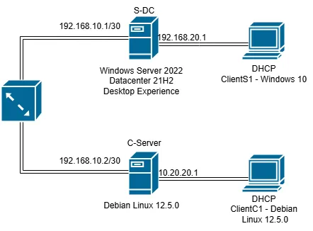

Swansea Network
Prmit ICMP traffic, install the Routing and Remote Access Service and adjust the firewall rules.
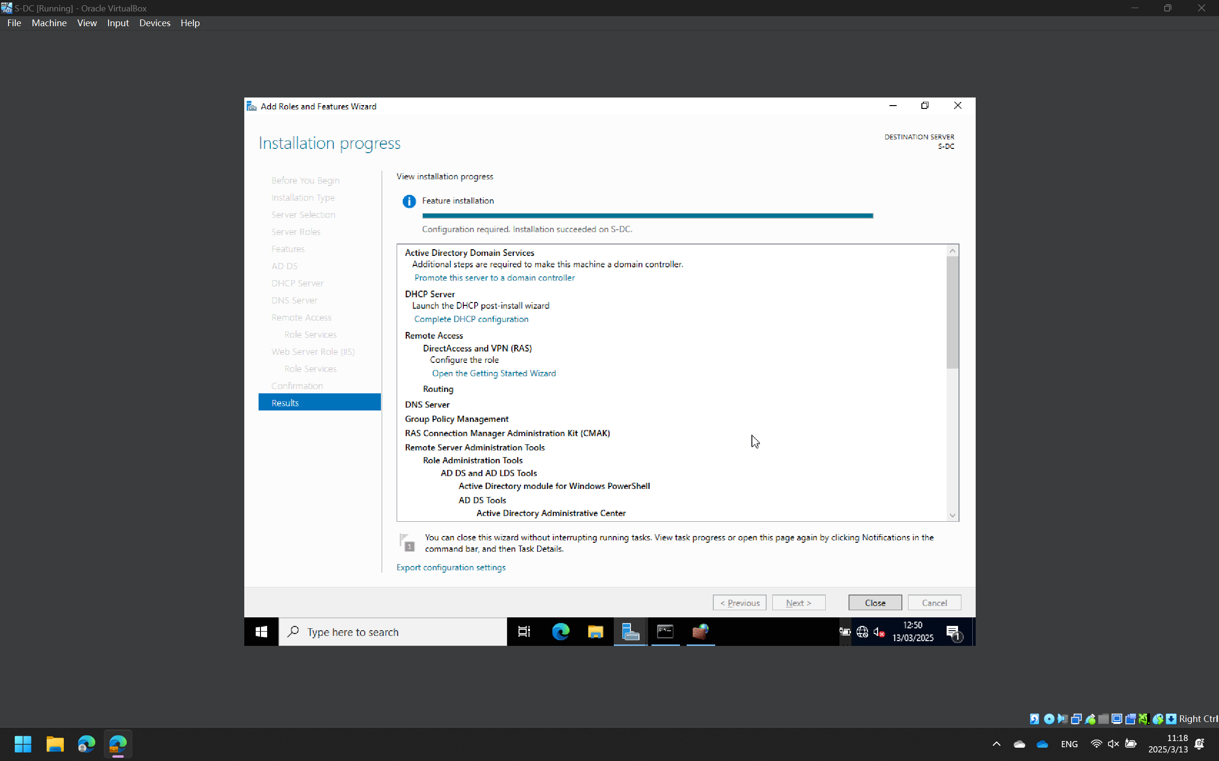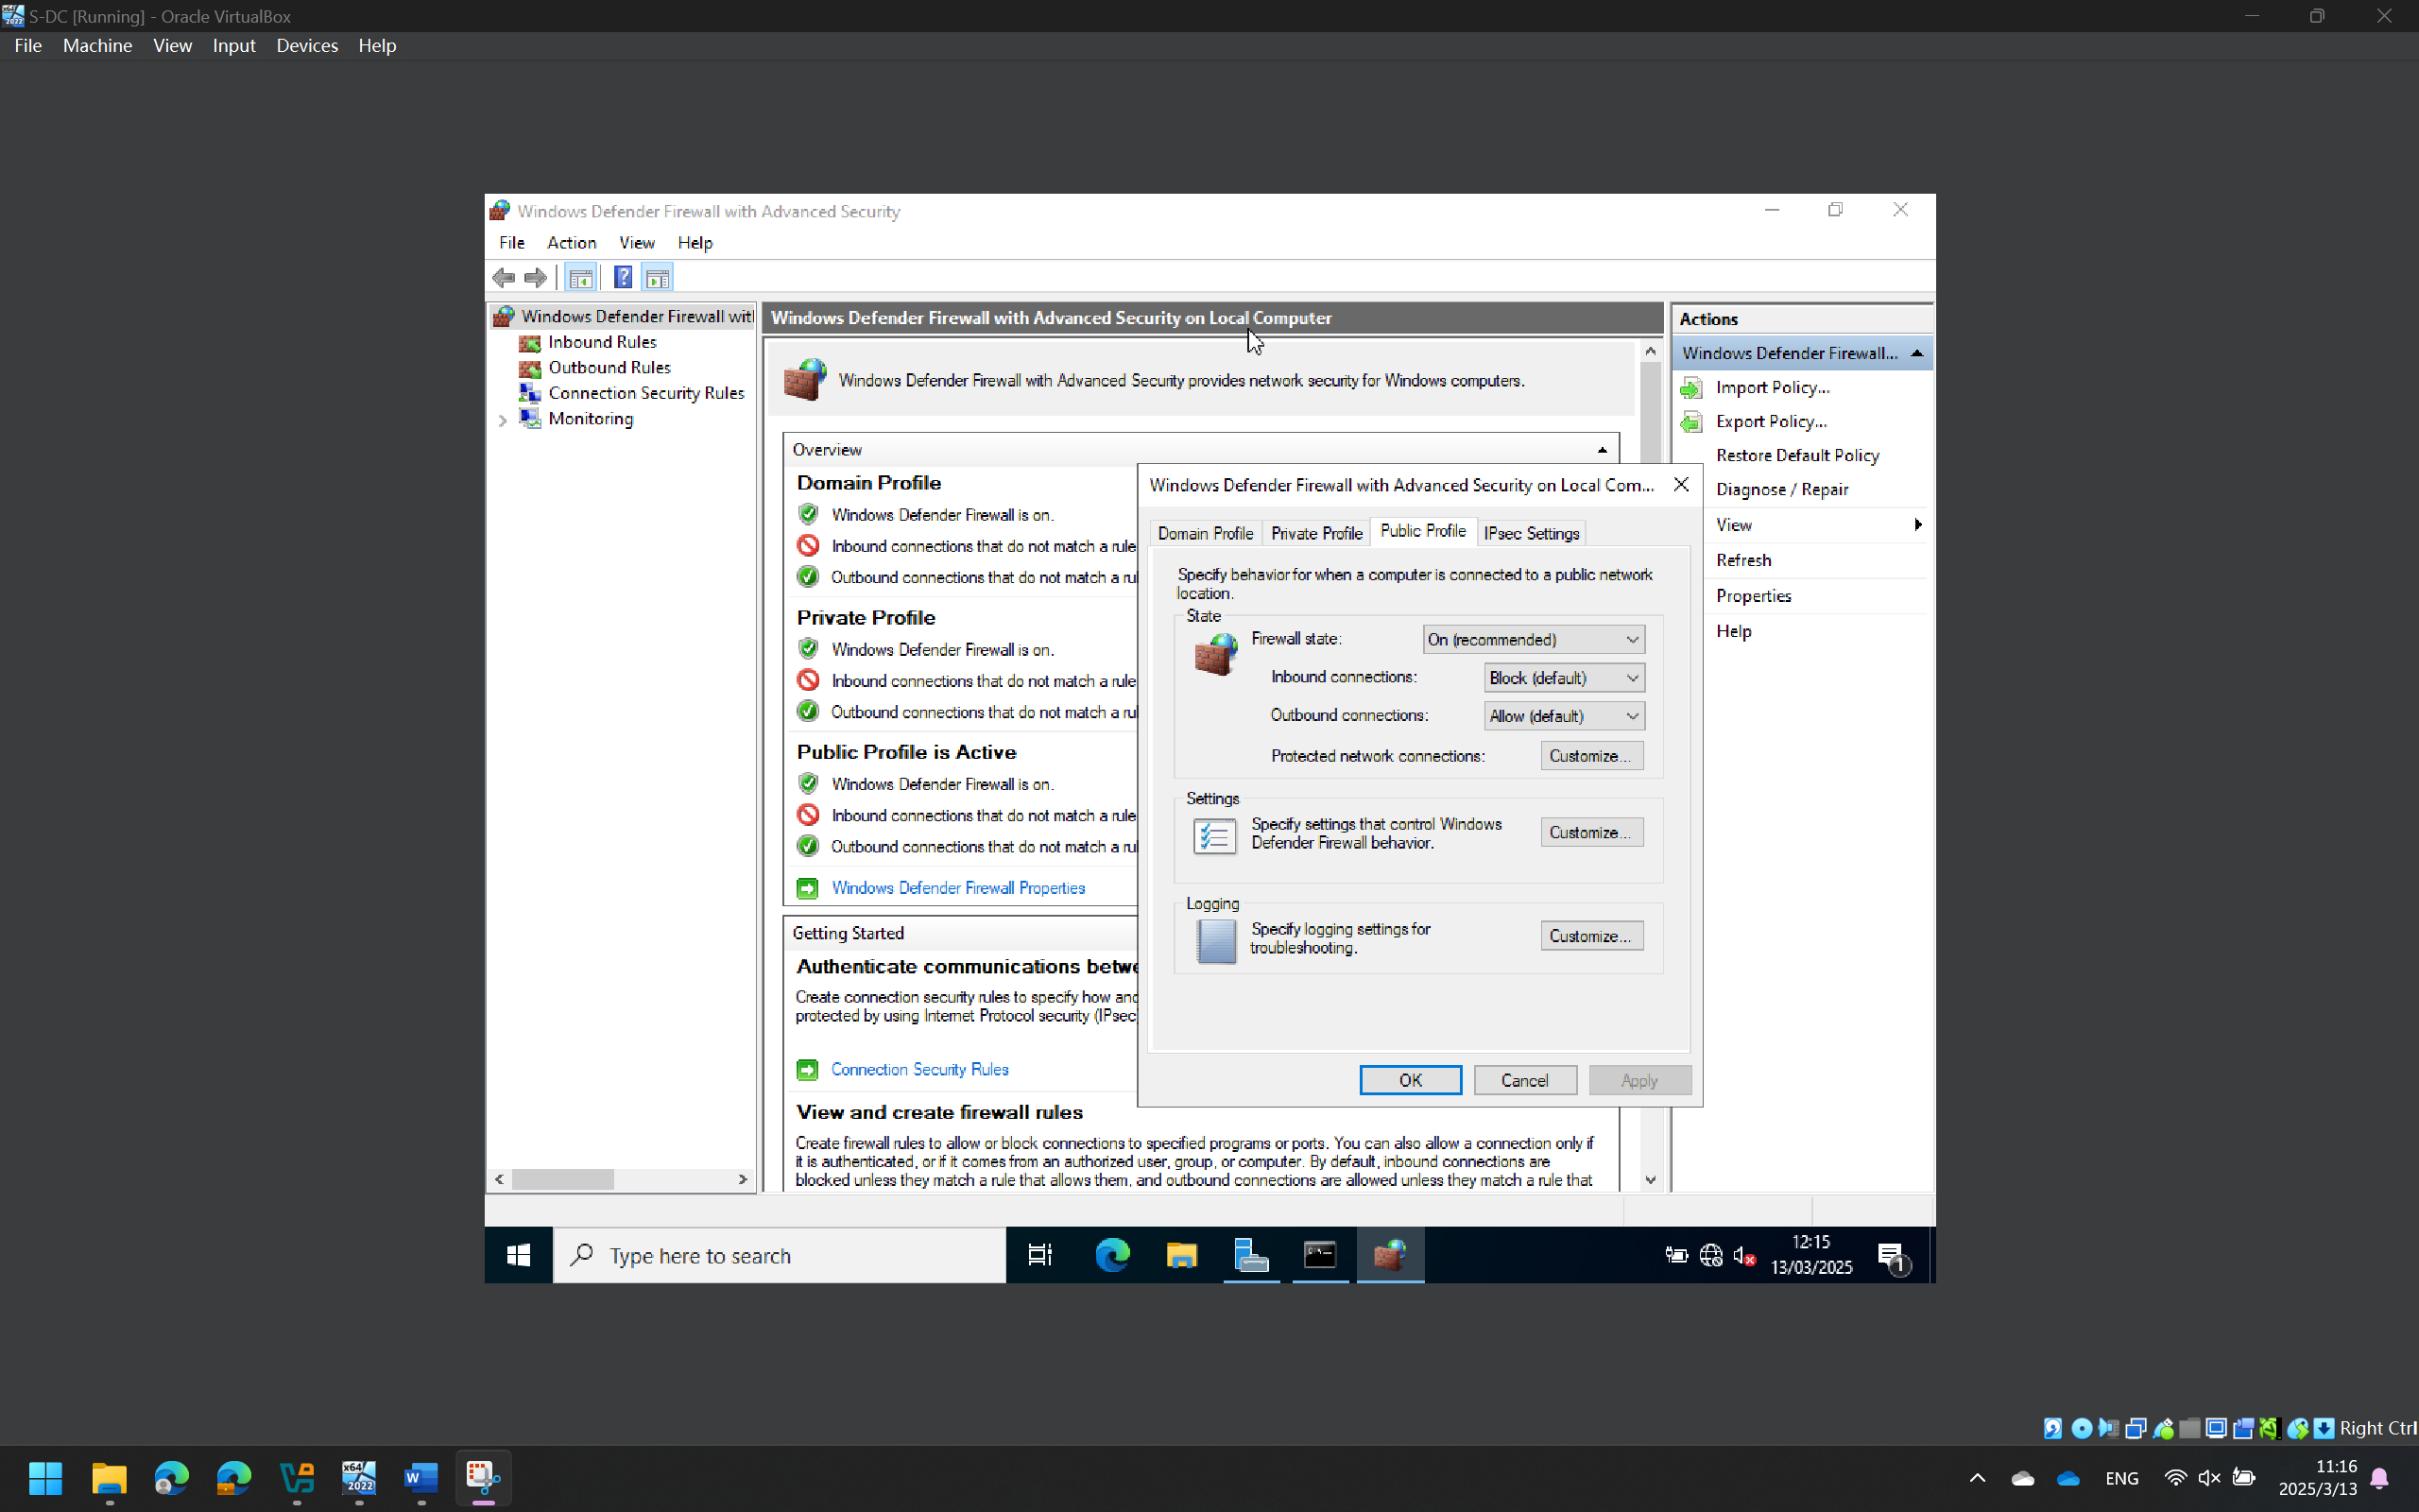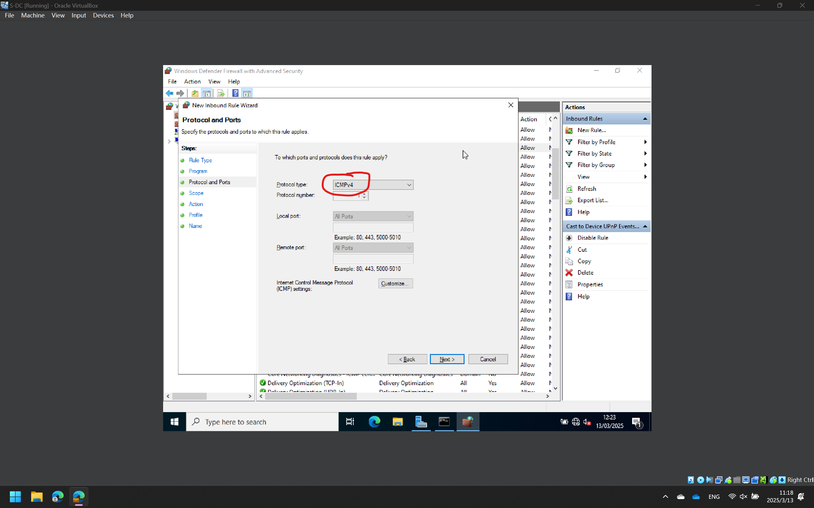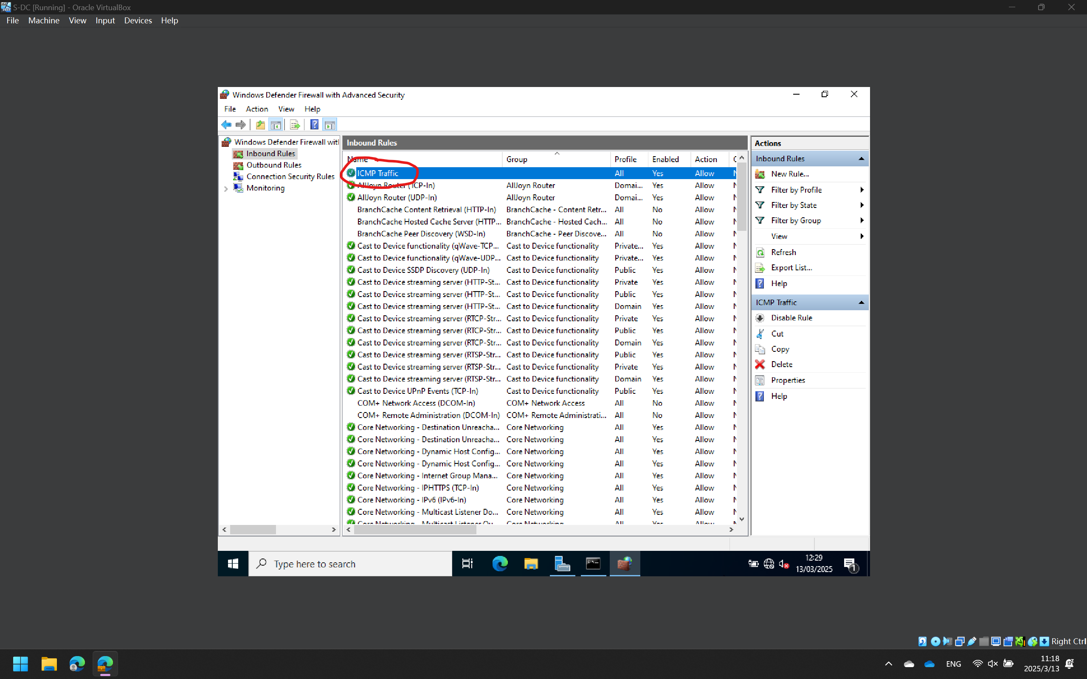

Set up a CServer Network site-to-site virtual private network. Select "permanent connection" as the connection type.
Add the RRAS role
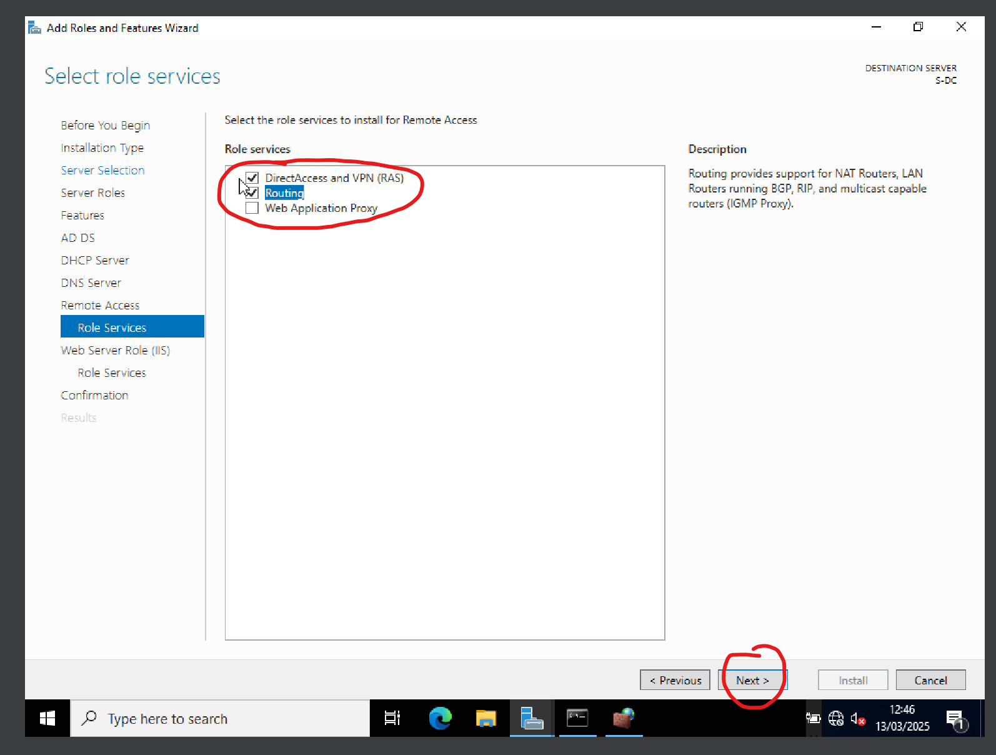
Configuring RRAS to Enable VPN
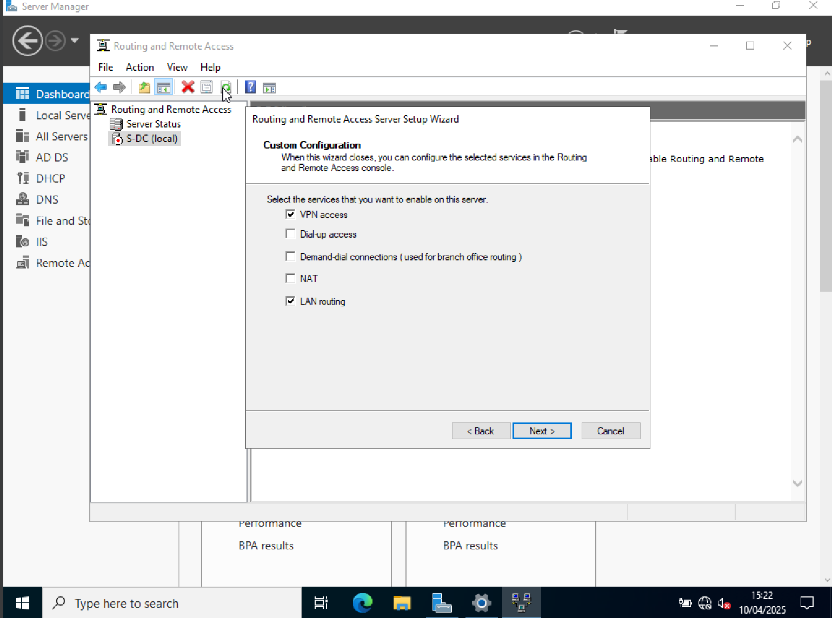
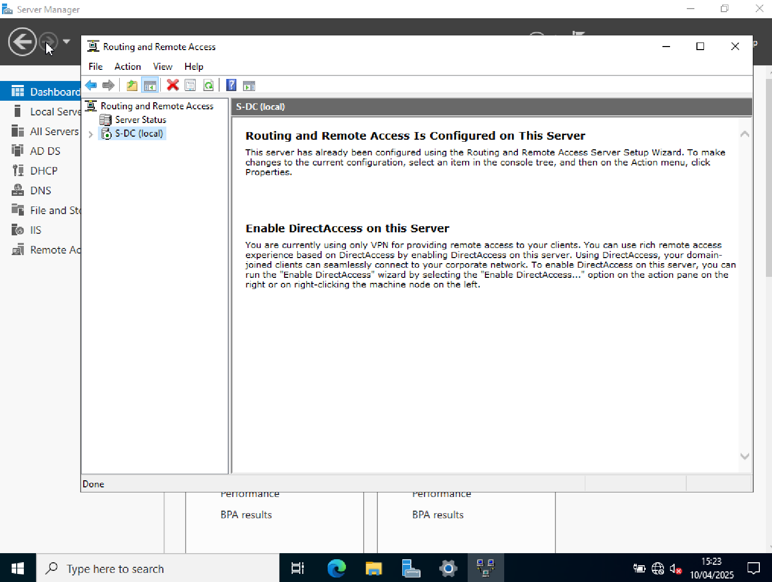
Configuring VPN Interfaces (Site-to-Site VPN)
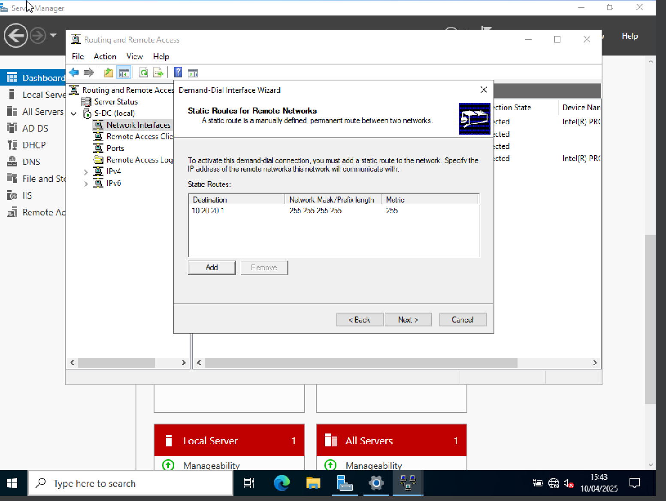
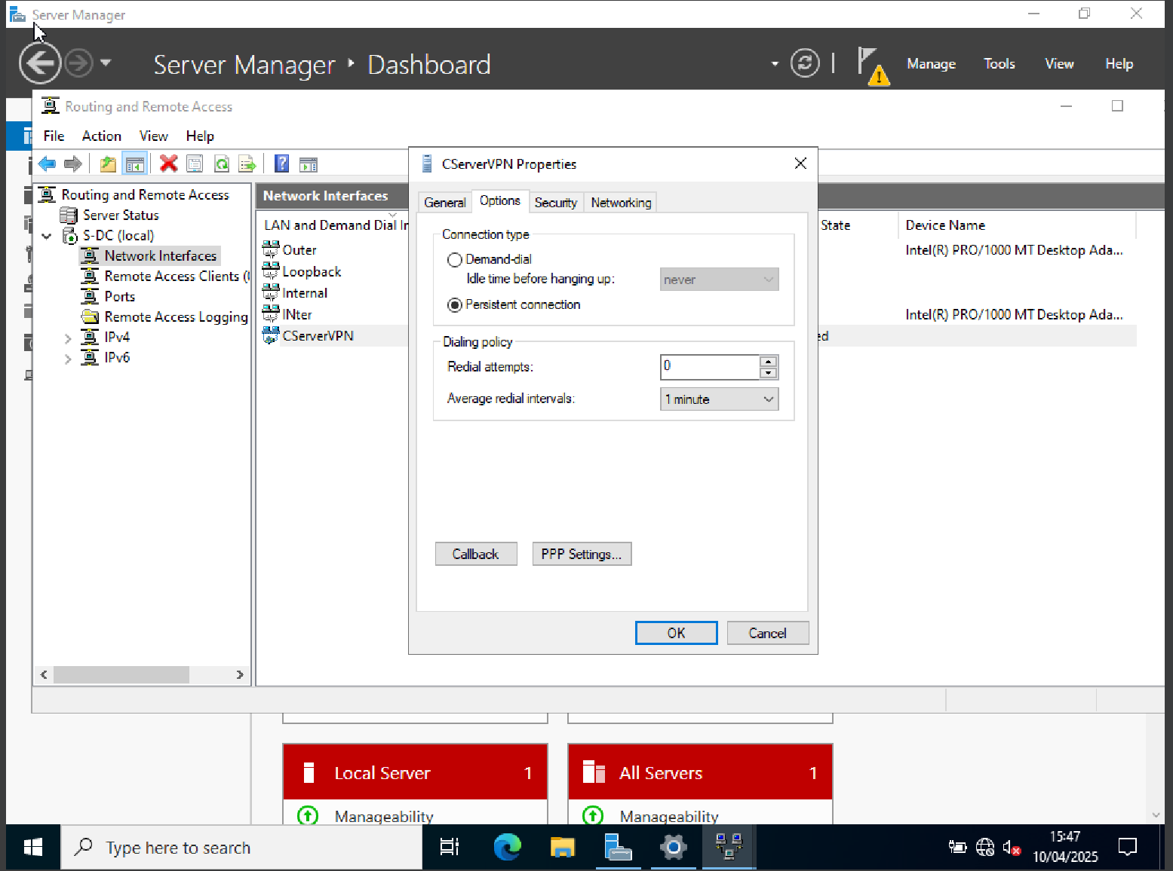
The Routing and Remote Access Service (RRAS) was used to set up a site-to-site VPN on the S-DC server. With the VPN type set to IKEv2, a demand-dial interface called "CServer" was made and connected to the CServer site's public IP address. Redial settings were activated to guarantee constant connectivity, and the connection was set up to be persistent. By creating a virtual tunnel that facilitates inter-site routing and policy enforcement, this configuration enables secure internet connectivity between the local network and the distant London location.

Make the domian cheng.acca.
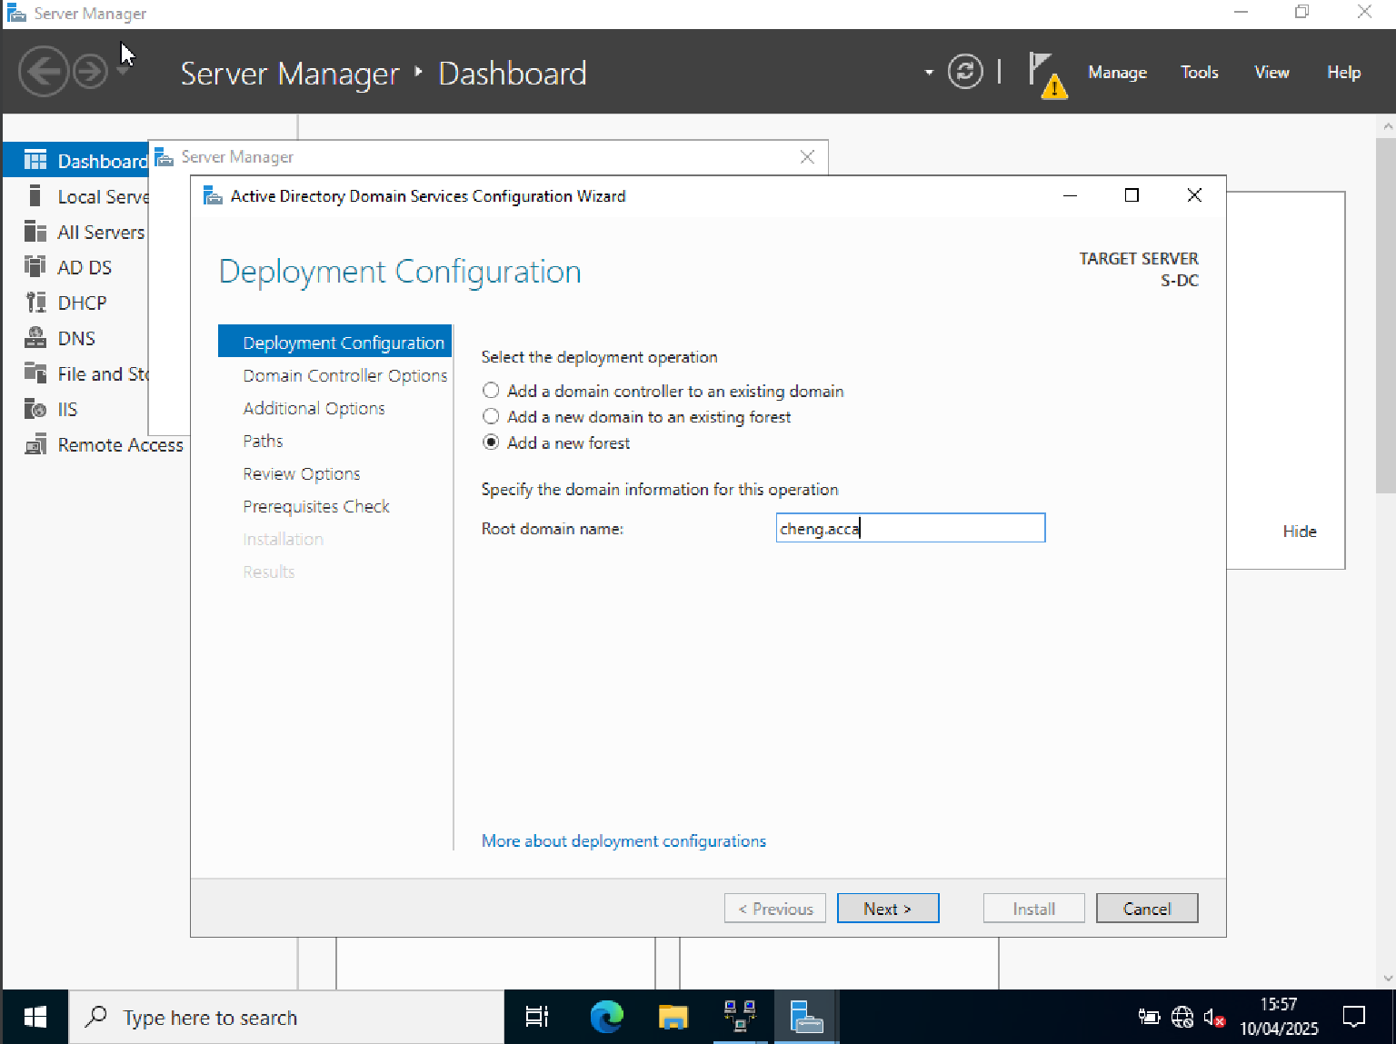
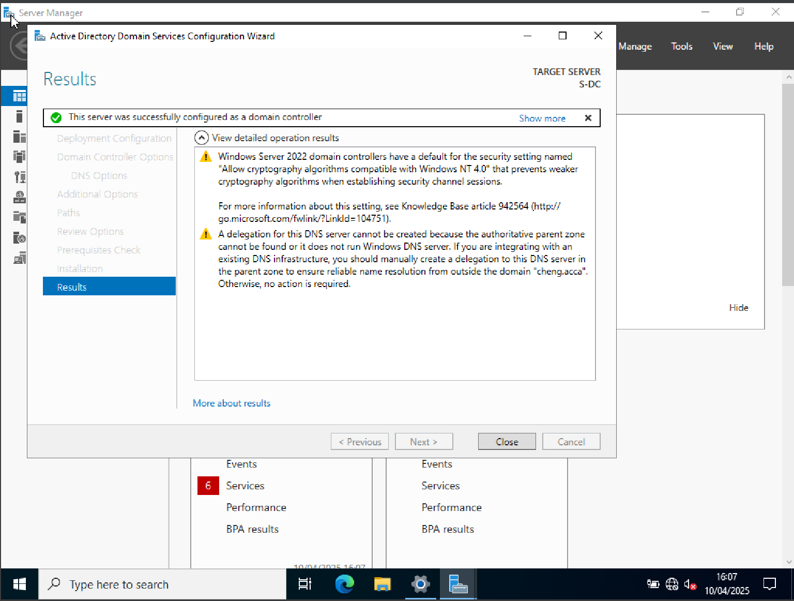
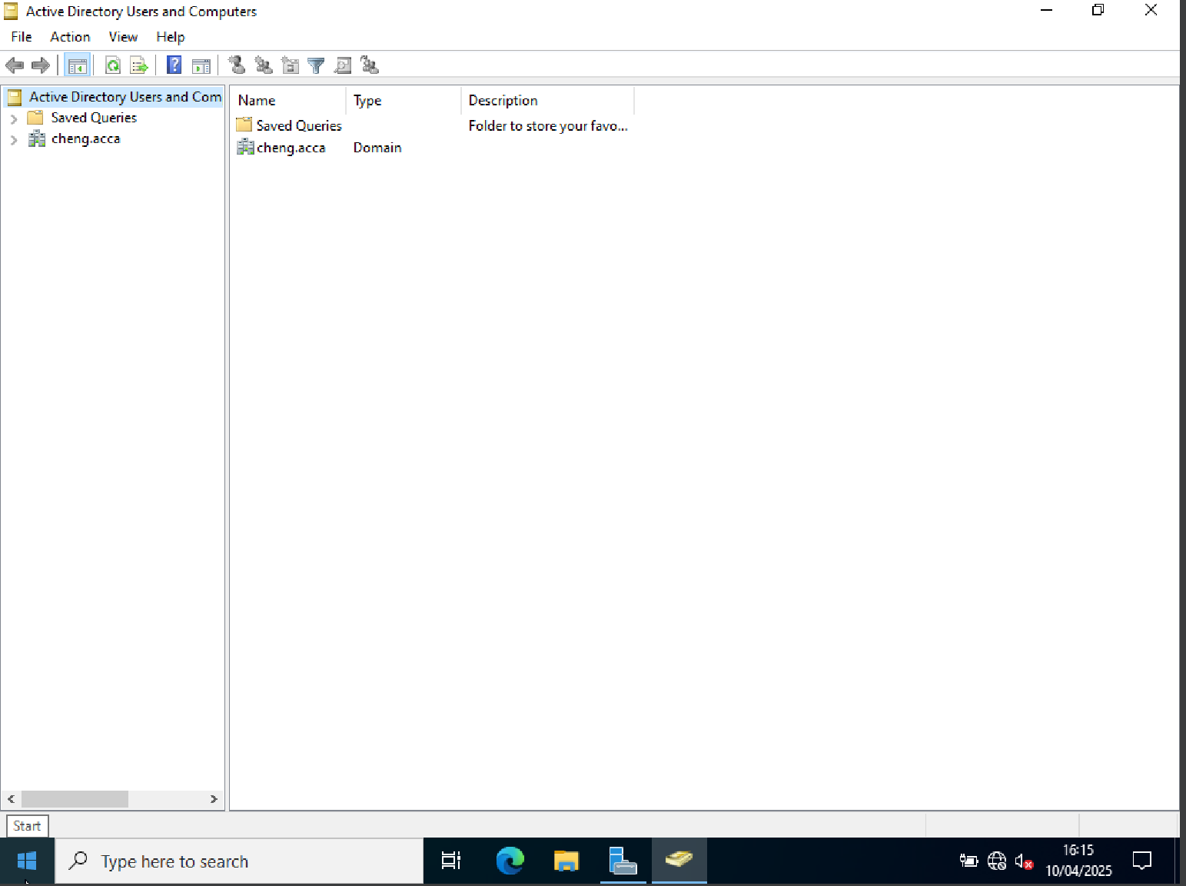
The S-DC Windows Server 2022 machine had Active Directory Domain Services installed and set up. With the root domain cheng.acca, a new forest was established, signifying a scalable and safe directory environment. With the necessary Domain Services Restoration Mode (DSRM) password set up for recovery scenarios, the server was marketed as the first domain controller in the new forest. The Active Directory Users and Computers console was used to confirm the domain structure following a successful reboot.

For every server on 10.20.20.1/24 and 192.168.20.0/24, create the necessary A records.
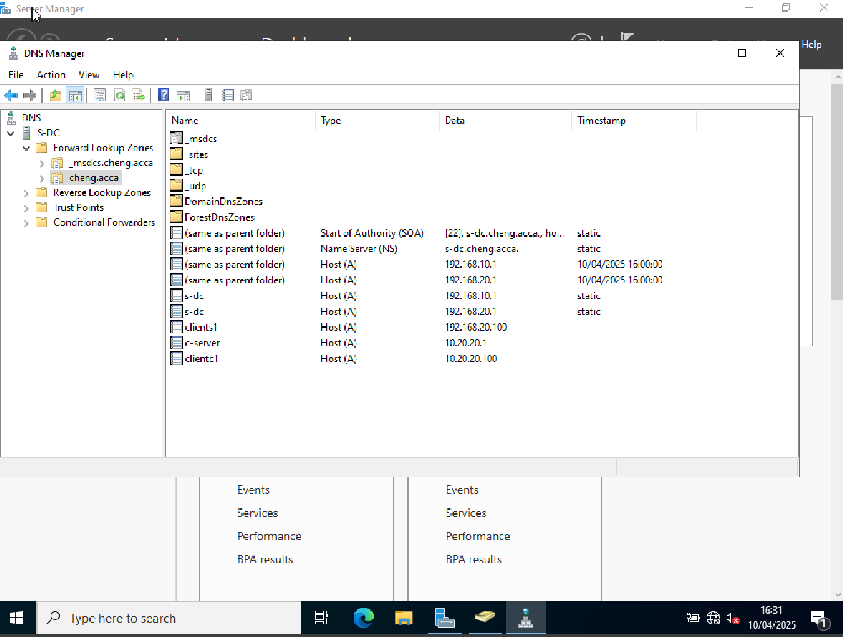
To enable name resolution for all servers and clients situated in the 192.168.20.0/24 and 10.20.20.0/24 networks, a record was manually generated in the DNS zone cheng.acca. To enable domain-joined systems to find resources by Fully Qualified Domain Name (FQDN), each host was given a unique name and IP address mapping.

Make PTR records for every server in a reverse lookup zone.
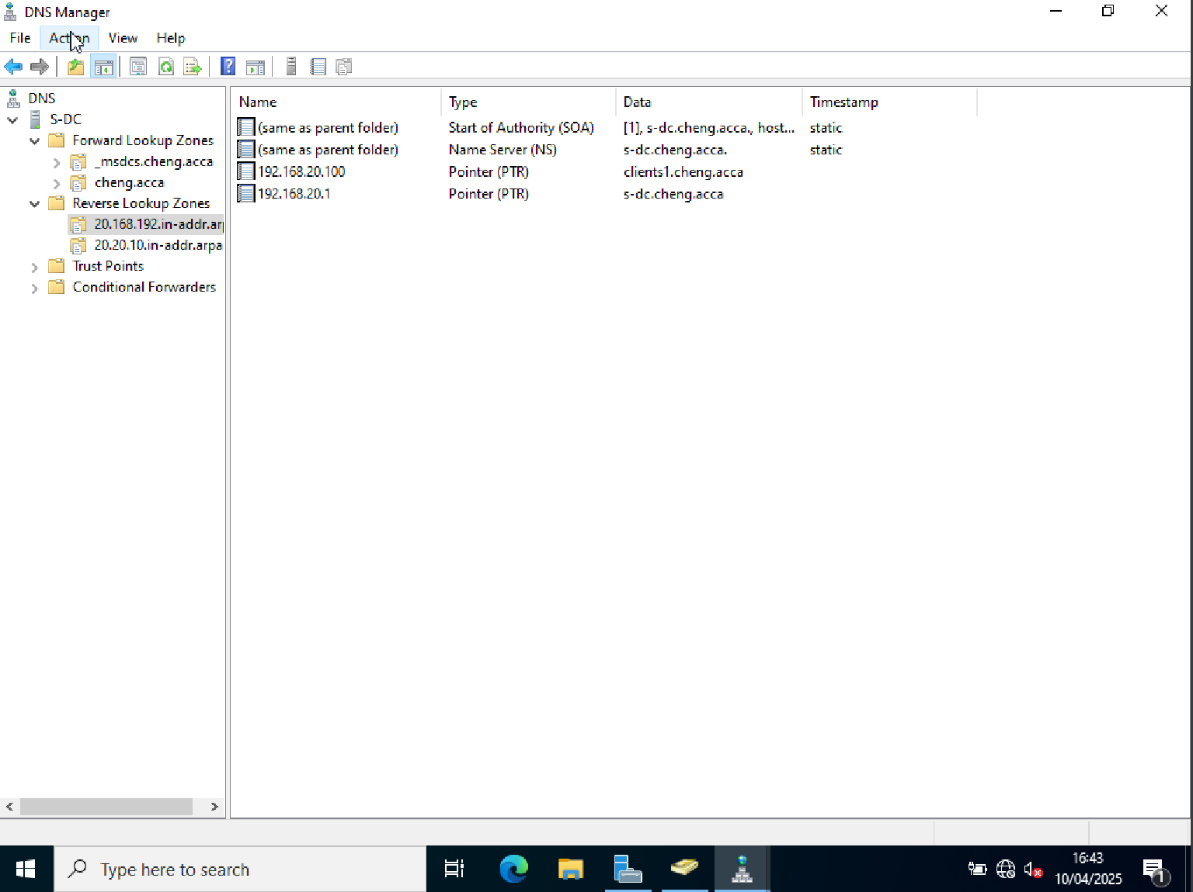
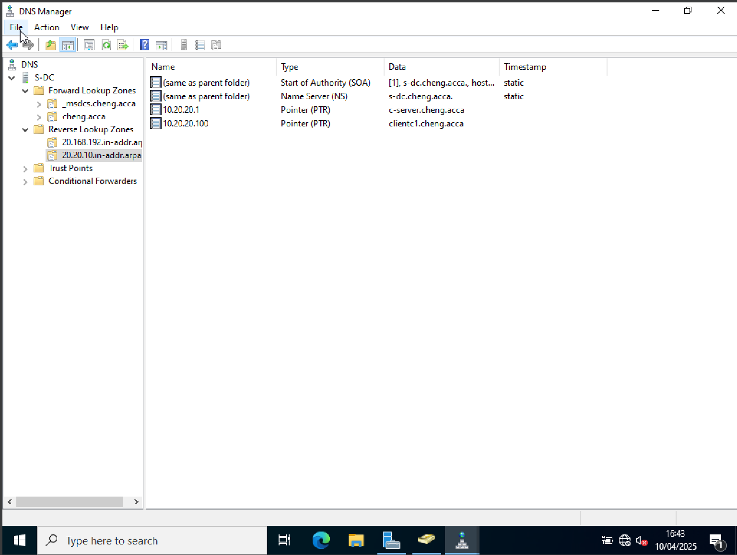
In the DNS server, reverse lookup zones were established for the 192.168.20.0/24 and 10.20.20.0/24 networks. To enable IP-to-hostname resolution for every server on the network, PTR entries were manually inserted. Backward DNS lookups are made possible by this setting, which is necessary for enhanced traceability and for some services.

Make user accounts for the domain cheng.acca.
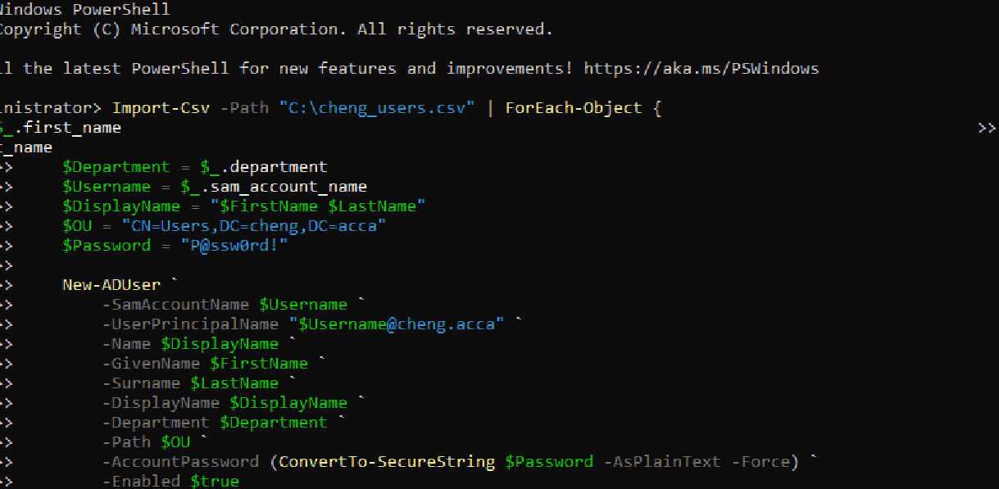
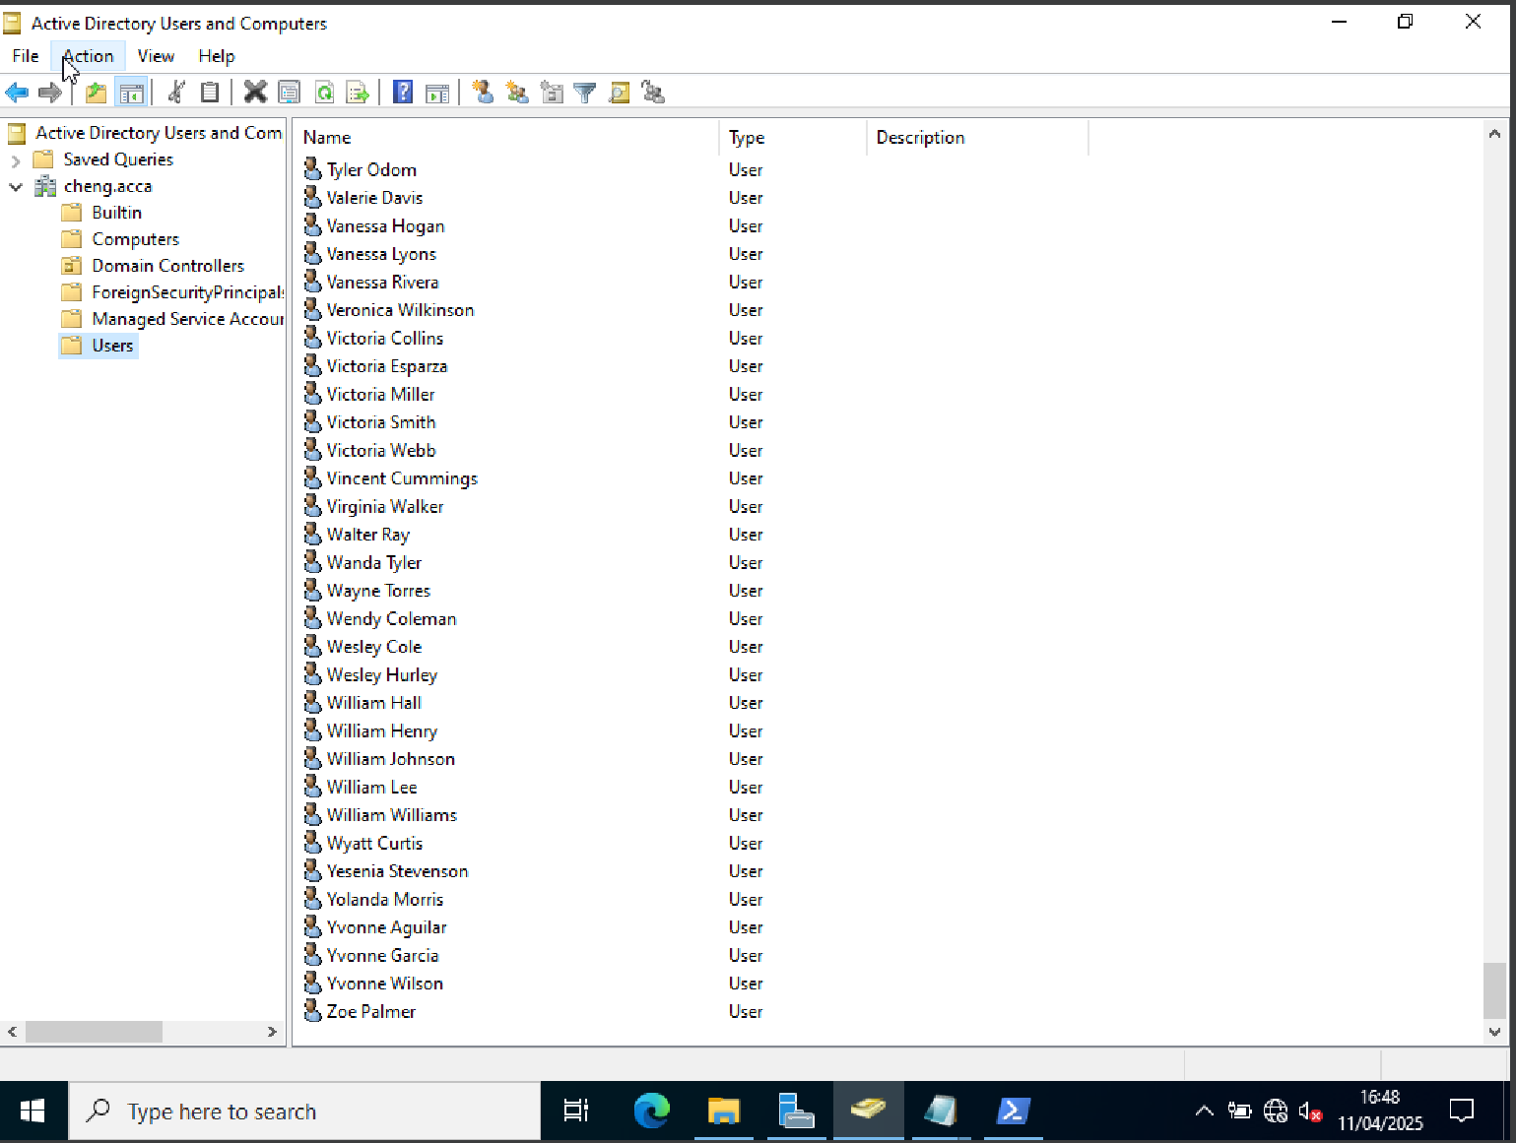
The data in the cheng_users.csv file was used to establish user accounts on the cheng.acca domain. A consistent format that combined the first initial and entire last name was used to name each account. The entire user creation procedure, including assigning organizational units, establishing display names, and applying safe passwords, was automated using a PowerShell script. Active Directory tools were used to successfully verify the accounts.

The second disk drive should be mounted at D:\SwanseaFile
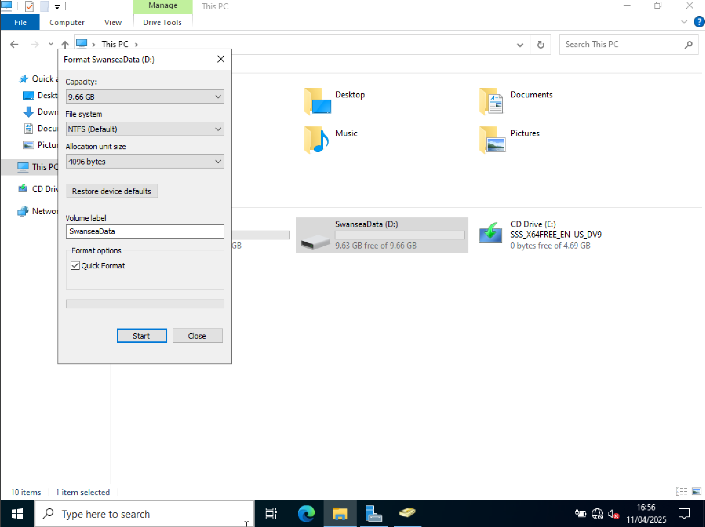
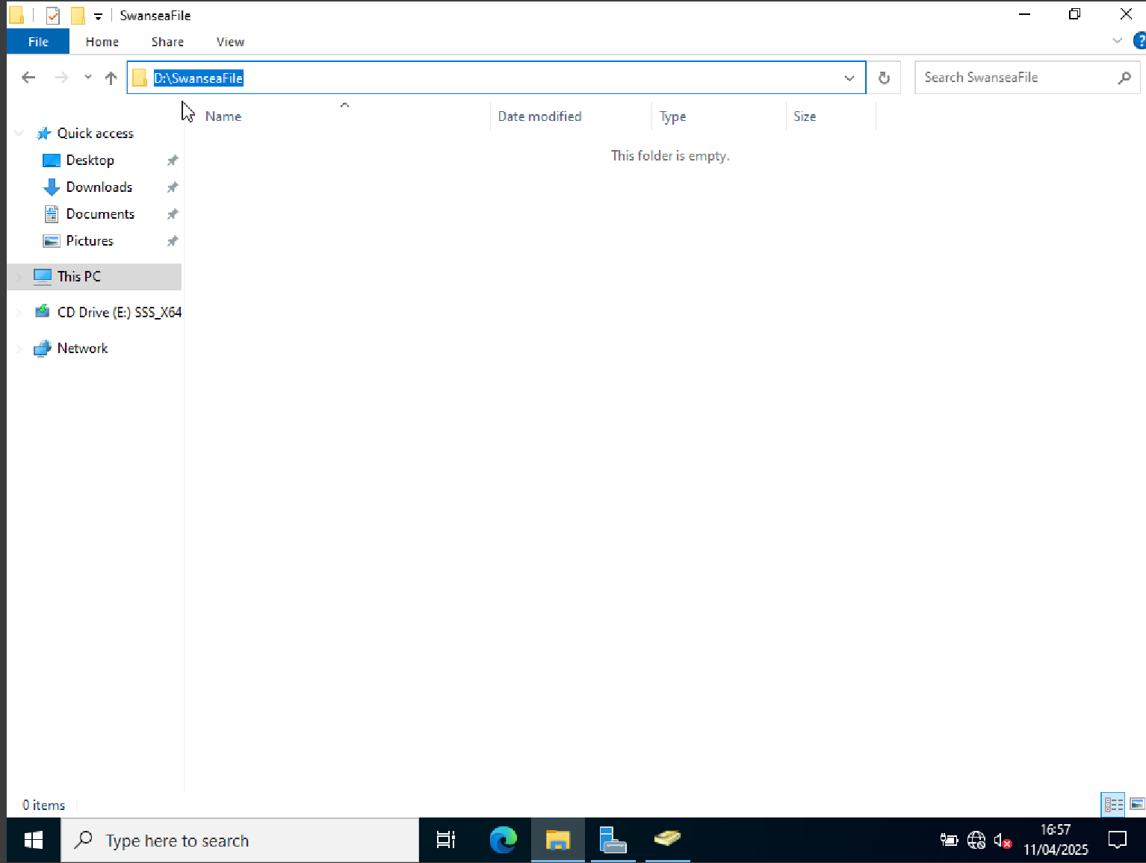
The second disk drive is initialized and formatted using the NTFS file system and then mounted to the directory path D:\SwanseaFile.

Set up the DHCP services. 192.168.20.1 to 192.168.20.100 is the range. Find additional DHCP choices based on the infrastructure.
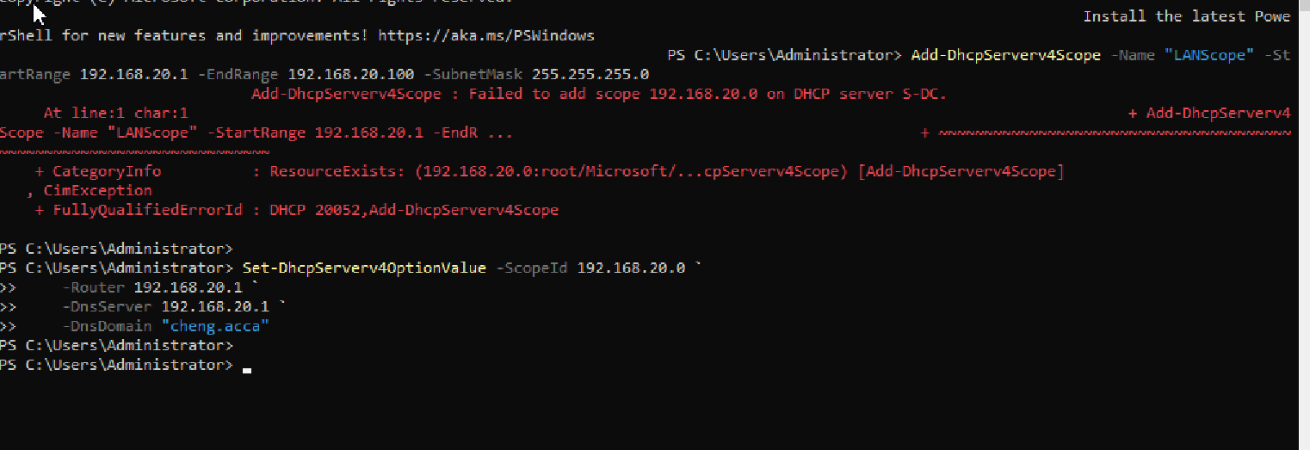
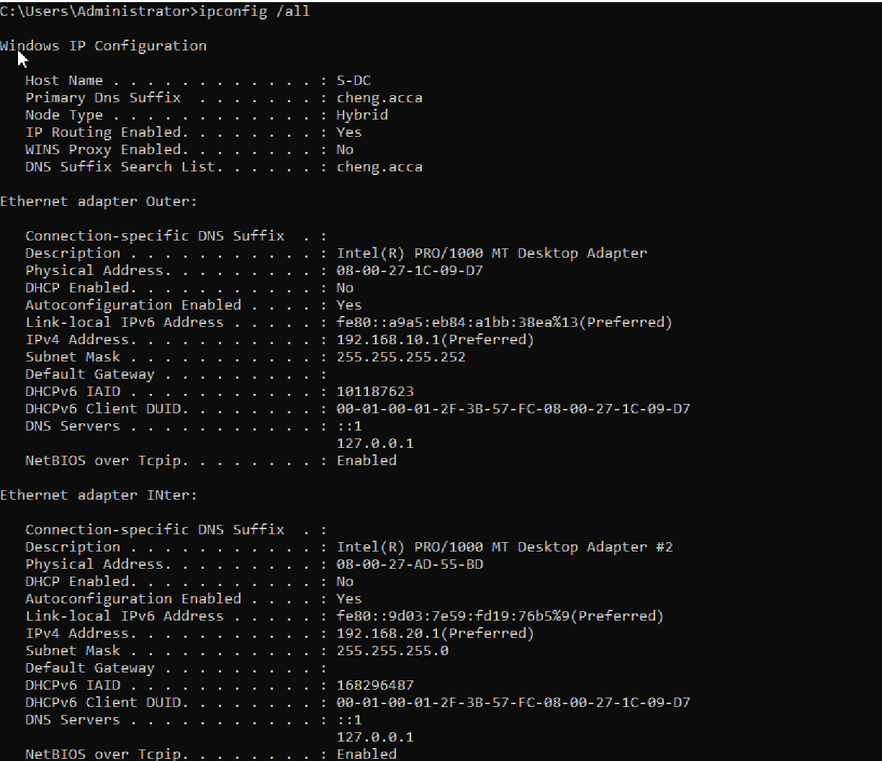
S-DC's DHCP server was successfully set up with a working IPv4 scope that was between 192.168.20.1 and 192.168.20.100. The default gateway, DNS server, and DNS domain suffix (cheng.acca) were among the DHCP parameters that were used. The server interface settings were checked to confirm the validation, and a client computer that successfully received dynamic network parameters via DHCP was used for additional verification.
Join the ClientS1 to chang.acca domain.
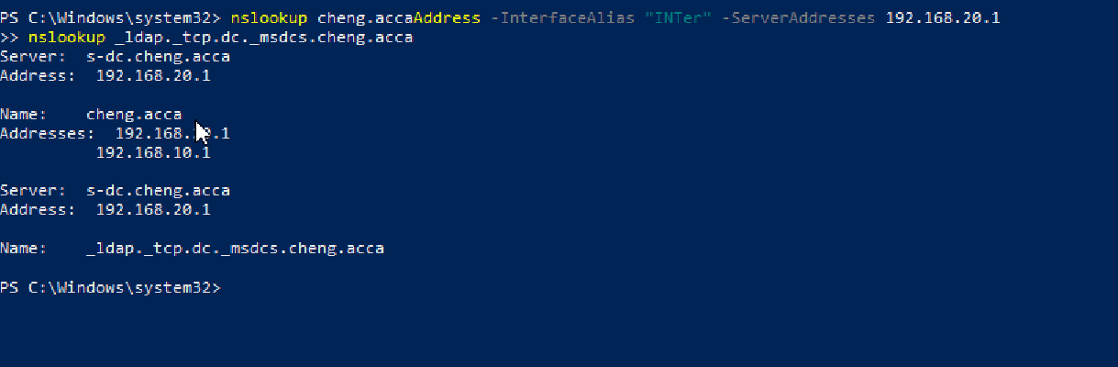
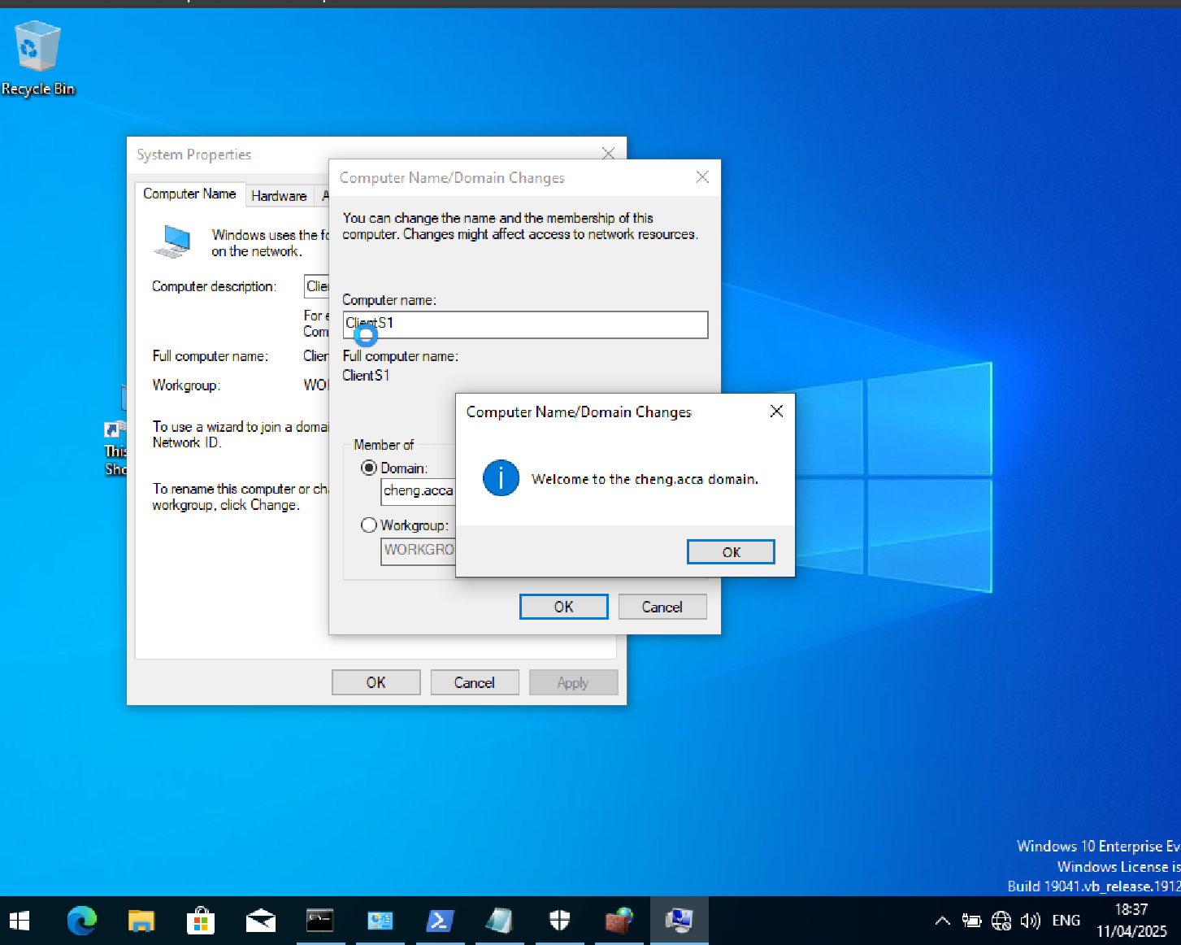
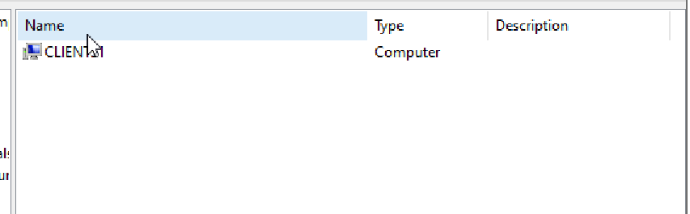
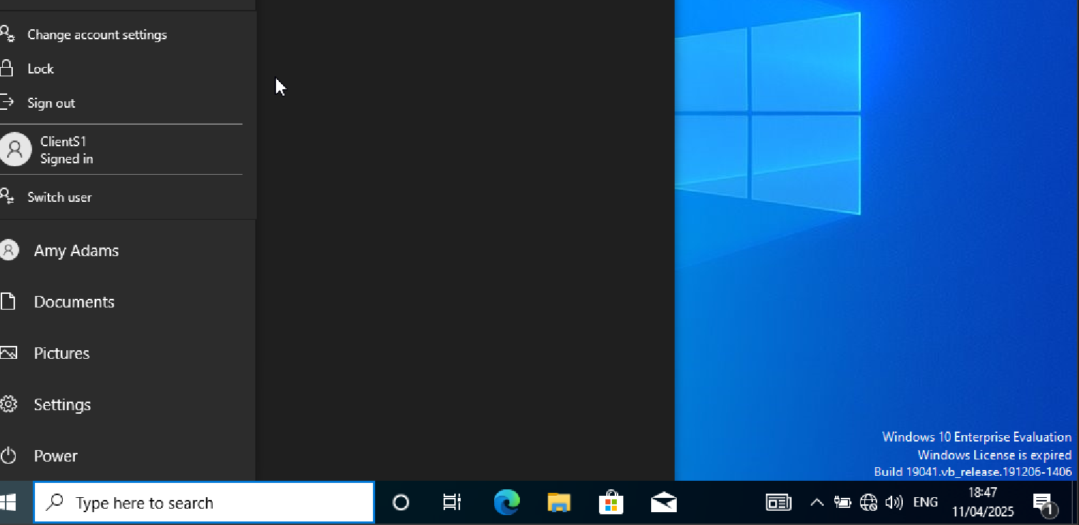
The cheng.acca domain was successfully connected to the ClientS1 computer. The DNS settings were set up to point to the domain controller (192.168.20.1) before joining. After utilizing domain administrator credentials to finish the domain join process, the system was rebooted. Successful domain integration was confirmed when the client was able to authenticate using domain credentials after rebooting.

Assign a DHCP IP address to Client S1.
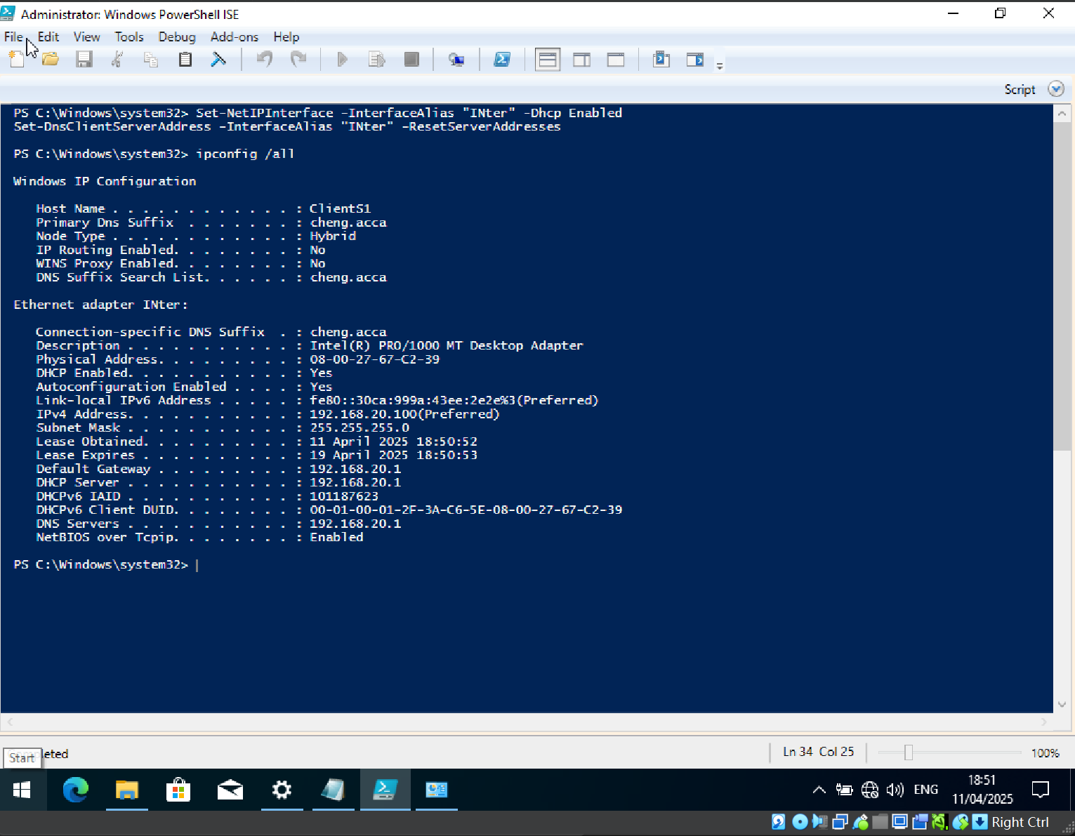
DHCP was successfully set up for IP addressing on ClientS1. The S-DC DHCP server (192.168.20.1) provided the computer with an IP address of 192.168.20.100 in addition to the default gateway and DNS configurations. Full integration into the cheng.acca domain environment was made possible by the setup being validated with ipconfig /all, which verified that DHCP and DNS parameters were received appropriately.

Add roles and features
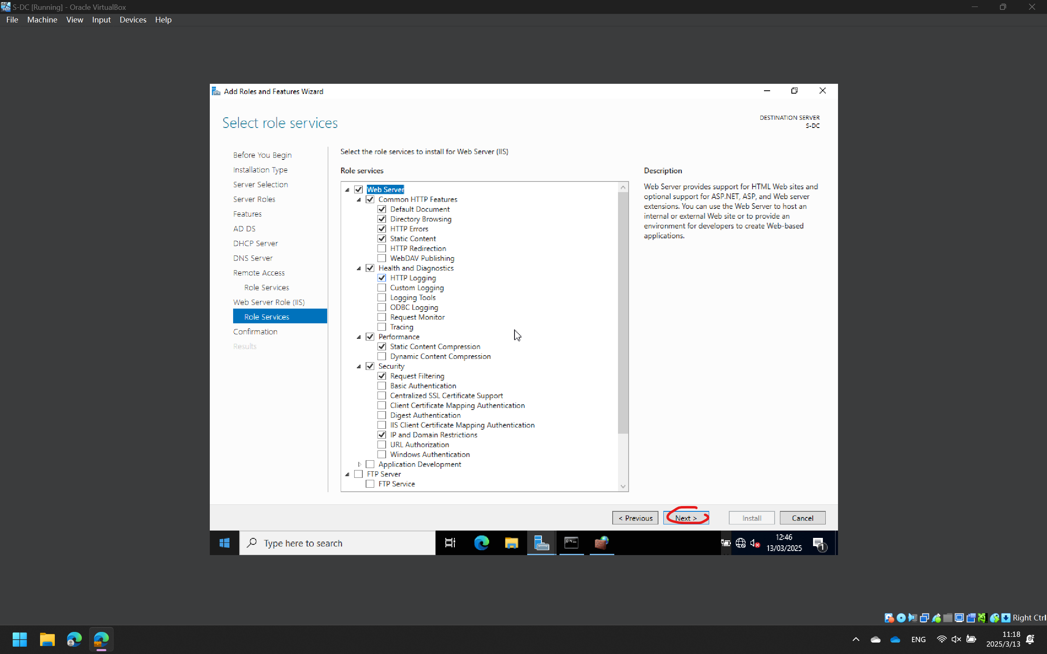

DNS
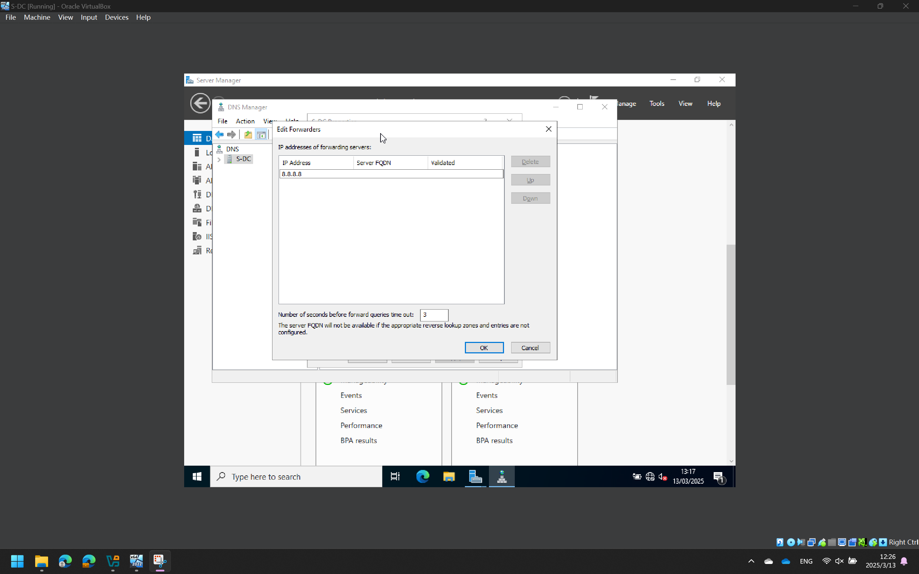
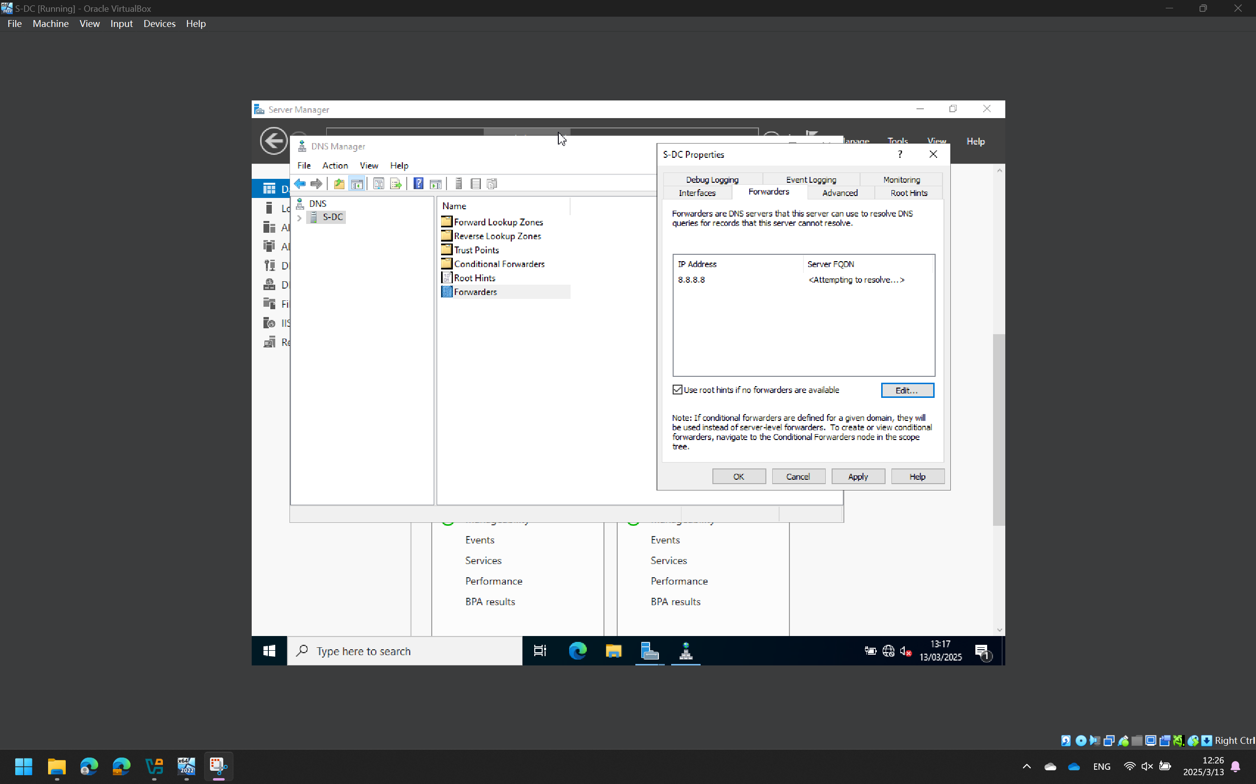

Cardiff Network
Install the equivalent of Routing and Remote Access Service and change firewall rules to permit ICMP traffic.
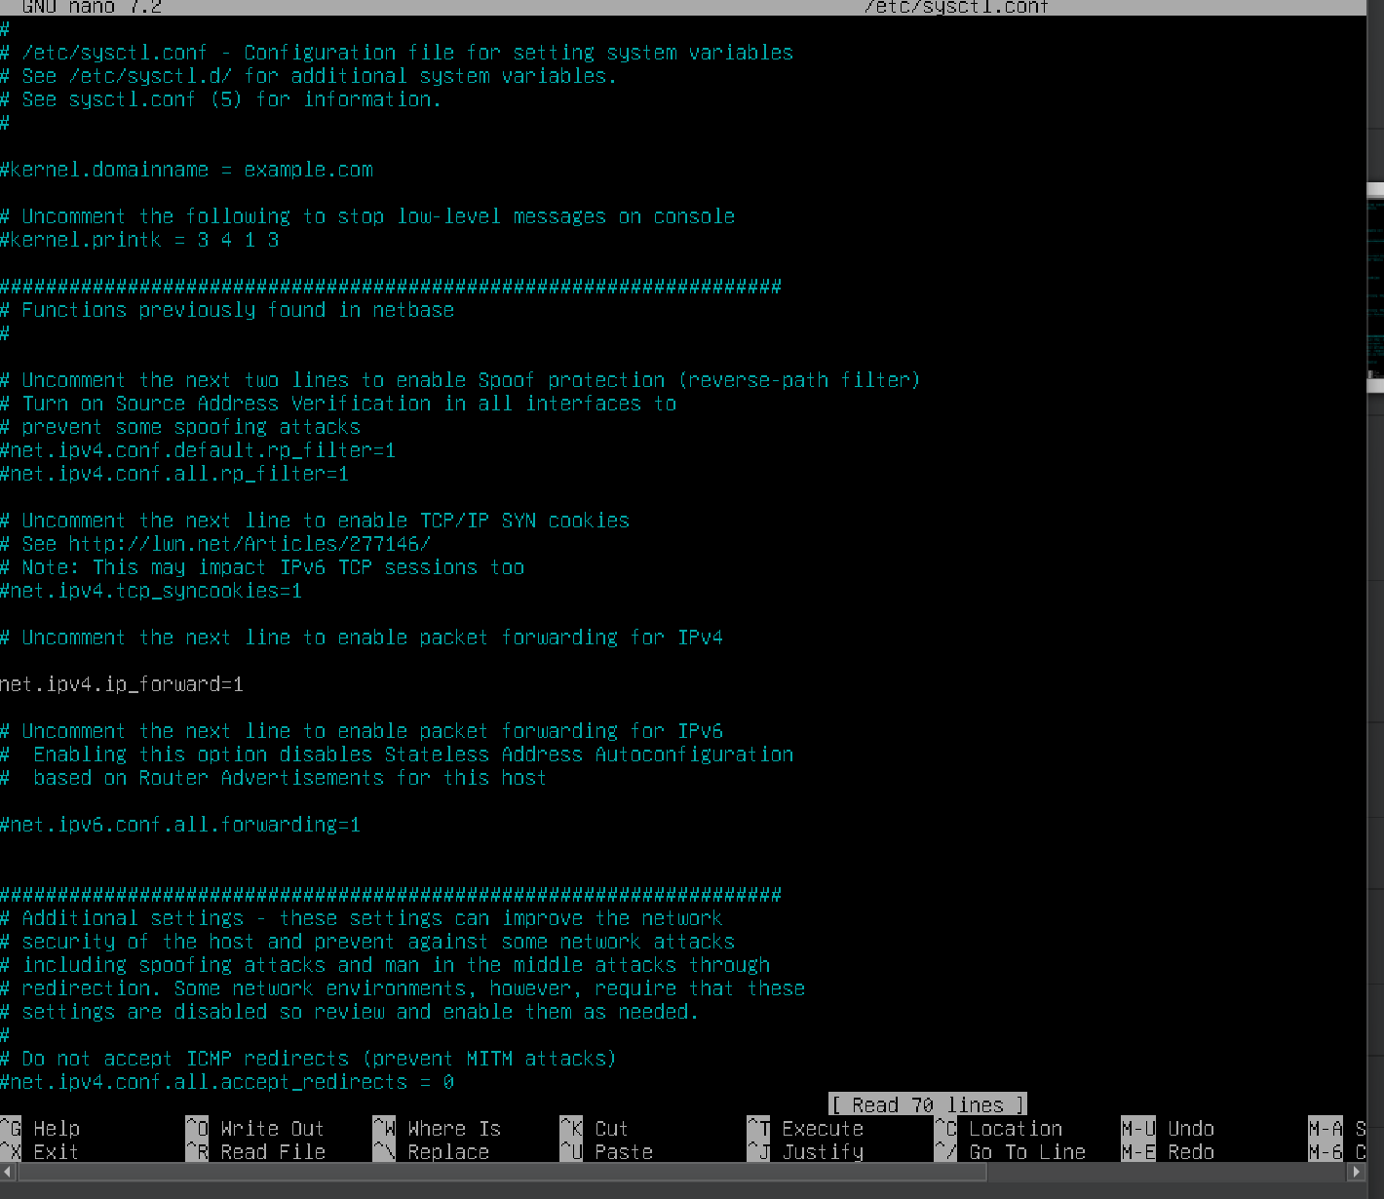
Configuring `iptables` and enabling IP forwarding on the Linux side can accomplish the equivalent installation of the Routing and Remote Access service. To do this, first edit `/etc/sysctl.conf` to enable `net.ipv4.ip_forward=1`, and then use `iptables` to set forwarding rules. To enable ICMP communication, open ICMP type packets through `iptables`, for instance, `iptables -A INPUT -p icmp --icmp-type echo-request -j ACCEPT`. Once this is done, basic routing and remote access functions can be accomplished.

Set up Swansea Network's site-to-site virtual private network. Select "permanent connection" as the connection type.
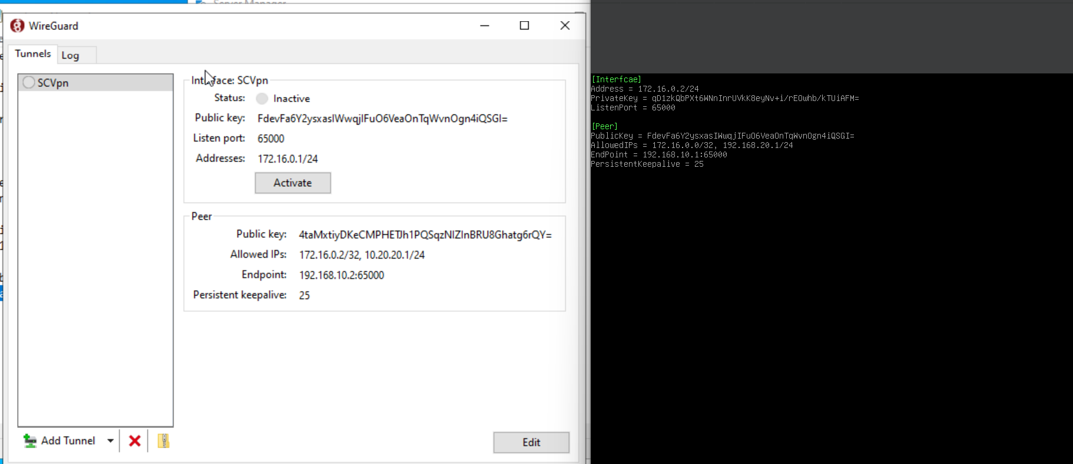
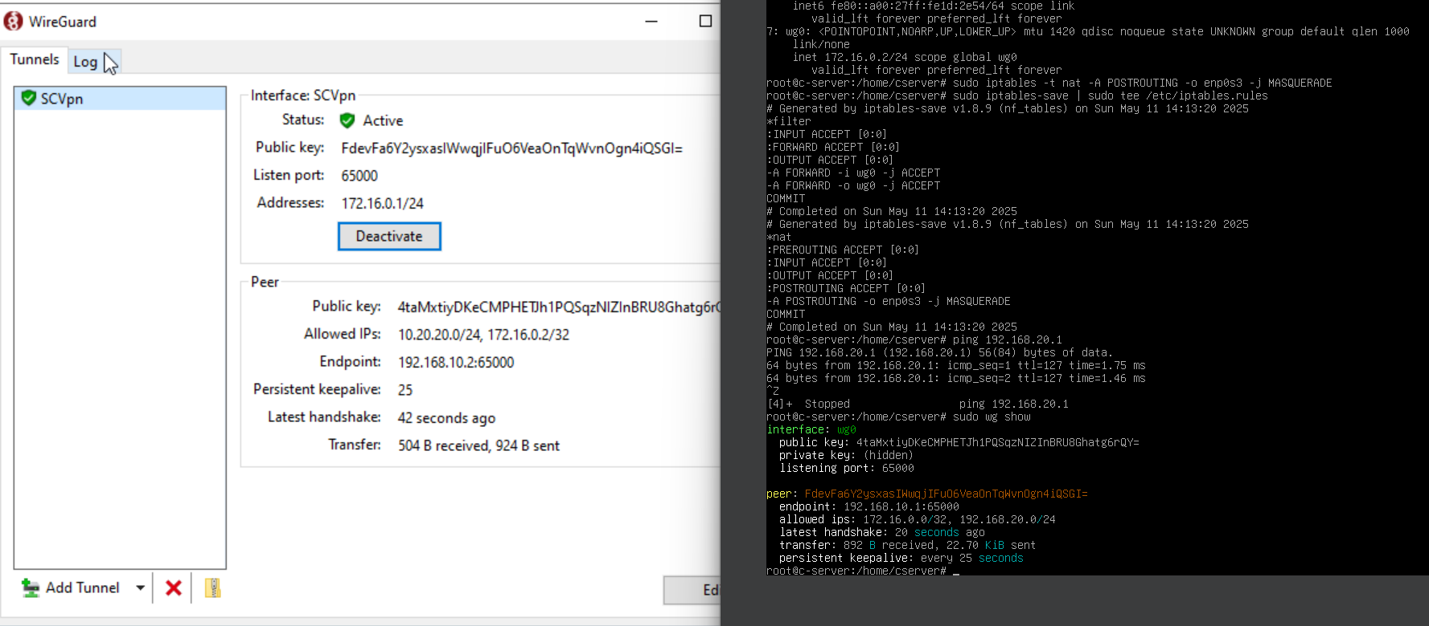
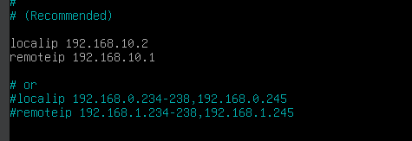

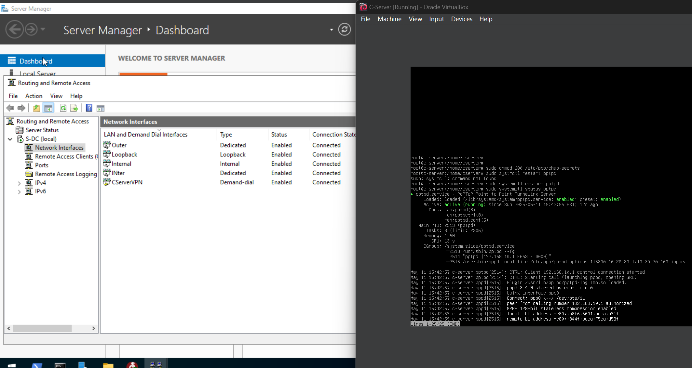
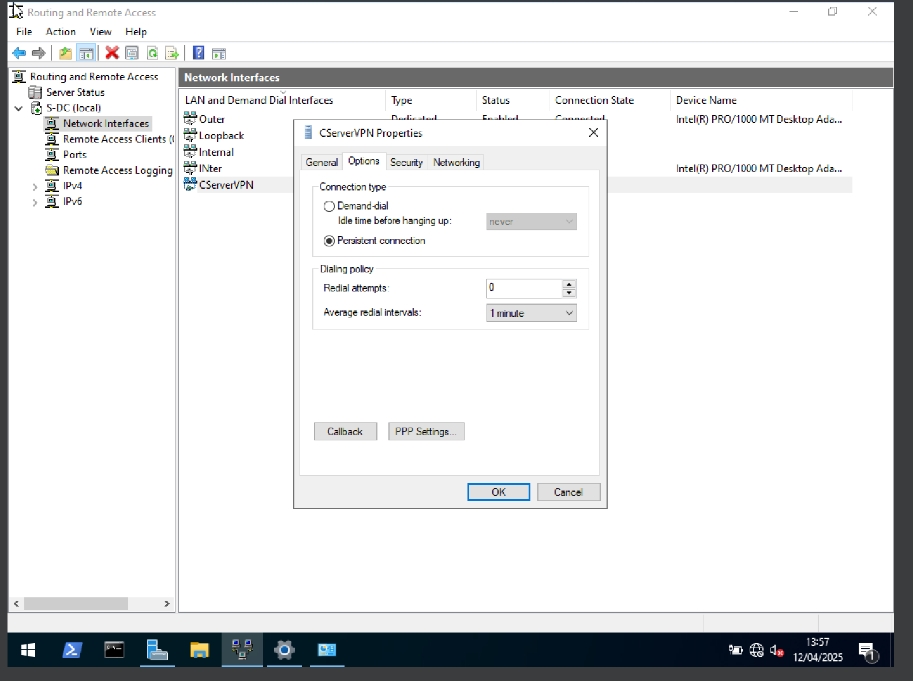
To establish a long-term connection to the Swansea network, set up site-to-site VPN on Linux and using WireGuard. To implement routing forwarding, create key pairs on both ends, set up the wg0.conf file, and activate net.ipv4.ip_forward. To establish a persistent connection, set the connection to begin automatically at boot (systemctl enable wg-quick@wg0). Lastly, to accomplish safe and reliable cross-site communication, permit VPN traffic via iptables and verify compatibility.

Connect devices to the cheng.acca domain within this network.
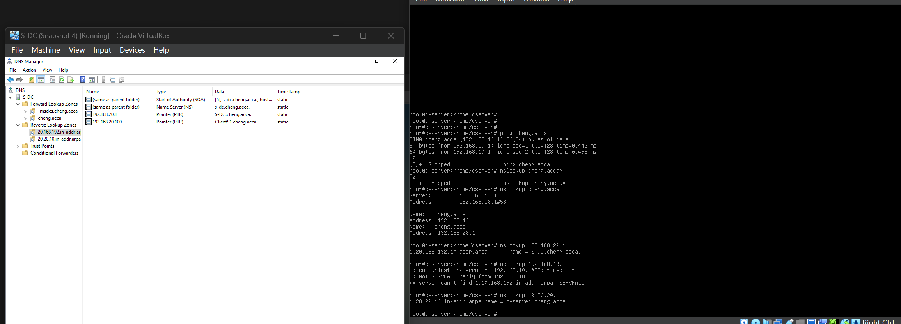
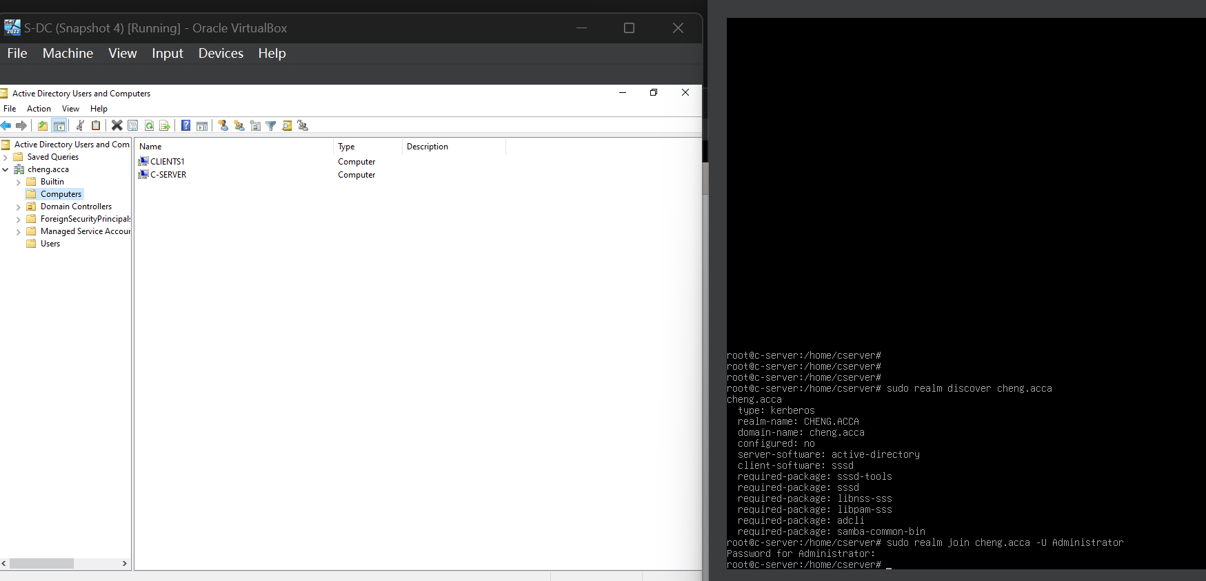
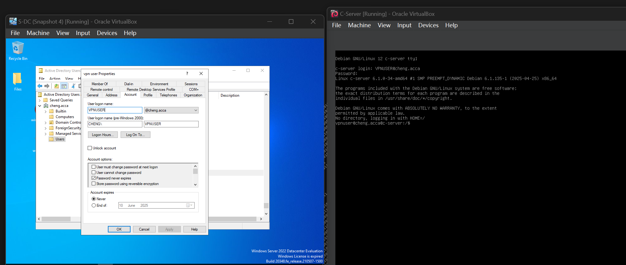
A crucial first step in creating centralized identity, security, and administrative control is integrating every device in the network into the cheng.acca domain. Using Active Directory Domain Services (AD DS) on a Windows server, the cheng.acca domain enables simplified network-wide management of people, devices, policies, and security settings. This is especially crucial in an enterprise or multi-site network setting, such as Swansea's site-to-site VPN arrangement, where smooth communication and uniform access controls are necessary.

Each computer was set up to utilize the domain controller's IP address as its primary DNS server to link Windows devices to the domain. This guarantees that domain names are resolved correctly. Each Windows client was then connected to the domain using domain credentials (often a domain admin account) via "System Settings" or sysdm.cpl. Rebooting the device and logging in with a domain user account verified that the domain join had been successful.

Tools like realmd, sssd, krb5-user, samba, and adcli had to be installed for Linux clients (like Debian) to integrate. The domain was joined using "sudo realm join cheng.acca -U administrator" after the DNS settings were pointed to the domain controller and precise time synchronization was confirmed (this is crucial for Kerberos authentication). By confirming that group policies could be searched and domain users could log in, the domain join was validated.

Justification:
- Centralized Management: Administrators can control software distribution, enforce Group Policies (GPOs), and universally define security settings on all PCs by joining devices to a domain.
- Enhanced Security: By eliminating the requirement for local user administration, domain-based logins improve security. The domain controller manages authentication, enabling password policies, account lockout rules, and multi-factor authentication.
- Source Access: By eliminating the need for re-authentication, users can access shared files, printers, and services across VPN-connected sites, increasing productivity.
- Scalability and Maintenance: Using AD to manage people and devices streamlines the onboarding, offboarding, and auditing procedures as the network expands.

Enforcing a professional IT infrastructure standard, improving security, and facilitating centralized, scalable network management by connecting all Swansea network devices to the cheng.acca domain guarantees that the network is prepared for future growth and complies with organizational IT policies.

Set up the DHCP services.
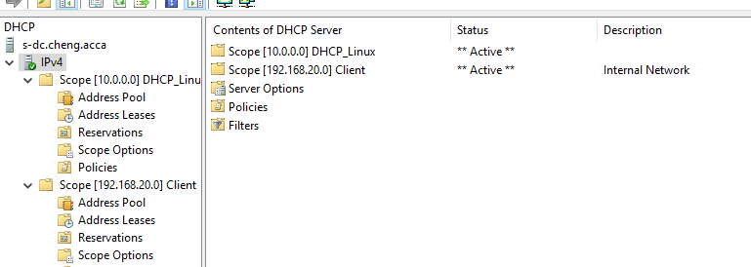
On the server s-dc.cheng.acca, the DHCP service was successfully set up to dynamically assign IP addresses to devices in two different network scopes. They are:

[10.0.0.0] Scope DHCP_Linux is probably reserved for infrastructure servers or Linux-based devices.
[192.168.20.0] is the range Client – only for internal network client devices.

Both scopes are active, according to the service status, indicating that DHCP is working and allocating IPs as intended. This configuration facilitates scalability and dynamic device connectivity within the domain-enabled network, lowers administrative cost, and guarantees automated, centralized IP management.

Assign the ClientC1 a DHCP IP address and connect it to the proper domain.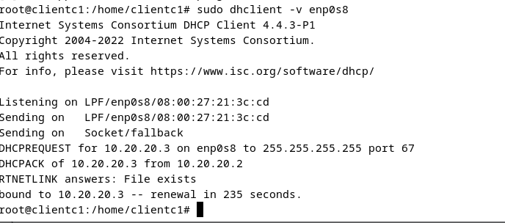
The server 10.20.20.2 successfully provided ClientC1 with a DHCP-assigned IP address 10.20.20.3, verifying correct network setup. The dhclient command on interface enp0s8 was used to do this. Additionally, the DHCP server supplied the DNS configurations required to resolve the cheng.acca domain. ClientC1 was linked to the cheng.acca domain using realm join with domain admin credentials once network connectivity and name resolution were confirmed. This made it possible to manage policies and authenticate users centrally. ClientC1 can apply Group Policies, access domain resources, and be securely controlled within the company network thanks to the successful domain connection.

Testing
Check for connectivity on the network.
S-DC – CLIENTS1
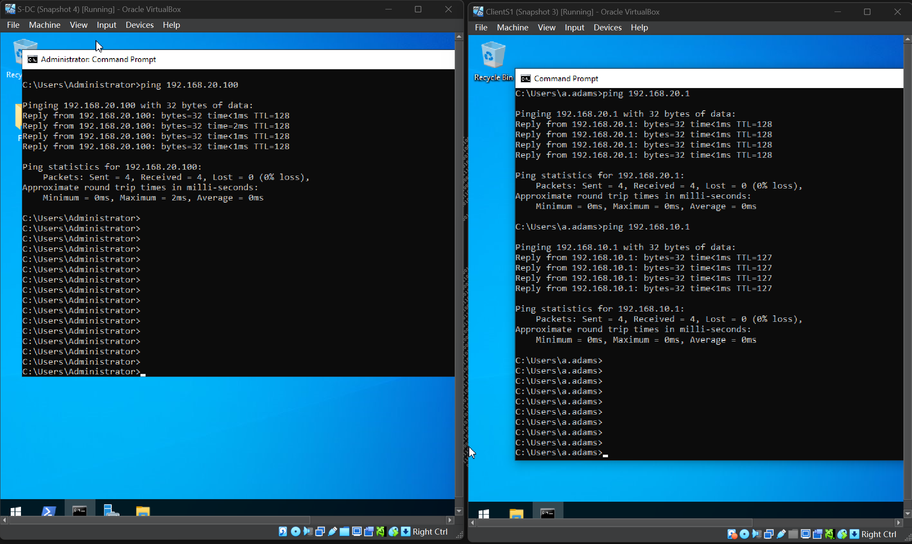
S-DC – C-SERVER
FAILED
CLIENTS1 – CLIENTC1
FAILED

S-DC -C-SERVER
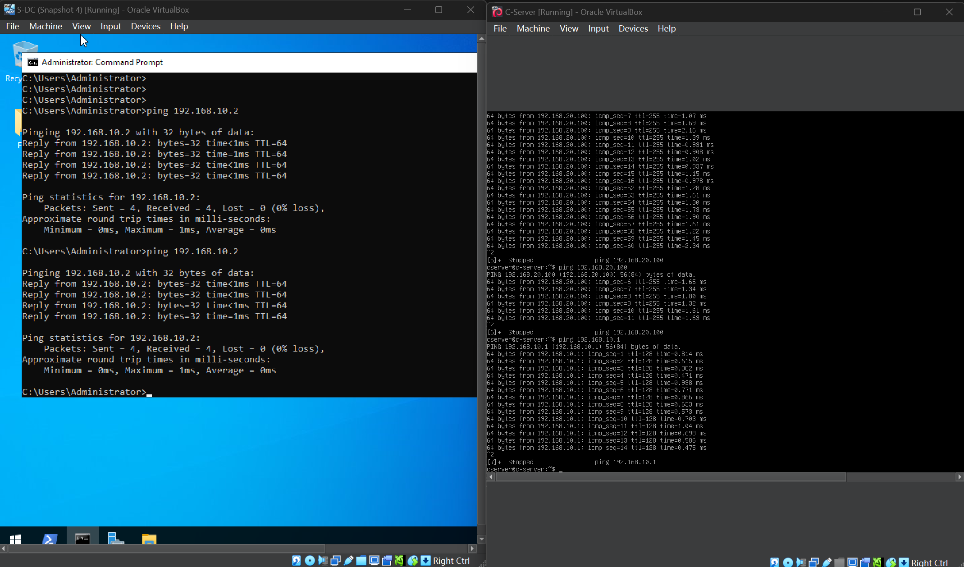
C-SERVER – CLIENTC1
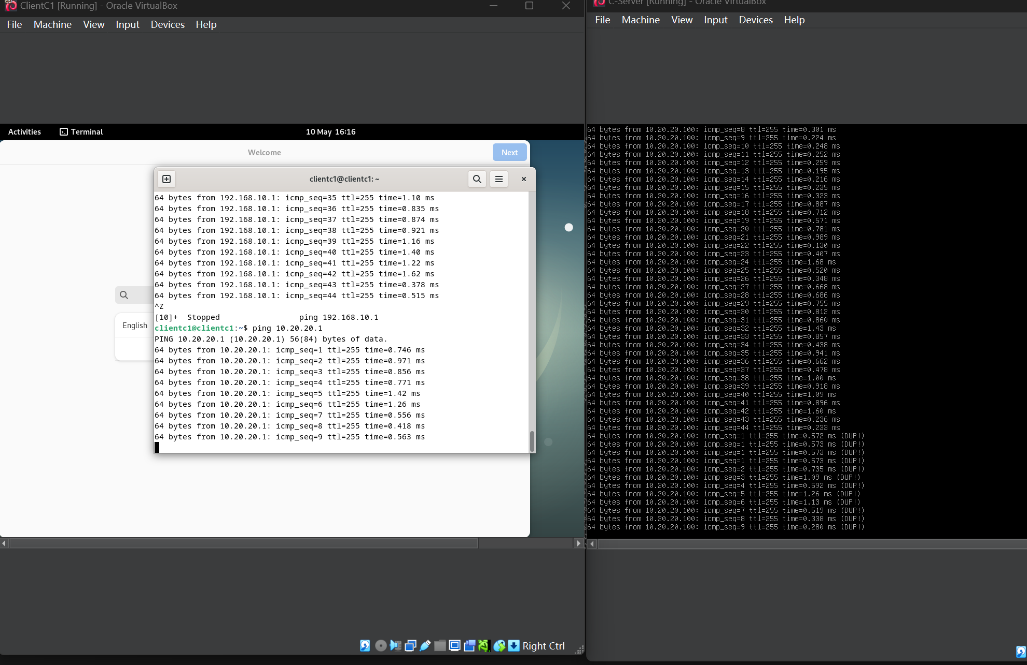

C-SERVER – CLIENTS1
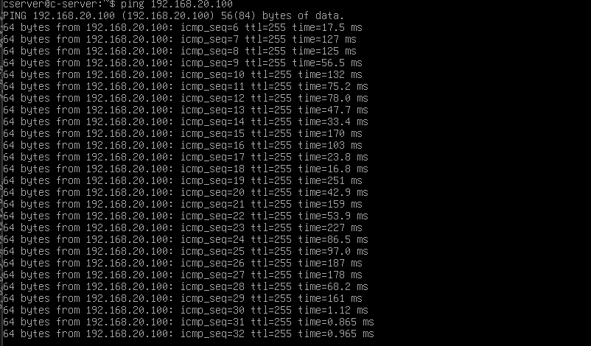
CLIENTC1- S-DC
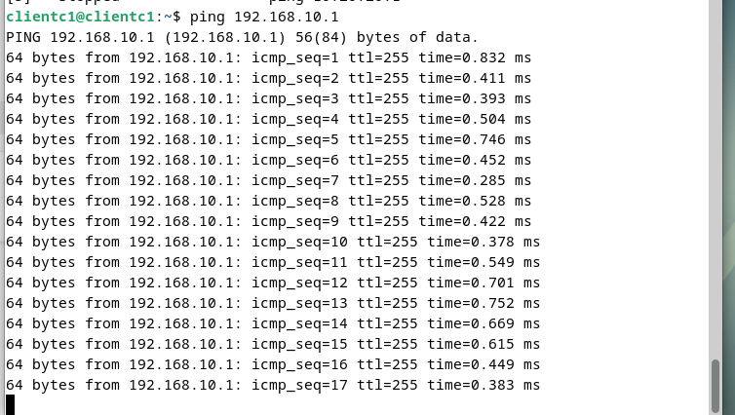
CLIENTC1 – CLIENTS1
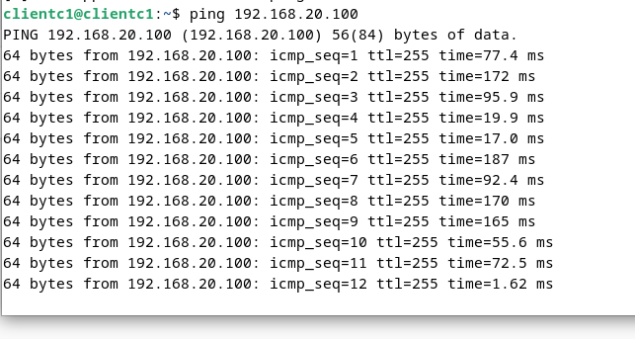
An overview of the problems with network communication failures: Troubleshooting and remedies for ping failures
I ran into the issue of some sites being unable to ping one another in this network deployment and VPN integration experiment, particularly when it came to access across Windows and Linux subnets. The following are the manifestations:
The issue is that Windows Server (S-DC) is unable to ping 10.20.20.1 and 10.20.20.100, and Windows client (ClientS1) is unable to ping Linux hosts (such as 10.20.20.100 and 192.168.10.2).
Most of the time, reverse access (Linux → Windows) is common.

Even though WireGuard VPN, PPTP tunnel, IIS service, and static routing between multiple subnets were all successfully configured in this network integration experiment, the Windows client was still unable to successfully ping hosts in the Linux subnet (such as 10.20.20.100 and 192.168.10.2). To resolve this issue, we set up static routing on Windows clients and servers, enabled IP forwarding and NAT on the Linux gateway (C-Server), verified that the client's default gateway points to the correct device, temporarily closed firewall rules, and changed AllowedIPs in the WireGuard configuration to prevent route hijacking. Made several rounds of attempts. Some routing links, particularly the one that blocked or redirected traffic from the Linux client back to Windows, were unable to create an efficient closed loop in the intricate cross-routing environment across multiple devices.

Gained a stronger understanding of Linux routing, Windows static routing administration, VPN tunnel debugging, and cross-platform communications because of the practice, even though the communication was ultimately unsuccessful. Additionally, it established a foundation of experience for the implementation of a more reliable and expandable network architecture in the future.

Disk Drive Files Sharing
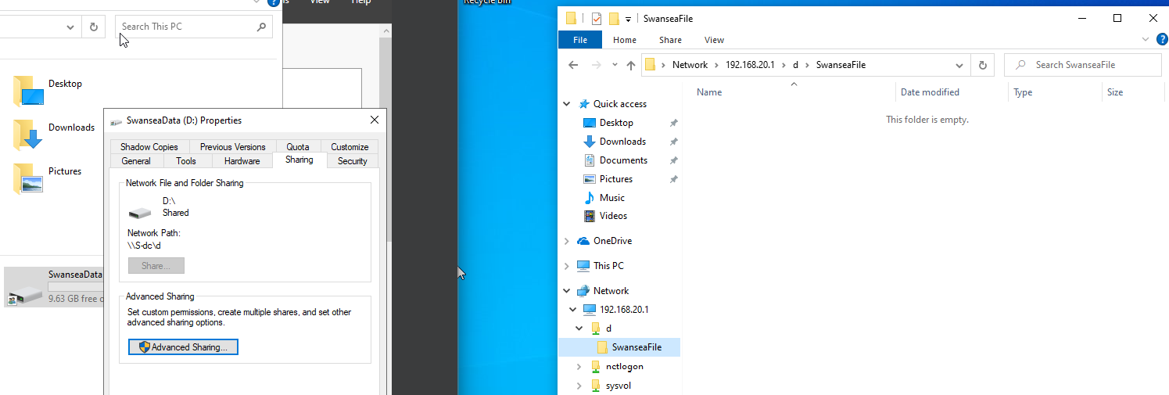
The shared folder SwanseaFile can be successfully accessed via the network at \\192.168.20.1\SwanseaFile, as the screenshot demonstrates. A UNC path (\\S-dc\SwanseaFile) is set up on the host computer, and the SwanseaData (D:) drive has been shared with network permissions using Advanced Sharing. The shared folder is being browsed by another client device on the same network, indicating that SMB file sharing was successfully set up. The connection confirms that file sharing across the network is operating as intended, even though the folder is now empty. This makes it possible for machines inside the cheng.acca domain or local subnet to collaborate and access files centrally.

IIS Server
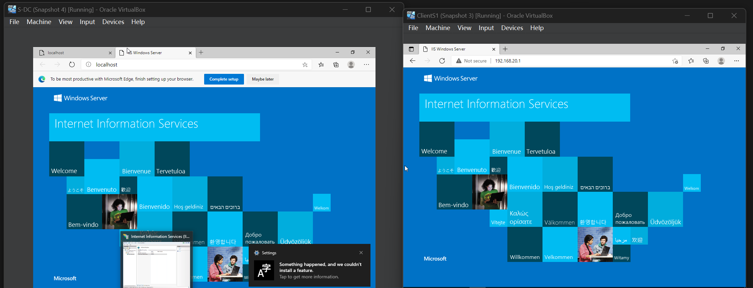
Internet Information Services (IIS) has been successfully installed and is available on the ClientS1 and domain controller (S-DC) computers running VirtualBox. The local web server setup is indicated by the left window, which displays IIS running on localhost (S-DC). ClientS1 is able to access IIS using IP address 192.168.20.1 in the right window, confirming remote HTTP connectivity over the network. This illustrates IIS availability, DNS resolution (if a hostname is used), and appropriate network routing. Additionally, it verifies that both servers are appropriately interacting within the cheng.acca domain or internal subnet and that firewall restrictions permit HTTP traffic.

Remote Desktops
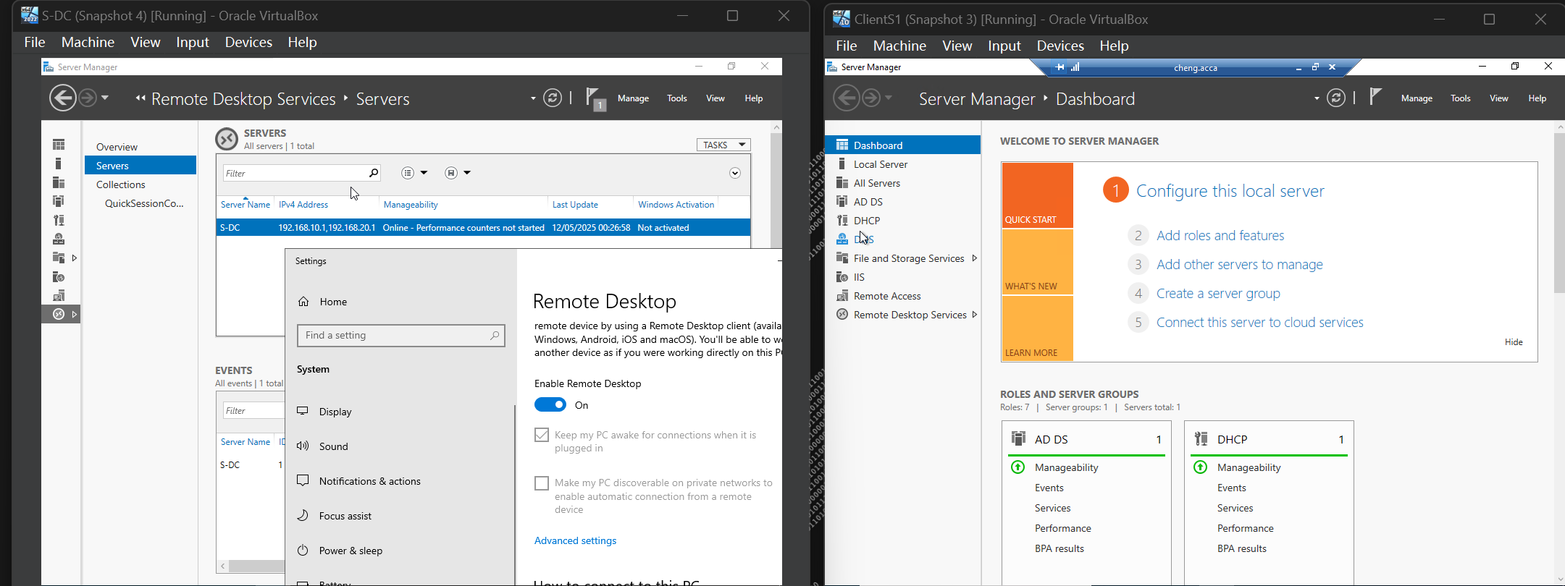
This shows that domain roles and Remote Desktop Services (RDS) have been successfully configured within the cheng.acca network. The server is actively listed with IP 192.168.10.1, and Remote Desktop is enabled, according to S-DC (domain controller) on the left. The Server Manager verifies that it is reachable over the network and that it oversees remote desktop access. ClientS1 is linked to the cheng.acca domain and displays active AD DS and DHCP roles in Server Manager on the right. In the virtualized lab environment, this validates domain trust, role-based service deployment, and appropriate remote management between the two servers.

