Forbidden Island Mobile Game
Usability Engineering Component 1 Technical Report
User Requirements and Prototype Design
ACCB6017
Hafsa Gul
Student ID 2323803
Module tutor Abiola Babatunde
University of Wales Trinity Saint David

1 Introduction
This report presents the user requirements and initial mobile interface design for a UWTSD adaptation of Forbidden Island. The cooperative objective is to recover four treasures and escape together [1]. The design uses a persistent board, clear action previews and a text-based board alternative to help students coordinate decisions on a small screen. University terminology provides a proposed theme while preserving the underlying game rules. Four interview-informed personas connect the requirements to practical scenarios. Monochrome wireframes show the main interactions, and an evaluation process sets out how the design will be assessed.

2 Personas and research approach

2 1 Research method and findings
Four participants provided responses to a twelve-question interview covering gaming experience, devices, play context, learning, controls, communication, accessibility and error recovery. Participant codes maintain a consistent link between each account and its persona: P1 Alex, P2 Maya, P3 Jordan and P4 Sam. The responses were compared descriptively to identify recurring needs and individual preferences. Appendix A records the source mapping, and Appendix B translates the findings into prioritised requirements.
The analysis supports short instructions, visible game information and straightforward ways to play with friends. Alex emphasises readable screens and recoverable actions. Maya places particular importance on confirmation, clear wording and preserving progress. Jordan highlights movement guidance, teamwork and continuity during travel. Sam favours simple instructions, easy controls and adjustable sound. These differences inform alternative interaction paths rather than a single assumed student profile.
Four personas provide a manageable design reference for this study. Salminen et al. show that the effect of persona quantity depends on how the information is used [2]. Guan et al. also identify the importance of addressing stereotyping in persona work [3]. Consequently, the profiles focus on reported behaviour and needs. Their scenarios illustrate intended use rather than observed task performance. The comparison follows a transparent relationship between response, interpretation and design decision, consistent with qualitative analysis guidance [4].

2 2 Alex the new cooperative player
Alex represents P1, a casual mobile player who enjoys cooperative tabletop games and is new to Forbidden Island. Small text, clutter and unclear rules can interfere with learning. Alex wants a short visual introduction, clear role information, visible remaining actions and a way to recover from accidental selections. The desired experience is a brisk session in which the team can make decisions confidently.
In the proposed scenario, Alex joins friends using a room code, reviews the tutorial and checks the board. Alex selects a destination, reads the action preview and cancels an unintended move before confirming another. A later interruption is handled through saved progress and a return summary. Requirements R1–R6 and R8 support this journey.

2 3 Maya the mobile team player
Maya represents P2, a mobile team gamer who is unfamiliar with Forbidden Island. The interview profile identifies an iPhone 14 Pro and a preference for thumb controls. Simple wording and labelled symbols support Maya because English is not their first language. Readable text, large buttons and progress preservation are central requirements. Confirmation provides a deliberate opportunity to review an action before it affects the team.
In the proposed scenario, Maya completes a short practice task, enters a room code and marks readiness in the lobby. During play, highlighted choices explain where a move is permitted. Maya previews the destination and cost, then confirms. If play is interrupted, the game restores the agreed state. Requirements R1–R6 and R8 address these needs.

2 4 Jordan the cooperative player on the move
Jordan represents P3, who plays mobile games and has experience of the Forbidden Island board game. Familiarity with the game does not remove difficulty remembering rules. Jordan plays at home and during bus or train journeys, prefers touchscreen interaction and values teamwork. Movement guidance, a short demonstration and an easy room-code connection help reduce effort. Disconnections and interrupted play are particular frustrations.
In the proposed scenario, Jordan joins a private room while travelling, checks the active player and selects a legal destination. The interface makes the available move clear without choosing a strategy. After a lost connection, a recap supports rejoining without repeating an action. Requirements R1–R4, R6 and R8 support this scenario.

2 5 Sam the social mobile player
Sam represents P4, a frequent mobile gamer who values playing with friends and is new to Forbidden Island. The profile describes phone and computer use at home. Sam prefers clear menus, easy controls and simple instructions. Adjustable sound allows the game to suit the surrounding environment. The intended experience is social and welcoming, with sufficient guidance to participate independently.
In the proposed scenario, Sam enters a room code, checks the team list and marks readiness. During play, Sam follows the action labels and changes the sound level without leaving the session. Team messages support coordination, while visible event explanations remain available during muted play. Requirements R1–R3, R6 and R7 support the scenario.

3 Usability issues and design responses

3 1 Learnability and visible game state
The interface must explain a changing shared situation without requiring players to remember every rule. Hassan’s review identifies entertainment value as an important consideration alongside accessibility [5]. For this game, reducing interface difficulty should preserve strategic uncertainty and the satisfaction of cooperating. A short optional tutorial introduces the objective and a sample turn, while contextual explanations remain available during play. The active player, action allowance, water level and treasure progress stay visible on the board. These choices address Alex’s learning needs and Jordan’s request for movement guidance.

3 2 Touch controls and error prevention
Small map tiles create a risk of inaccurate selection. The design therefore separates selecting a location from committing an action. A preview names the target, cost and resulting allowance. Cancel returns to selection without spending an action, directly supporting Maya’s preference. Legal targets receive a visible border and an explanation. Dragging and swiping are optional conveniences; labelled tap controls provide the complete route. Primary controls use a project target of at least 48 logical units with separation. Confirmation frequency should be assessed because repeated interruptions could slow experienced players.

3 3 Accessible information and output
Agrimi et al. discuss auditory alternatives and the difficulty of communicating spatial information in accessible games [6]. The proposed list view therefore retains location, condition, occupants and action access. Coordinates and neighbour descriptions preserve relationships that a simple list of names would lose. This is a design response to the literature, rather than an accessibility need assigned to an individual participant. Screen-reader output should announce significant changes concisely, with further detail available on request.
Rogers, Sharp and Preece emphasise understanding users and evaluating design alternatives [7]. Accordingly, the map and list should be compared through the same tasks. The trade-off is explicit: a list may improve selection while making simultaneous spatial comparison harder. Visible focus, stable navigation and a return to the triggering control after a dialog support predictable interaction. Large text should retain access to decisions, even when the layout must reorganise.
WCAG 2.2 informs the use of contrast, text resizing, keyboard access and understandable status communication [8]. The design specifies text and patterns alongside tile shading, so colour alone never communicates flooding. Essential events remain in a readable history; optional sound and vibration supplement the text. Separate audio volume and reduced-effects settings allow a quieter presentation. An interactive implementation should check focus order, screen-reader semantics, contrast and reflow; the wireframes express these requirements without making a conformance claim.

3 4 Cooperation and interruption recovery
Room codes and lobby readiness make the shared session understandable before play begins. During play, communication remains separate from action ownership, allowing teammates to offer advice without committing another player’s move. Saved progress and a reconciliation screen address interruptions. Reconnection must restore the last agreed state and explain subsequent changes before enabling actions. The interface should retain strategic responsibility while reducing avoidable confusion and repeated input.

4 Initial wireframe storyboards
The storyboard contains sixteen monochrome mobile screens using a 390-by-760 reference canvas. Figure 1 illustrates the main board. Appendix C provides the full set, including navigation and alternative states. The wireframes focus on content hierarchy and interaction sequence; their grayscale treatment keeps attention on usability. Stable screen identifiers allow requirements and evaluation tasks to refer to the same designs.
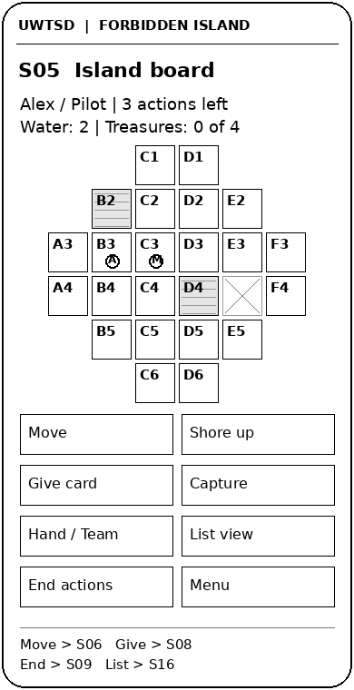
Figure 1 Main board wireframe S05

4 1 Joining and learning
S01 separates creating, joining, learning and resuming. S02 presents a room-code field with a recoverable error message. S03 shows names, roles and readiness before the host starts. S04 provides a short explanation and a practice route. This sequence supports unfamiliar players without forcing experienced players to complete a tutorial on every visit. Settings remain reachable independently of the learning route.

4 2 Selecting and confirming an action
S05 keeps the board and shared status together. S06 highlights legal movement targets, while S07 previews the chosen consequence. Confirm returns to an updated board; Cancel preserves the prior state. S08 presents the hand, team positions and role information. Card transfer and treasure capture reuse the preview pattern with action-specific conditions. A card transfer identifies its recipient; treasure capture identifies the site and required cards. Role exceptions must inform eligibility [1]. Appendix D specifies the checks for each transition.

4 3 Events and alternative routes
S09 explains turn events in sequence. S10 resolves excess cards before play proceeds, S14 handles emergency movement, and S15 explains the outcome and offers a review. The drawings show these as conditional branches rather than unrelated pages. S11 provides team conversation, and S12 allows presentation settings and leaving to be reviewed. S13 pauses commitments during connection recovery. S16 offers the equivalent list route and returns to the same game state when the player switches back to the map.
The UWTSD adaptation can use campus-inspired location names and student-facing language while retaining consistent coordinates and familiar action terms. Renaming must preserve each location’s function. Persistent help, event history and role descriptions reduce dependence on another player remembering the rules. These supporting elements should remain available without obscuring the board or resetting a selection.
The storyboard demonstrates information and navigation decisions. The evaluation will examine whether players can explain the current risk and intended consequence as well as reach the next screen. This distinction matters because a correct button press alone cannot establish understanding. The future colour design should preserve the current hierarchy and redundant state labels.

5 Feedback collection process and next iteration
Storyboard evaluation will use the same screen set and task instructions with participants who reflect the four personas. Alex and Maya provide perspectives on learning unfamiliar rules; Jordan contributes experience of the physical game and travel interruptions; Sam emphasises straightforward social play. Sessions will be conducted individually before group discussion so that one confident player does not determine the responses of others.
Participants will work through joining, interpreting the board, previewing and cancelling an action, coordinating with a teammate, adjusting presentation and returning after an interruption. The facilitator will ask participants to explain what they expect to happen next. Notes will distinguish independent completion, hesitation, incorrect selection and assistance. After each task, participants will rate ease from 1 to 5 and describe any confidence, frustration or uncertainty. Appendix D provides the task and recording structure.
The interview findings already provide positive design direction towards teamwork, short instructions and accessible controls. They also identify concerns about clutter, accidental actions, progress loss and disconnection. Storyboard evaluation will examine how effectively the proposed screens respond to these concerns. Feedback will be grouped by screen and issue, retaining differences between participants. Severity will reflect task impact and recoverability rather than frequency alone.
The next iteration will prioritise blocked actions and misunderstandings, then improve density and confirmation frequency. Later development can add a narrated demonstration and richer communication options. Revised designs will repeat the same tasks to compare changes in understanding and confidence.

6 Conclusion
The proposed interface connects four participant accounts to a clear cooperative game flow. Visible state, short learning support, action previews and continuity after interruption address the main usability concerns. The monochrome storyboard includes the principal journey and recovery routes, supported by prioritised requirements and evaluation tasks. Further design work should preserve the relationship between each user need, interface decision and observed task outcome while developing the visual presentation.

References
[1] Gamewright, Forbidden Island: Rules of Play, 2010. Accessed: Oct. 22, 2026. [Online]. Available: https://gamewright.com/pdfs/Rules/ForbiddenIslandTM-RULES.pdf
[2] J. Salminen, S.-G. Jung, L. Nielsen, S. Şengün, and B. J. Jansen, “How does varying the number of personas affect user perceptions and behavior? Challenging the ‘small personas’ hypothesis!,” International Journal of Human-Computer Studies, vol. 168, Art. no. 102915, 2022, doi: 10.1016/j.ijhcs.2022.102915.
[3] K. W. Guan, J. Salminen, S.-G. Jung, and B. J. Jansen, “Leveraging personas for social impact: A review of their applications to social good in design,” International Journal of Human–Computer Interaction, vol. 40, no. 19, pp. 5569–5584, 2024, doi: 10.1080/10447318.2023.2247568.
[4] C. H. Saunders et al., “Practical thematic analysis: A guide for multidisciplinary health services research teams engaging in qualitative analysis,” BMJ, vol. 381, Art. no. e074256, 2023, doi: 10.1136/bmj-2022-074256.
[5] L. Hassan, “Accessibility of games and game-based applications: A systematic literature review and mapping of future directions,” New Media & Society, vol. 26, no. 4, pp. 2336–2384, 2024, doi: 10.1177/14614448231204020.
[6] E. Agrimi, C. Battaglini, D. Bottari, G. Gnecco, and B. Leporini, “Game accessibility for visually impaired people: A review,” Soft Computing, vol. 28, pp. 10475–10489, 2024, doi: 10.1007/s00500-024-09827-4.
[7] Y. Rogers, H. Sharp, and J. Preece, Interaction Design: Beyond Human-Computer Interaction, 6th ed. Hoboken, NJ, USA: Wiley, 2023.
[8] World Wide Web Consortium, “Web Content Accessibility Guidelines (WCAG) 2.2,” W3C Recommendation, Oct. 5, 2023. Accessed: Oct. 22, 2026. [Online]. Available: https://www.w3.org/TR/2023/REC-WCAG22-20231005/.

Appendix A Interview mapping and design synthesis
Participant codes link the research accounts, personas and requirements. The wording below summarises the reported preferences rather than reproducing direct quotations. Scenarios in Section 2 illustrate how these needs inform intended interaction.
Table A1 Participant sources and principal design links
Code and persona | Interview source | Principal design links
P1 Alex | Forbidden Island Mobile Game QUESTIONS1.docx | Tutorial; readable state; room codes; action preview; recovery.
P2 Maya | P2.docx | Simple language; readable controls; confirmation; retained progress.
P3 Jordan | pt3.docx | Movement guidance; demonstration; teamwork; connection recovery.
P4 Sam | P4.docx | Simple instructions; easy controls; social play; adjustable sound.

Interpretation approach
The synthesis compares similar topics across participants while retaining individual preferences. A request for readable controls supports a design requirement; it does not establish a medical condition. Features derived from accessibility literature are identified separately from interview-led features. The design uses participant codes consistently, and the proposed scenarios do not add demographic or clinical assumptions.

Appendix B Requirements prioritised using MoSCoW
Must requirements define the core playable journey. Should requirements strengthen usability and inclusion. Could requirements extend the experience when the core flow is stable. Won’t requirements identify exclusions from this initial design. Priorities are design judgements based on the interview synthesis, the game rules and the literature.
Table B1 Core user and experience requirements
ID | Priority | Requirement and experience aim | Basis | Screens
R1 | Must | Provide short instructions and on-demand help so a newcomer can begin confidently. | P1–P4 | S01 S04 S12
R2 | Must | Create and join private rooms by code; show roles and readiness before starting. | P1–P4 | S02 S03
R3 | Must | Keep active player, actions, water and treasure progress visible. | P1; P3; rules | S05 S16
R4 | Must | Show legal destinations and explain action eligibility without choosing the team’s strategy. | P1–P3; rules | S06 S07 S08
R5 | Must | Preview target and consequence; allow cancellation before commitment without spending an action. | P1 P2 | S06 S07
R6 | Must | Use plain wording, labelled controls and readable text; retain event information visually. | P1 P2 P4 | S04 S05 S09
R7 | Should | Offer separate sound controls and adjustable presentation without losing the current game. | P4; literature | S12
R8 | Should | Save agreed progress and reconcile state after interruption, avoiding duplicate commitments. | P1 P2 P3 | S01 S12 S13

Table B2 Additional requirements and scope boundaries
ID | Priority | Requirement and experience aim | Basis | Screens
R9 | Should | Provide a list alternative with equivalent locations, state and actions. | [6]–[8] | S16
R10 | Should | Support cooperative text messages and quick phrases without changing action ownership. | P1; teamwork theme | S08 S11
R11 | Could | Offer optional voice communication and a narrated demonstration alongside text. | P1 P3 | S04 S11
R12 | Could | Offer reversible local selections where game information has not changed. | P1; design response | S06 S07
R13 | Won’t | Include public matchmaking, advertising or time-pressured input in this initial design. | Scope decision | All screens
R14 | Won’t | Use final colour artwork or alter strategic game rules in the wireframe submission. | Component 1 scope | All screens

Appendix C Wireframe storyboards

Starting a private session
Select Create or Join on S01 to reach S02. A valid room code or successful room creation opens S03; invalid input keeps the player on S02 with a recovery message.
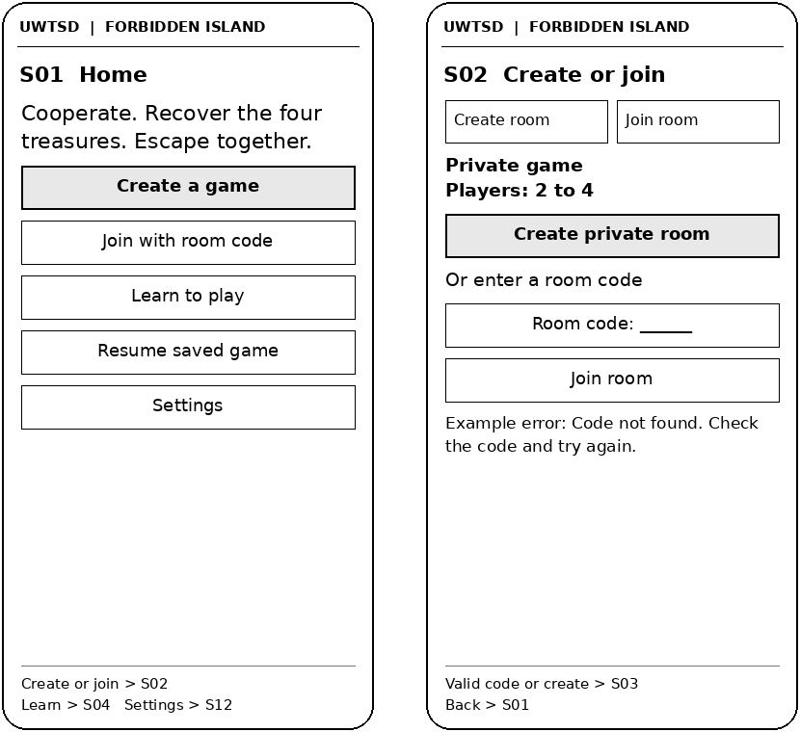
Figure C1 Screens S01 and S02

Appendix C Wireframe storyboards continued

Readiness and learning
S03 exposes roles and readiness before entering S05. S04 is available through Home or Help; a practice route explains selection and confirmation without changing a live session.
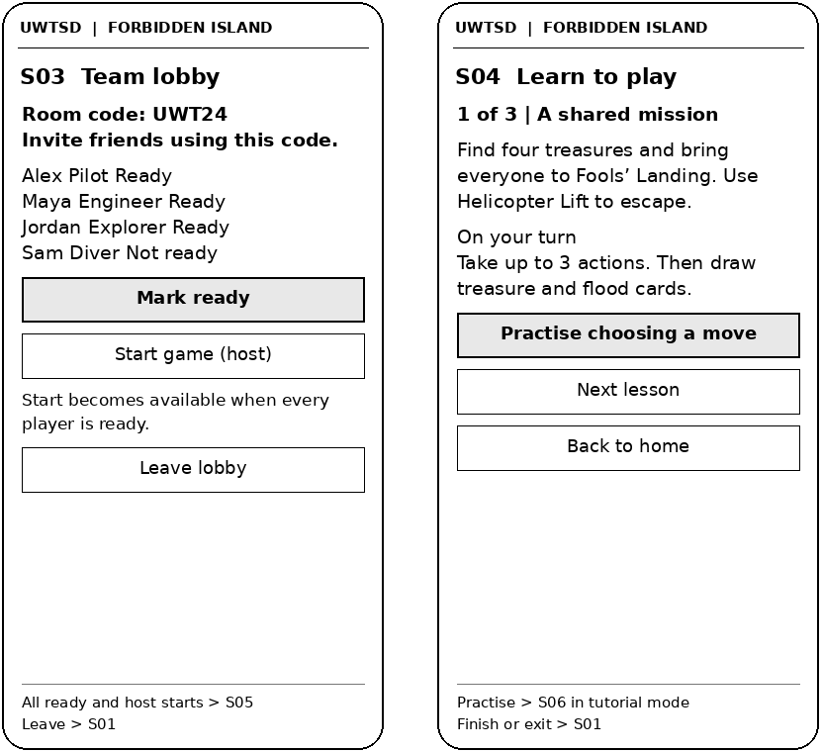
Figure C2 Screens S03 and S04

Appendix C Wireframe storyboards continued

Board overview and movement selection
S05 provides shared state and action access. Choosing Move opens S06. Legal targets receive bold borders; Cancel returns to the unchanged board.
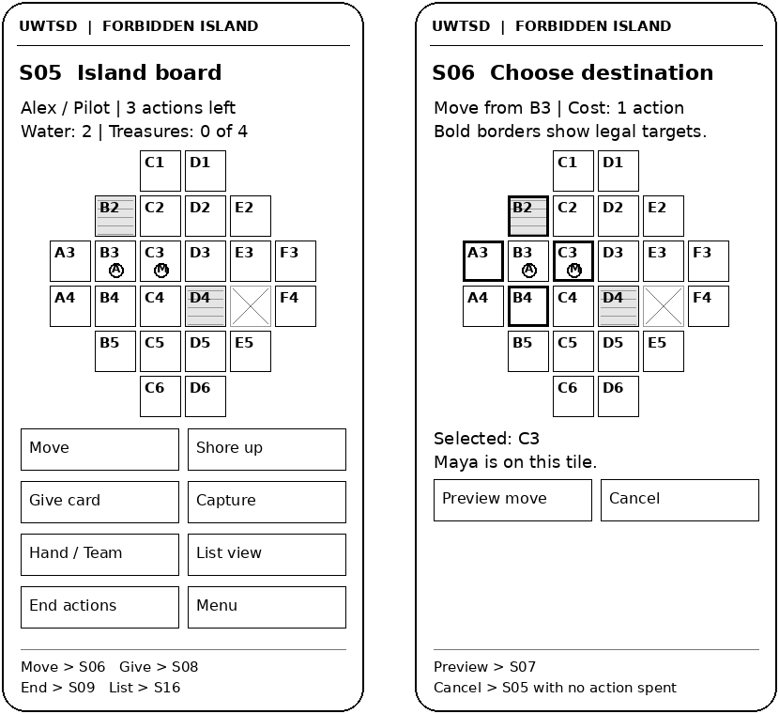
Figure C3 Screens S05 and S06
Board key: plain tile = dry; horizontal lines = flooded; crossed tile = sunk. Bold borders in S06 indicate legal destinations. Pawn initials identify the players. Coordinates act as stable references; full location names are available through location detail and list view.

Appendix C Wireframe storyboards continued

Confirmation and cooperative decisions
S07 previews the action-specific target and cost. S08 provides hand, role and team information. Giving a card or capturing a treasure reuses the same confirmation structure with relevant conditions.
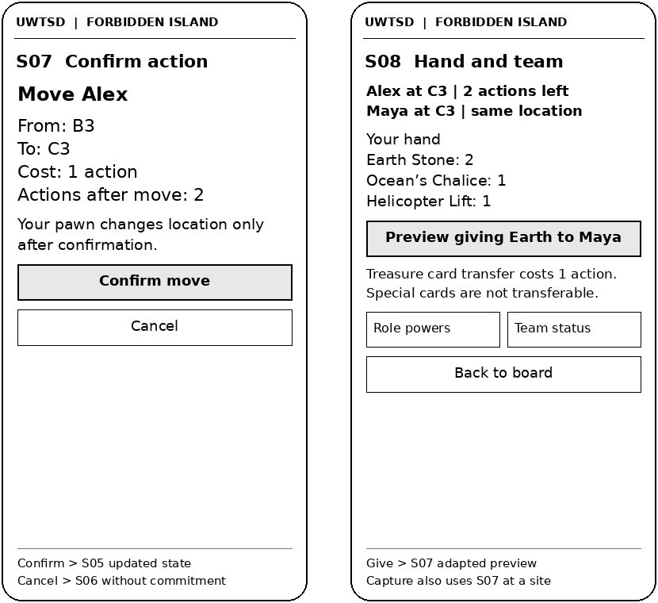
Figure C4 Screens S07 and S08

Appendix C Wireframe storyboards continued

Turn events and hand management
Ending actions opens S09. Excess cards branch to S10; valid resolution returns to event processing. Event history remains available for review.
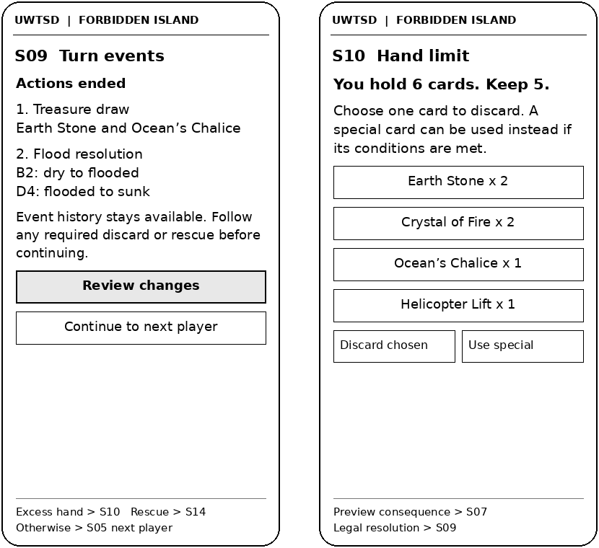
Figure C5 Screens S09 and S10

Appendix C Wireframe storyboards continued

Communication and presentation settings
Team status opens S11. The game menu opens S12. Applying settings preserves the session; Save and leave uses a consequence preview before returning Home.
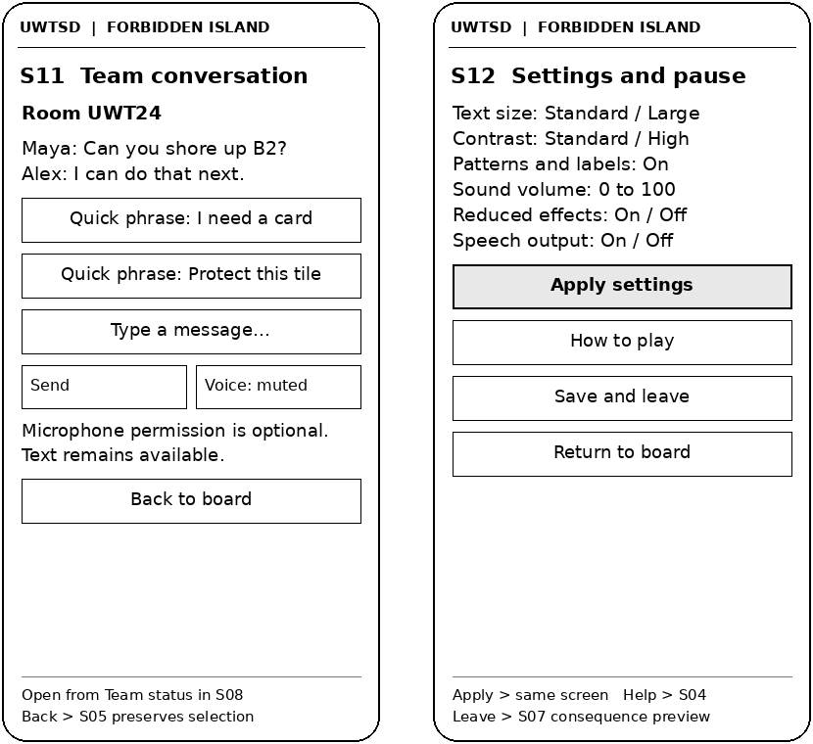
Figure C6 Screens S11 and S12

Appendix C Wireframe storyboards continued

Recovery and emergency movement
S13 blocks commitments until the shared state is reconciled. S14 handles an affected pawn after a tile sinks, using role-specific eligibility before the game resumes.
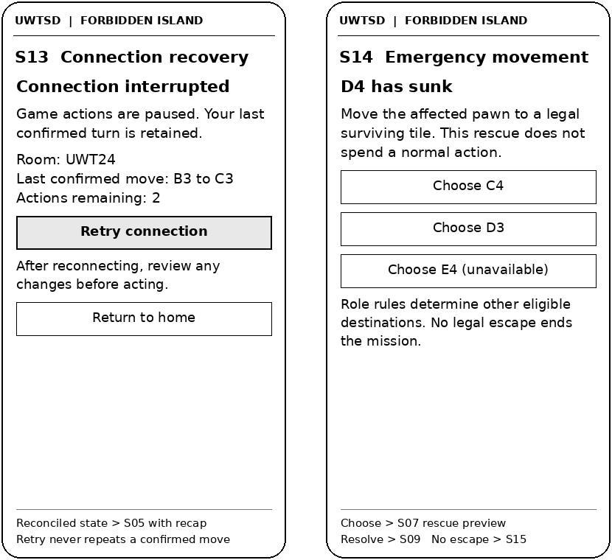
Figure C7 Screens S13 and S14

Appendix C Wireframe storyboards continued

Outcomes and the board alternative
S15 explains the result and offers a read-only final-board review. S16 provides a list alternative with the same state and legal actions as S05.
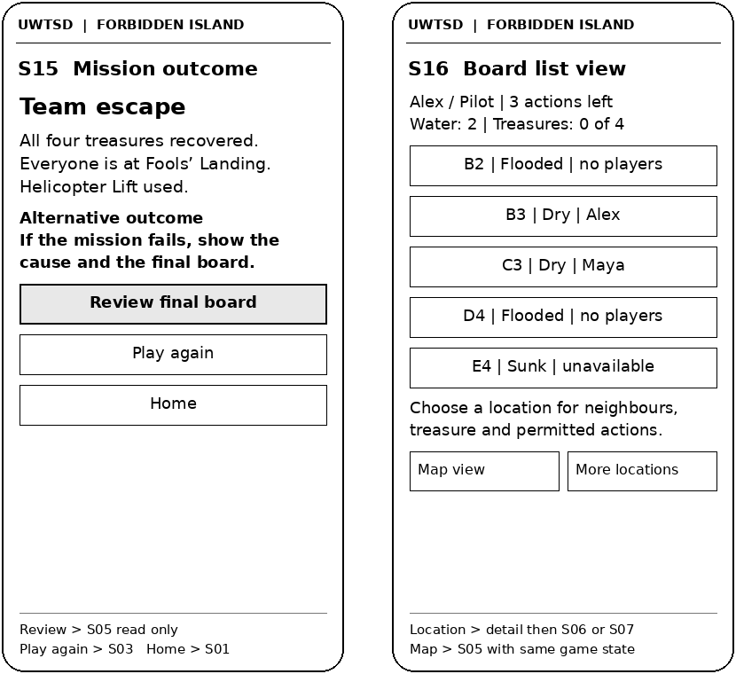
Figure C8 Screens S15 and S16

Appendix D Evaluation tasks and recording framework
Use the same storyboard version for each session. Record participant code, screen, expected outcome, assistance, observed issue, ease rating and emotional response. Begin with neutral instructions and allow the participant to explain their reasoning before offering help.
Table D1 Task routes and observable checks
Task | Route | Observable check
T1 Join friends | S01–S03 | Enter a valid code, identify the team and explain readiness. Recover from an invalid code.
T2 Interpret the board | S05 | Identify active player, remaining actions, water level and a flooded tile.
T3 Correct a selection | S05–S07 | Preview a move, cancel it and confirm that no action is spent. Confirm another and identify the new allowance.
T4 Coordinate a decision | S08 S11 S07 | Find a teammate, distinguish a message from a committed action and explain the card-transfer preview.
T5 Resolve turn events | S09 S10 S14 | Explain a flood change, resolve an excess hand and identify an emergency movement branch.
T6 Change presentation | S12 S16 | Locate sound/text options and interpret equivalent information in list view.
T7 Resume play | S13 S05 | Explain paused commitments, retry and check the reconciled state before acting.
T8 Review the outcome | S15 | Explain the result and choose a final-board review or a new session.

Recording and prioritisation
Record positive responses alongside difficulties. Ease uses a 1 to 5 scale, from very difficult to very easy. Issue severity uses 0 for no usability problem, 1 for cosmetic, 2 for a recoverable minor problem, 3 for a major problem requiring assistance and 4 for a blocked essential task. These scales are proposed project measures. Retain disagreements between participants and connect each change to its screen, requirement and task.

