
Module Name: Academic Skills in the Digital Era
Module Code: BMSW4013
Assessment 1: E-Portfolio
Student Name: Hibah Harb
Student Number:2511464
Lecturer: Scott James
Deadline: Friday 21st November 23:59PM

AI Acknowledgement
I acknowledge the use of ChatGPT (https://chatgpt.com/) on 17 February 2026 to assist with paraphrasing and improving the clarity, grammar, and structure of my writing using the prompt(s):
- Please paraphrase the following paragraph while keeping the original meaning.
- Please shorten this paragraph without changing the main ideas.
I confirm that I have not presented AI-generated content as my own original ideas. The ideas and core content are my own work. I confirm that I have copies of my drafts, notes, and other resources used before and after the use of AI tools, which I may be asked to provide as evidence.

Contents
Component 1 – Research and Planning Template 4
Source Exploration 4
Key Challenge for Students 4
Key Opportunity for Students 4
Planning Your Report 4
Timeline for Component 2 4
Component 2 – Answering the Question 5
Introduction 5
Challenges Students Face 5
Opportunities Digital Tools Provide 5
How Students Can Adapt 5
Conclusion 5
Component 3 – Reflective Presentation 6
Slide 1 (Overview) 6
Slide 2 (Research) 6
Slide 3 (Planning & Writing) 6
Slide 4 (Challenges) 6
Slide 5 (Successes) 6
Reference List 7

Component 1 – Research and Planning Template

Source Exploration

The chosen source is "Educational Management Innovation: Challenges and Opportunities in the Digital Era," written by Dadang Mulyana and published in the Journal Info Sains: Informatika dan Sains in 2023. The article highlights the need for educators and students to adjust as it looks at how digital technologies, including gamified learning environments, online collaboration platforms, and learning management systems, are changing education.
Because it is current, trustworthy, and directly related to my research on the opportunities and difficulties faced by students in the digital age, this source was selected. Mulyana draws attention to challenges such as unequal access to technology and disparities in digital literacy, but she also highlights chances for participation and the development of digital skills.

Key Challenge for Students
With the use of digital tools, students can access educational materials at any time and from any location. Mulyana (2023) asserts that online libraries, tutorials, and learning management systems (LMS) enable students to study autonomously and go over content at their own speed. Additionally, these resources facilitate group projects and online debates, which foster teamwork and enhance communication abilities in pupils. This flexibility is something I value since it encourages self-directed learning, creates lifetime learning habits, and equips students for tech-savvy and adaptable jobs.

Key Opportunity for Students
The ability to access instructional materials at any time and from any location is one of the main benefits of digital tools. With learning management systems, online libraries, and video tutorials, students may study at their own speed and revisit content as needed. This flexibility promotes self-organized learning and empowers students to take charge of their own growth, according to Mulyana (2023). When students are struggling with a subject, for instance, they can watch class records or access online tutorials rather of waiting for the next lesson. Learning is made easier and less stressful by this flexibility, which enables me to study at my own pace and with my own preferences, review content that I have missed, and build academic confidence and self-management abilities.

Planning Your Report
I'll look at both the negative and positive aspects of digital learning because although the negative highlights the need for change, the positive aspects will be highlighted. I will demonstrate how students access information and communicate online using examples from Mulyana (2023), using Moodle and Google Classroom as well as Zoom and Microsoft Teams as collaboration tools. I might also use my personal experiences in the classroom. The essay will discuss important issues, the benefits of digital tools, ways for pupils to adjust, and a summary of the significant ideas.

Timeline for Component 2
Task | Date/ Deadline
Finish research | 11/11/2025
Draft first section | 18/02/2026
Complete first draft | 18/02/2026
Final editing | 24/02/2026

Component 2 – Answering the Question

Introduction
With students studying through digital tools, online platforms, and virtual collaboration, technology is essential to modern education. These tools increase the flexibility and interactivity of learning, but they also raise new standards and problems. This study emphasizes the significance of acquiring the skills required to thrive in a technologically advanced environment while examining the opportunities and challenges students have when learning digitally.

I'll look at both opportunities and challenges because, while opportunities emphasize advantages, understanding issues demonstrates the need for adaptability. Mulyana (2023) provides examples of LMS platforms like Moodle and Google Classroom as well as tools like Zoom and Microsoft Teams , I'll demonstrate how kids use the internet to collaborate and obtain information. I might also use what I've learned in the classroom.

Challenges Students Face
Digital learning presents a number of difficulties for students. Participation may be restricted by unequal access to gadgets and dependable internet. While self-discipline and time management are crucial but challenging for many, developing digital literacy and handling online chores need work. These problems can make learning more difficult and cause more stress if they are not addressed.

Opportunities Digital Tools Provide
Despite some challenges, digital tools offer many advantages for students. Learning platforms such as Moodle and Google Classroom enable easy access to study materials and assignments at any time. Communication tools, including Microsoft Teams and Zoom, support collaboration and group discussions. Mulyana (2023) explains that online libraries and interactive resources help students strengthen research, critical thinking, and independent learning skills. These tools encourage flexibility, improve engagement, and prepare students for academic and professional environments.

How Students Can Adapt
How Students Can Adapt to Digital Learning
For online learning to be successful, students must possess excellent digital literacy and self-regulation abilities. According to Mulyana (2023), having the capacity to independently manage learning is just as crucial as having access to technology. Frequent use of digital resources, such learning platforms and academic databases, increases productivity and confidence.

Time management skills are particularly crucial because online learning necessitates independence and might cause procrastination. Making study plans, establishing due dates, and segmenting work into manageable chunks all contribute to a decrease in stress and an improvement in performance.

Lastly, using peer forums, workshops, and tutors to get academic and technical support improves comprehension and writing abilities. When combined, these techniques strengthen students' resilience and facilitate their smooth transition to digital learning settings.

Conclusion
In conclusion, students in the digital era encounter both challenges and opportunities Issues such as limited access to technology, digital skill gaps, and time management difficulties can affect learning. However, online platforms also promote flexibility, independence, and collaboration. By developing effective study habits, improving digital literacy, and using available support, students can successfully adapt to digital learning and enhance their academic performance.

Component 3 – Reflective Presentation

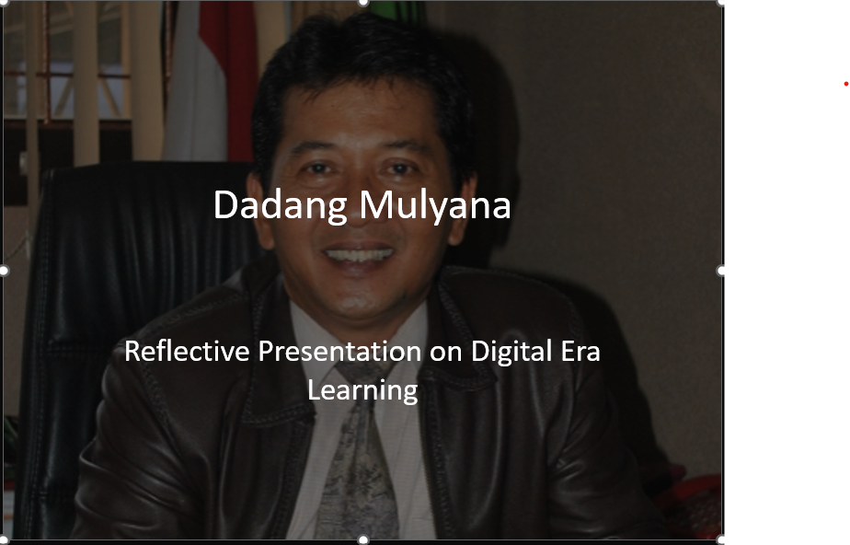

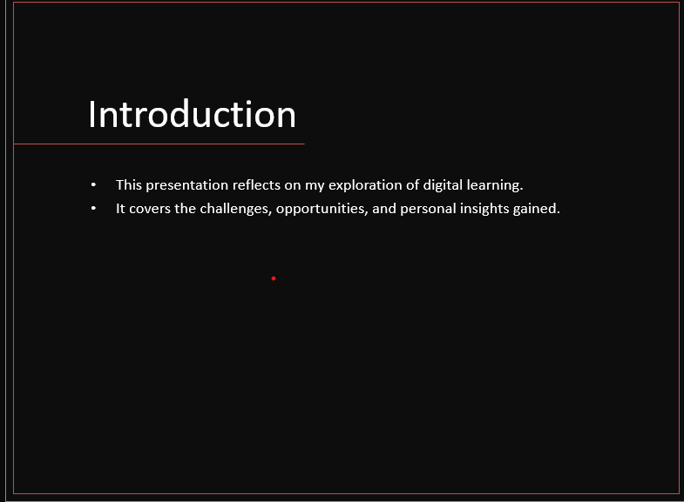

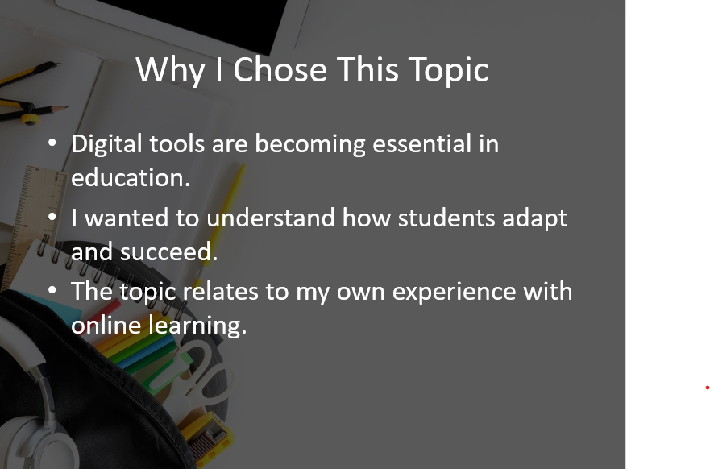

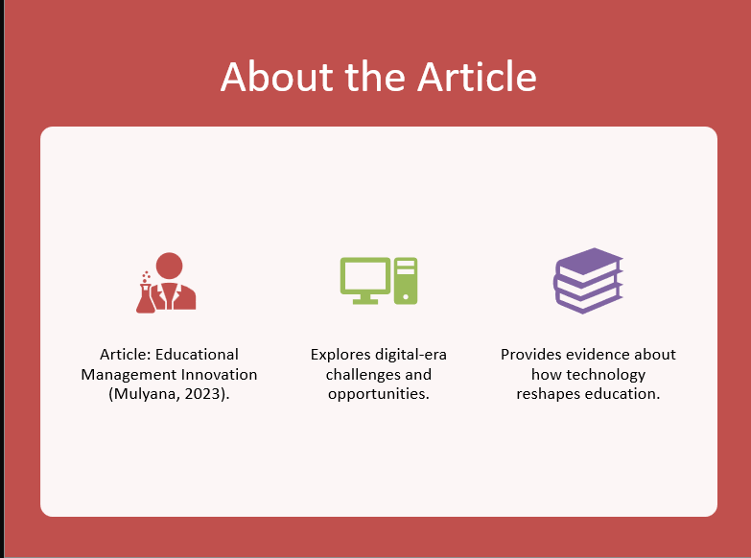

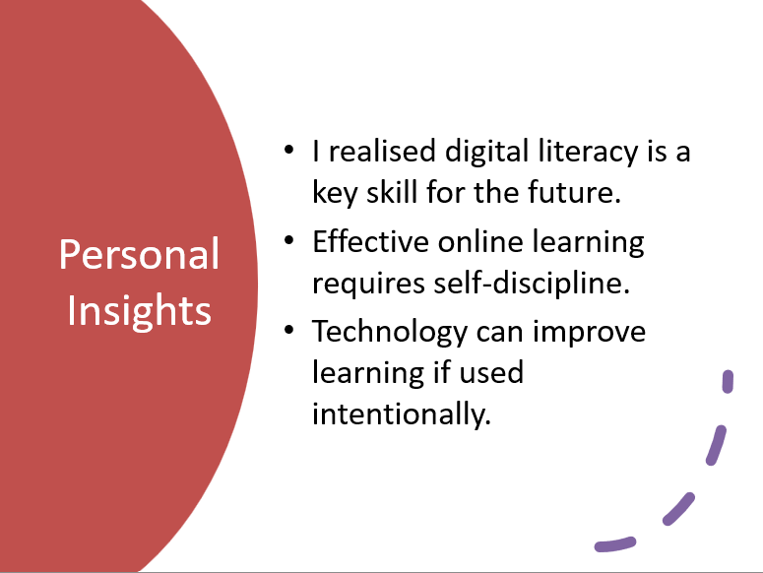
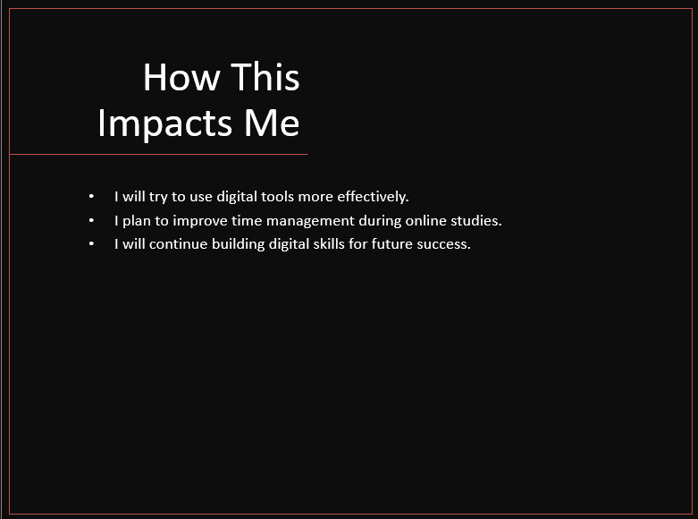
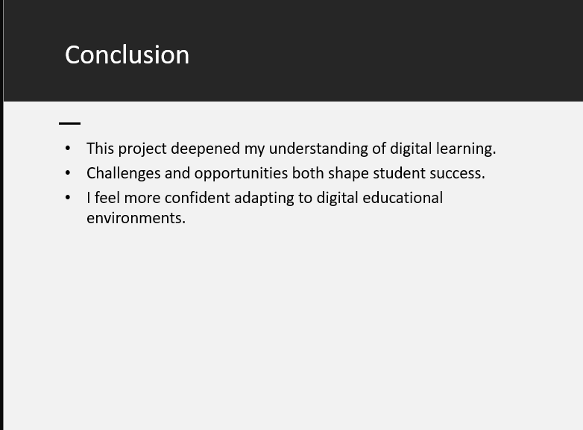

Reference List
Mulyana, D, (2023), educational management innovation: challenges and opportunities in the digital era. Jurnal Info Sains: informatika dan sains ,13(3),1201-1207: https://ejournal.seaninstitute.or.id/index.php/InfoSains/article/view/4082
Anderson, T. (2016) The theory and practice of online learning. 2nd edn. Athabasca: Athabasca University Press.
Bates, T. (2019) Teaching in a digital age: Guidelines for designing teaching and learning. 2nd edn. Vancouver: BCcampus.
Bond, M., Buntins, K., Bedenlier, S., Zawacki-Richter, O. and Kerres, M. (2020) ‘Mapping research in student engagement and educational technology’, International Journal of Educational Technology in Higher Education, 17(1), pp. 1–30.
Broadbent, J. and Poon, W.L. (2015) ‘Self-regulated learning strategies & academic achievement in online higher education’, Internet and Higher Education, 27, pp. 1–13.
Kirkwood, A. and Price, L. (2014) ‘Technology-enhanced learning and teaching in higher education’, Learning, Media and Technology, 39(1), pp. 6–36.
Means, B., Toyama, Y., Murphy, R. and Baki, M. (2013) ‘The effectiveness of online and blended learning’, Teachers College Record, 115(3), pp. 1–47.
Selwyn, N. (2016) Education and technology: Key issues and debates. 2nd edn. London: Bloomsbury.
Sun, A. and Chen, X. (2016) ‘Online education and its effective practice’, Journal of Information Technology Education, 15, pp. 157–190.
Zimmerman, B.J. (2002) ‘Becoming a self-regulated learner’, Theory Into Practice, 41(2), pp. 64–70.

