Kofoworola Grace Adedeji
2019603
BMSW4004
Problem Solving and Decision Making

Table of Contents
Introduction 3
Workplace: Scope and Impact 3
Information Analysis of the Problem and Decision-Making Process 3
Range of alternative solutions to the problem 5
1. Participate in mass vaccination program 5
2. Contact Tracing 5
3. Work from Home 6
Decision making technique 6
Implementing Mass Vaccination at Marriott 8
Planning 8
Hosting and Promotion 8
Communication with the stakeholders 9
1. Emails and newsletters 9
2. Automated emails 9
3. Virtual presentations 9
Monitor and Review Techniques 9
1. Vaccination Rate 9
2. Covid Infection Rate 10
3. Absent rate due to Covid Infection 10
4. Vaccine propensity 10
Conclusion 10
Reference 10

Introduction
Marriott International is one of the most prominent hotel business corporations operating in the UK that has been dealing with the economic and social effects of COVID-19 for a long time. The report focuses on the burning issue of health and safety of Marriott employees who are consistently threatened by the possibility of COVID-19 infection at workplace. The report proposes our decision-making process which is used to formulate several suggestions to address this issue. The report also chooses the best alternative by conducting a decision-making technique and provides follow-up to the stakeholders.

Workplace: Scope and Impact
Workplace can be defined as an accommodating work setting established for workers and employees who are contracted by the organization on the basis of both temporary or permanent work permit who utilize their cognitive skills as well as behavioral integrity to contribute to the productivity level of the organization. The concept of workplace can be interchangeably used with the term, Modern Workplace. Such a concept is often referred to having a workplace setting that is characterized by digital collaboration, end to end encryption of communication tools and a virtually dispersed hierarchical structure that stretches beyond the confines of national boundaries (Brown et al., 2009). Some of the requirements of working for a modern workplace includes effective means of communication, workability from any device at any place, taking business process everywhere and less paper work for end-to-end users. Such process demands skills and competencies like independent problem solving, digital literacy, IT literacy, digital citizenship, communication and collaboration. Personal organization and many more.
The report focuses on the workplace health and safety issues at Marriott International Hotels in the UK due to the surge of COVID-19 pandemic.

Information Analysis of the Problem and Decision-Making Process
The main reason of the health and safety problems at hospitality business sectors, especially in the case of Marriott International Hotel in the United Kingdom can be traced back to the speedy nature of the COVID-19 virus that can be transmitted from person to person based on clothes in direction where the virus can be passed on to other people through aerosol from nasal are mouth emission of cough (Anderson et al., 2021). Besides that, you are more person who are close contact among each other, a distance which is no less than 1 m can be under severe threat of getting infected by the virus. Moreover, droplets from eyes, nose and mouth that are exhaled from the infected person can be transmitted to other person in close range who might inhale the air.
Therefore, the Marriot management group must construct a rigorous decision-making process to identify some viable solutions so that the COVID-19 protocols can be strictly maintained within the workplace to standardize the health and safety policies.
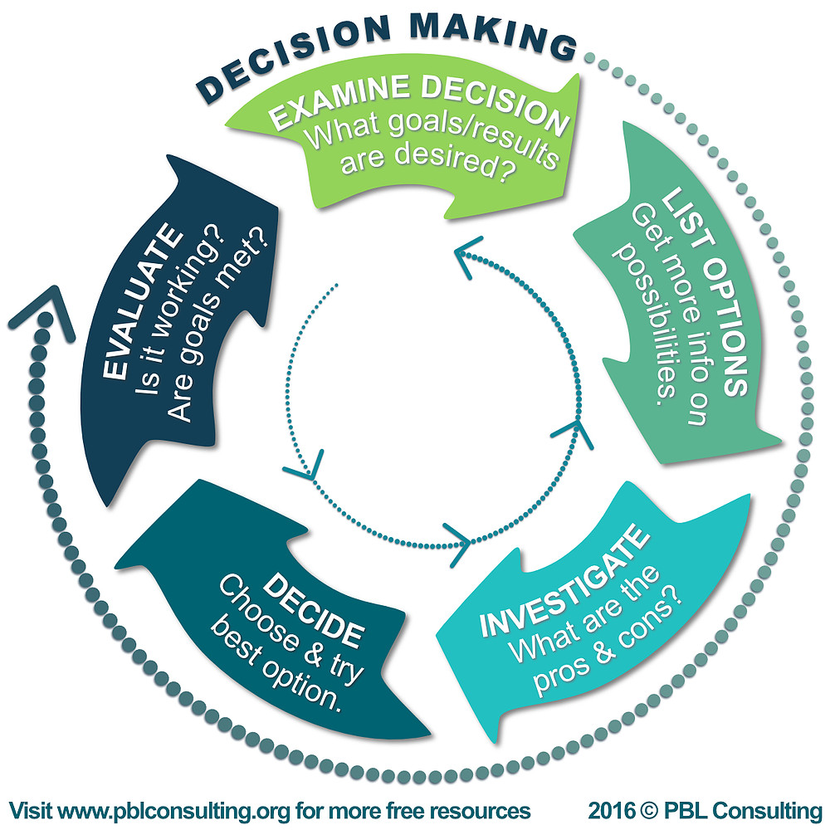
Figure 1: Decision Making Process (Vroom, 2000)
The above figure states are five stage decision-making process that can be followed by Marriott hotels in order to initiate the health and safety protocols in its workplaces.
- The first stage is about examining the decision. Here, the consent authority must formulate some specific goals and end results that they might want to achieve through this decision-making process.
- Next, the decision-making team must find alternatives and make a list of such alternatives based on their priority level and attractiveness.
- After that, there should be some investigation directed by the team members of the decision-making process do identify some of the merits and demerits of the alternatives of choices that has been listed above.
- Afterwards, the best option should be chosen by the organization that contains the highest value of return, minimization of organizational resources and attainment of decision-making goals.
- The final stage is related with a review and monitoring section where the progress must be measured against the expected result.

Range of alternative solutions to the problem

1. Participate in mass vaccination program
Marriott International hotels must make a collaboration with the National health service to avail mass vaccination program for its employers and workers. While there might be other options and alternatives for the organization, no other solution can provide a long-term focus for Marriott International to go forward in the future by complying and abiding by the COVID-19 Health and safety protocols. Besides, mass vaccination can accelerate heard immunity through which the effects of COVID-19 pandemic can be quickly dispensed. There are options for Marriott International to participate in voluntary vaccination program or make arrangements of commercially dispatched vaccine doses which can be privately conducted on the employees and workers of the organization (Dye and Mills, 2021).

2. Contact Tracing
Contact tracing is a medically approved and scientifically proven process of isolating the population who maintained a close interaction and association with the probable COVID-19 patients. Normally, people who come close to a potentially infected person wait in the range of 6 feet or less and continue the in direction with the possible COVID-19 patient for a time period of 15 minutes or less are considered the usual suspects of contact tracing. People normally takes about 5 to 6 days to show symptoms of COVID-19 after being infected with the virus (Keinman and Merkel, 2020). However, meaning medical research and journals show that on rare cases such symptom can be exhibited as late as 14 days. Therefore, the main purpose of contact tracing is to isolate the suspected COVID-19 contacted patients and prepare medical care for them as weak as possible. Contact tracing has been largely beneficial for many countries to control the spread of the virus and has since become an essential public health apparatus at the face of pandemic. In case of Marriott International workplaces, the hotel management can initiate such actions when one of the employees or workers shows symptoms of COVID-19.

3. Work from Home
Work from home or home office system can be another viable solution to address the health and safety issues at hospitality business workplaces. Many organizations around the world have been adapting to the new reality of work from home due to the acceleration of existing drains in prioritizing remote work system, automotive solution, e-commerce platforms and many more that has dispatched about 25% of workers in the UK to either switch occupations or upscale their job competency (Dey et al., 2020). The post-pandemic economy has posed with many alterations in the current consumption behavior of the customers and buyers alike that has enhanced the power of innovative and productive tools that can be better leveraged from working at home.

Decision making technique
Decision matrix can be used as the decision-making technique that allows its users to prepare a list of pros and cons of a decision alternative based on the level of importance of each factor determined.
Option #1: the first option provides a long-term solution to address the health and safety problems at the workplaces of Marriott International. There is a proverb that says that prevention is better than cure. By eliminating the risk associated with the short-term beneficial factors, Marriott International can launch a full-blown attempt to maintain the integrity of COVID-19 protocols and procedures at the workplaces so that the employees and workers can work in collaboration without having to worry much about getting infected with COVID-19 (Dodd et al., 2021). However, on the downside, such process can be both worrisome and redundant for some of the employees. There have been many cases of manifested protest against the mass vaccination program that has been advocated by almost every country. While, the vaccination program has not been made mandatory for every citizen in the UK, Marriott International cannot force any employee to go through such process (Khubchandani et al., 2021).

Figure 2: Decision Matrix: Pros/Cons (Gul and Guneri, 2016)
Option #2: the second option improves on the demerit point of the first alternative stated above. Contact tracing can be very useful in keeping the momentum of the work and causing too much disruption in the workplace. While the infected population can be isolated in a secure place, the management can reinstate a few extra hands to sustain the productivity level (Ahmed et al., 2020). However, contact tracing can be very expensive and inefficient for the hotel management as such process requires multiple testing of COVID-19 test. Besides, contact tracing does not bring any fruitful long-term solution to the table that can be clearly manifested to address the health and safety issues at Marriott International.
Option #3: work from home can provide both freedom and safety to the employees of Marriott International that can significantly bring down the probability of getting infected from COVID-19. Besides, in the post pandemic Business world, the requirement for creative and innovative skills and competencies have skyrocketed which can be bolstered by the work from home facilities. On the contrary, work from home does not provide a 100% governing area especially for the hotel businesses that require provision of services to the customers while maintaining a close interaction and association with them. Moreover, working from home for a continued period of time can have bad psychological impact on the cognitive behavior of the employees.
Chosen Alternative: By Adjudging every option and alternative, Marriott International will be better off choosing the first alternative of mass vaccination to address health and safety related problems at their workplace.

Implementing Mass Vaccination at Marriott

Planning
The planning of the implementation program should combine top management, human resources, employees and labor related groups.
- The senior management should support the hosting of our flu vaccination clinic at the workplace or at the closest distance from the workplace.
- They must assign a vaccination coordinator with clearly defined roles and authoritative directions.
- The authority must decide whether to opt for a private vendor or contact the NHS for government provided vaccination doses.
- The scheduling of the program must be at the behest of the facilitation of the employees so that maximum participation can be insured.
- A prior estimation should be calculated so that the number of doses does not run out before full vaccination of employees (DeRoo et al., 2020).

Hosting and Promotion
In order to negate the negative aspect and downsides of the mass vaccination alternative, Marriott International should launch a corporation wide promotional campaign and activities in order to raise awareness about the importance of COVID-19 vaccines to get long-term immunity.
- The organization should clearly state the fringe benefits of availing vaccine and inform them that such programs do not cost a single penny. The management can also champion dignitaries like vaccine heroes to assimilate the image of getting vaccinated to protect oneself and others.
- The promotion campaign can use the activities like posters that can be hung around critical vantage point of the workplaces like leisure rooms, cafeterias, assembly room or other high traffic corners (Sherman et al., 2021).
- The management can also effectively implement such promotional campaigns through social media is by dispatching colourful and informative infographics that can hold the attention of the employees.
- Handout and flyers are also effective communication tools that can provide the employees with insights about the information related to vaccines as well as time and date of the program.

Communication with the stakeholders
Stakeholders can be defined as an individual, a group or an organization who all have our common interest in the outcome of an organization. The performance of the organization largely affects the interest of the stakeholders. The implementation plan can be communicated to the stakeholders in various ways.

1. Emails and newsletters
Email is definitely the most effective and efficient way of maintaining shareholder communication. It provides immediate dispatch of information, proof of senders ID as well as easy interpretation of the message.

2. Automated emails
Automated emails provide the same service as the traditional emails and newsletters. However, from the sender’s perspective, this process saves both time and money, resources that can be allocated elsewhere.

3. Virtual presentations
Virtual presentations and online PowerPoint videos have become the norm of holding our stakeholders meeting in the new reality transcended by the COVID-19 pandemic. There are many engaging and interactive video presentation tools that can be referred to by the implementation team to share progress with the stakeholders (Pan et al., 2004).

Monitor and Review Techniques

1. Vaccination Rate
Vaccination rate is the manifestation of the current percentage of employees vaccinated against the expected numbers.

2. Covid Infection Rate
The infection rate due to COVID-19 must be estimated on a daily basis to make a comparison of the positive impact of vaccination on the health and safety of employees.

3. Absent rate due to Covid Infection
Absenteeism from work due to Covid illness should also be monitored and reviewed to make a comparison between revaccination and post vaccination status (Wang et al., 2020).

4. Vaccine propensity
Spontaneous engagement of employees in vaccination program can also ensure success of the issue.

Conclusion
In a world which is a skill characterized by the overarching impact of COVID-19, for hotel businesses and enterprises like Marriot International, the health and safety issues of their employees remain the most burning and pressing issue. Such problems must be dealt immediately to restore the pre-Covid error of business activity at Marriott.

Reference
Ahmed, N., Michelin, R.A., Xue, W., Ruj, S., Malaney, R., Kanhere, S.S., Seneviratne, A., Hu, W., Janicke, H. and Jha, S.K., 2020. A survey of COVID-19 contact tracing apps. IEEE access, 8, pp.134577-134601.
Anderson, E.J., Campbell, J.D., Creech, C.B., Frenck, R., Kamidani, S., Munoz, F.M., Nachman, S. and Spearman, P., 2021. Warp Speed for Coronavirus Disease 2019 (COVID-19) Vaccines: Why Are Children Stuck in Neutral?. Clinical Infectious Diseases, 73(2), pp.336-340.
Brown, W.A., Brown, W., Bryson, A., Forth, J. and Whitfield, K. eds., 2009. The evolution of the modern workplace. Cambridge University Press.
DeRoo, S.S., Pudalov, N.J. and Fu, L.Y., 2020. Planning for a COVID-19 vaccination program. Jama, 323(24), pp.2458-2459.
Dey, M., Frazis, H., Loewenstein, M.A. and Sun, H., 2020. Ability to work from home. Monthly Labor Review, pp.1-19.
Dodd, R.H., Pickles, K., Nickel, B., Cvejic, E., Ayre, J., Batcup, C., Bonner, C., Copp, T., Cornell, S., Dakin, T. and Isautier, J., 2021. Concerns and motivations about COVID-19 vaccination. The Lancet. Infectious Diseases, 21(2), p.161.
Dye, C. and Mills, M.C., 2021. COVID-19 vaccination passports.
Gul, M. and Guneri, A.F., 2016. A fuzzy multi criteria risk assessment based on decision matrix technique: A case study for aluminum industry. Journal of Loss
Prevention in the Process Industries, 40, pp.89-100.
Khubchandani, J., Sharma, S., Price, J.H., Wiblishauser, M.J., Sharma, M. and Webb, F.J., 2021. COVID-19 vaccination hesitancy in the United States: a rapid national assessment. Journal of Community Health, 46(2), pp.270-277.
Kleinman, R.A. and Merkel, C., 2020. Digital contact tracing for COVID-19. CMAJ, 192(24), pp.E653-E656.
Pan, Z.G., Chen, T., Zhang, M.M. and Xu, B., 2004. Virtual presentation and customization of products based on Internet. International Journal of CAD/CAM, 4(1), pp.1-10.
Sherman, S.M., Smith, L.E., Sim, J., Amlôt, R., Cutts, M., Dasch, H., Rubin, G.J. and Sevdalis, N., 2021. COVID-19 vaccination intention in the UK: results from the COVID-19 vaccination acceptability study (CoVAccS), a nationally representative cross-sectional survey. Human vaccines & immunotherapeutics, 17(6), pp.1612-1621.
Vroom, V.H., 2000. Leadership and the decision-making process. Organizational dynamics, 28(4), pp.82-94.
Wang, J., Jing, R., Lai, X., Zhang, H., Lyu, Y., Knoll, M.D. and Fang, H., 2020. Acceptance of COVID-19 Vaccination during the COVID-19 Pandemic in China. Vaccines, 8(3), p.482.

