Qualification: CIPD Diploma in Applied Human Resources

Contributing to Coaching and Mentoring in the Workplace.

Word Count: 2862
Activity 1- 1587
Activity 2- 1275

Student Name: Carys Ratcliffe
Student Number: 2005792
CIPD Membership Number: 5665681X
By signing below, I confirm that the work/evidence presented is my own, unaided work. I understand the regulations pertaining to candidate malpractice and the action that may be taken as a result.

Signed:


Date: 28th June 2021

Contents Page
Evidence Matrix Sheets Page 3
Personal Statement LO1: Be able to assess the impact of coaching and mentoring activity within an organisation and make recommendations for further development.
Page 4-6
Evidence Page 7-9
Personal Statement LO2- Be able to support the implementation of coaching and/or mentoring programmes within the organisation. Page 10-12
Evidence Page 13
Bibliography Page 14-15

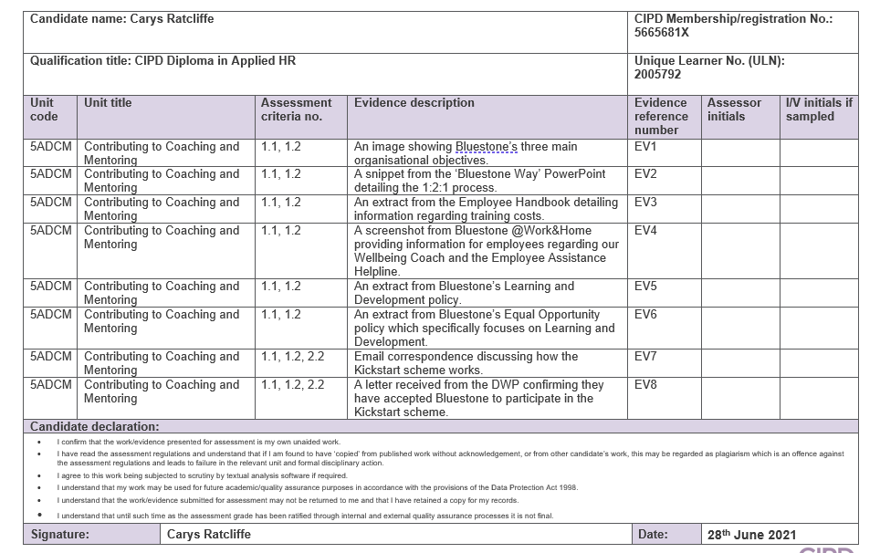Activity 1- Be able to assess the impact of coaching and mentoring activity within an organisation and make recommendations for further development.
Bluestone (Wales) National Park Resort is a family-run private sector business with over 700 employees based in Pembrokeshire (Business Wales 2016). Bluestone’s business purpose is to provide a ‘spirited visitor experience’ which ‘inspires memories in beautiful surroundings’ allowing guests to leave with their ‘inner selves relaxed and refreshed’. To achieve this, Bluestone has built 300 luxury self-catering lodges and cottages (BluestoneWales). As an organisation, we realise that this is not possible without our employees. Employees are our greatest asset as they are key to achieving the organisation’s strategic plans and objectives. It is vital that coaching and mentoring practices uphold our company ethos and are effective in supporting the achievement of these objectives.
One of Bluestone’s main organisational objectives (EV1) is the ‘ability to grow as a team’. To create this culture, we focus on a combination of both informal and formal coaching and mentoring practices which are implemented using line managers. They take the role of key stakeholder in our coach/coachee relationships. Line managers apply coaching as part of their day-to-day activities through both formal and informal activities. This is beneficial to all involved as line managers are invested in supporting employees to ensure they succeed, achieve their aims and desired outcomes (Causeway Coaching 2019). However, they also strive to ensure the organisation is achieving its objectives and are aware of how their role fits into this. The CIPD (2020) Learning and Skills at Work Survey discovered that line managers take the main responsibility for delivering coaching. This is also the case in Bluestone, as they are responsible for being both enablers and facilitators- helping employees make decisions, improve their skills, and strive towards their goals whilst providing them with the needed support and encouragement (FM 2016).
To grow as a team, we identify training requirements through business plans, service needs, development reviews and annual appraisals. Bluestone have recently implemented a new 1:2:1 process (EV2) which replaces annual appraisals. Line managers must conduct one compulsory private conversation with an employee. These conversations should be based on performance, motivation, ideas, improvements, and development options. In these conversations, managers are encouraged to use SMART goals. This ensures that all goals are specific, achievable, and relevant to both the organisation and employee (MindTools 2021). The employee can request a further four additional conversations in a year if they feel they are needed. The extent that this takes place, varies depending on department. Several departments have failed to complete/implement the 1:2:1 process. This means that we are missing the chance to converse with employees, discover both their skills and weaknesses, career goals and the opportunities to coach/mentor them to achieve their goals.
Bluestone places an emphasis on continuous learning and development which encourages internal progression allowing us to both develop and grow as a team (one of Bluestone’s main organisational objectives). In Bluestone 80% of our managers are ‘home-grown’. For employees progressing internally, we use specific planned booklets. This allows them to demonstrate and develop their skills, learn more about the role and record observations. We also encourage employees to obtain formal qualifications as and when required for their job role/career development, to do this Bluestone work closely with Pembrokeshire College. As an organisation, we consider training to be an investment in our employees, and therefore consider it fair to request a reasonable length of employment from the employee following completion of training/learning activity (EV3).
Bluestone also uses peer mentoring in all departments throughout the business- this is seen as the ‘relationship between employees at the same career stage, where they can provide support, share knowledge and skills’ (Art of Mentoring 2015). This co-learning environment is used as we feel that it is less intimidating leading to more open communication which contributes to employee retention. Some examples of peer mentoring include ‘buddy programmes’, shadow shifts and skill-sharing schemes.

COVID-19 has meant that Bluestone’s approach to coaching and mentoring needed to be adapted. We now take a blended approach to learning and development- running training sessions both social distanced in person and through the use of online platforms. Like many organisations, the use of digital learning platforms has meant a shift away from ‘traditional’ systems and a shift towards wellbeing and informal coaching (Robinson 2020). We mainly used Zoom to conduct ‘check-in’ conversations which allowed employees to discuss their concerns and worries, manage stress, and navigate change. The empathetic part of our coaches/mentors’ role has been vital during this period- helping our employees consider their physical, emotional, and psychological state and contemplating how they can navigate this (Gotian 2020).
COVID-19 contributed to Bluestone placing an increased focus on creating a compassionate cultured workplace. To do this, we have an Employee Wellbeing Coach and an Employee Assistance Helpline which is available 24/7 (EV4). They both offer confidential advice on any aspect of health and wellbeing and use counselling to help employees deal with any personal problems which in the long run may impact their work performance, health, or wellbeing. Bluestone believe it is important to remove the stigma attached to mental health/illness and create an environment of trust and transparency in the organisation- with the hope to create a culture where individuals are willing to learn and progress.
What policies do Bluestone have to reinforce our coaching and mentoring activities?
Coaching and mentoring are effective development methods to help individuals reflect, conduct learning in the workplace, identify, and achieve their goals. Bluestone’s learning and development policy outlines our organisation’s approach to both formal and informal coaching and mentoring. This ensures as a business, we strive to unlock employee’s full potential (EV5).
After looking at this, I believe that it does fall in line with best practice. However, in the future, I think Bluestone would benefit from a combination of internal and external coaching/mentoring. Currently, almost no external coaching occurs in the organisation, and I personally believe it is time for the responsibility for professional development to be shared. External coaches have specialist knowledge and training into theories/coaching practices and when/how to use them. Currently, it is the responsibility of line managers to coach their employees- most of whom have no training themselves into how to coach individuals. Therefore, with the assistance of external coaches both the line managers and employees would greatly benefit. Although this comes at a higher cost to the business, outside specialist expertise can bring new ideas and ways of working to the company (TPC Leadership 2021).
Bluestone has an equal opportunity policy (EV6) which details the measures taken to both eliminate and prevent discrimination in the workplace. This applies to everything we do as an organisation, including our policies and procedures for Learning and Development.
How can coaching and mentoring be further developed in Bluestone?
There are several factors which may affect the organisation’s learning and development policy and its further implementation in the future. One of which is organisational structure, currently Bluestone is being restructured with the re-launch of the Bluestone Academy. This provides apprenticeships for individuals unsure of what career path they would like to follow. They have the opportunity to undergo coaching and mentoring in a variety of different settings. We are hoping that this creates a positive learning environment to showcase everything Bluestone has to offer and its wide range of opportunities.
Bluestone has a strong company culture which is constantly progressing and adapting, depending on this our coaching and mentoring approaches also change. For example, during COVID-19 especially when most of our employees were on furlough, our focus shifted away from coaching and mentoring and shifted towards employee well-being. To do this, we offered counselling, support and advice through employee communications and online training platforms.
The combination of formal and informal coaching and mentoring processes interlink together to enable employees to reach their potential, achieve the desired outcome and meet organisational objectives. However, the effectiveness and extent of Bluestone’s coaching and mentoring activities vary depending on department, managerial approach, and individual attitude. Several departments fail to complete appraisals, 1:2:1 meetings and regular training exercises. This means that we are missing the chance to converse with employees, discover both their skills and weaknesses, career goals and the opportunities to coach/mentor them to achieve their goals. We need to ensure consistency across the board to ensure that all involved follow a documented and standardised process. As an organisation, we ask our employees to be consistent in their performance, therefore it is only fair that we provide consistent coaching and mentoring opportunities across all departments. This builds trust and predictability throughout the organisation which positively impacts on retention rates and performance and decreases uncertainty and stress (Robertson-Smith and Markwick 2009). To do this, providing our line managers- who are responsible for implementing learning and development coaching themselves, run by external professionals would greatly benefit both our employees and the organisation.
Personally, I do not believe that Bluestone has a ‘coaching culture’ as although we strive to deliver results, as an organisation we fall short when making the most of employee’s potential. Although, coaching conversations do occur it is often a ‘tick box exercise’ rather than a genuine drive to build a stronger, more capable workforce. To create this shift, as an organisation we need to become more open and honest and diminish the politics which occurs. This encourages emphasis on both delivering results and the achievement of longer-term organisational objectives as coaching and mentoring will occur instinctively with constant opportunities for people to progress.

Evidence-
Evidence 1- An image showing Bluestone’s three main organisational objectives.
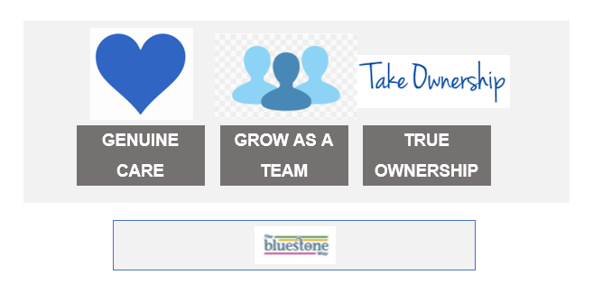

Evidence 2- A snippet from the ‘Bluestone Way’ PowerPoint which details the new 1:2:1 process and how this will work.
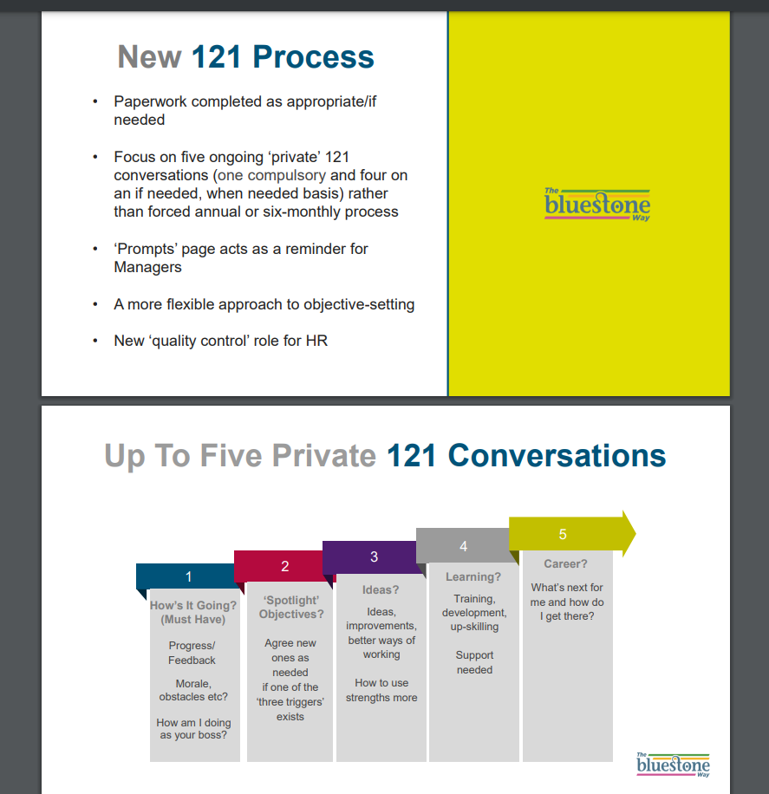
Evidence 3- An extract from the Employee Handbook detailing information regarding training costs.
An employee may be required to sign an undertaking to reimburse the company for all, or part of the cost of any training programme that represents a significant investment by the organisation.
Should the employee be provided with training in the course of employment, they undertake that on termination of their employment, they may be required to repay Bluestone as follows:
- 100% of the training costs, up to a maximum of £2,000, if the employment terminates during the period of 12 months immediately after any training has been completed.
- 66% of the training costs, up to a maximum of £2,000, if the employment terminates during the period of 18 months after any training has been completed.
- 33% of the training costs, up to a maximum of £2,000, if the employment terminates more than 18 but no more than 24 months after any training has been completed.
- Thereafter, no repayment will be required.

Evidence 4- A screenshot from Bluestone @Work&Home which provides information for employees regarding Amanda (our Employee Wellbeing Coach) and the Employee Assistance Helpline.
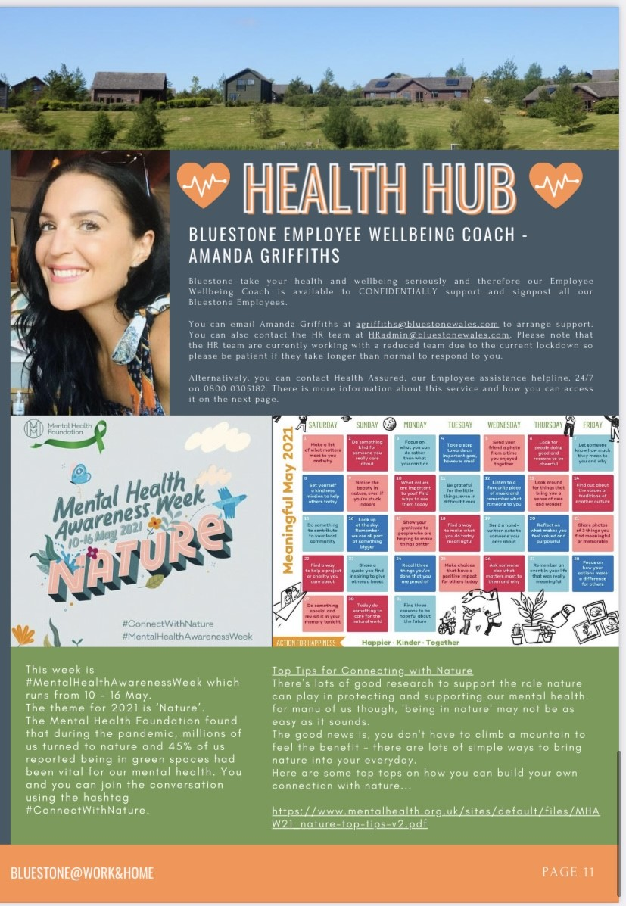
Evidence 5- An extract from Bluestone’s Learning and Development policy.
Prior to undertaking training, employees will be made aware of why the training is necessary and what the expected results will be. Employees are expected to participate in the evaluation of any training they undertake to make sure it is meeting bit their and the organisation’s needs.
Procedure
As an organisation we will:
- Regularly review overall Training and Development needs in light of changes to the business objectives, and changes in the marketplace, as well as specific requirements under Health and Safety and other relevant legislation to ensure full competency in specified areas.
- Ensure that managers are aware of their role with regard to their staff’s training and development, and that they have the skills and knowledge required to support their staff in identifying training and development needs and to follow through with the implementation of that training and development in the workplace.
- Encourage employees to pursue development over and above their job role and to give consideration to career development.
- Allocate adequate resources to meet the learning and development needs of individuals and the organisation e.g., finance, equipment, time, and opportunities.
- Agree learning objectives for learning activities and evaluate the results.
- Encourage employees to obtain formal qualifications and professional membership, as appropriate.

Evidence 6- A screenshot showing an extract from Bluestone’s Equal Opportunity policy specifically focusing on Learning and Development.


Activity 2- Be able to support the implementation of coaching and/or mentoring programmes within the organisation.
How do I actively promote and contribute to the development of coaching and mentoring in my organisation?
Working at Bluestone for 5 years has allowed me to explore various avenues and potential career paths. I have finally found my niche in the HR Department. As I am still at the start of my HR career, gaining experience and expanding both my skills and knowledge I am currently at Band One on the CIPD Profession Map. According to the CIPD a HR Professional’s role regarding Learning and Development is to ‘build individual and organisational capability and knowledge to meet current and strategic requirements and create a learning culture to embed capability development (CIPD 2013).’
One way I help achieve this is through developing learning strategies and plans. I help research and source a variety of learning options/channels to meet specific needs. One example of this is the Kickstart programme (EV7) which offers six-month placements for 30 young people across a variety of our departments. The aim of this programme is to provide learning and development opportunities to individuals otherwise at risk of long-term unemployment, helping them develop their transferrable skills through a variety of workshops, coaching opportunities, and on-the-job training (EV8). I am involved in implementing this scheme across resort, the logistics behind this and working in conjunction with the Learning and Development team to create a training schedule.
My role also includes promoting the benefits of coaching and mentoring to line managers. It is then their responsibility to promote and implement this amongst their teams. To do this, firstly I ensure that everyone understands the advantages of partaking in coaching and mentoring and how this will positively impact them both on a professional and personal level. I then ensure that all coaching opportunities are communicated across the organisation in a timely manner, so they are available for everyone who wishes to participate.
In terms of delivery, my role includes talking enthusiastically about the learning and development opportunities within our organisation encouraging individuals and managers to benefit from these. The aim is to encourage all employees to both pursue and participate in development activities for their job role, above their current role and consider their career development. Additionally, I support the delivery of learning and training programmes- completing all tasks delegated to me. Positive employee engagement and having an emotional interaction with employees is crucial to my role as this ensures development needs can be identified and acted upon swiftly (CIPD 2013).
However, after a discussion with my line manager, we are both in agreement that I lack both skills and experience in developing learning strategies and plans. This includes activities such as collecting and analysing data on the capability/learning needs of the organisation. Through peer mentoring in my organisation, I am hoping to improve my knowledge and gain more experience in these areas.
What skills, knowledge and behaviours are needed by coaches and mentors?
Coaching and mentoring are regarded as leadership styles where the coach/mentor motivates and supports their employees to generate better performance, improve their skills/knowledge and achieve their goals. Good coaches and mentors will support individuals in both a professional and personal capacity. But what makes a good coach?
It is vital that coaches are active listeners to gather information about the employee in an engaging, non-judgemental manner. Ensuring each employee receives the coach’s full attention and genuine interest (Schuy, 2018). To demonstrate this, coaches should use empathetic listening. Stephen Covey defines this as ‘reflecting what a person feels and says in your own words to their satisfaction, so they feel listened to and understood’ (Hester 2012).
Communication is another essential skill to coaching and mentoring. Tone of voice, energy, attitude, emotions, and body language have a stronger impact than words alone. Coaches need to be aware of their own behaviour and the impact and impressions it can have on others. Communicating with transparency gains the trust of employee ensuring everyone is clear on expectations. This also creates an inclusive environment helping improve performance and enjoyment in work.
Asking the right questions is at the heart of effective communication and information exchange. Coaches and mentors should use Funnel questions which involve starting with general questions, then drilling down to more specific points using open, closed, and probing questions (Mind Tools 2009).
Coaches need to show empathy and be good at building rapport. This is an important element of coaching and mentoring as it builds trust which lays the foundation for mutual respect between both parties (Schuy, 2018).
Finally, coaches and mentors need to be positive to move an employee/the team in a productive direction, focusing on weaknesses will only discourage individuals.
Coaches also need to be aware of and be able to use coaching and mentoring models. Some of which include the GROW, CLEAR and OSCAR models. Each coach will have a different model that works best for them and their employees/team. Despite this, all coaches and mentors need to ensure they do not follow the model/s to the letter as they are designed to guide conversations rather than be rigid templates.
How does Bluestone conduct on-going evaluation and improvement?
Evaluation measures the expected changes and impact of coaching and mentoring over time. It helps ensure that the training is on track to meet the client’s desired outcome.
As an organisation, Bluestone do not currently conduct any evaluation exercises following coaching and mentoring activities. Personally, I believe this is because most of our coaching and mentoring is conducted on an in-house informal basis.
In the future, Bluestone could implement Kirkpatrick’s Four-Level Training Evaluation Model. This model is used to evaluate coaching, mentoring, and training in organisations to analyse the impact, discover how much individuals have learnt and to improve learning in the future.
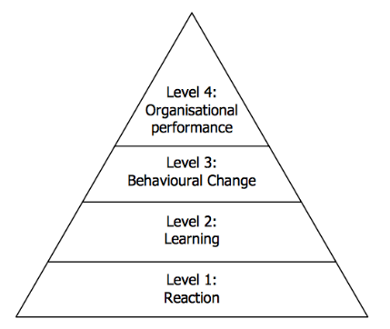
Level 1: Reaction. Training, coaching and mentoring practices in an organisation need to be valuable, ensuring employees are engaged throughout. The responses from this can help organisations implement changes to future programs.
Level 2: Learning. This stage focuses on measuring what individuals have and have not learnt, what they will do differently following the coaching exercise and their confidence/motivation following this.
Level 3: Behaviour. The aim of this level is to understand how well people apply the training in the workplace and where employees may need extra help or support. This is a longer-term process to uncover if any of the trainees have put their learning into practice.
Level 4: Results. This final step aims to analyse the final results of the coaching/mentoring exercise (MindTools 2009).
Another evaluation method we could implement into Bluestone is 360 Degree Feedback. This is a process in which ‘employees receive confidential anonymous feedback from their colleagues and manager/s.’ This allows individuals to gain a better understanding of their strengths and weaknesses so they can create a development plan and become more effective in their role. For individuals looking to progress, 360 Degree Feedback helps employees identify areas to focus on and improve (CustomInsight 2019). This method also helps organisations, such as Bluestone measure perceptions of behavioural change following coaching and mentoring exercises, therefore demonstrating how effective they have been when put into practice.
Surveys and control groups can also be used to evaluate and improve coaching and mentoring in organisations (Arema).
Finally, I propose that Bluestone implements coaching plans into the organisation. This focuses on activities and steps which managers need to undertake to increase their performance and/or effectiveness regarding coaching and mentoring. In addition, this is important for employees, as coaching plans are proven to increase performance, enhance productivity and encourage the development of new skills (AGS).

Evidence-
Evidence 7- Email correspondence discussing how the Kickstart scheme works.
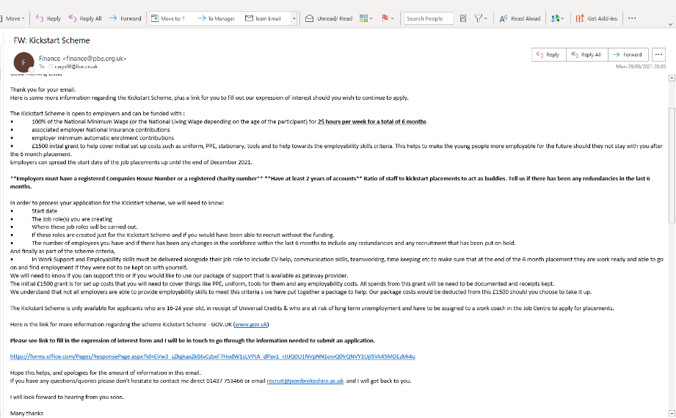

Evidence 8- A letter received from the DWP confirming they have accepted Bluestone to participate in the Kickstart Scheme.
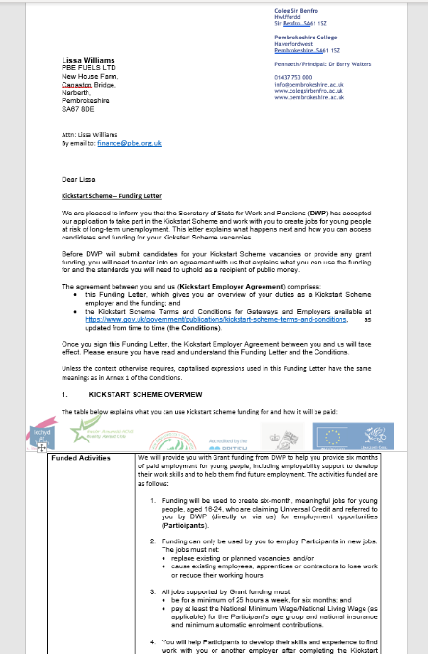

Bibliography
AGS- The Best Coaching Plan for Coaching Managers and Employees| (AGS) Airiodion (online). Available at: https://www.airiodion.com/coaching-plan/. (Accessed 27th June 2021).
Arema- Evaluating Coaching| ILM (online). Available at: https://www.arema.co.uk/uploads/5/3/0/3/53034997/1.6_white_paper_evaluating_coaching_april_2020.pdf (Accessed 27th June 2021).
Art of Mentoring (2015) What is Peer Mentoring? Advantages and Implementation (online). Available at: https://artofmentoring.net/peer-mentoring/#:~:text=Peer%20mentoring%20is%20a%20relationship,or%20experienced%20in%20a%20group (Accessed 24th June 2021).
BluestoneWales Employee Benefits|Careers [online] Available at: https://www.bluestonewales.com/about-us/careers-1/employment-benefits (Accessed 6th June 2021).
Business News Wales (2017) Pembrokeshire Resort Bluestone to Showcase Impressive Growth at Flagship Business [online]. Available at: https://businessnewswales.com/luxury-pembrokeshire-resort-bluestone-showcase-impressive-growth-flagship-business/ (Accessed 25th June 2021).
Business Wales (2016) Bluestone [online] Available at: https://businesswales.gov.wales/bl (Accessed 10th June 2021).
Causeway Coaching (2019) The role of the Sponsor-being a useful stakeholder in coaching. (online). Available at: https://www.thecausewaycoaching.com/blog-feed/on-being-a-useful-stakeholder-of-coaching (Accessed 22nd June 2021).
CIPD (2013) CIPD Profession Map- Learning and Development Band 1, Band 2, Band 3, and Band 4 (online). Available at: https://www.cipd.co.uk/Images/LD_tcm18-9649.pdf (Accessed 25th June 2021).
CIPD (2020) LEARNING AND SKILLS- SKILLS AT WORK. Mind the gap: time for learning in the UK (online). Available at: https://www.cipd.co.uk/Images/learning-skills-work-report-1_tcm18-79434.pdf (Accessed 19th June 2021).
CustomInsight (2019) What is 360 Degree Feedback? (online). Available at: https://www.custominsight.com/360-degree-feedback/what-is-360-degree-feedback.asp (Accessed 25th June 2021)
FM Magazine (2016) A coaching approach to line management (online). Available at: https://www.fm-magazine.com/news/2016/may/line-management-tips-201614365.html. (Accessed 19th June 2021).
Gotian, R (2020) Mentoring during the COVID-19 pandemic| Nature (online). Available at: https://www.nature.com/articles/d41586-020-01028-x (Accessed 29th June 2021).
Hester, J (2012) The Power of Really Listening: A tribute to Stephen Covey| Blanchard LeaderChat (online). Available at: https://leaderchat.org/2012/07/19/the-power-of-really-listening-a-tribute-to-stephen-covey/#:~:text=Stephen%20Covey%20described%20empathic%20listening,%E2%80%94ears%2C%20eyes%20and%20heart.&text=Diffuse%20feelings%E2%80%94Listening%20allows%20the,to%20get%20their%20feelings%20out. (Accessed 25th June 2021).
Indeed Career Guide (2021) Essential Coaching Skills for Strong Leadership (online). Available at: https://www.indeed.com/career-advice/career-development/coaching-skills (Accessed 25th June 2021).
MindTools (2009) Kirkpatrick’s Four-Level Training Evaluation Model Analysing Training Effectiveness (online). Available at: https://www.mindtools.com/pages/article/kirkpatrick.htm (Accessed 26th June 2021).
MindTools (2021). SMART Goals – How to Make Your Goals Achievable. [online] Mindtools.com. Available at: https://www.mindtools.com/pages/article/smart-goals.htm.
MindTools (2009) Questioning Techniques: Asking Questions Effectively| MindTools Content Team (online) Available at: https://www.mindtools.com/pages/article/newTMC_88.htm (Accessed 25th June 2021).
Robertson-Smith, G and Markwick, C (2009) Employee Engagement: a review of current thinking. Brighton: Institute for Employment Studies (Accessed 20th June 2021).
Robinson, T (2020) Leading in a changing world| CIPD (online). Available at: https://www.cipd.co.uk/knowledge/strategy/organisational-development/thought-pieces/leading-changing-world (Accessed 29th June 2021).
Schuy, M (2018) 12 Coaching Skills that make you a good coach| CleverMemo (online). Available at: https://clevermemo.com/blog/en/coaching-skills/ (Accessed 25th June 2021).
TPC Leadership (2021) Benefits of using an external coach| Blog| TPC Leadership [online]. Available at: https://tpcleadership.com/uk-en/benefits-of-using-an-external-coach/ (Accessed 6th June 2021).

