

Student Name: Meron Banger

Student Number: 2430071

Module Code: LCHS4010

Module Title: Psychology in Health and Social Care

Lecturer’s name: Peace Okachuku

Assignment Title: Assignment 2: Written Task

Table of Contents
Introduction 3
1. Care home setting for older people 3
2 Detailed overview of the theories 3
2.1 Piaget’s cognitive development theory 3
2.2 Vygotsky’s sociocultural theory 5
3 Application in the Health and Social Care context 6
3.1 Application of Piaget’s Cognitive Development Theory in a Dementia Care Home 6
3.2 Application of Vygotsky’s Sociocultural Theory in a Dementia Care Home 6
3.3 Potential challenges for professionals in applying these theories 7
3.4 Strategies to manage them 7
Conclusion 7
Reference list 8

Introduction
This report aims to discuss the health and social care working with older patients aged 65 and over who are living with dementia. In that case, St. Monica Trust in Bristol, which is a popular care home in the UK, provides versatile services and healthcare support to older adults. Dementia patients need personalised care, theory-informed approaches to meet the social and cognitive needs of the older patients. Moreover, to handle dementia patients, health and social care workers need a strong understanding of psychological needs for patient well-being. Hence, this report will discuss two psychological theories, such as Piaget’s cognitive development theory and Vygotsky’s sociocultural theory, to understand the dementia care needs and how the approaches of these two theories can be applied in real-world care effectively. Along with the potential limitation of applying these two theories in the health and social care setting will be illustrated.

1. Care home setting for older people
St. Monica Trust in Bristol is a reputable care home that provides high-quality healthcare support to dementia patients. This is a not-for-profit healthcare setting in the UK that provides residential care, nursing and special dementia care to older age patients (St Monica's Trust, 2025). The primary aim of this healthcare setting is to maintain patients’ dignity and provide patient-centred care, and foster therapeutic environments to motivate patients to live a healthy life appropriately. Dementia patients get appropriate healthcare support and the opportunities to improve their communication skills, problem-solving ability and expressing their emotions. Healthcare workers are responsible for understanding the psychological needs of dementia patients to motivate them for social interaction and live a healthy life (St Monica's Trust, 2025). In that case, the application of the psychological theories is essential to enhance patient well-being and meet the complex needs of dementia patients in St. Monica Trust.

2 Detailed overview of the theories

2.1 Piaget’s cognitive development theory
Definition
Piaget’s cognitive development theory helps to analyse how every person constructs their understanding and gains knowledge throughout their life span. This theory has four stages such as schemas, assimilation, accommodation, and equilibration (Oogarah-Pratap et al., 2025). These stages help understand dementia by applying the concept of "cognitive regression,” as people with dementia lose their cognitive abilities to live a healthy life and conduct daily activities.
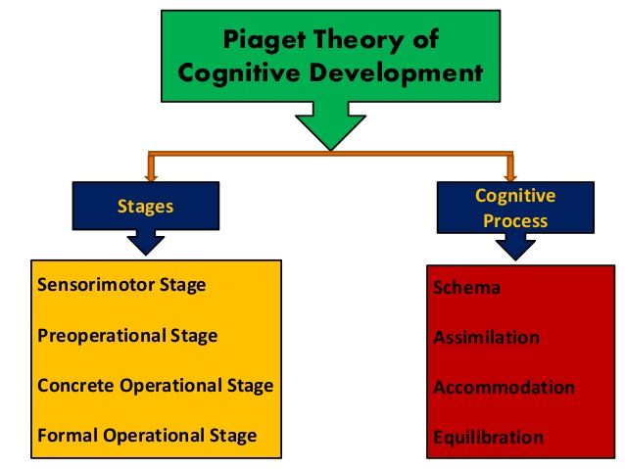
Figure 1: Piaget’s cognitive development theory
(Source: Oogarah-Pratap et al., 2025)
Application of this theory to adults aged 65 and over
Piaget’s cognitive development theory does not align directly with ageing. Despite that, a few elements of this theory can be aligned with dementia life. Dementia is characterised by a gradual deterioration in attention, memory, reasoning, and problem-solving (Huang, 2022). In elderly people, it can be a lack of ability to assimilate new information, such as a shift in routine and diminished ability to adapt to new tasks, which leads to confusion and disorientation. A decrease in formal operational skills creates barriers for older patients to think in a constructive way. In that case, the mentioned theory can be used to explain some of the prevalent challenges that are found among older adults in dementia care environments.

Critical analysis of this theory
Piaget’s cognitive development theory allows health and social care professionals to understand why dementia patients face difficulties in learning new things and to recognise their daily activities (Malik and Marwaha, 2023). Moreover, by following this theory, the healthcare professionals can develop strong and trustworthy relationships with dementia people with dementia, as it helps to analyse the cognitive abilities of patients. These are the core strengths of this psychological theory. On the other hand, the mentioned psychological theory does not apply directly in the dementia situation because it avoids the impact of ageing on the cognitive abilities (Oogarah-Pratap et al., 2025). Besides, this theory also avoids the social influences that are necessary for dementia patients to live a social life and motivates them for social interaction. These are the clear limitations of Piaget’s cognitive development theory.

2.2 Vygotsky’s sociocultural theory
Definition
Vygotsky's sociocultural theory explains that cognitive development can happen through social interaction and language. Based on this theory, people learn different activities through social interaction and working with others. The two key principles of this theory are the Zone of Proximal Development (ZPD) and the More Knowledgeable Other (MKO) (Sarmiento-Campos et al., 2022). ZPD refers to the gap between what a person can do alone and what they cannot do alone and need support with. Furthermore, MKO is where an individual develops their skills and ability to do any activity through social interaction.
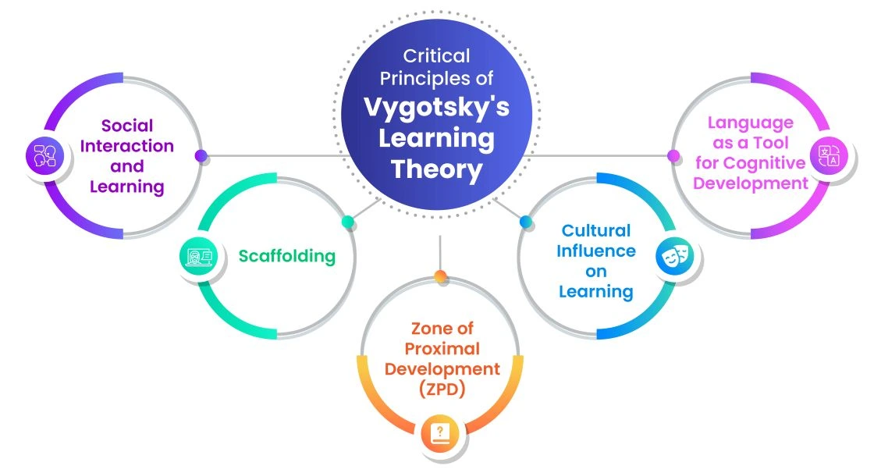
Figure 2: Traits of Vygotsky’s sociocultural theory
(Source: Sarmiento-Campos et al., 2022)
Application of this theory to adults aged 65 and over
Vygotsky's sociocultural theory is generally developed for children, but this theory can be applied to dementia patients. This theory prioritises social interaction, and proper social interaction is necessary for dementia people with dementia to get support for a healthy life (Kozulin, 2023). Along with that, through interaction, people with dementia can get support on what they need to do and how to do their daily tasks effectively. Thus, Vygotsky’s sociocultural theory can be applied to adults aged 65 and over.
Critical analysis of this theory
Vygotsky’s sociocultural theory can be applied to dementia care as it is based on communication, support, and social connection, which older adults need (Grossen et al., 2022). Nonetheless, it may be challenging to determine the ZPD of an individual in the case of severe dementia. It is also time-consuming, patient and involves regular staff. Although these are the boundaries, the theory can be of great help in promoting cognitive and emotional well-being among the aged.

3 Application in the Health and Social Care context

3.1 Application of Piaget’s Cognitive Development Theory in a Dementia Care Home
This theory can be applied in a dementia care home because, by following this theory, the healthcare staff can understand the cognitive abilities of the older people. Based on that, healthcare professionals can provide support to people with dementia for a better life.
Practical examples
Dementia patients generally lose their ability to perform their daily life activities and fail to make strong decisions about their care. In that case, the principles of the mentioned theory help people to execute their daily routines (Cerovac and Keane, 2024). For instance, dementia patients reduce their formal thinking, so care staff can offer simple tasks and can guide them on how to complete them. Hence, the health care professionals of St. Monica Trust can follow this theory to help dementia patients by doing daily activities such as washing and choosing their clothes.
Addressing the psychological and behavioural challenges
Residents are unable to make schemas easily due to a lack of cognitive ability. The healthcare staff can assist them to live independently, which can reduce frustration. Once a resident is disoriented by a new routine, the staff can help them follow the routine. This tactic will eliminate distress and encourage a feeling of security.
Critical evaluation
Piaget’s theory helps healthcare staff to understand why dementia patients lose their memory (Cerovac and Keane, 2024). However, this theory cannot be applicable to understand residents’ emotions and cultural background, and these are important for dementia patients.

3.2 Application of Vygotsky’s Sociocultural Theory in a Dementia Care Home
Vygotsky's theory focuses on social interaction and clear communication for developing cognitive abilities (Adams-Price and Morse, 2024). This theory is relevant for dementia people with dementia for social engagement.
Practical examples
The healthcare staff can help patients perform daily activities by guiding them following this theory (Sarmiento-Campos et al., 2022). For instance, while eating, care staff can guide residents to hold a spoon or can support them in making decisions for food preferences through communication. Thus, motivations for social interaction can be developed among residents in St. Monica Trust.
Addressing the psychological and behavioural challenges
Residents became upset if they felt alone. The principle of Vygotsky helps the staff to provide emotional support, collaborate with residents, and communicate positively (Adams-Price and Morse, 2024). This minimises activities like agitation, restlessness or withdrawal.
Critical evaluation
The theory is very appropriate for dementia care since it places importance on relationships and communication. However, this theory may be hard to discover the area of a resident that is close to their proximal development.

3.3 Potential challenges for professionals in applying these theories
- Time pressure: Healthcare professionals may face challenges in providing accurate guidance on time to residents.
- Advanced dementia: Severe cognitive decline among patients creates difficulties for staff to follow these two theories equally (Ma et al., 2022).
- Staff turnover: Staff shortage affects social interaction as the healthcare organisation fails to follow these two theories.

3.4 Strategies to manage them
- Training: Providing adequate training to healthcare staff for developing a trustworthy relationship with dementia patients.
- Environmental adaptation: Using memory boards, structured routines and visual cues is necessary to support the principles of Piaget’s theory.
- Family involvement: Family involvement is necessary to provide a familiar environment to people with dementia for a better life.

Conclusion
It can be concluded that psychological support is necessary for old people living with dementia. In that case, the healthcare organisations need to follow psychological theories such as Piaget’s cognitive development theory and Vygotsky’s sociocultural theory to support residents to live a better and independent life. Moreover, the St. Monica Trust needs to follow these two psychological theories to provide better support and motivate residents to do daily life activities on their own, as well as to live independently.

Reference list
Adams-Price, C.E. and Morse, L.W. (2024) 'Creativity, ageing, context and culture: Reimagining creativity in everyday life in older adults', Possibility Studies & Society, 65(8), pp. 67–98. Available at: https://doi.org/10.1177/27538699241235247.
Cerovac, M. and Keane, T. (2024) ‘Early insights into Piaget’s cognitive development model through the lens of the Technologies curriculum’, International Journal of Technology and Design Education, 35(1), pp. 61–81. Available at: https://doi.org/10.1007/s10798-024-09906-5.
Grossen, M., Zittoun, T. and Baucal, A. (2022) ‘Learning and developing over the life-course: A sociocultural approach’, Learning, Culture and Social Interaction, 37(7), pp. 100–478. Available at: https://doi.org/10.1016/j.lcsi.2020.100478.
Huang, S.-S. (2022) ‘Depression among caregivers of patients with dementia: Associative factors and management approaches’, World Journal of Psychiatry, 12(1), pp. 59–76. Available at: https://doi.org/10.5498/wjp.v12.i1.59.
Kozulin, A. (2023) The cultural mind: The sociocultural theory of learning. Cambridge University Press.
Ma, N., Sutton, N., Yang, J.S., Rawlings-Way, O., Brown, D., McAllister, G., Parker, D. and Lewis, R. (2022) ‘The quality effects of agency staffing in residential aged care’, Australasian Journal on Ageing, 42(1), pp. 195–203. Available at: https://doi.org/10.1111/ajag.13132.
Malik, F. and Marwaha, R. (2023) Cognitive development. In StatPearls [Internet]. StatPearls Publishing.
Oogarah-Pratap, B., Bholoa, A. and Ramma, Y. (2025) ‘Stage Theory of Cognitive Development—Jean Piaget’, Springer Texts in Education, 67(7), pp. 125–142. Available at: https://doi.org/10.1007/978-3-031-81351-1_8.
Sarmiento-Campos, N.-V., Lázaro-Guillermo, J.C., Silvera-Alarcón, E.-N., Cuellar-Quispe, S., Huamán-Romaní, Y.-L., Apaza, O.A. and Sorkheh, A. (2022) ‘A Look at Vygotsky’s Sociocultural Theory (SCT): The Effectiveness of Scaffolding Method on EFL Learners’ Speaking Achievement’, Education Research International. Edited by E. Rezvani, 2022(7), pp. 1–12. Available at: https://doi.org/10.1155/2022/3514892.
St Monica's Trust (2025) Communities where older people flourish, St Monica Trust. Available at: https://www.stmonicatrust.org.uk/ (Accessed: 3 December 2025).

