LCHS4003 Component 1
Student I’d – 2438383
Student Name – Naanaz Saddiq

Table of Contents
1. Introduction 5
2. Origin of the NHS 5
3. Current Structure and Functioning 5
4. Conclusion 6
References 7

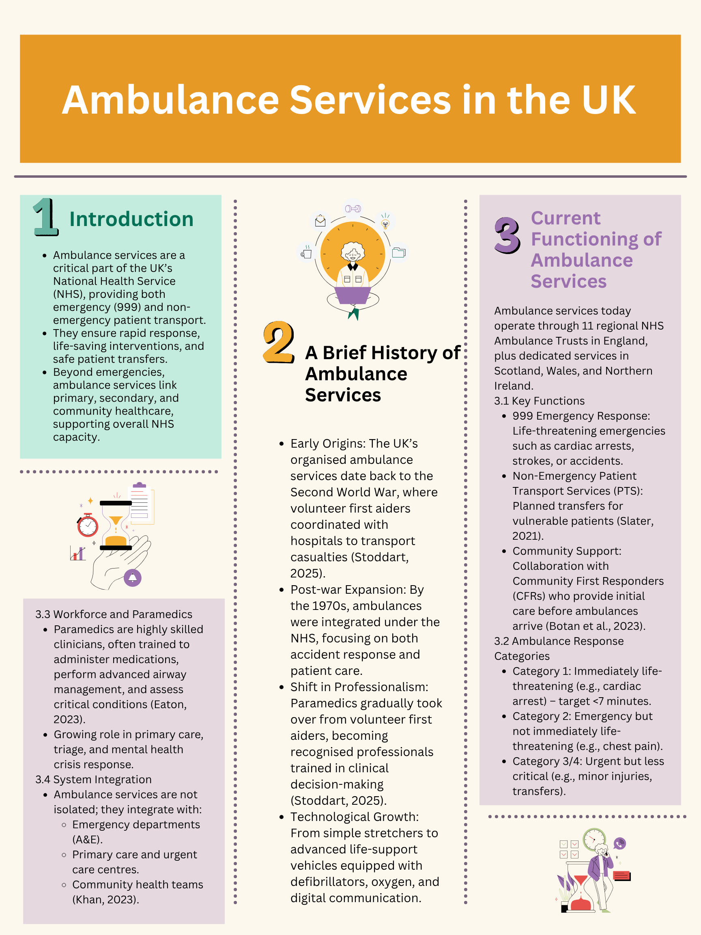
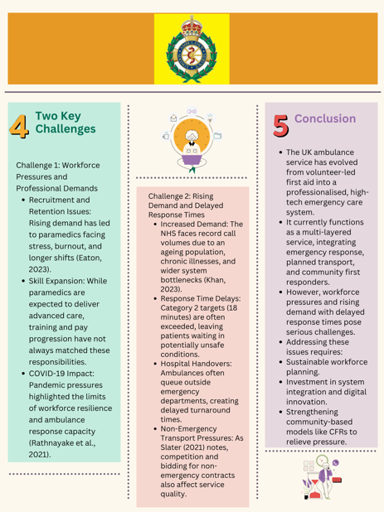
Task 2

1. Introduction
NHS is the main organ of the UK system of health and social care which provides universal, fair and free-of-charge healthcare at the levels of health and social care (Ham, 2024). This essay focuses on the history of the NHS, its principles of creation, and general organization, and critically analyses its advantages, problems, and its continued relevance (Crisp et al., 2024).

2. Origin of the NHS
The history of the NHS is associated in the first place with the years following the war ends, when Britain which had gone through the global conflict experienced generalized poverty, lack of healthcare, and untenable disparity in healthcare access (Ham, 2024). The social and political environment required far-reaching reforms in order to build equitable, accessible, and publicly funded healthcare system. The key player here was Aneurin Bevan, and the Welsh Labour movement, who was the core to the negotiation of the political compromises and formation of the official guidelines through which the NHS was founded (Davies, 2024). With three principles that included universality, where everyone in the country could obtain care, irrespective of social and economic condition; free at the point of delivery, where healthcare was not conditioned by the possible ability to pay; and equity and quality, which were to decrease health disparity and enhance outcomes among the population (Crisp et al., 2024). Although these principles are still most applicable to this day, it still struggles to transform them into meeting modern issues of workforce stresses and increased expectation (Crisp et al., 2024).

3. Current Structure and Functioning
An NHS currently consists of four devolved administrations: NHS England, NHS Scotland, NHS Wales and Health and Social Care Northern Ireland each charged with the responsibility of providing health care within their regions (Abela, 2023). In those administrations hospitals, ambulance services, primary care networks and community services are governed by a mixture of regional and local structures making sure that a whole country is covered. There are key elements of care which the NHS provides (Anderson et al., 2021). Emergency care is a combination of ambulance and accident and emergency (A&E) services, which offer life-threatening intervention of life-threatening illnesses. Primary health care that involves general practitioners, clinics and preventives, is the initial touch point with most patients. Hospital-based secondary and tertiary care is considered to be specialist care offered and complex procedures. Social care integration includes intensive work with the local government and local community teams, as well as helping the patients outside the hospital context (Miller et al., 2021).
Universal coverage system, factions towards equity, and accessibility plus an established organization that enables integration to care pathways are beneficial to the NHS. Its original values are to this day directing policy and action (Crisp et al., 2024). Nevertheless, the system has serious issues: human resources are strained because of the lack of doctors, nurses, and paramedics (Anderson et al., 2021), demand is increasing due to the ageing population and complicated conditions, there are weak ties among health and social care, and investments are low due to funding restrictions which restrict the capabilities of the service and innovation (Ham, 2024). Although the NHS does not alter its primary principles, these new issues entirely put efficiency and responsiveness at risk, and to ensure high-quality care, the NHS has to adapt itself strategically (Crisp et al., 2024).

4. Conclusion
To sum up, the NHS has been a groundbreaking agent in the UK health and social care, starting out as it has evolved to be a universal system all-encompassing and post-war. Its ideals of universality, equity and free-at-point-of-use care are ever the most relevant in the modern age. Access to talent, finances, and pockets without integration are persistent issues, however, which highlights the need to consume strategic planning, innovation, and adaptability to enable the NHS to remain responsive to the needs of the 21st century population.

References
Abela, S., 2023. The Structure of the NHS. In Leadership and Management in Healthcare: A Guide for Medical and Dental Practitioners (pp. 3-18). Cham: Springer International Publishing. https://link.springer.com/chapter/10.1007/978-3-031-21025-9_1
Anderson, M., O'Neill, C., Clark, J.M., Street, A., Woods, M., Johnston-Webber, C., Charlesworth, A., Whyte, M., Foster, M., Majeed, A. and Pitchforth, E., 2021. Securing a sustainable and fit-for-purpose UK health and care workforce. The Lancet, 397(10288), pp.1992-2011. https://www.thelancet.com/journals/lancet/article/PIIS0140-6736(21)00231-2/abstract
Botan, V., Asghar, Z., Rowan, E., Smith, M.D., Patel, G., Phung, V.H., Trueman, I., Spaight, R., Brewster, A., Mountain, P. and Orner, R., 2023. Community first responders’ contribution to emergency medical service provision in the United Kingdom. Annals of Emergency Medicine, 81(2), pp.176-183. https://www.sciencedirect.com/science/article/pii/S019606442200364X
Crisp, N., Bamrah, J.S., Morley, J., Augst, C. and Patel, K., 2024. The NHS founding principles are still appropriate today and provide a strong foundation for the future. bmj, 384. https://www.bmj.com/content/384/bmj-2023-078903.abstract
Davies, N., 2024. The language of priorities: Aneurin Bevan, Welsh labour and the politics of the past. The British Journal of Politics and International Relations, 26(1), pp.62-78. https://journals.sagepub.com/doi/abs/10.1177/13691481231158296
Eaton, G., 2023. Addressing the challenges facing the paramedic profession in the United Kingdom. British Medical Bulletin, 148(1), pp.70-78. https://academic.oup.com/bmb/article-abstract/148/1/70/7262998
Ham, C., 2024. Health policy in Britain: The politics and organization of the National Health Service. Routledge. https://www.taylorfrancis.com/books/mono/10.4324/9781003571896/health-policy-britain-christopher-ham
Khan, Z., 2023. The emerging challenges and strengths of the National Health Services: a physician perspective. Cureus, 15(5). https://www.cureus.com/articles/153209-the-emerging-challenges-and-strengths-of-the-national-health-services-a-physician-perspective.pdf
Miller, R., Glasby, J. and Dickinson, H., 2021. Integrated health and social care in England: ten years on. International journal of integrated care, 21(4), p.6. https://pmc.ncbi.nlm.nih.gov/articles/PMC8555479/
Rathnayake, D., Clarke, M. and Jayasinghe, V.I., 2021. Health system performance and health system preparedness for the post-pandemic impact of COVID-19: A review. International Journal of Healthcare Management, 14(1), pp.250-254. https://www.tandfonline.com/doi/abs/10.1080/20479700.2020.1836732
Slater, A., 2021. Reflections on an NHS ambulance service trust bidding for non-emergency patient transport services. International Journal of Emergency Services, 10(1), pp.147-157. https://www.emerald.com/insight/content/doi/10.1108/ijes-05-2020-0028/full/html
Stoddart, H., 2025. Shifting First Aid: A Socio‐Historical Analysis of Tracing the Changing Relations Between First Aiders and the UK Ambulance Service From 1941 to 2020. Sociology Compass, 19(8), p.e70105. https://compass.onlinelibrary.wiley.com/doi/abs/10.1111/soc4.70105

